

Module Name: Digital Skills for Personal and Professional Growth
Module Code: BMSW 4008
Assignment Name: Portfolio
Student Name: Elena Oruci
Student Number: 2530282
Lecturer: Philippa Fitzgerald
Deadline: 16/03/2026
AI Acknowledgement:
I confirm that I have not presented any AI generated materials as my own work.
I confirm that I have copies of my drafts, notes, and other resources I used, which I may be asked to provide in evidence.
Content:
-Title and cover page 1
-AI acknowledgement 1
-Assessment of digital skill 2-4
-LinkedIn Learning Certificates 5
- The Relevance and Importance of Microsoft Excel in the Modern World 6-9

My Assessment of digital skill
In today’s world, having digital skills is about much more than just knowing how to use a smartphone or post on social media. For students and professionals alike, digital capability is a fundamental requirement for success. It involves being able to find the right information, stay safe online, and use different software to solve problems. According to researchers, digital literacy is now a "core competency" that is just as important as reading and writing (Secker, 2020). For a student like me, these skills are the key to accessing global research and creating high-quality assignments. In my future career, being good with technology will make me more adaptable in a fast-changing job market where most roles now require some form of advanced digital knowledge (Beetham and Sharpe, 2020).
Summary of JISC Results
To understand my own skills better, I completed the JISC Digital Capability self-assessment tool. This tool looks at six different areas, including how we handle data, how we communicate, and how we look after our wellbeing in a digital space. After finishing the survey, the JISC tool generated a graph that gave me a clear picture of where I stand. The results showed that I am quite balanced in some areas, like basic communication, but I have a lot of room to grow when it comes to creating professional digital content. This assessment was very helpful because it gave me an objective way to see my skills. It made me realize that even though I use technology every day, I am not always using it in the most professional or efficient way (JISC, 2024).
Strengths and Weaknesses
When I looked closely at my JISC results, I identified two main strengths. My first strength is Digital Communication and Collaboration. I find it very easy to work with others using tools like Microsoft Teams, Zoom, or Google Docs. I can organize group chats, share files, and make sure everyone is on the same page during a project. My second strength is Information Literacy. I am good at using library databases and search engines to find academic articles for my essays. I know how to check if a source is reliable or if it is "fake news," which is a vital skill in modern education (Gilster, 2021).
However, the assessment also showed me two clear weaknesses. The first is Digital Content Creation. While I can make basic documents, I struggle with more advanced tasks like editing videos, creating complex spreadsheets, or making interactive presentations. I usually just stick to basic designs because I do not know how to use the advanced features. My second weakness is Digital Security and Wellbeing. I realized that I do not change my passwords often enough, and I sometimes struggle to balance my time online. I often spend too many hours staring at a screen without taking a break, which can lead to eye strain and stress. Experts note that managing your "digital footprint" and your health is one of the hardest parts of living in a connected world (Bennett, 2021).
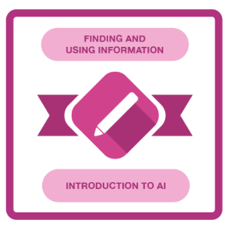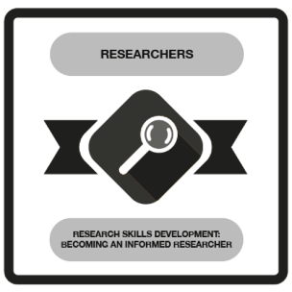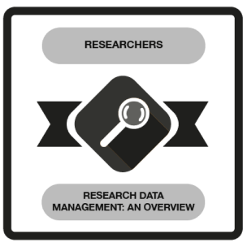
Action Plan
1. Content Creation Goal: Over the next four weeks, I will spend two hours every Saturday morning watching tutorials on LinkedIn Learning about advanced PowerPoint techniques. My goal is to learn how to make an interactive infographic. I will use these new skills for my final presentation this semester to make it look more professional.
2. Digital Wellbeing Goal: To fix my habit of staying online too long, I will start using a "digital wellbeing" app on my phone starting tomorrow. I will set a limit to reduce my social media use by 30 minutes a day. I will also follow the "20-20-20" rule, where I look away from my screen every 20 minutes to protect my eyesight. I plan to stick to this for at least three months until it becomes a habit.
Conclusion
Focusing on my digital skills is going to make a big difference in my life. In the short term, it will help me get better grades because I will be able to present my work more clearly and find better research. In the long term, these skills will help me get a better job. Many employers now look for people who are "digitally agile," meaning they can learn new software quickly (Selingo, 2020). By using the JISC tool to find my weaknesses and setting clear goals to fix them, I am taking control of my future. Digital skills are not just about computers; they are about being a smart, safe, and creative person in the 21st century.

Reference List:
Beetham, H. and Sharpe, R. (2020) Rethinking Pedagogy for a Digital Age: Principles and Practices of Design. 3rd edn. London: Routledge.
Bennett, L. (2021) The Digital Researcher: How to Handle Your Digital Footprint and Wellbeing. 2nd edn. London: Sage Publishing.
Gilster, P. (2021) Digital Literacy and the Information Age. New York: Wiley & Sons.
JISC (2024) Digital capabilities framework: The six elements. [Online] Available at: https://www.jisc.ac.uk/ (Accessed: 15 March 2026).
Secker, J. (2020) Digital Literacy: A Guide for Students and Educators. Cambridge: Cambridge University Press.
Selingo, J. (2020) Who Gets Hired and Why: Is Your Degree Enough? New York: Scribner.

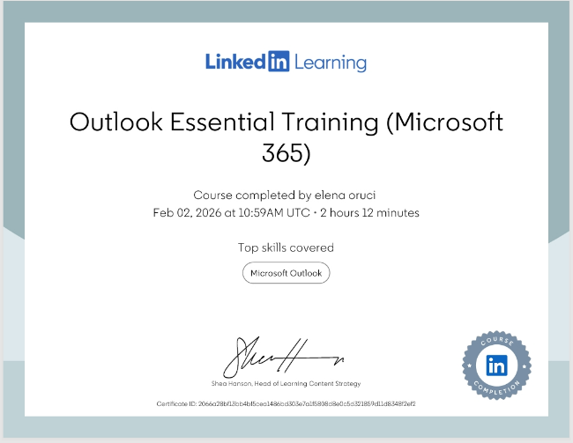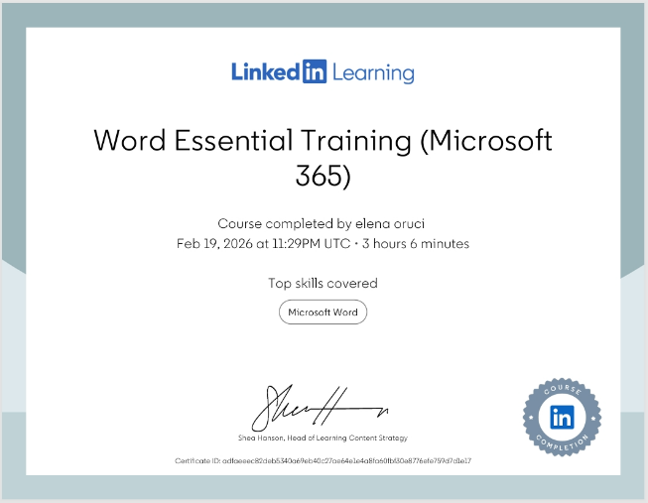
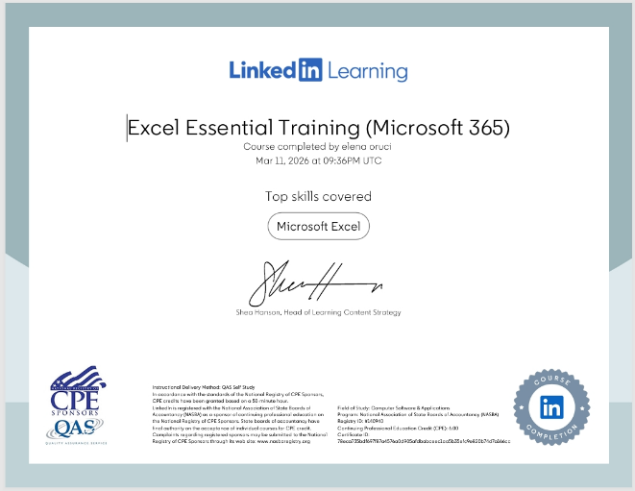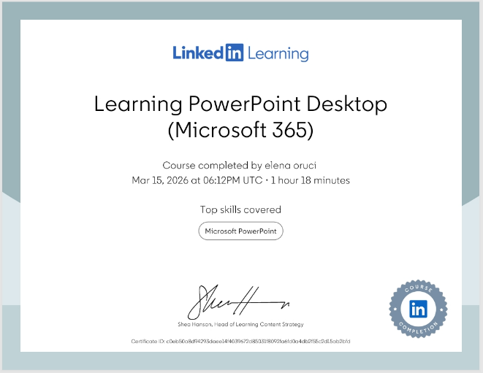

The Relevance and Importance of Microsoft Excel in the Modern World
Introduction
In the digital age, the ability to manage and interpret data is one of the most valuable skills a person can possess. Among the many tools available for this purpose, Microsoft Excel remains the industry standard. Since its release in the 1980s, Excel has evolved from a simple electronic ledger into a powerful data processing engine used by millions of people worldwide. Its relevance spans across various sectors, including education, personal finance, and global business operations. This essay explores why Excel is so important, focusing on its role in data analysis, budgeting, reporting, and decision-making, while providing practical examples of its use in daily life.
The Foundation of Data Analysis
The primary reason for Excel’s enduring popularity is its capacity for data analysis. Data in its raw form is often disorganized and difficult to understand. Excel allows users to organize this data into rows and columns, making it easy to sort, filter, and search. For example, a business owner with a list of a thousand customers can use Excel to quickly find only those who live in a specific city or those who have spent over a certain amount of money.
Advanced features like Pivot Tables allow users to summarize massive amounts of information in seconds. Instead of manually counting sales, a user can drag and drop fields to see total sales by region or by month. As noted by Walkenbach (2020), the flexibility of Excel’s grid system allows it to manage everything from simple lists to complex scientific calculations. This versatility makes it an essential tool for anyone who needs to find patterns or trends within information.
Budgeting and Financial Management
One of the most practical applications of Excel is budgeting. Whether for a multi-million-pound corporation or a simple household, managing money requires a clear view of income versus expenses. Excel’s mathematical functions, such as SUM, AVERAGE, and IF statements, automate the calculation process, reducing the risk of human error that comes with manual math.

In a household setting, Excel helps individuals track their spending habits. By categorizing expenses into "Fixed" (like rent) and "Variable" (like groceries), a user can see exactly where their money is going. For instance, if the spreadsheet shows that entertainment costs are rising every month, the user can make an informed decision to cut back. This level of financial transparency is vital for long-term saving and debt management. Alexander and Kusleika (2022) argue that Excel is the most accessible tool for financial literacy because it provides immediate visual feedback on financial health.
Professional Reporting and Data Visualization
Reporting is another area where Excel shines. In the professional world, it is rarely enough to just have the data; that data must be presented to others in a way that is easy to digest. Excel’s charting and graphing tools transform rows of numbers into visual stories. A "Pie Chart" can show a department’s share of a budget, while a "Line Graph" can show whether company profits are growing or shrinking over time.
Charts are more than just pictures; they are communication tools. When a manager presents a report to a board of directors, a clear bar chart showing a 10% increase in productivity is much more impactful than a spoken list of numbers. Excel also allows for "Conditional Formatting," which can automatically highlight cells in red if a goal is not met or green if a target is exceeded. This allows for "management by exception," where leaders can focus their attention only on the areas that need improvement (Harvey, 2021).
Supporting Better Decision-Making
The goal of using Excel is to make better decisions. In business, this is called "What-If Analysis." Excel allows users to change one variable such as the price of a product and see how it affects the final profit without having to rewrite the entire spreadsheet. This allows planners to simulate different scenarios before they happen in real life.
For example, if a family wants to buy a house, they can use Excel’s PMT (payment) function to calculate monthly mortgage payments based on different interest rates. By comparing a 3% rate to a 5% rate, they can decide if they can afford the loan. Decision-making backed by data is always more reliable than making choices based on "gut feeling" or guesswork. According to Carlberg (2020), using Excel for predictive modelling helps organizations minimize risk and maximize their resources.
Efficiency and Automation
Excel also promotes efficiency through automation. Many tasks in an office are repetitive, such as generating monthly sales reports or calculating payroll. Using formulas and Macros (automated scripts), Excel can perform these tasks in a fraction of the time it would take a human. This frees up time for employees to focus on more creative or strategic work.
Furthermore, Excel’s compatibility with other software makes it a "universal language" for data. Most software programs allow users to "Export to Excel," meaning that data from a website or a specialized accounting program can be moved into Excel for further refinement. This interoperability ensures that Excel remains at the centre of the professional workflow (Frye, 2022).
Conclusion
Microsoft Excel is much more than a digital piece of paper. It is a comprehensive tool that empowers individuals and organizations to organize, analyse, and visualize their world. From the simple task of tracking a household budget to the complex requirement of analysing global market trends, Excel provides the functionality needed to turn data into knowledge. As technology continues to advance, the demand for data-literate individuals will only grow. Mastering Excel is not just about learning a software program; it is about developing a mindset for logical problem-solving and informed decision-making. Whether in the classroom or the boardroom, Excel remains an indispensable asset for success in the 21st century.

Income | Amount per month £££ | Expenditure | Amount per month £££
Wage | 769 | Rent/Mortgage | 1000
Wage 2 | 1700 | Council tax | 212
Trust Funds | 0 | Electric | 150
Stocks/Share payouts | 0 | Gas | 250
Universal credit | 0 | Water rates | 65
Student Finance | 1100 | Food | 1200
Other | 104 | Car insurance | 100
 |  | Car Tax | 20
 |  | Fuel | 150
 |  | Child Care Costs | 0
 |  | Loans/credit cards | 600
Total | 3673 | Total | 3747

Reference List:
Alexander, M. and Kusleika, D. (2022) Microsoft Excel Bible: The Comprehensive Tutorial and Reference. Indianapolis: Wiley.
Beetham, H. and Sharpe, R. (2020) Rethinking Pedagogy for a Digital Age. 3rd edn. London: Routledge.
Carlberg, C. (2020) Business Analysis with Microsoft Excel. 6th edn. London: Pearson Education.
Frye, C. (2022) Microsoft Excel Step by Step (Office 2021 and Microsoft 365). Washington: Microsoft Press.
Harvey, G. (2021) Excel 2021 All-in-One For Dummies. New Jersey: John Wiley & Sons.
Walkenbach, J. (2020) 101 Excel 2020 Tips, Tricks and Timesavers. New York: Wiley & Sons.
Winston, W. (2021) Microsoft Excel Data Analysis and Business Modeling. 7th edn. Washington: Microsoft Press.

