
Problem solving tools and techniques used in health & social care settings
Jessica Brito
Student Number: 2008475
Module code: BMSW4004

University of Wales Trinity St David

Table of contents

Introduction of the problem on the specific setting 1

Relative Legislations and Theories 2

Relative model & Analysis of the problem 4

Suggestions of Solutions 5

Conclusion 8

This report was written to help to identify common problems in health and social care settings.
Problem- “A present unsatisfactory state that needs to be changed to a desired state soon as possible”, “It involves diagnosing the situation so that focus on the real problem” (Glasgow Caledonian University, Robert Harris January 5, 2002)

In a variety of health and social care settings, there are many problems that affect and intruder into the development and performance of the care provider to the service user within the setting.
It is crucial to investigate what problems are causing malfunctioning and performance within the environment in the health and social care setting. Some of the identified problems in the health and social care settings are:
- Lack or shortage of personal protective equipment, such as gloves, mask, essential kits, especially during this difficult global pandemic.
- Insufficient staff to help specially during the beginning pandemic, where staff needed to be tested frequently as they were unsure how to do deal with the quickness of the spreading of the virus
- Inequality pay gap-staff members get to work and overdo too many extra working hours, in which the end of the day it does not match to the worked hours.
- “Tight budget”
- “Management and organisational culture”
- “Team-work and collaboration challenges”
- “Processes that should be followed for various work-related issues”
The problem that will be bought up in this report will be the fact of how communication on the absence of staff members has an impact to the stakeholders within the setting. The chosen setting is a care home called “The Lilac care home”. This particular care home, the problem identified was the lack of communicating and reporting to the care home an absence and when it happened it would be late to reorganise the daily routine for the residents and students doing placements, potentially affect staff members and other team leaders who have later shifts on the day.
The problem was identified from a few students, who at the moment were doing placement work, as it was requested from their college to practice it in certain hours and days of the week. As a student, naturally it raises concerns on how you are meant learn procedures in such short period of time. Therefore, there was contracted competent staff members, group leaders and sub-leaders. The sub-leaders normally at this particular care home is in charge of leading college students and put the routine that is described on the schedule moving. The problem started to escalate when one of the sub-team leaders is meant to accompany the students, in which both of the team leader and sub-leader agreed, starts to fail to call in to report their absence. This kind of failure started to affect the stakeholders such as: care providers who work there, team leader when they are not present specially when it is for reasonable reasons such as for meetings regarding to the care setting and others. A sub-leader is “a person in a position of authority but subordinate to a leader of greater prominence” (“Subleader.” Merriam-Webster.com Dictionary, Merriam-Webster, https://www.merriam-webster.com/dictionary/subleader. Accessed 21 Apr. 2021.)

The role of the sub-leader is to:
- Organise the daily routine and schedule of the residents in general
- Plan outdoor activities for the residents who attend the setting.
- Make sure that they confirm with every care provider what is their dietary needs (food allergies & intolerance)
- Plan indoor activities (such as light exercise), reading time & playing within socializing time.
supporting your manager to run your workplace according to standards and legislation.(2002 Skills for care )

These kind of failures does disorganise the care providers schedules as the sub-team leader is meant to guide them as well as the residents who live in the setting. Also this problem does affects mainly the students who come for work placement, as the role of the sub-team leader of is to guide them through the day, what is like to work on a care setting, how is like to provide special care to residents who require special attention, also they meant to show you and present you to halls of the setting, where everything is usually placed and stored. As well it affects mainly staff members, who tiredly work hard to make sure they are providing the correct care and commit to the service user needs. The staff members who end up overworking due to the absence of sub-leaders who have got half of the responsibilities of a team leader. Staff who end up overworking more hours than any other staff who provide any type of care, can eventually prejudice against their well-being in which, in this including mental health
Therefore, is always good to have in consideration into having a backup plan or second alternative for the absence of people who have the biggest role into that specific listed setting. The legislations that can help to avoid certain equalities in the health and social care place of work would be: “ The Equality Act 2010”, which was established in order to “aim to integrate consideration of the advancement of equality into the day-to-day business of all bodies subject to the duty” (NHS Equality hub resources 2016-2020)The equality of Act is Well structured for this specific problem in the care setting, in which affects the majority of the stakeholders, this Act will cover the inequalities that they face while working.

RELATIVE MODEL-
Within the problem on going a crucial action to be taken would be an intervention. “Interventions that bring theories and principles into use involve joining education and consultation in a single action”( organization and management problem solving: A systems and consulting approaching; Ziegenfuss,James T., 2002).
When there are problems like this in a healthcare settings is really important that the issues gets raised and addressed by someone in a higher pose to do so, such as the a manager of the setting, coordinator or even team leader. It also important It does get done in a very professional, responsible way The model that can be adapted to the current issue, to introduce the change of the management would be the “ADKAR process”.
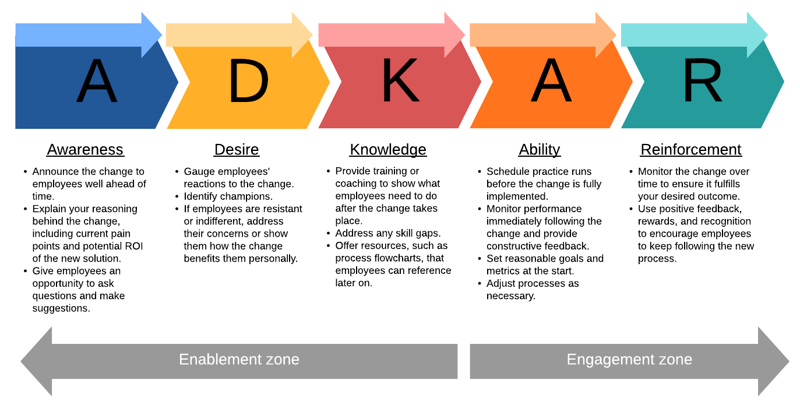
The reason why the management change is needed, is due to the fact it can eventually help to improve and increase the big probabilities of achievement of success, improvement on better professionalism outcome, better understanding of the current circumstances and how they could be avoided near future. The “ADKAR process” focuses on the transition of the problem for the solution for a better future, it’s a process in which you look for better solutions for the current setting.
ADKAR Stands for:
A – Awareness for required change
D- Desire to support the change
K- Knowledge of change
- Ability to incorporate required skills
R- Reinforce the change
Here below is the process of the ADKAR process within the problem:
A-awareness, Awareness was raised for the simple fact that, the culture of absence without previous notice or justification needs to change. There occurs a minimal risk if the change does not happens, absence culture can extend to a point where everyone normalises it which can affect negatively not just for the company but also for the care receivers who are dependent.
D- Desire to change, specially when it comes to personal change. Desire to change yourself for better for the company can have a good influence. It also helps to address issues like lateness in between their peers. Little thing such as arrive to the work place 5-10 minutes early, marks a good impression to people who surrounds you.
K- knowledge in how change and improve for better, especially on this specific bought problem, is required to know how to change the behaviour of being late and absence without giving notice. Also this covers you to understand what is required to achieve the desired change.
- Ability to know what is required to support the changes of the behaviours for high performance of improvements! Setting goals for each staff member would be fulfilling also it makes them understand which areas of their personal development they can improve.
R- Reinforcement to keep up within the change, it requires this specific setting to incentive members who are working towards to the goal for a good and improved communication skills when it come to absence and lateness. This also can be used to keep up on the good feedback and making sure evaluations are being done and tracked within improvement

The fishbone analysis is a diagram which gives the ability to “prioritise the problems in diverse processes especially when it goes comes from industrial production” (Wikipedia 2011).
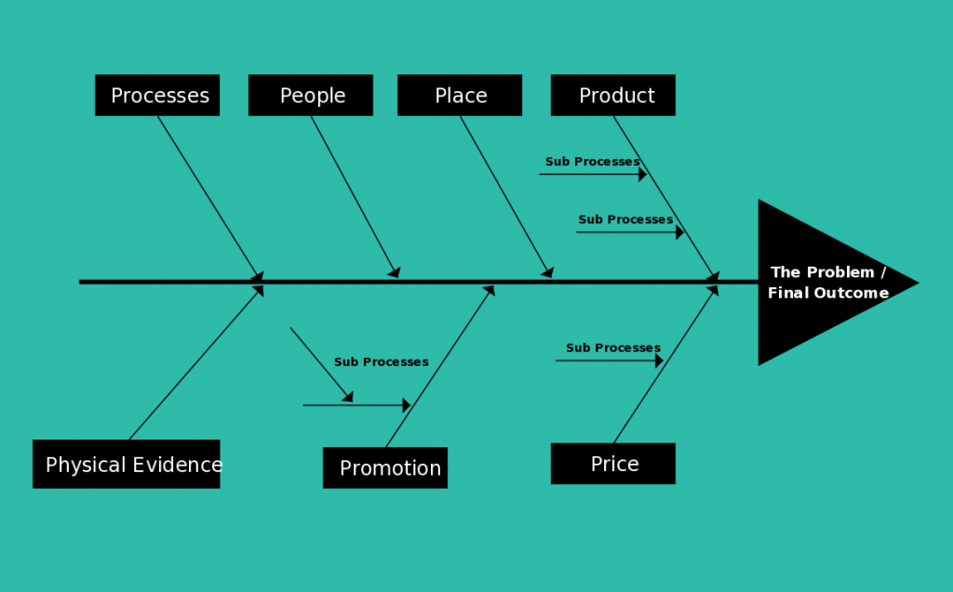
Here is an example of fishbone.

This fishbone is an example of the priority of the problems have been placed to and how urgent they need to be solved, as it affects the stakeholders into the specific business industry, which is not related to the picked topic.
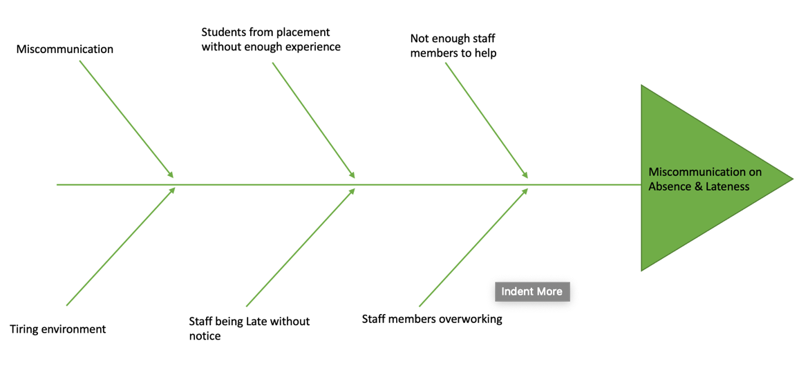
Here below is a picture of the topic and it’s problems by order or urgency:

SUGGESTION OF SOLLUTIONS-
The suggestions of solutions that would be beneficial for this particular setting in case of absence and miscommunication of the same are:
- Being able to afford to have at least one extra staff member, to avoid any later disappointment; In which contributes to overworking to a standard wage payment. That staff member would have to have training to at least know how to practice a bit of everything, so they are able gyrate that one person everywhere in the setting where he/she can provide help to other members as well as the residents who live in the setting.
- Having a backup plan/routine already planned for at least for the whole month, so staff members would know what steps to take forward to elevate a good quality and performance of care provided. It is never too much to plan ahead the routine of the setting as they are residents that depend emotionally on certain Activities that are done throughout the day, such as exercising, playing table games with other with a variety of opponents, socialising with other residents, especially on days that they don’t get visits. Times like these pandemic residents were only able to maintain calls to survive with the absence of presential figures of their family.
- Students who come for work placement, in case of absence of the member who is meant to guided them and supervise them through the day, should be allowed to have study time for themselves in a separate room, it proportionate a good time management on both ways also contributes for consistency on students education. It also contributes for a good educational life.

WAYS TO INTRODUCE THE SUGGESTIONS MENTIONED-
There are so many ways that the problem could be raised and mentioned to every single member of the staff, this going from the team leaders to care providers. The three best. Solutions found to introduce the suggestions above mentioned for better improvement in near future would be:
- Arrange a meeting: From the difficulties that we are facing now a days it might be complicated to arrange a presential meeting, due the pandemic that we are facing the best solutions would having the meeting regularly via, Microsoft teams, Zoom and etc, It is more convenient and it can be done and your own comfort. These meetings would have the purposes to address the issues raised in the beginning of this report, which is the Miscommunication of reporting absence and lateness. These meetings could also be done in small amount of group of people on the same day but different timetables, as mentioned before due covid19, we are maintaining social distancing.
- Introduce campaigns where staff members get rewards such the employer of the month, or good report cards to increase their motivation while at work. It does also helps to improve their self-motivation and make them believe in their potential.
- Having support for when get to be absent, support for coming back to work, some of the staff members do be dealing with their mental health and still yet trying to make themselves able to available to take care of residents who dependent of their help and care.

CONCLUSION
The problems raised in this report are common and they do happened a lot in health and social care setting unfortunately there are some cases that are not taken serious and we should always keep in mind that people do be dealing with their struggles outside of their pathway on their career. Communication plays a big a role in our daily routine and we need to be able to provide this skills to others to for basic life skills. Communication does really matter in health and Social care as it helps us to express our current feelings.
It is important to have intervention on going. When there are situations that affect the stakeholders, but we also need to keep in minds is good to keep a good communication skill specially when we think that our personal life might be interfering into our professional life. Fishbone analysis also was good to analyse what this specific problem is affecting and how important it is to prioritize to solve it soon as possible. Legislations also have a big role in health and social care setting and it is important that they get updated consonant to the current problems that leads to serious problems t. the point where some care can potentially close down

References list:
“It involves diagnosing the situation so that focus on the real problem” (Glasgow Caledonian University, Robert Harris January 5, 2002)

Fishbone- Wikipedia 2011).
( organization and management problem solving: A systems and consulting approaching; Ziegenfuss,James T., 2002).

