DEVELOPING RELATIONSHIPS AND WORKPLACE ACHIEVEMENT
BMSW5102
Presentation

Student name: Gheorghe Albu
Student number: 1813898
Lecturer: Mr Ze Zook

London 2020

Table of Contents
PRESENTATION 2
APPENDIX 12

PRESENTATION
Slide 1

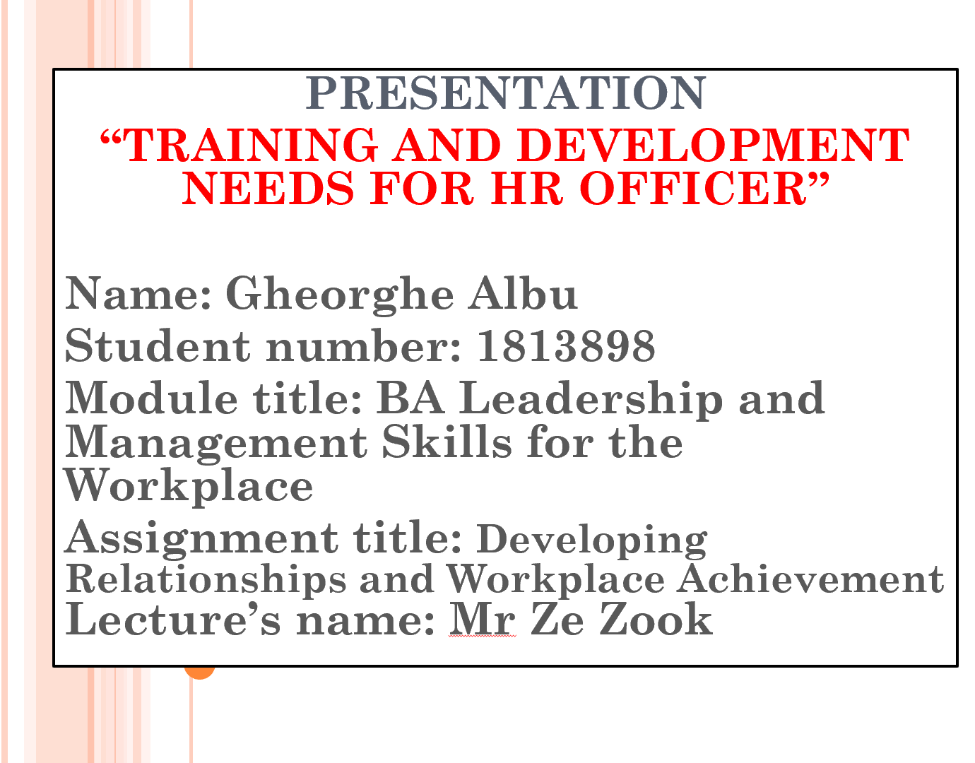

Slide 2

Slide 3

Slide 4

SKILLS REQUIREMENTS OF HR PROFESSIONAL
The skills requirements for HR professional related with the expertise or command over certain area of filed that must be inculcated to enhance the capability of dealing complex HR related business situation. The skills requirements for HR professional are defined as under-
Communication skills: A HR professional needs to have command over both oral and written communication that helps in presenting the ideas and concepts in front of others effectively.
IT skills: A HR professional needs to handle several IT related software and tools and thus needs a command on skills of IT. Use of database, software, spreadsheets etc comes under IT skills.
Problem solving skills: A HR professional can face situations in workplace in which there will be requirement of resolving the issues and hence an excellent command over problem-solving skills is must for HR professional.
Management skills: A HR professional needs the skills of managing people as well as managing work related aspects and tasks.
Critical thinking Skills: It is must that a HR professional has the ability to critical think over issues of situation to come up with best solutions and business aspects.
Slide 5

KNOWLEDGE REQUIREMENTS OF HR PROFESSIONAL
An individual is said to be knowledgeable if he/she has detailed idea and clear concepts about certain aspects or areas. The knowledge requirement for HR professional is given as under-
- A HR professional needs to have knowledge about the thorough concepts and aspects of Human Resource Management
- Knowledge about handling the staff and managing and organizing the human resources
- Knowledge about the importance of good employee relations and their implications in practical basis
- knowledge about the aspects of Payroll department such as salary structure and the structure of compensation
- Knowledge about the aspects of hiring to recruit and select most potential employees for the workplace
- The knowledge about the employee’s legislation and its strict implementation in the organization

Slide 6

BEHAVIOUR REQUIREMENTS OF HR PROFESSIONAL
Behaviour of the HR professional relates with the attitude, action and reaction that comes out for a particular situation or aspect in business. The behavioural requirements of HR professionals are given as under-
- The attitude of HR professional should always be positive and the behavior must also be aligned towards effectively handling and interacting with the divergent departments for work related purpose.
- The behaviour of HR must always be supportive and must be able to give clarification about the doubts of human resources
- The behaviour of HR professional must be aligned with active listening capabilities to avoid any workplace miscommunication

Slide 7

Based on the skills, behaviour and knowledge requirements and my personal skills audit the training requirements of mine for being an effective HR professional are given as under-
Training in IT skills: I find myself weak with some of the IT skills such as use of excel spreadsheets, using HR specialist software and using database and hence I require training in them.
Training in Communication skills: I need to have training on some of the communication skills such as drafting the employment contract, interviewing and resolving the disputes.
Training about payroll and hiring procedure: I have less knowledge about the payroll departments including the salary structure and also I need to have training in the hiring procedure to recruit potential employees.
Problem solving skills: I need to have training in some of the problem solving skills such as the use of verbal reasoning skills to handle the complex data in workplace.

Slide 8

There are certain potential benefits that organization can get by training and developing their HR professionals which are given as under-
- The training and development facilities if are provided to the HR assists in enhancing their job satisfaction. More satisfied HR profession put more dedication and hard work thereby giving new heights to business.
- If the HR professionals are trained and developed in required skills, competencies and knowledge the organization gets opportunities to get more success and growth and also assists in enhancing the efficiencies of the business.
- More skilled Hr professional has the potential to adopt the latest trends and technology in business and thus helps in dealing with the existing rivals of the company.
- The productivity of business also gets enhanced as more skilled HR professional can easily motivate and align the workplace staff to attain the business goals and objectives with effectiveness.
- Recruiting best and potential employees is also possible by efficiently training the HR professionals in an organization and enhances the success rate of business.
Slide 9

Slide 10

APPENDIX
PERSONAL SKILLS AUDIT
Name:
Job Role: Human Resource Officer

 | Very Good | Good | Adequate | Little or no
Information Technology
Using Excel Spreadsheet
Using Microsoft Office Word
Using Specialist HR software
Use a Database
Use Email
Using the Internet
Using PowerPoint

 | Very Good | Good | Adequate | Little or no
Communication Skills
Writing Reports
Drafting contracts of employment
Delivering training sessions
Interviewing
Producing material to support
Advising on HR issues
Resolving complaints/disputes

 | Very Good | Good | Adequate | Little or no
Problem solving skills
Explore more than one solution in order to solve a problem
Make good use of verbal reasoning skills, able to handle complex data and make selective use of information
Consider the ideas of others to help solve problems

Supervisory Management
How much experience have you had in your role? | < 1 month | 1-3 months | > 3 months
How many people have you managed at any one time? | None | 1-5 | Above 5

I declare that the information given in this form is true

Signed | Gheorghe Albu
Date | 21/08/2020

