Module code: BMSW 4004
Problem Solving and Decision Making

Student name: Petrisor Cornel Neagu
Student ID: 2027761

Table of Contents
Task 1 3
Introduction 4
Problem of work-related stress 5
Impact of work-related stress on the performance of the organisation 6
Cause and effect analysis of complex problem 7
PESTEL Analysis 8
Alternative Solution for the Problem 9
Selection of the appropriate solution for the problem 10
Implementation of the chosen solution for solving the complex problem 11
Evaluation of the outcome of implementation 12
Conclusion 13
References 14
Task 2 15
Introduction 15
Problem of work-related stress 15
Nature and Impact of work-related stress 16
Cause and effect analysis of complex problem 17
PESTEL Analysis 18
Alternative Solution for the Problem 19
Selection of the appropriate solution for the problem 20
Implementation Plan for implementing the selected solution 21
Evaluation of the outcome of implementation 22
Discussion of success indicators to measure the effectiveness of your decision 23
Conclusion 24
References 25

Task 1


Introduction
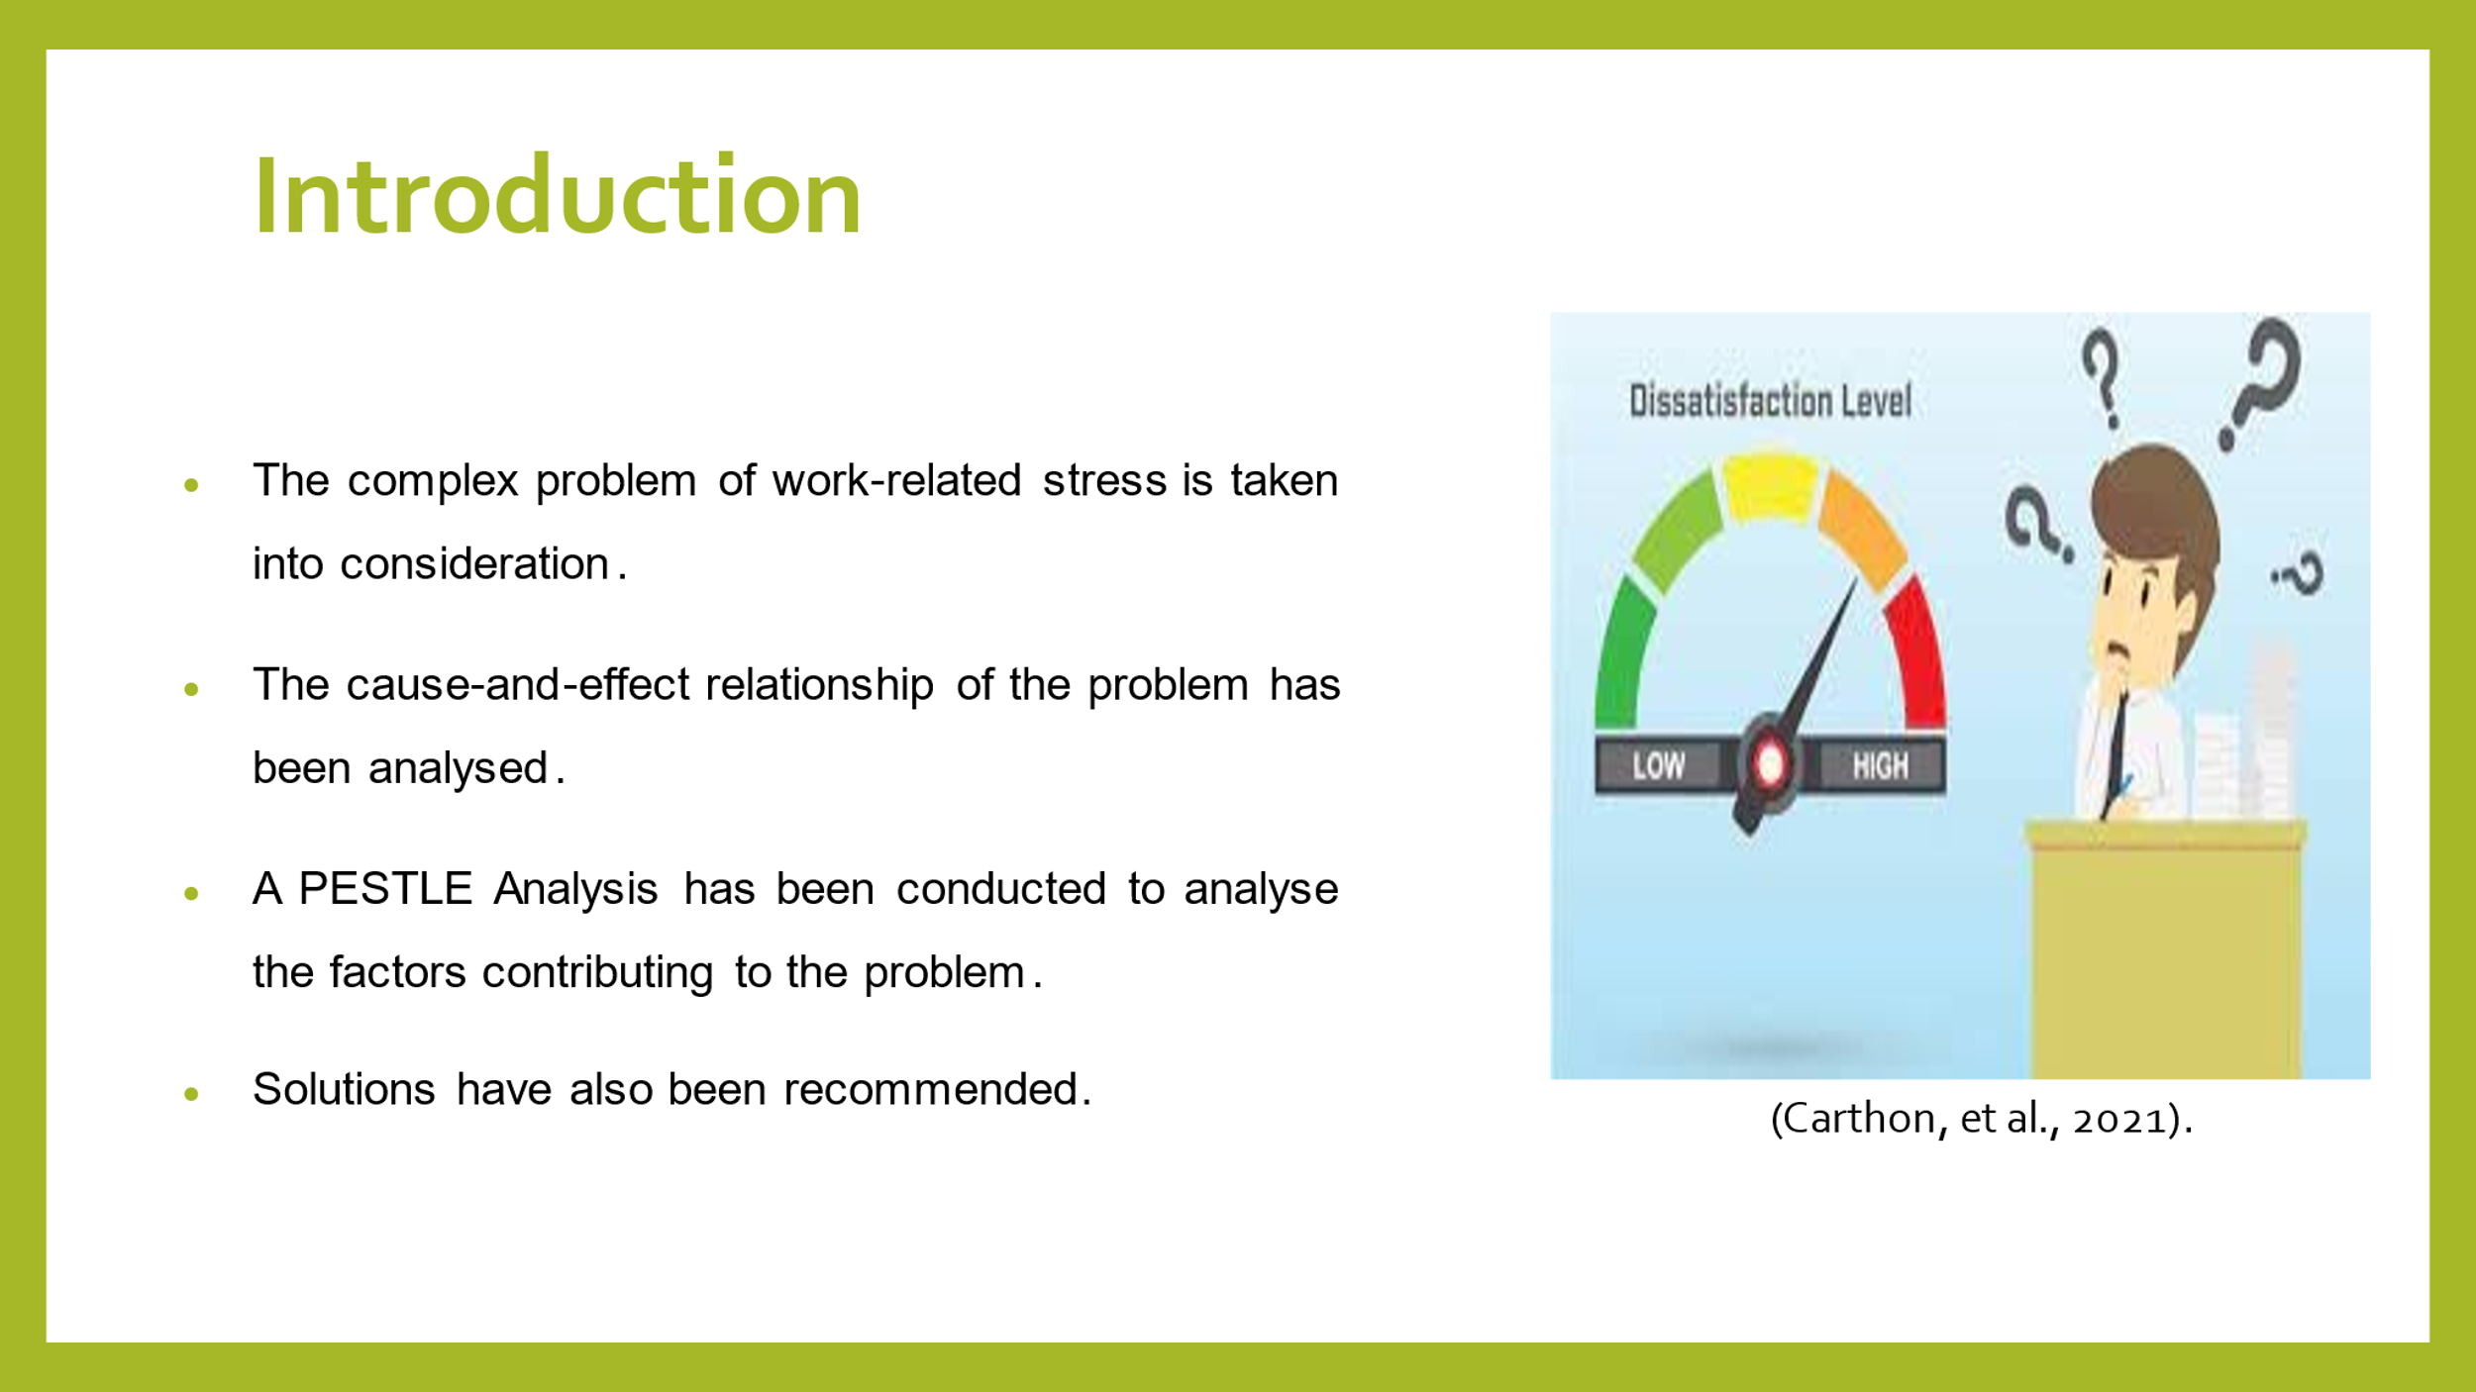
Speakers Note: In this presentation, a complex problem of work-related stress that is faced by the employees of United Kingdom has been analysed. A detailed cause and effect relationship has been considered with respect to the problem and pestle analysis has also been conducted.

Problem of work-related stress
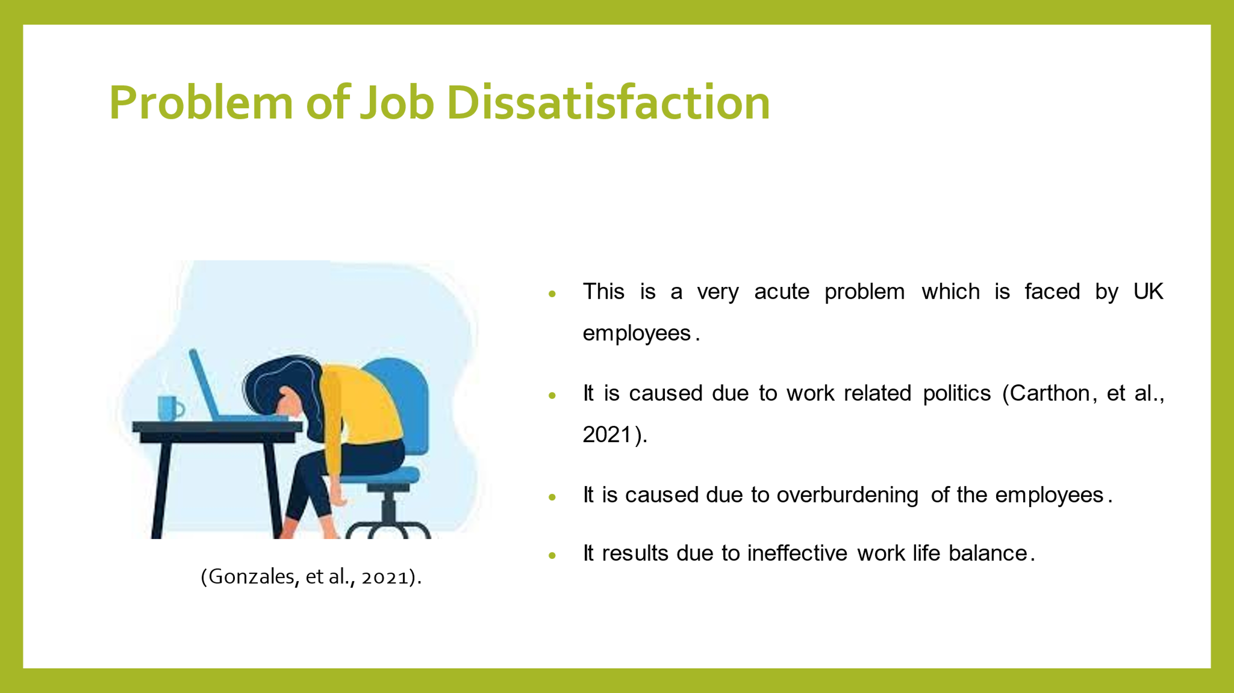
Speakers Note: The problem that is being faced by the employees of United Kingdom is work related stress. This problem has arisen due to work related politics prevailing in the organisation. Moreover, it has resulted due to the overburdening of employees with lots of pressure and work. Also, they have been unable to maintain a balance between their work life and professional life that has enhanced this problem further.

Impact of work-related stress on the performance of the organisation
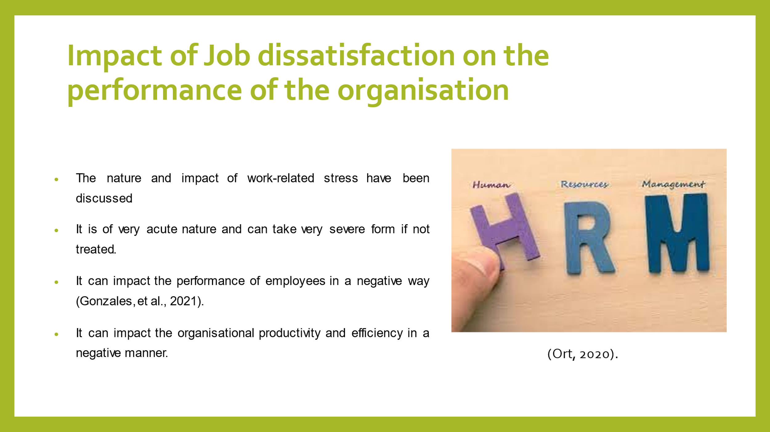
Speakers Note: The work-related stress is a very acute problem which can lead to severe dissatisfaction among the employees if it is not controlled. It will have the impact of reducing the efficiency of the employees and at the same time will cause damage to the organisation’s profitability.

Cause and effect analysis of complex problem
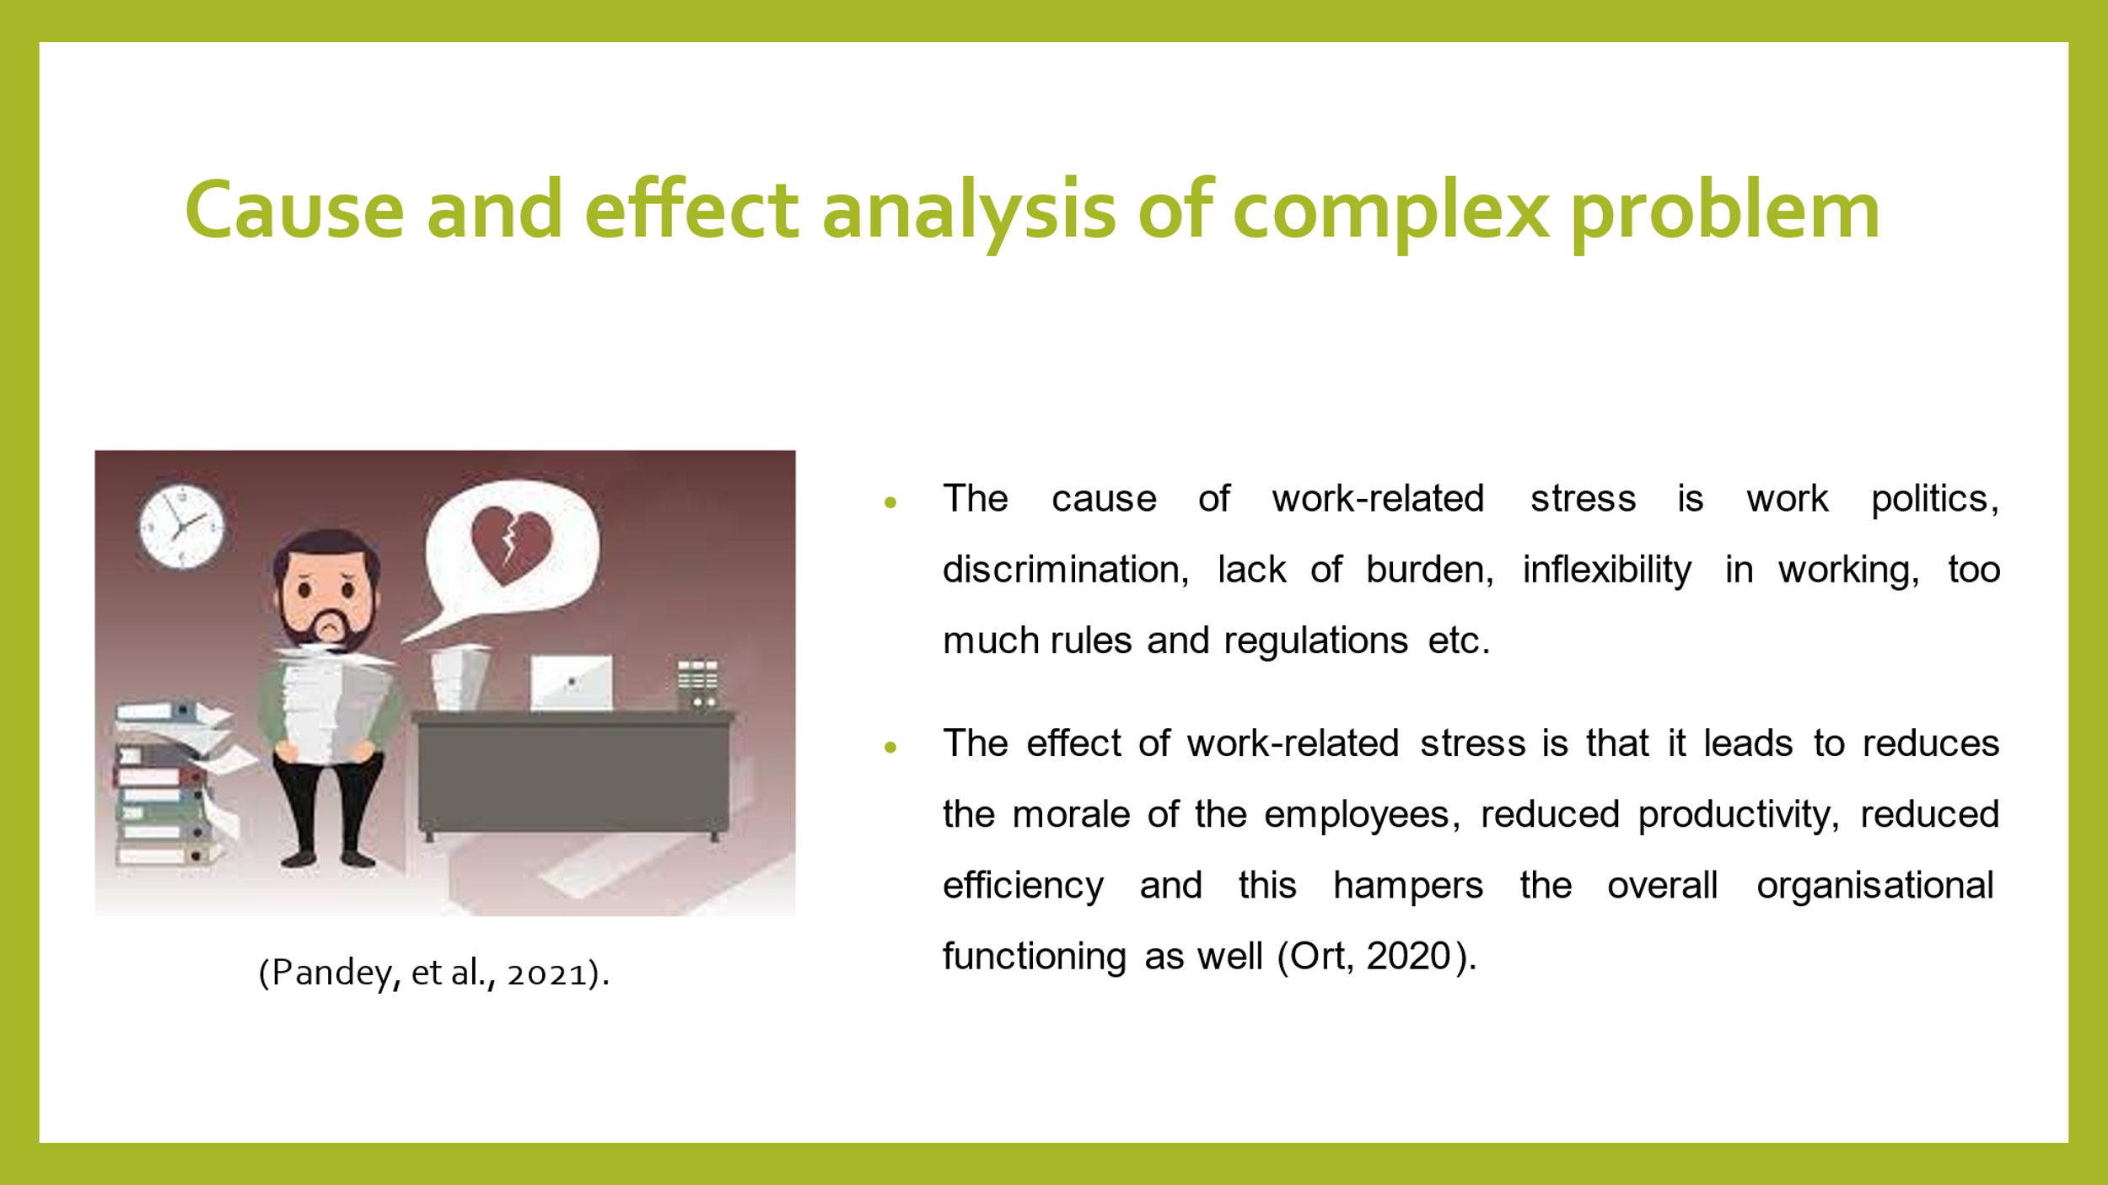
Speakers Note: The cause of work-related stress comprises of overburdening of the employees with lots of work providing them with inflexible work life balance, too much imposition of rules and regulations etc. Whereas the effect of work-related stresses that both organisational as well as individual employee productivity is highly pampered.

PESTEL Analysis
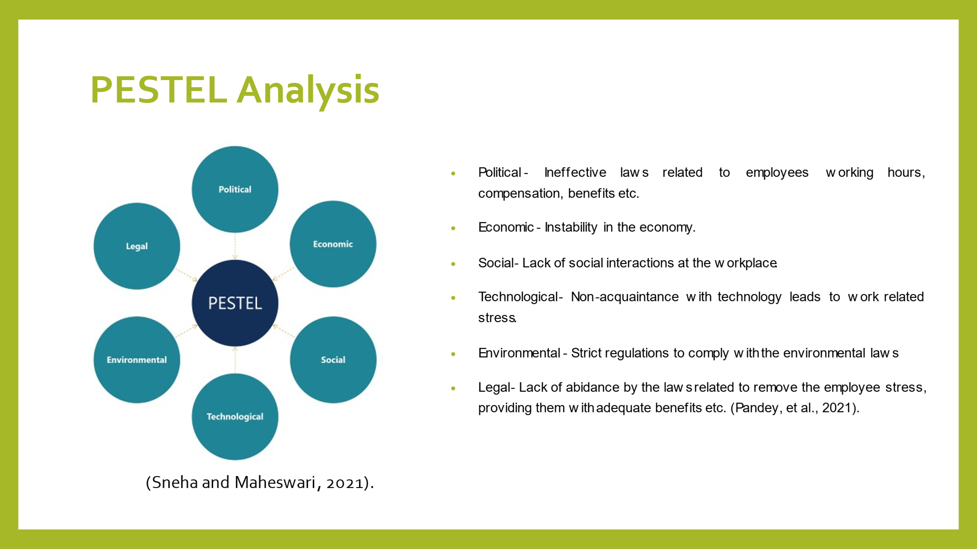
Speakers Note: The several factors that have an impact upon the work-related stress comprise of political, social, economic, mental, technological, legal etc. All these factors must be analysed effectively.

Alternative Solution for the Problem
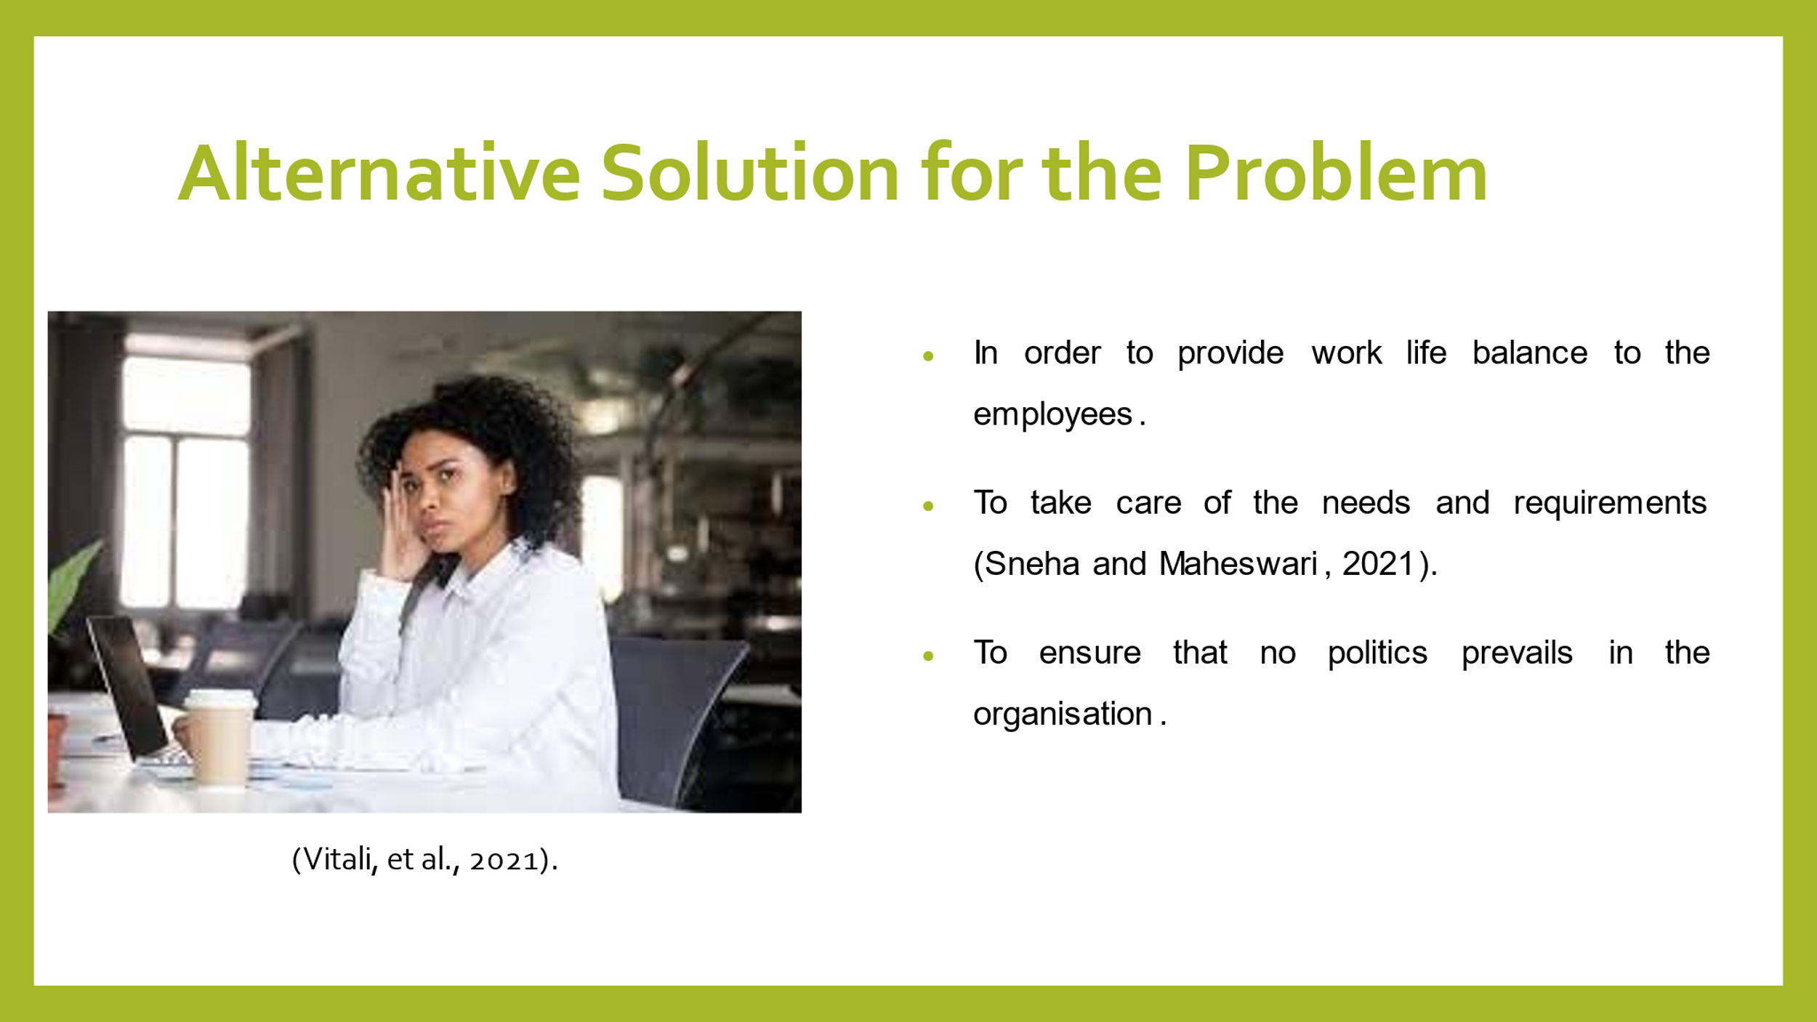
Speakers Note: The various solutions that can be taken in order to reduce the work-related stress of the employees of United Kingdom is to provide them with effective work life balance, ensuring that no political activities prevail in the organisation and to take care of their needs and requirements.

Selection of the appropriate solution for the problem
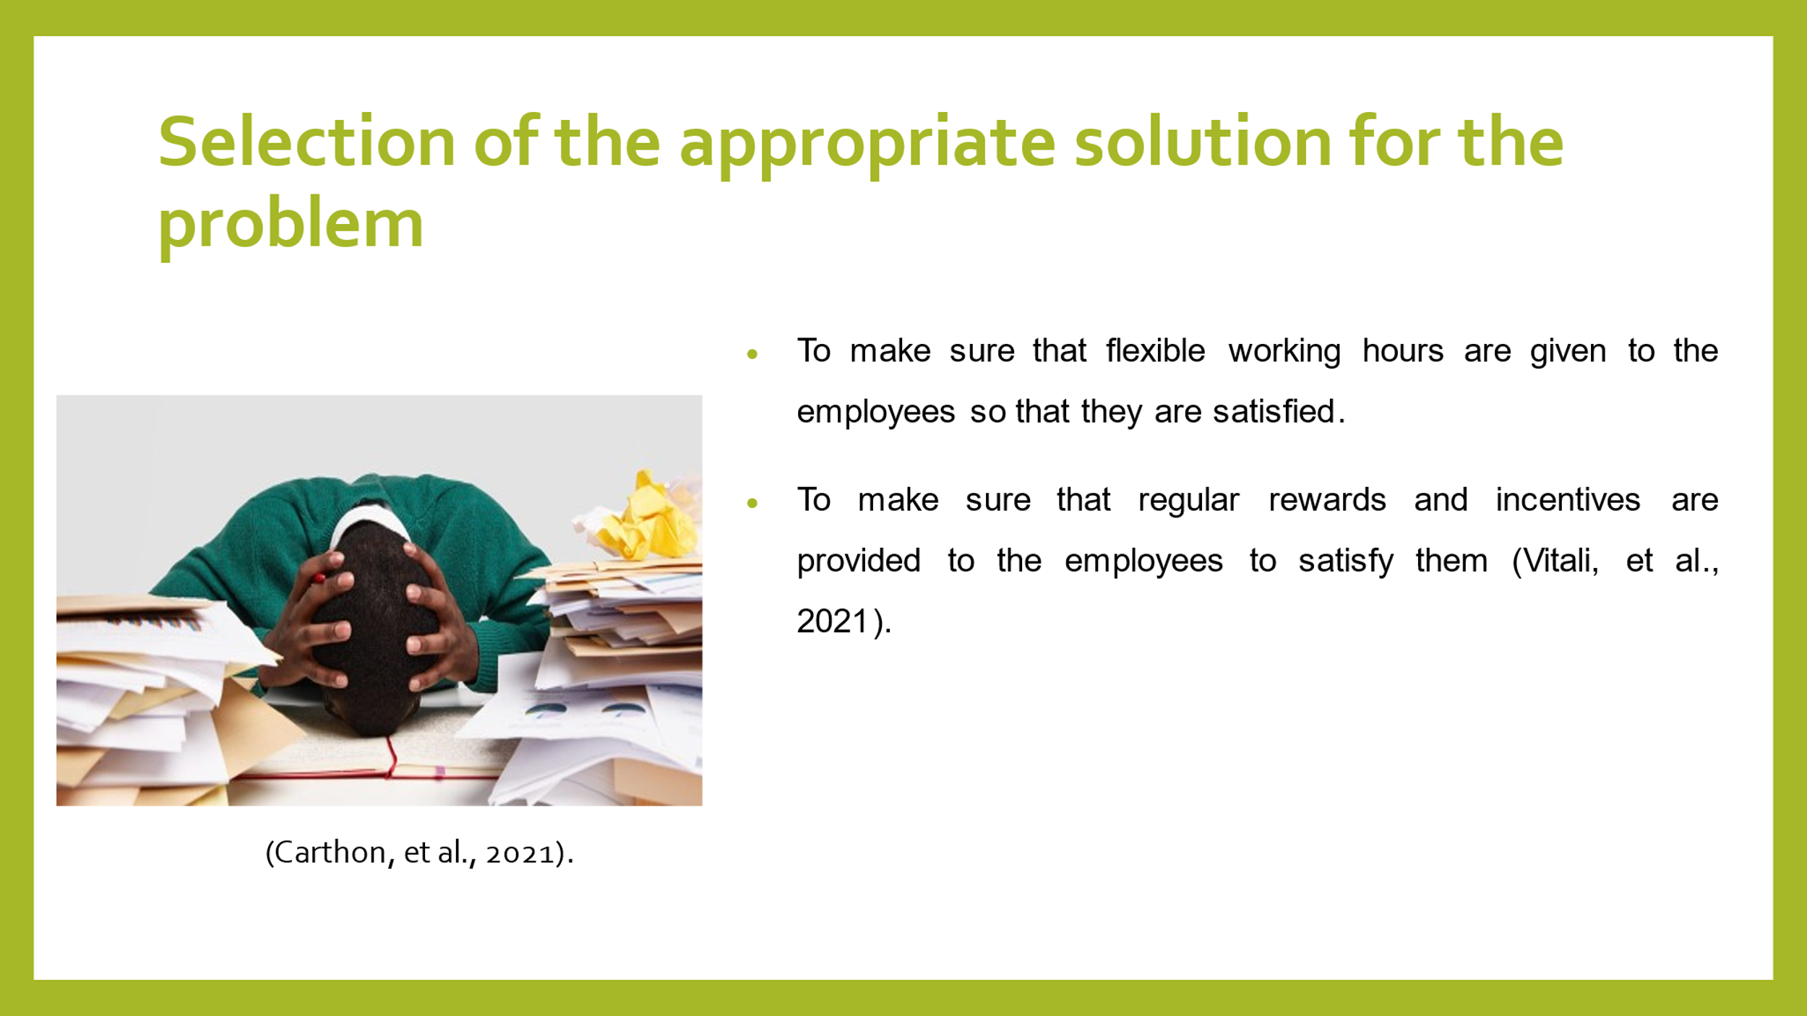
Speakers Note: The best solution that can be implemented in order to reduce the work-related stress of the employees is to make sure that flexible working hours are provided to them and to offer them with regular rewards and incentives so that they remain motivated.

Implementation of the chosen solution for solving the complex problem
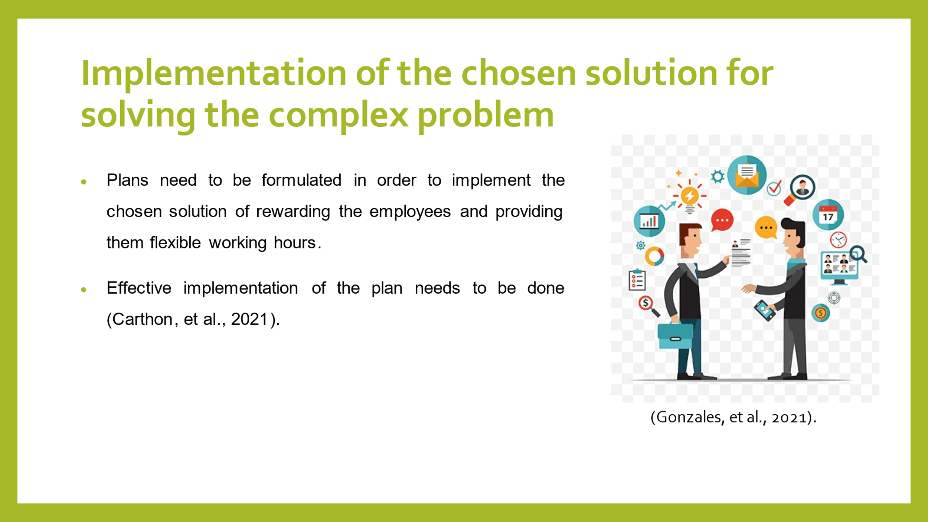
Speakers Note: The implementation of the solutions can be done by preparing effective plans and policies. Moreover, these plans must be effectively implemented so that best results can be obtained.

Evaluation of the outcome of implementation
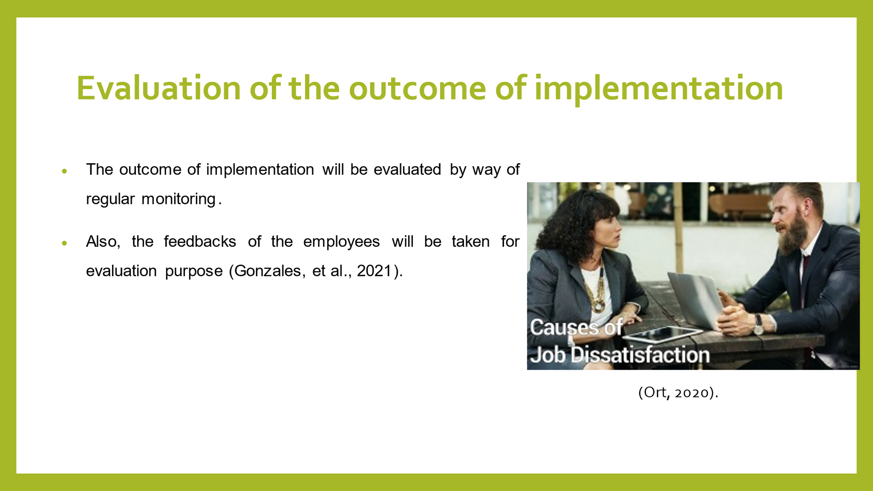
Speakers Note: The effectiveness and outcomes of the implementation can be monitored by implementing monitoring mechanisms and by taking feedbacks of the employees.

Conclusion
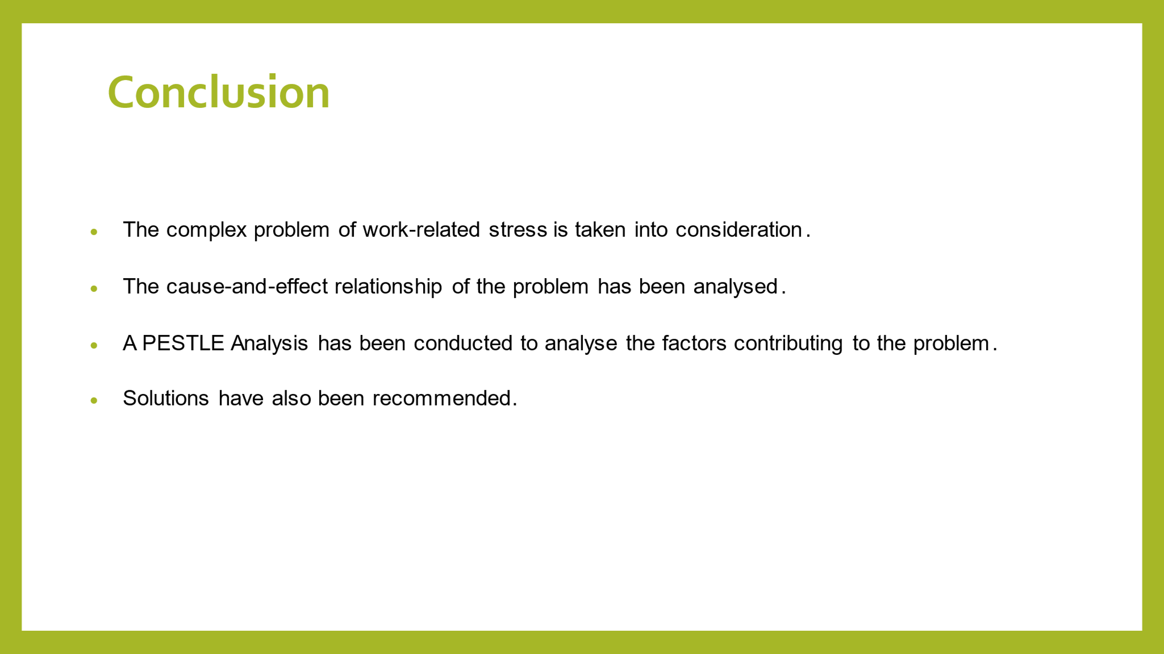
Speakers Note: Thus, this presentation takes into consideration the causes and solutions of work-related stress among the employees of United Kingdom. A complex problem of work-related stress that is faced by the employees of United Kingdom has been analysed. A detailed cause and effect relationship has been considered with respect to the problem and pestle analysis has also been conducted.

References
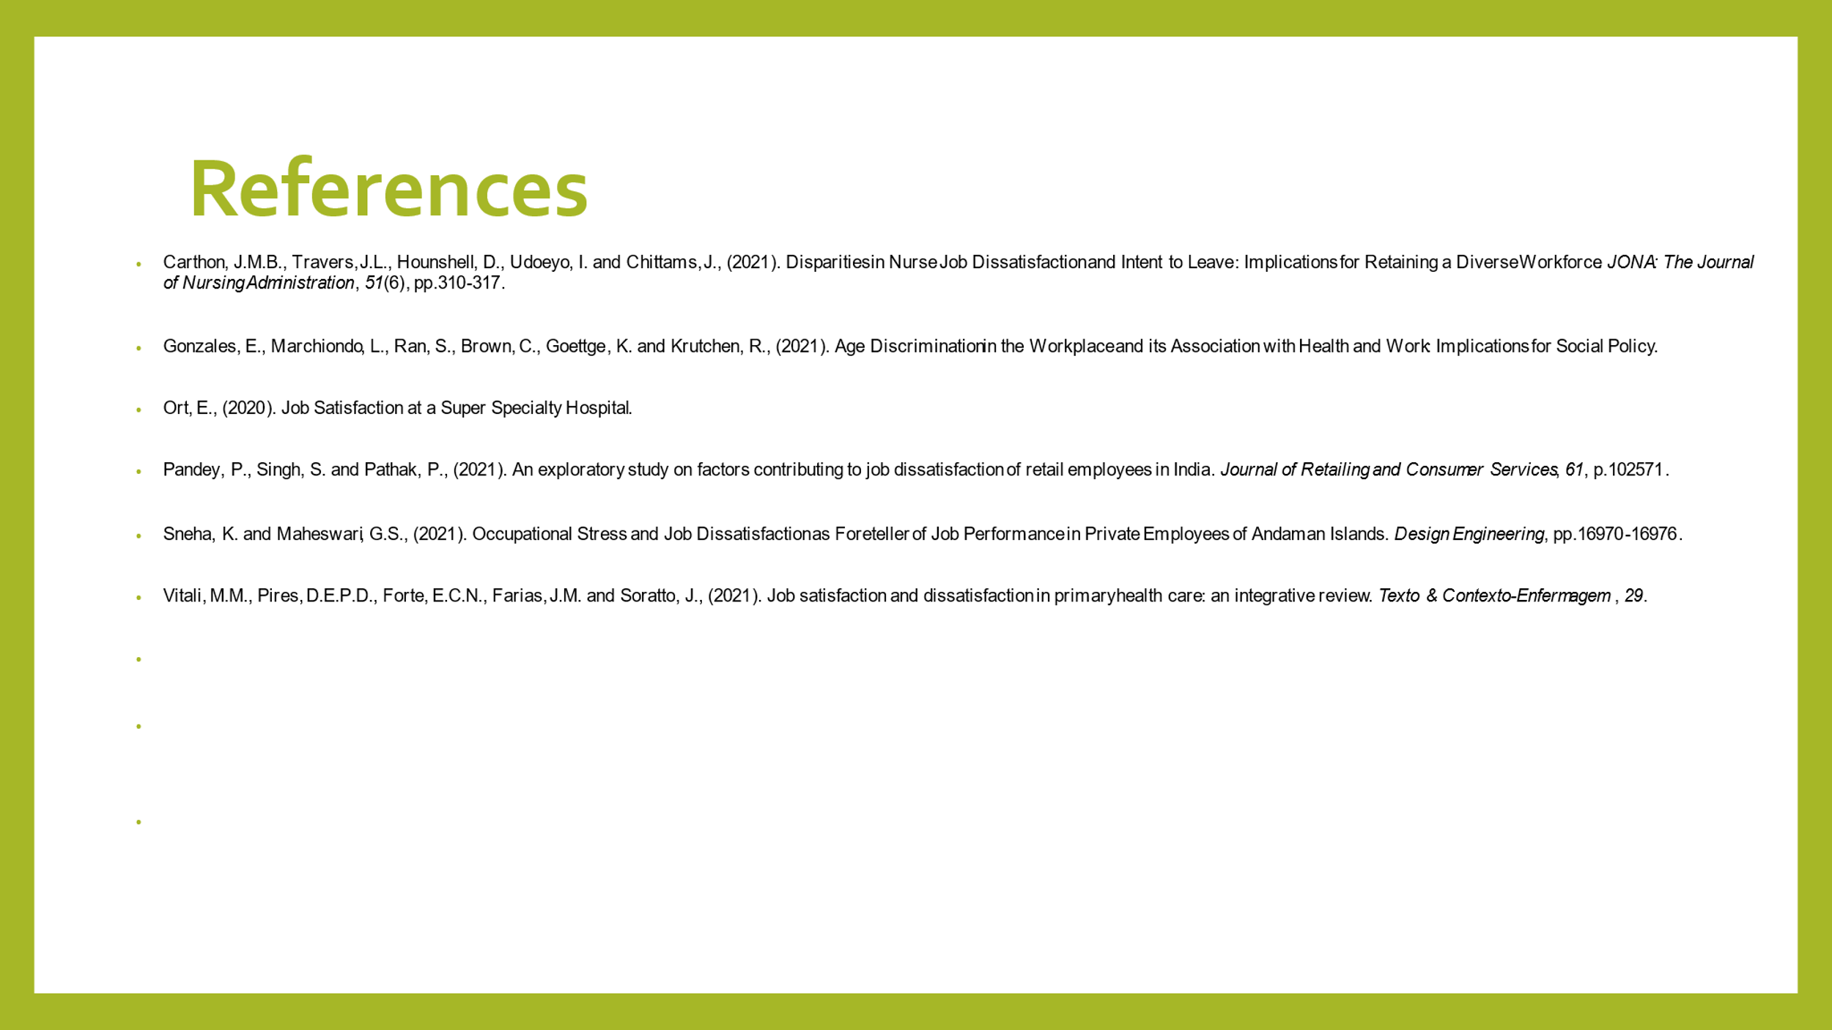

Task 2
Executive Summary
The report discusses the problem of work-related stress, its causes and the effect. Several alternative solutions have been arrived at and the best one has been selected by showing its detailed implementation plan to resolve the problem.

Introduction
In this work, the problem that has been taken into consideration is work related stress that the employees of the United Kingdom are facing. The various causes of this problem and the effect that it can create have been discussed. Moreover, several alternative solutions have been formulated and the best one has been selected by showing its detailed implementation plan. Also, the success indicators have been determined for measuring the effectiveness of the selected solution.

Problem of work-related stress
The problem that has been taken into consideration is work related stress that the UK employees are facing. This problem is really leading to their mental and physical health related issues and they are not able to concentrate upon their performance. As a result, they are highly dissatisfied and the organisational performance is also hampering (Alenezi, et al., 2018).

Nature and Impact of work-related stress
The nature of work-related stress is very acute. It can cause immense disturbance in the organisational activities as it pampers of productivity of the employees. This stress does not allow the employees to concentrate completely on their work as a result of which they are not able to deliver good performances. It has a negative impact upon the operations of the organisation and its objectives cannot be attained if the employees are not stress free (Alosaimi, et al., 2016).

Cause and effect analysis of complex problem
There are several causes that lead to work related stress among the employees. One of the major causes the organisational politics that the employees encounter and this makes them highly dissatisfied and their stress increases. Another cause is that the needs and requirements of the employees are not appropriately addressed and they are not satisfied with the compensation that they are getting this is increasing work related stress among them. The effect of work-related stress is immense as it hampers the productivity of the employees and they cannot contribute their best towards the attainment of organisational goals. This in turn, leads to degradation of the overall organisational performance (Bessa, et al., 2021).

PESTEL Analysis
1. Political- The various policies and acts that are implemented by the government can lead to work related stress if they are not in favor of the employees. Due to political conflicts between UK and various other countries, the companies may remove their operations from the country, due to which the employees of the United Kingdom may lose their job and this is a cause of work-related stress (Billah, et al., 2021).
2. Economic- As a result of the COVID-19 pandemic, the economy of the United Kingdom has been adversely affected. As a result, many of the businesses are retrenching their employees and it is creating work related stress among the employees as many of them have to lose their jobs.
3. Social- Due to limited social interactions as a result of the pandemic and the use of modern technology to collaborate, work related stress among the employees is increasing.
4. Technological- As more and more modern technologies are used, it is replacing the human resources as a result of which there is work related stress among the employees. Moreover, as many of the employees are not acquainted with the use of modern machines and technologies, it leads to stress level increase among them.
5. Environmental- The changes in business environmental factors lead to stress among the employees (D'angelo, et al., 2021).
6. Legal- When the organisations do not comply with the various acts related to the employee’s welfare and safety, protection of their rights etc., it leads to work related stress among the employees.

Alternative Solution for the Problem
Several alternative solutions can be discussed for the purpose of reducing work related stress among the employees. The employees must be motivated regularly by offering them with rewards and incentives and by appreciating their good performances. Moreover, it must be ensured that no politics prevails within the organisation as it harms the performance of employees and their work-related stress is also increase. The feedbacks of the employees must be regularly taken in order to analyse the causes and to reduce the work-related stress among the employees. Flexibility of working must be given to the employee so that they can maintain their work life and personal life and their work-related stress is also reduced (Giorgi, et al., 2017).

Selection of the appropriate solution for the problem
There is a need to select the most appropriate solution in order to resolve the problem of work-related stress. The solution that is selected is to give flexible working hours to the employee so that they can maintain a good balance between their professional as well as personal life. When this flexibility is given to the employees, they will be highly satisfied and motivated this will reduce their stress levels and they can concentrate on their jobs effectively and can contribute their best towards the attainment of objectives of the organization (Hasan, et al., 2018).

Implementation Plan for implementing the selected solution
For the purpose of implementing the solution of offering flexibility to the employees to maintain a balance between their work life and personal life, an implementation plan needs to be formulated. This plan is as follows-
1. At first, a strategy is to be prepared regarding flexible working hours of the employees.
2. Then, the strategy must be reviewed in order to analyse its strengths and weaknesses (Alenezi, et al., 2018).
3. Then, the implementation of the strategy must be done.
4. Then the feedbacks of the employees are to be taken to know the effectiveness of this strategy.

Evaluation of the outcome of implementation
In order to evaluate the outcomes of implementation, it is very essential to take into consideration the performance of the employees and their feedback. If the performances of the employees are improving consistently, then it can be ensured that they implemented solution is working. Moreover, if the employees give positive feedbacks regarding the implementation of flexible working system for the employees, then it means, that this system is effective (Alosaimi, et al., 2016).

Discussion of success indicators to measure the effectiveness of your decision
The various success indicators can be determined with the help of which effectiveness of the implemented solution can be analysed. These Success factors are as follows-
1. A major success factor is the improvement in the functioning of the organisation which will be noticed if they implemented solution is effective.
2. Another essential success factor is the enhancement of employee productivity.
3. Another vital success factor which will be obtained if the solution is successful is that the work-related stress of the employees will reduce and they will be highly motivated to perform well (Bessa, et al., 2021).

Conclusion
The various causes of this problem and the effect that it can create have been discussed. Moreover, several alternative solutions have been formulated and the best one has been selected by showing its detailed implementation plan. Also, the success indicators have been determined for measuring the effectiveness of the selected solution

References
Alenezi, A.M., Aboshaiqah, A. and Baker, O., (2018). Work‐related stress among nursing staff working in government hospitals and primary health care centres. International journal of nursing practice, 24(5), p.e12676.
Alosaimi, F.D., Alghamdi, A.H., Aladwani, B.S., Kazim, S.N. and Almufleh, A.S., (2016). Work-related stress and stress-coping strategies in residents and administrative employees working in a tertiary care hospital in KSA. Journal of Taibah University Medical Sciences, 11(1), pp.32-40.
Bessa, I., Charlwood, A. and Valizade, D., (2021). Do Unions Cause Job Dissatisfaction? Evidence from a Quasi‐Experiment in the United Kingdom. British Journal of Industrial Relations, 59(2), pp.251-278.
Billah, S.M.B., Saquib, N., Zaghloul, M.S., Rajab, A.M., Aljundi, S.M.T., Almazrou, A. and Saquib, J., (2021). Unique expatriate factors associated with job dissatisfaction among nurses. International Nursing Review, 68(3), pp.358-364.
Carthon, J.M.B., Travers, J.L., Hounshell, D., Udoeyo, I. and Chittams, J., (2021). Disparities in Nurse Job Dissatisfaction and Intent to Leave: Implications for Retaining a Diverse Workforce. JONA: The Journal of Nursing Administration, 51(6), pp.310-317.
D'angelo, S., Syddall, H., Ntani, G., Harris, E.C., Linaker, C., Cooper, C., Stevens, M. and Walker-Bone, K., (2021). How does job dissatisfaction interact with self-rated health in determining the risk of health-related job loss? Prospective findings from the Health and Employment After Fifty (HEAF) study. Occupational and Environmental Medicine, 78(1), pp.36-42.
Giorgi, G., Arcangeli, G., Perminiene, M., Lorini, C., Ariza-Montes, A., Fiz-Perez, J., Di Fabio, A. and Mucci, N., (2017). Work-related stress in the banking sector: a review of incidence, correlated factors, and major consequences. Frontiers in psychology, 8, p.2166.
Gonzales, E., Marchiondo, L., Ran, S., Brown, C., Goettge, K. and Krutchen, R., (2021). Age Discrimination in the Workplace and its Association with Health and Work: Implications for Social Policy.
Hasan, A.A., Elsayed, S. and Tumah, H., (2018). Occupational stress, coping strategies, and psychological‐related outcomes of nurses working in psychiatric hospitals. Perspectives in psychiatric care, 54(4), pp.514-522.
Hassard, J., Teoh, K.R., Visockaite, G., Dewe, P. and Cox, T., (2018). The cost of work-related stress to society: A systematic review. Journal of occupational health psychology, 23(1), p.1.
Magnavita, N., Capitanelli, I., Garbarino, S. and Pira, E., (2018). Work-related stress as a cardiovascular risk factor in police officers: a systematic review of evidence. International archives of occupational and environmental health, 91(4), pp.377-389.
Ort, E., (2020). Job Satisfaction at a Super Specialty Hospital.
Pandey, P., Singh, S. and Pathak, P., (2021). An exploratory study on factors contributing to job dissatisfaction of retail employees in India. Journal of Retailing and Consumer Services, 61, p.102571.
Sneha, K. and Maheswari, G.S., (2021). Occupational Stress and Job Dissatisfaction as Foreteller of Job Performance in Private Employees of Andaman Islands. Design Engineering, pp.16970-16976.
Vitali, M.M., Pires, D.E.P.D., Forte, E.C.N., Farias, J.M. and Soratto, J., (2021). Job satisfaction and dissatisfaction in primary health care: an integrative review. Texto & Contexto-Enfermagem, 29.

