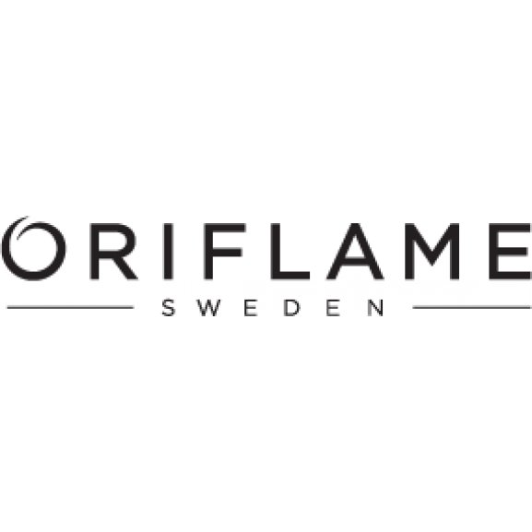  Strategic analysis report on Oriflame Holding AG  BMM7013 | KHISHIGJARGAL GANTUMUR  2208615  BMM7013

EXECUTIVE SUMMARY
This analysis of Oriflame examines every aspect of the business, including its history and overall profile, all of which are crucial. the definition of strategic management is also included. Because of the competitive environment in which it operates and internal organizational shortcomings, no corporation on Earth is immune to dangers that pose external factors. Everyone is aware that the SWOT, PESTEL, and Porter's Five Forces analyses are essential resources or great benchmarks for every organization to determine its present worth in a fiercely competitive market. A strategy action should also be created to address any company issues. Therefore, it becomes crucial that this report disclose the organization's internal strengths and shortcomings as well as its external growth opportunities and competitors who pose a risk to the organization. To get a comprehensive understanding of Oriflame, I have done three analyses: SWOT, PESTEL, and Porter's Five Forces. In response to the culture of today, Oriflame's criticism has been given equal weight in this report. The report's section that includes recommendations and suggestions is located here. Additionally, it ends with the overall strategic management report's conclusion.

Table of Contents
EXECUTIVE SUMMARY 1
CHAPTER I: INTRODUCTION 3
CHAPTER II: DEFINITIONS 4
2.1 Strategy 4
2.2 Strategy management 4
2.3 Purpose of strategic management 5
2.4 Multi-Level marketing strategy 6
2.5 Three-pronged approach strategy 6
CHAPTER III– ANALYSES 8
3.1 SWOT Analysis 9
3.1.2 Strengths 10
3.1.3 Weaknesses 10
3.1.4 Opportunities 11
3.1.5 Threats 11
3.2 PESTEL Analysis 12
3.2.1 Political Factors 12
3.2.2 Economic Factors 12
3.2.3 Social Factors 13
3.2.4 Technological Factors 13
3.2.5 Legal Factors 13
3.2.6 Environmental Factors 14
3.3Porter’s five forces 14
3.3.1 Threats of New Entrants 15
3.3.2 Bargaining Power of suppliers 16
3.3.3 Threats of Substitute products 16
3.3.4 Bargaining Power of Buyers 16
3.3.4 Rivalry among existing firms 17
CHAPTER IV: CONCLUSION 18
CHAPTER V: RECOMMENDATIONS 20
REFERENCES 21

CHAPTER I: INTRODUCTION
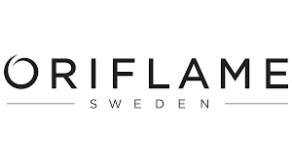
60 countries directly access Oriflame Holding AG, a 51-year-old global beauty company. The Swedish corporation promotes a variety of nature-inspired goods to at least 3 million Oriflame consultants in an effort to innovate. Through its numerous humanitarian and environmental activities, Oriflame has been spreading its idea of encouraging respect for both people and nature since its founding in 1967. The organization's altruism is reflected in several philanthropic organizations around the world, notably the World Childhood Foundation, which Oriflame co-founded. Around €1.4 billion in annual sales have been produced thanks to the cohesion and enthusiasm of the business and its employees. Oriflame is one of the businesses that employ a three-pronged strategy and multilevel marketing. In order to comprehend the strategic aspects using various analytical methods, Oriflame has been selected for this study. Several strategic analysis methodologies are used in this report, and chapter 2 has extended key definitions of strategic management terms including "strategy" and "strategic management."
SWOT analysis, PESTEL analysis, and Porter's 5 forces are analyzing techniques that are employed and utilized to conduct an in-depth study on the many areas of Oriflame Holding AG.

CHAPTER II: DEFINITIONS
2.1 Strategy
There isn't one clear definition of strategy because different professionals define it differently. Michael Porter, meanwhile, describes strategy as a company's "deliberately picking a new set of operations to create a unique mix of value" in order to maintain a competitive position. In order to decide how an organization should respond, the organization must comprehend rivals and the market they've selected. (Porter 1996) A strategy is a broad plan to accomplish one or more overarching, long-term objectives in the face of uncertainty. Integrating organizational operations, using and allocating the limited resources existent in the organizational environment, and achieving the current goals are all part of a strategy. (Johnson et al. 2020) Managers use strategy to accomplish one or more of the organization's goals. An overall direction established for the business and its numerous parts to achieve a desirable condition in the future is another definition of strategy. Planning a strategy requires keeping in mind that choices are not made in a vacuum and that each action done by a company is likely to elicit a response from those it will likely affect, including competitors, clients, employees, or suppliers. The understanding of objectives, the unpredictability of events, and the necessity of taking into account other people's potential or existing actions are other definitions of strategy. (Juneja. 2019)
2.2 Strategic management
Strategic planning and strategic thinking are related ideas in strategic management. Strategic thinking, which combines the facts to develop the strategy, is analytical in nature and refers to established processes to produce the data and analyses utilised as inputs. Strategic planning may also refer to the enforcement procedures utilised to carry out the chosen course of action. Therefore, strategic planning revolves around the practise of strategic thinking or strategy creation. (Johnson et al. 2020), (Juneja. 2019)
Employees of an organization can better grasp how their jobs fit into the overall organizational plan and how they are related to other organizational members thanks to strategic management's larger viewpoint. It is simply the skill of managing personnel in a way that maximizes the achievement of organizational goals. (Juneja. 2019)
As they can closely link to each organizational work, the personnel become more dependable, more devoted, and more content. With the aid of strategic management, they can comprehend how environmental changes affect the firm and the likely response of the organization. Employees can then assess how these changes will affect their own jobs and adapt to the changes successfully. Both managers and employees must act in a professional manner. They must be both efficient and effective. (Johnson et al. 2020), (Juneja. 2019)
2.3 Purpose of Strategic Management
Strategic management can be the key to generating a strong bottom line in a market where workplaces are constantly being disrupted by technological innovation. Business executives who have a thorough understanding of their own company's goods and services as well as a comprehensive understanding of what their main rivals will do next can forecast and plan timely business actions. They can also get ready for potential hazards and future possibilities. (Johnson et al. 2020)
Understanding global trends, the competitive landscape, and stakeholder expectations are necessary for creating a strategic vision. The appropriate resources can be provided to carry out a strategy if a company is aware of what its objective is. Organizations can improve their long-term competitive position by making strategically sound decisions and dedicating themselves to strategic planning. (Johnson et al. 2020)

2.4 Multilevel marketing Strategy
Multi-level marketing (MLM), sometimes known as network marketing or pyramid selling, is a controversial marketing approach for the sale of goods or services in which the MLM company's income is obtained from a non-salaried workforce selling the company's goods or services, while the profits of the participants are derived from a pyramid-shaped or binary compensation commission system. (Tarver 2022). Multilevel marketing is a sound business technique that is frequently employed by companies whose revenue is (heavily) based on sales. Networks are used for sales and to find new participants in multilevel marketing programs, in contrast to conventional sales channels. They are frequently referred to as network marketing as a result. (Napoletano, Curry 2022)
2.5 Three-pronged distribution strategy
A business plan ought to be present in every company. And this strategy should be based on The Three Prongs System regardless of the type of business you are in.
The three-pronged strategies are
- Consulting
One-on-one is simply known as consulting. The act of lending expertise on a subject to a third party in exchange for payment is known as consulting. Advisory or implementation services may be provided as part of the service. The consultant's duty is fundamentally one of taking an objective, impartial position on a matter. In theory, a consultant can provide services to any industry. The phrase has grown to be used interchangeably with business advisory over the years, which primarily focuses on organisational structure, management, operational procedures, and technology. (D’Souza 2015)
- Training
A fundamental idea in human resource development is training. It is involved with teaching and practising a specific talent until it reaches the target level. An employee can be placed in a situation where they can accomplish their job accurately, successfully, and conscientiously with the help of training, which is a very valuable tool. Training is the process of enhancing a worker's knowledge and abilities to do a specific profession. (D’Souza 2015)
- Leverage
By taking out a loan against a portion of the whole portfolio to purchase more of the underlying, a leveraged strategy (more particularly, the payout profile) can be created. As a result, the market participant receives a daily return equal to the leverage factor times the underlying's return, less the cost of borrowing the funds. (D’Souza 2015)

CHAPTER III – ANALYSES
3.1 SWOT Analysis
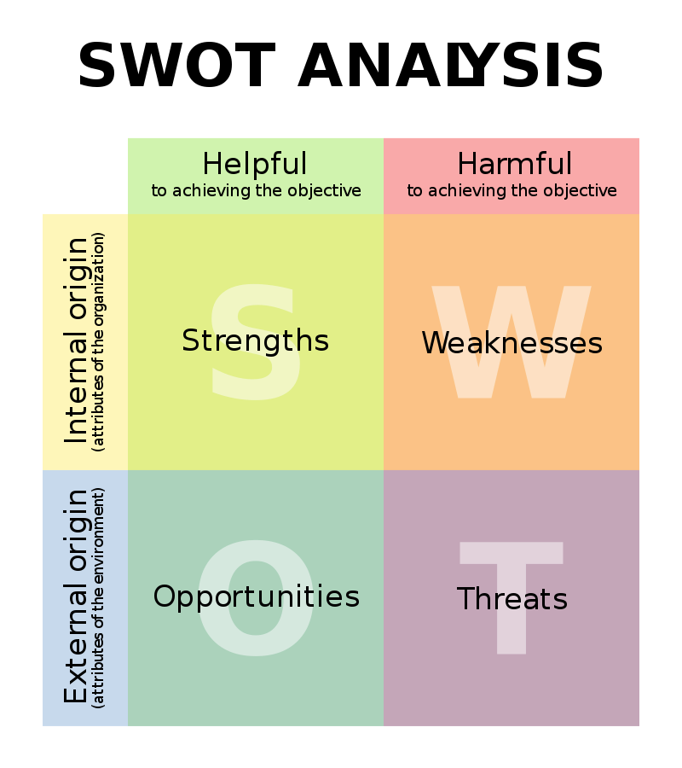
SWOT analysis (or SWOT matrix) helps a person or organization identify Strengths, Weaknesses, Opportunities, and Threats connected to business competitiveness or project planning. It is a strategic planning and strategic management tool. Situational analysis or situational evaluation are other names for it. (Johnson et al. 2020)
SWOT analysis is a method for evaluating a company's performance, rivalry, risk, and potential as well as that of any division, product line, industry, or other entity that the company may have. (Kenton. 2022)
SWOT analysis considers four factors, as its name suggests:
- Resources and qualities that exist inside to promote success, such as a wide range of products, devoted clients, or effective customer service.
- Success is more challenging to achieve due to internal variables and resources such as a poor brand, heavy debt, or insufficient staffing or training.
- External elements that the company can benefit from, such as advantageous export tariffs, tax breaks, or new enabling technology.
- external issues, such as escalating competition, declining demand, or an unreliable supply chain, that could make it more difficult for the business to succeed.

SWOT analysis of Oriflame Holding AG
Strengths | Weakness
- Release catalogs frequently with offers on products  - Customers get help from consultants in choosing a skincare product that is compatible with them  - Access to residential areas  - Business mode suited to modern social networking  - Loyal customers | - Consultant with insufficient training  - Depends on the network or individual distributor  - Limited stores  - Pyramid structured management  - One of the Manufacturing facilities is in Russia (Interfax.com 2022)  - Difficulty in recruitment  - Cheap products in which case low quality
Opportunities | Threats
- Celebrity endorsements  - Specializing across consumer segments  - Expansion in Tier 2 and Tier 3 cities or urban communities | - Established brands with deeper penetration  - Price competition with well-known cosmetic brands  - The presence of many established brands in one place in the stores thus gives customers variety on social media  - The war between Ukraine and Russia (Interfax.com 2022)

3.1.1 Strengths
Oriflame, a company with a more than 51-year history, was one of the first to employ a multi-level marketing technique to establish a considerable market position. The company has a good reputation with clients and does continual research using natural ingredients for a variety of skin types rather than just one. A three-pronged distribution strategy(D'Souza 2015), which combines online and direct sales to clients, is one of their tactics. Oriflame has never relied on magazines or television commercials, in contrast to competitors like L'Oréal and Lancôme. Instead, they place a strong emphasis on word-of-mouth advertising (Hayes 2021) and client endorsements found online or in catalogs. As a result, it drastically lowers their advertising costs.
3.1.2 Weakness
First off, Oriflame prioritizes hiring housewives or unemployed women when hiring salespeople. Oriflame is having trouble locating qualified sales reps, and training them takes time, which is having an impact on their business strategy. Oriflame frequently sets expectations for commissions and benefits when hiring more sales agents. These representatives are disillusioned when they join the network and learn that their commissions are based on the number of sales they can produce. Oriflame does not provide regular training to their representatives on products or on selling skills, which has the effect of making it difficult for their agents to generate good business for the company. The success of a multi-level marketing firm depends on how the representative is able to persuade the customer since that is their only interface with the company.
Oriflame products typically lack quality and are expensive when compared to other high-end brands. For sales agents, this presents difficulties. Additionally, due to the conflict between Russia and Ukraine, Russia's production process slowed, which negatively impacted sales. The corporation will be exposed to risk if the war goes on. (Interfax.com 2022)
3.1.3 Opportunities
The expansion of distribution channels is one of the great potentials for Oriflame. As a result, the company can create seminars to improve selling executives' comprehension of marketing and facilitate their learning from specialists. There are innumerable companies that provide a wide range of products for various, distinct needs. To better understand what customers actually want, Oriflame has to increase the size of its Research & Development Division. Another successful growth strategy for the corporation is to expand its distribution networks to urban, rural, or developing places. The local communities, citizens, and businesses will all benefit from this.
3.1.4 Threats
The main competitors of Oriflame include companies like Avon, Amway, Faberlic, Amazon, and others. Consumers today prefer to buy luxury goods like Chanel or Lancôme. Thanks to the existence of online stores, customers may now more easily access more products from the global market and better-quality brands from the comfort of their homes or office. Despite having an online shop, Oriflame hasn't been able to compete with the success of well-known retailers like Alibaba or Amazon. Oriflame is reducing its investment due to the war between Russia and Ukraine. They are reducing to 16% even if the manufacturing site is in Russia. (Interfax.com 2022)

3.2 PESTEL analysis
PESTLE analysis examines many outside elements that have an impact on the commercial environment in which the organisation operates. It denotes elements related to politics, the economy, society, technology, law, and the environment. Understanding the market's opportunities and risks can help the firm plan its business and marketing strategy appropriately and get an advantage over rivals. (blog.oxfordcollegeofmarketing.com 2016)
3.2.1 Political factors
Because Oriflame is a multinational corporation, it is vulnerable to the risk of political unrest and the risk of governmental laws that will make doing business more challenging. It is active in more than 60 nations. In the nations where it has manufacturing facilities, Oriflame is required to adhere to laws and regulations. These elements affect the company's overall sales and earnings even if they are not under the company's direct control and are seen as crucial elements for the enterprise. Since the majority of the company's revenues originate in Europe, Brexit may have a significant influence on the operation of the company. The corporation must thus develop ways to deal with this problem because Brexit may have an impact on supply and distribution to the UK.(mbaskool.com 2021)
3.2.2 Economic Factors
The Oriflame company employs more than 6000 people and deals in products including skincare, cosmetics, and perfumes. Strong customer support and a very established brand have enabled the business to generate numerous profits over an extended period of time. Any deterioration in the economic situation of the nations where it conducts business may also have an impact on consumer demand for the brand, resulting in a drop in sales and earnings. Therefore, challenging economic circumstances in one country may likewise have an impact on other nations. Numerous people have lost their jobs as a result of COVID, which has decreased consumer disposable income and decreased demand. Since the market for cosmetics items is likely to decline as a result, this could pose a serious danger to the business.( Gerstell et al 2020)
3.2.3 Social Factors
Some examples of social influences are consumer habits, tastes, preferences, demand for particular items, and more attractive user interfaces. In the eyes of its clients, the business is well-regarded. From one country to the next, people have different cultures. The value of saving for the future is waning among people as they become more affected by western society. They desire to spend money to upgrade their way of life, which is excellent for the business's revenue. Natural alternatives are becoming more popular among consumers in place of cosmetics loaded with chemicals. The organization also provides a wide range of natural goods, which can be quite advantageous for the business. Over time, the corporation has also launched a number of initiatives aimed at empowering women and children.
3.2.4 Technological Factors
When it comes to innovating in various ways, technology is crucial. Technology is particularly important in boosting the consumer experience, from the production of goods to customer interaction. Oriflame has invested in R&D in fields like plant stem cell technology, which has greatly aided the business in generating incredibly high-quality items to satisfy its clients. By utilizing highly sustainable anti-aging active substances, it has the potential to offer products at reasonable prices. Today's emergence of social media has given a number of businesses the opportunity to target their potential clients by using important information via various metrics.
3.2.5 Environmental Factors
Any business should not overlook these elements because they are crucial to the success of the enterprise. Oriflame's corporate philosophy is to support numerous social programs that safeguard the nation's environment. All of the company's exfoliating products are made with biodegradable materials. The business also has a wellness factory in Roorkee, India, equipped with a variety of solar panels that utilize the sun's energy to cut down on power usage. The corporation also made a commitment to cut its relative climate effect by 50% between 2010 and 2020, demonstrating how seriously they take these considerations. Due to its numerous environmental measures, the corporation also enjoys a very positive reputation with the general population.
3.2.6 Legal Factors
The legal landscape for cosmetics industries around the world is still shifting. It consists of several national and international rules that a corporation must go by in order to keep governmental and international organizations from interfering with how the firm is run. Oriflame works in more than 60 countries, so the company has to adapt its operations to comply with local legislation, which adds to the complexity of its operations. Given that it is a Swedish firm, the laws and tax regulations of Sweden must be followed. These elements are directly tied to the nation's political elements. To protect the safety of its employees, the corporation must make sure that it complies with the rules established by the governments of various nations in order to restrict the spread of the COVID-19 virus.
3.3 Porter’s five forces
According to Michael Porter, the Porter Five Forces Framework is a tool for analysing the competitive environment in which a corporation operates. It draws on industrial organisation economics to extract five forces that control the level of competition and, consequently, the profitability (or lack thereof) of an industry.(Porter 1979)
In contrast to the more generic word macroenvironment, Porter refers to these factors as the microenvironment. They are made up of the external factors that have an impact on a company's capacity to serve its clients and turn a profit. Given the general shift in industry knowledge, a business unit typically needs to re-evaluate the market whenever one of the forces changes. The attractiveness of the industry as a whole does not guarantee that every company will be profitable. Businesses can use their core strengths, business strategy, or network to generate profits that are higher than the sector average.(Martin 2022)
Industry
The cosmetics sector sells classic cosmetics like makeup and perfume as well as personal hygiene items including shampoos, soaps, and tooth-care items. The cosmetics industry is currently pushed by innovation, which includes new color palettes, treatments tailored to particular skin types, and original formulae focusing on various demands. The lifespan of the majority of cosmetic kinds is less than five years, and manufacturers reformulate 25% of their goods annually.
3.3.1 Threats of New Entrants – Medium
Oriflame provides unique products and makes use of economies of scale in its manufacturing. Brand recognition and product differentiation are particularly important in the cosmetics sector. Due to the significant amount of R&D necessary to produce cosmetic items, high capital is needed. Starting a new cosmetic business in this sector is undoubtedly quite expensive due to the significant investments required for product creation, testing, and advertising. The expense of switching is not extremely great, but it is expensive to switch to a new type of cosmetics to which the consumer might be allergic. The distribution channels are heavily regulated, and because certain chemicals are required to make cosmetic items, access to raw materials is constrained. Because particular chemicals are required to make cosmetic items, distribution channels are heavily regulated, and access to raw materials is constrained. In the cosmetics sector, government laws and regulations are also getting stronger to protect consumers, which puts financial and social barriers in the way of new rivals.
3.3.2 Bargaining Power of suppliers – High
Because the items sold by cosmetic companies require expensive research and skill, the leverage suppliers have over cosmetic enterprises is high. Because their suppliers created the formulations for their products, cosmetic enterprises are therefore dependent on them.
Bargaining Power of suppliers at Oriflame – Low
Since Oriflame produces the majority of its own raw materials, the company mostly buys packaging materials. The price of suppliers is actually quite affordable when compared to the cost of the company's goods.(oriflame 2021)
3.3.3 Threats of Substitute products-High
It is simple to discover a substitute product that is of superior quality than Oriflame because Oriflame is a firm that produces a wide variety of cosmetic products, from hair products to makeup and crèmes. The majority of Oriflame clients are likely to migrate to other cosmetic firms like Avon, Faberlic, or Amway because most of their products are affordable, making the switching cost (both financially and health-wise) less.
The current fashion for natural makeup-free appearances is another alternative.
This tendency typically coexists with anti-consumerist movements that consider cosmetics unnecessary.
3.3.4 Bargaining Power of Buyers – Medium
According to Micheal Porter, Buyer bargaining power reflects the pressure that consumers place on companies to provide high-quality goods at reasonable costs and with top-notch customer service. This force has a direct impact on Oriflame's capacity to meet its strategic goals. A strong negotiating position reduces profitability and increases industry competition. Conversely, when consumer power is weak, the sector is less competitive, which increases Oriflame's profitability and expansion potential.
3.3.5 Rivalry among existing firms – High
In today's world, the beauty we experience in our lives is greatly influenced by the cosmetics industry. The global demand for cosmetic products from both men and women is enormous, and the cosmetic industry is expanding quickly. The demand for beauty products is rising, and there is fierce global competition. (bhagwatilabeling.com, 2018) One of those competitors, particularly one that employs the same tactic as firms like Amway and Faberlic. Oriflame Holding AG must regularly create new cosmetic items to stay current with trends.
Some aspects make it more competitive for Oriflame among the current businesses. For instance, if market participants are strategically varied and focus on the same market, the company will encounter fierce competition from other current enterprises. like Estee Lauder, Revlon, L'Oreal, etc. If consumers are not loyal to their current brands and switching to other brands has minimal switching costs, there will also be fierce competition. Competitors with similar market share, undifferentiated product offerings, and weak industry development frequently use aggressive tactics to outperform one another. These and other elements make rivalry between established businesses a top strategic issue for Oriflame. (researchdive.com, 2021)

CHAPTER IV: CONCLUSION
The management of Oriflame places a high importance on employee motivation and happiness because it recognises the significance of its people capital. Employees are given difficult goals to work toward, but management addresses their concerns and avoids applying pressure that could result in burnout. The following actions are taken to achieve balance between employee and task orientation:
- Establishing difficult objectives and providing incentives to maximise task performance
- Giving staff the coaching, mentorship, and direction, they require to achieve the designated goals
- Preventing the employees from making working overtime a regular practise.
- Motivating and educating employees about stress and time management is crucial for both enhancing task performance and psychological health.
Overall, the analysis has shown that Oriflame's success is due to its internal management style, effective marketing of its products, and, of course, the products they sell. Oriflame understands how to manage its business internally, and they understand that in the cosmetic industry, direct selling is a great marketing tool because it allows customers to get a feel for the product, try it, and then judge it. Despite the fact that many cosmetic companies permit product testing, there is no assurance that the product will remain effective over time, and there is no money-back guarantee if the consumer is unhappy with the product's effectiveness. Natural products have always been the finest therapy for generations, but when new formulae were discovered, people forgot what is best for their health, skin, and so on. Today, both in the media and among the general public, there is a growing awareness of the trend toward living more sustainably and being more health conscious. Since it began as a company, Oriflame has had trouble holding onto that concept. They have succeeded by providing people with excellent, all-natural items that are healthy and beneficial for them at a reasonable price, allowing them to try the products and receive any necessary personal assistance or answers to any concerns they may have about the products. Customers receive responses much more quickly thanks to the staff's education, and Oriflame is well aware of its customers' evolving needs thanks to its tight customer relationships. However, the recent conflict between Russia and Ukraine has greatly affected them, therefore they are attempting to keep costs to a minimum. They are now making do with what they have. However, with their loyal customers and established tactics, they will continue to get better.

CHAPTER V: RECCOMANDATIONS
On the basis of the analytical report, certain recommendations have been made. The following recommendations assist in improving Oriflame. Considering these factors will undoubtedly enhance sales.
- The beauty business is continually challenged to develop engaging marketing initiatives that will increase revenue and draw in new clients. For instance, a company could host a gathering where customers could drop by and talk to skincare and beauty experts. People are frequently motivated by their surroundings when shopping for makeup, thus arrangements must be carefully considered. The best approach to increase membership and encourage current consumers to purchase more goods is through campaigns. Oriflame nonetheless frequently use this technique. However, brands can invite well-known makeup artists to create specific looks using their own products; this will not only teach customers how to achieve new looks, but will also encourage them to buy the suggested items. Using the brand's makeup, customers can be urged to create various appearances for contests in which they can actively participate. These looks can then be offered to the customer. The Oriflame Holding AG may conduct a poll to determine the finest customer-created look, and the winner may receive a gift basket filled with the newest products from the business.
- Before making a purchase, the majority of shoppers read product reviews online. The present consumer market is primarily dominated by bloggers that write about cosmetics, thus Oriflame has to work extra hard to sell to target audiences by giving them all the information they need about a product and by creating the correct hype. Utilizing free samples, the business can ask well-known bloggers to submit reviews of the products after using them. To help customers grasp the newest trends and innovative approaches, videos of cosmetic tutorials and interviews with makeup professionals should be posted to the business website and social media pages. On their website, Oriflame cosmetics include a number of videos. Some of these movies teach viewers how to apply cosmetics, while others provide product recommendations and advice in an effort to attract additional viewers. For targeted audiences, they require more videos and beauty instructions.
- The majority of people consider multi-level marketing to be a pyramid scheme. Therefore, Oriflame must adopt a constructive stance on the approach on social media in order to achieve this. A pyramid scam is an unethical and unreliable investment pitch that depends on guaranteeing irrational profits on fictitious investments.
REFERENCES
- Whittington, R., Regnér, P., Angwin, D., Johnson, G. and Scholes, K. (2020). Exploring strategy. 12th ed. Harlow, England Pearson.
- Prachi Juneja (2019). Strategy - Definition, and Features. [online] Managementstudyguide.com. Available at: https://www.managementstudyguide.com/strategy-definition.htm. [Accessed 02 Dec. 2022]
- Kenton, W. (2022). SWOT Analysis: How To With Table and Example. [online] Investopedia. Available at: https://www.investopedia.com/terms/s/swot.asp. [Accessed 02 Dec. 2022]
- Bigelow, S.J. (n.d.). What is a SWOT Analysis? [online] SearchCIO. Available at: https://www.techtarget.com/searchcio/definition/SWOT-analysis-strengths-weaknesses-opportunities-and-threats-analysis. [Accessed 02 Dec. 2022]
- FactoHR. (2021). Strategic Management - Know The Purpose, Importance, Definition and Process. [online] Available at: https://factohr.com/strategic-management/.
- Hayes, A. (2021). Word-of-Mouth Marketing (WOM Marketing). [online] Investopedia. Available at: https://www.investopedia.com/terms/w/word-of-mouth-marketing.asp. [Accessed 02 Dec. 2022]
- Oriflame annual report 2021, Available at: https://vp233.alertir.com/sites/default/files/report/oriflame_annual_report_2021.pdf (Accessed: 17.11.2022).
- Sarsby, A. (2016). Swot Analysis: a Guide to SWOT for Students of Business Studies. England: Leadership Library.

- D’Souza, S. (2015). How To Craft A Business Plan: The Three Prong System. [online] Psychotactics. Available at: https://www.psychotactics.com/three-prong-system/ [Accessed 25 Nov. 2022].
- https://scanmagazine.co.uk/oriflame-cosmetics-from-lab-to-bottle-passion-for-beauty-and-science/
- https://www.forbesindia.com/article/brand-connect/oriflame-beauty-with-a-purpose/67091/1
- https://www.cosmeticsdesign.com/Article/2005/05/17/Oriflame-ups-supply-chain-capabilities
- Porter, M. (1996). What Is Strategy? [online] Available at: http://cs.furman.edu/~pbatchelor/mis/Slides/Porter%20Strategy%20Article.pdf. ‌ [Accessed 5 Dec. 2022].
- Tarver, E (2022). Understanding Multilevel Marketing and How to Avoid Pitfalls. [online] Available at: https://www.investopedia.com/terms/m/multi-level-marketing.asp#:~:text=The%20term%20marketing%20(MLM)%20refers. ‌ [Accessed 5 Dec. 2022].
- Forbes. (2022). Understanding of Multi-level marketing. [online] Available at: www.forbes.com. (n.d.). What Is Multi-Level Marketing? – Forbes Advisor. [online] Available at: https://www.forbes.com/advisor/investing/multi-level-marketing-mlm/#:~:text=illegal%20pyramid%20schemes.-. ‌ [Accessed 5 Dec. 2022].
- Gerstell, E., Marchessou, S., Schmidt, J. and Spagnuolo, E. (2020). How COVID-19 is changing the world of beauty. [online] McKinsey & Company. Available at: https://www.mckinsey.com/~/media/McKinsey/Industries/Consumer%20Packaged%20Goods/Our%20Insights/How%20COVID%2019%20is%20changing%20the%20world%20of%20beauty/How-COVID-19-is-changing-the-world-of-beauty-vF.pdf. ‌ [Accessed 5 Dec. 2022]
- bhagwatilabeling.com (2018). Rising Competition in Cosmetic Industry - Bhagwati Labelling. [online] Available at: https://www.bhagwatilabeling.com/rising-competition-in-cosmetic-industry/. ‌ [Accessed 10 Dec. 2022]
- www.researchdive.com. (2021). Global Cosmetics Market: Opportunity Analysis and Industry Forecast, 2020–2027. [online] Available at: https://www.researchdive.com/8336/cosmetics-market. [Accessed 10 Dec. 2022]
- Michael E. Porter(1979) "How Competitive Forces Shape Strategy", Harvard Business Review, (Vol. 57, No. 2), pp. 137–145.
- Martin, M. (2022). Porter’s Five Forces: Analyzing the Competition. [online] Business News Daily. Available at: https://www.businessnewsdaily.com/5446-porters-five-forces.html. [Accessed 13 Dec. 2022]
- investors.oriflame.com. (2021). Annual reports | Oriflame. [online] Available at: https://investors.oriflame.com/en/annual-reports. [Accessed 13 Dec. 2022]
‌
- Oxford College of Marketing (2016). What is a PESTEL analysis? [online] Oxford College of Marketing Blog. Available at: https://blog.oxfordcollegeofmarketing.com/2016/06/30/pestel-analysis/. [Accessed 13 Dec. 2022]
- Team, M.S. (2021). Oriflame PESTLE Analysis. [online] MBA Skool. Available at: https://www.mbaskool.com/pestle-analysis/companies/18222-oriflame.html#:~:text=Political%20Factors%3A&text=Oriflame%20must%20follow%20government%20regulations [Accessed 16 Dec. 2022].
‌

