Module Code: BMSW4002
Module Title: Effective Team-Work and Communication
Student Name: Liliana Tofan (2008331)
Lecturer’s Name: Timothy Hopkins

Table of Contents

Introduction 3
Different Communication Models 4
Shannon and Weaver’s Model of Communication 4
Schramm Model of Communication 5
Berlo’s Model of Communication 7
Problems and Solution of the Case Study 8
Example of Miscommunication 9
Conclusion 10
References 11

Introduction
The word communication can be termed as a process of imparting knowledge, information, data, or any news from sender to receiver by using any form of medium for exchange (Pract., 2007). Communication involves two parties namely sender and receiver. The sender sends the information to the receiver who receives the information. There is a medium of communication through which the information is exchanged between two parties. Effective communication is imperative for any parties involved with such communication. It enables the management, executives, employees, and other parties to become well informed about their activities and exchange their required information and feedback smoothly (Romas and Sharma, 2017). To determine the nature and properly understand the types of communication in different contexts, there are many theories and models of communication. Those models define the type of communication in different working environments and determine the ways of making effective communication (Petersons and Khalimzoda, 2021). A business entity can use those models to bring the best of any communication by eliminating the problems and challenges of such communication. This report is made for the purpose of showing the importance of those models and the required attributes of effective communication by using a case study.

Different Communication Models
The communication model is the conceptual understanding of the process and nature of communication between different parties. Those models explain the nature, method, and elements of effective communication (van Ruler, 2018). There are many different models of communication that arise at different times. Those models have arisen by observing the communication process and common practices that people follow while expressing their views to the other parties. In this section, we will see the discussion of three different communication models, namely:
- Shannon and Weaver Model
- Schramm Model and
- Berlo Model

Shannon and Weaver’s Model of Communication
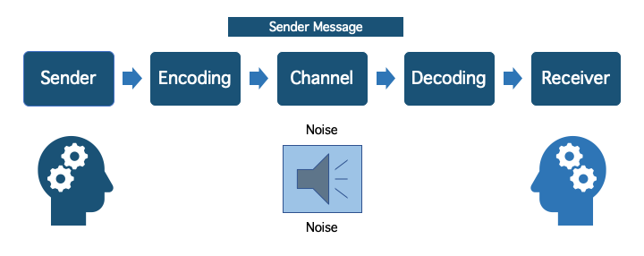
The model of Shannon and Weaver is a mathematical model of communication that was developed by them in 1948. The model is known as the “mother of all models” and is used to determine and develop effective communication between two parties such as sender and receiver (Drew, 2021). The model is also used to determine the factor that inhibits the effective communication process. The factor that they determine is “Noise”.
Figure 1: Elements of Shannon and Weaver's Model (Drew, 2021)
According to them, the communication process between two parties can be fragmented into 6 key elements. A brief discussion of each is given below:
- Sender: The sender is the person who has the information and intends to exchange this information with the other party (van Ruler, 2018). This segment is the source of information and the initial element of communication. The communication process starts from the sender.
- Encoder: An encoder is a person, machine, or any element that transforms the message of the sender into a signal which is then transmitted through the channel. This element is also regarded as transmittal of a communication (Al-Fedaghi, 2012). For example, in a telephonic conversation, the vocals of the sender are converted into an electric signal by the microphone and sent using radio waves and through the channel.
- Channels: This is the medium through which signals move from one place to another from source to destination (van Ruler, 2018). For example, mobile networks, wireless networks are the channels through which messages can be transmitted.
- Decoder: It is the element that resides with the receivers’ end that works perfectly opposite of the encoder (Blythe, 2021). The decoder converts the signals into the message. In telephonic communication, the electric signals from the sender’s end are reconverted into sounds for the receiver.
- Receiver: This is the final destination of the information that has been sent from the sender. The information is transmitted from the sender to the receiver.
- Noise: While a message is transmitted from the sender to the receiver, the message can be disturbed by any source both internal and external in the process of communication. Noise interrupts the message and limits the understanding and meaning of the message. The main obstacle to effective communication is the Noise produced in the channel according to Shannon and Weaver (Littlejohn and Foss, 2015). There are two types of Noise. They are internal noise and external noise. Internal noise comes out from the sender’s end when the sender is providing the information or encoding it (Drew, 2021). For example, the sender may mispronounce a word while speaking or misspell something while typing. On the contrary, external noise is generated from outside sources. For example, natural calamities can weaken the signal that is transmitted. Noise can interrupt the message during the time of both encoding and decoding.

Schramm Model of Communication
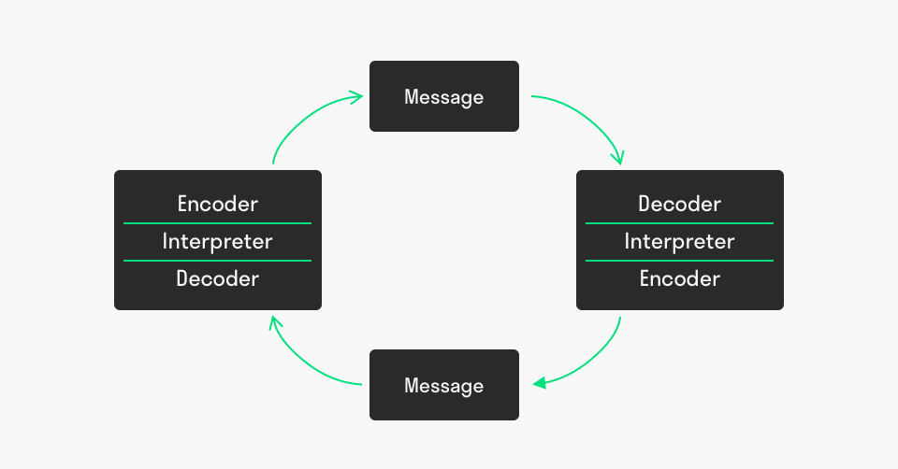
The model proposed by Wilbur Schramm in 1954 which is known as the Schramm model denotes communication as a two-way street. Effective communication involves a continuous process from sender to receiver. The model regards communication as a cyclical or reciprocal exchange of information between two parties (Blythe, 2021). For a complete communication, the model requires three elements namely: Sender or source, Message, and Recipient. It is not necessary under the model that the sender and recipient should be different parties. The same person can be the sender and recipient. In such a case, communication is considered intra-personal communication. According to the model, effective communication is never possible if the receiver does not provide any feedback message to the sender party of the communication process. The model breaks the communication in a practical way, not in a traditional approach as described in the Shannon and Weaver Model (Schramm's Model of communication - QS Study, 2021).
Figure 2: Communication Model of Schramm (Schramm Communication Model, 2021)
As already mentioned that there are three main elements under the model namely source, message, and receiver, they are discussed below:
The “Source” initialises the communication process by sending the message to the destination. For any effective communication, the source has to be certain about the meaning and the form of the message. There is no communication if the message or the information that would be sent has no use to the recipient. The message of the source should be converted in a transferrable way. The encoder of the source converts the message or the information into electronic data or binary information (Schramm Communication Model, 2021). The process of encoding should be conducted in a way so that it becomes meaningful or extractable when reached to the receiver. If the message is not available to the receiver, then the actual purpose of communication would not be achieved.
The second element of communication is the message. Message can be regarded as any sort of news, information, or data that is intended to exchange from one party to another (Blythe, 2021). The information consists of symbols, words, or vocals. Message can be comprised of verbal and non-verbal content. Verbal content can be any kind of voice message and non-verbal content can be a text message or body language.
The third element of communication is the receiver or recipient of the message. The receiver when receiving the message that was sent from the sender has to decode the message. After decoding the message, the person interprets the message. Interpreting means analysing and investigating the message for a better understanding of the context and meaning of the message (Graham, 2009). Effective communication requires feedback from the recipient. When the receiver receives the message, he then provides feedback to the other party. During the process of feedback sending, the party has to encode his message and send it through the proper channel. Now the initial sender has to decode and interpret the message sent from the receiver as feedback. This is known as the cyclical process of communication which is the main feature of the communication model by Schramm (Schramm Communication Model, 2021).
The model is superior in the sense that it is more practical and flexible than other models. The model assumes communication is a circular process that is more practical than others. But one of the prime limitations of the model is the fact that it does not consider internal and external interrupting factors into account (OSGOOD- SCHRAMM MODEL OF COMMUNICATION, 2021).

Berlo’s Model of Communication
According to the model of Berlo, there are four components under the communication process and there are various factors that fall under each component. The model is also called as SMCR model which is formed with the initials of each four components: Sender, Message, Channel, and Receiver (BERLO’S SMCR MODEL OF COMMUNICATION, 2021). The model illustrates the impact of each factor under the components to produce effective communication. The attributes that produce effective communication are described in this model. The four components are the most essential components of communication. The sender is the source of the message as usual. The message is the news or information that would be delivered to the desired parties. Channel is the medium through which information or message would be transmitted (McQuail and Windahl, 2016). The last portion is the receivers who are the targeted people for whom the message would be delivered. To exemplify the process, we can think of television news. The news presenter is the source of information, Message, in this context, is the news that the presenter would like to present. Television is the channel and the listener who would like to listen to the news is the receiver. But, the model goes a bit deeper and determines some factors that will ensure the smooth process of communication.
The factors of each component are given on the following page:
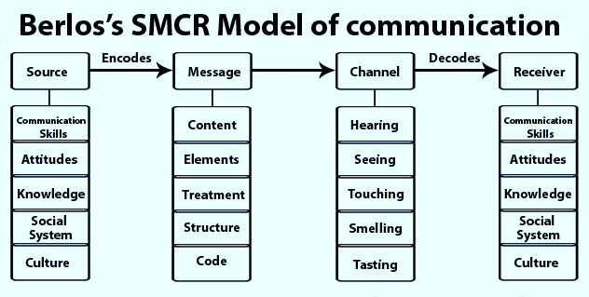
Figure 3: Components and factors of Berlo's Model (BERLO’S SMCR MODEL OF COMMUNICATION, 2021)
The effectiveness of the first component depends on the communication skills of the person providing the message. The source has to maintain a proper attitude and knowledge regarding the subject matter of the message. The second component “Message” should be properly organised and structured. The content and other elements of the message should be well designed for a concrete message. The effectiveness of the channel or medium depends on the ability to hear, see, touch, and feel the message (Muyanga and Phiri, 2021). The effectiveness of communication from the side of the receiver depends on the same factors that affect the component “Source.” In short, the effectiveness of the factors listed under each component ensures the effectiveness of communication.

Problems and Solution of the Case Study
The given case study of Pedro and Maria illustrates the impact of noise on the interruption of the message. Noise can distort the meaning of any message. As Pedro is a worker at a construction site, he is exposed to the huge noise of the construction site. When his wife Maria called him and asked him to bring chicken with him, he listened that she might have told him to go to the kitchen. The reason for such miscommunication is the external noise that comes from the construction site where Pedro works.
The phenomenon of this type of communication is perfectly explained in the model of Shannon and Weaver. According to them, the main obstacle to effective communication is the presence of noise. Noise distorts the message and inhibits the understanding of the receiver (Blythe, 2021). The issue got important in the model of Shannon and Weaver. Similar to that, Berlo’s model also identifies the problems. There are five sense organs in the “Channel” component of the communication (Muyanga and Phiri, 2021). Communication can be occurred using any one of them. As hearing is one such channel, the case study denotes that the problem lies in the hearing due to excessive noise in the surroundings.

Example of Miscommunication
Communication error or miscommunication is very common in different organisations. I have once faced a problem due to poor communication. I was assigned a team of some members in my organisation. One day, one of my teammates informed me that the project was out of our capacity. As there was so much noise on the ground floor, I heard that he said the project was disturbed due to electricity. So, I went to solve the problem and contact my supervisor about the problem with electricity. Management hire an electrician but he did not find any problem there. When asked, my teammate said that he never complains about the electric problem. But he eventually said that he told about the capacity problem of the organisation. I then realised that I did not listen to him properly due to the noise. Here, the main problem was a noise that creates barriers to effective communication.

Conclusion
Effective communication is instrumental for achieving certain goals in the organisation. Communication problems may generate unnecessary hassle, trouble, and cost (Graham, 2009). That’s why effective communication is important for any kind of organisation. The given case study also exemplifies the issue accurately. The common obstacle in effective communication is the noise that comes from internal and external sources. Proper communication requires communication skills and attributes that make the whole process of communication smooth and effective (McQuail and Windahl, 2016). With effective communication, an organisation can participate in growth and prosperity.

References
Al-Fedaghi, S., 2012. A Conceptual Foundation for the Shannon-Weaver Model of Communication. Routledge.
Blythe, J., 2021. The Schramm Model of Communication. Pearson.
Communication Theory. 2021. BERLO’S SMCR MODEL OF COMMUNICATION. [online] Available at: <https://www.communicationtheory.org/berlos-smcr-model-of-communication/> [Accessed 22 December 2021].
Communication Theory. 2021. OSGOOD- SCHRAMM MODEL OF COMMUNICATION. [online] Available at: <https://www.communicationtheory.org/osgood-schramm-model-of-communication/> [Accessed 22 December 2021].
Drew, C., 2021. Shannon Weaver Model of Communication - 7 Key Concepts (2021). [online] Helpful Professor. Available at: <https://helpfulprofessor.com/shannon-weaver-model/> [Accessed 22 December 2021].
Graham, I., 2009. Communication. Mankato, Minn.: QEB Pub.
Littlejohn, S. and Foss, K., 2015. Encyclopedia of communication theory. Sage.
McQuail, D. and Windahl, S., 2016. Communication models. London: Routledge.
Muyanga, C. and Phiri, J., 2021. Assessment of Effective Communication in International Schools in Developing Countries Based on the Berlo’s SMCR Model. Open Journal of Business and Management, 09(01),
Petersons, A. and Khalimzoda, I., 2021. COMMUNICATION MODELS AND COMMON BASIS FOR MULTICULTURAL COMMUNICATION IN LATVIA.
Pract., J., 2007. Developing Effective Communication Skills. Journal of Oncology Practice, 3(6),
Qsstudy.com. 2021. Schramm's Model of communication - QS Study. [online] Available at: <https://qsstudy.com/business-studies/schramms-model-communication> [Accessed 22 December 2021].
Romas, J. and Sharma, M., 2017. Effective Communication. Practical Stress Management,
Shannon, C. E. and Weaver, W. (2019) The mathematical theory of communication. Baltimore, MD, USA: University of Illinois Press.
toolshero. 2021. Schramm Communication Model. [online] Available at: <https://www.toolshero.com/communication-skills/schramm-communication-model/> [Accessed 22 December 2021].
van Ruler, B., 2018. Communication Theory: An Underrated Pillar on Which Strategic Communication Rests. International Journal of Strategic Communication, 12(4),

