Milena Tomaszewska (1902366)

investigation into resonant circuits

Contents
No table of contents entries found.

Abstract
In this assignment I have created two circuit simulations using Proteus. Proteus allows for live testing and probing, so I applied a Frequency Response graph to both circuits to record the data.

Introduction
These circuits are used in a lot of different devices. Mostly devices like TV’s and radios. This is because it needs to select a narrow range of frequency from the surrounding radio waves.

Simulation Setups

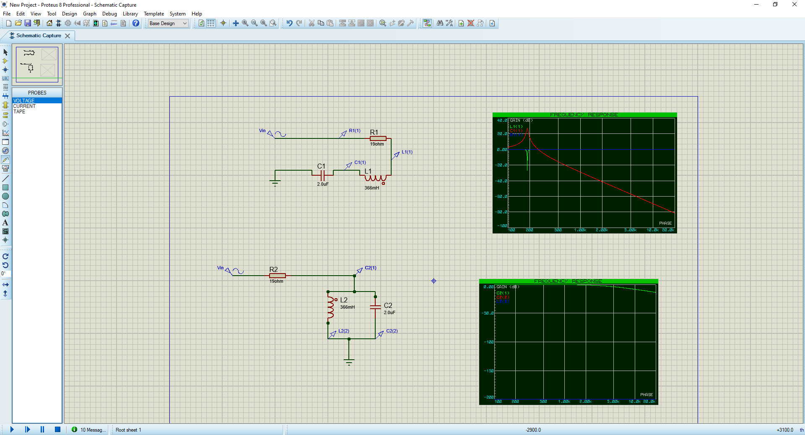
In this RLC series circuit, I used my student ID to create the values for the components. The Resistor is the first 2 numbers of my student ID, so 19 Ohms. The Capacitor is the next 2 digits in my ID, 02uF. So, I just set it to 2uF. The last 3 digits of my ID is for my Inductor. Which is set to 366mH. I also have voltage probe points before the resistor, after the resistor and after the inductor. The Vin SINE Generator is set to 353.553m RMS at 100hz.

This frequency response graph contains the data probed by the above voltage probes in the circuit. The Blue line is the probe before the resistor. The green line is the probe after the resistor, and the red line is the probe after the inductor. As you can see the frequency on the green line dips down to about -36dB to -38dB at around 200hz and then jumps back up to 0dB. The red line on the other hand slowly climbs up to about 34dB to 36dB until around 200hz and then slowly falls off for the rest of the simulation. As for the blue line, it stays at a constant 0dB.

Just like the RLC Series circuit, I used my student ID to create the parameters for the components for this parallel RLC circuit. This time the first voltage probe point is just before the parallel capacitor and inductor. The second voltage probe point is after the inductor, and the third voltage probe is after the capacitor. The Vin is the same as the Series RLC Circuit.

This time the green line and red line are overlapping each other as they are identical. They both stay at 0Db until about 2khz and then start to drop down to about -20dB. As for the blue line, it stays at a constant -200dB.

Results

Discussion

Conclusion

References

