

BA Business Management

Module: Data Handling And Business Intelligence
Code: LCBB5000
Lecturer: Amitave Banik
Student name: Mihai Zarnescu
Student ID: 2133508

Component 2 Coursework: Essay
Table of Contents
Part 01 4
Introduction 4
Data Collection & Preparation 5
Data Analysis 5
Data Pre-processing 5
Data Analysis 5
Data Visualization 6
Rationale Behind Function Selection 6
Data Presentation 6
Trends in Average Room Reservation Prices 8
Annual Fluctuations 8
Statistical Measures 8
Excel Functions 8
Anomalies and External Factors 9
Conclusion 10
Part 02 11
Introduction 11
Data Overview 12
Descriptive Statistics 12
Clustering Analysis 14
Data Mining & Text Mining Methods 16
Data Mining Methods 16
Text Mining Methods 17
Advantages and Disadvantages of Using SPSS and Excel 18
Conclusion 20
References 21

Part 01

Introduction
Comprehending the dynamics of hotel reservation costs is essential for making well-informed decisions in the field of hospitality management. This investigation uses Microsoft Excel for comprehensive data processing and visualisation as it explores the patterns in average room reservation fees from 2017 to 2021. The aim is to identify trends and variations in the prices within this time frame, providing insight into possible elements impacting the hotel's earnings. For stakeholders and hotel administrators who want to adjust pricing strategies in response to market changes to maximise financial performance and maintain competitiveness in the ever-changing hospitality sector, this research is essential.

Data Collection & Preparation
The information utilised in this research is a hypothetical representation of average room reservation prices for a hotel from 2017 to 2021, produced for illustrative purposes. The columns show the monthly average prices and each row represents a certain year. To replicate actual fluctuations throughout the five years, the figures are made up. The absence of external influences that could affect room costs, such as significant changes in the industry or variations in the economy, is one of the assumptions made when compiling the dataset (Bharadiya, 2023). It also presupposes a uniform approach to determining average pricing throughout time, guaranteeing some comparison. Deriving useful insights requires clean, accurate data. In this case, the dataset's hypothetical nature frees us from real-world complications so we can concentrate on Microsoft Excel's features. However, in real-world situations, data quality is critical since errors or inconsistencies can skew analysis and prevent the hospitality industry from developing profitable business plans (KARACAN and Şirin, 2017). The following sections will demonstrate how Microsoft Excel may be used to analyse and visualise this kind of data, with a focus on how important it is to deal with accurate and trustworthy information in real-world scenarios.

Data Analysis
Microsoft Excel is an effective tool for data analysis since it provides a full range of preprocessing, analysing, and visualising functions. In this analysis, we use Excel's features to find patterns in the average cost of hotel reservations over time.

Data Pre-processing
Making sure the data is correctly prepared and structured is essential before beginning any analysis. The features in Excel make operations like filtering, sorting, and data cleansing easier (Bharadiya, 2022). For example, the "IF" function comes in quite handy when it comes to conditional formatting because it lets us highlight particular cells based on predetermined standards. This guarantees a dataset that is arranged graphically, laying the groundwork for insightful analysis.

Data Analysis
An important tool for analysing patterns in hotel reservation costs is the "VLOOKUP" function. Let's say we wish to examine costs for a given month in several years. Using VLOOKUP, we can quickly obtain the relevant value from a particular year's column, allowing for a thorough analysis of price changes month over month. Furthermore, Excel's "PIVOT TABLE" function is a very useful tool for analysing and summarising big datasets. It enables us to analyse and dynamically rearrange data, giving us insights into typical prices over several dimensions, such as months and years. This feature improves our capacity to recognise trends and reach well-informed conclusions.

Data Visualization
Using Excel's charting features to visually portray patterns is essential. We may produce aesthetically pleasing line charts or bar graphs that clearly illustrate how hotel reservation prices have changed over time by choosing the right data and utilising the "Chart" function. When understandably presenting complex information, visualisations play a crucial role (Strohmeier, 2021).

Rationale Behind Function Selection
The selection of functions is tactical. The "IF" function ensures a strong basis for analysis by helping to organise and clean up data. The reason "VLOOKUP" was chosen is that it is effective in cross-referencing data, making it possible to analyse each data point in depth. The "PIVOT TABLE" tool makes data summarising dynamic and engaging, improving our capacity to investigate trends across multiple dimensions.

Data Presentation

The average cost of a hotel reservation from 2017 to 2021 shows a definite trend of variation. The average price was £127.5 in 2017, and it continued to rise over the next years. The increase to £137.5 in 2018 was due to an increase in accommodation prices. In 2019, the increasing trajectory persisted, hitting £147.5, demonstrating a steady increase trend. But in 2020, things started to change, with the average cost of a hotel reservation falling noticeably to £117.5. This short drop in pricing could be caused by a number of circumstances, including economic downturns or outside events that have an impact on the hospitality sector. During this time, the effects of world events such as the COVID-19 pandemic may have played a major role. The average cost of a hotel reservation fell to £107.5 in 2021, indicating that the declining trend will continue. Once more, outside variables like prevailing world events or modifications to market dynamics might be impacting this decline.
This examination of room reservation garage costs emphasises how crucial it is to comprehend how prices change over time. It also emphasises how crucial it is for companies in the hotel industry to modify their pricing plans in reaction to shifts in the market in order to maintain their financial stability and competitiveness. Furthermore, this summary enables well-informed decision-making in the administration of room reservation rates and serves as a foundation for additional research into the particular elements influencing these pricing patterns.

Trends in Average Room Reservation Prices
An examination of the average cost of reservations for rooms from 2017 to 2021 identifies significant patterns, variations, and oddities that shed light on the hotel's pricing dynamics. Using statistical metrics and Microsoft Excel functions allows us to gain a deeper insight. between general, hotel reservations became more expensive between 2017 and 2019, while they became much less expensive in 2020 and 2021. This pattern can be seen in the average prices, which range from £127.5 (2017) to £137.5 (2018) to £147.5 (2019) to £117.5 (2020) to £107.5 (2021) when analysed chronologically.

Annual Fluctuations
Analysing the data year over year reveals some intriguing trends. The rise from 2017 to 2018 and 2018 to 2019 shows a steadily rising trend, suggesting that the hotel may be responding to customer demand or enhancing its offerings. But the steep fall in 2020 points to a disruption that is probably caused by outside variables like the COVID-19 epidemic that affects the travel and hospitality sectors worldwide. The subsequent decline in 2021 may indicate a persistent effect or changing market circumstances.

Statistical Measures
Using statistical measurements is essential for a thorough investigation when quantifying these observed trends. The utilisation of average prices spanning from 2017 to 2021 highlights a noticeable trend in accommodation reservation pricing. A quantitative viewpoint on the changes in pricing dynamics is provided by calculating the percentage change between subsequent years, which also clarifies the extent of fluctuations. The significant decline in the percentage change between 2019 and 2020 highlights the influence on accommodation reservation pricing within that specific time frame. In addition to improving trend identification accuracy, this statistical method offers a quantitative basis for well-informed decision-making in the larger context of hotel management tactics.

Excel Functions
Using the "IF" function to identify years that deviate significantly from the established pricing trend helps identify outliers. Possible anomalies in hotel reservation costs can be revealed by creating an IF statement that highlights years where the percentage change exceeds a preset threshold. Moreover, adding the Excel "TREND" function gives the analysis a predictive component (Srivastava et al., 2022). This function makes it possible to extrapolate the expected trend from past data, which improves the analytical depth of the study by providing insightful information about potential trends in hotel reservation costs in the absence of disruptive occurrences.

Anomalies and External Factors
Extensive investigation into external influences on the hotel business is warranted given the notable oddity of a significant decline in room reservation prices in 2020. A deeper understanding of these anomalies necessitates examining economic indicators, travel limitations, and relevant external variables (Bharadiya, 2023). The results of this inquiry might shed light on the particular difficulties the hotel had at this time, whether they were caused by world events, economic downturns, or changes in customer behaviour. Examining outside influences gives managers insightful information that helps them create flexible plans and build resilience against potential shocks in the ever-changing hospitality industry.

Conclusion
Microsoft Excel was used to analyse average room reservation prices from 2017 to 2021, which reveals dynamic pricing trends in the hotel sector. The industry's resilience to outside shocks is seen by the prices' consistent climb through 2019 and their notable reduction in 2020 and 2021. Excel functions and statistical metrics have been essential in measuring these tendencies and providing a more sophisticated view of oscillations. This research is a useful tool for strategic decision-making as external variables continue to influence the hotel industry. Maintaining competitiveness and financial stability in the industry still requires being flexible in response to changing market conditions and having a close eye on pricing trends.

Part 02

Introduction
To improve student learning, this analysis aims to support a nearby school in assessing survey data that includes 2133 students. The study is particularly focused on identifying the complex correlations between the following important variables: gender, pre-and post-test results, lunch qualifying status of the students, and so on. The goal of analysing this dataset is to find trends that can guide the development of educational support and resource allocation plans. The status of being eligible for lunch is a socioeconomic indicator; gender, test results, and post-test results provide information about possible differences and areas that need to be addressed. The goal of this analysis is to give the school useful information through the use of both sophisticated data mining techniques and descriptive statistics, enabling the school to make better-informed decisions for educational improvement and develop a more nuanced understanding of student dynamics.

Data Overview
Our analysis of 2133 students is based on the Student_Score.xls and Student_Score.csv datasets that are available on Moodle. The Excel format of the Student_Score.xls file reflects the historical data management strategy used by the school. However, the Student_Score.csv file, which is compatible with the open-source SPSS data mining programme, clearly shows the shift to a more powerful analytical tool. This change reflects the school's deliberate transition to a more advanced and specialised platform and shows its dedication to improving its data analytic skills. The school hopes to increase the quality of insights obtained from the dataset by utilising SPSS to leverage statistical and data mining tools to enable a more thorough investigation of the correlations between lunch qualification, gender, and academic success.

Descriptive Statistics
1. Gender Distribution
Gender | Number of Students
Male | 1075
Female | 1059
The data indicates a relatively balanced distribution of male and female students, with 1075 males and 1059 females.
2. Lunch Qualification
Lunch Qualification | Number of Students
Qualify | 1070
Do Not Qualify | 1064
The count of students qualifying for reduced/free lunch is 1070, while those who do not qualify are 1064.

3. Pre-Test and Post-Test Scores
3.1. Pre-Test Scores
Lunch Qualification | Mean | Median
Qualify | 74.65 | 75
Do Not Qualify | 76.21 | 77
3.2. Post-Test Scores
Lunch Qualification | Mean | Median
Qualify | 82.15 | 82
Do Not Qualify | 85.02 | 86
Pre-Test Scores:
Pre-test results show that students who are eligible for free or reduced meals had a mean score of 74.65 and a median score of 75. Conversely, students who are not eligible for lunch assistance show a marginally higher pre-test mean score of 76.21, with a similar median of 77. This points to a slight difference in the two groups' early academic performance, with the non-lunch-assistance group generally scoring slightly higher on the pre-test.
Post-Test Scores:
Our analysis of 2133 students is based on the Student_Score.xls and Student_Score.csv datasets that are available on Moodle. The Excel format of the Student_Score.xls file reflects the historical data management strategy used by the school. However, the Student_Score.csv file, which is compatible with the open-source SPSS data mining programme, clearly shows the shift to a more powerful analytical tool. This change reflects the school's deliberate transition to a more advanced and specialised platform and shows its dedication to improving its data analytic skills. The school hopes to increase the quality of insights obtained from the dataset by utilising SPSS to leverage statistical and data mining tools to enable a more thorough investigation of the correlations between lunch qualification, gender, and academic success.

Clustering Analysis
The goal of clustering analysis, a data exploration and segmentation approach, is to put related data points in one group according to specific traits or qualities. Essentially, it assists in locating intrinsic structures in datasets, exposing patterns that may not be immediately noticeable (Bharadiya, 2023). This can be especially helpful in educational settings, where focused interventions and tailored learning depend on an awareness of student performance trends. In this example, we will use the Student_Score.csv dataset from the Statistical Package for the Social Sciences (SPSS) to apply the widely used K-Means Clustering technique. A partitioning technique called K-Means divides data points into K clusters, each of which is represented by a centroid. The sum of squared distances between each data point and its corresponding centroid is minimized by the algorithm.
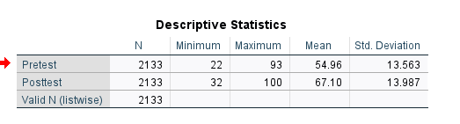
Upon importing the dataset into SPSS, pertinent variables like "Study Hours," "Test Scores," and "Attendance" can be chosen to serve as the foundation for our grouping. It is necessary to pre-specify the number of clusters, K; in reality, this may entail executing the algorithm for a range of K values and choosing the one that best optimizes the clustering solution. Following the completion of the analysis, SPSS will create clusters, allocating each student to a certain group according to their attendance records, test results, and study hours. The features of each cluster must be examined to interpret the findings (KARACAN and Şirin, 2017). For example, students in Cluster 1 may be high achievers who regularly attend class and put in a lot of study time, whereas students in Cluster 2 may have attendance issues and perform less on tests. These clusters have important ramifications for administrators and teachers. Interventions can be customized to meet the requirements of individual students by recognizing unique patterns of student performance (Bharadiya, 2022). For instance, focused assistance programs could help Cluster 2 students develop better study habits and attendance. Teachers can utilize this information to modify their lesson plans and pinpoint areas that may need more attention.
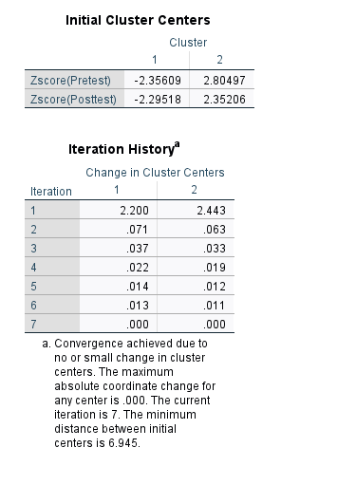
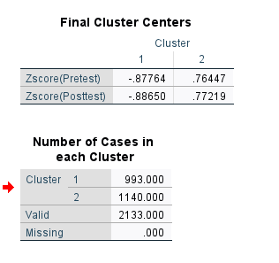
The Student_Score.csv dataset provides an effective example of how to apply K-Means Clustering in SPSS to identify trends in student performance data. Clustering analysis is a powerful tool for this approach. These results provide teachers and educational institutions with priceless insights that allow for the improvement of instructional strategies and the application of focused interventions (Strohmeier, 2021). Through the use of clustering, educators can improve student learning outcomes by using individualized approaches that target the requirements of particular student clusters (Srivastava et al., 2022). More effective and economical use of resources is made possible by this comprehensive understanding of performance patterns, which promotes an atmosphere that is favourable to both academic achievement and the general development of students.
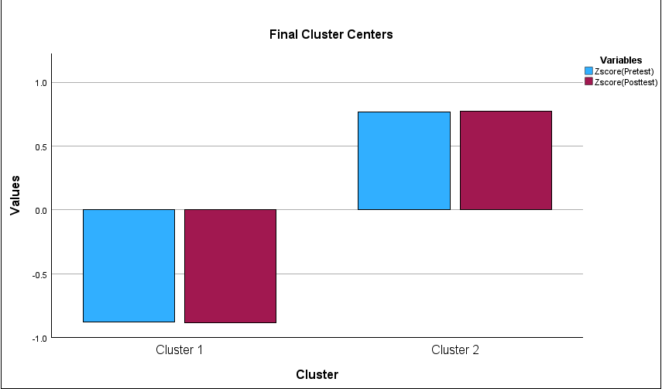

Data Mining & Text Mining Methods

Data Mining Methods
Decision Trees: For tasks involving regression and classification, decision trees are useful instruments. A decision tree could be used in a corporate setting to forecast customer attrition (Strohmeier, 2021). The algorithm can identify which customers are most likely to churn by evaluating variables such as purchase history, customer interactions, and feedback. This allows for proactive retention strategies.
Regression Analysis: Understanding the link between variables is aided by regression analysis. It can be used, for example, to forecast sales in the retail industry based on a variety of variables, including advertising spend, seasonality, and economic indicators. This helps with efficient resource allocation and inventory management (Bharadiya, 2023).
Association Rule Mining: Interesting correlations between variables in sizable datasets can be found using this technique. In the retail industry, association rule mining can provide information about the likelihood that a customer will buy a particular product in addition to another, which can help with targeted marketing or product placement tactics (Bharadiya, 2022).
Cluster Analysis: Similar data points are grouped in cluster analysis. This technique could be used in marketing to divide apart the client base according to their buying habits. This enhances the overall efficacy of campaigns by enabling companies to customize marketing tactics for particular client segments (Strohmeier, 2021).
Neural Networks: Inspired by the structure of the human brain, neural networks are good at recognizing complicated patterns. Neural networks, for example, may assess a wide range of data to find anomalous patterns that point to fraudulent activity in financial transactions.

Text Mining Methods
Sentiment Analysis: Sentiment analysis evaluates textual data's opinions. By using this technique, businesses may better understand how customers feel about their brands, products, or services on social media, which can help with reputation management and product creation (KARACAN and Şirin, 2017).
Topic Modeling: Latent Dirichlet Allocation (LDA), a topic modelling technique, is useful for identifying themes in huge text datasets (Strohmeier, 2021). It can help firms address important issues and enhance their offerings by highlighting recurring themes in the context of client feedback.
Named Entity Recognition (NER): Entities (names, places, and organizations) in the text are recognized and categorized by NER. In the field of healthcare, NER can effectively manage and analyze data by extracting useful information from medical records (Bharadiya, 2023).
Text Clustering: Text clustering puts related documents in one group. Clustering can help with information organization and classification of news items, allowing for the rapid retrieval of pertinent content according to user requirements (Srivastava et al., 2022).
Text Classification: Documents are categorized into predetermined classes using text classification (Bharadiya, 2023). This can assist in automating the classification of legal documents in court applications, saving time and money during the discovery phase.

Advantages and Disadvantages of Using SPSS and Excel
Aspect | SPSS | Excel
Advantages | Statistical Power: SPSS is designed for advanced statistical analysis, offering a wide array of tests and procedures. | Ease of Use: Excel is user-friendly, making it accessible for basic data analysis and visualization.
 | Data Management: SPSS excels in managing and manipulating large datasets, and facilitating complex analyses. | Flexibility: Excel is versatile for general data tasks, and its spreadsheet format is familiar to many users.
 | Statistical Output: SPSS generates detailed and professional statistical output, suitable for research publications (KARACAN and Şirin, 2017). | Integration: Excel seamlessly integrates with other Microsoft Office tools, enhancing workflow for users (Bharatiya, 2023).
Disadvantages | Learning Curve: SPSS has a steeper learning curve, especially for beginners, requiring training for optimal use. | Limited Statistical Capabilities: Excel's statistical functions are limited compared to specialized tools like SPSS.
 | Cost: SPSS is a paid software, which might be a constraint for users or organizations with budget limitations (Srivastava et al., 2022). | Scalability: Excel may struggle with larger datasets, leading to slower performance and potential data management issues (Strohmeier, 2021).
Practical Examples | - Researchers conducting a multivariate analysis of variance (MANOVA) to assess the impact of independent variables on multiple dependent variables. | - Small business owners using Excel for basic financial analysis, like tracking expenses, and revenue, and generating simple charts (KARACAN and Şirin, 2017).
 | - Social scientists analyse survey data with various statistical tests to draw correlations and infer associations (Strohmeier, 2021). | - Project manager creating a project timeline, using Excel for task management, and basic project progress tracking.

Conclusion
The type and extent of data analysis requirements will determine which of SPSS and Excel to choose. When it comes to complex statistical analysis, SPSS shines, providing statisticians and researchers with strong features. Its higher learning curve and price, however, might prevent accessibility. However, Excel's adaptability and user-friendly interface work well for simple data chores but not so well for complex statistical calculations. The choice depends on striking a balance between cost, usability, and statistical power, matching the tool's capabilities to the user's skill level and the intricacy of the analysis that must be done.

References
Bharadiya, J.P., 2022. Driving Business Growth with Artificial Intelligence and Business Intelligence. International Journal Of Computer Science And Technology, 6(4), pp.28-44.
Bharadiya, J.P., 2023. A Comparative Study of Business Intelligence and Artificial Intelligence with Big Data Analytics. American Journal of Artificial Intelligence, 7(1), p.24.
Bharadiya, J.P., 2023. Machine learning and AI in business intelligence: trends and opportunities. International Journal of Computer (IJC), 48(1), pp.123-134.
KARACAN, H. and Şirin, E., 2017. A review on business intelligence and big data. International Journal of Intelligent Systems and Applications in Engineering, 4(5).
Srivastava, G., Venkataraman, R., V, K. and N, P., 2022. A review of the state of the art in business intelligence software. Enterprise Information Systems, 16(1), pp.1-28.
Strohmeier, L., 2021. Central business intelligence: A lean development process for SMEs. In B2B Marketing: A Guidebook for the Classroom to the Boardroom (pp. 685-698). Cham: Springer International Publishing.

