MY E PORTFOLIO
ATTESTATION

A Production of an E Portfolio

Genevieve Nkwentamo

CONTENTS

Task one:
A Focus on Fathers in Child Mental Health Interventions (summary)

Task two:
Video presentation link.

Task three – Part 1:
Poster

Task three - Part 2:
One hundred and fifty word reflection on my contribution and experiences of group working to creating the poster.

Task three – Part 3:
Evidence of team communication and collaboration

References:

Task one
A Focus on Fathers in Child Mental Health Interventions (summary)
Compared to mothers, fathers are less likely to take part in treatments for mental health issues in children. A variety of groups and treatment approaches request a greater inclusion of fathers in clinical practice. Research suggests the success of treatments can depend on both parents’ participation. According to one analysis, 20% of parents participating in parenting interventions were fathers (Fletcher et al., 2011). It is imperative to include fathers to emphasize to families how crucial they are to their children's mental health and well-being. Fathers are not adequately represented in studies on parenting, child development, and child mental health (Panter-Brick et al., 2014).
Today, fathers are more active in raising children than. Mothers have been the main subject of studies looking at the efficacy of interventions. The effectiveness of an intervention can be improved by father involvement, yet it might be challenging for fathers to participate. Low levels of confidence, inadequate father engagement skills, and unfavorable practitioner attitudes are among the factors that could function as impediments. According to research, the least essential criterion to boost father participation in programs for children's mental health and well-being is having a male practitioner (Tully et al., 2017).
Only about one-third of practitioners responding to a study said that mums did not encourage dads to participate in parenting interventions (Tully et al., 2018). High rates of father engagement seem to depend on organizational support for father-inclusive activities. A crucial first step to including fathers is determining who the core parenting team is. Fathers are more likely to attend when they believe their contribution and participation are significant. Inviting both mothers and fathers to programs or interventions should be standard practice. Practitioners must actively encourage fathers' participation. Services can accomplish this by incorporating fathers into their inclusion policies and practices. It may suffice to use advertising services that are appropriate for both parents. Tully, Hawes, and Dadds. (2022)

Task two:
Video presentation link.

https://uowtsd-my.sharepoint.com/:v:/g/personal/2106944_student_uwtsd_ac_uk/Ecp_8dGNM_RLpAjuZW8fJogBF1iTbtKxs2A_kKXAywl6xQ?e=ZVUckx

Task three – Part 1:
Group Poster

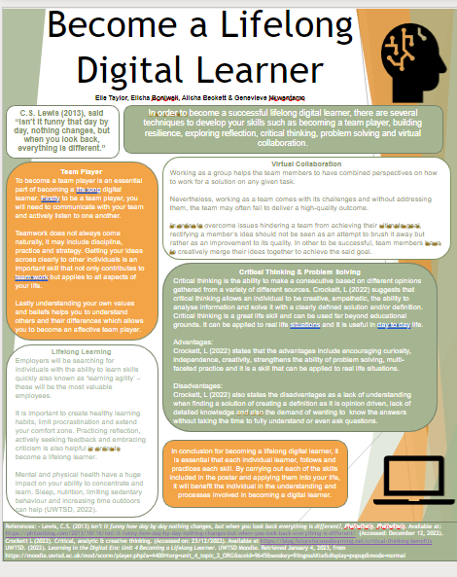

Task three - Part 2:
Reflection on my contribution and experiences of group working to creating the poster.

We had a team of four members. one of us had to lead. Our task was to create an academic electronic poster for the assigned module. Each member selected a topic from the module to write about and then emailed it to the team leader. At a convened team meeting, we had to discuss the poster format for the presentation. My WhatsApp message to the team leader was to inform her that I had chosen the topic of virtual collaboration. Upon completion, I emailed my work to the team leader.
Being a group member working towards the completion of a poster, gave me a new perspective to experience the comparison when writing a topic as an individual and as a team. I have now learned that group work enables team members to focus when working together and will achieve successful goals. Also through brainstorming, an idea could be remodeled to better suit the task at hand.

Task three – Part 3:
Evidence of team communication and collaboration:

WhatsApp message to Elle (team leader)
Hi Ell,
I'll be working on the topic: Virtual Collaboration.
Thanks. 👏🏼
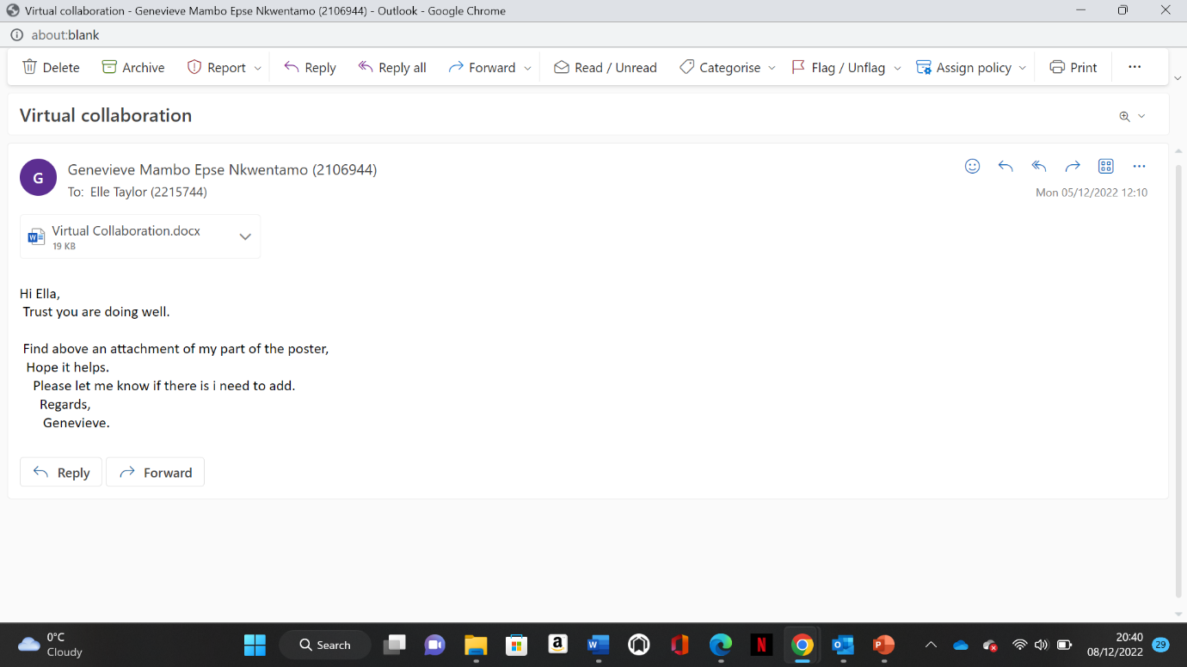

Genevieve Mambo Epse Nkwentamo (2106944)
To:
- Elle Taylor (2215744)
Mon 12/12/2022 20:58
This is the most i can reduce it to.

Working as a group helps the team members to have combined perspectives on how to work for a solution on any given task.
Nevertheless, working as a team comes with its challenges and without addressing them, the team may often fail to deliver a high-quality outcome.
In order to overcome issues hindering a team from achieving their ultimate goal, rectifying a member’s idea should not be seen as an attempt to brush it away but rather as an improvement to its quality. In other to be successful, team members have to creatively merge their ideas together to achieve the said goal.
Regards,
Genevieve.

Elle Taylor (2215744)
Elisha Boniwell (2113032)
Hi ladies,

Please can you check over this completed poster and make sure you're happy with it.
If you would like to make any corrections, alterations or amendments can you please let me know and I'll be happy to change it my end.

Thank you
Elle

References:

Bailey, R., Jones, S. M. (2019). An integrated model of regulation for applied settings. Clinical child and family psychology review, 22(1), 2-23.
Chenneville, T., Schwartz-Mette, R. (2020). Ethical considerations for psychologists in the time of COVID-19. American Psychologist, 75(5), 644.
Kontoangelos, K., Economou, M., & Papageorgiou, C. (2020). Mental health effects of COVID-19 pandemia: a review of clinical and psychological traits. Psychiatry investigation, 17(6), 491.
Moudatsou, M., Stavropoulou, A., Philalithis, A., & Koukouli, S. (2020, January). The role of empathy in health and social care professionals. In Healthcare, 8(1),26.
Perrotta, G. (2020). Borderline personality disorder: Definition, differential diagnosis, clinical contexts, and therapeutic approaches. Annals of Psychiatry and Treatment, 4(1), 043-056.
Reynolds, C. R., Altmann, R. A., & Allen, D. N. (2021). The problem of bias in psychological assessment. In Mastering modern psychological testing (pp. 573-613). Springer, Cham.
Senicola, C. A., Smith, J. B., & Wilson, K. (2020). COVID-19 Has Changed Patient-Clinician Communication: What Can Rehabilitation Professionals Do to Enhance It?, 16(Supp 1),141-145
Tallis, F. (2021). The Act of Living: What the Great Psychologists Can Teach Us About Surviving Discontent in an Age of Anxiety. Hachette UK.
Tully. L, Hawes. D, Dadds. M. (2022) A focus on fathers in child mental health interventions. https://www.bps.org.uk/psychologist/focus-fathers-child-mental-health-intervention

