A Study of Characterisation in Environmental Design
Liam W Jones
Swansea College of Art, UWTSD
Ljones.143935@student.UWTSD.ac.uk
The purpose of this research paper is to establish what artistic methods and components can be used to establish character and personality in environmental art and how effective each element is. The review covers works by: Josiah Brook, Ben Caldwell, Scott Rogers, Matt Rhodes and Ken Rohrer as well as mixed media such as the Angry Birds movie and Rayman Legends the video game. It covers various topics such as: Environment Design, Character Design, Visual Storytelling and Colour Symbolism.
The project specific research involved creating environment art pieces and evaluating if they communicate their intended character/personality traits and which elements of the pieces were identified to contribute to this.
The results found suggest that there are identifiable elements that can be used to instil character into an environment and that they have differing effectiveness when dealing with a naturalistic or manufactured setting.
Characterisation, Stylisation, Environment Art & Design

1. Introduction
In the early days of video games, environment art was not an overly important part of design, with it never being anything more than the mechanics demanded.

However, environment art is a primary factor in modern games design as it plays a key part of player immersion, which is key to the medium’s success. Chris Solarski (2013) suggests that environment is a key part of creating harmony or intentional dissonance within dynamic composition in gameplay and displays how design of environment is as important as character to establish a feeling of belonging or being out of place.

Character in stylised environment art is a very important factor in player immersion through visual storytelling as it allows the player to recognise important factors of the world they are playing in without expressly being told, which would break immersion, for example, a player should be able to tell, purely through the environment art whether they are in a safe or dangerous place.
While realistic environments appeal to audiences, and do not require stylisation or characterisation as they already fit into the same world, there is still a market for stylised games, which require characterisation to be consistent and effective.

This study seeks to explore the methods of establishing character in a stylised environment and will attempt to identify any artistic elements that can be used to convey particular character traits in order to bring diverse environments stylistically in line with each other and characters in a world. In addition, this study also seeks to investigate methods of visual storytelling through environmental art and how effective methods are.
The hypothesis being operated under throughout the study will be that there are identifiable elements within art to communicate character, personality and emotion. And, in addition to this, that there is a hierarchy of how effective each element is.
This study is being undertaken as it is important to understand how diverse elements can comply with the same style while maintaining their own individual personality and identity.

2. Critical & Contextual Review
2.1. Character in Environment Design
Environment design is the process of crafting a fictional environment’s appearance and layout through artistic means. In regard to games design, the purpose of environment design is to create the visual aspect of the world in which the player will be operating.
It is an important aspect of games design as, in modern games, the environment will be the majority of what the player will see and interact with, and therefore if environments are bland, confusing or inconsistent, the player may feel disengaged and not want to continue playing.
This study will focus on the process of imposing character onto an environment and what elements can be used to accomplish this. Ben Caldwell (2005) states that everything, including environment, in a fantasy setting should ideally be created with a noticeable characteristic. He shows an example of environmental elements with distinct visual appearances showing differing characters (See Figure 2a).

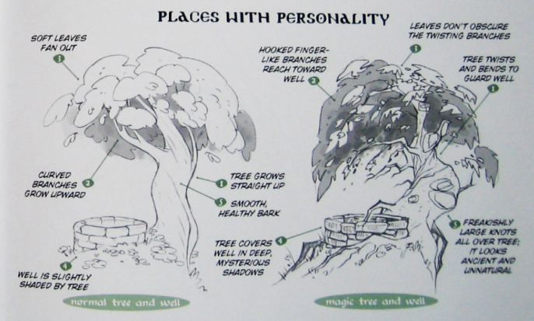
Figure 2a: Shows a tree and a well with two different characteristics. (Caldwell, 2005)

A good example of differing environments being artistically consistent while maintaining their own character can be seen in the worlds of Rayman Legends (Ubisoft, 2013), each world keeps a distinct visual style while still fitting in to the game. Figure 2b shows a light, peaceful environment while Figure 2c shows a dimmer, foreboding feeling environment, however both fit comfortably within the artistic style of the game.

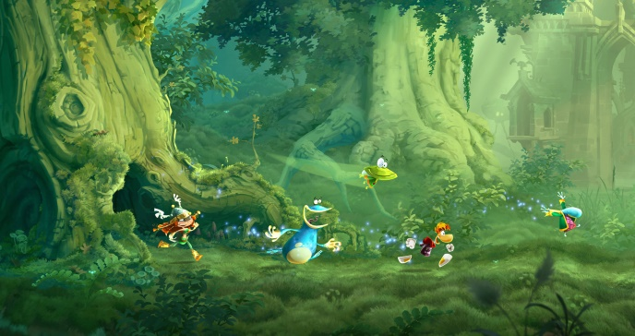
Figure 2b: Teensies in Trouble world in Rayman Legends. (Ubisoft, 2013)

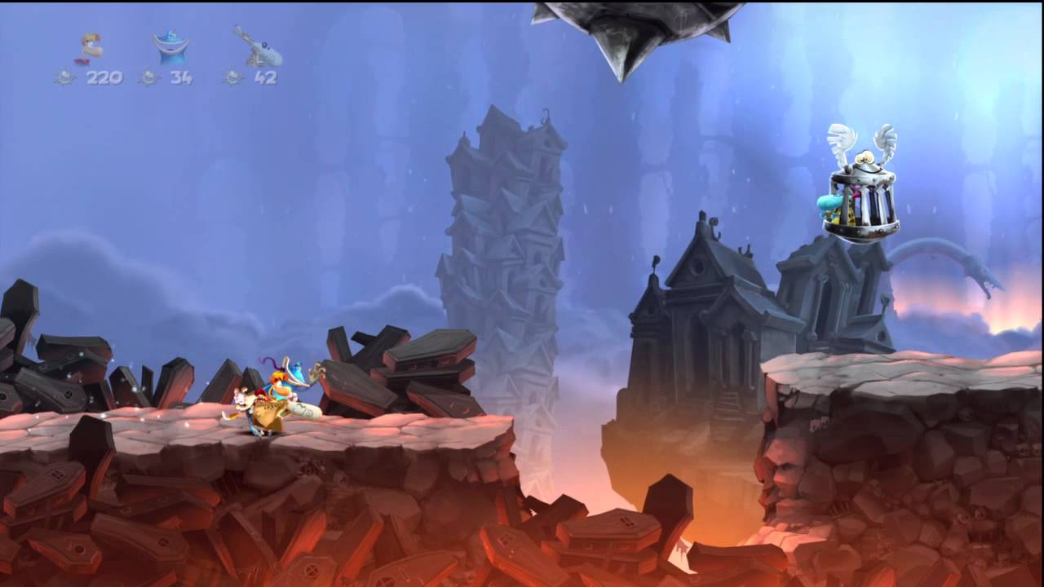
Figure 2c: Land of the Livid Dead world in Rayman Legends. (Ubisoft, 2013)

2.2. Shape Association in Character Design
Character design is the process of creating an imagined character’s appearance through artistic means, usually based on character traits, background story, desired design features or an amalgamation of these.
It is a long standing practice in character design, particularly in more cartoony styles, to use simple shapes in order to convey the personality of the character being designed.
Examples of shape association can be seen in Figures 2d and 2e (below) where the use of basic shapes is used to convey groupings of personalities into a design.

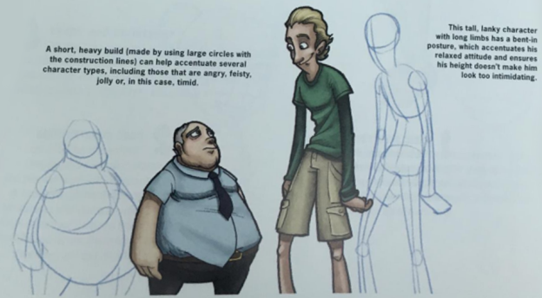
Figure 2d: Character shapes defining personality. (Brooks, 2016)
Rogers states that circles are used in games to communicate friendliness, squares are used for strength or stupidity depending on how they are used and triangles are used to display a heroic figure but can inversely be used to make a character look sinister.

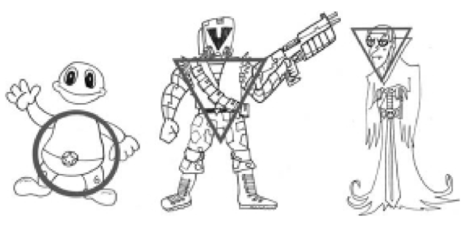
Figure 2e: Use of basic shapes to define personality. (Rogers, 2014)

Ben Caldwell (2005) shows how the use of different basic shapes can convey differing personalities in a character (see figure 2f).

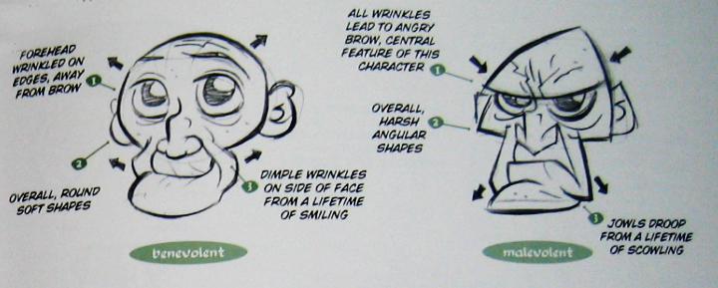
Figure 2f: Old men, Benevolent (left) using circles and Malevolent (right) using triangles.

An example of these can be seen in the 2016 film “Angry Birds” where each main character is clearly based off of a shape which reflects in their personality. With Chuck represented by a triangle, his personality being mischievous, Red being a rectangle and his personality being stubborn and solitary, and Bomb, represented by a circle whose personality is kind and clumsy, these can be seen in Figure 2g:

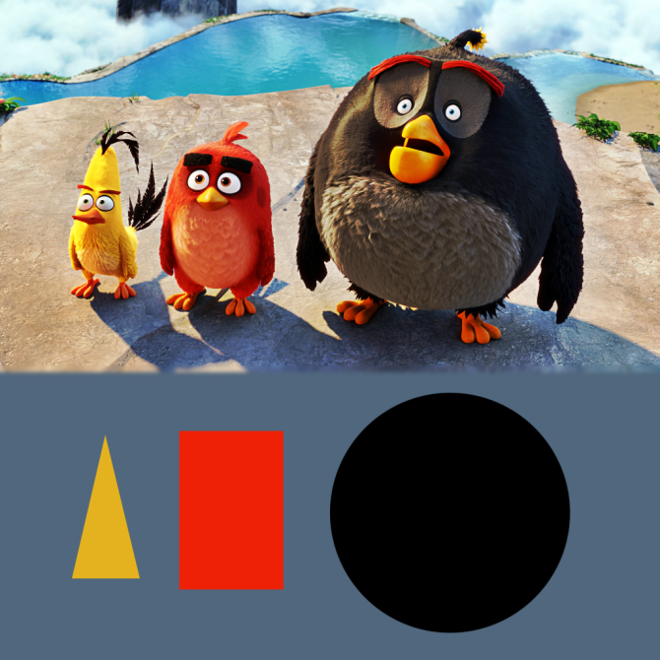
Figure 2g: Chuck, Red and Bomb characters, respectively, from the Angry Birds movie (Angry Birds, 2016) with corresponding shapes.

2.3. Visual Storytelling
Visual Storytelling is the use of visual mediums to tell a story, allowing for narrative without explicitly announcing it.
Matt Rhodes, (2016 cited in ACADonline, 2017) shows how visual storytelling should play a part in character design. Figure 2h (below) shows an imagining of how Han Solo would look if he were designed for a game today, and how it shows no character and reveals no story, and how the original design’s various components give character to the design and subconsciously tell the viewer everything they need to know about Han’s character. This shows how important visual storytelling can be; this study seeks to learn how this can effectively be utilised in environment art.

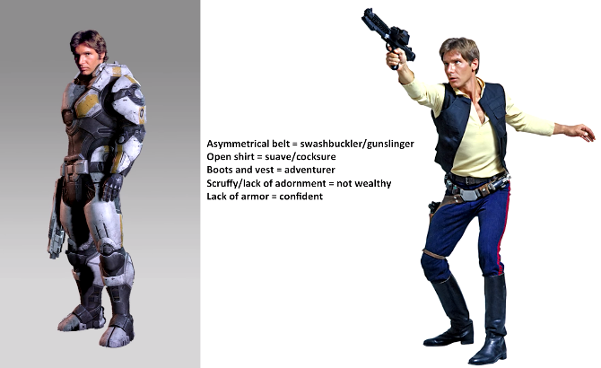
Figure 2h: (ACADonline, 2017) Left: Han Solo (Star Wars) Character design visual storytelling. “Made for Games today”, Right: Original detailing components.

2.4. Colour Symbolism
Colour symbolism is the use of colour as a representation of something in art. The association of colour can vary widely between cultures, for the purpose of this research, western culture will be concentrated upon.
Different colours have both positive and negative emotions and traits associated with them (Rohrer, 1994). A few examples of these that will be utilised in this research are:
Reds have positive associations with energy, love and strength, and negative associations with war, aggression and violence.
Blues have positive associations with peace, unity and trust, and a negative association with depression.
Purples have positive associations with nobility, wisdom and spirituality, and negative associations with cruelty, arrogance and mourning.
Greens have positive associations with nature, youth and generosity and negative associations with envy, misfortune and inexperience.

An example of colour symbolism can be seen in Figure 2i (below) which shows three images with two different castles with similar construction, the major differences being colour schemes and composition, but each image sends a differing message. With the left feeling evil and menacing, the centre feeling sullen and foreboding and the right feeling calm and peaceful.

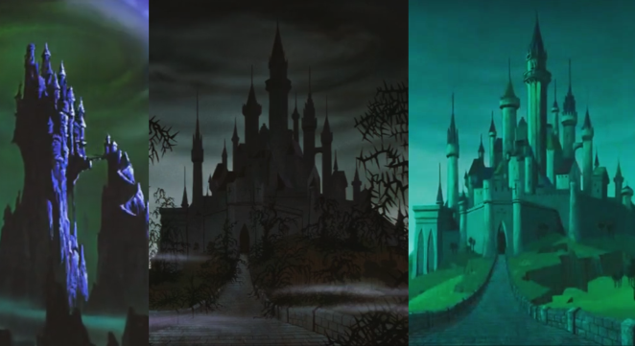
Figure 2i: Maleficent’s castle (Left), Aurora’s Castle – Cursed (Centre) and Aurora’s Castle (Right) (Sleeping Beauty, 1956)

3. Methodology
To test the effectiveness of adding character to an environment, an environment with a theme without a characteristic and a theme with a characteristic will be drawn at the current level of skill and understanding. For example, a Medieval Castle throne room and a Morose Medieval throne room (see Figures 4a and 4b).
After researching a variety of relevant media and texts, the same environment briefs will be attempted again to visualise any identified methods for stylisation and characterisation. This will likely take into account classic methods from character design and applying them to environmental aspects.
Afterwards, the brief and character trait will be changed and re-attempted in an attempt to identify any methods, features or elements that can be used to communicate said character traits or if the characterisation depends purely on artistic style.
In addition to the pieces created before research is undertaken, two pieces with the same brief as the originals will be created after research is undertaken, and another two using differing briefs will be created in order to view the effects on a different kind of environment, the design briefs are as follows:
Medieval Castle Throne Room: Before and After (No Associated Character Trait)
Morose Medieval Castle Throne Room: Before and After
Peaceful Canyon
Aggressive Canyon
If the pieces have correctly illustrated its intended theme, the piece and feedback will then be analysed to attempt to identify any particular elements of the image that help to elicit the character and which, if any, is more effective. These could include:
- The physical characteristics of the components.
- The composition and perspective of the art piece.
- The colour scheme of the overall piece including saturation and contrast.
- The lighting of the piece.
- The texture of the image components E.g. Cracked stone & Smooth stone.
- Social Stereotyping such as colour association.
- Associated imagery, such as horns for evil or white feathers for good etc.
The research and results will be recorded and evaluated through the use of reflective writing following the reflective cycle set out by Graham Gibbs (1988) with mind to the use of semiotics to confirm if the pieces have met their intended character and try to establish what elements of each image give meaning to them.

4. Project-Specific Research
The following figures (4a and 4b) show an example of characterised environments at the level of understanding before any research into the subject was undertaken. Both images were produced by the same design brief and contain similar elements; however Figure 8 has been characterised to elicit a character trait, in this case being morose.

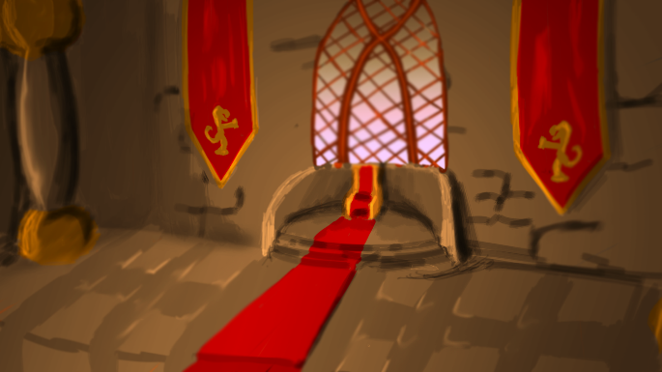
Figure 4a: Medieval Castle Throne Room (Before Research).

Figure 4a was created with no character trait in mind, however due to the warm colour scheme and the basic imagery of lions; it could potentially be perceived that it has a welcoming or strong characteristic. The colour scheme was chosen as it was the first imagery that came to mind when thinking of throne rooms and royalty.

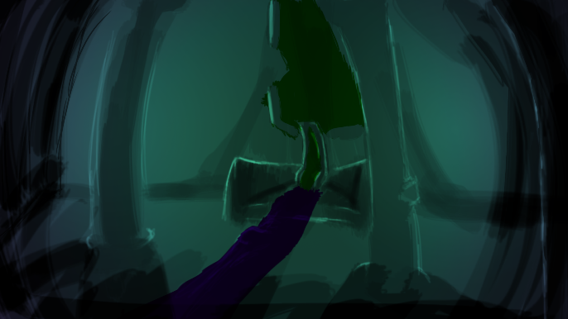
Figure 4b: Morose Medieval Castle Throne Room (Before Research).

In this example, it is believed that Figure 4b can be perceived as morose due to the colours used and the darkness of the piece; however the characterisations of the assets themselves could be observed as looming, overbearing or menacing. They were drawn with the image of a person slumping forward in mind, which would display moroseness in a character; it is perceived however that it in fact looks imposing with the appearance of the elements leaning in.
This research is being undertaken in order to establish aspects that can be used to impose character into environmental scenes while minimising any confusion such as what can be seen above and to create examples of these scenes with differing character aspects and to establish if these aspects have a hierarchy of effectiveness. E.g. Colour association is more effective than shape association.
After the literature and media research was undertaken, the following images (Figures 4c to 4f) were created following the short design briefs outlined in section 3.
Figure 4c (below) shows the post-research iteration of the castle throne room with no intended character trait. It was drawn with no shape association in mind and the colours were drawn from images of Buckingham palace’s throne room.

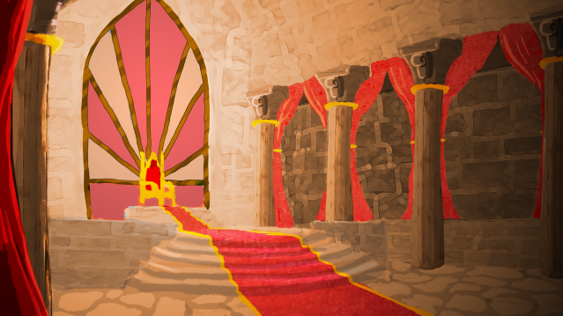
Figure 4c: Castle Throne Room with no intended characteristic (After Research).

Figure 4d (below) shows the post-research iteration of the castle throne room intended to display the morose quality. The teardrop shape was used throughout to attempt to instil the morose trait into the piece, this was done as May (2015) states that the teardrop was used in the creation of the Sadness character in Pixar’s Inside Out and it was though this could be replicated in an environment. The colours were chosen from a search for art associated with moroseness and there appeared to be a trend for purple, fuchsia, pale greens and blues. In addition to these, the image was drawn with broken or worn assets in order to evoke a ruinous atmosphere which could help link to the moroseness of the piece.

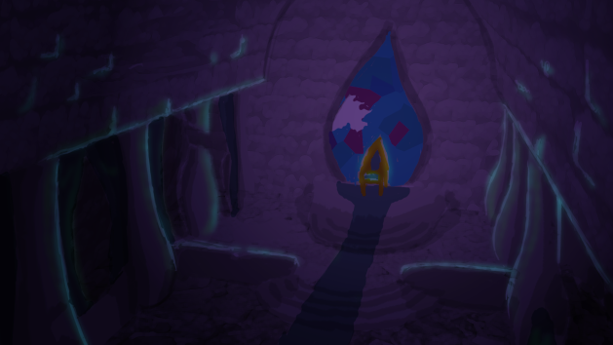
Figure 4d: Morose Castle Throne Room (After Research).
Figure 4e (below) shows the representation of a natural canyon with the peaceful character trait. Smooth curves and edges were used throughout the piece in order to evoke a sense of calmness and safety as a substitution for circular shapes as these may seem out of place in a non-manufactured environment. The colours and imagery of white clouds and rolling vibrant-green fields were chosen as it conveys a sense of nature and peace.

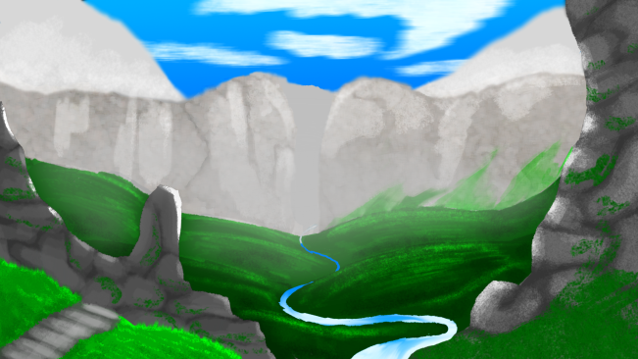
Figure 4e: Peaceful Canyon.

Figure 4f (below) shows the representation of a canyon applied with the Aggressive character trait. Sharp edges and triangular shapes were used throughout the piece to convey a sense of anger, evil and aggression in the piece, this effect can be seen in figure 2f where Caldwell (2005) uses triangles to evoke malevolence. The imagery in the piece, e.g. volcano and lava, was chosen in association with evil and aggression and in order to use reds sensibly in the colour scheme, which is negatively associated with aggression, danger and violence.

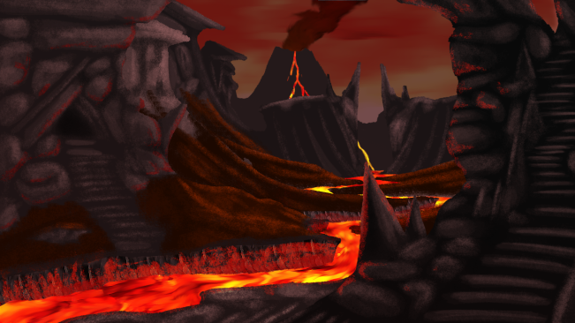
Figure 4f: Aggressive Canyon.

5. Results & Evaluation
5.1. Castle Throne Room Reflection
(See Figure 4c or Appendix 1)

The castle throne room with no intended trait was created after research into the various aspects that could influence characteristic of a piece was undertaken. A purely architectural viewpoint was used in order to avoid purposeful stylisation or characterisation. Due to this, images of Buckingham palace’s throne room and reconstructions of medieval throne rooms were viewed in order to get an Idea of layout and colour schemes. It was found that red, gold and generally warm colours were prevalent in these throne rooms and as such were selected for the image created.
It is felt that the use of vibrant colours did not work very well in keeping the piece void of character as it contributed greatly to unintentionally instilling a character into the piece.
It is believed that this image gives a welcoming, grand or powerful character rather than none at all due to its colour scheme and perspective. The colour scheme is purely warm, light colours which can be associated with strength and optimism while the perspective of the piece has all the lines of the image drawing attention to the throne, signifying power.
This result may be influenced by the subject matter’s association itself, with throne rooms by definition being a symbol of power.
The piece could have been approached with a less painterly art direction; the use of solid outlines in the artwork could have alleviated some of the difficult in the piece’s creation and allowed for a more architectural appearance to the final creation. This was not done as it was believed that a painterly approach would beget a more realistic result, which would in turn be less likely to contain unintended stylisation or character.
Additionally, the piece could have been created with less saturated colours which may have alleviated some of the typical associations that contributed to a character presenting itself. This was not done as it was known that other pieces would be using vibrant colours and it was believed that keeping all pieces as similar as possible would allow for more reliable and comparable results.
If this piece were to be re-attempted, it may be beneficial to attempt using a less saturated colour palette in order to achieve a less stylised result. Alternatively, it may be beneficial to attempt to achieve a character trait that is intrinsic with the subject matter, such as royalty, or power as opposed to attempting a creation with no character at all.

5.2. Morose Castle Throne Room Reflection
(See Figure 4d or Appendix 2)

To create the morose castle throne room piece, morose art was viewed in order to assess what could be implemented into the piece in order to instil the character trait. There was a tendency in the images with the most impact for the use of the colours; purple, fuchsia, pale greens and blues. The Adobe Kuler tool was then used to extract a colour scheme from a mood board of these images which was then used in the piece. Through the literature review, it was discovered that Pixar used a teardrop shape in the creation of Sadness’ character, which was believed to be a good solution for including the emotion into the piece; therefore it was introduced into the shape of the pillars, window and throne. Broken objects and cracked textures were introduced into the piece to elicit a sense of ruination and an aspect of visual storytelling.
It was felt that the use of the teardrop in the assets may have been a mistake, as they could possibly help perceive the morose character, but it is more likely that they will be perceived as objects hailing from Islamic architecture as they would fit well into the architecture type.
It is felt that the gloominess of the piece and the colours chosen work well in conveying the intended character of the artwork, however a different combination of these colours and lower saturation may produce a better effect. The visual storytelling aspects of the piece, being the broken objects and textures worked well in the construction of the image, and effectively told a story that the castle had been ransacked, however the heavy gloominess and dark shades of the piece mask most of this and remove its effectiveness.
It is believed that the intended character trait of Moroseness has effectively been communicated in the piece; the colours, gloominess and ruin association bring through a good sense of sadness and despair. This suggests that in these manufactured structure environments, shape, at least in the basic sense, does not hold much sway on emotional connection and would be low on a hierarchy of effectiveness.
Much as with the other castle throne room piece, this image could have been approached in a less painterly art direction, the use of flat colours and outlines could have made the experience easier and may have returned different results for the use of shapes as it would have been a more stylised and cartooned approach which may have given them more emphasis. This was not done as it is believed that it would redact from the gloominess of the piece and give a more light-hearted feel.
If this piece were to be re-iterated, it is believed it could be beneficial to increase the ratio of pale greens and blues in the piece to the majority as opposed to the deep purple. This could maintain a level of gloom and moroseness, while allowing more of the visual storytelling elements show through.

5.3. Peaceful Canyon Reflection
(See Figure 4e or Appendix 3)

It was planned for the creation of the peaceful canyon piece to use circular objects in order to give the piece a calmer and friendly association, however as circles would appear manufactured and out of place in the natural setting, soft curves and circular edges were used in place. Vibrant greens, light blue sky and pale greys were chosen as the colour scheme for their typical positive associations with nature, peace and calm respectively, according to Ken Rohrer (1994).
It was felt that the use of smooth curves as a compromise for circular shape was a successful alternation as it allowed the peace of the piece to show without any elements of the image looking out of place.
It is felt that the painterly style of the image works very well with the characteristic, but perhaps it would benefit from a higher level of detail or some visual storytelling elements should be introduced to generate visual interest while maintaining the characteristic.
It is believed that the peaceful characteristic has successfully been introduced through the piece; the shape association, colour scheme and brightness of the piece accomplish a good harmony to produce the peaceful trait. This suggests that in naturalistic settings, shape is more effective that it would be in constructed settings.
This piece could have generated more visual interest if a more dynamic composition or perspective was chosen, as the image as it stands is quite flat despite the use of depth in the image. This was not done at the point of creation due to the higher difficulty a more dynamic image would have taken to produce; it was felt that keeping the images simple would prove to be a better measure of the elements this research is concentrating on.
If this image were to be attempted again, it is felt that introducing some visual storytelling elements into the piece to generate more visual interest in the peace could benefit the image. An example of this could be a flock of birds in flight or perhaps some trees with falling leaves. However this could signify disturbance and reduce the peaceful aspect of the piece.

5.4. Aggressive Canyon Reflection
(See Figure 4f or Appendix 4)

In the creation of the aggressive canyon piece, triangular shapes and hard edges were used throughout. For the colour scheme, browns were chosen for their dirty, ruddy colour and the fact that they couple well with reds, which were selected for their association with war, violence and aggression. Additionally dark greys were used to darken the piece’s gestalt and to attempt to evoke some of the emotions associated with black, being anger and death, without directly using the colour as solid black looks fairly unnatural. Additionally, the imagery of lava and volcanoes was included in the piece to add an extra association with danger, malevolence and evil.
It was felt that the painterly style worked particularly well in this piece, making the environment feel natural and having a nice effect on the lava and sky.
It is felt that the rocks used in the image are too smooth and circular, which may be detracting from the aggressive nature of the piece, however, due to the composition of the piece, the eye is drawn away from these and towards the more edged shapes. Unfortunately this image feels rather generic for what it is, feeling like scenery from JRR Tolkien’s (1968) Lord of the Rings in Mordor.
It is believed that the aggressive character trait has been well established in this piece. The use of hard edges and triangles coupled with the negative association of the colours and imagery drives the trait well. In conjunction with the peaceful canyon piece, this also shows that naturalistic environments work very well with shape association. This is perhaps due to the organic nature of them, which couples in character design, and allows shapes to feel aggressive or peaceful etc. as opposed to feeling like they were just made that way with no reason in mind.
This piece could feel more coherent if the rocks in the close canyons were created with sharper shapes in mind, which could possibly accomplish a more aggressive piece. This was not done at the time because the imagery and composition were concentrated upon in order to achieve the character it currently has, and therefore the texture shape of the objects went unnoticed.
If this piece were to be iterated upon, it may be beneficial to attempt a different set of colour or imagery associations in order for the piece to stand apart from the many like it as well as sharpening the rocks of the piece to have a more aggressive, coherent appearance.

6. Conclusion
The final art pieces suggest that the hypothesis, that there are identifiable elements that can be used in art to communicate character, personality and emotion, and that they fall into a hierarchy of effectiveness, is true.
However, the effectiveness hierarchy may vary depending on the pieces subject matter. The experiment suggested that shape is more effective in natural settings as opposed to manufactured structures; this is possibly due to the possibility of any shape being used for purpose in manufactured environment.
This research has not accomplished all of its goals as there has been no discovery of elements or methods that can completely avoid any confusion between intended character traits, however methods to alleviate this have been touched upon. It is believed that this is largely due to the nature of perception and association. What one person perceives as foreboding and malevolent, another may perceive as warm and welcoming. In addition to this, visual storytelling was only touched upon briefly and would benefit from a more in depth review.
Further research with focus groups is required to definitively prove or disprove the hypothesis as the results of this paper were reflective and depend entirely off of a single point of view. Once this research is undertaken, it may be possible for learning documents to be created to share the knowledge.

7. References
Books
Brooks, J., 2016. Draw with Jazza – Creating Characters: Fun and Easy Guide to Drawing Cartoons and Comics. Online: IMPACT Books.

Caldwell, B., 2005. Fantasy! Cartooning. New York: Sterling.

Gibbs, G., 1988. Learning by Doing: A Guide to Teaching and Learning Methods. Manila: FEU

Tolkien, J., 1968, The Lord of the Rings. London: George Allen & Unwin Ltd.

Rogers, S., 2014. Level Up! The Guide to Great Video Game Design. 2nd Ed. Chichester: John Wiley & Sons, Ltd.

Online
May, S., 2015. 5 Surprising Facts about Inside Out’s Character Design. Creative Bloq: Art and Design Inspiration [blog] 05 November. Available at: < http://www.creativebloq.com/animation/inside-out-character-design-111517644> [Accessed 17 November 2017].

Rohrer, K., 1994. Color Symbolism and Culture. [online] Incredible Art Department. Available at: <https://www.incredibleart.org/lessons/middle/color2.htm> [Accessed 24 November 2017]

Solarski, C., 2013. The Aesthetics of Game Art and Game Design. [online] Gamasutra. Available at: <https://www.gamasutra.com/view/feature/185676/the_aesthetics_of_game_art_and_.ph. p> [Accessed 23 October 2017].

Videos
ACADonline, 2017. Matt Rhodes Artist Talk: The World of Concept Art (November 2016). [video online] Available at: <https://www.youtube.com/watch?v=m2BRl1hWnnY&t=1944s&list=WL&index=6> [Accessed 24 October 2017].

Angry Birds, 2016. [Film] Directed by Clay Kaytis and Fergal Reilly. Canada: Sony Pictures Imageworks, Inc.

Sleeping Beauty, 1959. [Film] Directed by Clyde Geronimi. USA: Walt Disney

Video Games
Ubisoft 2013. Rayman Legends, [video game], Xbox 360, Ubisoft Montpellier
8. Bibliography
Books
Thomas, F., Johnston, O., The Illusion of Life: Disney Animation. New York: Disney Editions.

Websites
Bilyana., 2016. How to Convey Character’s Personality Through Shape, Variance and Size. [blog] 05 December. Available at: <https://graphicmama.com/blog/conveying-characters-personality/> [Accessed 29 October 2017].

9. Appendices
9.1. Appendix 1 - Castle Throne Room (Large)
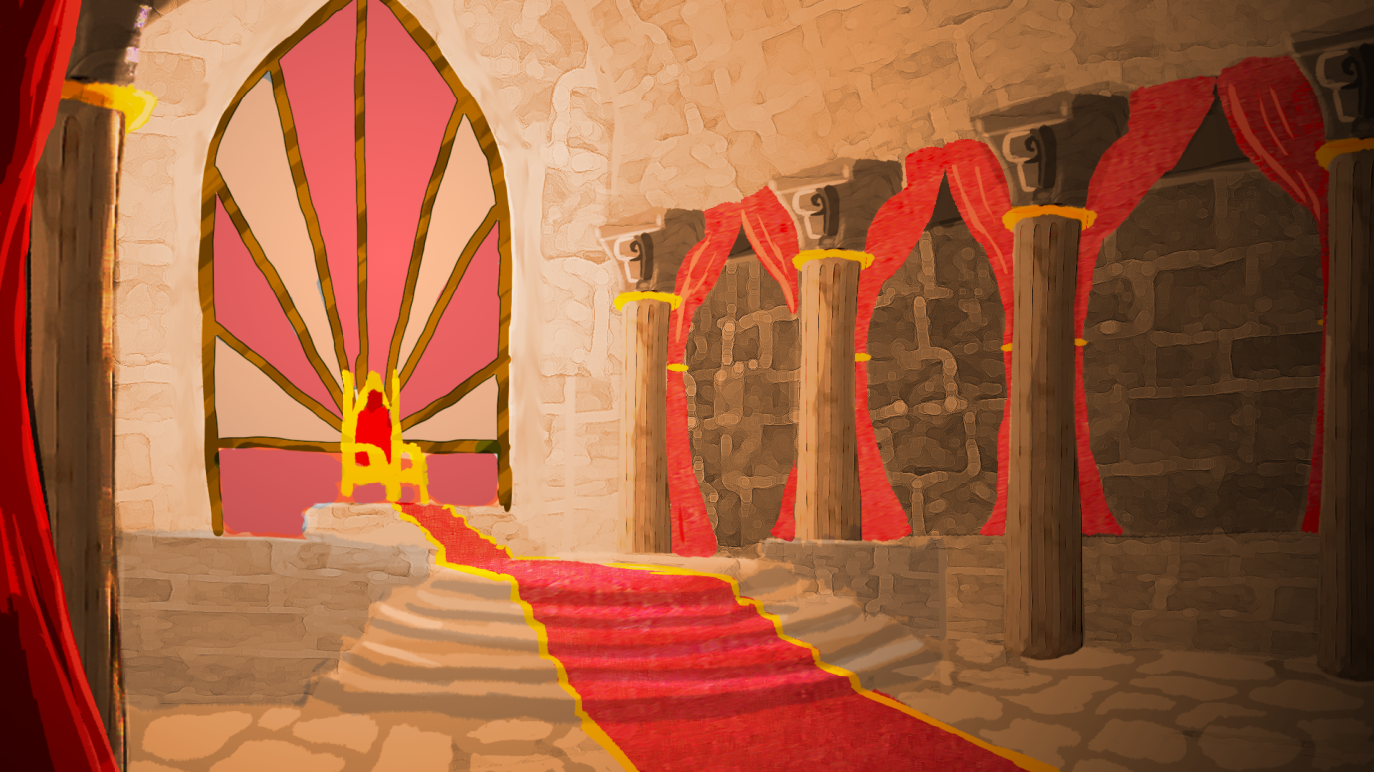

9.2. Appendix 2 - Morose Castle Throne Room (Large)
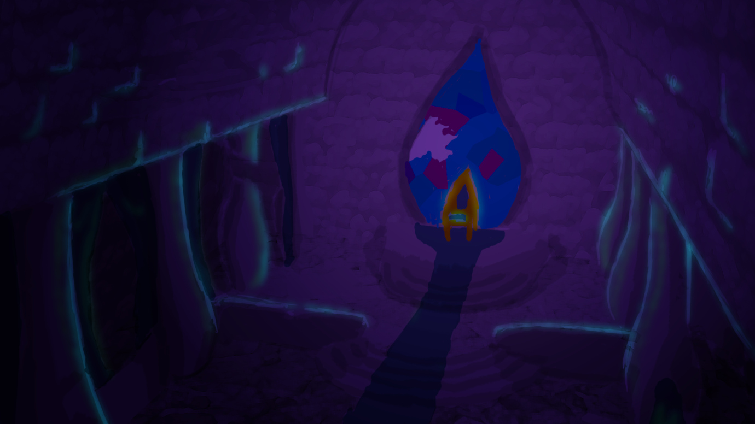

9.3. Appendix 3 - Peaceful Canyon (Large)
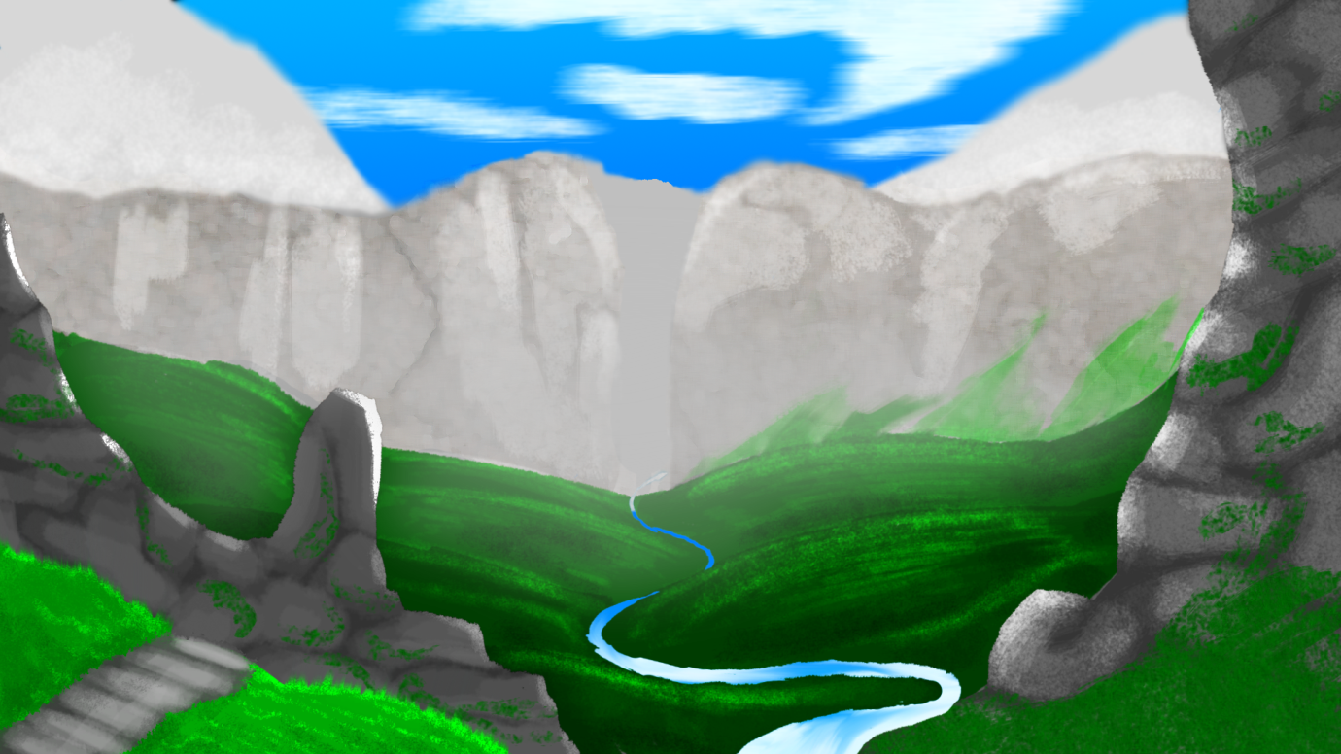

9.4. Appendix 4 - Aggressive Canyon (Large)


