  - 

Marine weather monitor / logger

  - University of Wales Trinity Saint David
School of applied computing
  - Student: Nicholas Jones, P149676
  - Module: Electronic System Design, (ACDA6002)
  - Lecturer: Gary Jones
  - Date: 25th January 2020

Abstract
A microcontroller-based design of a marine weather data logger is required, with various environmental and sea state conditions to be logged over a 7-day period, research into various marine weather / data loggers has been conducted, these include self-contained weather station, an over the air received weather data and a data logger with various sensor inputs.
Sensor selection with comparison tables has be provided with the chosen sensor being highlighted, a microcontroller was carefully selected by inputting relevant specification data into Microchips selection website. Utilising Excel and consulting datasheets voltages and currents were inputted next to the relevant components this then aided with battery selection, power switch rating and fuse rating, a table suggesting on best external connectors to use has been produced keeping in mind the harsh environment the system will be subjected too.
A circuit block diagram was created, and datasheets consulted to aid with producing a schematic in Proteus VSM, Easy-PC was used firstly to replicate the schematic then to translate to a PCB before creating the necessary Gerber files for manufacturing.
The chosen polycarbonate enclosure for the system is shown and suggested layout is included with mention of customisation needed.
A flowchart for software and structural system diagram has been created as well as calculation for non-volatile storage and a bill of materials, a list of suggested improvements and possible issues with original design finalises this report.
Contents
Abstract i
1 Introduction 1
1.1 Requirements 1
2 Survey of marine weather monitoring stations 1
3 Sensor selection 2
3.1 Wind speed and direction 2
3.2 GPS 3
3.3 Sunlight brightness 4
3.4 Temperature & Humidity 5
3.5 Wave height 6
4 Microcontroller selection 7
5 Connectors & battery 8
5.1 Battery & power switch 8
5.2 USB 9
5.3 Sensor connections 10
6 Circuit design 10
6.1 Schematic 11
7 PCB design, Easy-PC 16
8 Enclosure 18
9 Software flowchart 20
10 Structure diagram 22
11 Size of data storage 23
12 Bill of materials (BOM) 24
13 Suggested improvements 25
14 References 26
15 Appendices 28
15.1 Proteus full circuit schematic 28
15.2 Easy-PC, full schematic 28
16 BOM and other info from Excel 29

Introduction
A marine weather data-logger is required, data must be logged for 7-days, the device must be portable for use on any vessel.

Requirements
Required data:
- Air temperature & humidity.
- Wind speed & direction.
- Wave height.
- Sunlight brightness.
- GPS.
The system must be battery powered, have a PC connection via USB to collect data stored on non-volatile memory. No display, but an LED flashing for 1 second in every 10 seconds to show operation.

Survey of marine weather monitoring stations
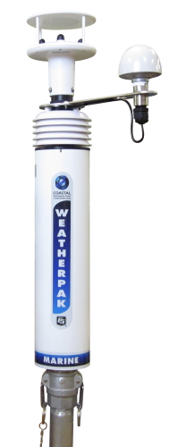 | 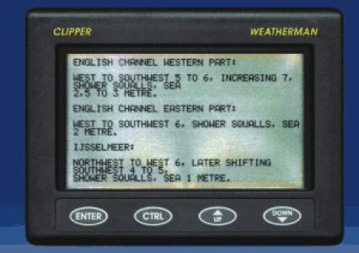 | 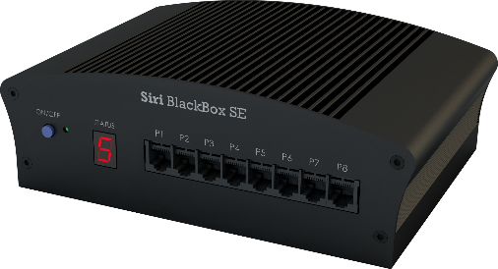
Weatherpak Marine [1] | NASA clipper weatherman [2] | Siri BlackBox [3]
Minimised exposed cables / connectors | 16 lines x 40 characters screen | Unix based data logger
GPS: | Back lit display | Multiple inputs from different protocols
Compass: Resolution 0.1˚ | 12 v supply 100 mA | Connect up to 8 sensors
Wind speed: Range 0 to 60 m/s, resolution 0.01 m/s | Auto timer back light | Support NMEA equipment
Wind direction: Range 0 to 360˚, resolution 1˚ | Non-volatile message and program memory | Ethernet or RS485 output
Air temperature: Range -35˚ to +70˚C | Receives forecast via RTTY | 25 Hz output rate
Relative humidity: Range 0 to 100% |  | Inputs from WaveRadars, GPS, Anemometers and other environmental sensors
Barometric pressure: Range 600 to 1100 mBar |  | Up to 2 TB data storage
Wireless touch screen display (optional). |  | 1 GB DDR3 ram
Anti-corrosive aluminium, coated with thermoplastic resin. |  | 12 Vdc max 4.5 A
Quick release mast mount.
Price £4000 - £7500 | £249.95

Sensor selection

Wind speed and direction
Table 1 wind speed and direction comparison.
Table 1 Wind speed and direction sensors
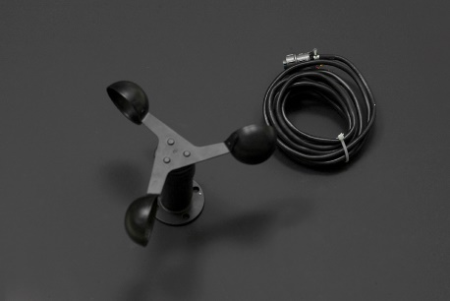 | 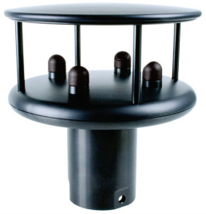 | 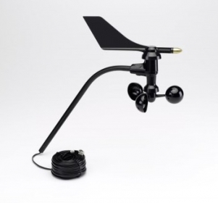
SEN0170 Anemometer [4] | Windsonic M [5] | Anemometer for micro logger weather station [6]
Wind speed | Wind speed and direction | Wind speed and direction
Supply: 12 – 24 VDC | Supply 5 – 30 VDC | Supply: Non specified
Output signal: 0 – 5 V | Outputs: Digital RS232, RS 422, RS485, NMEA 0183, or analog 0 – 5 V | Outputs: Contact closure for wind speed, 20 KΩ potentiometer for direction.
Power consumption: ≤ 0.3 W | Current: 5.5mA @ 12 V | Current: dependant on supply voltage.
Measurement range: 0 – 30 m/s | Wind speed: 0 – 60 m/s | Wind speed: 1 – 200 mph
Resolution: 0.1 m/s | Wind direction: 0 - 359˚ | Wind direction: 16 points (22.5˚) on compass rose
Connection: 3 wires. | Multiple connections available. | Connection: 4 wires.
Moving parts. | Solid state design. | Rugged components used.
£44.27 | £1,279.00 | £190

The highlighted anemometer in Table 1 is chosen, its designed for use in harsh environments, simple to interface, 1 wire for wind speed and 1 wire for wind direction. Figure 1 shows the internal schematic.
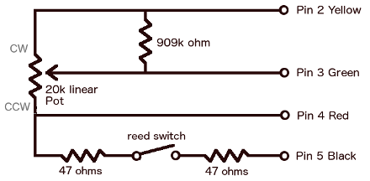
Figure 1 Davis wind speed / direction schematic [7]
Figure 1 pin 5 is for the wind speed and according to cactus.io [7] it has current limiting resistors built in, pin 3 is the voltage output for wind direction where half way is 180˚, pin 2 is supply voltage, pin 4 is ground, the 909 KΩ is there in case the wiper fails.

GPS
GPS comparison found in Table 2.
Table 2 GPS sensors
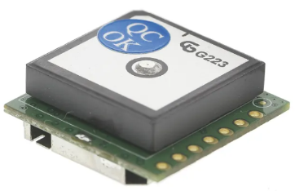 | 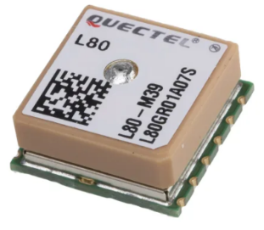 | 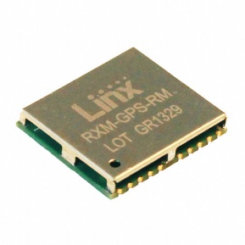
GPS-622F receiver [8] | L80-M39 GPS receiver [9] | RXM-GPS-RM-B [10]
Receiver type: 65 channel GPS L1 frequency. | GPS L1 1575.42 MHz, 65 channels, 22 simultaneous tracking channels. | Frequency 1575.42 MHz
Open sky start: Hot 1 sec, cold 29 sec. | Cold start: 15 secs, hot start 5 sec. | Hot start <1 sec, cold start <32 sec.
Accuracy: 2.5m | Accuracy: <2.5m | Accuracy 2.5m
Update rate 10 Hz. | Update rate: up to 10 Hz. | Update rate: up to 10 Hz
Power supply 3.3 to 5.5 V | Power supply: 3.3 V typical. | Power supply 3 to 4.3 V
Serial UART. | Serial UART. | Serial UART
NMEA-0183 protocol. | NMEA output. | NMEA 0183 version 3.01 protocol
£40.68 | £14.75 | £21.28

Each of the GPS modules in Table 2 have similar specification, price has determined the choice for this.

Sunlight brightness
Table 3 sensors for detecting sunlight brightness.
Table 3 Sunlight brightness
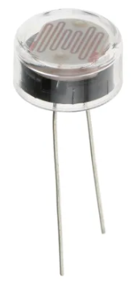 | 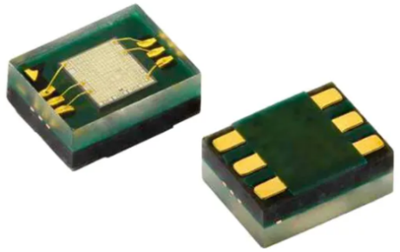 | 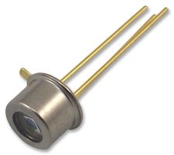
Luna Optoelectronics LDR [11] | VEML6070 Vishay, UV light sensor [12] | Photo diode S5971 [13]
Connection: 2-pin through hole | Connection: Surface mount, 6 pads | Connection: 3-pin through hole
Resistive: Light 5.4 KΩ, dark 1 MΩ | I2C interface | Dark current max: 1 nA
Plastic encapsulated photocell | Small compact package. | High speed response
Operating temperature: -60 to +75˚C | Operating temperature: -40 to +85˚C | Operating temperature: -40 to +100 ˚C
Voltage: Peak 250 V | Operating voltage: 2.7 to 5.5 V | Max reverse voltage: 20 V
550nm peak response | 355nm peak wavelength. | Spectral range: 320nm to 160nm
£2.93 | £2.53 | £1.22

The highlighted component in Table 3 has plastic encapsulated photocell which helps with ruggedness.

Temperature & Humidity
Table 4 shows comparison for temperature and humidity.
Table 4 Temperature & humidity sensor
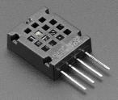 | 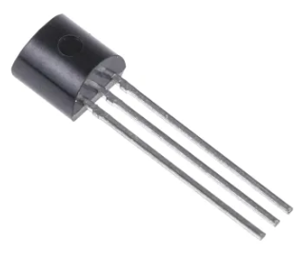 | 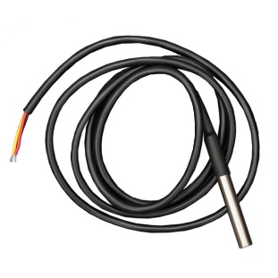
AM2320 Temperature & Humidity sensor [14] | LM35C Temperature sensor [15] | DFR0198 [16]
Connections: 4 pins | Connections: 3 pins | 3 wire connection
Power supply: 3.1 to 5.5 V | Supply: 4 to 30 Vdc | Supply: 3 to 5.5 V
I2C communication | Analog 10 mV / ˚C | Digital 1 wire communication
Relative humidity range: 0 to 100% | Temperature range: -40 to +110 ˚C | Temperature range: -55 to +125 ˚C
Temperature range: -40 to 80˚C | Accuracy: ±0.75 ˚C | 9 to 12-bit selectable resolution
Power consumption: Average 350 µA |  | Multiple sensors can share same bus.
£3.06 | £5.70 | £5.31

The AM2320 in Table 4 works on a supply as low as 3.1 V, houses both temperature and relative humidity, uses I2C communication in either 2 wire or 1 wire configuration, it’s not water proof so needs to be housed in a vented compartment.

Wave height
Wave height sensor seen in Table 5.
Table 5 Wave height sensor
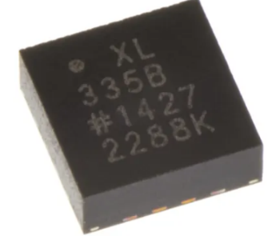 | 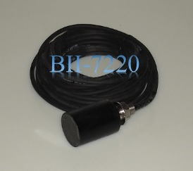 | 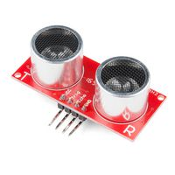
Accelerometer ADXL 335 [17] | BII-7220 series wave height sensor [18] | HC-SR04 ultrasonic sensor [19]
3-axis | Measures dynamic pressure. | Ultrasonic radar
Surface mount, 16 pads | Connection: 4-pin. | 4 pin connections
Supply: 1.8 to 3.6 V | Supply: 4.5 to 30 V | Supply: 5 V
Sensitivity 330 mV/g | Preamp included | Detection range: 2 cm to 4 m
Operating temperature: -40 to +85˚C | Waterproof connectors | Non-weatherproof
Output: Analog | Output: Vs - 1 | Output: Digital pulse high duration
£5.22 | No reply from supplier | £6.53

Table 5 the chosen sensor is designed to be used in the water, it can be supplied in various configurations, e.g. with our without pre-amp, produces an analog signal a supply as low as 4.5 V, the suppliers technical data advices to use a minimum 9 Vdc non switching power supply.

Microcontroller selection
Table 6 has been produced to calculate MCU clock speed.
Table 6 MCU clock speed
Component | Clock cycles | Sample rate
Wind speed | 4 | 100 ms
Wind direction | 4 | 100 ms
GPS | 4 | 300 sec
Sunlight brightness | 4 | 1 sec
Air temp / humidity | 4 | 10 sec
Wave height sensor | 4 | 250 ms
Total clk cycles | 24
Time period | 0.1 | Sec
F = 1/T = 24 / 0.1 | 240 | Hz
Minimum clock speed | 0.0024 | MHz

The measured data is sampled relatively slow hence why clock speed is low, 240 Hz is not feasible, 1 MHz would be adequate, this keeps power consumption down as well.
Table 7 has been drawn up to assist with pin count and module selection for the MCU.
Table 7 MCU pin count
Component | Digital | Analog | Modules
Wind speed | 1 |  | EXT Interrupt
Wind direction |  | 1 | ADC 10 bit
GPS | 3 |  | RS232 + reset pin
Sunlight brightness |  | 1 | ADC 10 bit
Temperature & Humidity | 2 |  | I2C
Wave height sensor |  | 1 | ADC 10 bit
LED Tell | 1 |  | Output
SD card | 3 |  | SPI
USB | 3 |  | USB: D+, D-, VCC
Total pins
Analog | 3
Digital | 13
Total | 16 | .+ pwr
Peripherals / modules
ADC | 1
USB | 1
SPI | 1
RS232 | 1
I2C | 1
Program memory | 12 | KB
RAM | 256 | bytes
CPU | 1 | MHz

In Table 7 minimum I/O pins are 20 plus power, program memory should be small, ram is high to ensure enough calculations can be stored before passing data to storage.
Figure 2 shows the MCU narrowed down on Microchip selection website.
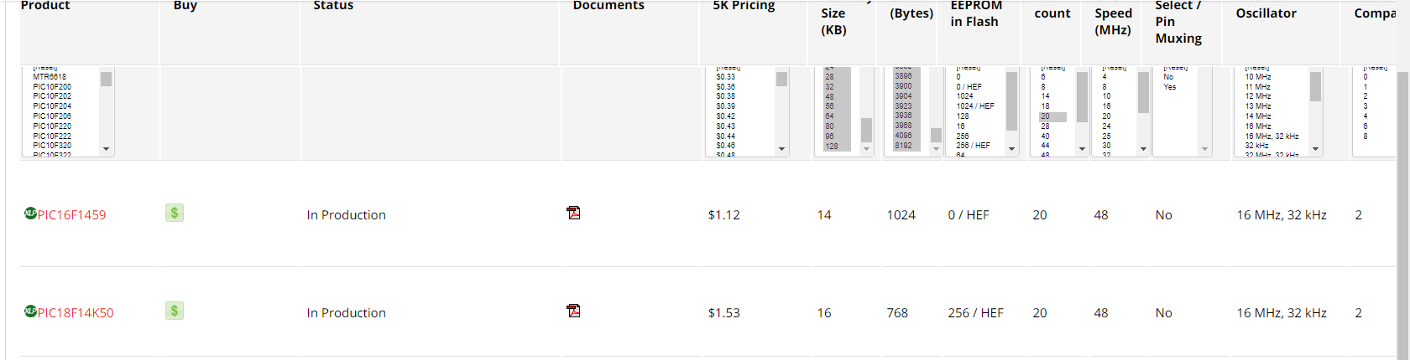
Figure 2 Microchip selection website.
Looking at Figure 2 it shows 2 MCU’s have been narrowed down, initially there was 13 this was further narrowed by lowering pin count to 20. Based on price and consulting the datasheet the PIC16F1459 has been chosen.

Connectors & battery

Battery & power switch
The calculations for power consumption over 7 days is just under 13 Amps. Figure 3 shows the chosen battery.
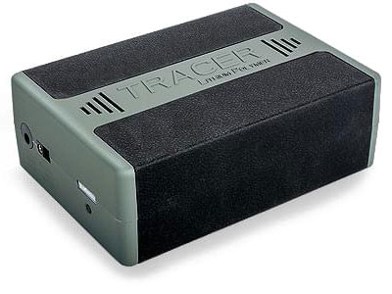
Figure 3 Tracer lithium 12 V 14 Ah battery [20]
In Figure 3 a lithium polymer battery pack with 12 V output and 14 Ah capacity, it’s compact (161 x 115 x 56 mm) and light weight (950g) but expensive @ £214.80 Figure 4 is the weatherproof switch.
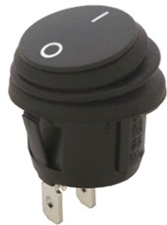
Figure 4 Power switch [21]
The SPST switch in Figure 4 is IP 65 rated and can handle 10 Amps.

USB
Figure 5 shows the USB socket.
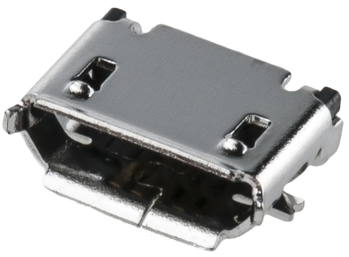
Figure 5 Micro USB receptacle [22]
The micro USB receptacle in Figure 5 is surface mount design.

Sensor connections
Table 8 shows the style of connectors chosen.
Table 8 External sensor connectors
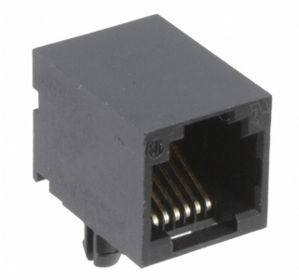 | 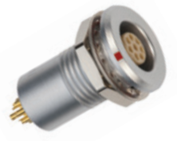 | 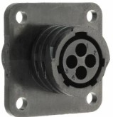
RJ socket [23]. | Lemo socket [24]. | TE connectivity AMP connector [25]
PCB mount. | Panel mount. | Panel mount.
Up to 6 contacts. | 2 to 32 contacts. | 4 pin contact
Plastic. | Metal housed | Plastic secure connection
Non waterproof. | IP 68 rated | Non waterproof
£0.49 | £35 | £2.92

The highlighted socket in Table 8 comes in various pin configurations and their plug to match, these are waterproof, self-latching and have a keyway to ensure correct orientation. A 4 way for the anemometer and 5 way for the wave height sensor has been chosen to ensure correct connection for each sensor.

Circuit design
Circuit block diagram shown in Figure 6.
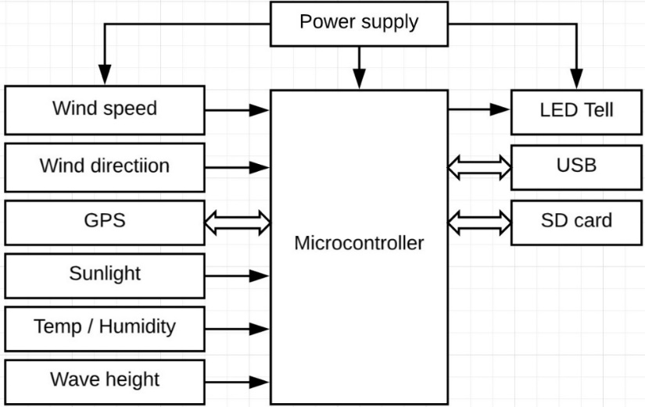
Figure 6 System block diagram
In Figure 6 the sensor inputs are shown on the left and outputs to the right.

Schematic
Schematic breakdown is primarily shown in Proteus, where needed the equivalent Easy-PC circuit will be shown. Full schematic of both can be found in the Appendices.
Figure 7 Microcontroller PIC16F1459
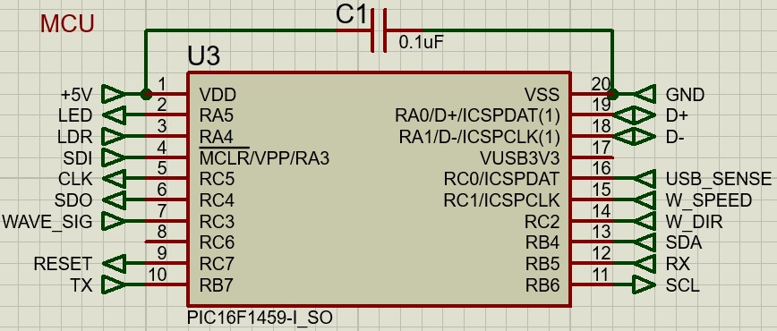
Figure 7 MCU 16F1459
Capacitor (C1) in Figure 7 is to decouple the power supply for the MCU. Figure 8 shows the LED tell.
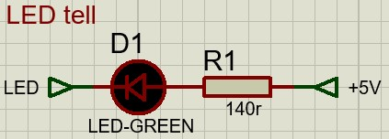
Figure 8 LED Tell
Figure 8 the 140 Ω (R1) limits the current to 20 mA. Figure 9 is the LDR.
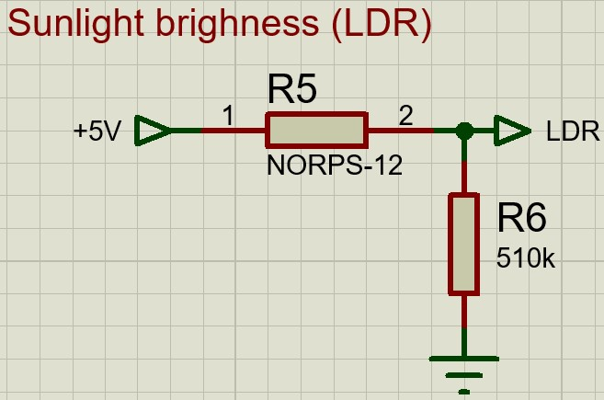
Figure 9 Sunlight brightness (LDR)
In Figure 9 the LDR (R5) and R6 creates a potential divider. Figure 10 is the Easy-PC equivalent.
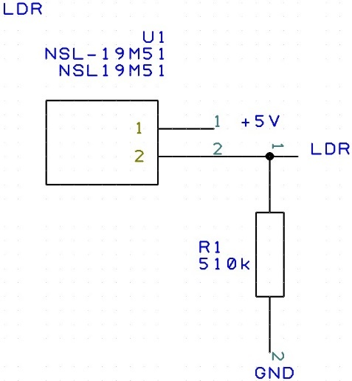
Figure 10 LDR circuit in Easy-PC
In Figure 10 the symbol for the LDR produces through hole connections for the PCB. Figure 11 shows the SD car socket.
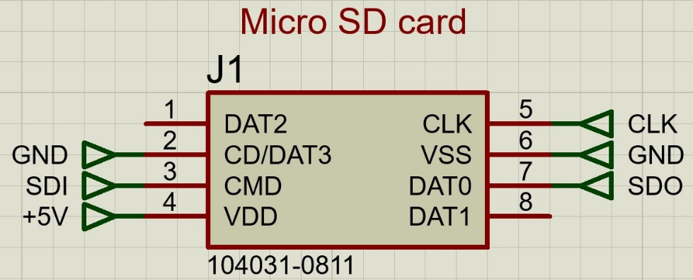
Figure 11 Micro SD card socket
SD card socket in Figure 11 is surface mount. Wave height sensor is seen in Figure 12.
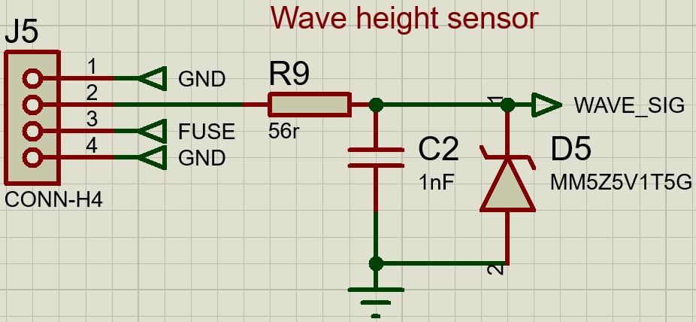
Figure 12 Wave height sensor
The wave height sensor circuit in Figure 12 includes a voltage clamp with R9 used to limit current, C2 coupled with R9 creates a low pass filter and D5 clamps the voltage to 5.1 V. GPS module and digital logic switch in Figure 13.
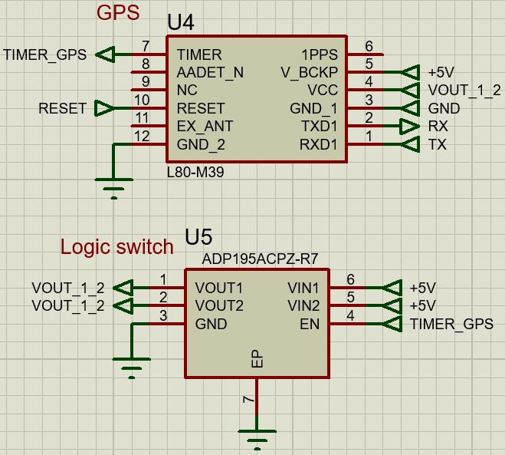
Figure 13 GPS & Digital logic switch
In Figure 13 is the GPS module, it uses RS232 protocol to communicate with the MCU, the data sheet shows a reset pin in case of issues with module, the “TIMER_GPS” pin is used to control the digital logic switch (U5) this can be used to switch the GPS of when not in use. Figure 14 is the connection for AM2320 temperature and humidity sensor.
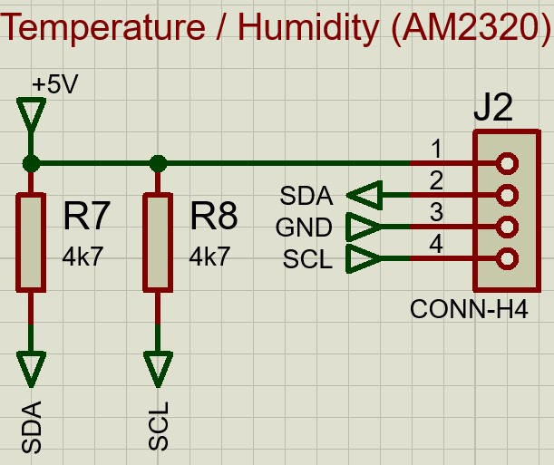
Figure 14 Temperature & Humidity
Figure 14 has 2 pull up resistors for SDA and SCL lines this is because the sensor works on I2C protocol, J2 is a header to allow the sensor to be connected away from the PCB in a separate compartment. The anemometer circuit is seen in Figure 15.
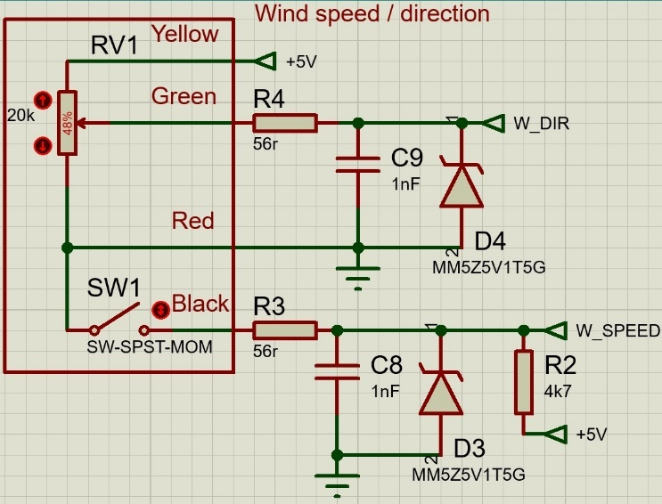
Figure 15 Wind speed & direction
Looking at Figure 15 RV1 and SW1 represent the internal circuit to the “Davis anemometer 6410”, the two signal outputs include voltage clamping the “W_speed” is connected to the MCU external interrupt pin and “W_dir” is connected to an analog pin. Figure 16 is Easy-PC equivalent.
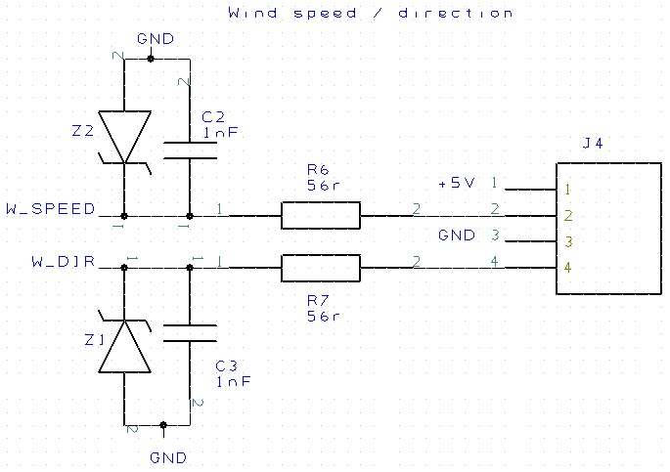
Figure 16 Easy-PC, wind speed & direction
In Figure 16 the wind speed & direction has a 4-pin connection. Figure 17 Shows USB socket circuit.
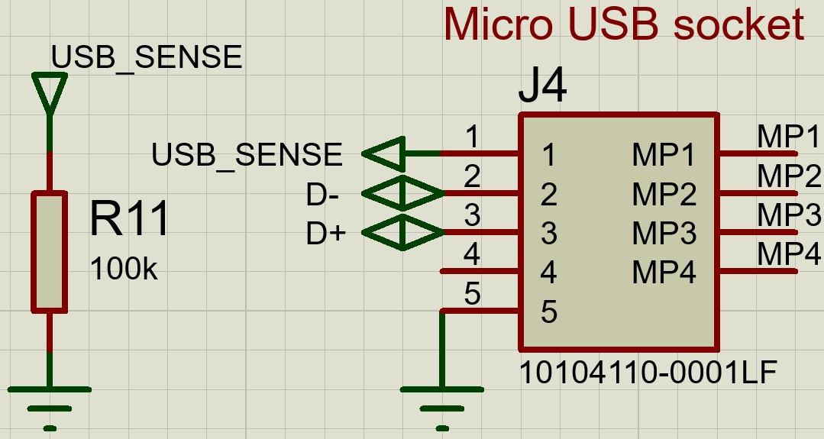
Figure 17 Micro USB socket
The micro USB socket in Figure 17 has a pull-down resistor (R11) on the “usb_sense” pin. Power supply circuit is seen in Figure 18.
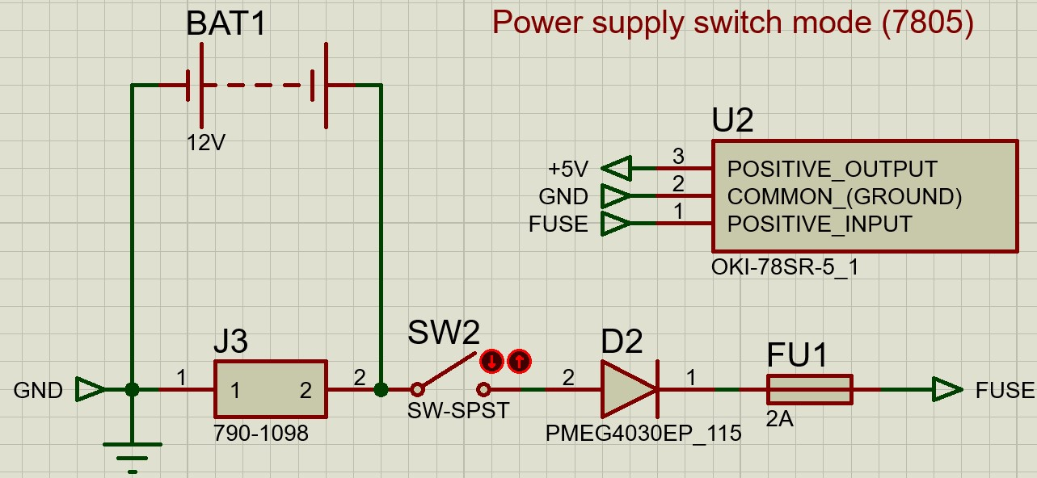
Figure 18 Power supply
For the power supply in Figure 18 a switch mode module is used to regulate the battery voltage to 5 v the module can handle input voltage from 7 to 36 v, a 2 amp fuse is included, D2 is used for reverse protection, SW2 is where a panel mount switch would connect and J3 is the battery connection. Figure 19 is the Easy-PC equivalent.
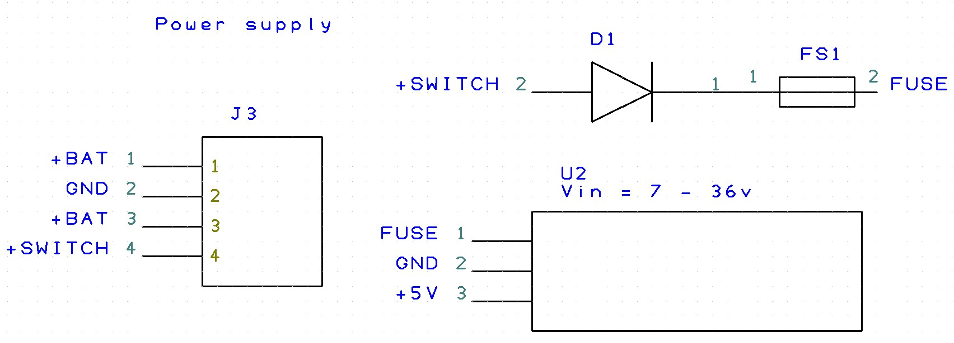
Figure 19 Power supply in Easy-PC
For the power supply the battery connection and the power switch are connected to the 4-way connector (J3) seen in Figure 19.

PCB design, Easy-PC
Figure 20 PCB bottom layer off
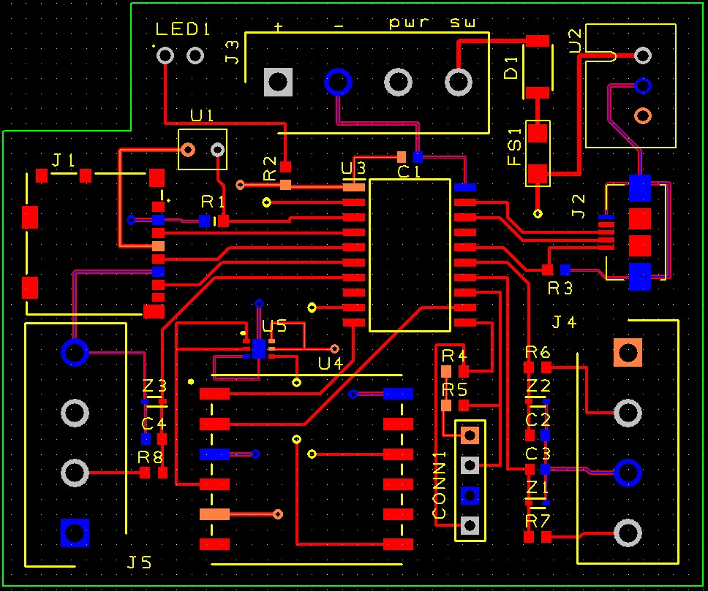
Figure 20 PCB, bottom layer off
In Figure 20 J3 is for battery and power switch, J4 is anemometer, J5 is wave height sensor, conn1 is for temperature & humidity. Figure 21 bottom layer on.
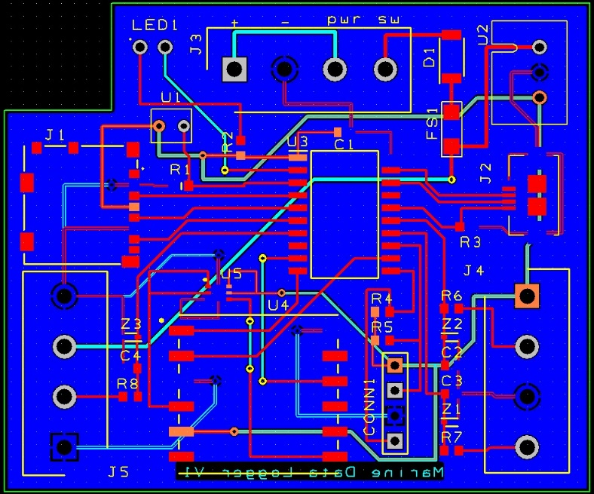
Figure 21 PCB bottom layer on
In Figure 21 copper pour is on bottom layer connected to ground. Figure 22 3D view of top.
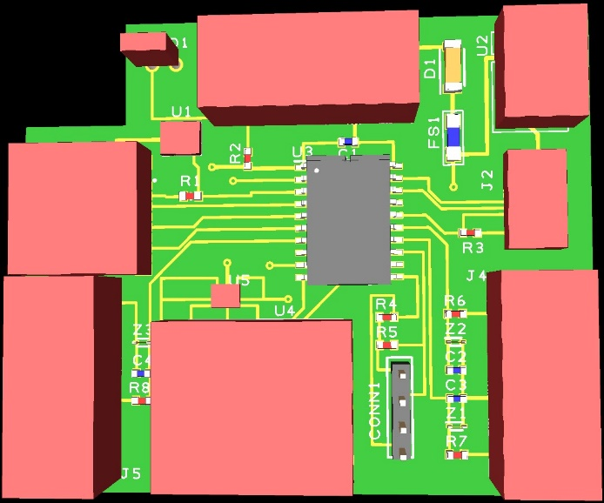
Figure 22 PCB, 3D view front
Figure 22 shows layout in 3D view. Figure 23 3D view of bottom.
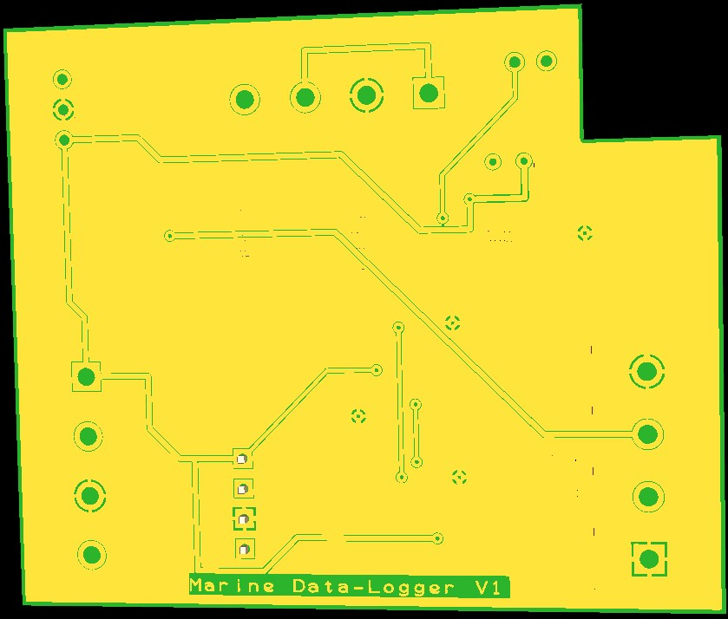
Figure 23 PCB 3D view back
In Figure 23 bottom shows “marine data logger V1”.

Enclosure
- Battery is 161 x 115 x 56 mm
- PCB is approx.: 50 x 60 x 20 mm
- Vented compartment needed for temperature & humidity sensor approx.: 60 x 60 x 30 mm
The polycarbonate enclosure in Figure 24 is chosen.
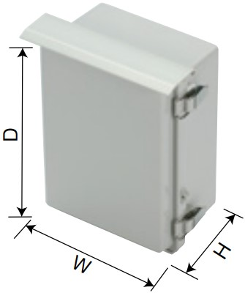
Figure 24 Enclosure
In Figure 24 the enclosure comes in various sizes are IP 65 rated, come with accessories for pole mounting and a datasheet [26] showing application examples is available.
Figure 25 shows the intended layout within the enclosure.
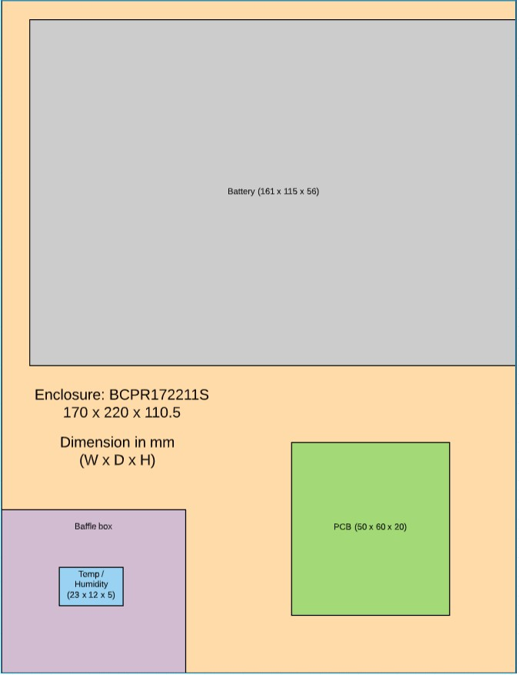
Figure 25 Enclosure layout
The chosen enclosure will need to be customised with the layout seen in Figure 25, bottom left will be a baffle box to house the temperature & humidity sensor, a shelf to support the battery at the top and the PCB to the bottom right with cable connections and power switch at bottom of box

Software flowchart
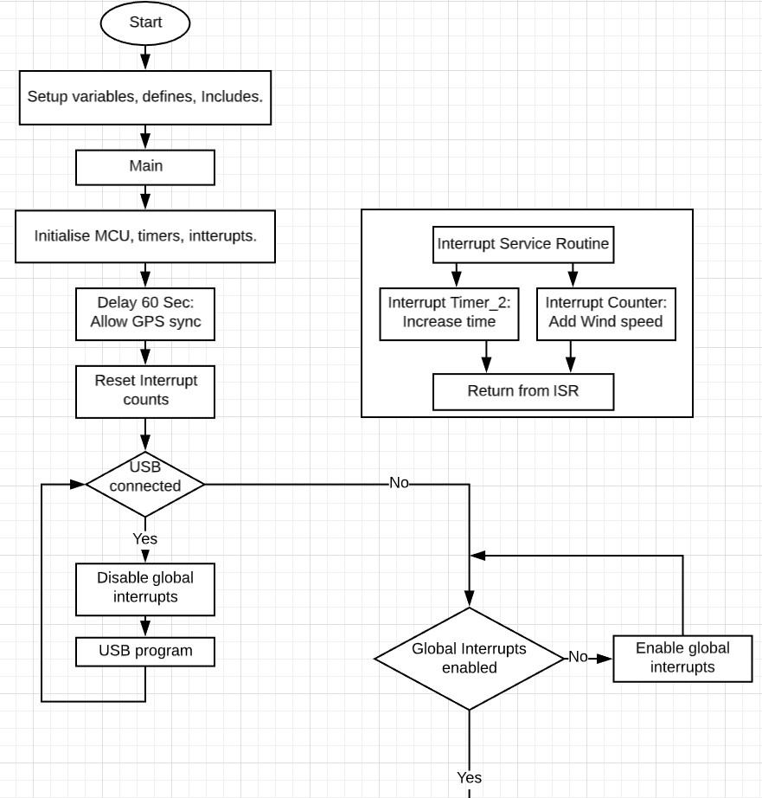
Figure 26 Software flowchart (1)
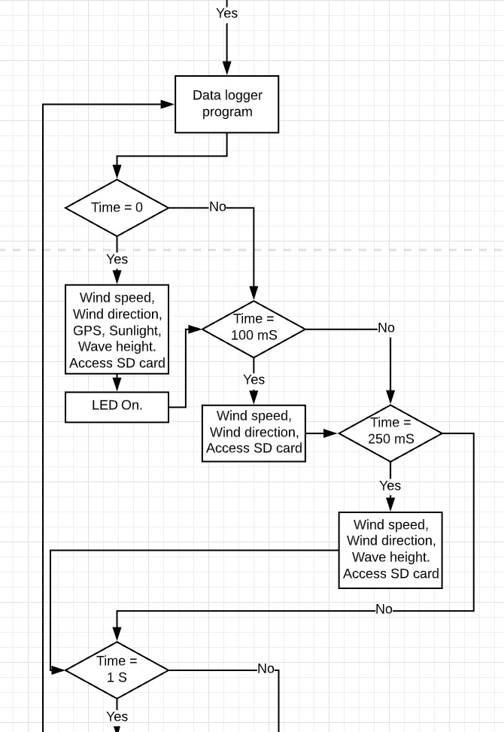
Figure 27 Software flowchart (2)

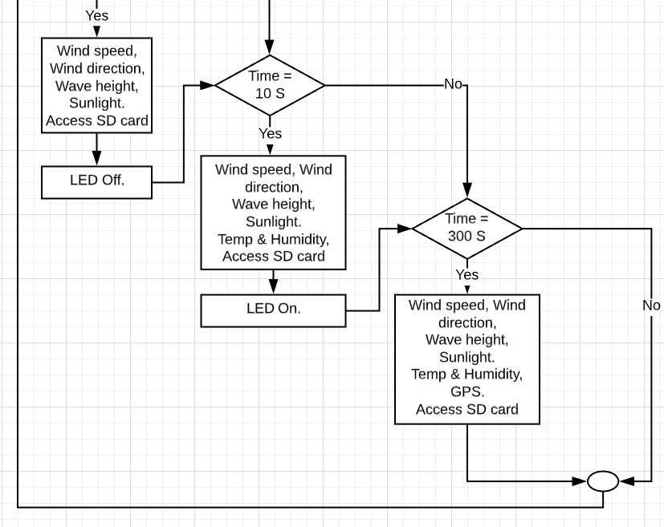
Figure 28 Software flowchart (3)
Figure 26, Figure 27 and Figure 28 shows Timer 2 interrupt is used to create the necessary time counts, anemometer is connected to external interrupt, while USB is connected disable global interrupts and run USB program, while USB is not connected ensure global interrupts are enabled and run data logger program to iterate through each Time = ‘x’ statements, if true process necessary instructions, loop data logger program.

Structure diagram
Structure diagram can be seen in Figure 29.
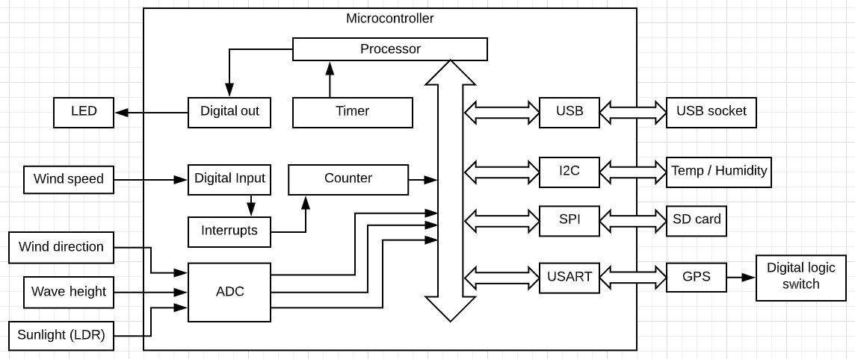
Figure 29 Structure diagram
In Figure 29 structure diagram the external connections and the necessary peripherals internal to the MCU can be seen.

Size of data storage
Figure 30 size of data storage
Figure 30 Screenshot of data storage calculation
In Figure 30 every 5 minutes a total of 15533 bytes will need to be stored to SD card, over 7 days that’s just over 31 Mb.

Bill of materials (BOM)
Figure 31 bill of materials
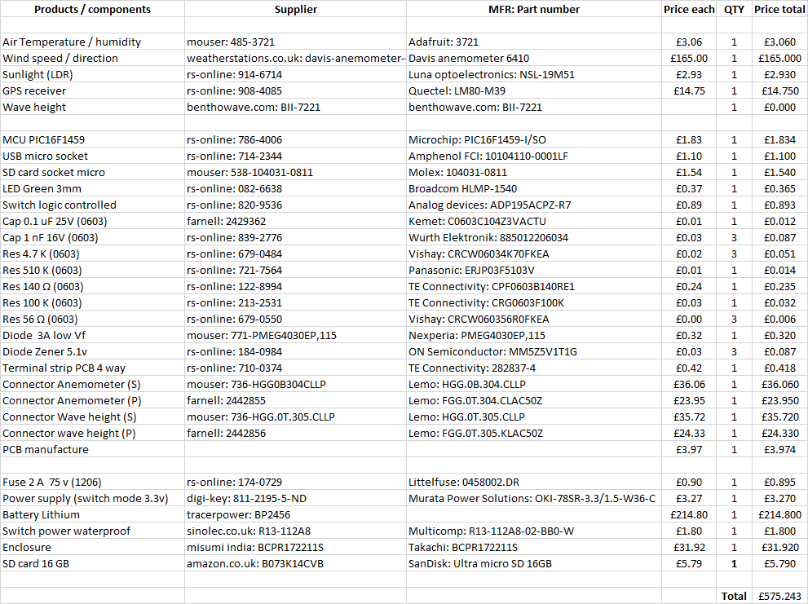
Figure 31 Bill of materials
Total BOM in Figure 31 is £575.24, this is high due to battery and anemometer cost, had no reply form supplier of wave height sensor.

Suggested improvements
- After rechecking the GPS datasheet, it may not be 5 V tolerant, the power supply module will need to be of 3.3 V and is a direct replacement for the 5 V.
- Wireless link for live data display and / or data transfer method.
- Ultrasonic wind sensor to eliminate moving parts or analog anemometer to could be used to charge the battery.
- Solar panel for charging.
- External antenna for GPS.
- Array of wave height sensors to determine wave direction.
- Switch to start and stop program whilst battery is connected.
- Buzzer in sync with LED for foggy days.
- Smaller headers on PCB to decrease size.
Overall the design is bulky this is due to the choice of battery, although the wave height sensor supplier recommends a power supply of 9 V or more it does show in their technical documentation that it could work as low as 4.5 V, testing the component at various voltages could be done before confirming power supply requirements.

References
[1] ‘WEATHERPAK MARINE - Weather Station for Marine Weather Applications’. [Online]. Available: https://www.campbellsci.co.uk/weatherpak-marine. [Accessed: 03-Jan-2020].
[2] M. S. Store, ‘NASA Clipper Weatherman - RTTY Weather Forecast Receiver - Marine Super Store’, Marine Super Store Ltd. [Online]. Available: https://www.marinesuperstore.com/marine-instruments/weather-instruments/nasa-clipper-weatherman. [Accessed: 24-Jan-2020].
[3] ‘BlackBox data logger’, Siri Marine. [Online]. Available: http://sirimarine.com/products/ship-data-logger/. [Accessed: 24-Jan-2020].
[4] ‘SEN0170 DFRobot | Mouser’, Mouser Electronics. [Online]. Available: https://www.mouser.co.uk/ProductDetail/426-SEN0170. [Accessed: 03-Jan-2020].
[5] ‘WindSonic M Heated Aluminium Wind Sensor | Gill Instruments’. [Online]. Available: http://www.gillinstruments.com/products/anemometer/windsonic-m.html. [Accessed: 03-Jan-2020].
[6] ‘6410_SS.pdf’. [Online]. Available: https://www.measurementsystems.co.uk/docs/6410_SS.pdf. [Accessed: 03-Jan-2020].
[7] ‘Davis Anemometer’. [Online]. Available: cactus.io/sensors/weather/anemometer/davis-anemometer. [Accessed: 03-Jan-2020].
[8] ‘GPS-622F | RF Solutions GPS-622F GPS Receiver | RS Components’. [Online]. Available: https://uk.rs-online.com/web/p/gps-chips-gps-modules/7043300/. [Accessed: 04-Jan-2020].
[9] ‘L80-M39 | Quectel L80-M39 GPS Receiver | RS Components’. [Online]. Available: https://uk.rs-online.com/web/p/gps-chips-gps-modules/9084085/. [Accessed: 04-Jan-2020].
[10] ‘RXM-GPS-RM-B Linx Technologies Inc. | RF/IF and RFID | DigiKey’. [Online]. Available: https://www.digikey.co.uk/product-detail/en/linx-technologies-inc/RXM-GPS-RM-B/RXM-GPS-RM-B-ND/4477366?utm_adgroup=&utm_source=google&utm_medium=cpc&utm_campaign=Google%20Shopping_RF%2FIF%20and%20RFID&utm_term=&mkwid=s1ihrgB4D&pcrid=337169636530&pkw=&pmt=&pdv=c&productid=4477366&slid=&gclid=CjwKCAiA6bvwBRBbEiwAUER6JQGbUz0Am0ploR84mia3-DXBj3GXXWC8ZnbXJamL96N3fYum1tHgbRoCP-UQAvD_BwE. [Accessed: 04-Jan-2020].
[11] ‘NORPS-12 | Luna Optoelectronics, 250 V Through Hole LDR (Light Dependent Resistor) 5.4 kΩ Light, 1MΩ Dark, 2-Pin TO-18 NORPS-12 | RS Components’. [Online]. Available: https://uk.rs-online.com/web/p/ldr-light-dependent-resistors/9146714/. [Accessed: 04-Jan-2020].
[12] ‘VEML6070 | VEML6070 Vishay, UV Light Sensor, Solar UV Light Intensity to Digital Data 355 nm I2C 6-Pin OPLGA | RS Components’. [Online]. Available: https://uk.rs-online.com/web/p/colour-light-sensors/1226789/. [Accessed: 04-Jan-2020].
[13] ‘S5971 - Photodiode, 70 pA, 900 nm, TO-18-3’. [Online]. Available: https://uk.farnell.com/hamamatsu/s5971/photodiode-900nm-100mhz-to-18/dp/1495572. [Accessed: 08-Jan-2020].
[14] ‘3721 Adafruit | Mouser’, Mouser Electronics. [Online]. Available: https://www.mouser.co.uk/ProductDetail/485-3721. [Accessed: 04-Jan-2020].
[15] ‘LM35CZ/NOPB | Texas Instruments LM35CZ/NOPB, Temperature Sensor -40 +110 °C ±0.4°C Analogue, 3-Pin TO-92 | RS Components’. [Online]. Available: https://uk.rs-online.com/web/p/temperature-sensors-humidity-sensors/5335890/. [Accessed: 04-Jan-2020].
[16] ‘DFR0198 DFRobot | Sensors, Transducers | DigiKey’. [Online]. Available: https://www.digikey.co.uk/product-detail/en/dfrobot/DFR0198/1738-1311-ND/7597054?utm_adgroup=Temperature%20Sensors%20-%20Thermocouple%2C%20Temperature%20Probes&utm_source=google&utm_medium=cpc&utm_campaign=Google%20Shopping_Sensors%2C%20Transducers&utm_term=&productid=7597054&gclid=Cj0KCQiAvJXxBRCeARIsAMSkAppLAVeFpDAAp1JDfo_GuD0njt1TGW-tUKXI3IQ2v6oHIvTi7DY51QQaAi37EALw_wcB. [Accessed: 20-Jan-2020].
[17] ‘ADXL335BCPZ | ADXL335BCPZ Analog Devices, 3-Axis Accelerometer, 16-Pin LFCSP | RS Components’. [Online]. Available: https://uk.rs-online.com/web/p/accelerometer-sensors/7090148/. [Accessed: 04-Jan-2020].
[18] ‘Wave Height Sensor’. [Online]. Available: https://www.benthowave.com/products/BII-7220WaveHeightSensor.html. [Accessed: 09-Jan-2020].
[19] ‘83-17989 - HC-SR04 Ultrasonic Sensor For Arduino And Raspberry Pi’. [Online]. Available: https://uk.farnell.com/mcm/83-17989/hc-sr04-ultrasonic-sensor-for/dp/2801408. [Accessed: 20-Jan-2020].
[20] ‘TracerPower.com Tracer 12V 14Ah Lithium Polymer Battery Pack’. [Online]. Available: https://www.tracerpower.com/12v-14ah-lithium-polymer-battery-pack.html. [Accessed: 20-Jan-2020].
[21] ‘Waterproof Rocker Switch, On Off, DPST - IP65’. [Online]. Available: https://sinolec.co.uk/en/waterproof-rocker-switches/1211606-double-pole-rocker-switch-240v-ip65.html. [Accessed: 20-Jan-2020].
[22] ‘10104110-0001LF | Amphenol FCI B 2.0 Micro USB Connector Receptacle, Right Angle | RS Components’. [Online]. Available: https://uk.rs-online.com/web/p/micro-usb-connectors/7142344/. [Accessed: 13-Nov-2019].
[23] ‘RJE0166001 Amphenol ICC (Commercial Products) | Connectors, Interconnects | DigiKey’. [Online]. Available: https://www.digikey.co.uk/product-detail/en/amphenol-commercial-products/RJE0166001/RJE0166001-ND/3083548?utm_adgroup=&utm_source=google&utm_medium=cpc&utm_campaign=Google%20Shopping_Connectors%2C%20Interconnects&utm_term=&productid=3083548&gclid=CjwKCAiA3uDwBRBFEiwA1VsajHuTS5c45b1xxAgQBzfG5doAxao2uhNMcQGKD08DEW-pB1ujtnec3hoCgSsQAvD_BwE. [Accessed: 11-Jan-2020].
[24] ‘HGG.0B.304.CLLP LEMO | Mouser’, Mouser Electronics. [Online]. Available: https://www.mouser.co.uk/ProductDetail/736-HGG0B304CLLP. [Accessed: 11-Jan-2020].
[25] ‘206430-1 TE Connectivity AMP Connectors | Connectors, Interconnects | DigiKey’. [Online]. Available: https://www.digikey.co.uk/product-detail/en/te-connectivity-amp/206430-1/A1360-ND/19367?utm_adgroup=Connectors%20and%20Interconnects&utm_source=google&utm_medium=cpc&utm_campaign=Google%20Shopping_TE&utm_term=&productid=19367&gclid=Cj0KCQiAyKrxBRDHARIsAKCzn8w6RtJ8nZbW4X-pnylA_g1XN3N8GdzbHFoibMHZd_uEqYwVbPORZ6saAo1BEALw_wcB. [Accessed: 24-Jan-2020].
[26] ‘c15_203204209230.pdf’. [Online]. Available: http://www.takachi-enclosure.com/data/c15/c15_203204209230.pdf. [Accessed: 24-Jan-2020].

Appendices

Proteus full circuit schematic
Full Proteus circuit seen in Figure 32.
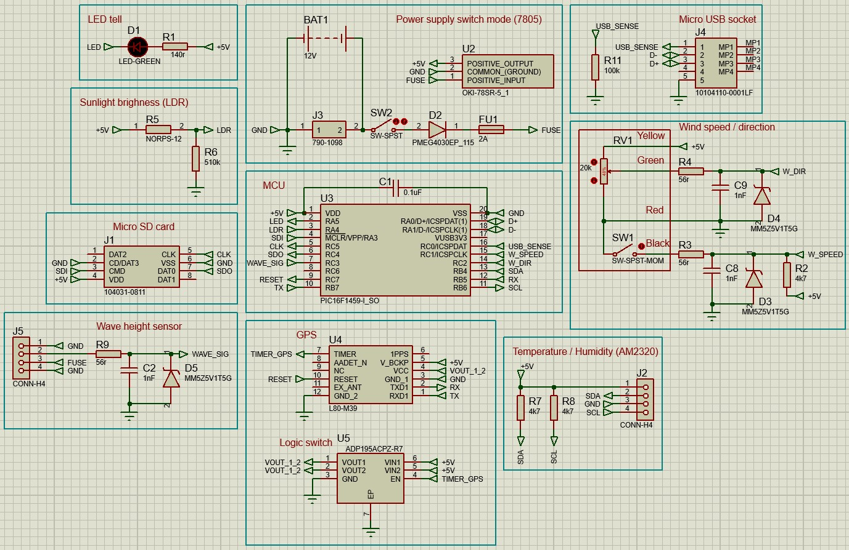
Figure 32 Full schematic in Proteus

Easy-PC, full schematic
Figure 33 shows the full schematic in Easy-PC.
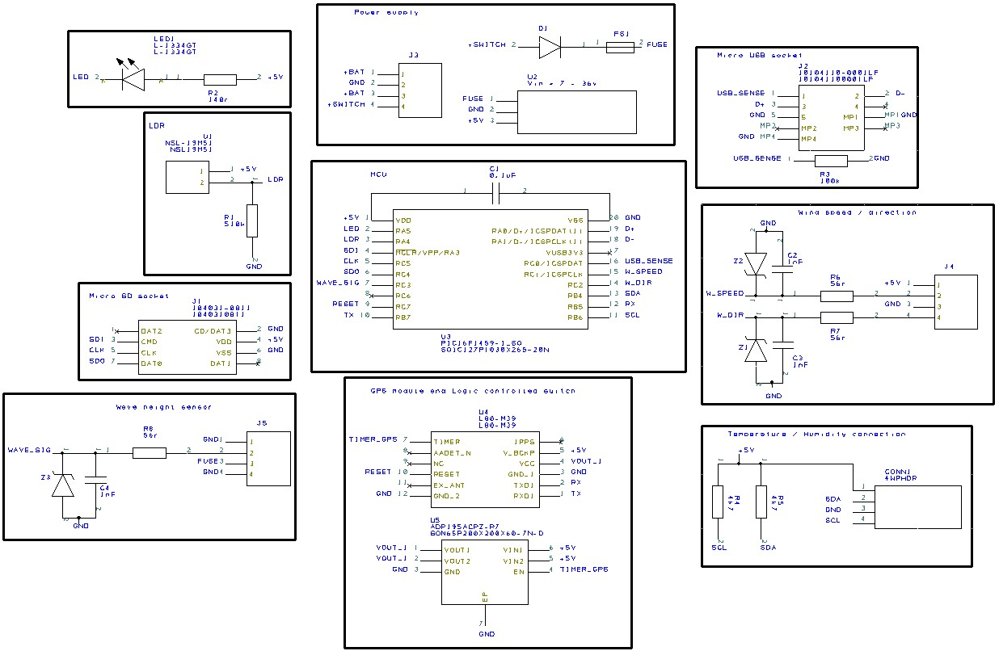
Figure 33 Full schematic in Easy-PC

BOM and other info from Excel
Figure 34 screenshot from Excel.
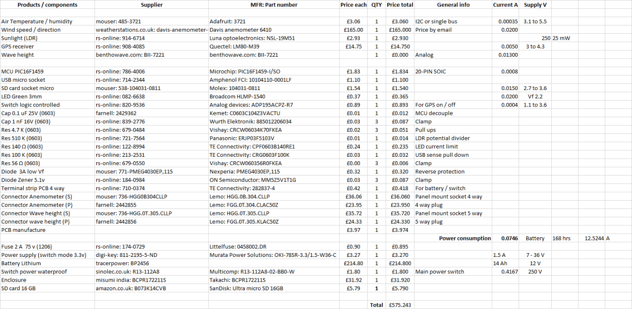
Figure 34 BOM and other info
Excel was used for any relevant information that may have been needed for this design Figure 34 shows components, suppliers, manufacturer part numbers, price, general info and any voltage / power requirements.

