
Skills for the Workplace
Module Assignment Submission 36
Student Name: | Gemma Senatore
Student Number: | 2017238
Module No: | BMSK4005
Module Title: | Professional Career Development

Statement of Confirmation of Authenticity
By the act of making this submission, the student declares that this is the work of the student named above. The work has not, in whole or in part, been knowingly presented elsewhere for assessment, or where assessment has been built on a previous assessment, this has been identified. Where materials have been used from other sources it has been properly acknowledged. If this statement is untrue, the student acknowledges that an assessment offence has been committed.
Attention is drawn to the plagiarism and unfair practice policies of both the University and of ILM.

Table of Contents
Section 1: Know how to identify development needs 3
1.1 Identify learning styles for self and another 3
1.2 Use a simple technique for identifying development needs for self & another 4
1.3 Identify potential barriers to learning for self and another. 5
1.4 Explain how these barriers to learning can be overcome. 6
Section 2: Know how to develop self & others to achieve organisational objectives 6
2.1 Analyse learning/development options to meet needs of self & another. 6
2.2 Identify support mechanisms for the development of self & another 6
2.3 Prepare development plans for yourself and another person 7
2.4 Method used to monitor the development of self & another. 8
Section 3: Know how to prepare for the recruitment process 8
Reflection on the recruitment process 8
3.1 Description 8
3.2 Feelings 9
3.3 Evaluation 9
3.4 Analysis 9
3.5 Conclusion 9
3.6 Action Plan 9
References 10
Appendix A 10
Appendix B 10
Appendix C 10
Appendix D 10

Section 1: Know how to identify development needs

1.1 Identify learning styles for self and another

I have found that there are different ways that you can find out what type of learning style suits you the best. There are 3 that I have used, Honey and Mumford [1982], Vark [Flemming,1987] and Dantec. I found that I am an auditory when completing Vark. This concluded that I learn best by hearing, speaking in group discussions and re listening to sound recordings. I do find that group interaction helps me to remember and learn. When completing Vark for my colleague I found she has a Kinesthetic way of learning. Learning from examples, practical demonstration and trial and error approaches.
When using the Honey and Mumford [982] it will determine if you are a reflector, activist, theorist or pragmatist when it comes to learning. This showed that I am an activist and Iearn things by trying it out without preparing and ’having a go’ and having a hands on approach.
My colleague also completed the questionnaire and found that they were a reflector. They prefer the side by side and collecting data approach.
I find that completing these questionnaires when a person is starting a new job or role is essential as you can then teach someone to their best abilities. You know you have a person who knows their job and can help your business thrive and succeed to its fullest. It can also help in life situations.

1.2 Use a simple technique for identifying development needs for self & another

My Swot Analysis
STRENGTHS | WEAKNESS
Transferable skills  I listen  I like to help others  I like to learn new things | Loud  Impatient  Like things to be done a certain way
OPPORTUNITY | THREAT
Get a degree  Pass driving test  Become a manager | No driving license  Not enough practise dude to current covid situation

My colleague’s Swot Analysis
STRENGTHS | WEAKNESS
Reading and writing skills  Maths skills  Looking at the bigger picture | Time management  Not a people person  Absorbing new information quickly
OPPORTUNITY | THREAT
Better education  Be promoted to management  Have a team of my own | Child care  Moving out of Cardiff

By looking at mine and my colleagues swot analysis you can see what strengths, weaknesses, opportunities and threats we face in the work place and in our personal life. We would both like to become managers within our role and have to face different issues to get to where we need to be. By using our Vark and Honey and Mumford learning styles, this can be achieved.
Next I will explain through gap analysis how I and my colleague can improve.
My gap analysis

Current skill level | HOW? | Desired skill level
Product knowledge | Learning from higher management | Knowing all product knowledge needed for management role
Level 3 in Customer service GNVQ | Side by side learning with team members and managers and completing my course | Becoming a team manager myself
Helping colleagues with difficult issues | Going on a course provided by work and side by side learning | Becoming a manager who can teach team leaders how to overcome difficult issues.

Current skill level | HOW? | Desired skill level
Helping with team stats | Side by side learning with the stats team | Becoming a part of the stats team
Level 1 in customer service | Continuing with my course | Getting to level 3

My Colleagues gap analysis

There is also a development plan named the Johari Window that shows skills that at unknown to yourself and others and explains the relationships between you and your colleagues.

My Johari Window

Known to self  I have good product knowledge  I listen  Always look at the bigger picture | Unknown to self  How helpful I am when others need me  How I explain things so others understand them more clearly
Façade  Not always asking for help when needed and try to deal with it myself | Unknown to others  Anxiety  IBS  Worrying over small details

1.3 Identify potential barriers to learning for self and another.
The barriers I face with being auditory is that I do not absorb information by reading a book. I seem to skim words and rush to get to the next topic through being impatient. My colleague also has the same issue due to her being dyslexic. I find that we both share them same issue of anxiety that we will not finish reading in time. This can also affect my physical job as I need to make sure I am reading notes carefully to help customers with their problems. I find that when we are both in a classroom situation I would need to write things down as my lecturer is speaking, where as my colleague would like it recorded.

1.4 Explain how these barriers to learning can be overcome.

The barriers that I have found for myself can be overcome by taking my time more and preparation. By asking my lecturer to give me the slides via email or paper so I can re-read them when I leave class. I could also ask for extra help or ask my fellow team and class mates to meet up for a group discussion or role plays.
With my colleagues barrier, she could ask for a tape player to be set up to record classes and meetings. Also there are different types of paper and technology that help people with dyslexia. Extra classes also to make sure she gets the best help. This will make sure that she is happy in her work. Also by setting goals for ourselves this will help and overcome any obstacles. You can use a tool called GO MAD [Making a difference] with goals and how to achieve them.

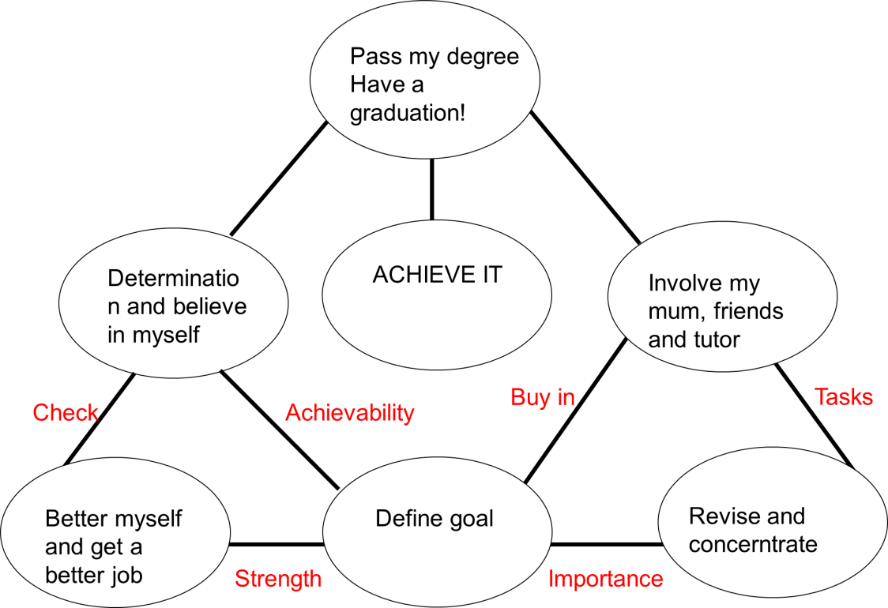

Section 2: Know how to develop self & others to achieve organisational objectives

2.1 Analyse learning/development options to meet needs of self & another.

I found that the SWOT analysis and Johari window has shown me what me and my colleague would need to do to help us develop in work and on our personal life. For me it would be to relax more and not to worry, Take time out for myself after work to relax such as yoga or swimming to clear my mind and be fresh for the next day. I also feel that reading a book when I am home will help me stop skim reading. My colleague will be looking into speaking to specialist who can help with dyslexia and teams that help in this area in our work place. Speaking up about it in the workplace is also a big step as a lot of people are too embarrassed to do so. By speaking up this will make people more aware of the issue and everyone can help.
I also found that SMART Objectives (Goals) provide the clarity and focus required to get the most out of your efforts. They omit the possibility of overlooking major or minor details that will help or hinder your efforts towards achieving your goals. SMART Objectives are also a good way of getting yourself mentally prepared for what is ahead. With more knowledge of what has to be done, you will be focused and aware of times when your attention should be aimed elsewhere
My SMART objective is that by 2023 I would become a manager of a customer service based team and pass my degree by keeping up with my assignments and learning through work.

2.2 Identify support mechanisms for the development of self & another

I found that the support me and my colleague could have is in the work place itself. By talking to friends and management, we can all work together by helping one another. Also by speaking to friends and family outside of work can help. There are also groups such as MIND that help people through tough times and who feel they do not have anyone they can speak to. By speaking to my lecturer, I find that this can help as they might have experienced it with other students in the past. I myself will speak to management and ask that we could have group meetings for people in similar positions as me and my colleagues. This would give peace of mind to both of us and others that there are people out there willing to help.

2.3 Prepare development plans for yourself and another person

Part 1: Personal Analysis
See SWOT Analysis in 1.2

Part 2: Setting Goals

What do I want to learn? | What do I have to do? | What support and resources will I need? | How will I measure success? | Target Date for Review
How to become a manager | Ask managers for help and feedback | Manager support and team support | By becoming a manager | 06/06/2021
Learning how to drive. | Book lessons | Keep lessons up and ask friends and family to help | By passing | 05/12/2021
Passing my degree | Keep up with lesson sand assignments | Books, laptops  Support from my lecturer and class mates | By getting a degree | 01/09/2021

My colleagues’ goals

What do I want to learn? | What do I have to do? | What support and resources do I need? | How will I measure success? | Target date for review
To lose weight | Sign up to classes | Classes in my area | by losing weight | 01/01/2021
Improve IT skills | Sign up to classes | Laptop, study books | By passing my course | 01/06/2021
People skills | Ask for help in work | Side by side learning | By feeling better around people | 01/06/2021

Part 3: Personal Objectives

Short Term Goals (next 12 months)
Graduate level 4 skills in the work place and get a degree and learn to drive
Medium Term Goals (2-3 years)
To be a manager of a team that teaches employees how deliver the best customer service
Also to have completed level 5 and 6 of my university degree.
Long Term Goals (3-5 years)
To buy a house and have my own company

2.4 Method used to monitor the development of self & another.

By using a personal development plan, I can keep track of my development weekly or monthly and to make sure I meet my end goals within the time frame I have set myself. I can then determine if I reached my SMART objectives. Within my Personal Development Plan, I can also see the resources and the support I will need to complete tasks and goals. I can also continuously review my development. By taking time to review my development I will be able to discover possible difficulties I might face, I can therefore focus my attention on problematic areas before they affect my long-term achievements.
My colleague also uses a personal development plan, her SMART objectives are different to mine as her goals are different for example one of her goals are for her was to develop her IT skills and to do this she needs to go on a course to help her improve. By doing this she will be able to become a better manager in the future so it’s important to stay on track of a personal development plan it helps you achieve you end goal.
There is the learning cycle (kolb,1975) here is a diagram below to show you the four stages of this learning cycle. This learning technique can be beneficial to you as it ca help you record each part of the learning cycle.
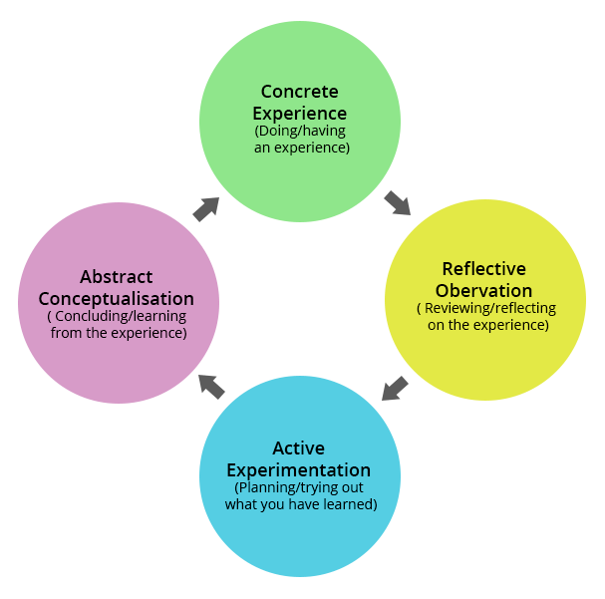

Section 3: Know how to prepare for the recruitment process

Reflection on the recruitment process


3.1 Description
When entering the foyer I was met by the recruitment manager who welcomed me to sit with a group of people. I did not realise it was going to be a group experience. We were all given name tags and told to introduce ourselves to one another. One of the interviewers came out to tell us how the day would pan out. We would have group tasks then individual interviews. We then sit side by side with employees to get a feel of the role. We would know if we were successful a few hours after we had left the building. The interviewers were running late so we were taken to the canteen for refreshments and had a chance to talk to each other. This gave me an insight of what I was up against. I made sure I was looking my best and wearing appropriate clothing and shoes and that makeup was to a minimal.

3.2 Feelings
Before coming to the interview I was very anxious and did research on managers and their roles so I could answer any questions they asked. I researched on more product knowledge so I felt I was prepared. The group task was a discussion and I felt very in control and relax during it as this is what I enjoy. I engaged with others in my group and showed that I listen and help when I can. As I have worked in teams for most of my working life I felt comfortable. During the one to one interview I had 2 interviewers. My anxiety was quite high as I always seem to rush things and I was worried I would not give an in depth answer. I was asked questions about myself and my work experience and what I could bring to the company which I felt at ease with. I was then asked to role play a difficult call which again I felt comfortable with. Throu8gh out the interview I kept calm and did not rush. I drank water which helped me answer questions a lot slower. At the end I was shown out and I felt relieved. I felt happy with all I done and that I shown my full potential. I did wonder that because there were 7 of us if I was good enough to pass.
3.3 Evaluation
I felt that the group task when extremely well. It showed how I cope in teams and that I can lead people as well as help them. Looking back I do think I may have overpowered people when it came to discussions, this may also seem as a positive to some companies so it did not worry me too much. While in my one to one interview I did feel I came across a tad flustered but as the time went by I became more confident in myself and what I was saying. As I have always been in customer service roles, it showed in my answers and in my role play. At the end I was thanked for attending and the interviewers spoke to me off the record about how well I did in my group tasks and asked general questions about what I would be doing in that evening. When leaving I felt so confident and happy that I had prepared myself for the role and researched the companies cores and values. Within one hour I was called to say they were happy to take me on for the role. They were happy with my knowledge and confidence and could tell I had done my research.

3.4 Analysis
I feel that I got the role as I set myself a goal to do so. I applied for the role 3 week prior and gave myself achievable goals to research and look at what the company is looking for. I also planned out role plays with colleagues and spoke to people that already worked at the company. I do believe that my customer service experience that is over 10 years helped me to get the role. By using SWOT and a PDP before the interview I could see what I was good at and what I needed to work on. I also feel that I helped others in the group tasks. There were a few people who were quiet and not contributing. I asked them myself what they thought and got them involved and I feel the company seen that as a positive in me.
3.5 Conclusion

I do not think I could set myself. It made me more confident within my work and personal life and I never felt happier. I have done anything better to prepare for my role. I did my own SWOT and PDP before arriving. I researched the company’s core values and what they want in a manager. I made sure I had great product knowledge. I arrived early to show I have great time management. I looked my best and showed that I am the person they want to hire for the role. I learned that I can do anything I set my mind to and achieve goals.

3.6 Action Plan
For future roles I would make sure I research more in depth about the company. Even if it seems a minor thing it would be good to know and would show my future employer that I am serious about my job. By finding out company policies down to who started the company will show I am willing to learn.

References

Vark – Auditory, Kinesthetic
Honey and Mumford – Activist, Reflector

Appendix A
Fleming, Neil, (2001) ‘’VARK -Multimodal Study Strategies’’ http://vark-learn.com/the-vark-questionnaire/
Kolb, D.A and Fry, R.(1975) ‘Toward and Applied Theory of Experimental Learning’, inc.Cooper(ed), Theories of Group Process, London, John Wiley
Honey, P. & Mumford, A. (1982) Manual of Learning Styles London: P Honey
Gibbs, G [1988]. Learning by doing: A guide to teaching and learning methods, Oxford Polytechnic
The Johari Window [Luft and Ingram, 1955]
Gilbert, A [2001] ‘go mad about coaching’ Bath, Bath press

Appendix B
I have extensive experience in the customer service industry and take it very seriously. When applying for job roles I research companies and look at the customer service satisfaction scores and how customers rate their phone experience. I also call the company as a customer and see how they deal with customers and if it is to my standard. I have always been in a call centre roll and love helping customers. Especially in hard situations as I find it for fulfilling that I have made someone’s day. I find that all issues not matter how big or small can impact a person’s day or life.

Appendix C

GEMMA SENATORE
Cardiff CF24
gemlsena05@gmail.com
07722753674
WORK EXPERIENCE
Tesco Customer Service Advisor
Tesco
June 2010
Respond to customers personally, using the appropriate communications, delivering a world-class service that exceeds customer's expectations, and reinforces their loyalty to the Tesco brand.
• Providing outstanding customer service with first-time resolutions to all customers that is; caring, efficient, and customer focused. Dealing with complaints, inquiries, and suggestions via inbound calls and emails.
• Working as a team to ensure excellent customer service is achieved and never compromised, whilst ensuring staff morale is kept high.
• Constantly achieving Green Productivity for my performance and consistently achieving Green quality on my responses. Achieving 100% Customer Satisfaction for my call and email handling.
• Keeping my team up to date on customer satisfaction scores and where improvements are needed. Also positive feedback and praise.
From 2008 - 2010 I was the prime carer for my grandmother ~~~~~
~~~~~~~~~~~~~~~ Sept 2003 -2008
• Directing calls to the correct offices.
• Making sure our Tenovus magazines were sent out on time.
• Filing the customer's personal data.
• Finding out the winners name from competitions in our magazines and contacting them for further information In my spare time, I like to run, take my dog on long walks and volunteer to walk dogs in shelters.
GCSE or equivalent
• Customer Care (8 years)
• Customer Experience (10+ years) • Call Center (8 years)
• Customer Service (10+ years)
EDUCATION SKILLS
ADDITIONAL INFORMATION
7 GCSEs, including Maths, English and Science
Intermediate certificate in Travel, Leisure and Tourism
Training undertaken at Tesco:
Little helps, big difference
Inspiring Great Performance
Social Media responding
Customer Service
Systems:
Outlook
Excel
Microsoft Word

Appendix D

Mr S Brown
Tesco house
Maes Y Glas road
Llanishen

Dear Mr Brown

My previous experience and knowledge would make me an ideal candidate to your team at Tesco house. Your company has an excellent reputation for great customer service and helping those in need and I will be a brilliant asset to you. I can bring my wealth of knowledge to make your company the best it can be and I am also willing to learn from you and your team.
My experience of customer service combined with my ongoing course in skills in the work place would keep your company known as the best. Even achieve call centre awards which I was known for in my previous role.
I look forward to hearing from you, if you would like to speak to me or have any questions please call me on 07722753674 or email me at Gemlsena05@gmail.com
Sincerely
Gemma Senatore

