

BSc (Hons) Professional Police Practice

LEVEL 5 - 40 Credits

Workbook title: Competency Based Workbook 3 (PCDA)

(SOUTH WALES POLICE, GWENT POLICE AND UWTSD)

Learner name: Jessica Swain
Learner’s University Registration Number: 1922419

FACULTY OF BUSINESS AND MANAGEMENT
PUBLIC SERVICE PROGRAMME

Module title: Professional Police Practice 2 (PCDA) BMPP5000D

Workbook Guidance

Please read these notes carefully; they provide essential information.

What is the workbook for?

The purpose of this workbook is to enable learners to demonstrate and provide evidence of how they meet the learning outcomes set by the College of Policing, for the BSc programme. Essentially, you are being asked to outline your experiential learning based upon your theoretical understanding in a range of operational situations.

- Wellbeing and Resilience
- Decision-making and Discretion
- Vulnerability and Risk
- Public Protection
- Maintaining Professional Standards
- Leadership and Team-working
- Policing the roads
- Information and intelligence
- Conducting Investigations

You may wish to use the same incidents as you’ve outlined in the Occupational Competence Portfolio.

How should the workbook be presented?

Blank electronic copies can be found on Moodle of this workbook. You must submit this document electronically therefore it is important that you save your work regularly and upload the final typed version through Turnitin on Moodle.

Word count policy can be found in chapter 7 of the Academic Quality under section 7.7 (this applies to presenting work above and under the specified word count).
(https://www.uwtsd.ac.uk/media/uwtsd-website/content-assets/documents/academic-office/aqh-chapters/chapters---en/Chapter_07_Assessment_Taught_Programmes_Pages_72-79-UPDATED-05-11-2019.pdf)

Reflective practice is a core aspect for your workbooks and although there is a variety of useful resources on Moodle, there is one particular book, that is specifically based on reflective practice in policing, here is a link to one chapter from Selina Copley’s Reflective Practice for Policing Students:
https://moodle.uwtsd.ac.uk/pluginfile.php/298870/mod_resource/content/1/Reflective%20Practice%20for%20Policing%20Students%20-%20Selina%20Copley%20Chapter5.pdf

How is the workbook assessed?

Advice and support about the completion of this workbook will be provided by university staff as part of your initial training day. Your tutor constable and in-force training staff will not be involved in assessing or marking your workbook after it has been submitted.

Dates of workbook submission will be made available during the initial training day and posted on Moodle.

Once submitted your workbook will be assessed and marked independently.

Confidentiality

It is important that no individual can be identified either directly or indirectly from the information in the workbook. Therefore, you must:

- adhere to guidance in the Student Handbook about unfair practice and plagiarism.
- not identify individuals including witnesses, victims or offenders by name.
- not write information that enables any individual to be identified indirectly through the description you provide. This includes references to names, colleagues, places (including hospitals, schools, town, villages, streets) specific incidents which were high profile and could be identified due to past publicity, other professionals or any other personal information including medical or other conditions.
- take personal responsibility for adhering to confidentiality rules.
- not include any dates of any incidents or anything that specifically identifies an actual incident.

NOTE

Your workbook will be submitted electronically via Turnitin on Moodle. Guidance on this is in the Student Handbook.

Remember that the workbook is YOUR responsibility you must not rely on the assessor or anyone else to pick up any confidentiality breaches as this is your work and you must accept full responsibility for confidentiality. Meeting all the confidentiality requirements is very important.

Dyslexia and other special circumstances

If you have any condition that you feel may affect your ability to deal with any part of the programme, please see the Student Handbook for further guidance. The University has a Student Services Unit that may be able to help but it is the learner’s individual responsibility to contact them.

Guidance:

- Your workbook must contain the items specified in the table below (clearly identified and in the order given);
- You should use this particular document to insert your text / answer within each section of this workbook;
- You should upload your completed document as a saved pdf file of this workbook; if this is not possible then a Worddoc file is acceptable. Do not send a scanned file from a photocopier, an apple.dot file or a Microsoft publisher file as Turnitin will not be able to assess them, despite you being able to upload them.

Contents

Workbook | Area of Professional Practice | Word count
Task 1 | Wellbeing and Resilience | 1250
Task 2 | Decision-making and Discretion  Vulnerability and Risk  Public Protection | 1750
Task 3 | Maintaining Professional Standards  Leadership and Team-working | 1750
Task 4 | Policing the roads  Information and intelligence  Conducting investigations | 1750
Task 5 | Individual Learning Plan | 1500 equivalent
 | Total | 8000
 | Bibliography

Task 1

Relevant areas of the National Policing Curriculum:
Wellbeing and Resilience

Having achieved Independent Patrol Status, reflect on the impact of organisation culture within policing on your wellbeing and resilience (organisation change, retaining personal values in a wider organisational culture).

Consider the risks of conforming to organisational culture.

Illustrate your strategies for maintaining wellbeing and resilience.

1250 words (+/- 10%: include your actual word count at the end of each section)

ANSWER:

In this essay, I will be reflecting on the impact that organisational culture within policing has had on my wellbeing and resilience. I will also be outlining the risks of conforming to organisational culture and identify my strategies for maintaining my wellbeing and resilience. These strategies include exercising, resistance training and maintaining a good sleep pattern.

According to Reiner (2000), police cultures can be defined as “a kind of shared values, beliefs, norms, working practices and informal rules. He stated police officers will use these cultures to justify their works in the world. This is often referred to as “cop culture”. Organisational culture of a police department affects the behaviour of the officers. Police culture is often viewed negatively and the blue wall of silence has resulted in police officers not being held accountable for misconduct (Frye, 2006). However, organisational culture can also have a positive effect on police officers and can reduce anxiety and uncertainty in human relationships, and communicate the ideology that defines what the organisation is all about (Champoux, 2006). Therefore, the establishment of a professional, moral, ethical culture in a police organisation can control, prevent, and punish misconduct and corruption. Waddington’s (2004) research suggested that op culture can also be a positive thing which provides officers opportunity to express their emotions as they have already suffered from high pressure on their daily work. He went on to state that police organisational culture also provides officers with an idea of spirit which fosters a strong sense of cohesion between officers and thus enhances their working attitude.

According to Inciardi (1990), police officers develop resources to deal with the isolation from the community that results from the job and the police socialization process. These police subcultural attributes include “protective, supportive, shared attitudes, values, understandings and views of the world”,” which result in a blue wall of silence (p. 227), or closed police society. Furthermore, this process of socialization or the creation of a blue fraternity begins at the police academy, but as with most forms of occupation socialization, it is an ongoing process throughout the officer’s career.

Every police officer is influenced by the organisational culture during training, during tutorship and once they have reached independent status.

The definition of stress is “pressure or worry caused by the problems in somebody’s life” (Oxford Dictionary, n.d). It states that things can easily go wrong when people are under stress. As police officers, we are faced with many stressors every day and have to be able to manage them to ensure that it does not affect the choices we make when dealing with an incident. Stress management is a key part of being a police officer which is still something that I am working on. The release of the stress hormone, cortisol is part of the human body’s response to stress. Stress is often a factor in the development of long-term sickness therefore, it is important that you are able to manage your stress, which is what I have learnt and am stilling learning to do. (Oxford Dictionary, n.d).

Stress and resilience are not the same thing, although some people believe that they are. Resilience is “the ability of people or things to recover quickly after something unpleasant such as shock” (Oxford Dictionary, n.d), Charles Darwin (DATE) highlighted that “it is not the strongest of the species that survive nor the most intelligent that survives, it is the one that is the most adaptable to change (resilient).

Another strategy that I used to aid in my wellbeing and assist in my resilience developing is exercise. Throughout tutorship, I created an exercise plan where I would guarantee that I spent at least one hour a day participating in some sort of physical activity. Whether I went swimming, attended a local fitness class or even if I just went for a run; I ensured that I made time for exercising in order to have all the benefits. Having achieved independent patrol, I continued to stick to this plan as I could see the benefits it was having on my mental health, such as reducing my stress levels. Not only did it become part of my daily routine but I actually look forward to exercising everyday now as I know that I always feel better after it and less stressed. Due to work pressures and shift changes I have had to adapt my exercise plan some days however this has not prevented me from exercising everyday.

Exercise assists an individual in being able to deal with the stress so that it doesn’t negatively impact them. This is supported by Kelly McGonigal (2020) who stated “On days when people exercise stressful things take less of a toll on their well-being.. Not only that, regular exercise changes your brain over time and maintains brain health”. McGonigal’s research shows that individuals are more resilient because of how movement makes them feel about themselves and their capacity to handle challenges. She also stated that there are changes in the systems of the brain that help regulate emotions and keep stress in check, so participating in regular activity over time can result in your resilience increasing.

Further research into exercise improving individuals’ wellbeing and resilience has been conducted by CHILDS and De WIT. They compared psychophysiological responses to an acute psychological stressor between individuals who did, or did not, report regular physical exercise. They measured every participants heart rate, blood pressure, cortisol levels and self-reported mood before and after each individual took place in either a Trier Social Stress test (TSST) or a non-stressful control task. Their findings support claims that regular exercise protects against the negative emotional consequences of stress and suggests that exercise has beneficial effects in healthy individuals.

Another way in which exercise promotes health is by increasing an individual’s resilience to stress, since stress exposure and chronic stress burden has been associated with physical and mental illness (McEwen, 2007). Police work involves stressful demands such as dealing with human misery, abused children and instantaneous life or death decisions. Sources of stress in policing may be classified into two general categories (Shane, 2010): those arising from “job content” which include work schedules, long-work hours, overtime, traumatic events and threats to physical and psychological health. The second category is referred to as “job context” which refers to characteristics of the organisation and behaviour of the people that produce stress such as bureaucracy and co-worker relations (PMC, 2017). A study conducted by Massachusetts General Hospital, examining brain scans for 293 patients found higher activity levels in the brain’s stress centre, the amygdala were associated with arterial inflammation – a high predictor of heart attack stroke (C. Le, C. Nowell, C. Kim-Fuchs, 2016). According to studies cited by the National Alliance on Mental health (NAMI) between seven and nineteen percent of police officers experience symptoms of Post-Traumatic Stress Disorder, compared to three and a half percent of the general population. This is due to the traumatic situations that officers have to deal with. Strategies such as exercising, resilience training and a regular sleeping routine were all strategies I have used to help manage my stress and develop my resilience.

Another strategy is used to develop my resilience is the “Developmental model for resilience”. As police officers it is important that we are resilient as we are constantly faced with different or changing circumstances that we have to be able to adapt to quickly in order to effectively deal with the situation. This model focuses on investing in the mind, body, heart and soul, whilst requiring you to reflect on four fundamental questions:
- Mental toughness – this is where I would ensure I have the correct mindset to address any challenges that I might face.
- Physical endurance – this is where I ensured that I invested in my body and continued to exercise everyday as the above strategy outlines.
- Emotional Balance – this is where I would channel and use my emotional energy in a positive way.
- Purpose – In this stage I would ensure I can see a sense of meaning and connectiveness in the job I do.

The theory underlying this model is that in order to develop resilience, we need to attend each of the four described areas in order to build resilience we need for all of life’s challenges but also the challenges we face in the workplace. I found this model to be extremely beneficial as it allowed me to break everything down into four elements and make it more manageable

Another strategy that I used to improve my resilience and wellbeing is prioritising sleep. I ensured that I maintained a regular sleep pattern throughout tutorship and I have continued this since becoming independent. Prior to joining the police, I had never worked shifts before, and it took me a while to get used to it. According to Bond and Baughman (2013,2014) rotating shifts often lead to inadequate sleep for officers which lowers physiological resistance to stress. I ensured that I had 8 hours sleep every night as this is what is recommended for a twenty year old. (NHS, 2020).

In conclusion, since achieving independent patrol status I have had to particate in strategies that develop my resilience due to the ever changing circumstances that police officers are constantly faced with. I have also had to prioritise my wellbeing as reaching independence comes with a lot of new stressor and added pressure, which you have t be able to deal with effectively in order to prevent it from negatively effecting you. The skills that I have learnt since reaching independent patrol status, such as developing my resilience and ensuring my wellbeing is not being compromised are skills that I can use in the future as I progress my career in the police.

Wordcount: 1375

Task 2

Relevant areas of the National Policing Curriculum:
Decision-making and Discretion, Vulnerability and Risk, Public Protection.

You must choose an incident, for example a domestic related incident, and reflect on how you made decisions in complex and unpredictable circumstances using dynamic risk assessment.

Give a brief description of the problem including social and legislative contexts and any relevant cultural, ethnicity and language issues.

Evaluate decisions made during the incident and your use (or otherwise) of the National Decision Model. Explain the rationale behind your decisions and your considerations when recording details of the incident. Consider your ethical approach to the decision. Outline the consequences of your decision making.

1750 words (+/- 10%: include your actual word count at the end of each section)

ANSWER:

In this essay, I will be outlining a domestic related incident and reflect on how I made decisions in complex and unpredictable circumstances using a dynamic risk assessment model. I will also be evaluating the decisions I made during the incident and my use of the national decision model. I will use Borton’s reflective model to explain my rationale behind my decisions and considerations throughout this incident.

South Wales Police define domestic abuse as being “any incident of controlling, coercive or threatening behaviour, violence or abuse between those aged 16 or over who are or who have been intimate partners or family members, regardless of their gender or sexuality”. This includes physical, sexual, psychological or financial abuse (SWP, n.d)

For the year ending March 2020, the Crime Survey for England and Wales (CSEW) showed that an estimated 2.3 million adults aged 16 to 74 years experienced domestic abuse in the last year. This equates to a prevalence rate of approximately 5 in 100 adults (Office for National statistics, 2020). Domestic abuse is a hidden crime and not everyone reports the incidents, therefore it is predicted that these statistics are much higher however only recorded incidents can be included. The below diagram shows a higher percentage of adults were victims of partner abuse than family abuse:

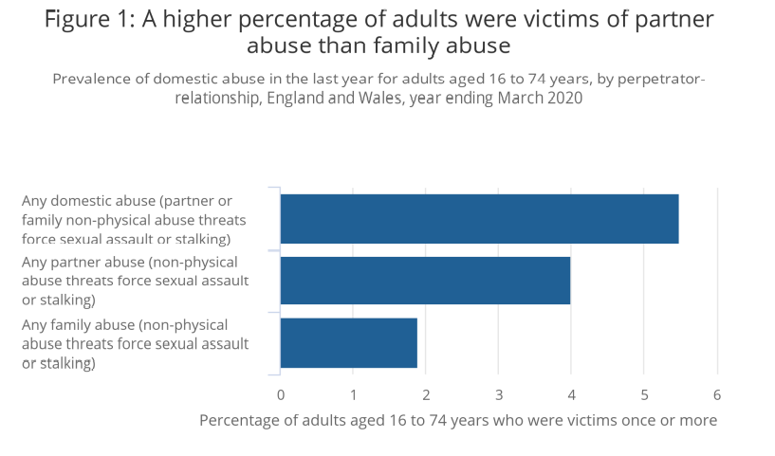

Source: Office for National statistics – Crime Survey for England and Wales

Police officers have the ability to make effective decisions quickly based on the information they have available to them at the time, the National Decision Model (NDM) is used to assist police officers with this. The NDM consists of five elements, each element provides the decision maker with an area for focus and consideration. The NDM includes the code of ethics – this is what separates the NDM from other decision making models (College of Policing, 2013). Below is a diagram outing the different stages of the NDM:

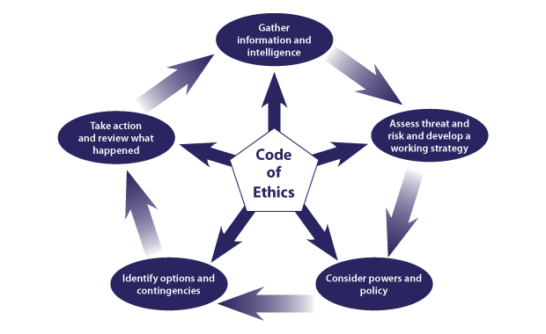

The first stage of the NDM is gathering information and intelligence. This is where the decision maker has to obtain information in order to be able to make effective decisions (College of Policing, 2013). For example, when I was instructed to attend this incident, the only information provided by the control room was that the call ended after a male could be heard requesting police. Police officers are often provided with little information when attending incidents. Whilst on route to this incident, I requested more information such as who lives at the address; including any children, whether any weapons had been seen, did anyone have any injuries and any warning markers. Warning markers are used to provide officers with an individual’s history which would allow officers to conduct a risk assessment and make a decision based on this information. For this incident, the individual’s identities were not disclosed therefore, we were unable to check warning markers.

During this incident, the identity of the caller was unknown however, we were able to identify where the call was made from and I therefore conducted a check on the address. Warning markers can also be placed on an address to inform police of previous incidents, whether there are any critical markers which can affect the police’s response to the incident. Conducting a check on the address allowed me to identify that the address had markers for previous domestics at the location. It also allowed me to identify that there were two children aged 5 and 10 linked to the address.

Stage 2 of the NDM is assessing threat and risk and developing a working strategy. In order to do this, the parties involved should be separated. Therefore, I spoke to a male in the kitchen whilst my colleague spoke to the female. The female did not want us to talk to the male without her present however due to the nature of the call, separating them was necessary to ascertain what had happened. Once inside the kitchen, I saw a male who had clear facial injuries however the male would not disclose anything to me on how he sustained his injuries. I had conferred with my colleague who had informed me that the female stated that the male must have fallen over because he was intoxicated.

The next stage is considering powers and policies. This stage involves considering what powers, policies and legislation could be applied to a particular situation (CoP, 2013). When dealing with this incident, I considered all possible options and needed to identify the most suitable one. First I needed to establish if any criminal offences had been committed and if so, how to deal with these offences, such as make an arrest or using an out of court disposal (OOCD). These are responses to crime that the police can administer locally without having to take the matter to court. Some examples of OOCDs are cautions, penalty notice for disorder and community resolutions such as Restorative Justice or women’s pathfinder (HM Government, 2014).

The next stage is to identify options and contingencies. South Wales Police’s policies state that positive action must be taken when dealing with domestic abuse incidents. Positive action doesn’t always mean making an arrest however, officers must be able to justify their decision, whether that be why they did or did not arrest someone. In some situations for example, when the behaviour does not amount to criminal conduct another approach may be taken, such as the ones mentioned in the stage above.

The final stage of the NDM is ‘Take action and review what happened’. An example of this is when an officer makes an arrest which has required the officer to consider all of their options, powers, polices, legislation and decide which the most suitable option is. In the incident I dealt with, an arrest was the most suitable outcome as the male eventually disclosed to me that his wife had punched him in the face and then slapped him across his face however he did not want us to arrest his wife. Sometimes officers attend incidents where individuals have requested police in order to stop them from being hurt however then do not want any action taken. As police officers, it is our job to protect life and limb even if sometimes it is not what the individual wants.

It is an offence for any person to unlawfully assault another. An “assault” is any act, which intentionally or recklessly, causes another person to apprehend immediate and unlawful personal violence. Examples of injuries sustained from common assault include; grazes, minor bruising and reddening to skin. Due to what the victim had disclosed to me during this incident and my understanding as to what category his injuries would be classed as, I arrested his wife for common assault under Section 39 of the Criminal Justice Act 1988 (Gov.uk, n.d)

Although, this is not what the victim wanted, due to what he had disclosed I had to take positive action and safeguard him and his children – which I did by arresting her.

Considering the consequences of your actions is another way to assist in your decision making. For example, domestic incident’s where an individual has hit their partner but they both state that they are fine now. If you were an officer attending this incident, you have to consider the consequences of your actions, such as what could happen if you leave them both there. One being, there could be further violence once you have left, the victim could be too scared to say anything in front of their partner or you could leave and everything could be fine. However, if everything is not fine, further violence could occur due to the decision you made.

For example, if you attend a domestic and decided to leave both parties at the same address, there could be a further disturbance after you have left. Also, by leaving both parties together, safeguarding has not been addressed.

There were 362 domestic homicides recorded by the police in the three year period between March 2018 and March 2020. This represents 19% of all homicides where the victim was aged 16 years and over during this period. Of the 362 homicides, 214 (59%) were female victims who were killed by a partner or ex-partner. In contrast, 33 (9%) were male victims were killed by a partner or ex-partner (CSEW). South Wales Police’s policy when attending domestics is to always take positive action to safeguard the victim, and in this case the appropriate outcome was to make an arrest.

Safety and support for victims is paramount. The definition of safeguarding is “protecting an adult’s right to live in safety, free from abuse and neglect” (Department of health, 2014). There are numerous organisations and charities that offer support and guidance for victims. One organisation that offers support to victims is called “LIVE-FEAR-FREE”. This is a helpline service for sexual violence and domestic abuse victims in Wales. Live fear free can provide help and advice to:
- Anyone experiencing domestic abuse
- Anyone who knows someone who needs help, such as a friend, family member or colleague
- Practitioners seeking professional help (Gov.wales, n.d)

There also campaigns that were designed to raise awareness such as the ‘Make yourself heard’ campaign. This is a national campaign that raises awareness about a system called ‘Silent Solution’. This system was created in 2002 and enables a 999 caller who is unable to make a noise or speak to press 55 when prompted – to inform police they are in a genuine emergency (Belfast Area, 2019). ACC Alan Todd stated that this method “allows people who are unable to speak to contact police while filtering out huge volumes of accidental calls made every day”. This campaign is supported by the family of Kerry Power, who was killed by her ex partner in 2013. Power made a silent 999 call but did not respond to the operator and did not press 55. This led to the call being terminated and Devon and Cornwall Police were not notified of Power’s call. The IOPC have launched a poster campaign aimed at “debunking the myth” that a silent 999 call alone will automatically bring help. The lack of public awareness about alerting the police could have potentially saved Power’s life.

Police officers safeguard victims by liaising with different agencies, such as Social services, local education authority and mental health services. This is due to the identification that police information was not known to other agencies which resulted in a lack of multiagency risk identification, assessment and action planning (Detective Superintendent Fiona Grant, 2019). Police use an information sharing document called Public Protection Notification (PPN) reports to do this (SWP, 2008), where officers can record safeguarding concerns when they have been identified. It is important to acknowledge the General Data Protection Regulation (GDPR), Data Protection Act (DPA) 2018 and Human Rights legislation are in existence to provide a framework to ensure that personal information about individuals is shared appropriately. There are four different categories: child concern, honour based abuse, adult at risk and domestic abuse/stalking & harassment (DASH). In this incident, I had to complete a domestic abuse PPN, whereby DASH questions had to be completed. I then submitted this to our SWP Public Protection Unit who share it with the relevant agencies.

In conclusion, the NDM is a useful tool that was created to assist when making decisions efficiently. Police officers have to make decisions quickly and effectively, even when the circumstances are actively changing and quite often, very little information is available. Police officers have to be able to take whatever information they have and make an effective decision whilst considering their powers, legislation and safeguarding. I am confident that I effectively used the NDM and made the correct decision by arresting the female. When I later reviewed the situation, I identified that a consequence of not arresting the female could have led to the victim being subjected to further violence. It is important that officers are aware of the consequences of their actions as this assists the when making the decision.

Wordcount: 1925

Task 3

Relevant areas of the National Policing Curriculum:
Maintaining Professional Standards, Leadership and Team-working

Evaluate theories of team dynamics as a means of developing team cohesion (reasons why some teams cannot function, theories and models relating to team dynamics, ways to improve team cohesion).

Consider why inter-personal conflict can occur within a team and outline what strategies can be adopted to enhance individual and team performance.

Consider how team dynamics within the police service can result in failing to comply with professional standards requirements (Code of Ethics, policies, procedures, protocols or legislation).

1750 words (+/- 10%: include your actual word count at the end of each section)

ANSWER:

In this essay, I will be evaluating the theories of team dynamics as a means of developing team cohesion. I am also going to be discussing why inter-personal conflict can occur within a team and outlining what strategies can be adopted to enhance individual and team performance. Additionally, I am going to be examining how team dynamics within the police service can result in failing to comply with professional standards requirements, including the code of ethics, policies, procedures, protocols, and legislation.

An early definition of team cohesion is “the total field of forces which act on members to remain in the group” (Festinger, Schacter & Back, 1950). A team differs from a group in that team members are required to complete a task or project (Dr Towler, 2019) for example a team of employees working towards an organisations goal.
In a Harvard business review article in 2011, team cohesion was shown as occurring when the members engage in collective work and demonstrate mutual commitment to challenging goals in order to reach an overarching purpose. The authors state that “collective work produces more innovative and productive outcomes that exceed the simple sum of individual efforts” (Hill & Lineback, 2011).

According to Bruce Tuckman (1965), there are four stages in team development that can be used to assess a team’s cohesiveness. Tuckerman’s model recognises the fact that groups do not start off fully-formed and functioning. He suggests that teams grow through clearly defined stages, from their creation as groups of individuals to cohesive task-focussed teams (The four stages of Tuckerman’s model are; Forming, Storming, Norming and Performing. Tuckerman stated that by understanding these stages, individuals would be able to understand why certain behaviours are happening and make informed changes.

The first stage of Tuckerman’s model is Forming. This stage occurs at the beginning so when a new team forms, individuals will be unsure of the team’s purpose, how they fit in, and whether they’ll work well with one another. Teams have high expectations and are eager of what is to come(Miller, 2014). When a new group is formed, it must learn to discover itself. Interactions must be built between the different members of this group which may take time (Paquet, 2020).

The second stage of Tuckerman’s Model is Storming. During this stage, individuals start to push against the established boundaries. Conflict and friction can also arise between team members as their true characters – and their preferred ways of working – surface and clash with other people’s. At that stage, team members may start to challenge the leader’s authority or management style, even the team’s mission. Without intervention, this can lead to face-to-face confrontations. The more conflict averse team roles can struggle here and need to see that is it natural and beneficial to professionally argue about the right things (Miller, 2014). If this is handled in a specialised way, the conflict can allow for innovation and forward moving. Too much conflict avoidance at this stage will lead to more conflict and ultimately an unsettled cycle of conflict. Knowing everyone’s role can naturally accelerate by contributing more insight on who is likely to deal with arising conflict and who will avoid it and risk keeping the team here (Miller, 2014).

The next stage is Norming – this is where self-expectation and others in the team begin to line up with reality instead of the individual’s perception of reality. Methods of providing feedback to others are established whilst self-esteem and confidence rises as team language develops and responsibility and control are shared (Miller, 2014).

In the performing stage, team members will project their strengths in team roles and offset each other’s weaknesses with confidence (Miller, 2014). Plus, collaboration has turned into an integral aspect of team strength. At this stage, members of the team gain a sense of confidence and positivity, even under pressure. The team can now more clearly focus on reaching team goals and dealing with interpersonal issues effectively.

An advantage of this model is that it helps us understand that teams evolve and also allows us to consider how they may encounter different problems at different stages of their development (Happy manager blog, n.d). However, a limitation is that the model makes team building appear too linear and sequential (Happy manager blog, n.d) Some teams may revisit certain stages whilst they are in development but this is not outlined in the model. Below is a diagram of Tuckerman’s model:

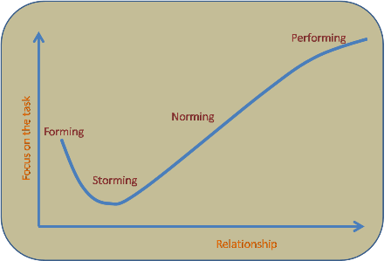

Interpersonal conflict can occur on any team, even the ones with the best performance. Patrick Lencioni outlines five common problems team experience that impact their effectiveness in his book called “The five dysfunctions of a team” (2005). Lencioni stated that the five dysfunctions are Lack of trust, fear of conflict, lack of commitment, avoidance of accountability and inattention to results. These are all displayed in the diagram below:
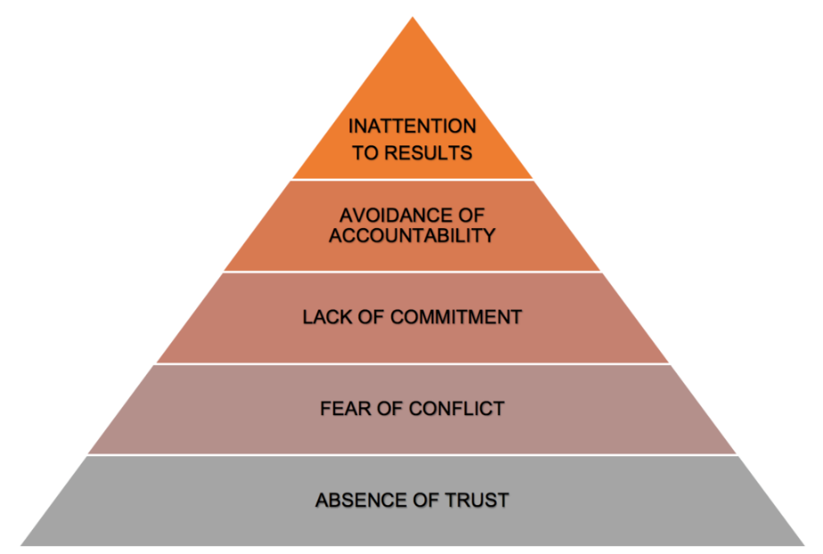

Lencioni created this diagram and advised when tackling each dysfunction that individuals start from the bottom and work their way up. He believes that establishing trust is a crucial first step to being able to manage conflict, achieve commitment, create accountability and focus on results. Although all teams face some sort of interpersonal conflict, multiple methods have been created in order to assist with team cohesion and team development that include dealing with interpersonal conflict.

One strategy that can assist in individual and team performance is the DISC model. This model was developed by Dr. Marston in 1928. The model is used for conflict management as it predicts behaviours based on four key personality traits, which he originally described as Dominance, Inducement, Submission and Compliance (Marsten, 1928). The DISC model is often used in professional contexts because having some insight into individual’s personality traits can help when trying to resolve conflicts with a team. Below is a diagram of the DISC model, and it outlines some of the characteristic that are associated with each section of the DISC model:

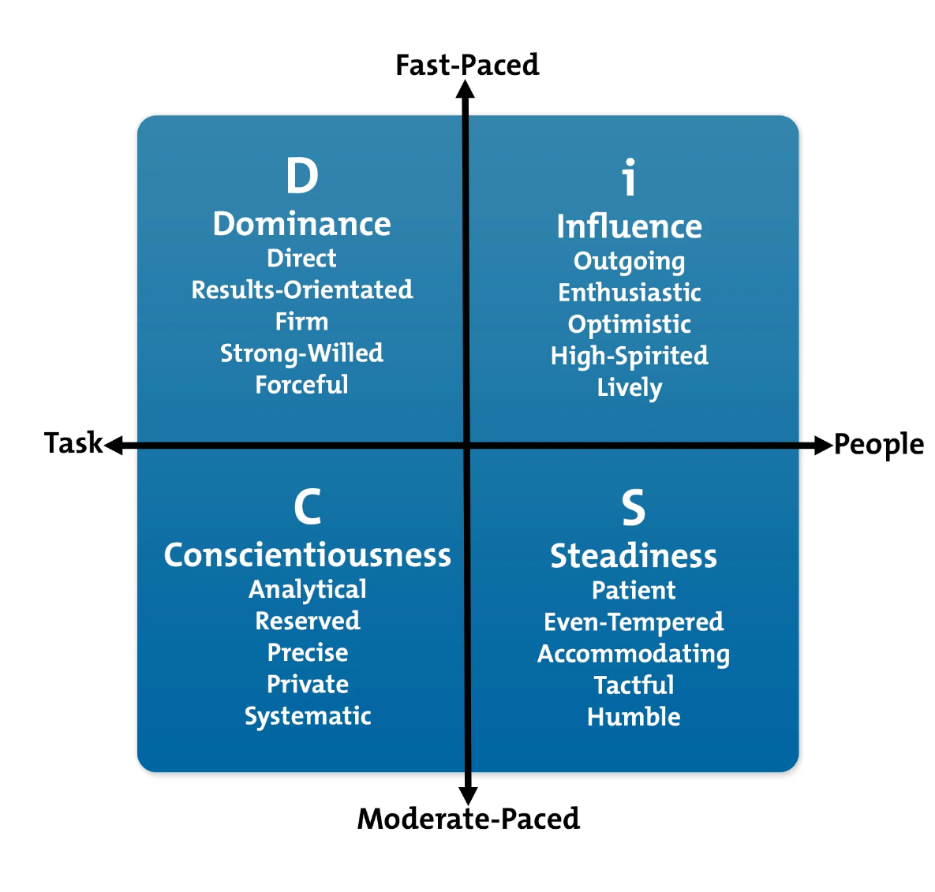

The DISC model allows individuals to analyse their own preferred behavioural style and those of their team members. Also, by sharing DISC profiles with other individuals on a team, it helps them to understand their differences so they can work more effectively together. This model can be used to increase team building as it allows individuals to understand that everyone has different preferences and that individuals are able to improve their interpersonal relationships and manage team members in a way that plays to their strengths.

An advantage of this model is that it allows individuals to analyse their own preferred behavioural style and those of their team members (MindTools, n.d). However, this is a simplified model and individuals are complex and sophisticated therefore this model is not always the most suitable model.

Another model that facilitates team progression is Belbin’s model of Team Role. Dr Belbin’s research identified that there are nine clusters of behavioural attributes which are effective for team development. The nine Belbin team roles can be broken down and defined as:

- Resource investigator – where the individual is extrovert, enthusiastic and communicative.

- Team worker – where the individual is mild, perceptive, diplomatic, listens and averts friction.

- Co-ordinator – where the individual takes a mature approach to situations, is confident and delegates well.

- Plant – where the individual is creative, imaginative, unconventional, introverted and a problem-solver.

- Monitor Evaluator – where the individual is astute, sees all options and points of views whilst judging accurately.

- Specialist – whereby the individual has in-depth knowledge of a key area.

- Shaper – the individual is dynamic, thrives on pressure, has the drive and ability to overcome obstacles.

- Implementer – whereby the individual is reliable, efficient and can turn ideas into practical actions.

- Completer Finisher – where the individual is conscientious, anxious, searches out errors and omissions, whilst being a perfectionist. (Belbin,2012b:22).

Belbin stated “The types of behaviour in which people engage are infinite. But the range of useful behaviours, which make an effective contribution to team performance is finite. These behaviours are grouped into a set number of related clusters, to which the term ‘Team Role’ is applied” (Belbin, 1981). Belbin’s research indicated that the most successful teams were made up of a diverse mix of behaviours. This does not mean that every team needs to consist of nine individuals to be effective, instead some individuals will have more than one preferred team role so will often occupy more than one beneficial trait in their team. Belbin created a psychometric test called the “Belbin Team Inventory test” to establish the ideal team roles for individuals to possess within a team. Participants must evaluate their own behaviours, receive feedback from observers and compare the two.

An advantage of this model is that it reflects how individuals like to work and their preferred ways of working. However, there are also limitations to this model, such as individuals who use this model needing to understand that their test results are not fixed for life. Behaviours change and people adapt therefore it is possible for individuals to achieve a different ‘preferred role’ if completing the test again in the future.

A contradiction of Belbin’s model is Honey’s team roles, whereby Honey’s research exhibits five team roles that are essential for an effective team.
- The leader – whereby an individual ensures that the team understand their aims and objectives whilst ensuring involvement and commitment stays high. In the police force an Inspector would be associated with this role.
- The challenger – whereby the individual questions the effectiveness of the task, the team etc and asks to implement improvement. In the police force this role could be associated with a sergeant. This role is important as it is crucial that time isn’t wasted and productivity is high.
- The doer – whereby the individual attempts to get the team to make a contribution to the task at hand and plays a practical part of all tasks.
- The thinker – whereby the individual comes to the team with well-thought ideas and attempts to improve ideas of other team members.
- The supporter – whereby the individual tries to keep team cohesion and harmony. They try to ease all the tension and ensure good team work. Again, in the police force this role can be associated with a sergeant.

Although team cohesion is needed for an effective team, there can be times where individuals take it too far and forget that they must adhere to specific standards such as the professional standards of policing, which includes the code of ethics, policies, procedures, and legislation. This can often lead to a misconduct hearing for the officers involved and can even result in their dismissal from the job, an Example of this would be Deniz Jaffer and Jamie Lewis. Both Jaffer and Lewis were Metropolitan police officers who were both sentenced to two years and nine months after they took photos of two murder victims whilst they were meant to be guarding the scene in London 2020 (Guardian, 2021). The two officers took photos of the bodies and shared them in Whatsapp groups, one of which contained 41 other officers. Their actions amounted to a gross breach of trust and even helped the defence of the murderer, Danyal Hussein as his defence team tried to claim possible contamination by the two officers entering the crime scene to take photos. Both officers had to leave their post and enter the crime scene to take the photos that were found on their phones as these could not have been taken from the post that they were assigned to (Gaurdian, 2021).

As police officers there are certain expectations and standards that we have to live up to and both Jaffer and Lewis abandoned these. Within the code of ethics, there are ten standards of professional behaviour. These are:
- Honesty and integrity
- Authority, respect and courtesy
- Equality and diversity
- Use of force
- Orders and instructions
- Duties and responsibilities
- Confidentiality
- Fitness for work
- Conduct
- Challenging and reporting improper behaviour

Jaffer and Lewis breached multiple of these standards as they did not act with integrity, they compromised and abused their position by accessing the crime scene. Also they did not abide with police regulations as they left their post. Moreover, they did not follow the reasonable order which was to stay at their post. Adding to that, they breached confidentiality by not treating the victims/victim’s family with respect. They accessed and disclosed information/photographs which were not in proper course of their duties. Lastly, they brought discredit to the police service and undermined public confidence in policing.

In Conclusion, multiple theories of team dynamics such as Tuckerman’s, Belbin’s and Honey’s have been created as a means of developing team cohesion. All of these theories have benefits and limitations however some contradict each other, such as Belbin’s and Honey’s. There are many reasons why interpersonal conflict can occur and models like Lencioni’s outlines five common problems that teams experience which impacts their effectiveness. Lencioni’s model breaks down the five areas and he suggest that trust should also be targeted first when trying to reduce interpersonal conflict. I have also considered how team dynamics within the police force can result in failing to comply with professional standards.

Wordcount: 1925

Task 4
Relevant areas of the National Policing Curriculum:
Policing the roads, information and intelligence and conducting investigations.

Explain how information and intelligence can be used in the disruption of the more prevalent criminal activity (e.g. drug smuggling, human trafficking, child sexual exploitation, counterfeit goods, organised crime groups and ‘county lines’) by effective policing of the roads.

Outline how ANPR can be used as investigative resource when disrupting criminal activity.

1750 words (+/- 10%: include your actual word count at the end of each section)

ANSWER:

In this essay, I am going to be analysing how information and intelligence can be used in the disruption of the more prevalent criminal activity, such as drug smuggling, human trafficking, child sexual exploitation, counterfeit goods, organised crime groups and ‘county lines’ by effective policing of the roads. I am also going to be explaining how automatic number plate recognition cameras (ANPR) can be used as an investigative resource when disrupting criminal activity.

Information has been defined by Liew (2007) as a message that contains relevant meaning, implication, or input for decision and/or action. Information comes from both current (communication) and historical (processed data) sources. The purpose of information is to aid in making decisions and/or solving problems (Liew, 2007). Information consists of bits of data that, when combined and viewed together with relevant background knowledge, may be used to produce intelligence, which informs the actions and decisions of policing organisations (Innes and Sheptycki, 2004) such as South Wales Police.

Intelligence-led policing (LIP) was introduced in the UK in the 1990s as a new model of policing. Within this policing model, intelligence from several agencies is pooled with the explicit intention to ‘disrupt, disable or undermine criminal behaviour’ (Newburn & Neyroud, 2008). The concept of intelligence-led policing underpins all aspects of policing including the investigation of serious and organised crime and terrorism (Thornton, 2007). The Mantra of the ILP became to “target the criminal and not just the crime” (Adapted from an observation made by the Audit Commission, 1993) and this led to a much greater emphasis on intelligence gathering, by using the 5x5x5 model and the use of intelligence analysis.

LIP allows police forces to create strategies and tactics that aim to disrupt criminality in a way such as to prevent the crime from occurring or to reduce it’s gravity if it does occur instead of aiming at the detection of crimes that have already occurred. This has allowed police objectives to become more pragmatic, aiming to disrupt and disorganise criminal networks and markets (Innes & Sheptycki, 2004).

There is a link between road and traffic offences and other forms of criminality. Research has demonstrated that 79 per cent of disqualified drivers had a criminal record and that approximately 50 per cent of dangerous drivers had a previous conviction and approximately 25 per cent were convicted of an offence within a year – this is three times the average (Rose, 2000). For organised criminal group, the acquisition, shipment and trade of stolen vehicles is a low-risk way to make profits. Also, stolen vehicles are regularly used to finance and carry out other criminal activities, ranging from drug trafficking, arms dealing, people smuggling and international terrorism (Interpol, n.d).

Organised crime groups use vehicles to assist in their criminal activities such as County Lines, human trafficking and child sexual exploitation (gov.uk, 2017). County lines is where illegal drugs are transported from one area to another, often across police borders using cars or vans (NCA, n.d). Human trafficking involves the recruitment or movement of people for exploitation by the use of threat, force, fraud or the abuse of vulnerability (Gov.uk, 2017). Trafficking is a process of comprising various stages, starting with recruitment and followed by travel and transit, destination and exploitation. Organised crimes groups use vehicles such as cars and vans to transport their victims (Gov.uk, 2017).

Technology has the ability to transform how the police tackle criminality on the roads. One source of technology available to police forces to disrupt criminality is Automatic number plate recognition (ANPR).

Automatic Number Plate Recognition (ANPR) cameras are used to help detect, deter and disrupt criminality at a local, regional and national level, including tackling travelling criminals, organised crime groups and terrorists. ANPR provides lines of enquiries and evidence in the investigation of crime and is used by LEA throughout England, Wales, Scotland and Northern Ireland. (Police.uk (2021).
When a vehicle passes an ANPR camera, its registration number is read and instantly checked against database records of vehicles of interest. A record for all vehicles passing a ANPR camera is stored, including those vehicles that are not known to be of interest at the time of the read that may in appropriate circumstances be accessed for investigative purposes.

Police officers can then use the data received from ANPR cameras to intercept and stop a vehicle, check it for evidence and where necessary, make arrests. (police.uk).

Another benefit of ANPR is it allows officers attention to be drawn to offending vehicles whilst allowing law abiding drivers to go about their business unhindered. (police.uk). When activated they send alert to police providing info on the car make model etc and the direction of travel this allows specific departments ie traffic to create effective operations in order to intercept the vehicle in the best way / way that has least impact on members of the public.

Adding to that, another advantage of ANPR is that the cameras are linked to a number plate reading device (NRD) that collect data, which is then stored on the National ANPR Service (NAS) database. ANPR can identify a vehicle of interest based on the number plate it is displaying. The capability of the reader dictates the number of vehicles that can be read. NRDs can be:
- Static – these are built to capture and read VRM’s in a fixed location which will not be moved.
- Moveable – These are built to capture and read VRM’s in a fixed location but on a temporary basis.
- Multi-lane – these have the capability to read VRM’s across multiple lanes, as well as vehicle movements in the same or opposite directions of travel. This can be done using a single NRD.
- CCTV integrated – these have a dual-purpose camera that can operate as CCTV and as an NRD. Integrated systems only provide data to the NAS when in ANPR mode.
- Mobile – these are built to capture and read VRMs from a mobile base, including vehicle-mounted systems or other portable systems.
- Covert - Can be static, moveable, or purpose-built and are authorised for deployment to support covert policing operations, such as a pre-planned operation to stop a vehicle.

Police officers have the authority to seize a vehicle on the road if it may have been used to commit crime or has been left in a dangerous, unlawful position, or in a dangerous condition. Some examples of these powers are:

- Section 163 of the Road Traffic Act 1988 – whereby a person driving a mechanically propelled vehicle on a road must stop the vehicle on being required to do so by a constable in uniform or a traffic officer (CoP, 2013)

- Section 4 of the Police and Criminal Evidence Act 1984 – Which allows either all vehicles or those selected by a particular criterion to be stopped in a particular locality in order to locate an offender or witness involved in an indictable offence (subject to authorisation). This section affords maximum protection to both the public and police while giving little warning to the suspect and no escape routes (CoP, 2013).

- Section 43, 44 and 45 of the Terrorism Act 2000 – This gives officers a preventative stop and search power to the police when terrorist activity is anticipated in a particular location (CoP, 2013).

Despite police officers having a power to stop vehicles (s163 RTA 1988) and the driver being required to comply, there are circumstances when drivers choose to ignore this and continues to drive. This could be because are part taking in criminal activities or have contraband in their vehicle which tey do to want the officer to seize. As a result of this, there are times when a police pursuit is required in order to disrupt crime (CoP, 2013). A police driver is deemed to be in a pursuit when a driver indicates by their actions or continuance of their manner if driving that:
- They have no intention of stopping for the police and
- The police driver believes that the driver of the subject vehicle is aware of the requirement to stop and decides to continue behind the subject vehicle with a view to either reporting its progress or stopping it (College of Policing, 2013)

When a situation meets the definition of a pursuit, officers have to decide whether a pursuit is Justified, proportionate and conforms to the principle of least intrusion. Pursuits can be spontaneous or part of a pre-planned operation (CoP, 2013).

Pre-emptive tactics can be used to prevent a pursuit from taking place. An officer may find themselves behind the suspect’s vehicle in the normal flow of traffic. The driver of the suspect vehicle may remain unaware of the police interest or decide to continue driving normally in the hope that the officer’s presence is coincidental. during this time, it allows the officer to consider the use of preventative and pre-emptive tactics. When preventative or pre-emptive actions are clearly proportionate to the intelligence (CoP, 2013).

I am now going to outline some of the techniques/tactics used by police forces to stop subject vehicles/drivers:
- Boxing – this is where several police vehicle positions themselves around the pursued vehicle bringing it to a slow and gradual stop by boxing the target vehicle in on all sides.

- Spike strip or stinger – this method is employed if boxing would be too difficult, this could be due to the speed or the aggressive driving of the target vehicle. A hollow spike tyre deflation device is placed across the front of the target vehicle to deflate its tyres. This can safely stop even a fast-moving vehicle as the hollow spikes allow a controlled deflation to the tyres.

- Tactical contact – this method is only used if there is an immediate danger to life and if it would be inappropriate to break off the pursuit. Tactical contact involves a police vehicle hitting the back end of the target vehicle causing the target vehicle to spin around and lose traction.

- Static stop – this method is used as a last resort. Police vehicles can block off a road therefore forcing the target vehicle to stop. this tactic requires authorisation from an officer of an inspector rank or above as it may cause damage to the police vehicle and injury to officers.

- PIT Manoeuvre – this method begins when the pursuing vehicle pulls alongside the target vehicle so that the portion of the pursuing vehicle’s front wheels are aligned with the target vehicles back wheels the pursuing vehicle then gently makes contact with the targets side and then steers sharply into the target. As soon as the target vehicle’s rear tyres lose traction and start to skid, the pursuer then turns the same direction as the target vehicle, causing the target vehicle to turn the opposite direction, in front of the pursuer and will spin out. Another police vehicle with then follow the target vehicle to proceed with the arrest while the PIT vehicle recovers its own control and completely stops the vehicle.

These methods are all used by all Police forces, including South wales Police.

In conclusion, information and intelligence is widely used in the disruption of the more prevalent criminal activity such as county lines, human trafficking and child sexual exploitation. Effective policing of the road plays a massive part in disrupting criminal activities and technology such as ANPR and NRD contribute to this. By using ANPR as an investigative resource policing has developed and become more efficient. Information and intelligence can be used to first identify a subject vehicles route, ANPR can then be used to detect the location of the vehicles and then tactics and strategies such as the PIT manoeuvre are used to stop vehicles when required to do so.

Wordcount: 1925

Task 5
Individual Learning Plan

The second learning outcome identified in the accompanying module descriptor (BMPP 5000D) asks that you create an individual learning plan to meet your identified needs through reflection upon your continuing practice. This shows confidence in your ability to manage your own learning in response to evolving circumstances in the workplace.

This task differs from the PDPs that you have completed in your previous workbooks in that this learning plan allows you to assess what level you believe you are in key knowledge, skills and experience against where you believe you (and the force) consider you should be – now and in the coming 6 to 12 months of your placement. This should then be used to target future development need.

1500 words equivalent. Please note that this is not the actual number of words used in completing the table, the count reflects the thought and research behind it.

It will count towards the overall equivalent word count of 8000 words expected from this module.

ANSWER:

Knowledge, Skills and Experience Assessment

 | REQUIRED |  |  | RATING |  |  | DEVELOPMENT NEED
KNOWLEDGE | Low  1-4  4 | Med  5-7 | High  8-10 | Low  1-4  4 | Med  5-7 | High  8-10 | As a front-line response officer, I have been faced with many different situations and circumstances, although I have not been in the police force for a long period of time, I feel that my experience is at four. At the end of my tutorship, I would have graded myself a two however since being independent my knowledge has increased, hence why I would now grade myself a four  I will also be able to further my knowledge when I complete the necessary attachments. For example, as a response officer, I have not dealt with many Road traffic collisions (RTC) as South Wales Police have their own specialised traffic unit that attends all the Road Traffic Collisions. I have an attachment booked with the traffic unit for February whereby I will stay with a traffic officer for a few shifts and observe how they deal with incidents. This will further my knowledge and they will be teaching me new things regarding traffic in general. I have also booked other attachments to assist in developing my knowledge such as the Public Protection Unit, Custody, The Hub which is where all interviews take place and Crime investigation detectives.
SKILLS | Low  1-4  5 | Med  5-7 | High  8-10 | Low  1-4  5 | Med  5-7 | High  8-10 | In relation to my skills, I would grade myself a five as although my skills have developed since I have achieved independent status, I know that I still must further develop them in order to become a skilled officer. I plan on ensuring that I take the correct steps to further develop.  I know that throughout my career, I will be able to progress and develop my skills. One way of me being able to do this is by going on police attachments. I plan on completing an attachment with the Public protection unit – this will allow me to develop my victim and safeguarding skills. I will also complete my interviewing and CID attachment to develop my investigative skills.  In addition to this, I will be using my Blackstone’s policing book to further my skills by making myself aware of certain techniques and alternatives ways to conduct policing policies. This will result in me being a well-rounded police officer in the future which I intend to be.
EXPERIENCE | Low  1-4  3 | Med  5-7 | High  8-10 | Low  1-4  3 | Med  5-7 | High  8-10 | In relation to my experience of the job, although I have successfully completed by 6 months theory-based training, I have only been independent for approximately eighteen months. In terms of having a full career in the police, which is thirty-five years, my knowledge is little compared to what it will be in the future when I have been in the job for a longer period.  I plan to develop my experience by completing different attachments such as CID, Public protection unit, the interviewing unit, traffic unit etc. these will allow me to develop skills in those specialised departments that I can then use whilst on response.

Bibliography
The bibliography should only include sources referenced within the workbook using the Harvard referencing system. Information about referencing in written assignments and how to avoid plagiarism can be found on Moodle. It is important that you are aware of the importance of ensuring that the work submitted is your original work.

References:

- BBC News (2019) Silent 999 calls: Press 55 to confirm emergency. Available at: https://www.bbc.co.uk/news/uk-47847735 (Accessed on 20.12.21)

- BC campus Authoring platform - Five models of understanding Team Dynamics ( ) Available at: https://pressbooks.bccampus.ca/technicalwriting/chapter/understandingteamdynamics/#return-footnote-1135-8 (Accessed on 03/08/2021)

- Belbin (1981) Belin Team Roles. Available at Management Teams: Why they succeed or Fail. (Accessed on 31.12.21)

- Belbin Associates (n.d) The nine Belbin team roles. Available at: https://www.belbin.com/about/belbin-team-roles (Accessed on 31.12.21)

- Belfast Area (2019) Make yourself heard campaign. Available at: https://belfastdvp.co.uk/make-yourself-heard-campaign/#:~:text=Make%20Yourself%20Heard%20Campaign%20%E2%80%98Make%20Yourself%20Heard%E2%80%99%20campaign,are%20in%20imminent%20danger%20but%20unable%20to%20speak. (Accessed on 20.12.21)

- Bond et al & Baughman et al (2013, 2014) Available at Police stressors and health: a state-of-the-art review (nih.gov) (Accessed on 25.12.21)

- Borton (1970) Model of reflection. Available at: https://essaywritingserviceuk.co.uk/advice-and-guidance/bortons-model-of-reflection (Accessed on 29.12.21)

- Childs. C & De Wit. H (2014) Regular exercise is associated with emotional resilience to acute stress in healthy adults. Available at: https://www.ncbi.nlm.nih.gov/pmc/articles/PMC4013452/ (Accessed on 29/11/2021)

- College of policing (2014) Code of Ethics. Available at: https://assets.college.police.uk/s3fs-public/2021-02/code_of_ethics.pdf (Accessed on 31.12.21)

- College of Policing (2013) National Decision Model. Available at: https://www.app.college.police.uk/app-content/national-decision-model/the-national-decision-model/#the-model (Accessed on 01/08/2021)

- College of Policing (2015) Positive action. Available at: https://www.app.college.police.uk/app-content/major-investigation-and-public-protection/domestic-abuse/arrest-and-other-positive-approaches/ (Accessed on 22/07/2021)

- College of Policing (2013) Road Policing, Police pursuits. Available at: https://www.app.college.police.uk/app-content/road-policing-2/police-pursuits/ (Accessed on 31.12.21)

- Culture in the Police Force (2018) UKEssays. Available at: https://www.ukessays.com/essays/cultural-studies/culture-as-the-way-of-life-cultural-studies-essay.php?vref=1 (Accessed on 09.12.21)

- Department of Health (2014) Definition of safeguarding. Available at: https://www.gov.uk/ government/uploads/system/uploads/attachment_data/file/366104/43380_23902777_Care_Act_Book.pdf (Accessed on 20.12.21)

- Festinger, Schacter & Back (1950) – Social pressures in informal groups: a study of human factors in housing. Available at: https://www.collectionbooks.net/pdf/social-pressures-in-informal-groups-a-study-of-human-factors-in-housing-by-leon-festinger-stanley-schachter-and-kurt-back – page 164 (Accessed on 02/09/21)

- Gov.uk (2017) Human Trafficking: migrant health guide. Available at: https://www.gov.uk/guidance/human-trafficking-migrant-health-guide (Accessed at 31.12.21)

- Gov.wales (n.d) Live Fear Free. Available at: https://gov.wales/live-fear-free/domestic-abuse-wales#:~:text=Live%20Fear%20Free%20can%20provide%20help%20and%20advice,member%20or%20colleague%203%20practitioners%20seeking%20professional%20advice. (Accessed on 01/11/2021)

- Hill & Lineback (2011) – Article titled Turn your group into a true team. Available at: https://hbr.org/2011/06/turn-your-group-into-a-true-te.html (Accessed on 02/09//21)

- HM Government (2014) Out of Court Disposals. Available at: https://consult.justice.gov.uk/digital-communications/out-of-court-disposals/results/out-of-court-disposals-response.pdf (Accessed on 9.12.21)

- Honey (2001) Team roles theory. Available at https://studyhub.fxplus.ac.uk/study-guides/teams-groupwork/activities/team-roles (Accessed on 31.12.21)

- Indeed Editorial Team (2021) The nine Belbin team Roles. Available at:https://www.indeed.com/career-advice/career-development/belbin-team-roles#:~:text=Meredith%20Belbin%20devised%20the%20Belbin%20Team%20Inventory%20test,receive%20feedback%20from%20observers%20and%20compare%20the%20two. (Accessed on 31.12.21)

- Innes & Sheptycki (2004) From detection to disruption. Available at: https://journals.sagepub.com/doi/abs/10.1 (Accessed on 31.12.21)

- Interpol (n.d) Vehicle crime. Available at: https://www.interpol.int/en/Crimes/Vehicle-crime (Accessed on 31.12.21)

- Juducael Paquet(2020) Tuckerman Model: Team cohesion. Available at: https://www.myagilepartner.com/blog/index.php/2020/07/30/tuckman-model/ (Accessed on 16/12/21)

- Le. C, Nowell. C, Kim-Fuchs. C (2016) Chronic stress in mice remodels lymph vasculature to promote tumour cell dissemination. Available at https://doi.org/10.1038/ncomms10634 (Accessed on 25/12/21)

- Legislation.gov.uk (n.d) Criminal Justice act 1988. Available at: Criminal Justice Act 1988 (legislation.gov.uk) (Accessed on 25.12.21)

- Lencioni, P – The five Dysfunctions of a Team (2005) Available at: https://www.academia.edu/39178542/The_Five_Dysfunctions_of_aTeam_Patrick_Lencioni (Accessed on 03/08/2021)

- Liew (2007) Data, information, Intelligence, Wisdom and their interrelationships. Available at: https://www.researchgate.net/profile/Anthony-Liew-2/publication/236870996_DIKIW_Data_Information_Knowledge_Intelligence_Wisdom_and_their_Interrelationships/links/0deec519c0cac9afca000000/DIKIW-Data-Information-Knowledge-Intelligence-Wisdom-and-their-Interrelationships.pdf (Accessed on 31.12.21)

- McGonigal (2020) Available at: https://www.shape.com/fitness/tips/exercise-mental-resilience-stress#:~:text=%22On%20days%20when%20people%20exercise%2C%20stressful%20things%20take,your%20brain%20over%20time%20and%20maintains%20brain%20health. (Accessed on 13/11/2021)

- Miller (2014) When four worlds collide. Available at: Training journal, pages 22-27 https://www.thecampuscommon.com/library/ezproxy/ticketdemocs.asp?sch=suo&turl=https://search-ebscohost-com.southuniversity.libproxy.edmc.edu/login.aspx?direct=true&db=bth&AN=95880476&site=eds-live (Accessed on 29.12.21)

- MindTools (n.d) The DISC MODEL. Available at: https://www.mindtools.com/pages/article/newCDV_92.htm (Accessed at 31.12.21)

- National Alliance on mental Health (2018) why high rates of PTSD in police officers. Available at: https://nationalpolicesupportfund.com/police-officers-experience-high-rates-of-ptsd/#:~:text=That%20issue%20is%20Post%20Traumatic%20Stress%20Disorder.%20New,and%20large%2C%20police%20officers%20suffer%20from%20cumulative%20PTSD. (Accessed on 25.12.21)

- Newburn (1999) Understanding and preventing police corruption: Lessons from the literature. Available at: Police Research series Paper 110 (Accessed on 15/09/2021).

- Newburn and Neyroud (2008) Available at: Dictionary of Policing, Page 146. (Accessed on 15/09/2021)

- NHS (2020) How much sleep do children and adults need? Available at: https://www.nhs.uk/live-well/sleep-and-tiredness/how-much-sleep-do-kids-need/ (Accessed on 25.12.21)

- Office for National Statistics (2021) Domestic abuse prevalence and trends, England and Wales: year ending March 2021 Available at: https://www.ons.gov.uk/peoplepopulationandcommunity/crimeandjustice/articles/domesticabuseprevalenceandtrendsenglandandwales/yearendingmarch2020 (Accessed on 22/07/2021)

- Oxford Dictionary (n.d) Definition of Resilience. Available at: https://www.oxfordlearnersdictionaries.com/definition/english/resilience?q=resilience (Accessed on 09.12.21)

- Police.uk – Automatic Number Plate Recognition (ANPR) (2021) Available at: https://www.police.uk/pu/advice-crime-prevention/automatic-number-plate-recognition-anpr/ (Accessed on 18/07/2021)

- Reiner (2000) Crime and Control in Britain. Available at: https://journals.sagepub.com/doi/10.1177/S0038038500000067 (Accessed on 09/12/21)

- Rose (2000) Available at: the criminal histories of serious traffic offenders, HORS 206 (Accessed on 15/09/2021).

- Shane (2010) Organisational stressors and police performance. Available at: Journal of criminal Justice, Volume. 38, No. 4, pp. 807 – 818 (Accessed on 25/12/21)

- South Wales Police (n.d) What is domestic abuse? Available at: https://www.south-wales.police.uk/advice/advice-and-information/daa/domestic-abuse/what-is-domestic-abuse/ (Accessed on 22/07/2021)

- The Gaurdian (2021) Two Met police officers jailed over photos of murdered sisters. Available at: https://www.theguardian.com/uk-news/2021/dec/06/two-met-police-officers-jailed-photos-murdered-sisters-deniz-jaffer-jamie-lewis-nicole-smallman-bibaa-henry (Accessed on 31.12.21)

- The happy manager (n.d) Teamwork theory. Available at: Teamwork Theory | Tuckman's Stages of Group Development - The Happy Manager (the-happy-manager.com) (Accessed on 31.12.21)

- Thornton (2007) Available at: Introduction in ACPO practice : introduction to Intelligence-led policing, ACPO centrex, Page 3 (Accessed on 15/09/2021)

- Tobin, R (n.d) Team cohesion in the workplace. Available at: https://www.russelltobin.com/culture/team-cohesion-in-the-workplace/ (Accessed on 16/12/21)

- Towler (2019) – Article titled The importance of team cohesion for team effectiveness. Available at: https://www.ckju.net/en/dossier/importance-team-cohesion-team-effectiveness (Accessed on 02/09/21)

- Tuckerman (1965) – Developmental sequence in small groups. Available at: (Accessed on 16/12/21)

- US National Library of Medicine (PMC) (2017) Police stressors and health: A state of the art review. Available at: https://www.ncbi.nlm.nih.gov/pmc/articles/PMC6400077/ (Accessed on 20.12.21)

- Waddington (2004) British Journal of Criminality. Available at: https://www.researchgate.net/publication/249284138_Police_canteen_sub-culture Accessed on 09.12.21)

- William Marsten (1928) – Emotions of Normal people. Available at: https://archive.org/details/emotionsofnormal032195mbp (Accessed on 03/08/2021)

