- Framed

- P151405

3 BA Glass: Architectural Arts

4 Word Count 2117

5 Julia Lockheart

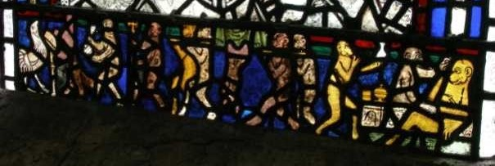
Figure 1The Pilgrimage Window, York Minster, with the Monkey's Funeral at its base. (Brown, n.d.))

The link between early glass and illuminated manuscripts within religion has always interested me, especially the cartoon like animals that so often appear at the sides and bottom that front page of a new chapter, peaking out of foliage, sometimes with a moral tale to tell. In the Pilgrimage Window in York Minster, made in around 1325 as shown in figure 1, animals in the roles of humans can be seen not hidden away, but where it can be clearly viewed (Rosewell, 2007); very much in the style of this early marginalia.
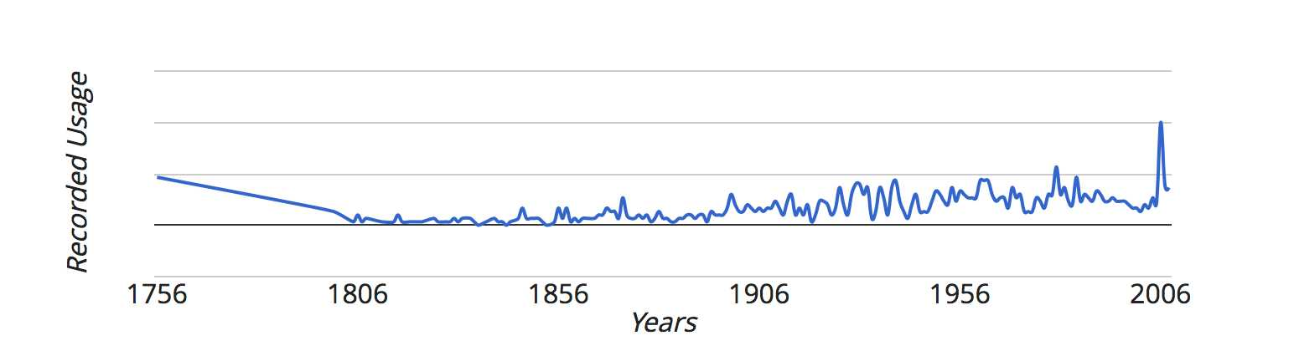
Figure 2Recorded use of Marginalia (Collins Dictionary, 2006))

The Collins Dictionary online describes marginalia as being notes in the margin (Collins Dictionary, 2006). The phrase marginalia may be relatively new, marginal which it derives from first appeared in 1573 (Merriam-Webster, n.d.). Looking at figure 2 we can see that the word was in common use from 1756, then declined steeply.

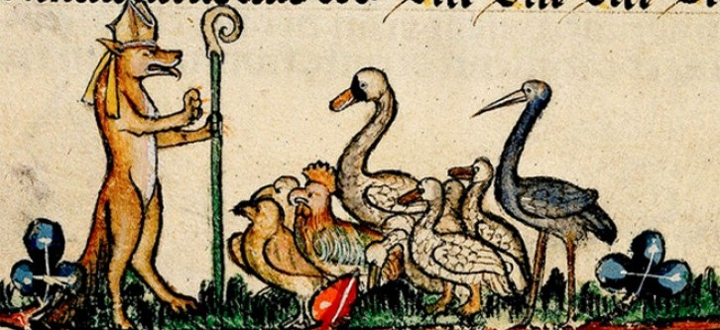
Figure 3 A fox ministering to a congregation of birds. (Dobrinska, 2016))

Traditionally, the view can be seen that marginalia consisted of religious art work with religious texts (Sayers, 2017), however, delve a little deeper and a more abstract world appears. Animals replace people, foxes minister to geese, (figure 3), monsters peer from leaves, birds with the faces of men walk round the top of pages, while knights battle snails (Biggs, 2013). The means for these illustrations over time have become lost, the snails it has been argued could represent social climbers, the Resurrection, or the Lombards (Biggs, 2013).

At times the marginalia we see clearly matches the texts it accompanies, at others it wildly differs suggesting it is a later addition. An example of this is the Skarðsbók manuscript from Iceland which has a Crucifixion by a section on the law regarding manslaughter (Schott, 2010). Others clearly illustrate the text, as can be seen with the delightful depictions which accompany Mirror of Phlebotomy & Practice of Surgery, some being quite anatomical in penmanship (Burgess, 2017).
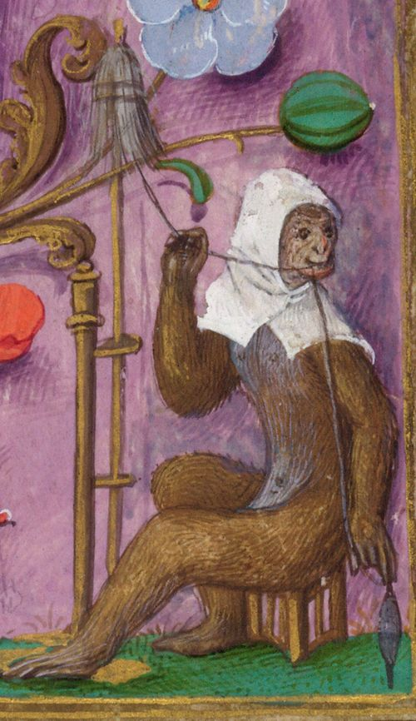
Figure 4 A monkey wearing a cowl and spinning thread, in the boarders of the Isabella Breviary, Southern Netherlands, between the late 1480s and 1497 (Biggs, 2012))

This space within the margins can be seen as a way of recording the lives of those that wrote the manuscripts, they comment on the weather and the quality of the materials they have to work with (Schott, 2010). Monks complaining about their working and living conditions were not unique to Iceland, in the margins from a codex originally from Georgia, the words, “God knows that sort of original I had to work with” (Anon., 2010). The lives of the people are beautifully recorded in the illustrations that make up the rich designs within the margins as can be seen in the Gorleston Psalter, a man ploughs his fields with oxen while a blacksmith shapes horse shoes in another scene (Biggs, 2012). Females be they human, animal or imagined, appear less in marginalia than men; when women do appear their hair is respectfully covered, as can be seen in figure 4 and often carry a distaff or spindle (Schaus, 2006). The vellum itself can also become part of the marginalia too, with holes in the pages being incorporated into the designs reminding us that this was the hide of an animal (Schott, 2010), at times a temperamental surface to write upon.

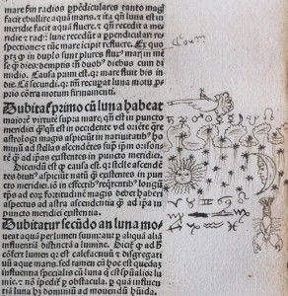
Figure 5 A hand with a finger points to a key piece of text and various astrological signs. (Scott-Warren, 2015))

It is as though what is written in the margins is entirely separate to the main text, this is a place for asides, practicing your signature and occasionally changing the spelling of someone who has written before you (Schott, 2010). The hand with a pointing finger to highlight a point or phrase, also, begins to appear in the margins in the 15th century, with one fabulous example of a whole hand with fingers outstretched being used to high light an entire passage (Kwakkel, 2014). The use of the marginal spaces as practice areas or to test a new quill, small illustrations of animals can be seen (Green, 2016). The pointing fingers are our sticky notes of today, to remind us of important passages in texts; they serve as high lighters. The practice marks and illustrations the doodles of the day, both point to being later additions to the original texts while some were clearly done at the time of the original manuscripts being created.

Roundels tend to be visually noticeable due to their detailed paintwork and use of silver stain. Silver stain is silver nitrate in a carrier, which when fired in a kiln stains the glass a rich yellow colour (Elskus, 1982). This technique has been used since the fourteenth century, the resulting colour ranging from a pale yellow to rich orange depending on application and heat of firing (Couteur, 1978).
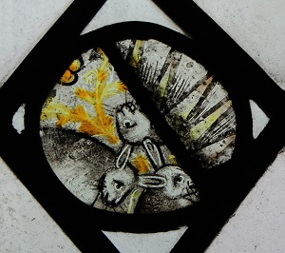
Figure 6 The Hare or Rabbit Roundel from Holy Trinity Church Long Melford (Churchedit, 2018))

Roundels from around five hundred years ago can be seen depicting religious imagery, such as that from Long Melford Church in Suffolk, which shows three hares or rabbits (Churchedit, 2018). Each hare has only one ear, but shares the ear of the hare next to it, resulting they look as though they each have two, it is seen to represent the Trinity (Halliday & Lashington, 1976). Of a similar age is a roundel from the Church of St Asaph and St Cynderyn, Llanasa, showing a hand holding a silver stained money bag out towards a silver stained cockerel (Crampin, 2014). To those viewing this roundel it would have been something they knew; and possibly something they had seen in a Passion play (Halliday & Lashington, 1976). What survives of this early glass shows it was made by artists who used a language rich in symbolism.
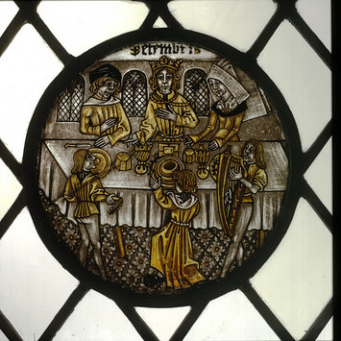
Figure 7 The December Feasting, (Anon., n.d.))

From the fifteenth century roundels often showed people going about their daily life, showing agricultural tools (Coe, 1980). These scenes are often known as the Labours, although, no one full set remains, there would have been one roundel for each month of the year. The scenes relate to the agricultural jobs of the month, in four roundels from Cassiobury Park now in the Victoria and Albert Museum we see a labourer pruning vines, while a crow pecks at his lunch bundle in March; in August a woman cuts corn with a sickle while a man follows on behind tying it in bundles, both wear straw hats. In October one man leads two horses, harrowing the field; while his companion sows the field, horse and men both step forwards on their right foot, lest they be ‘wrong’ footed (Williamson, 2003). The last is December, which shows a table set for a feast and behind stands a ‘king’ and two other figures; in front are two musicians and a servant who is carrying a large number of dishes.

While many roundels are a single piece of glass, some are multiple pieces; this can be due to damage, or at times to allow the inclusion of coloured glass. The November roundel from Brandiston Hall, Norfolk, from the 15th century, is made up of multiple pieces (Halliday & Lashington, 1976). It shows a person sheltering from a hailstorm. It has a detailed silver stain boarder, which would have needed to be made in several pieces and then the roundel itself, of a person going into a small building to shelter from the hail. The person wears robes of deep maroon and blue hose; behind them the garden is in one piece and we see it in great detail, including a spade and the hail falling through the air.

Through a proliferation of these images the lives of those who lived during the Medieval period are recorded. Their monthly labours are shown and their annual end of year gathering and feast depicted in a number of different ways. Not all the Labours show the same tasks for each month, which suggest regional variations. Some we know were commissioned for churches and others for cathedrals, as we have records of this, also some were for secular buildings (Coe, 1980). An earlier manuscript held by the British library showing illustrated roundels as part of the marginalia, also, shows a variation in Labours (Anon., n.d.), the variations in monthly labours across years, and roundels suggest different areas of production, spring arrives later in the north of England than in the south, therefore, roundels being produced in varying parts of the country would show different tasks. Those produced in Europe would also show different tasks in different months.

Roundels were also popular on the continent with a large number being painted in the Netherlands, showing Old Testament narrative scenes (Masters, 2015). Often a whole story would be told across a series of roundels; for example; ‘The Book of Tobit’, but for those familiar with the stories of the Old Testament a single rondel would have been enough to remind them of the churches teaching. These were of a similar didactic nature as the British roundels and also appear in British buildings as well as European settings (Hughes, et al., 2016).

The Story of Susannah is one such story where often only one image from the story is needed and it was often seen in government buildings to remind those in authority to think wisely, and with integrity (Anon., 2016). While she is often shown naked or partially covered, in two roundels in the Victoria and Albert Museum showing scenes from the story she is fully clothed with her hair covered; both were made around 1530 in the Netherlands (Anon., 2017). These two roundels are rich in painted details, to create shadows a light matt has been applied and then the paint carefully scrapped off, and the silver stain is applied with great care. Both roundels, additionally, have decorative square boarders with painted and silver stained pieces, these would have been costly to make. The Victoria and Albert Museum has another roundel in the series, this one is not currently on display it is sixteenth century and Flemish (Anon., 2017). It shows the last scene in the story where the Elders are being stone with Daniel and Susannah standing in the background; at some stage it has been damaged and a section has been lost. While there is some shading it is not done with the same sophistication as there other two, there is detail in paint work, but not to the same refinement; the silver stain is there, but not with the same delicacy, it looks far more like a line drawing (Raguin, 2003). This could be an apprentice piece, or it could be a piece produced to satisfy demand for decorative glass at the time to be surrounded by quarries in a window (Couteur, 1978). This is a piece done for a different pocket, showing a market for all levels of price range.

While secular roundels do exist and were clearly popular, roundels with a clearly ecclesiastical message were made for both secular and ecclesiastical settings, just as marginalia with both meanings appears all books. Both roundels and the illuminations seen in marginalia seem to take inspiration from each other during the other Middle Ages (Halliday & Lashington, 1976), as can be seen in the window from York Minster featuring the Monkey’s funeral (Rosewell, 2007). The use of didactic art to carry deeper meaning can be seen long before in the Lothair Crystal, which also tells the story of Susanna and the Elders and was probably made in Germany between 855 and 869 of rock crystal (MacGregor, 2012).This is a single roundel of rock crystal that tells the story of Susanna and the Elders with Latin text to explain each scene as well.

Through marginalia Christians were shown morals in non-religious texts, while roundels reminded those in power to judge wisely during the Middle Ages, Bishop Andrew John reminds us that Christ is in the margins (Andrew John, 2018). While six hundred years ago the links between religion and daily life would have been even more apparent (MacGregor, 2012), literacy was low, but visual literacy and understanding of metaphor was high.

This has led me to consider three areas I would like to further explore within a dissertation:
-The intercontextuality of imagery within religious glass.
-How animal symbols are used in art to tell moralistic stories.
-How a strongly visual and symbolic language was used in Mediaeval York and the surrounding area.
I feel that I need to do further research other the summer to better explore these ideas and intend to visit York to better understand the Mediaeval imagery used. I also hope to visit Exeter and Truro Cathedrals, as they are two cathedrals with very different historical time frames, as well as some of the smaller Cornish churches.

Bibliography
Andrew John, B. o. B., (2018). Evangelism and Mission update, Governing Body of the Church in Wales. Llandudno, s.n.
Anon., (2010). Illuminating a dark age. [Online] Available at: https://www.economist.com/node/17722535 [Accessed 10 April 2018].
Anon., (2016). Netherlandish painted glass 1500–1530. [Online]
Available at: http://www.vam.ac.uk/content/articles/n/netherlandish-painted-glass-1500-1530/ [Accessed 22 April 2018].
Anon., (2017). Roundel. [Online] Available at: http://collections.vam.ac.uk/item/O332410/roundel/ [Accessed 22 April 2018].
Anon., (2017). Susannah Accused by the Elders and Led to Judgement. [Online]
Available at: http://collections.vam.ac.uk/item/O11244/susannah-accused-by-the-elders-roundel-unknown/ [Accessed 22 April 2018].
Anon., n.d. (c1260), Calander, use of Sarum with the feasts for each month, small roundels of the labours. [Online] Available at: http://www.bl.uk/manuscripts/Viewer.aspx?ref=add_ms_62925_fs001r# [Accessed 27 April 2018].
Anon., (n.d). Labours of the month, December. [Online]
Available at: http://collections.vam.ac.uk/item/O7617/labours-of-the-months-december-panel-unknown/#.Wl9mmp0czmE.facebook [Accessed 30 April 2018].
Biggs, S. J., (2012). Monkeys in the Margins. [Online] Available at: http://blogs.bl.uk/digitisedmanuscripts/2012/04/monkeys-in-the-margins.html
[Accessed 29 April 2018].
Biggs, S. J., (2012). More Gorleston Psalter 'Virility': Profane Images in a Sacred Space. [Online] Available at: http://blogs.bl.uk/digitisedmanuscripts/2012/10/more-gorleston-psalter-virility-profane-images-in-a-sacred-space.html [Accessed 10 April 2018].
Biggs, (S. J., 2013). Medieval Manuscripts blog, Knight v Snail. [Online] Available at: http://blogs.bl.uk/digitisedmanuscripts/2013/09/knight-v snail.html?cid=6a00d8341c464853ef019b005601c9970b#comment-6a00d8341c464853ef019b005601c9970b [Accessed 25 March 2018].
Brown, S., (n.d). A Stained Glass Walk in York Minster. [Online]
Available at: http://www.yorkglazierstrust.org/assets/PDF/A-Stained-Glass-Walk-Around-York-Minster.pdf [Accessed 29 April 2018].
Burgess, A., (2017). The Strange and Grotesque Doodles in the Margins of Medieval Books. [Online]
Available at: https://www.atlasobscura.com/articles/medieval-marginalia-books-doodles [Accessed 10 April 2018].
Churchedit, (2018). Holy Trinity Long Melford with St Catherine's. [Online] Available at: http://www.longmelfordchurch.com/visiting/church-history/ [Accessed 16 April 2018].
Coe, B., (1980). Stained Glass in England: 1150-1550. 2nd ed. Ipswich: W.H. Allen & Co, Ltd. .
Collins Dictionary, (2006). Collins Dictionary. [Online] Available at: https://www.collinsdictionary.com/dictionary/english/marginalia [Accessed 04 April 2018].
Couteur, J. D. L. E., (1978). English Mediaeval Painted Glass. 2nd ed. London: Whitstable Litho Ltd.
Crampin, M., (2014). Stained Glass frm Welsh Churches. 1st ed. Talybont: Y Lolfa.
Dobrinska, L., (2016). In Defense of Marginalia. [Online] Available at: https://www.abaa.org/blog/post/in-defense-of-marginalia[Accessed 01 May 2018].
Elskus, A., (1982). The Art of Painting on Glass. 2nd ed. Richboro: Glass Press.
Green, J., (2016). The mystery of the medieval doodle, Today BBC Radio 4 [Interview] (01 December 2016).
Halliday, S. & Lashington, L., (1976). Stained Glass. 1st ed. New York: Crown Publisher Inc.
Hughes, J. O., Fleming, C., Crampin, M. & Lloyd, A., (2016). Trysorau Cudd, Hidden Gems. 1st ed. Aberystwyth: Sulien Books.
Kwakkel, E., (2014). Getting Personal in the Margin. [Online] Available at: https://medievalbooks.nl/2014/09/05/getting-personal-in-the-margin/ [Accessed 10 April 2018].
MacGregor, N., (2012). A History of the World in 100 Objects. 2nd ed. London: Penguin.
Masters, R., 2015. A Didactic Legend in Glass: Netherlandish Silver-Stained Roundels Depicting Scenes from the Book of Tobit. [Online] Available at: http://vidimus.org/issues/issue-94/feature-a-didactic-legend-in-glass/ [Accessed 19 April 2018].
Merriam-Webster, (n.d). Merriam-Webster. [Online] Available at: https://www.merriam-webster.com/dictionary/marginalia [Accessed 04 April 2018].
Raguin, V. C., (2003). The History of Stained Glass, The History of Light Medieval to Contempotary. 1st ed. London: Thames & Hudson.
Rosewell, R., (2007). Monkey Business in the Margins. [Online] Available at: http://vidimus.org/issues/issue-09/feature/ [Accessed 22 April 2018].
Sayers, K., (2017). Leeds University Library Blog. [Online] Available at: https://leedsunilibrary.wordpress.com/tag/medieval-manuscripts/ [Accessed 10 April 2018].
Schaus, E. M., (2006). Routledge Revivals:Women and Gender in Medieval Europe (2006): An Encyclopedia. 1st ed. s.l.:Routledge.
Schott, C. M., (2010). Footnotes on Life: Marginalia in Three Medieval Icelandic Manuscripts. [Online]
Available at: https://skemman.is/bitstream/1946/6060/1/Thesis%20Whole%20Edited.pdf
[Accessed 10 April 2018].
Scott-Warren, J., (2015). Early Modern Visual Marginalia. [Online] Available at: https://www.english.cam.ac.uk/cmt/?p=4687[Accessed 03 May 2018].
Williamson, P., (2003). Medieval and Renaissance Satined Glass. 1st ed. London: V&A Publications.

