Contributing to Employee Engagement 5AEEG

Name: Alys Owens
Student Number: 2005306
CIPD Membership Number: 56652305
Word Count: 2931

Module Name: Contributing to Employee Engagement in the Workplace

By signing below, I confirm that the work/evidence presented is my own, unaided work. I understand the regulations pertaining to candidate malpractice and the action that may be taken as a result.

Signed: Alys Owens
Dated: 14th March 2022

Learning Outcomes:

LO1 – Be able to assess levels of employee engagement within the organisation.
LO2 – Be able to evaluate current organisational approaches to employee engagement.
LO3 – Be able to recommend and plan strategies to raise levels of employee engagement within an organisation.

Contents Page

Item | Content | Page No
1 | Evidence Matrix listing evidence for every assessment criteria (ACs) | 3
2 | Personal Statement for LO1 | 4
3 | Evidence to support LO1 | 7
4 | Personal Statement for LO2 | 18
5 | Evidence to support LO2 | 20
6 | Personal Statement for LO3 | 21
7 | Evidence to support LO3 | 22

Candidate name: ALYS OWENS |  |  |  | CIPD membership No: 56652305
Qualification Title: CIPD Diploma in Applied Human Resources |  |  |  | ULN
Unit  Code | Unit Title | Assessment  Criteria No | Evidence  Description |  | Evidence  Reference  No | Assessor initials | I/V initials if sampled
5AEEG | Contributing to Employee Engagement in an Organisation | 1.1, 1.2, 1.3, 1.4 | Personal Statement for LO1 |  | EV1
“ | “ | 1.1, 1.2, 1.3, 1.4 | Witness statement from coach and mentor |  | EV2
“ | “ | 1.2 | Email exchange discussing plan |  | EV3
“ | “ | 1.3 | Use of Gallup 12 |  | EV4
“ | “ | 1.3 | Staff uniform engagement |  | EV5
 |  | 1.3 | Powerpoint on values |  | EV6
“ | “ | 1.3 | Engagement on absence |  | EV7
“ | “ | 1.3 | St David’s day engagement |  | EV8
“ | “ | 1.3 | Photos of Xmas and St David’s day |  | EV9
 |  | 1.4, 2.1 | Personal Statement for LO2 |  | EV10
 |  | 2.1, 2.2 | Proof of enrolment on ILM L3 for manager |  | EV11
 |  |  | Personal Statement to support LO3 |  | EV12

EV1

Personal Statement for LO1

1.1
There are several ways of measuring employee engagement and I can identify first the simplest means of asking a sample group of employees what they feel about working for our organisation. I have done this many times in team meetings and also within appraisals. 1.3 I have made sure that a spectrum of employees are questioned but through conversation rather than targeted questions, ensuring that all roles and all functions are sampled. I have asked planned questions within general catch ups and I have also given the opportunity for employees to free talk. Sometimes this has led to unexpected conversations that has provided very useful insight into how employees feel. An example of this is that I discovered that the employee’s downstairs on the factory floor perceived that management and office staff on the upper floor had privileges, didn’t not work as hard and were often seen drinking cups of tea and coffee. The “upstairs downstairs” social class divide promoting inequality perception. This fostered sadly a culture that the opinions of the employee’s downstairs did not matter. I can justify using this tool as we are a family run business with many employees that have been there a long time and have no issue being open and honest about what’s going on. They talk freely and do not fear repercussion for being perceived as outspoken. 100% of employees have had appraisals and 91% responded to questions within discussion about engagement. 1.4
Another diagnostic tool is to send out requests for thoughts on ideas and uptake of initiatives. The easiest means is by email or through mediums such as WhatsApp for Facebook messenger. An example of this that I facilitated was to engage employees on what their thoughts were about having staff uniform.1.3 I already had all employee’s emails for payslips so I posed the question and waited for responses. The engagement was high to the extent where I had to collate a Q&A response to send out prior to the uniform launch as so many questions were raised and large volumes of feedback given. EV5 I can justify this tool as many employees enjoy engaging through email more than face to face. This also is due to shift work, ease of use and the fact that two depots are remote from the central site. Every employee was positive about wearing uniforms. 63% interacted/engaged in discussion. 1.4
I also measured engagement by employee activity and participation. For example, at Christmas time and on St David’s day how engage were employees in taking part in wearing for example Christmas jumpers and then Welsh tops, daffodils. Again, this was high with much enthusiasm across the company.1.3 I can justify this tool as we have not done any activities of this nature in the history of the business so it is interesting to see how many people actively take part and explore the reason some did not. Christmas jumpers were worn by 41% of staff 1.4 and St. David’s day saw just 19% of red jerseys 1.4 but all the cawl and welsh cakes were eaten! EV8 & EV9
Other diagnostic tools can be employee reactive indicators such as sickness levels, unauthorised absences, safety incidences and refusal to carry out reasonable requests. I measure sickness levels as part of my KPI’s and we do well as a company, well under the national average. 1.3 In 2020 – 2022 we had 2 x unauthorised absences and 2 x disciplinary for refusal to carry out a reasonable request (same employee) EV7
Employee proactive indicators fed back by supervisors and managers such as evident negativity, cynicism, criticism and complacency can all indicate lack of engagement. There is also the diagnostic tool of carrying out exit interviews to establish any trends as to why employees leave. This can enable actions to be taken on increasing employee engagement and any actions that may be needed to make the organisation one of choice.
Another diagnostic tool that I utilised within my organisation was a “bring a friend to work scheme” This was a reward incentive for employees to encourage friends or family to apply for roles within the organisation. I measured engagement through it as I did not believe that employees would encourage others to work at a place that they did not like themselves. The uptake on this scheme was good in that 5 employees at our Haverfordwest site took this up. 1.3, 1.4 There was also the added bonus leading to more engagement in that friends worked well together and increased workplace happiness.
1.3
Lastly, I rolled out the Gallup 12 engagement survey to all employees within the organisation.EV4 I chose this as it is well known in industry and I could facilitate it through the web-based platform Survey Monkey. 70% of employees engaged in the survey and the results were as follows:
- I know what is expected of me at work. 80%
- I have the materials and equipment I need to do my work right. 100%
- At work, I have the opportunity to do what I do best every day. 100%
- In the last seven days, I have received recognition or praise for doing good work. 80%
- My supervisor, or someone at work, seems to care about me as a person. 80%
- There is someone at work who encourages my development.60%
- At work, my opinions seem to count. 60%
- The mission or purpose of my company makes me feel my job is important. 90%
- My associates or fellow employees are committed to doing quality work. 80%
- I have a best friend at work. 30%
- In the last six months, someone at work has talked to me about my progress.70%
- This last year, I have had opportunities at work to learn and grow.80%
1.4
On analysing all of my data from diagnostic tools there is evidence of positive engagement and areas where we could improve. The results of the Gallup do correspond with the content of one to one discussions in that we do need to encourage staff more to reach their full potential. We need to take staff opinions more seriously and give them the avenues to be able to voice their opinions which I know is absent. We need staff forums and suggestion boxes. We also need to encourage the development of friendships and rapport so colleagues work well together. The social side of working life needs to be promoted through maybe evenings and days that do not surround alcohol

Another tool that I could use but have not as yet is a pulse survey. I do feel that this would be good for 2022 and I am making it one of my development goals. We are about to introduce a new processing method, take on a national supermarket and go through a period of growth. I feel a regular pulse survey would tell me how employees are feeling and coping through periods of change and challenges. This may show us trends and triggers that cause engagement or disengagement. We can then intervene appropriately.

1.2
The key people I liaise with to plan and agree the application of diagnostic tools is the Business Owner (MH) The Factory Manager (JH) and my coach and mentor (SJ) I discussed with them how I would use discussion and appraisals to establish levels of engagement.EV3 Bringing in employee uniform was a large piece of work and I had to liaise with the business owner, finance manager, function managers and all employees. With the Gallup 12 survey for example I needed permission from the business owner and both he and the factory manager wanted to see the questions that were being asked.
With tools such as sending emails for input from employees I liaised with the management team over what I wanted to do and why and did they want anything in particular discussed. With proactive and reactive indicators from employment relations I liaised with my coach and mentor. We agreed on the areas we would look at to measure levels.

Evidence to support LO1
EV2
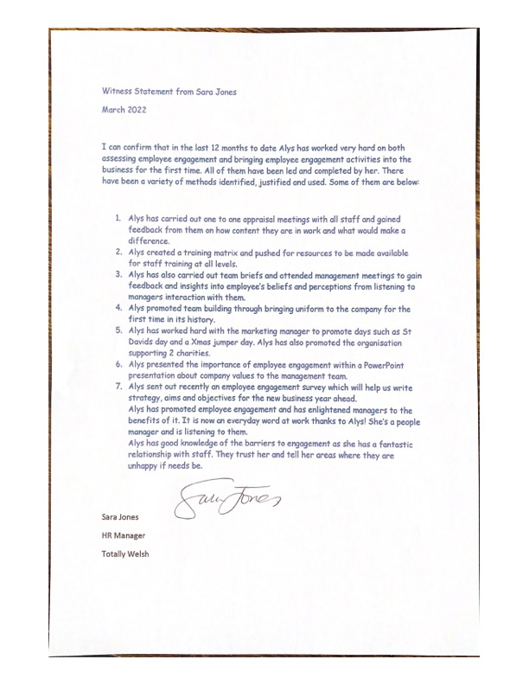

EV3

Hi Sara,
Thank you - I have created the employee engagement on survey monkey, it was the best platform for myself. I aim to send the survey out before Wednesday.
I will track the results and will be able to populate data into an excel spreadsheet, I will also ask everyone if they would take the time to complete it for myself as well.
Many thanks
Alys Owens
HR & Safety Advisor
T: 01437 760166
M: 07484 013997
E: alys@totallywelsh.co.uk
A: The Fresh Produce Centre, East Estate, Withybush Business Park,
Haverfordwest, Pembrokeshire, SA62 4BW
If you have received this email in error, please notify us by telephone on 01437 760166 and delete it from your computer immediately. Os ydych chi wedi derbyn yr e-bost hwn trwy gamgymeriad, byddwch cystal a rhoi gwybod inni trwy ffonio 01437 760166. Wedyn dylech ddileu’r e-bost ar unwaith oddi ar eich cyfifadur
-----Original Message-----
From: Sara Jones
Sent: 21 February 2022 08:22
To: Alys Owens <alys@totallywelsh.co.uk>
Subject: Employee Engagement
Hi Alys,
I’m just confirming our meeting last Tuesday and the outcomes we discussed.
We have agreed to send out an employee engagement survey and you have agreed to facilitate that. You also need to seek permission from Mark and potentially John to do so. They may want to see the questions as well.
I agree with you in that the Gallup Q12 will be a good set of questions to ask. I think SurveyMonkey is a great platform.
Lets hope that we get a good return rate for some good data to be achieved.
Can you let me know how you are progressing and especially how you are going to try and get a good return rate?
Thanks
Sara.

EV4
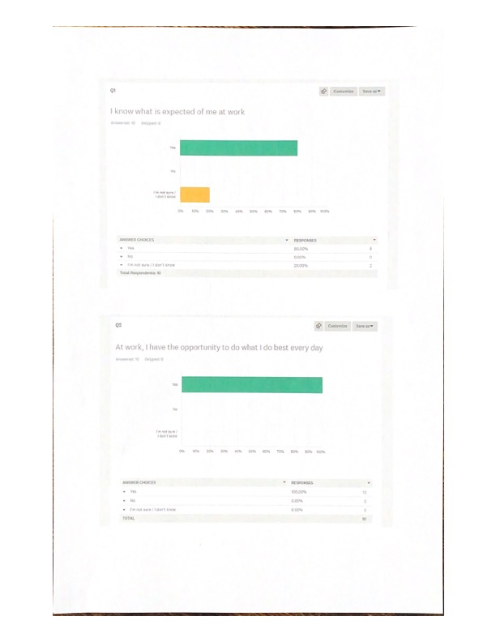

EV5
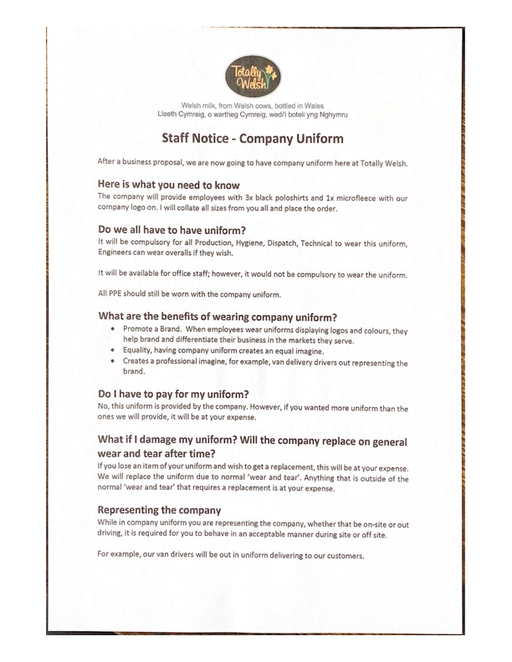

EV6


EV7
Questionnaire on means of reporting

When you joined the company, was the means of reporting to you explained your first day?
_______________________________________________________________________________________________________________________________________________________________________________________________________________________________________________________________________________________________________________________________________________________________________________________

When you are ill, do you know the correct way to report?

_______________________________________________________________________________________________________________________________________________________________________________________________________________________________________________________________________________________________________________________________________________________________________________________

If answered no, please explain how you think you should report your illness to the company
_______________________________________________________________________________________________________________________________________________________________________________________________________________________________________________________________________________________________________________________________________________________________________________________

Was it outlined to yourself that the company monitors sickness?
_______________________________________________________________________________________________________________________________________________________________________________________________________________________________________________________________________________________________________________________________________________________________________________________

How do you feel when phoning in sick?
_______________________________________________________________________________________________________________________________________________________________________________________________________________________________________________________________________________________________________________________________________________________________________________________

When you return to work after being off on the sick, how do you feel?
_______________________________________________________________________________________________________________________________________________________________________________________________________________________________________________________________________________________________________________________________________________________________________________________

Does your manage conduct a RTW with yourself?
_______________________________________________________________________________________________________________________________________________________________________________________________________________________________________________________________________________________________________________________________________________________________________________________

Do you feel the company would support you with long term sickness?

_______________________________________________________________________________________________________________________________________________________________________________________________________________________________________________________________________________________________________________________________________________________________________________________

EV8
Dear All,
RE: St Davids Day
Welsh milk, from Welsh cows, bottled in Wales
Llaeth Cymreig, o wartheg Cymreig, wedi'i boteli yng Nghymru
Staff Communications
St Davids day is fast approaching and Totally Welsh really want to celebrate it this year as a proud Welsh business selling Welsh Milk and other products. It’s a big day for us and we hope you will join in.
We’d love it if you get into the theme of the day on the 1st and wear a daffodil, leek or even traditional Welsh costume. Football or rugby shirts are great too (as long as it is our team!!)
We’re hoping that we may be able to get some of the lorries decorated to the theme before they set off for the day and that we may be able to put some photos up on social media.
There will also be Welsh Cakes and other traditional food in the canteen on this day so please enjoy these at break time.
We are also supporting two charities this year so if you feel you can give there will be a collection that day for them as well.
Many Thanks
Alys Owens
HR & Safety Advisor Totally Welsh
22/02/2022

EV9
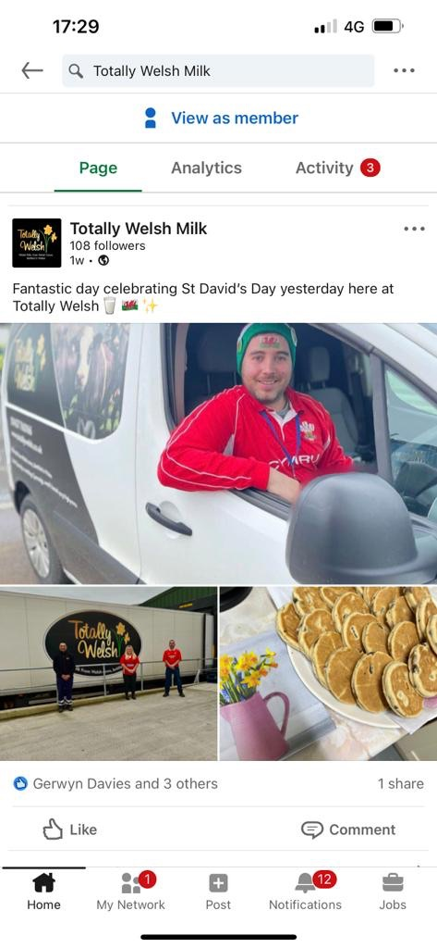
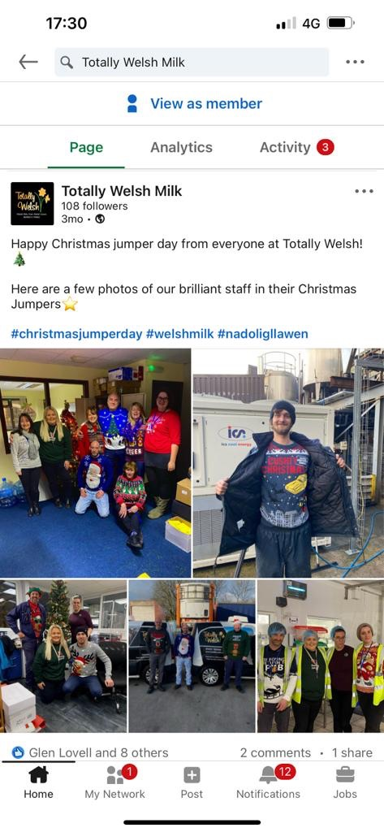
EV 10
Personal Statement for LO2

The approach to employee engagement historically has been minimal as there have been no issues recruiting and retaining staff. However, over the last 5 years this has changed due to competition in the area.
2.1
On analysis, the principal drivers for employee engagement in my organisation now is that we wish to retain staff, particularly in the more manual worker groups and also senior management. Recruitment and retention is hard at the moment as on analysis we do have barriers to employment such as being remote from public transport, repetitive work involving manual handling, shift work and early starts. (HSE, 2022) (Richards, 2020) (SHRM, 2006) (SHRM, 2006)
We also do not want to management staff that we like and have invested in to any competitors. We have similar businesses in the area and a potential competitor setting up in 2023. We have core management staff that have been with us many years and we recognise that people are reassessing all areas of their life after the pandemic and we do not want to lose them. (Kahn, 1990)
There is also the need for staff to be content in work so that they are not only productive but that they add value with ideas and innovation. (Oluwatayo, 2020)
Pre-pandemic we were facing a period of significant growth which went off track due to the pandemic. This is now back on track and we need our current management team to be with us all the way.
2.2
With respect to assessing behaviour that may hinder engagement I refer to the findings of the CIPD’s Discussion Report published in January 2021 entitled, “Employee Engagement: Definitions, measures and outcomes” (CIPD, Employee Engagement: Definitions, measures and outcomes, 2021) The study leading to the report finds some of these influence levels of engagement:
- The individual’s psychological state
- Job Design
- People Management
- Perceptions of organisational and team factors
- Organisational interventions
- Social support
- Empowerment
- Job characteristics
- Organisational justice
- Recognition and Rewards
- Leadership

Aspects of our organisational behaviour that link to the above and is likely to hinder engagement is our approach to pay. We do not have a transparent pay system and this leads to employees making assumptions over who is paid what. This lack of transparency has been fed back to me through appraisals but the business owner does not wish to publicise pay. (SHRM, 2006)
Language barriers can hinder engagement in our organisation especially when it comes to facilitating training and communicating about organisational events. Many employees are from Lithuania, Poland or Romania. Literacy can also be a barrier in that some of our employees cannot read or write very well. (CIPD, Employee Communication, 2021)
A lack of respect for some new managers has been evident from feedback from some employees and this has led these employees becoming disengaged. This resulted in these managers being put on the ILM L3 Management course and some improvement plans being issued. EV10. One manager was exited.
Tiredness from shift work and long days is a barrier. Some employees just want to come in, do their job and go home.
Ability to use technology has also been a barrier as many employees own a phone but not a laptop. This can link with a lower level of IT literacy. Also, some phones owned by staff do not support all mediums. (CIPD, Employee Engagement and Motivation, 2021)
There has also been evidence of social barriers in employee engagement. Historically when staff parties have been organised, differing perceptions of a “great night out” has caused problems. Due to this staff parties only exist within certain factions and are not publicised.

Evidence to support LO2

EV11

Hi Marija, There will be a new trainer coach allocated to you next week. I am not sure if they will be able to meet the date we have agreed, so I have primarily changed the date to the 16^{th of} March. You will be able to reschedule this with them when they contact you.

I have also completed another review that I would like you sign off; the link has been sent to both you and your employer. This is to ensure that when the next trainer coach is allocated, they don’t have the worry of rushing in another review without reviewing your file.

Good luck with your study.

Kind regards

  Lee Williams​
  Hyfforddwr | ,
  Trainer/Coach
  M: 07542025239
  T: 01443 749 000
  e: LeeW@educ8training.co.uk
  www.educ8training.co.uk
We work flexibly – so whilst it suits me to email now, ​I do not expect a response outside of your own working hours.

Educ8 Group, Tredomen Gateway

Ystrad Mynach, Hengoed CF82 7EH

EV12
Personal Statement to support LO3.
3.1
I have discovered that historic external studies have encouraged the concept and evolvement of employee engagement from being potentially one dimensional of just “doing your job well” to being more holistic with evident benefits to everyone. (Gallup, 2017) (Zone, 2021)
We have to be careful to a degree at my organisation as some employees, managers in particular are very engaged to the extent where it may unbalance their work and home life which could lead us to longer term problems with them like stress and absence. (Wiley, 2010)
Current external studies from the last two years show a decline in employee engagement unfortunately with the pandemic being the main cause. We have not seen this, infact the pandemic has brought us together more as a team due to pride in being key workers. (CIPD, Employee Communication, 2021)
External studies indicated that as the UK and global economy gains strength and recover, employee engagement strategies are likely to be high priorities for leaders and HR functions. It is difficult to say at this stage what the impact of the war against the Ukraine will be.
3.2
Barriers to acceptance of engagement strategies for us will be:
- Employees memories of previous social activities
- Costs that they may have to find connected to social activities
- Time and tiredness of taking part
- Image about taking part and socialising with managers they may not trust
- Convincing employees that their views will be taken into account and that we will not just pay them “lip service”

These will be hard to address but they need to be made to happen, a positive experience given and then this communicated widely to maybe those who did not attend or participate. The company will have to pay or subsidise events and most importantly try a variety of events to see which one’s staff engage in more. The business owner has no barriers to encouraging employee engagement. Training and development needs to be advertised more to staff and encouraged and most of all achievements recognised. The same goes for staff recognition of good work. An employee of the month scheme would be worth trialling.

3.1 & 3.3
Relevant best practice on employee engagement for us is those promoted by the Chartered Management Institute. (CMI, 2022)They promote 10 pointers which I have used for my strategic action plan in increasing employee engagement.

ACTION | Priority | What’s needed | By when
- Getting to know your team | RED | We need to bring in more social events and team building exercises to enable employees to get to know each other better. Ideas such as 10 pin bowling, Sunday football match, workplace buddy scheme. | June 22
- Set clear expectations | GREEN | We do well on this through promotion of core values from recruitment into working life but we need to maintain it and make more use of work and improvement plans for employees. We have seen the benefits of these in employees but have not used them enough. | On going plus end of year
- Keep team members in the loop | RED | We need to improve communication between upstairs and downstairs to remove the them and us perception and the perception that managers aren’t doing much work. Managers need to share workplans with their team and their job descriptions so they can see what their role entails. | June 22
- Build relationships of trust | AMBER | As above we need to build more trust between managers and employees and also managers to managers. A new senior manager can be pivotal in helping this happen as soon as possible through team building. | End of year
- Encourage open discussion and debate | GREEN | We need to continue with our staff appraisal programme | On going
- Empower your team | RED | We need to take feedback from colleagues and act on it. | June 22
- Give feedback | GREEN | We need to continue with our staff appraisal scheme | On going
- Take the aspirations of team members seriously | RED | We need to work more on the learning and development of staff by maintaining our training matrix and identifying further opportunities that may be available to us through grants and schemes | asap
- Deal promptly with performance issues | GREEN | We need to continue with our robust disciplinary policy | On going
- Tackle conflicts at an early stage | GREEN | As above | On going

Bibliography & background reference

ACAS. (2022, February). ACAS Working for Everyone. Retrieved from ACAS: acas.org.uk/productivity and management
CIPD. (2021). Employee Communication. London: CIPD.
CIPD. (2021). Employee Engagement and Motivation. London: CIPD.
CIPD. (2021). Employee Engagement: Definitions, measures and outcomes. London: CIPD.
CIPD. (2021). Evaluating Learning and Development. London: CIPD.
CMI. (2022, March 13th). CMI. Retrieved from CMI: managers.org.uk
Edwards, W. (2021). The Deming Institute. Retrieved from deming.org: deming.org/explore/pdsa/
Gallup. (2017). State of the Global Workplace. New York: Gallup.
HSE. (2022). HSE Health and Safety Executive. Retrieved from HSE: hse.gov.uk/invlovement/
Kahn, W. (1990). Psychological conditions of personal engagement and disengagement at work. Academy of Management, 692.
Oluwatayo, A. A. (2020). Influence of Employee Attributes, Work Context and Human Resource Management Prctices on Employee Job Engagement. Global Institute of Flexible Management Systems, 295-308.
Richards, J. G. (2020). The Four Aspects of Culture that Drive Engagement. Industry Week.
Schaufeli, W. B. (2006). The Measurement of Work Engagement. Utrecht Univeristy.
Service, T. I. (2020). The Customer Knows: How employee engagement leads to a greater customer satsfaction and loyalty. London: The Institute of Customer Service.
SHRM. (2006). Employee Engagement and Committment. A guide to understanding measuring and increasing engagement in your organisation.
Zone, W. B. (2021). The State of Employee Engagement 2021. Milton Keynes: Work Buzz.

