+
  Component One:  What are the key skills required when working in the housekeeping team? 750 words (+/- 10%)  Contribution to Overall Module Assessment: 25% | Student No: | 2123684
 | Module Title: | OPERATING HOTEL FACILITIES
 | Module Code: | BMIH4006
 | Lecturer: | LISA KNIGHT
Housekeeping teams are a part of the “operational department” of the hotel industry which is delegated with the major responsibility of maintaining hygiene, cleanliness as well as upkeep of rooms. washrooms, and the entire surrounding. The services are of 4 types which include cleaning services, “live-in housekeeping services”, “live-out housekeeping services” and finally, “house manager services” (Guo et al. 2019). Such jobs can be performed either by a single or by a group of people. However, the hotel industry, being a huge one, employs a lot of people in groups for this purpose. It has There are various skills associated with the job of housekeeping so that the job can be performed efficiently and in an improved manner as hygiene has become one of the most essential factors for customers to opt for different hotels. It has been viewed that about 71% of the tourists and boarders are more impressed with “above average” housekeeping activities and opt for such hotels (Hospitality net, 2019). The major required skills for efficiently performing tasks in this sphere are mentioned as follows:
Time and task administration: The housekeeping teams are generally provided with a set of tasks that they have to complete in a given time duration so that the same can be performed for the other rooms as well (Pai et al. 2020). It is because the hotels have various sizes of rooms and huge numbers which have to be cleaned. therefore, the teams must allocate specific time for providing services to all the rooms effectively within the provided time.
Paying attention to minute details: The job that the housekeeping group performs requires providing attention to little details to view that all the dirt is removed, and every room is thoroughly cleaned. proper setting of the room aesthetically is also necessary
Coordination: Since in hotels, the work is done in groups, therefore, the quality of coordination must be present in them so that the people can decide on their duties and then execute the same effectively. Without proper coordination, the tasks cannot be accomplished in the desired manner.
Physical health and fitness: The tasks to be performed in housekeeping require immense fitness such as flexible body movements to clean dirt from all places, lifting heavy things, standing for long hours, and bending as well as moving up and down stairs from room to room. Therefore, for the same, good fitness is mandatory.
Effective Communication: It is one of the most crucial skills essential in housekeeping services. Since the tasks are performed in teams, proper communication regarding which areas require more cleaning and how the present tasks can be performed more effectively can be understood more effectively (Ateşoğlu and Erkal, 2020). Along with that, effective communication with the boarders aids in developing trust and understanding the level of cleanliness and room organization required. Proper communication also ensures that the customers’ needs are completely understood by the team.
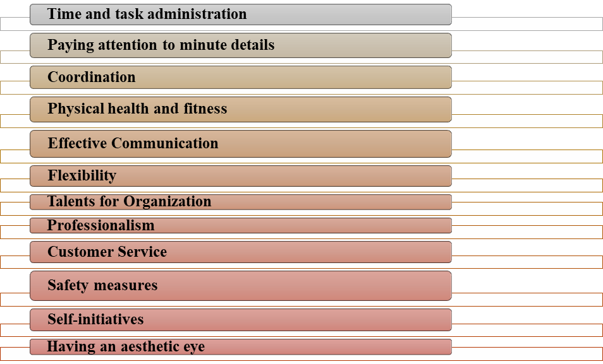
Figure 1: Skills essential for the housekeeping team
(Source: Self-created)
Flexibility: It is another essential skill that is present while doing various activities in housekeeping. In such a job, the people must be willing to do jobs such as cleaning washrooms and taking out bins (Subash, 2021). Along with that, the person must also be willing to work at various times of the day and in various areas of the hotel as per the needs of the job and the hotel's requirements.
Talents for Organization: the people in the housing department must possess organizing talents so that a proper track can be kept of the various schedules, supplies, various machines, and equipment. Therefore, the involved people must possess a talent for the same.
Professionalism: Since the people in the housing department have to adhere to the needs and demands of the hotels and the customers, therefore, they must always display a professional outlook and behavior towards everyone.
Customer Service: Another very crucial skill required in this field is to provide superior customer service to everyone. In this regard, such people must be friendly, show polite and warm behavior, as well as must be approachable properly (Moral et al. 2023). Furthermore, the people must be efficient and adhere to the customers’ requests timely.
Safety measures: The people involved in housekeeping jobs in hotels must be aware of the included safety measures. It is extremely essential since it enables people to understand the hurdles and problems included in the jobs. It prevents accidents in the housekeeping areas.
Self-initiatives: The people in these areas can also take essential steps to recognize various areas which require cleaning and organizing. It is essential for the people in such activities to proceed with areas requiring more attention.
Having an aesthetic eye: The people in such areas must have an aesthetic sense for organizing and maintaining beauty. The people in this area must plan to organize hotel rooms effectively and therefore maintain a soothing and pleasing environment so as to attract more customers can gain better feedback.
Therefore, from the above discussion, it has been viewed that housekeeping is an essential aspect, and as such specific skills must be practiced so that people can be more efficient.

Word Count | 852

Component Two:
Contribution to Overall Module Assessment: 25%
In this scenario – You have just been promoted to the team leader for a floor within the hotel. A guest complains that on their arrival, their room had not been properly cleaned. Create an action plan and answer the following questions.
Issues | Cause | Solutions | Future Preventions | Measures to induce effectiveness
Improper and unclean bedsheets | - Swift exit and the entrance of different customers have been one of the major reasons for such faults  - The new staff employed for cleanliness did not have proper training and skills to complete cleaning in time.  the staff has also been negligent towards their duty of performing their tasks effectively | At the very beginning apology must be asked from the customers for the poor service and feedback must be gathered concerning the areas that require improvement and reclean the room so that the customers can be satisfied (Vos et al. 2019).  For such issues in the hotel such as cleanliness, the first step to be taken is to call all the staff members to understand the reason why such faults have been committed in the hotel for which the customers complained, leading to a reduction in the reputation of the entire organization | The staff must be made aware of the consequences that can arise if the same problems persist | Regular meetings and exams must be held to understand the level of development of all staff.
Hair in the Bathtub | - There might have been a lack of required equipment to remove the hair properly from the bathtub  - A lack of cross-examination after cleaning must have happened for which several mistakes might have remained in making the room tidy and proper for the next guests.  The staff had a lack of time administration skills for that they could not complete all the tasks within the provided time.  - Issues also occurred owing to the lack of washing by the staff, which is one of the signs of a lack of seriousness regarding the job and extreme negligence | next process is to allocate the person responsible for the issue so that proper steps can be taken and the issues can be understood in greater detail, and further steps can be determined.  - Next, a meeting must be held to understand the persisting gaps between the allocated jobs and the prior performance. Here all the staff will be summoned to provide their views on the issues of cleanliness, their faced problems and their inputs on how such problems can be solved. It will not only make the people more engaged but also show their perspectives on solving the issues. | Proper training and skill education must be provided along with proper supervision so that the same mistakes do not get repeated ever. | Delegating responsibilities to all the members in the group individually will ensure that every member is working efficiently.
An unclean toilet seat as well as the entire dustbin (Hospitalitynet, 2019) | For this specific fault, the cleanliness department is responsible since they did not properly check all the areas that required proper cleaning  - There has been miscommunication among the personnel for which they missed out certain aspects of proper cleaning and housekeeping.  - The personnel might also not have access to superior technology and tools for which they could not clean the toilet seat with so much efficiency.  - the staff also sometimes lacks in utilizing proper cleaning standards such as proper methods, which can allow germs to breed and the presence of foul smells all over the toilet, not only the seat.  - lack of timely inspections can also be one of the major reasons for which there might have been issues regarding toilet cleanliness in the hotel  - proper checklists and schedules might have not also been maintained by the staff because of which they might have missed out on this specific area of the washroom.  - there was staffing issues as well for which there was a lot of tasks to be done by a lesser number of people. As a result, there was overwork and this caused issues in cleaning the toilet seat properly. | Once the main issues have been found out, the next step will be eradication of the same. For this purpose, the staff associated with housekeeping will be provided with extensive training measures.  - Individual issues will be sorted by collecting information about individual limitations and courses will be conducted likewise.  - Along with that technological and technical improvements will also be brought about so that such issues can be eradicated (Go et al. 2020) | The work must be well divided among all and communication must be enhanced so that everyone performs their duties effectively so as to eradicate challenges in the coming times. | proper feedback will be conducted to understand the issues related to such problems that the staff is encountering. By this means effective remedies can be brought about (Yu et al. 2021).
Rubbish under the bed and extreme amounts of dirt | The area under the bed can be easily neglected since very few people pay proper attention to so minute details. having so much work at hand, this area can be neglected easily.  - If proper schedules are not formed with adequate checkboxes about the areas that must be cleared before new guests enter, then the staff misses this part of the room to be cleaned.  - along with the same, the furniture in the hotel is quite heavy and it is not always possible for the staff to remove them from their own places for cleaning.  - Furthermore, inadequate working of the vacuum cleaner, with settings for efficient cleanliness of smaller areas can lead the dire to remain under the bed.  - It also happens that the dirt gets accumulated under the bed even after proper cleaning. As such, these places such as extreme interiors cannot be adequately cleaned. | Pre-made schedules will be prepared to enlist every area which must be cleaned before new guests arrive and as such no area will remain unchecked and uncleaned after that. | The staff must be provided with the latest technology and equipment so that cleaning facilities can be conducted in the best possible manner. | Rewards and other motivation methods must be adopted for good work. it will ensure that the staff is effectively performing their duties without any disruptions.
Broken lights and fingerprints on glasses as well as window panes | One of the most adequate reasons for broken lights and remains of fingerprints on glass walls can be a lack of time for fixing the same.  along with the same, the coordination with cutlery cleaners and other fixing staff might be inadequate, for which proper information might not have been passed between them, leading to such issues in cleanliness, organizing as well as cleaning of the rooms. | Better methods and techniques will be introduced based on the requirements of the staff so that every area can be effectively cleaned (Insights, 2019).  Along with that more staff will be recruited so that there is no overwork in the cleaning department. | proper schedules and lists must be made with a list of every the area that is to be cleaned. Through this method, no sphere of cleaning that will be skipped in the future (Pillai et al. 2021). | Personal overseeing must be conducted to view the performance level and its applications in maintaining cleanliness and hygiene in individual rooms so that the previous mistakes can be solved and efficiency can be encouraged.

Component Three:

Contribution to Overall Module Assessment: 50%

Your task is to create and prepare a presentation following the detailed scenario provided below.

As the floor housekeeping manager and given the recent guest complaints you need to put together a basic training presentation for your colleagues within the housekeeping team to get the best out of them, ensure that brand standard is being achieved and that Health and Safety procedures are also being followed.
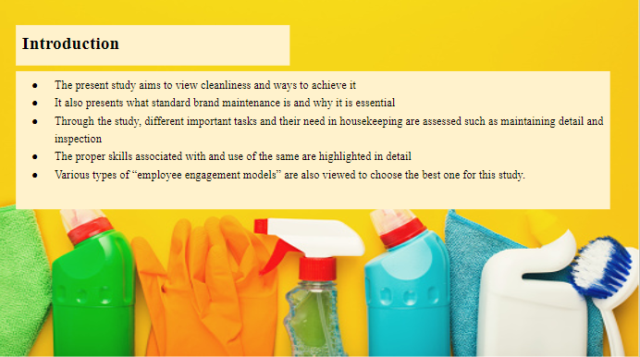
Training Notes: The present study focuses on shedding light on the essential components of housekeeping and how the same is essential for developing the standard brand for customer satisfaction. Along with the same, the study also views how elements such as paying attention, proper inspection, and development of the needed skills can bring about a huge change in the current housekeeping practices and methods. In addition, the study also displays various types of “employee engagement models” and their uses to find out the most suitable one for this hotel so that the current mistakes can be avoided and a better housekeeping service can be made available to the customers to eradicate all types of complaints.

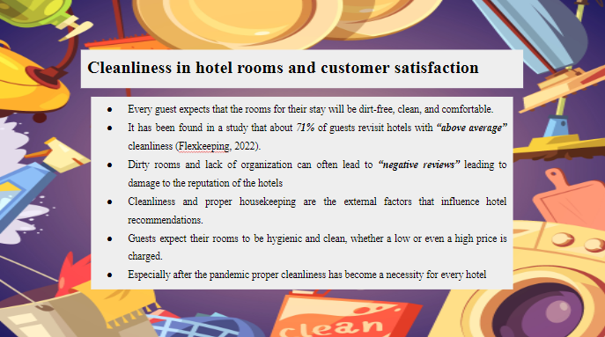
Training Notes: Based on the current statistics it has been found that one of the major criteria for guests to choose and revisit hotels is their hygiene and cleanliness, especially after the “Covid-19 Pandemic”. Therefore, it is a necessity that must be upheld by all hotels including Trinity. Thus, all the personnel associated with the housekeeping facilities must provide their optimum effort to satisfy the customers and earn a high reputation.

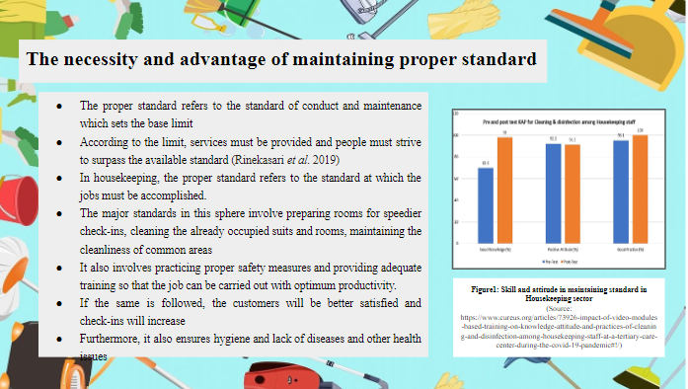

Training Notes: Proper standard is necessary for any type of job to ensure that it is performed correctly. For housekeeping, it is of crucial importance as based on such matters, an impression can be created on the guests. Good housekeeping and cleanliness attract customers and enhance goodwill and revenue.

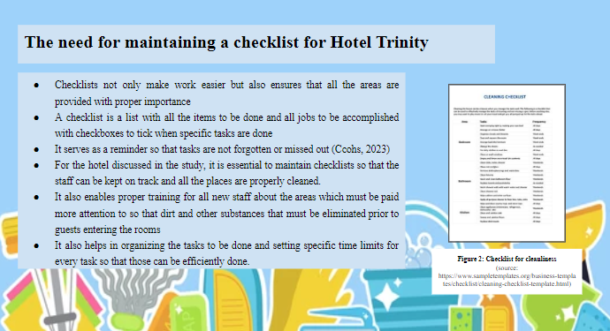
Training Notes: There are various needs for maintaining a checklist. It must be understood that having a checklist solves all types of issues as forgetfulness and missing out on essential detail. It also aids in keeping track of the tasks done and left so that time can be managed accordingly.

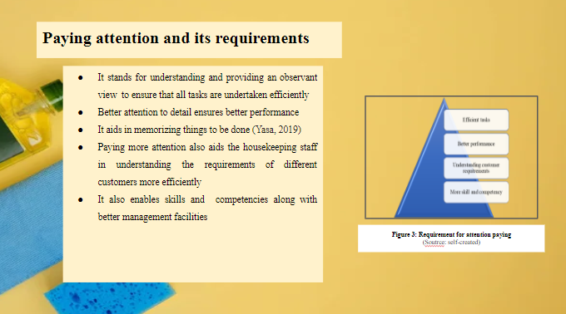
Training Notes: Paying attention is one of the most essential skills that enhance competency among employees for work. It aids in better understanding the job in dept along with the specific requirements and demands of the customers. As such, paying more attention enables housekeeping to be dynamic and customized for different customers so that they can feel more satisfied, especially for the Trinity Hotel.

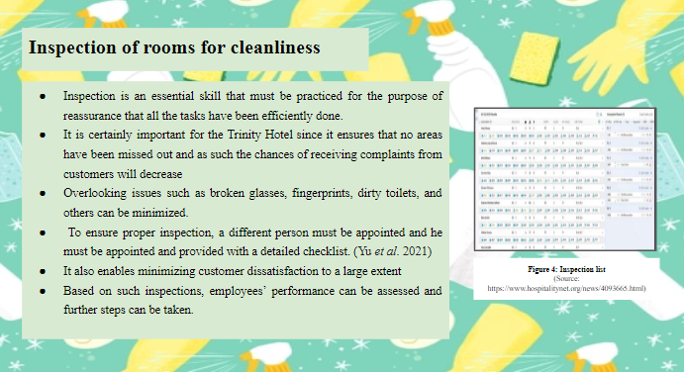

Training Notes: Inspection is one of the major factors to be considered in housekeeping. It ensures equal administration of all areas without any problems. It enables the staff to become more productive and minimize customers’ problems effectively to provide greater satisfaction.

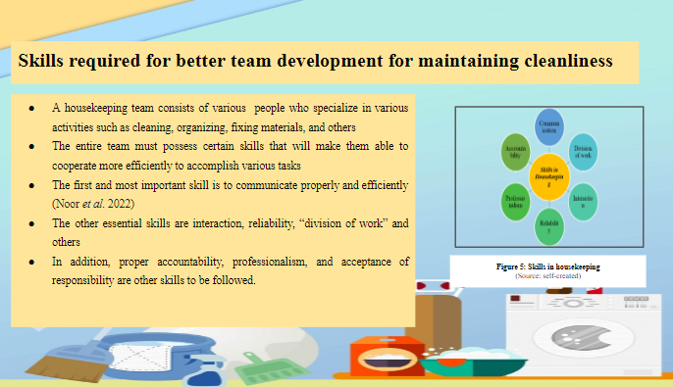

Training Notes: The housekeeping team must possess and develop various skills, especially for the hotel mentioned in the topic, Trinity Hotel. The main skills such as communication and interaction must be learned to understand team members and the customers to develop bonds. Professionalism and work division ensure that each person understands his duty and performs his job with utmost sincerity to eradicate all forms of errors.

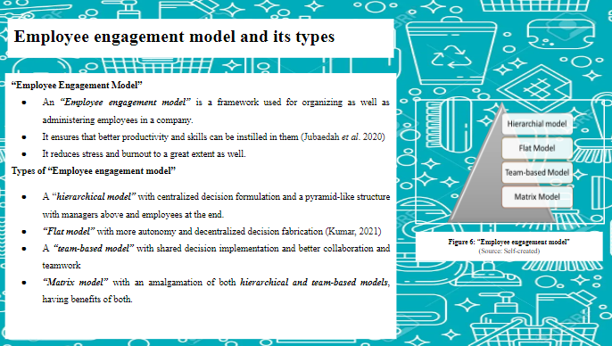

Training Notes: “Employee Engagement Models” ensure that all the staff involved in the housekeeping of the Trinity Hotel are properly involved with the activities so that they can be upskilled and made more productive. The models are of varying types based on the decision-making process as well as leadership structures as mentioned above.

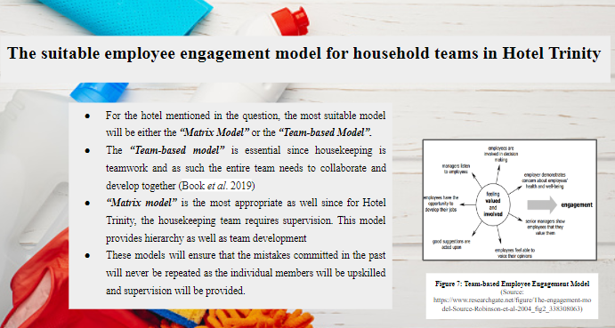

Training Notes: Both the “Matrix Model” and “Team-based Model” will ensure that the jobs are done properly without any errors by facilitating individual training as well as overall team development. Moreover, decisions will also be made within the team and finally will be rechecked by the leader to double-check and remove errors.

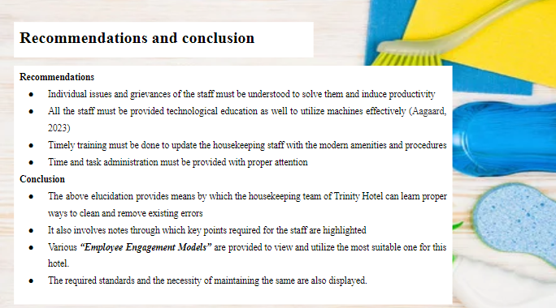

Training Notes: This section provides certain suggestions to improve the existing conditions through proper training and development of the employees. Along with it, a summary of the entire study is also displayed for quick revision.

References
Component 1
Journals
Ateşoğlu, L. and Erkal, S., (2020). Development of performance evaluation scale for housekeeping staff in the accommodation companies: Ankara sample. International Journal of Home Science, 6(2).
Guo, X., Cheng, A. and Pavlou, P., (2019). Skill-biased technical change again? Estimating the effect of TaskRabbit on local employment in the housekeeping industry.
Moral, R.V., Embalsado, E. and Lomocso, V.R.B., (2023). PERSPECTIVE DRAWINGS OF SENIOR HIGH SCHOOL ST
UDENTS IN HOUSEKEEPING AND TECHNICAL DRAFTING: A THEORY DEVELOPMENT APPROACH. Web of Education: Journal of Novel Research, 1(1), pp.11-23.
Pai, A., Manjunath, M., Kowshik, C.S., Ayedee, N., Malarout, N. and Naik, N., (2020). SOFT SKILLS AS A KEY COMPETENCY FOR THE FUTURE LEADERS OF THE HOSPITALITY INDUSTRY. PalArch's Journal of Archaeology of Egypt/Egyptology, 17(9), pp.4341-4355.
Subash, T., (2021) SKILL REQUIREMENT IN TRAVEL AND TOURISM INDUSTRY. GLOBAL JOURNAL OF BUSINESS MANAGEMENT, pp. 30-52.
Websites
Hospitalitynet, (2019). Do you know the factors that affect the guest experience? Available at: https://www.hospitalitynet.org/news/4087829.html
Component 2
Journals
Go, H., Kang, M. and Suh, S.C., (2020). Machine learning of robots in tourism and hospitality: interactive technology acceptance model (iTAM)–cutting edge. Tourism review.
Pillai, S.G., Haldorai, K., Seo, W.S. and Kim, W.G., (2021). COVID-19 and hospitality 5.0: Redefining hospitality operations. International Journal of Hospitality Management, 94, p.102869.
Vos, M.C., Galetzka, M., Mobach, M.P., van Hagen, M. and Pruyn, A.T., (2019). Measuring perceived cleanliness in service environments: Scale development and validation. International journal of hospitality management, 83, pp.11-18.
Yu, J., Seo, J. and Hyun, S.S., (2021). Perceived hygiene attributes in the hotel industry: customer retention amid the COVID-19 crisis. International Journal of Hospitality Management, 93, p.102768.
Websites
Hospitalitynet, (2019). Hotel Guests' Most Common Complaints and How to Prevent Them. Available at: https://www.hospitalitynet.org/opinion/4087001.html
Insights, (2019). The top 5 hotel guest complaints and how staff can respond. available at: https://insights.ehotelier.org/insights/2019/01/09/the-top-5-hotel-guest-complaints-and-how-staff-can-respond/
Component 3
Journals
Aagaard, L.K., (2023). When smart technologies enter household practices: The gendered implications of digital housekeeping. Housing, Theory and Society, 40(1), pp.60-77.
Book, L., Gatling, A. and Kim, J., (2019). The effects of leadership satisfaction on employee engagement, loyalty, and retention in the hospitality industry. Journal of Human Resources in Hospitality & Tourism, 18(3), pp.368-393.
Jubaedah, Y., Rinekasari, N.R., Rohaeni, N.E.N.I., Maosul, A.S.E.P. and Ana, A., (2020). Competency based-assessment using electronic rubric: implementation on manual polishing practice in housekeeping. Journal of Engineering Science and Technology, 15(1), pp.046-053.
Kumar, P., (2021). V-5 model of employee engagement during COVID-19 and post-lockdown. Vision, 25(3), pp.271-274.
Noor, S.M., Salim, A., Hussin, S., Mahat, F. and Rohiat, M.A., (2022). A STUDY ON HYGIENE AND CLEANLINESS TOWARDS CUSTOMER SATISFACTION: A FOCUS ON SUNWAY LOST WORLD OF TAMBUN HOTEL. International Journal of Social Science Research, 4(3), pp.238-252.
Rinekasari, N.R., Jubaedah, Y. and Sobariah, S.N., (2019). Standard Operating Procedure of Housekeeping Adaptation: The Development of Assessment Tools in Cleaning Bathroom Practices at Vocational High School. KnE Social Sciences, pp.150-161.
Yasa, I.K., (2019). The Implementation of Total Quality Management (TQM) in Housekeeping Department of W Bali-Seminyak. International Research Journal of Management, IT and Social Sciences, 6(2), pp.22-30.
Yu, J., Seo, J. and Hyun, S.S., (2021). Perceived hygiene attributes in the hotel industry: customer retention amid the COVID-19 crisis. International Journal of Hospitality Management, 93, p.102768.
Websites
Ccohs, (2023). Workplace Housekeeping. Available at: https://www.ccohs.ca/oshanswers/hsprograms/housekeeping/cklstgen.html
Flexkeeping, (2022). Housekeeping SOP (Standard Operating Procedures) Checklist. Available at: https://www.flexkeeping.org/housekeeping-sop/

