Contents
Wellbeing of future generations (Wales) act 2015 2
Conference Venue 2
Database Administration 3
Planning the database 3
Creating the database 3
Comparison between databases 5

Wellbeing of future generations (Wales) act 2015
The well-being of future generations (wales) act is about improving the social, economic, environmental and cultural being of wales. Its purpose it to encourage the public bodies listed think more about long-term goals for local communities. There are several goals in this act to make sure everyone is working on the same vision. The goals include
- A global responsible wales
- A prosperous wales - An innovative, productive and low carbon society which recognises the limits of the global environment and therefore uses resources efficiently
- A resilient Wales - A nation which maintains and enhances a biodiverse natural environment with healthy functioning ecosystems that support social, economic and ecological resilience and the capacity to adapt to change
- A healthier Wales - A society in which people’s physical and mental well-being is maximised and in which choices and behaviours that benefit future health are understood.
- A more equal Wales - A society that enables people to fulfil their potential no matter what their background or circumstances
- A wales of cohesive communities - Attractive, viable, safe and well-connected communities.
- A Wales of vibrant culture and thriving Welsh language - A society that promotes and protects culture, heritage and the Welsh language, and which encourages people to participate in the arts, and sports and recreation.
- A globally responsible Wales - A nation which, when doing anything to improve the economic, social environmental and cultural well-being of Wales, takes account of whether doing such a thing may make a positive contribution to global well-being.
(Welsh Government, 2015)
Conference Venue
The conference venue I have selected as the most appropriate is the Welsh millennium centre, located in Cardiff. This is the perfect venue to host this event for several reasons. Firstly, the millennium centre is a truly iconic welsh venue and fits in perfectly with aim from the well-being of future generations act. Hosting at such a prestigious welsh venue will attract visitors from all over the country. The team at the welsh millennium centre are committed to the welsh language, they do everything in their power to promote and use the welsh language and this fits perfectly with the aim of promoting the welsh language.
Another key factor which influenced my decision in the capacity, this venue has the capability of hosting around 2000 people, although I do not expect to reach those numbers straight away, I believe it offers the chance to grow, and build a special event. The best thing about this venue is the amount of different sized room it has on offer. They will always be able to accommodate the event as it grown itself.

Database Administration
Planning the database
Before starting the database, it is important to plan what information you are aiming to collect, I was aiming to find the suitability of different venues. To do this I decided that some of the key information that I would need to find wold be related to venue capacity, Costs per delegate, cost for facilities, whether the venue offers parking facilities and more. To keep the database organised I decided to use three tables.
Creating the database
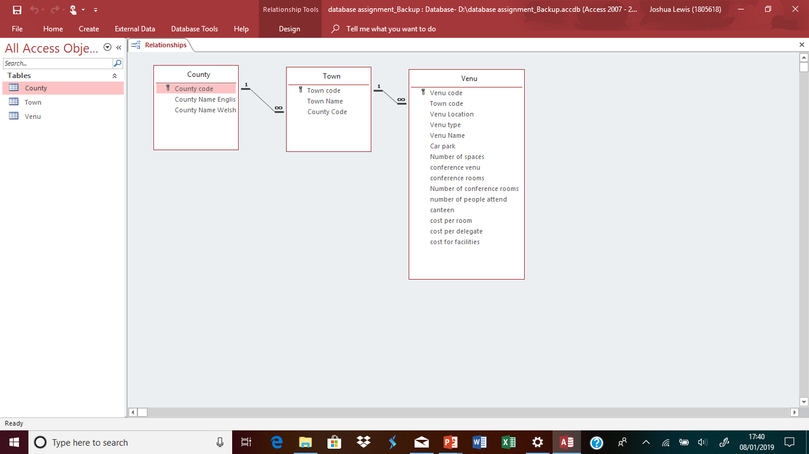
The first step I did while creating my database was to create a table. In each table I then added the field names and chose the data type I was going to use. To organise my data, I set the primary key. The primary key is to uniquely identify the row or record in the table. After I had created the three tables, County, town and venue and set all the field names and data types I created the relationships.

When the same field name is used in more than one table it is important to create the relationship. The relationship I used was a one to many relationships. A one to many relationships is when a record in table a can have more than one record in table b, however, table b has at most one matching record in table a. It is important to remember that when creating relationships, the data types much be the same in each table.
Next, I was ready to input my data.
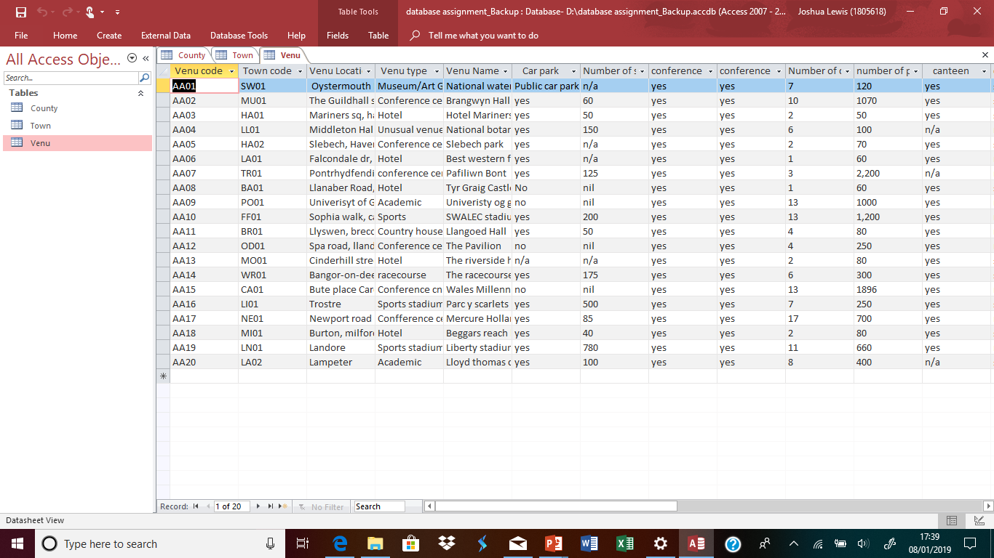

Information I found from my research was stored in my database. It is important to find relevant information to put into the database, so you can compare all your results with each other.
After I had completed entering data for twenty different venues, I then moved on to creating forms, I created one form for each of my tables.
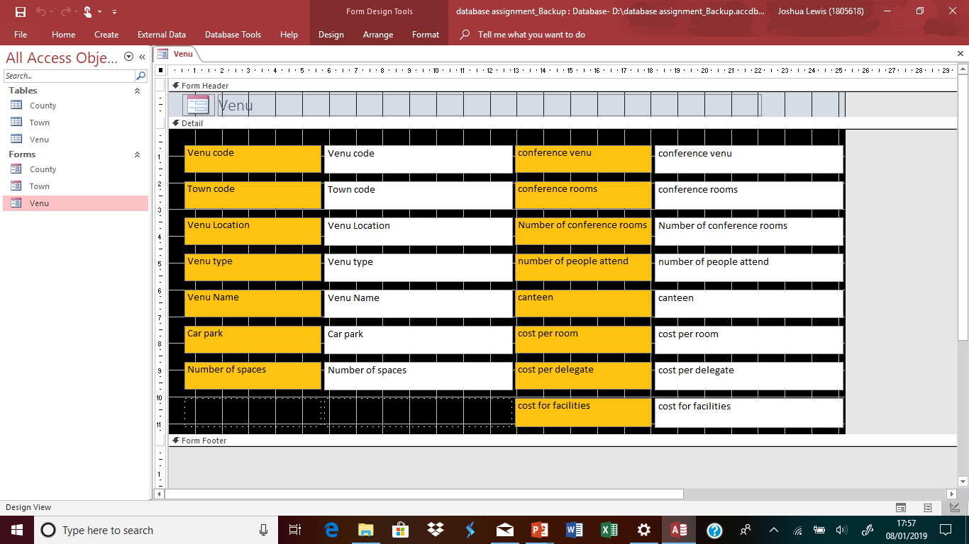
The forms are a way of presenting the data, while creating the forms you can change the properties which allows you to change the way the data is presented.

Queries was the next stage, queries are questions you can ask your database to extract specific info. Queries are great when you want to look at one data type or compare one field throughout the database. An example of how queries could be used is finding out if venues offer parking on site and the number of spaces. I used four queries altogether in my database. I used the queries to find out about venue capacity, venue location, venue prices and car parking.

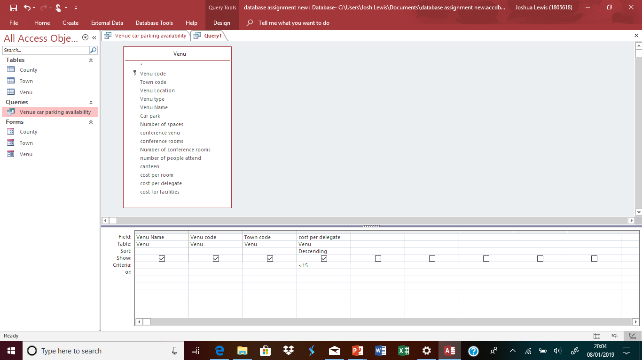

Comparison between databases
The prosumer database was a database created on Microsoft excel whereas the conference database uses Microsoft access. Microsoft excel is a spreadsheet application, that deals with tabular data using spreadsheets, in comparison access is used to collect, manipulate and sort data.
The platform used for the prosumer database, Microsoft excel is primarily used for creating spreadsheets and financial calculation compared to Microsoft access which is primarily used for storing and manipulating large amounts of information.
Both platforms use a different structure on Microsoft access the structure consists of tables, queries, forms, reports, modules and macros which is different to excel which has a spreadsheet structure. The flexibility of the access platform is comparatively less than the flexibility of the excel platform.
The advantages of using a Microsoft excel platform are it is easy to use and implement, it is ideal for creating one-time analysis and easy to generate a customer output. The excel platform is easier to use in general and requires less time to learn.
The advantages of using the access platform are data structure and normalisation through multiple tables, the scalability of platform is good. It offers the use of queries and reports which enables you to extract more information from your data ("Database", 2016)

Welsh Government. (2015). Well-being of Future Generations (Wales) Act 2015.
Database. (2016). Retrieved from http://www.differencebetween.info/difference-between-microsoft-excel-and-access

