Question 1: What’s the main idea of this text?
The text mainly explains how online platforms can give small businesses more attention and help them reach new customers from different places.
Question 2: What are 2 key points?
- Popular content on platforms such as TikTok and Instagram can bring more customers and improve business sales.
- People are sometimes willing to travel long distances to visit a business they discovered through social media.
Question 3: What part of the text did you find most important and why?
The most interesting part for me was the story about people travelling for several hours to buy a chicken burger. I think this example clearly shows how much online content can influence customer decisions.
Question 4: Was anything unclear or difficult to understand?
Overall, I understood the article quite well. However, a few of the examples and some vocabulary related to online marketing required more attention.
Question 5: How did your group help you understand the text better?
Discussing the article with my group helped me see different opinions and notice important details that I had not considered at first.
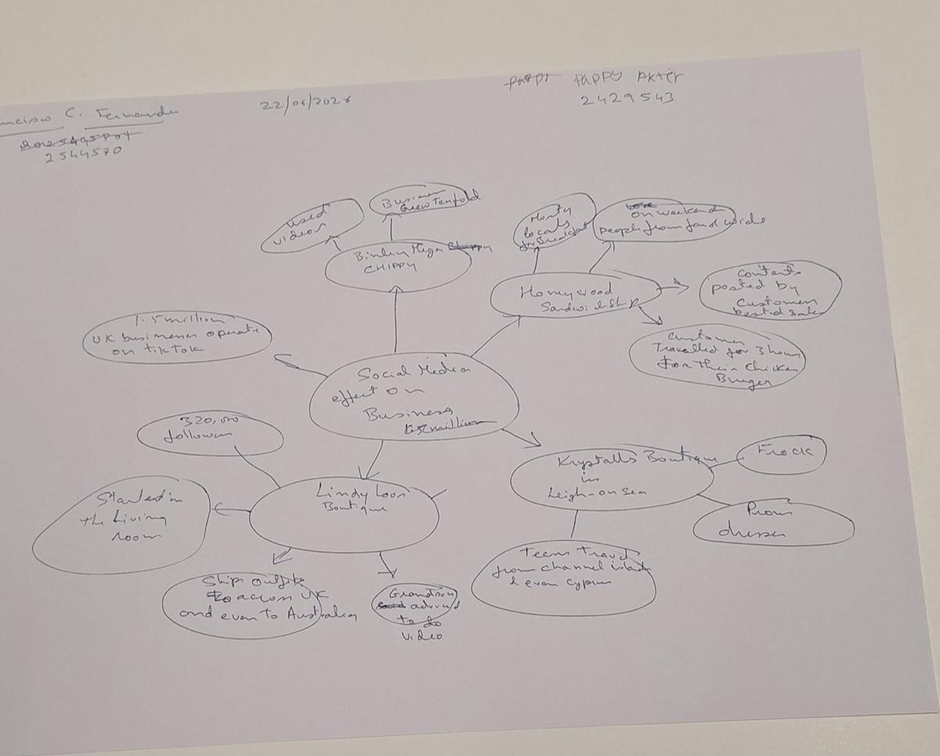
One-sentence reflection: What did you find challenging about this task?
The most difficult part was deciding which ideas to focus on because the article contained many useful and interesting examples.

