GAME TITLE | [1] DOOM (1993) (Created by id Software)

INTENDED PLATFORMS | [2]PC, SNES, Sony PlayStation, Atari Jaguar, Sega 32X, 3DO Interactive Multiplayer, Sega Saturn

TARGET AGE / DEMOGRAPHIC OF PLAYERS
Late teens to adults

INTENDED PEGI / ESRB RATING
ESRB MATURE (17+) OR PEGI 15

SUMMARY OF GAME STORY (FOCUSING ON GAMEPLAY)
There is no story in particular that is shown in the game as in there are no cutscenes or really any knowledge on previous story, but it is given in the instruction manual

[2] [3] A space marine. Beaten a higher rank officer because he ordered his soldiers to shoot at civilians. After, you were transferred to Mars inside the ‘Union Aerospace Corporation’. Which they control its two moons, Phobos and Deimos. UAC’s biggest supplier, has used the remote facilities on Phobos and Deimos to conduct various secret projects, including research on interdimensional space travel. So far, they have been able to open gateways between Phobos and Deimos, recently however, the Gateways have grown dangerously unstable. Prisoners were sent in and had either disappeared or been stricken with a strange form of insanity. After being sent up pronto to Phobos. The space marine was ordered to secure the base while the rest of the team went through the portal. For hours, your radio went silent, expecting they had all perished it is now up to you to sort out this mess once and for all, leaving you with only a pistol.There isn’t a lot of stories to be mentioned in the game itself but instead in the manual, it mentions here (in short) [3] You're a space marine. Three years ago, you beaten a higher rank officer because he ordered his soldiers to shoot at civilians. After, He sent to Pearl Harbor in a cast, whilst you were transferred to Mars, which houses the ‘Union Aerospace Corporation’. A multi-planetary conglomerate with radioactive waste facilities on Mars and its two moons, Phobos and Deimos. UAC’s biggest supplier, has used the remote facilities on Phobos and Deimos to conduct various secret projects, including research on inter-dimensional space travel. So far, they have been able to open gateways between Phobos and Deimos, recently however, the Gateways have grown dangerously unstable. “volunteers” entering them have either disappeared or been stricken with a strange form of insanity. You and your buddies, the only combat troop for fifty million miles were sent up pronto to Phobos. You were ordered to secure the perimeter of the base while the rest of the team went inside. For several hours, your radio went silent, expecting that your buddies have died it is now up to you to sort out this mess once and for all leaving you with only a pistol.

REFERENCES
[2]
Wiki, C. to D. (no date) Doom, Doom Wiki. Available at: https://doom.fandom.com/wiki/Doom (Accessed: 27 November 2025).

UNIQUE SELLING POINTS (USP)
During this time this was one of its first FPS shooters that would come out and was one of the biggest games to exists and was a unique concept. A fast-paced fps that involves you, giving you a linear (there is a lot more exploration however in the later levels) exploration system where you can find Easter eggs and overpowered guns that will shred demons that stand in your way!
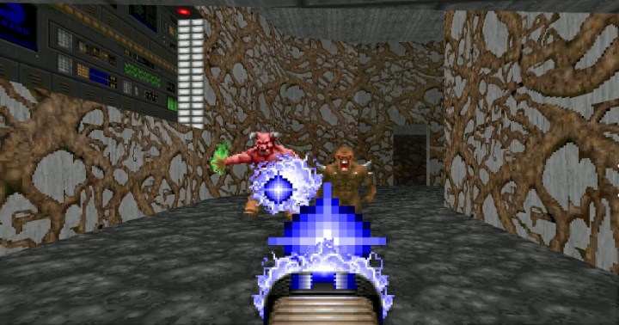
It’s also one of the early examples of a game that had a difficulty setting, where you can modify how hard an experience the player will want, which means that for most people in the world could play this game without the player complaining that the game is either too hard or too easy
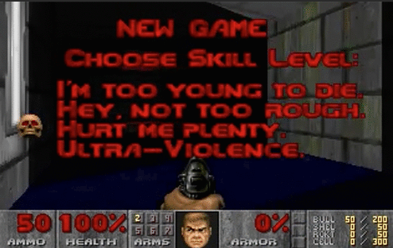
Whilst not considered a game to have ‘puzzles’ it does however expect the player to go and look for key cards to open certain doors to progress in the game, meaning there are puzzling parts of the game where it puts the fast-paced shooting for a short break.


(Useless fact [4], this was one of the more pirated game at the time, especially not helped with its demo disc)

REFERENCE
[4]
“High Score | Netflix Official Site,” www.netflix.com. https://www.netflix.com/gb/title/81019087

COMPETITIVE PRODUCTS / SIMILAR GAMES
Wolfenstein is the only example I could think of (Created by Muse Software) as its time as that the fps genre was super new and was not at all popular before DOOM 1993, however 2 years later a game “Terminator: Future Shock” created by Bethesda (the company behind Fallout 3 and Skyrim).

Contents
DOOM (1993) A Report Of A Classic 4
What’s important about DOOM? 4
Story 5
Content 5
Playing through it 5
Game design levels 7
References 9
Bibliography 9

DOOM (1993) A Report Of A Classic

The game was created by ‘id Software’ and was created in 1993, According to [5] the game was created by 7 people “programmers John Carmack and John Romero, artists Adrian Carmack and Kevin Cloud, and designer Tom Hall. Late in development, Hall was replaced by Sandy Petersen and programmer Dave Taylor joined, the game was thought of because after the release of Wolfenstein 3D” which is considered the grandfather of FPS games.

What’s important about DOOM?
DOOM was one of the first FPS games for its time and was the one who popularized the genre, and began the new wave of “DOOM clones” to be released such as [6], “Star Wars: Dark Forces”, “Rise Of The Triad Dark War”, and most notably “Strife” which in this game had NPC’s you were able to talk to and made it into a more FPS/RPG the first of its kind.
What’s also important about the game is that it is one of the very few of its time that a game was released for very late teens to adults and was actually very successful, which is super rare at a time like this since that the gaming scene normally had more kid friendly games such as Super Mario bros world and Banjo Kazooie. [7] This was THE FIRST game to ever make DEMO’s, shareware distribution was popular for publishing for small developer’s, with companies using this like Apogee Software (3D Realms, popular for Duke Nukem), Epic MegaGames (now as Epic Games popular for Fortnite), and of course id Software.
DOOM is one of the most revolutionary games of all time in terms of design and technology!
[3]

Content
The game contains power ups to increase the player's health and shield, which is important since a single level can be around 20 minutes for someone who hasn’t played, the game before without dying once. So, they give players items so they wouldn’t die and lose all their progress after defeat, since there are no checkpoints in the game.
The game has indicators of your health, ammo, armour, key cards and ammo for all guns. But also, they do have another health indicator and that’s the doom guy’s face and the bloodier he gets means the less health he has, meaning in a quick time situation it's an indicator on how aggressive you can have with the player's play style.
There are 7 weapons in the game, that being; fist, pistol, shotgun, chaingun, rocket launcher, Plasma rifle, BFG 9000. And these guns use 4 types of ammo, the pistol and chaingun uses ‘clips’ which is the easiest ammo to get, the shotgun uses ‘shells’ which are common but not as much with the clips, rocket launcher uses rockets and these are found mainly in Easter egg locations which means they are quite rare weapons to gather, and Plasma rifle and BFG 9000 use cells, which are found only in Easter eggs except in later location levels which are given at the end of levels for special events.

Playing through it
Doom being an iconic game. Lots of people might use their sounds in their own titles which can be seen in castleminer z as an example, (lots of games do this to a degree or at least they will tinker with it slightly).
The game doesn't really have any story telling in terms of in the game, but fun to play either way, meaning players don't really need a story to make it enjoyable. The game's graphics for its time were incredible! However, when you compare it nowadays it has aged for sure, but it's not offensive to look at which is impressive, very surprising since this was 1 of the first fps at its time. Ammo is plenty for most weapons in the game, in gameplay players will encounter the pistol, Shotgun, minigun, RPG, plasma gun, both ammo’s are quite easily achievable other than the plasma and a tad with the rpg.
These game's secrets are hidden, which are not easy to find whatsoever. Once dead, you lose all weapons and ammo you have been carrying throughout the entire game except your pistol, this game is brutal, meaning if the player were to find a secret gun, then die, you would lose it on the stage after it. Doom has some extra details to show the players stats, the biggest for me is our main guy's facial expressions when on idle or when damaged and running around to indicate that he is damage/low. The Hud that shows you your ammo, health, armour (etc). It is not distracting at all.
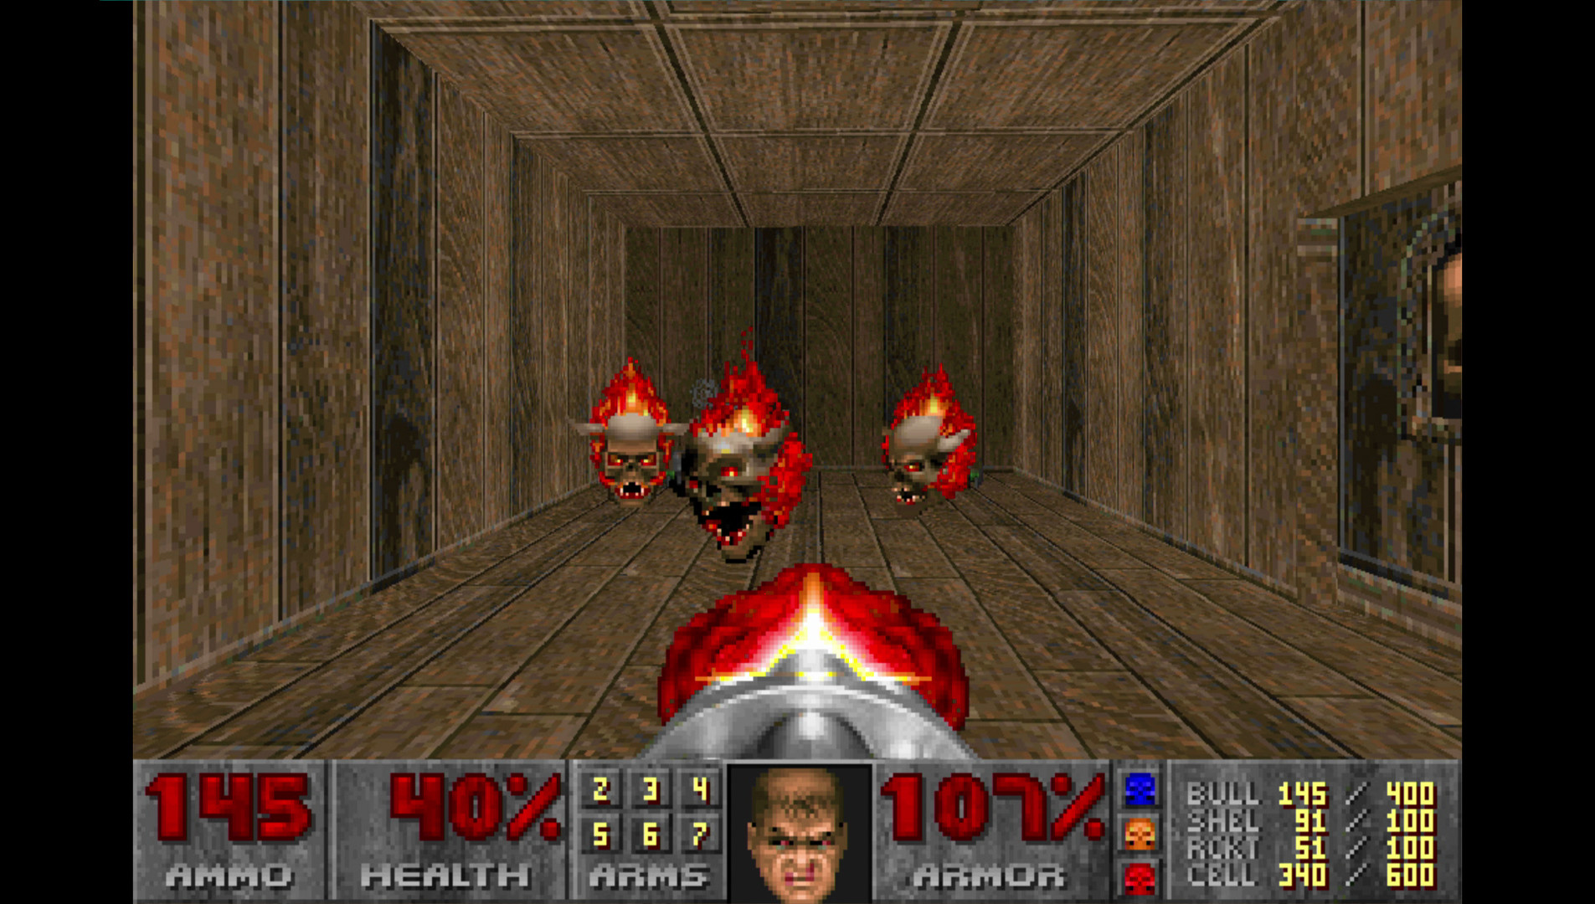
Aiming is very unique cause you cannot look up or down (instead how it works is if an enemy was on a higher platform as you and your sights is directly under then the enemy would get hurt when the gun has been shot, same thought process if the character is under you (just to add your sights turn yellow when your target can be hit and green for when it isn't).
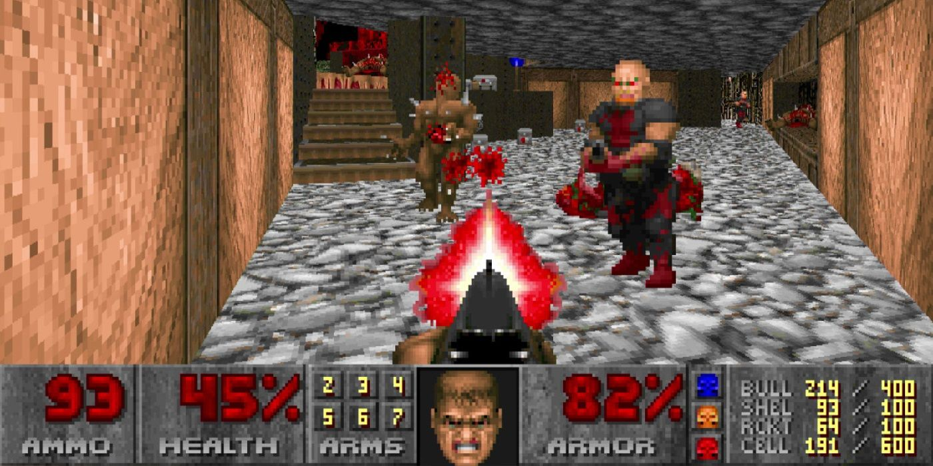
There are no controls that are shown
off when you boot the game (or pop up in gameplay), its only when you go into settings during play and click "Input Options" is then you can see what buttons do what, which means the player can get stuck at a door for until they look at the manual or check online what the controls to open the door.
Players can find the light laser, invisibility cloak, in its last level you get to have the shot gun and rail gun (if died the player loses all their loot, or when they boot up into the game again and lost it that way). On its last level (8) the music changes to a
more heavenly spooky type of beat which adds a tense sense feeling that you are on the final stage and this is the last battle you will have against the demons. Fight 2 big demons that you never have thought previously in the game, these 2 guard the teleporter that would bring you to the boss of the game. However, instead what really happens is instead you spawn in a dark room and die in seconds, it then pops up with a message saying how you died and what to do, telling the player to go onto the next episode.

Game design levels
The level designs are around the interpretation of a military research facility, the levels were modelled over real military bases at the time which quite a lot of effort for the time, but the levels were not so good which led to Tom Hall[5] being replaced by Sandy Petersen.
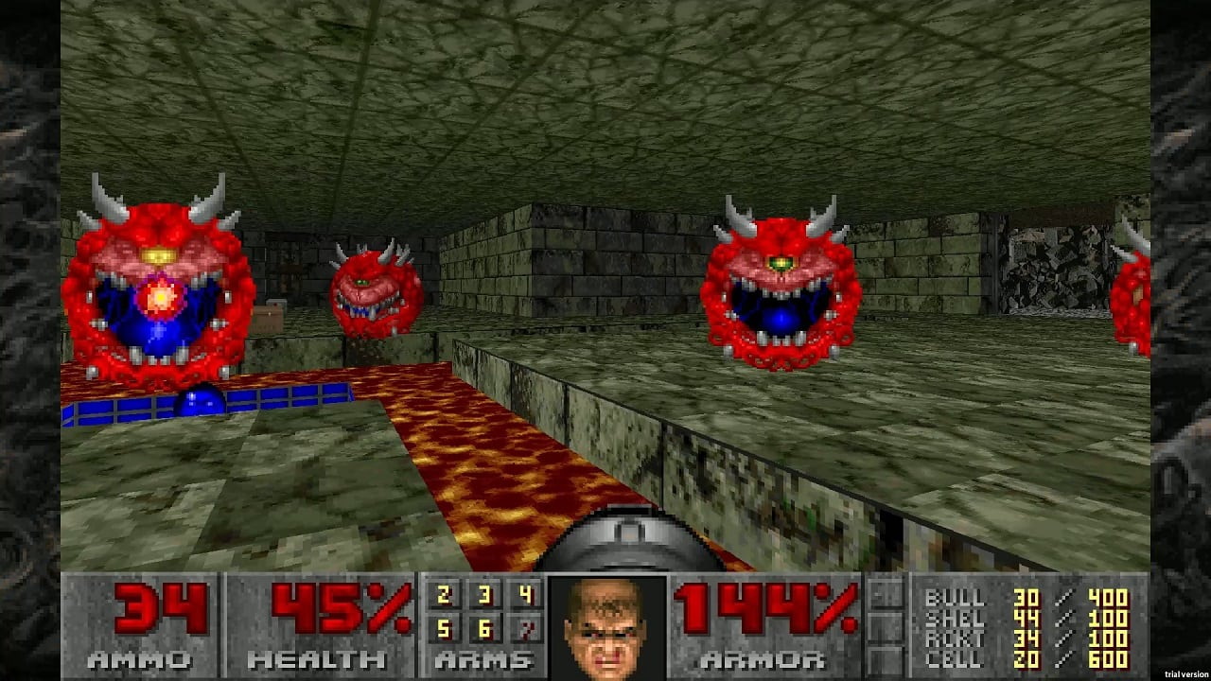The team created around Tom Hall’s idea for DOOM and created the levels we see today
[7]
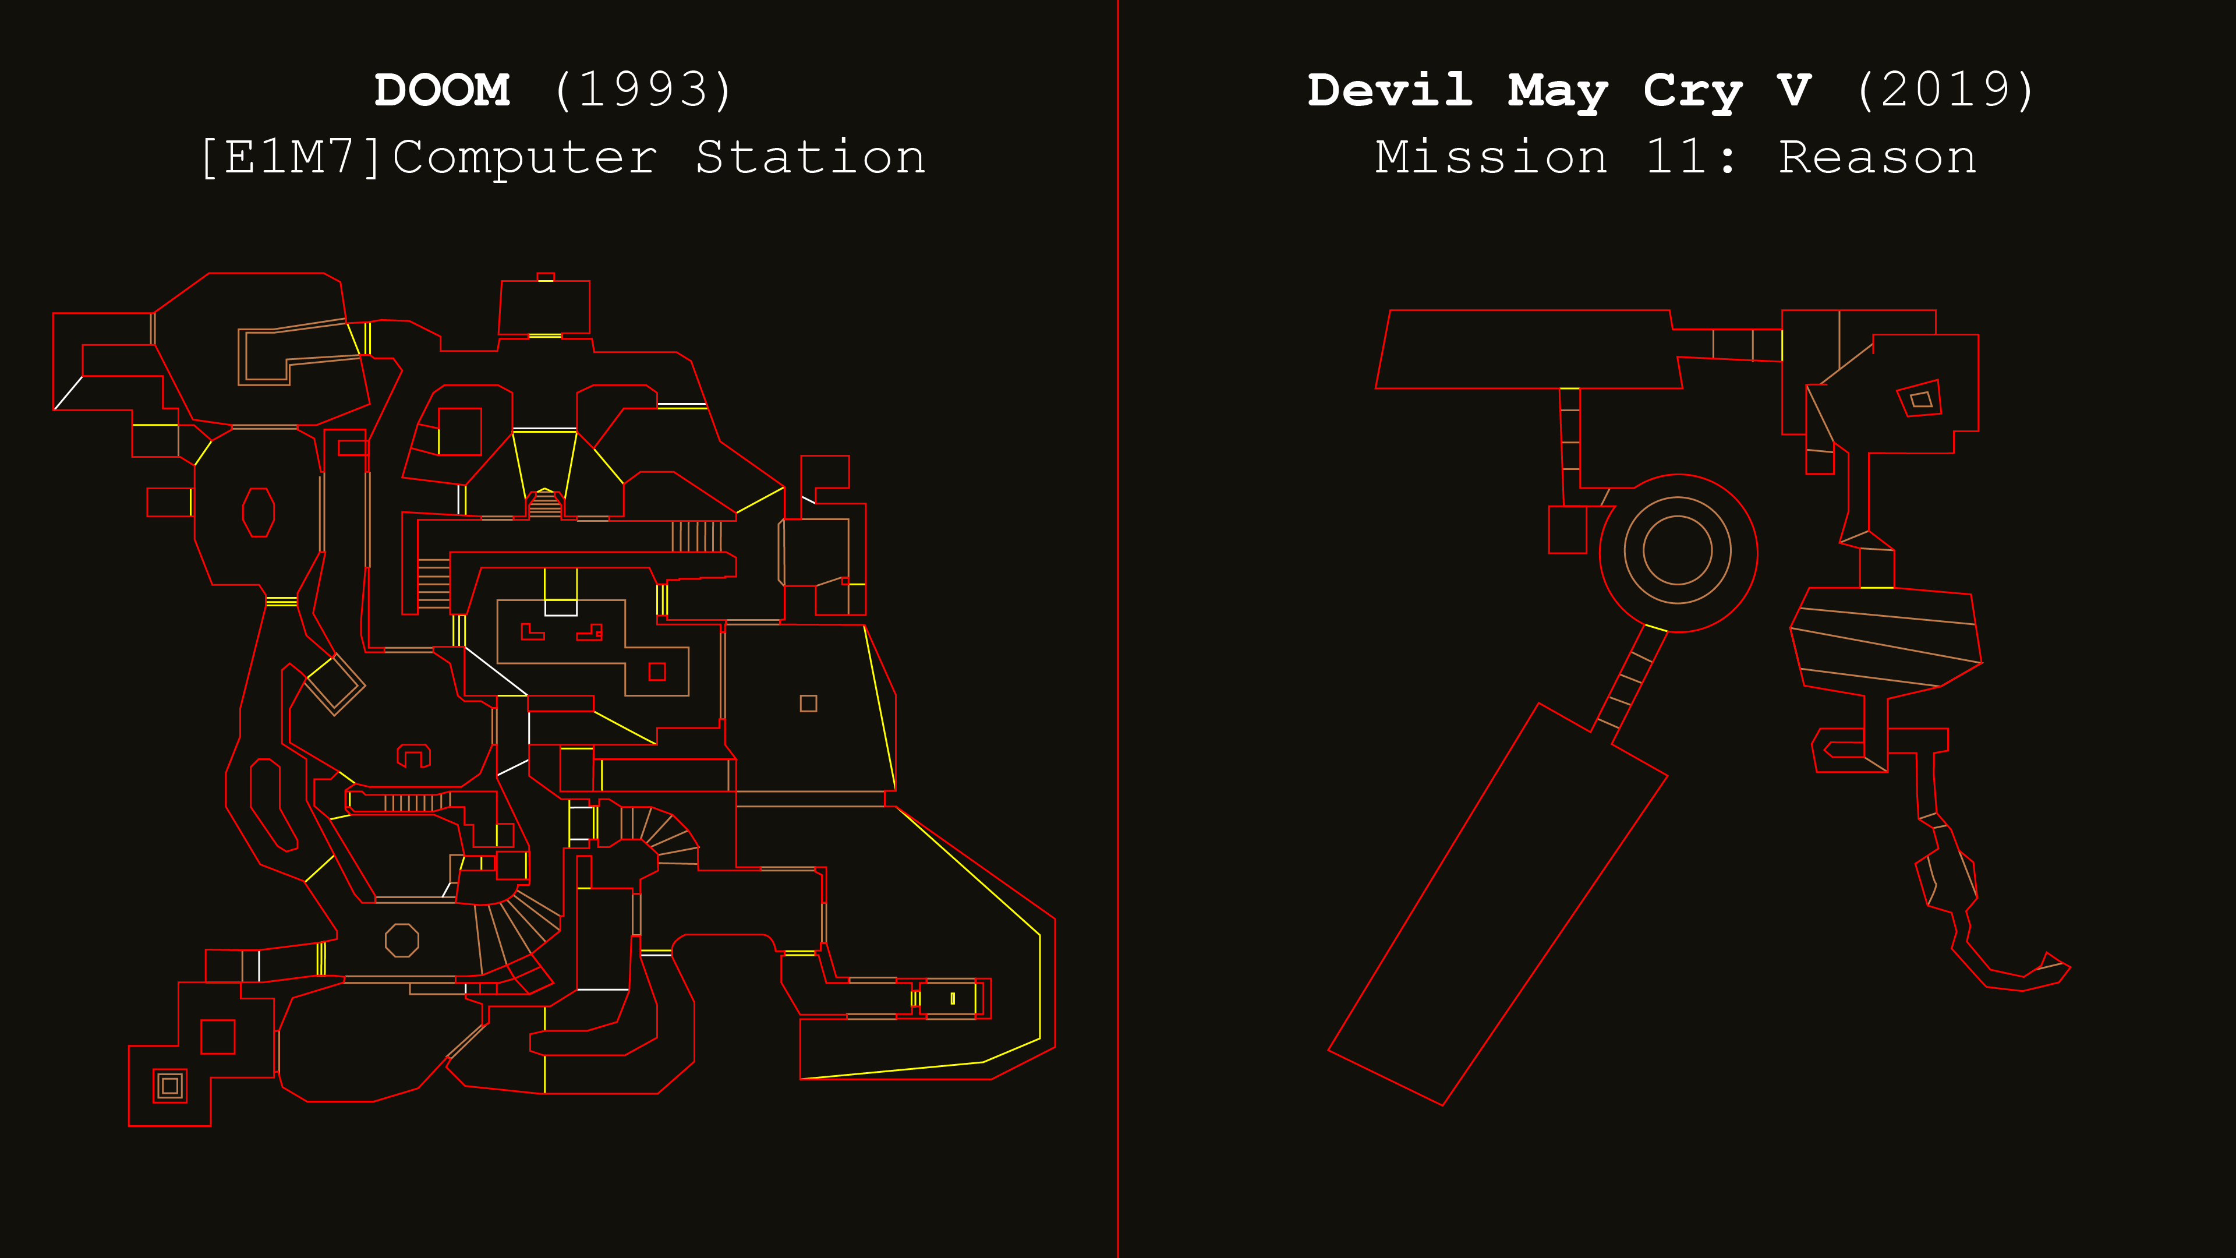

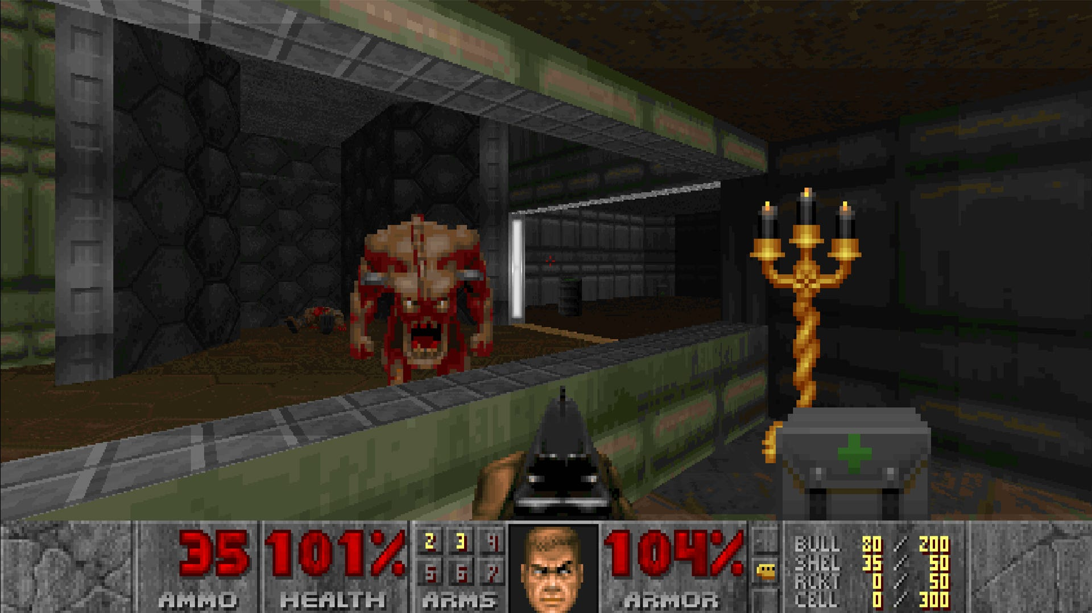

References

Bibliography

[1] | i. software, “DOOM + DOOM II,” id software, 30 4 1995. [Online]. Available: https://store.steampowered.com/app/2280/DOOM__DOOM_II/?curator_clanid=33028765. [Accessed 12 12 2025].
[2] | Wikipedia, “List of doom ports,” Wikimedia Foundation, 8 12 2025. [Online]. Available: https://en.wikipedia.org/wiki/List_of_Doom_ports. [Accessed 12 12 2025].
[3] | Contributors to Doom Wiki, “Doom Wiki,” 27 11 2025. [Online]. Available: https://doom.fandom.com/wiki/Doom.
[4] | Internet Archive, “Doom (1993) manual : Free download, borrow, and streaming,” DOOM, 1 1 1993. [Online]. Available: https://archive.org/details/doom-manual/page/n1/mode/1up. [Accessed 27 11 2025].
[5] | Netflix, “Watch high score: Netflix official site,” 19 8 2020. [Online]. Available: https://www.netflix.com/gb/title/81019087.
[6] | Wikipedia, “Development of doom,” 8 11 2025. [Online]. Available: https://en.wikipedia.org/wiki/Development_of_Doom.
[7] | J. Pursey, “10 best doom clones of all Time, ranked,” 21 3 2021. [Online]. Available: https://gamerant.com/best-doom-clones-ranked/.
[8] | Wikipedia, “Game demo,” Wikipedia, 23 6 2025. [Online]. Available: https://en.wikipedia.org/wiki/Game_demo. [Accessed 27 11 2025].

[7]
E. Brouwer, “What lessons can Action games learn from classic DOOM?,” Game Developer, Dec. 09, 2023. https://www.gamedeveloper.com/design/what-lessons-can-action-games-learn-from-classic-doom-

