UWTSD

Network Operating Systems and Services
Laurice Keogh – 2115745@student.uwtsd.ac.uk

Contents
Network Operating Systems and Services 0
Abstract 1
Introduction 1
Hypervisors 1
Hypervisor choice 2
IP addressing 8
Configuring IP Addresses for NOSS 10
Network Testing and Troubleshooting Techniques 12
Network Testing for NOSS 13
Conclusion 17
References 18

Abstract
This report uses virtual machines to demonstrate connecting servers to PCs and PCs to servers within one topology based on the NOSS solution. Which hypervisor is most suitable is investigated and trouble shooting methods are applied when errors occur. IP addressing and its importance is also discussed

Introduction
Networks can be set up on virtual machines given the appropriate information and tools are available. Necessary features include IP addresses, subnetting, hypervisors etc. It is important that the virtual machines are configured correctly meaning that a deep understanding of these components is important. The given NOSS scenario will be displayed and being able to identify which IP addresses and hypervisors etc to use is key to having an efficient system.

Hypervisors
[1] Hypervisors help with making and maintaining virtual machines by taking a computer’s software from the hardware. Hypervisors bridge/aid communication between the physical and virtual elements of an operating system. All hypervisors can run multiple operating systems on one server, and they can have multiple guest operating systems running on a host system all at once. There are type 1 and type 2 hypervisors which work in different ways.
[1] A type 1 hypervisor is a virtualisation software which is downloaded and installed onto the host’s hardware. Due to this, the system is considered quite secure from operating system attacks. [2] There is no need for an extra operating system layer especially since an operating system isn’t required, and it works very directly with the host’s hardware and software. [3] There is often a need for a secondary device to be connected to type 1 hypervisors for the operations to be performed. This means that extra hardware is required and extra costs. Hardware-assisted virtualisation devices can be purchased to improve performance and resource management further. [4] Some uses for type 1 hypervisors are in enterprise and servers because of the ability to have multiple virtual machines running on one device which is ideal for larger companies, and this works well because each guest has their own operating system. Furthermore, any attacks on a guest are isolated to that guest not any other users. The type 1 hypervisors also have good availability, are reliable, and can be scaled up which makes them useful to those working in cloud computing and server virtualisation. Some examples of type 1 hypervisors are VMware ESXi, KVM, and Microsoft Hyper-V.
[1] Type 2 hypervisors are set up in a different way as they are like a software layer on an operating system. [2] A type 2 hypervisor is easier to set up because it can be downloaded like any other software on the host operating system. The security risks are higher with a type 2 hypervisor because if other applications being run on the host operating system have issues it can interfere with the virtual machine environment. A security strength is that the guest operating systems are not directly linked to the host operating system meaning that the operating system of the main device should remain intact even if guest operating systems malfunction. The type 2 hypervisors have slower communication between the hypervisor and hardware due to the added layer and the shared resources with other applications, but it is well suited for [4] smaller applications/environments. The type 2 hypervisors are preferred when using the virtual machine environments for development and testing where the performance isn’t important. Type 2 hypervisors are also preferred for educational and personal use where high security isn’t as needed. Type 2 hypervisors can run multiple operating systems on one laptop device which means that for smaller companies where employees must share hardware that this hypervisor is ideal. [4] This hypervisor is user friendly and preferred by beginners. Type 2 hypervisors can work on low spec hardware/basic desktops which makes it a cheaper option and a more accessible option. Some examples of a type 2 hypervisor are Oracle, Microsoft Virtual PC, and VMware Workstation.

Hypervisor choice
For this scenario, it is most appropriate to use a type 2 hypervisor to create the virtual machines. Based on type 2 hypervisors being the most user friendly and easy for beginners this is appealing to those in an educational setting which is a reason why this is a good choice for this assignment. Type 2 hypervisors being able to function on low specification laptop devices is also a factor for choosing a type 2 hypervisor because I am working on a personal laptop. The scenario NOSS which is going to be created does not require advanced security measures at this stage and does not require exceptionally fast speeds as it is just important that it is all set up correctly and working as it should. [2] Type 1 hypervisors usually require a second device to manage the operations, but this isn’t available to me which is another reason why type 2 is more desirable. I have chosen the VMware Workstation application to host the virtual machines because it is able to run multiple machines at the same time such as the Swansea and London setup described in the topology. VMware Workstation saves virtual machines as files which is easy to manage. VMware Workstation is also available on a free 90-day trial which keeps costs at a minimum.
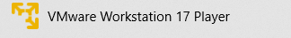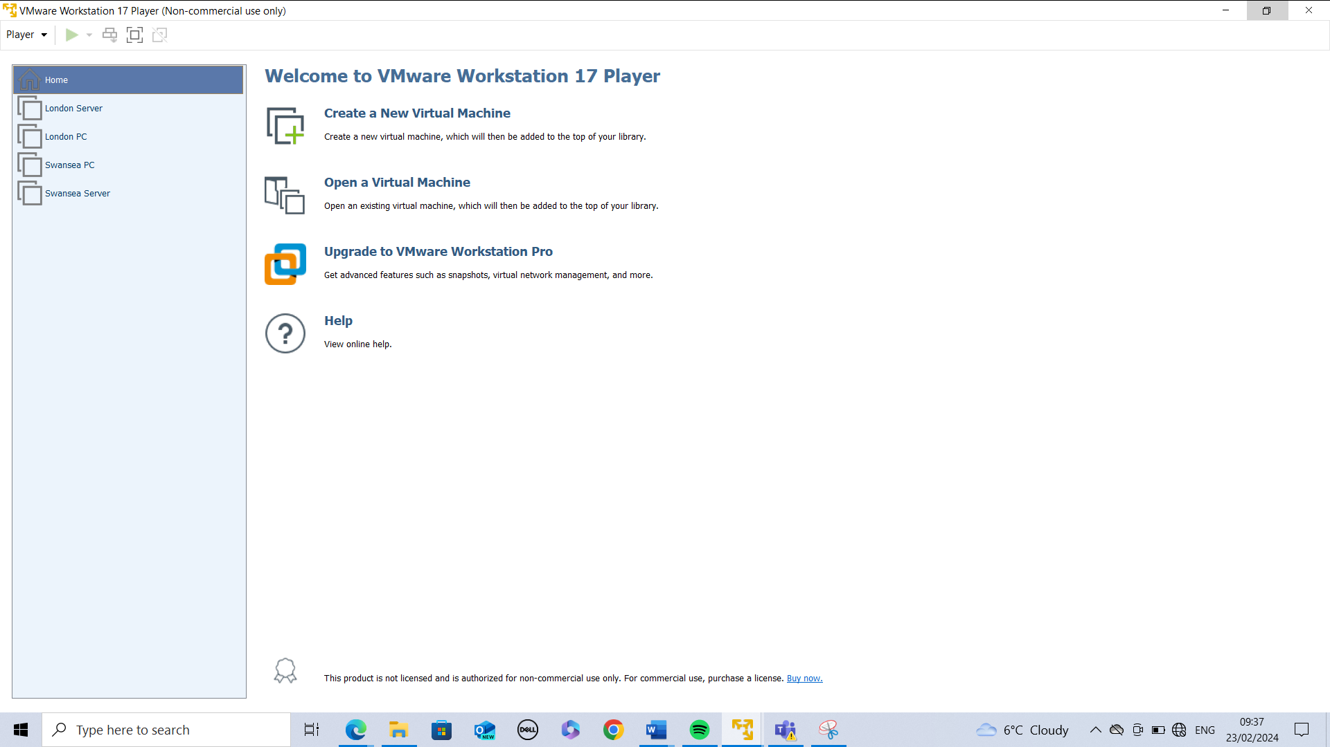
Fig.1 The hypervisor downloaded was VMware Workstation 17 player.

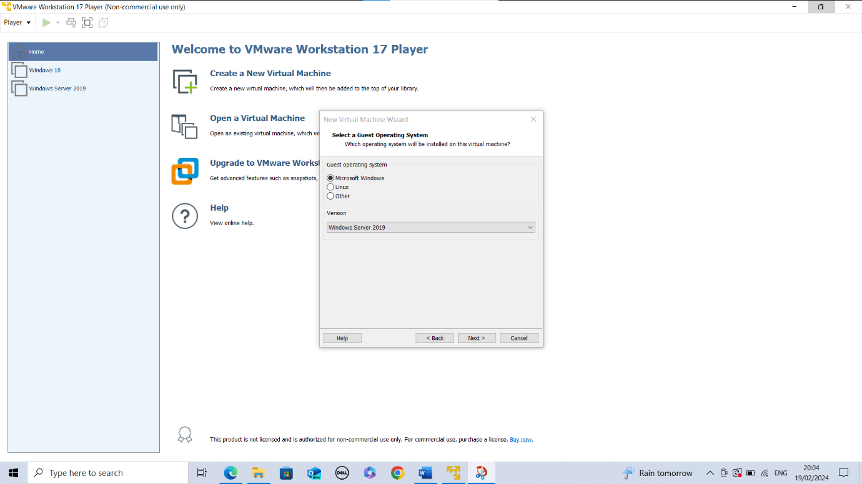
Fig.2 The Server downloaded from the Microsoft website.
2019 Server chosen upon setup. Even though Windows 11 has been released, it has a higher cost. Windows 2019 has all the features needed for a basic server, client setup as per the topology.
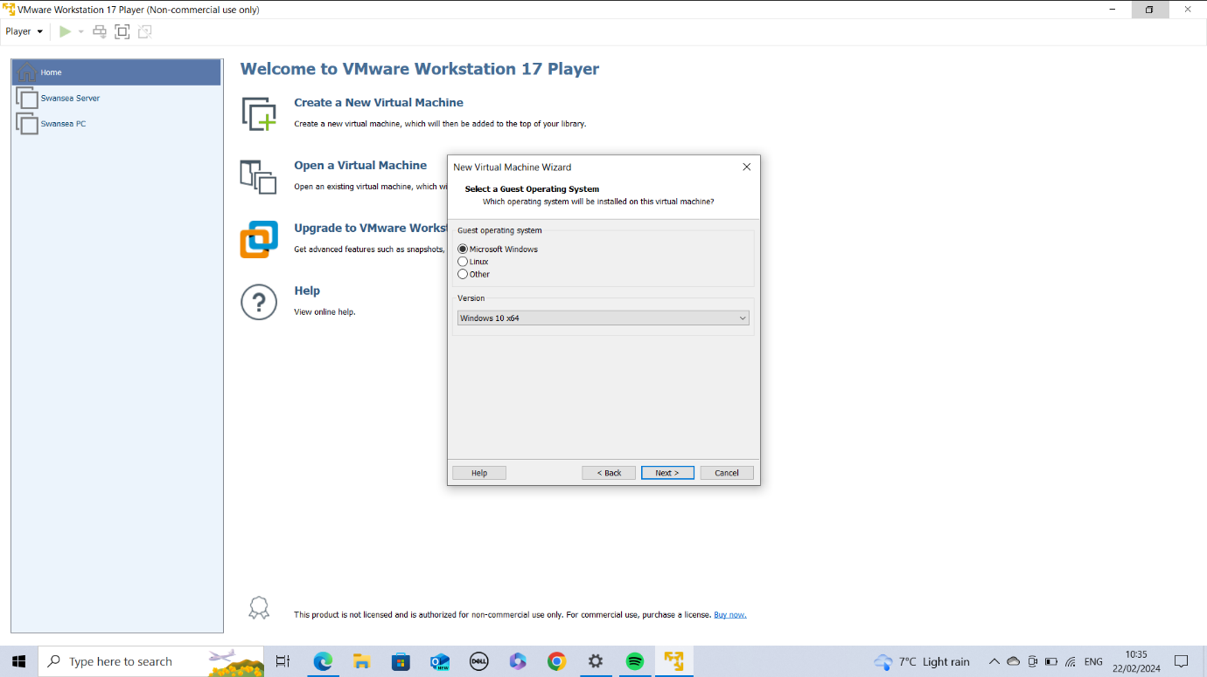
Fig.3 The Client downloaded from the Microsoft website.
Windows 10 was chosen for client PCs upon setup. Despite Windows 11 being available for download, Windows 10 is cheaper to run, is still user friendly, and meets the basic requirements needed for the basic topology setup. Windows 11 can be installed at a later date if preferred.

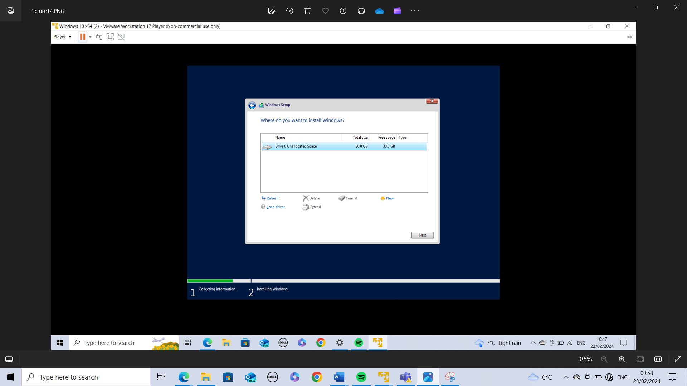Fig.4 Storage space allocated to both the Swansea and London PCs.
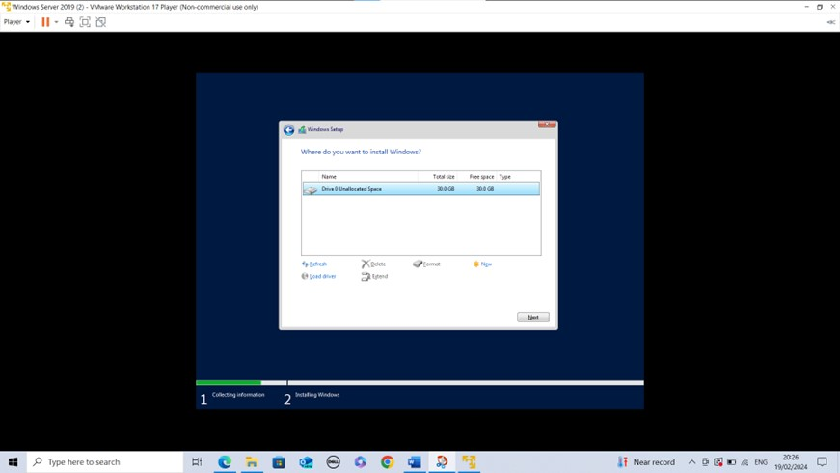
Fig.5 Storage space allocated to both the Swansea and London Servers.
30GB was the chosen amount due to the personal laptop having a lack of storage, this is the most storage I could give without the laptop having issues. If I entered anything higher, I would get an error message to say insufficient space available. I had to delete some inactive apps on my machine to create space. This is something to consider when setting up a network because the correct storage space must be available and might incur further costs.
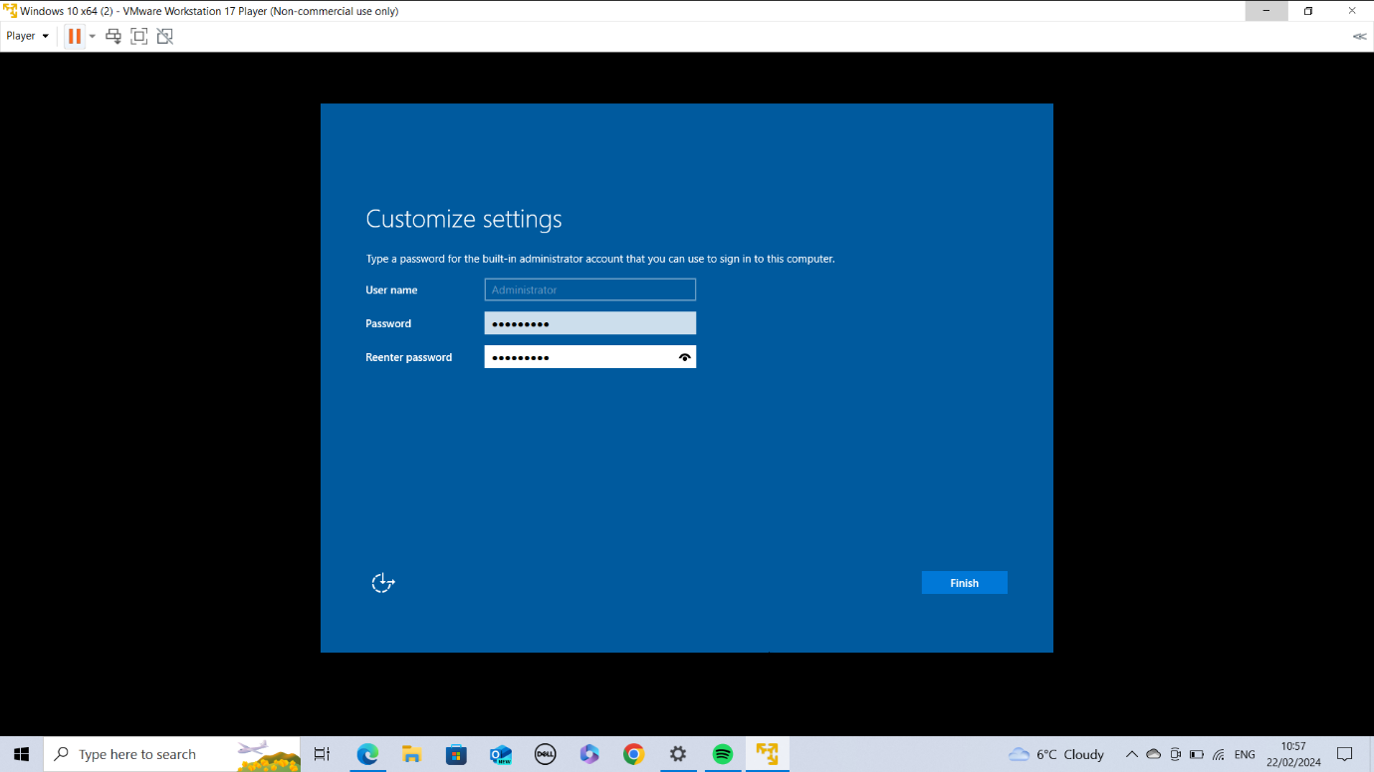
Fig.6 Password for the Server machines were set to Pa55w0rD!
A picture of the password was not possible due to security reasons on my PC.
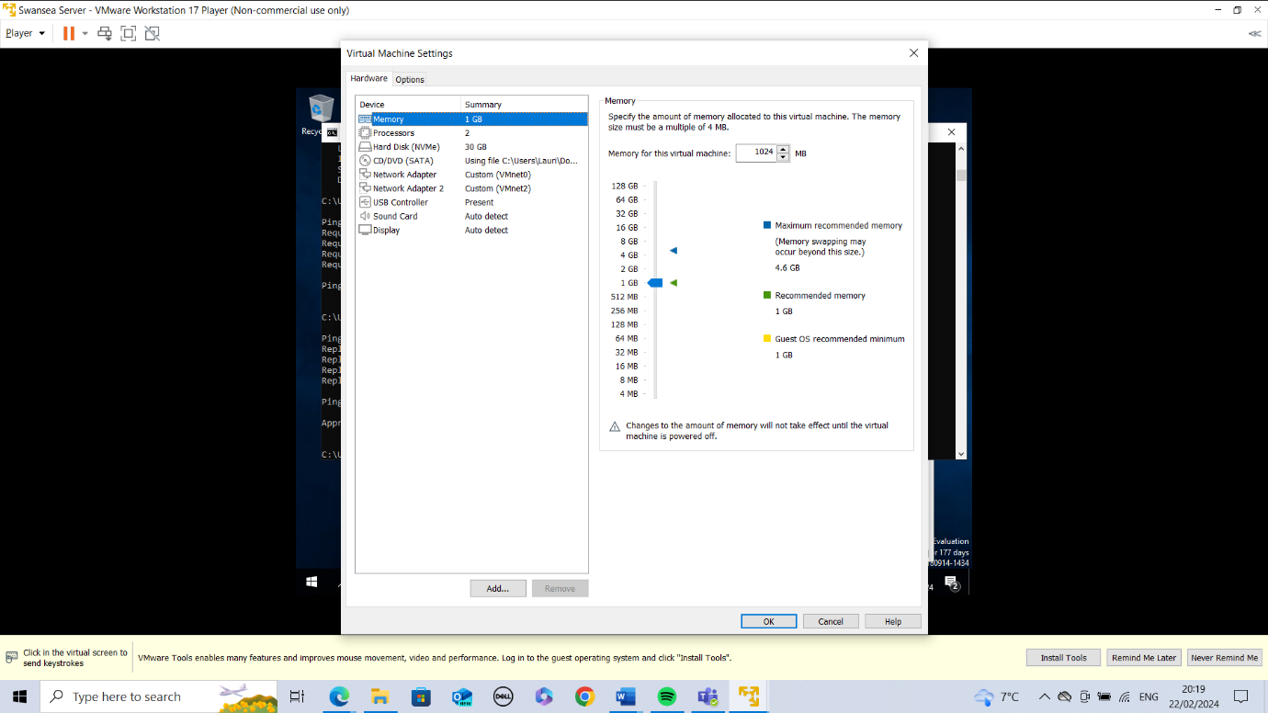
Fig.7 Swansea Server VM setup as per the NOSS topology.

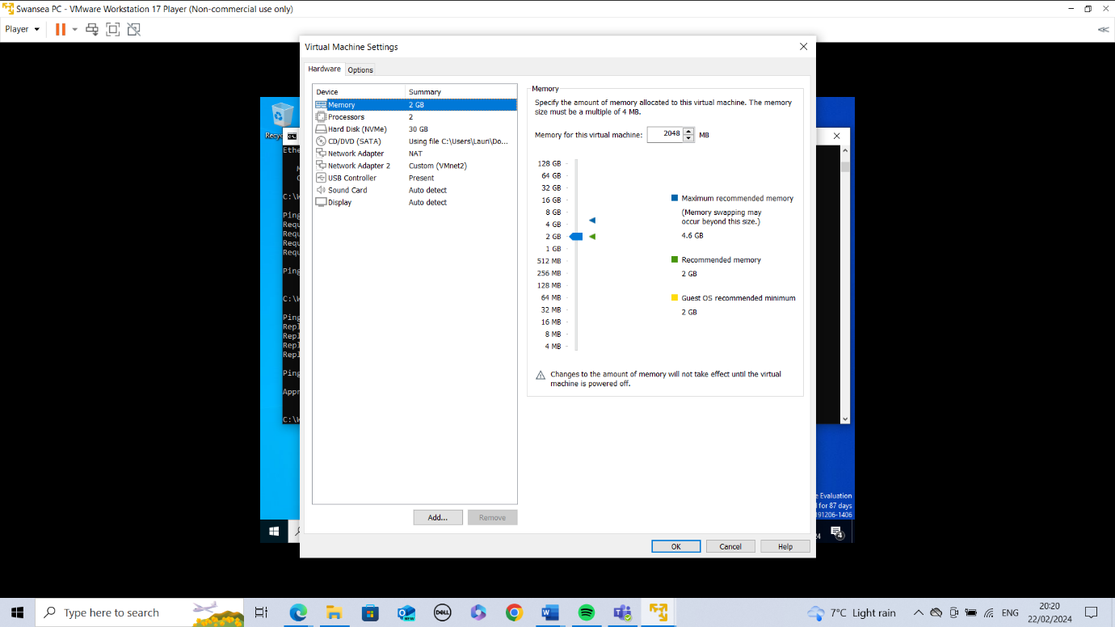
Fig.8 Swansea PC VM setup as per the NOSS topology.
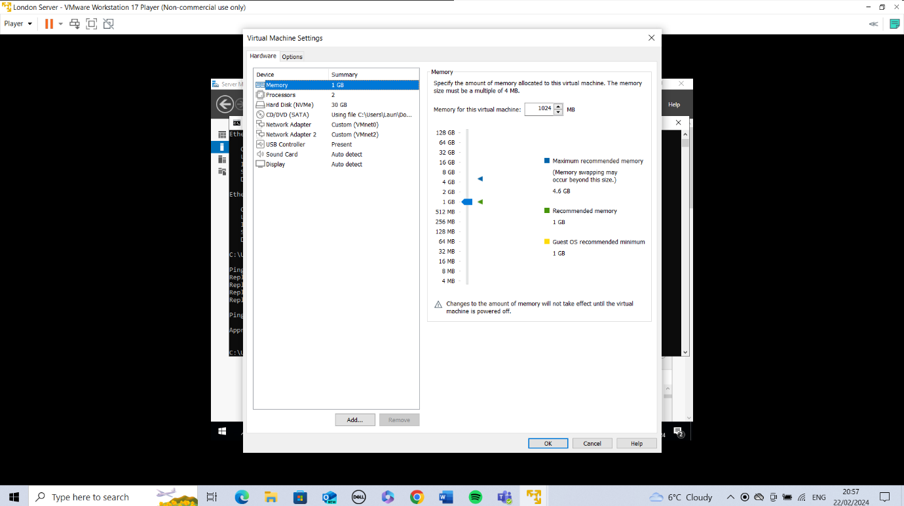
Fig.9 London Server VM setup as per the NOSS topology.
Both London and Swansea Servers were set up so that the ethernet0 network adapter was a VMnet0 and ethernet1 network adapter was VMnet2. VMnet1 was avoided because this is the host connection.
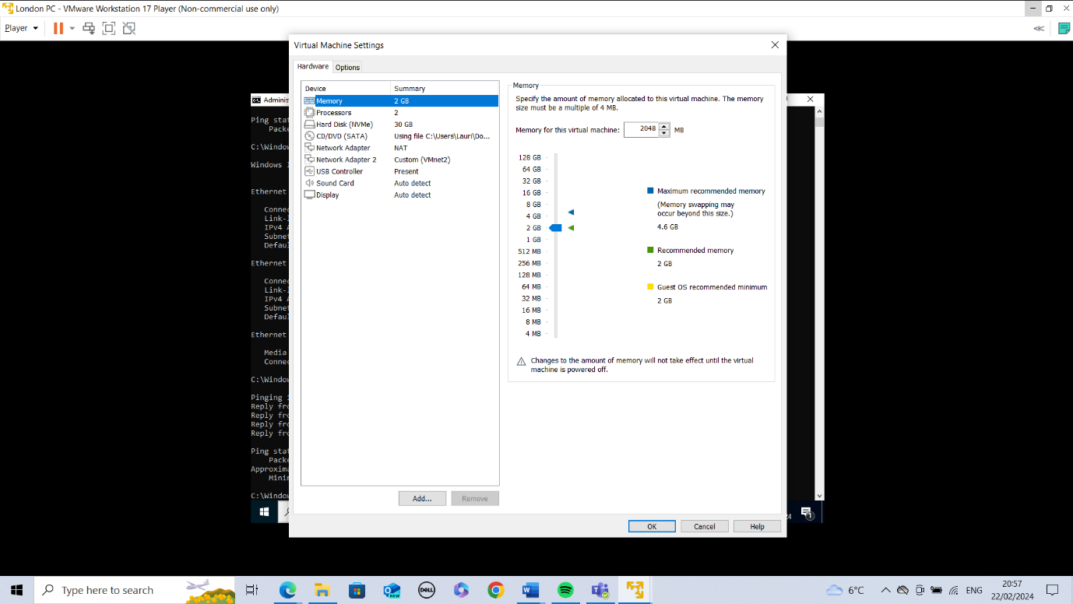
Fig.10 London PC VM set up as per NOSS topology.
Both the London and Swansea PCs were set up with ethernet0 as a NAT connection and ethernet1 as a VMnet2. The NAT connection is running as IP addresses automatically assigned by DHCP while VMnet2 is manually inputted. NAT offers protection because anything outside of the network cannot get through.

IP addressing
Data can be sent from one computer to another over the internet, and this happens by routing packets in line with internet protocols (IP) and transport control protocols (TCP). [6] The packets are bits of data that gets broken up, where the header says where the data is coming from and the rest of the packet saying where it should go to. IP addresses are essential to device communication over the internet. Every device must have an IP address for it to be able to interact with other devices.
There are ipv4 and ipv6 addresses. Originally there were only ipv4 style addresses, but we ran out of available addresses leading to the creation of ipv6. [5] IPv4 addresses are 32-bit binary numbers which have been changed to decimal and they range from 0 to 255 looking like 192.168.10.10 where the first three octets tell the network where the packet is going to and the last octet is the specific device it needs to reach. IPv4 addresses therefore have a network and host component.
[5] Ipv6 has some differences in it’s features where it is split by colons and each segment can be a hexadecimal value in between 0 and FFFF. These addresses have more bits as they are made up of [5] 128 compared to ipv4’s 32 bits. Having a bigger number of addresses available means that there is [5] more scalability for the network and better security. Ipv6 is keeping up to date with security threats as when ipv4 was created the threat was lesser and was sufficient at the time.
[6] The domain name system (DNS) is used for searching for information on the internet, as it changes IP addresses that the devices can understand into domain names which users remember.
[7] The implementation of subnetting is important for larger networks and it breaks the IP addresses within a network into subnetworks which is easier to manage, and the devices can communicate with each other directly. [7] A subnet has three key elements in the ID; a network address, a broadcast address which is where a packet is forwarded on to all the addresses in the subnet named, and a subnet mask which identifies the subnet of an IP address.
[7] A subnet has an easier to manage network for IPv4 because the host addresses are put into class A (16,777,214 addresses), B (65,534 addresses), or C (254 addresses). If a standard network has over 254 addresses, subnetting could bring this number down making it more manageable. Subnetting is useful because if one subnet has a security breach the other subnets will be unaffected. It also allows for better network performance because in a standard network a packet will reach all devices which makes the network busy but with a subnet you can tell the packet to only reach devices in a certain group.
[7] The use of subnetting can be unnecessary in smaller networks and can affect the network negatively. The limitations of subnetting include the need for a router for one subnet to communicate with another and this is extra hardware cost.
The use of routers and switches on the internet help facilitate the flow of data between different networks. [8] The role of a router is to forward packets of data on the best path between networks and a switch is what connects the devices within a Local Area Network (LAN). They work together with the aim of allowing data packets to get to their destination seamlessly. [8] Routers also have protection features for the network and devices such as firewalls, Virtual Private Networks (VPNs) and Network Address Translation (NAT) which preserve IP addresses. [8] The switch can operate at the data link layer of the OSI which means that they deal with data regarding the MAC/physical address of devices. This means that they can sort the packets to their destination at a micro level which reduces the chance of collision, and this is something that the routers cannot do. Having both routers and switches on a network will optimise the speed of data transfer over networks.

Configuring IP Addresses for NOSS
SW - PC
Swansea Domain
Group Policies
10.1.0.1
RRAS
192.1.1.1
VPN
10.1.0.2
SW - DC

London Domain
LD - PC
RRAS
10.2.0.1
192.1.1.2
Group Policies
VPN
LD - DC
10.2.0.2

Fig.11 NOSS Topology

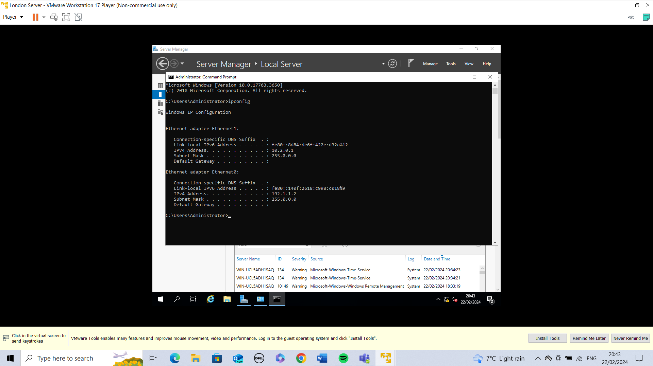
Fig. 12 London Server Ipconfig.
Set up both of the ethernets with manually inputted IP addresses.

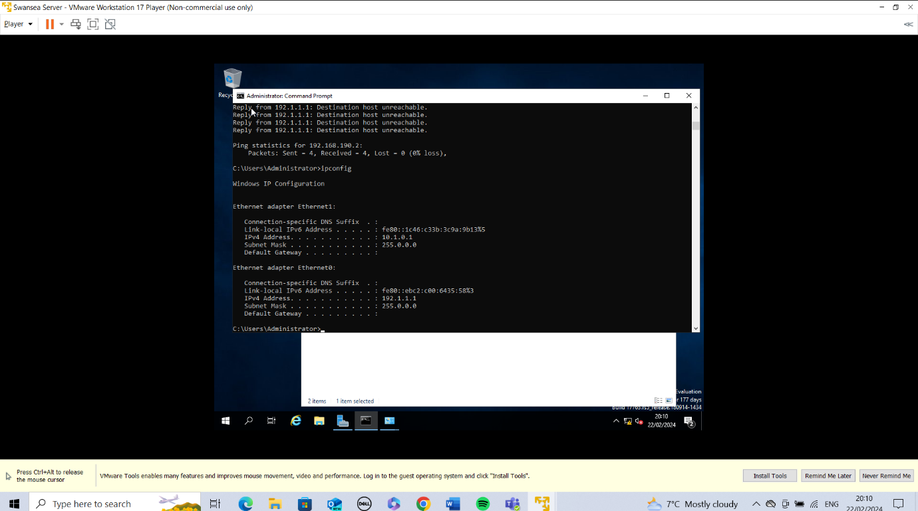Fig.13 Swansea Server Ipconfig.
Set up both of the ethernets with manually inputted IP addresses.
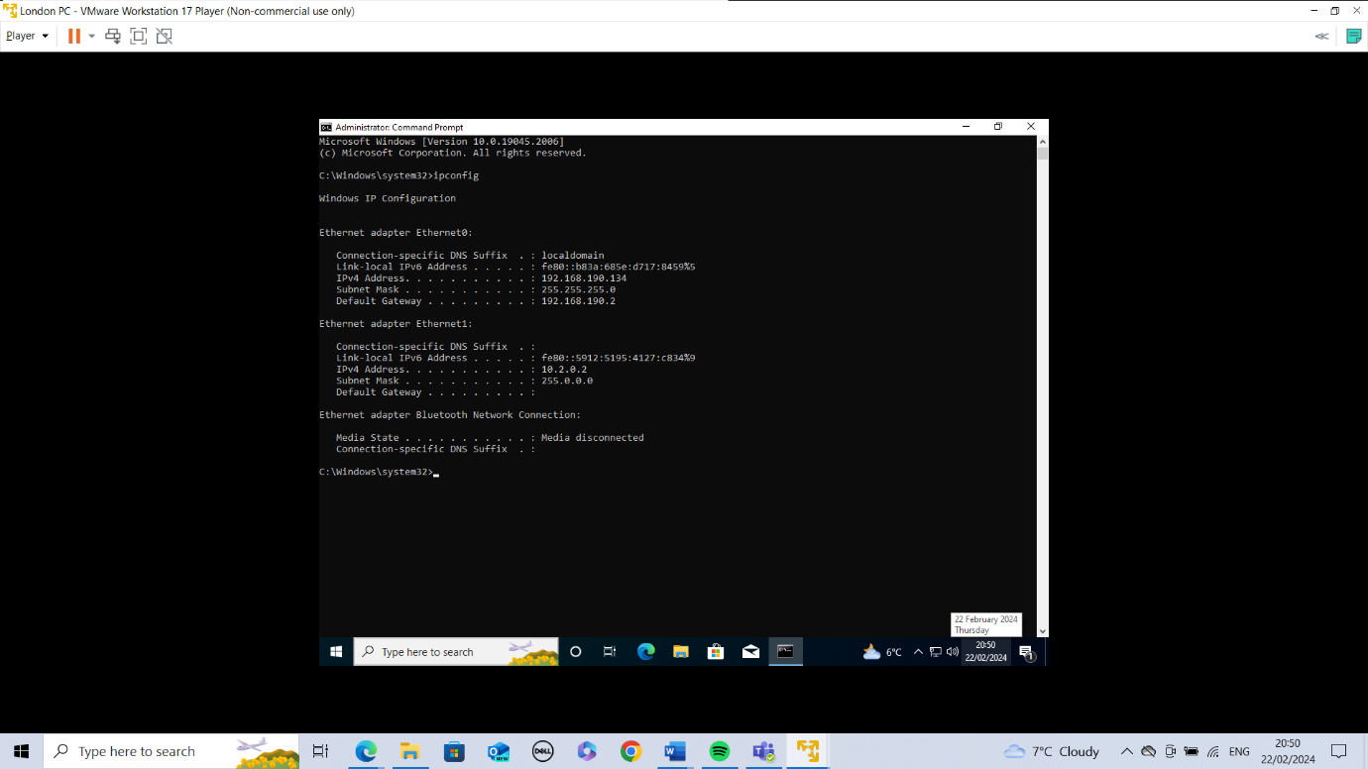
Fig.14 London PC Ipconfig.
Ethernet0 is assigned automatically by the DHCP, while ethernet1 has a manually assigned IP address.
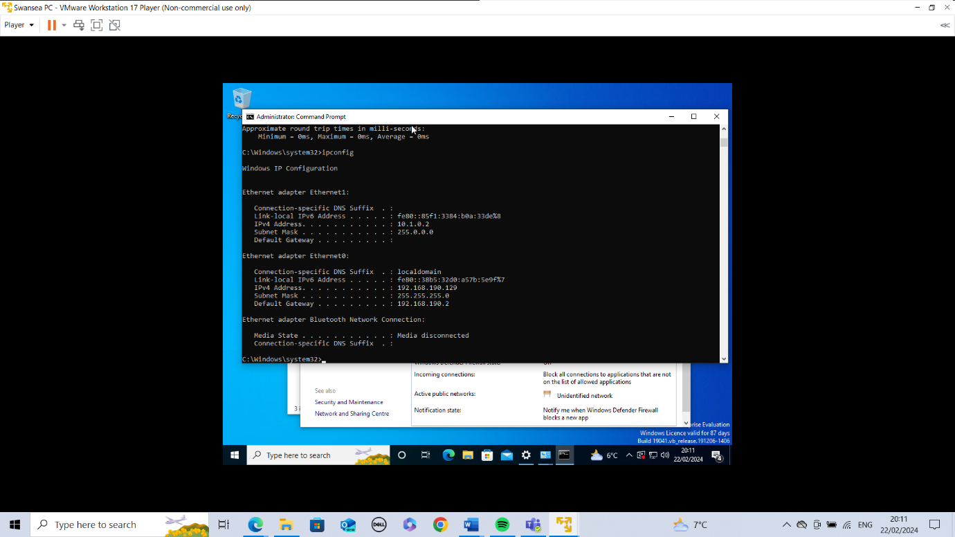Fig.15 Swansea PC Ipconfig.
Ethernet0 is assigned automatically by the DHCP, while ethernet1 has a manually assigned IP address.

Network Testing and Troubleshooting Techniques
[9] The four most frequently found issues requiring troubleshooting in a network are network connectivity issues, bandwidth issues, connectivity device configuration and IP/address issues.
When dealing with connectivity issues such as devices not communicating with each other, the best way to trouble shoot is to use the command line. [9] The PING command will show which IP addresses are communicating and which ones aren’t. [9] Another useful command is IPCONFIG which will display the TCP and IP details of devices in the network. Even though [9] firewalls are usually beneficial for security because they decide what is allowed on a network, if it isn’t set up correctly it can stop the network from functioning as it should so in some cases it should be turned off. Other security measures should be put in place if packets are coming and going involving the internet.
Users are usually alerted to bandwidth errors when websites take a long time to load/timeout or apps aren’t syncing with their servers. Another sign of this could be communication and packets being delivered very slowly. [9] A solution for this issue could be bringing in a file size restriction and another method could be implementing a Quality of Service which prioritises what tasks should be done on the network before others.
Errors can be encountered through configuration issues on devices within a network where they struggle to connect to the network when the network is working as normal. [9] A troubleshooting method for this issue includes using the command line for ping and tracert to see if all paths are connecting from the client to the destinations successfully. Rebooting could also fix the issues. [9] IP addresses, subnet masks, and DNS should be investigated to see if changing these would fix configuration issues.
IP addresses can cause issues on a network. [9] If there is a device on the network with the same IP address it will either cause one or both devices to be disconnected or to not function correctly. The wrong DNS could be running which applies the wrong gateway. These elements can be manually changed by administrators.
Ultimately, the best and easiest trouble shooting comes from good network management and documentation of key elements such as IP addresses.

Network Testing for NOSS
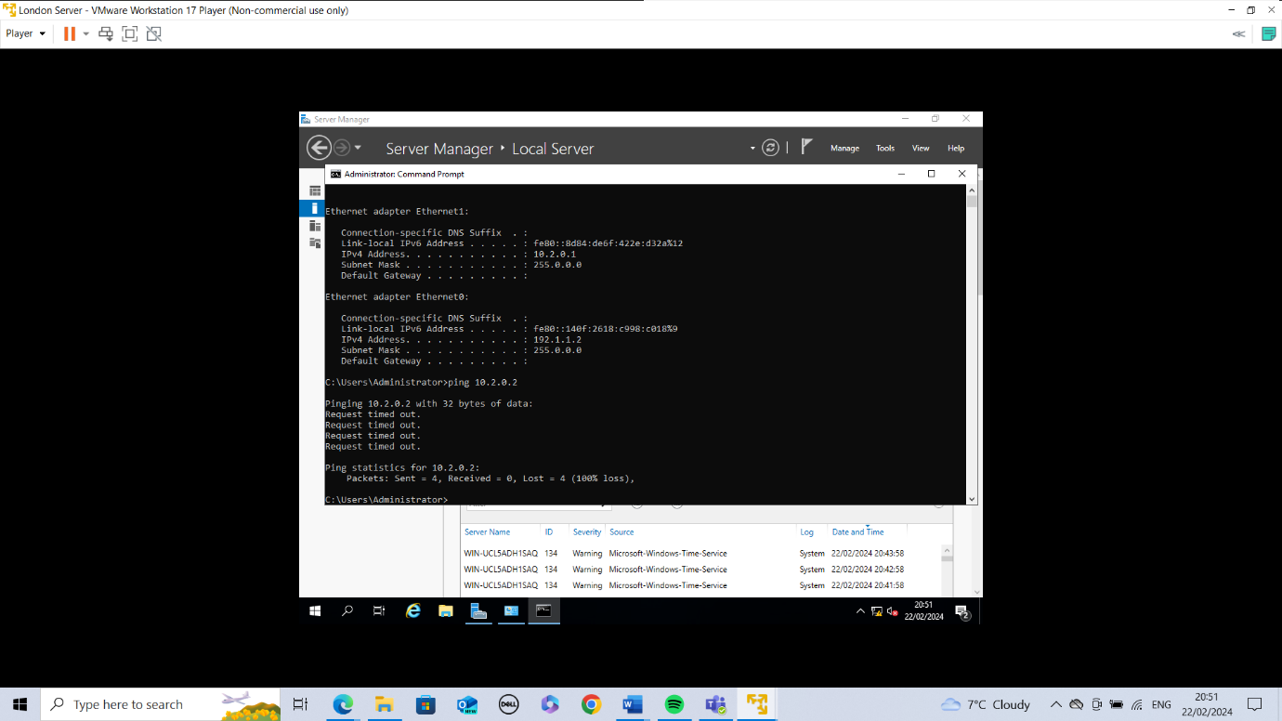
Fig.16 London Server to London PC failed ping.
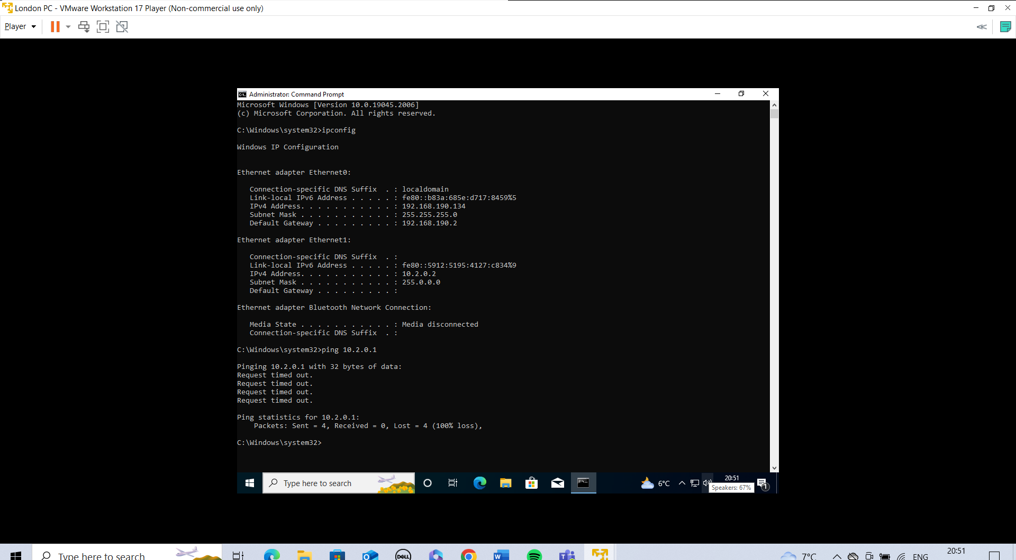Fig.17 London PC to London Server failed ping.
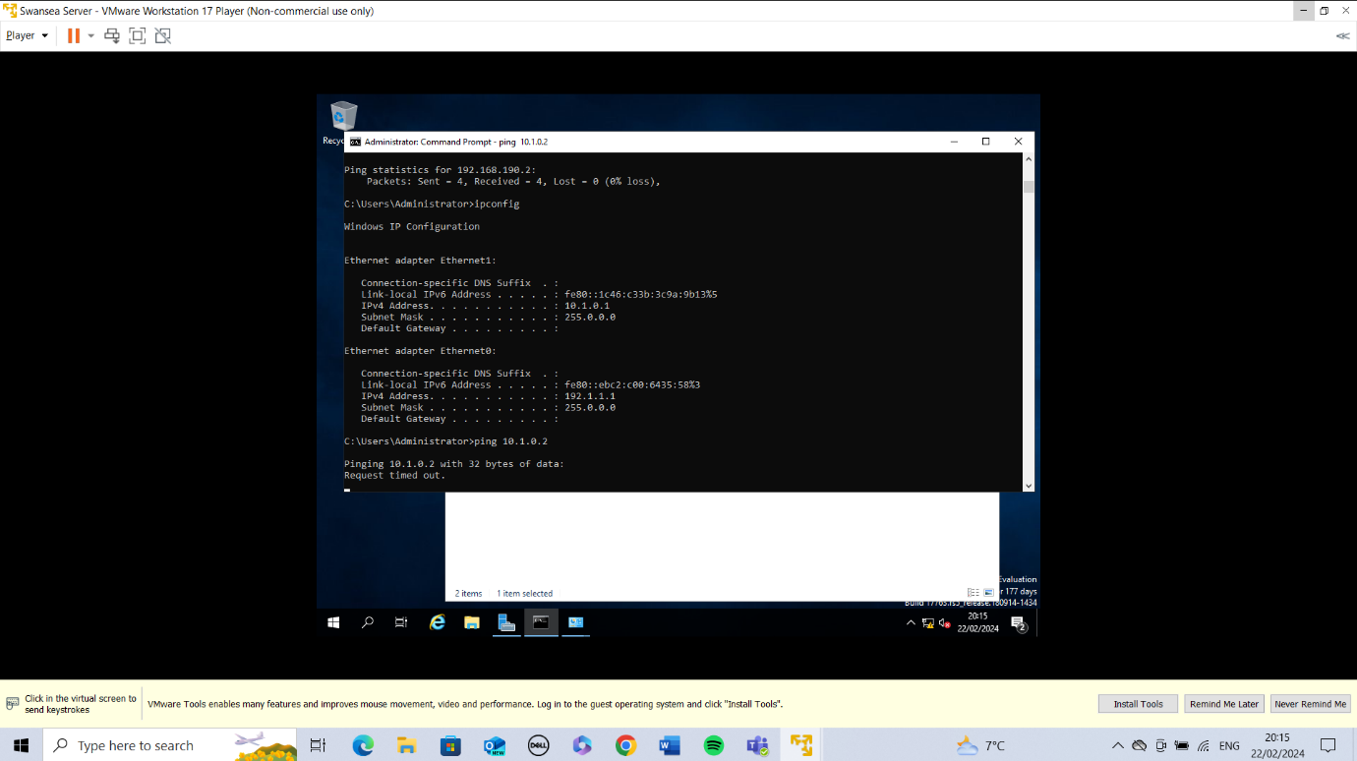
Fig.18 Swansea Server to Swansea PC failed ping.
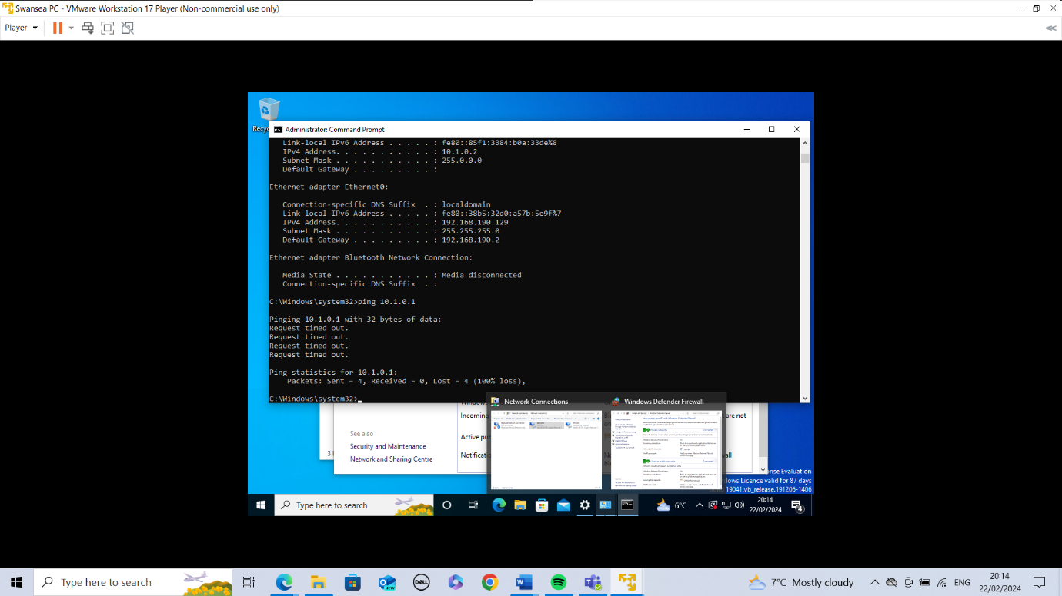Fig.19 Swansea PC to Swansea Server failed ping.

In each ping test the error message states, ‘request timed out’. After researching about trouble shooting techniques, I decided to turn the firewalls off on every virtual machine.

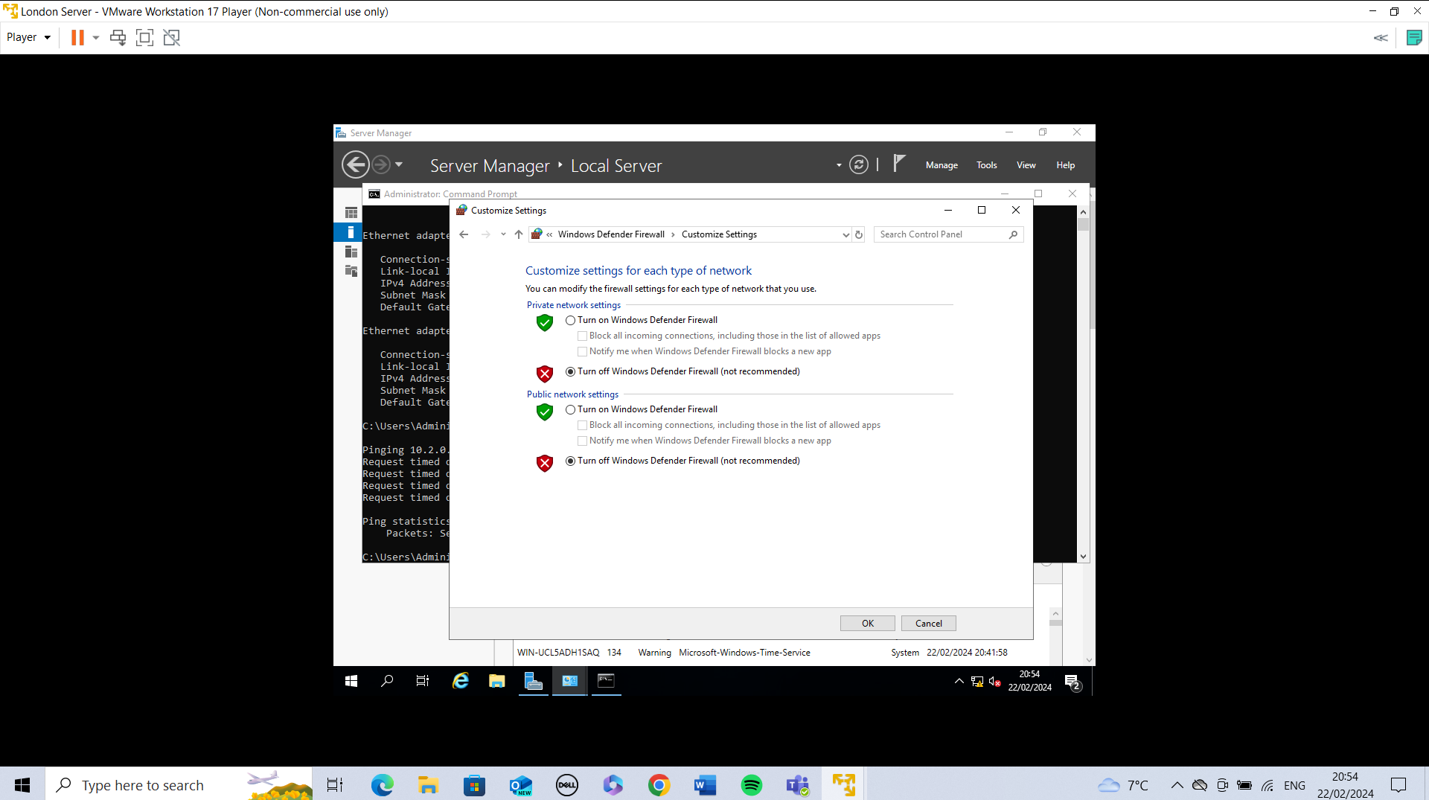
Fig.20 The Firewalls were turned off configured to these settings on each Virtual Machine environment.

After turning the firewalls off I redid the ping testing from London PC to London Server, London Server to London PC, Swansea PC to Swansea Server, and Swansea Server to Swansea PC. These ping tests were successful showing a successful connection as all 4 packets sent were now being received.

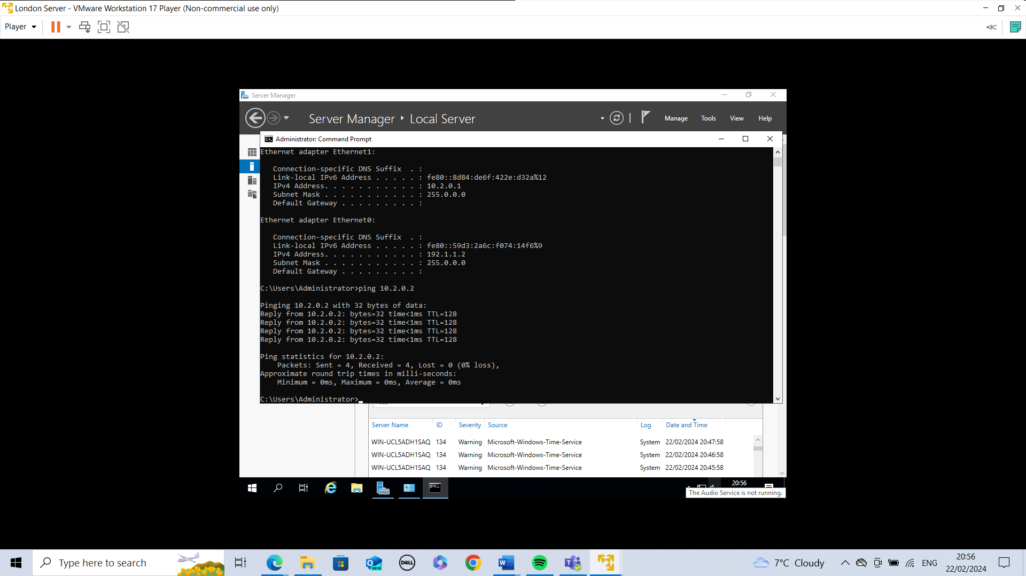
Fig.21 Ping from London Server to London PC successful.
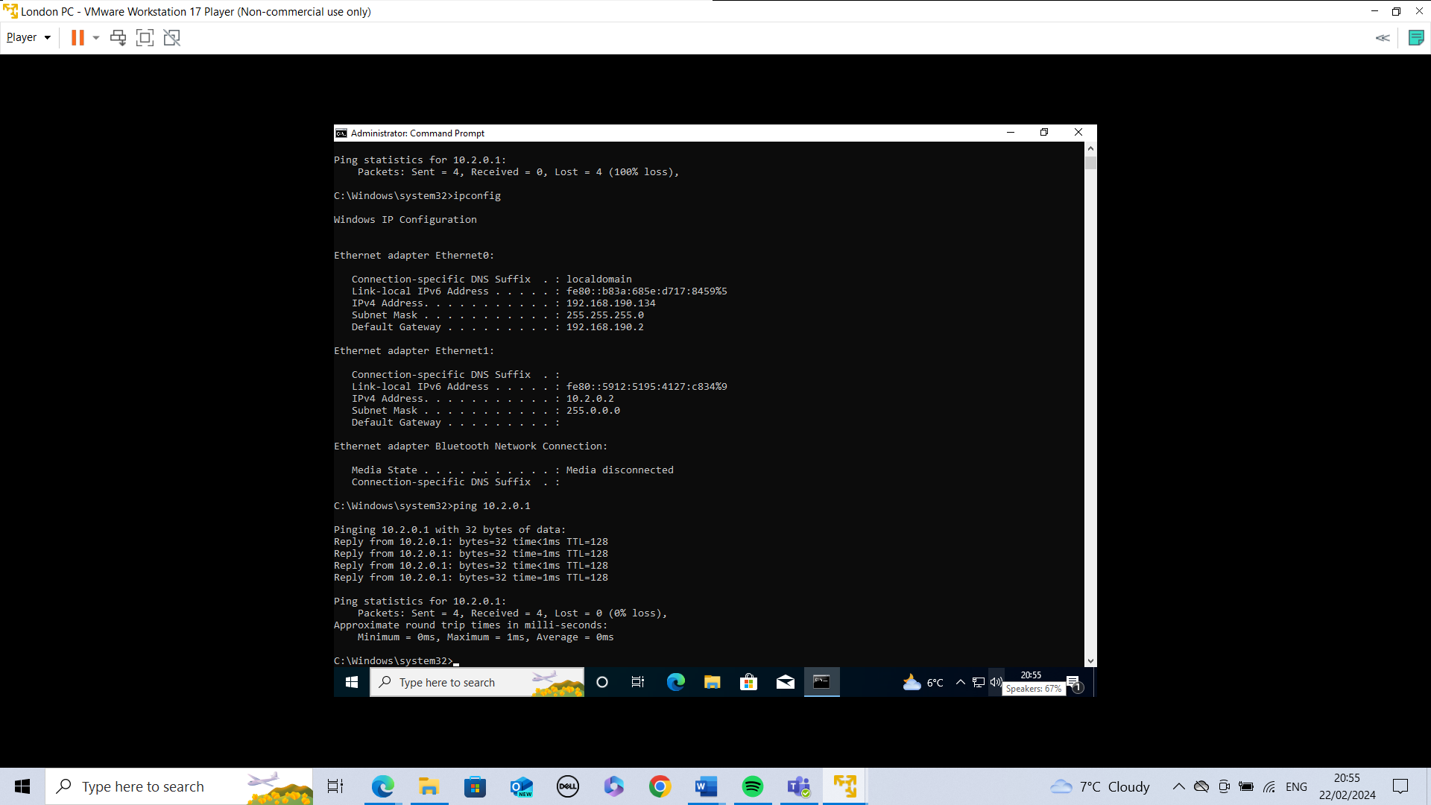Fig.22 Ping from London PC to London Server Successful.
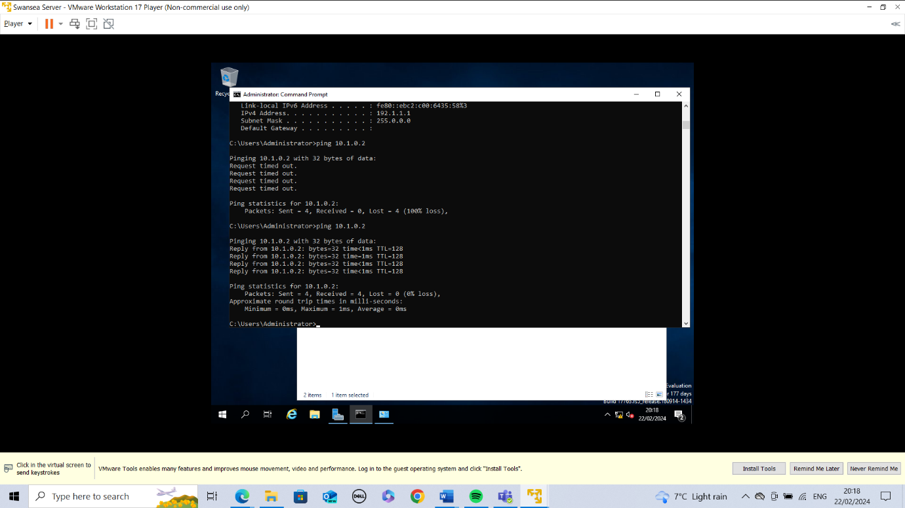Fig.23 Ping from Swansea Server to Swansea PC.
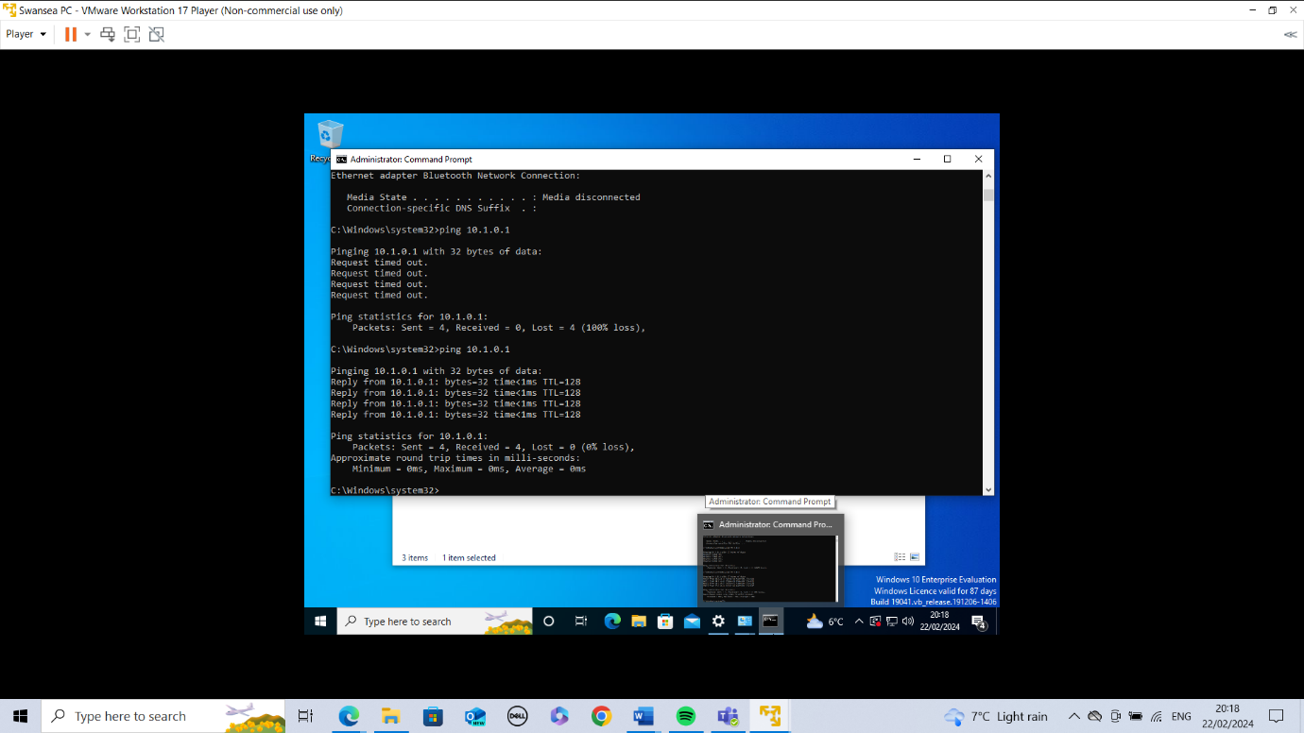Fig.24 Swansea PC to Swansea Server successful ping.

Conclusion
When setting up a network IP configuration is very important. It is advisable that a note of all IP addresses and their corresponding devices are made and kept as a long so that the network is easier to manage. Trouble shooting techniques are essential to a successful networking because many different aspects such as bandwidth, and firewalls could be impacting the performance of the network and the devices. For this topology it would be useful to implement some other security measures because having the firewalls down can let viruses and malware into the network and devices. Something to look at in future would be VPN as it masks IP addresses making the network more secure and hidden from attackers. The choice on VMware is important so it is essential to investigate what functionality the VM should produce and whether type 1 or 2 is more suitable.

References
[1]
“What is a Hypervisor? | VMware Glossary,” VMware, Aug. 04, 2022. https://www.vmware.com/uk/topics/glossary/content/hypervisor.html
[2]
O. Pankevych, “Type 1 vs. Type 2 Hypervisor: What Is The Difference?,” StarWind Blog, Jul. 20, 2023. https://www.starwindsoftware.com/blog/type-1-vs-type-2-hypervisor-what-is-the-difference
[3]
“Hypervisor,” GeeksforGeeks, Jul. 23, 2018. https://www.geeksforgeeks.org/hypervisor/
[4]
P. Storage, “Type 1 vs. Type 2 Hypervisor,” Pure Storage Blog, Oct. 02, 2023. https://blog.purestorage.com/purely-informational/type-1-vs-type-2-hypervisor/
[5]
“Data networks and IP addresses: View as single page,” Open.edu, 2020. https://www.open.edu/openlearncreate/mod/oucontent/view.php?id=129584&printable=1
[6]
A. Dubey, “Ever Wonder How data is transferred over the internet?,” Medium, Sep. 19, 2022. https://blog.devgenius.io/ever-wonder-how-data-is-transferred-over-the-internet-ec4eb3d6d66f
[7]
SolarWinds, “What Is Subnetting? How Subnets Work - IT Glossary | SolarWinds,” www.solarwinds.com. https://www.solarwinds.com/resources/it-glossary/subnetting
[8]
“What are the roles of routers and switches in network architecture?,” Tutorchase.com, 2023. https://www.tutorchase.com/answers/a-level/computer-science/what-are-the-roles-of-routers-and-switches-in-network-architecture (accessed Feb. 21, 2024).
[9]
L. Zelleke, “Troubleshoot Network Connectivity: The Ultimate Guide for 2022,” Comparitech, Mar. 10, 2022. https://www.comparitech.com/net-admin/troubleshoot-network-connectivity/

