University of Wales
Trinity Saint David
Certificate of Higher Education in
Skills for the Workplace (Level 4)
Skills what we need to be successful.

Xenia Eniko Gyorgy

Shao Yuen

Academic and Employability skills (ACE)
BMSW4001_LON

TERM (June) 2020

Contents

- Introduction

- Time management
  - Deligation
  - Recognise
  - Prioritise

- Listening skills
  - Types of listening

- Team building
  - Types of groups
  - Example from my own

- Leadership skills
  - What is leadership?
  - The leadership challenge

- Public speaking
6.1 Reaching peoples
6.2 Understanding peoples
6.3 Promoting
6.4 Place checking
7 References

Introduction
In my report, I am going to talk about what skills are essential to improve for my future and what skills are essential to becoming a good manager learn how to manage my own time, how to speak and reach peoples (customers) In my closes future, I see myself as a good team worker especially manager because within the next education in this University with the following year, will makes me a successful and independent student who can be available to run my future business. Wich is it will be a Hungarian food truck here I have to improve a few skills and get more knowledge within during this course. I did analyse how I can manage my time cutting down on non-important stuff and focusing only on duties I most to do in my 24hours at the same time being successful on my course staying on schedule. I already have experienced some of the cases what I am going to talk about. In my business for me is the most important my customers and my Team, and this is one of my reasons why I am practising with this University.
2 Time management
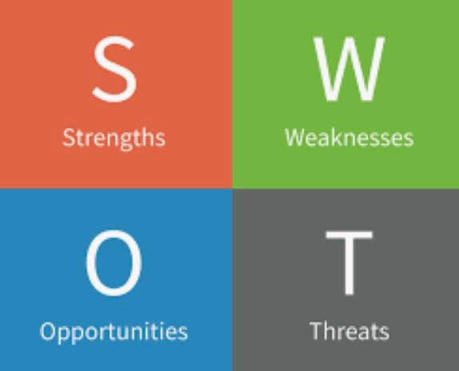
We may not realise it, but time management affects your entire life. It allows you to get more essential things done, which boots your productivity. Our time is an essential thing because maybe we do not realise immediately, we can lose valuable time. We regularly need to do, time management because without we cannot organise our information on time otherwise easily can lose valuable data. Here we can also use swot analysis wich it means the organisation of my time coordinating and planning. The order should always be shared. Sometimes we are facing some unexpected challenges, but that is why we had organised our daily routine complete pending tasks one by one. I would not start new work unless I finished the previous job. I have to make sure which task takes me for a day, and wich responsibility will take me less than a day it can be in one hour or less or a month and so on. Sometimes we are facing some unexpected challenges, that is why we had organised our daily routine complete pending tasks one by one. Ensure you finish the tasks within the specified time case. Know the variation between primary and urgent action. Most essential purposes should be done earlier. People who realise the value of time are the ones who manage to reach the aims, and those peoples can spend most of the time benefit. I exercised in these cases because I am studying and working at the same time, including the rest of my responsibilities, hobbies. I can say I am good with and I had learned a lot from lectures already and keep going exercising.
Delegation
It suggests Believing in capacities and learn to trust
Recognise
It involves Notes making, primary daily routine
Prioritise
Are an organisation and choice making
- Goal setting
- Multitasking
- Problem-solving
- Strategic thinking
- Scheduling
- Managing appointments
- Record keeping
Xenia paraphrase Pope, G. 2020 Time Management

3 Listening skills 
We have four different types of skills
- Reading
- Writing
- Speaking
- Listening
From these four essential language skills, the oldest skills for conversation are speaking and listening, and the oldest forms of communication. It signifies that speaking and listenings are the most basic and primal way to dispatching messages. When example having a baby, your baby does not understand your language when you were speaking, but she heard from your sound urgent or not. However, it does not mean that communication does not take place. The skill of listening has such a massive potency on learning the language is that though children cant communicates in the same system with, patience, attention, everyone can understand another A great example is a situation that often happens when we are added to a piece of the original information. Understand that listening is hard work good listeners adjust quickly to any strange situation; poor listeners manage unfriendly situations and, in some cases, they create madness for themselves. Practice about 40 to 45 per cent of our working hours to listening? Do we listen at only 25 per cent performance? A good listener does not feel insecure or insulted, or need to resist messages that disclaim his beliefs, attitudes, ideas, or personal values. Try to understand and think the words or expressions most upsetting to your emotions. Usually, we cannot show up what we are feeling most of the people are hiding them emotionally. However, we should always be straight and saying what we think about anything. Without listening to others, we cannot let things go genuinely, and we are going to be always frustrated about something. I can say that this is one of muy weakness. If I don't focus exactly to the conversation easily, I can create a mad situation because I didn't pay attention to the anothers.
Xenia Pharaphrase Neil, T. 2004 The Concise Adair on Teambuilding and motivation
4 Team building
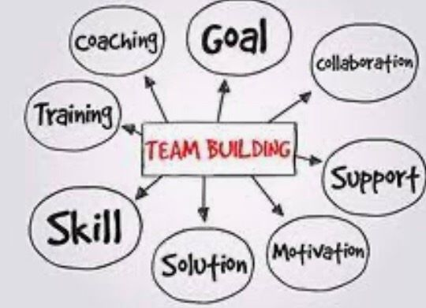 For Team working the teams needs to have defined membership
• A common goal
• excellent communication amongst its members
• A dependence on each other to join the individuals together.
- Feel confidence in a team.
A team can provide friendship, comfort and support to its members. Teams experience similar values, attitudes, ideas, opinions, aims. We can select between two types of groups
- Primary groups are small teams of people who work closely together always.
- Secondary groups are teams of more significant numbers where members do not know each other or work together closely. Teams it needs to spend time to know each other while analysing the task in hand and how they are likely to take it. Every new member of the Team will own requirements and expectations about the newly created group. A new team needs to have limits placed for it, which allow it to develop. Usually, the more experienced groups come with their features. Whit time, the group will improve how it works on tasks or any new challenges. If anyone has been successful in the previous Team, It can give the members more inspiration. Teams are always reacting in different ways. So, in this situation, I have to ask myself

- Are they engaged in the conversation?
• Did something preventing them from my speaking?
• If one member of the Team talking too much and not letting others have their say?
So if I am ahead of the Team need to exercise the skill of 'gate-keeping ask the person who is holding much time and then ask the quiet member to add their opinion. Every member's voice is essential! At my workplace when we are facing with some problem, we use to have a meeting because if the last week we got any misunderstood situation or we had any confusions with rules either customers or question of the products we try to discuss and making a decision together also like as team leader I have to welcome another's an opinion and creating the best solution together like as a team. In this meeting, when we have issue or example they do not know what to do if the customers are not happy enough with our service here we have to explain what how to solve the problem and end of the discussion customer will leave the store satisfied and grateful.
Xenia paraphrase Adair, J.2004 The Concise Adair on Teambuilding and Motivation

5 Leadership skills
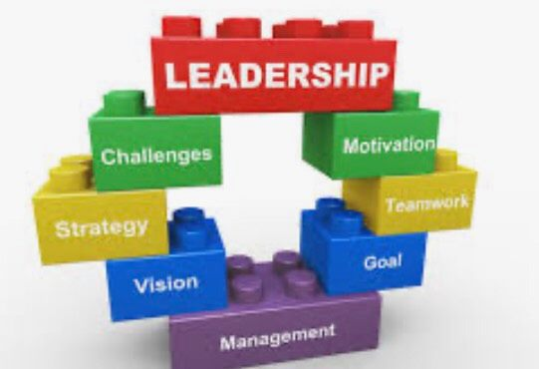
What is Leadership?
This is not something that can do on your own. It is an explanation of collective, agreement work of leaders and followers who trust enough to reach common goals together. Is based on shared values that create universal respect, freedom, justice, unity, and happiness. Leadership is often described in names of the relationships built up by the leader and team members. The quality of relationships tends to be decided in terms of characteristics such as empathy, kindness, respect and genuineness, all of which are connected more with the female stereotype females traits and behaviours, some traditional features of the female strategy.[are] presented to be more appropriate and successful.
Direction giving: finding a way forward, communicate a clear direction, recognise new goals, services and structures
Offer inspiration: have ideas and articulate thoughts always motivate others
• Build teamwork: use teams as the typical effective style of leadership, spending their time building and promoting collaboration
• Placed an example: model what leaders do and how they do it
• Gain acceptance: act in ways that produce acknowledgement of their leadership status in believers

- THE LEADERSHIP CHALLENGE.
Increasingly, today leaders are coming to see their role in development as a responsibility of building a trust culture to undergird both personal and institutional growth. Once leaders have created and concluded this unifying cultural background, they can allow co-workers to change the organisational structure or system because they give common aims. Trust culture provides a unifying setting within which leader and followers work and focus effort to agreed-upon goals, preferences, and vision ideals. The mixed impact is to push the formal structure to change. Collectively the sum of individual changes is to improve our circumstances as an organisation, a community, a nation, the world.

Xenia paraphrase Moyles, J. 2006 Effective Leadership and Management

6 Public Speaking


First of all, the reason why I have chosen this skill because I do not have that many exercises in those skills. I would love to acquire more about it and develop for my own business. As I said, in the beginning, I would like to open shortly my food truck. Nevertheless, for that is essential to reduce the place first and also do a survey because we should usually think with customer's head significant to know about concurrence and also what is the most popular food example at the moment I am living in England, so in this case, for sure I will make English breakfast every day to attain more customers periodically offering something unique. I have to do promoting to get more customers to let the people know we are going to open soon giving tasting.
- Reaching peoples
- Understanding peoples
- Promoting
- Place checking

When we have learned the language enough, we can make a public conversation. Get more inspiration, good conversation. Moreover, like a conversation, it should be attuned to the reactions of listeners. In a business connection, speakers and listeners of this 'conversation' are usually motivated business people, looking for oral effectiveness and performance. Some primary references for the value public speaking of a business authority have been made since English for Business started to have status [30-32]. In the beginning of the twentieth century, the newly-born Business English concentrated domain shows its self-governing status in any manuals, which were supposed for people requesting 'efficient business. Also, many Englis book can help to develop your won language. The strategic communication skills in today's workplace have been thoroughly documented in the literature on organisational leadership.

Xenia Paraphrase
Zanola, A.2016 Business Communication and Public Speaking in the ESP Domain: Some Considerations

- References

Adair, J.2004 The Concise Adair on Teambuilding and Motivation Avaible at

https://www.questia.com/read/107338159/the-concise-adair-on-teambuilding-and-motivation?fbclid=IwAR2ULkl7m3d91VGdBVB05dBrpdtoz1OY56flpcDVDyhi6WGUGLHXwV4Q5Xc
Accessed on 13/8/2020

Moyles, J. 2006 Effective Leadership and Management Available at

https://www.questia.com/read/118298749/effective-leadership-and-management-in-the-early-years
Accessed on 16/8/2020

Neil, T. 2004 The Concise Adair on Teambuilding and motivation Available at
https://www.questia.com/read/107338174/the-concise-adair-on-teambuilding-and-motivation?fbclid=IwAR2ULkl7m3d91VGdBVB05dBrpdtoz1OY56flpcDVDyhi6WGUGLHXwV4Q5Xc
Pope, G. 2020 Time Management Available at
https://play.google.com/books/reader?id=QU3PDwAAQBAJ&pg=GBS.PT8 Accessed on 14/8/2020
Zanola, A.2016 Business Communication and Public Speaking in the ESP Domain: Some Considerations
Available at https://scholar.google.co.uk/scholar?hl=en&as_sdt=0%2C5&q=public+speaking+in+business&btnG=
Accessed on 22/08/2020

