
BA Business Management
Entrepreneurship
Assessment Component 2: Report
LCBB5001


Lecturer Name: Vasilios Tavlaridis
Student Name: Sava Daniela
Student Number: 2028792
Contents
Introduction 2
Body 3
James Dyson's Life History 3
James Dyson's Entrepreneurial Traits 6
Conclusion 8
Reference List 9

Introduction
200 words

Entrepreneurship is a dynamic journey marked by innovation, resilience, and strategic thinking. An entrepreneur is defined as "a person who recognizes an opportunity and organizes and manages a business, assuming the risk for the sake of potential return" (Mariotti and Glackin, 2015). This report explores the life and entrepreneurial journey of James Dyson, highlighting his key traits and life experiences. It will represent the Dyson's background, his alignment with entrepreneurial traits, and the lessons we can learn from his successes and challenges.

A good entrepreneur as it is James Dyson should have a lot of traits which will help him to achieve the desired scop. Some examples of traits which should have an entrepreneur are the next ones:
- Curiosity: Great entrepreneurs possess curiosity to discover new problems and innovate.
- Time Management: Careful planning and execution are crucial for prioritizing tasks and achieving milestones.
- Strategic Thinking: Solving problems and identifying growth opportunities through creative solutions.
- Efficiency: High performance in problem-solving and task management.
- Resilience: Determination in the face of setbacks and challenges.
- Communication & Networking: Effective communication and building networks for business opportunities.
- Finance Management: Proper handling of resources is vital for business success.
- Branding & Sales: Building a consistent brand and creating new business opportunities.

Body

James Dyson's Life History
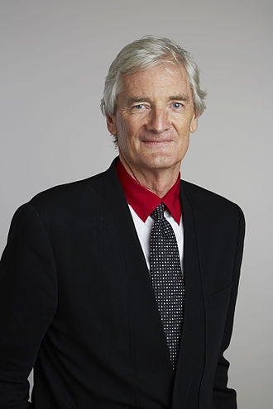
Fig 1. ( Wikipedia)
James Dyson, born on May 2, 1947, in Norfolk, England, is renowned as a British inventor, industrial designer, and entrepreneur. He gained international recognition for his revolutionary innovations in household appliances, particularly vacuum cleaners. Dyson attended the Royal College of Art in London, where he developed a keen interest in design and engineering. After years of experimentation and numerous setbacks, Dyson launched his first bagless vacuum cleaner, the "G-Force," in 1983. Despite initial rejection from major manufacturers, Dyson persisted and established his company, Dyson Ltd., in 1991.
Today, Dyson is a prominent figure in the business world, leading a multi-billion-dollar empire with a diverse range of products, including bladeless fans, air purifiers, and hand dryers. His company continues to prioritize innovation and has expanded globally, with manufacturing facilities and research centres worldwide.
Fig 2. (Wikipedia – 1st Dyson)
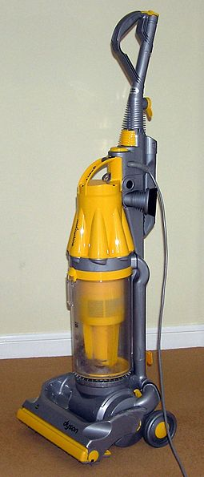
James Dyson's invention - the Dyson vacuum cleaner stemmed from a combination of frustration, curiosity, and a desire for innovation (Forbes). Dissatisfied with the inefficiency of traditional vacuum cleaners, which often lost suction power due to clogged bags, Dyson saw an opportunity to revolutionize the industry (James Dyson Foundation). His journey began with a simple observation during his time as a design engineer in the 1970s - the inherent flaw of conventional vacuum cleaners (Britannica).

Dyson's frustration with the constant need to replace or clean clogged vacuum bags sparked his curiosity to find a better solution. Instead of accepting the status quo, he embarked on a mission to develop a vacuum cleaner that would maintain consistent suction power without the need for bags (Dyson). This quest for innovation led Dyson through a gruelling process of experimentation, iteration, and countless failures in his trial to find a solution (Champions Speakers).

Despite facing scepticisms from industry experts and enduring financial hard times, Dyson remained undeterred in his scope (Forbes). He meticulously tested various prototypes, refining his designs through trial and error (Dyson). Dyson's perseverance and determination were instrumental in overcoming the technical challenges inherent in developing a bagless vacuum cleaner (Chaston).

Finally, after years of relentless effort and over 5,000 failed prototypes, Dyson achieved a breakthrough (Dyson). His patented Cyclone technology, which utilized centrifugal force to separate dust and debris from the air, revolutionized the vacuum cleaner industry (Dyson). The Dyson vacuum cleaner not only solved the problem of clogged bags but also offered superior performance and efficiency compared to traditional models (Dyson).

Ultimately, James Dyson's invention of the Dyson vacuum cleaner exemplifies the power of curiosity, determination, and innovation in entrepreneurship. His willingness to challenge the status quo and relentlessly pursue his vision against all odds not only transformed an industry but also cemented his legacy as one of the most influential inventors of our time (Forbes).

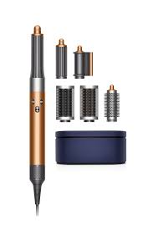
James Dyson's invention of the Dyson Air Wrap was driven by a combination of innovation, consumer demand, and a desire to revolutionize the beauty industry (Forbes). Dyson, known for his groundbreaking work in engineering and product design, sought to address common frustrations experienced by consumers when styling their hair as well in one of his interviews James mentioned that one of the most important driven was his wife. He wanted to invent a styler which will be appropriate for her and will save her time (James Dyson Foundation). The traditional hair styling tools often caused damage, lacked versatility, and were hard to use, Dyson was exploring a better way to style the hair (Forbes).

Dyson's curiosity and commitment to innovation led him to invent a hair styling device that would offer exceptional performance, ease of use, and minimal damage to hair (Forbes). With the success of previous Dyson products, such as vacuum cleaners and bladeless fans, Dyson recognized the potential to apply his engineering expertise to the beauty industry (James Dyson Foundation). The Dyson Air wrap was conceived as a revolutionary hair styling tool that utilized air technology to style hair without extreme heat, reducing the risk of heat damage while delivering exceptional results (Forbes).

Furthermore, Dyson identified a growing demand among consumers for high-quality, technologically advanced beauty products (Forbes). The Dyson Air wrap was designed to cater to this market demand, offering a unique combination of innovation and performance that set it apart from traditional hair styling tools (James Dyson Foundation). By leveraging Dyson's reputation for excellence in engineering and design, the Air wrap appealed to a broad spectrum of consumers seeking a superior hair styling experience (Forbes).

The Dyson Air wrap was intended for a diverse range of consumers, including individuals concerned about hair health, beauty enthusiasts looking for innovative styling tools, and professionals seeking efficient and effective styling solutions (James Dyson Foundation). By offering a versatile and intuitive hair styling device, Dyson aimed to revolutionize the way people styled their hair, catering to the needs and preferences of a wide audience (Forbes).

James Dyson's Entrepreneurial Traits

James Dyson exemplifies several key entrepreneurial traits:
- Curiosity: Dyson's relentless curiosity drove him to reinvent conventional household appliances, leading to groundbreaking innovations.
- Strategic Thinking: He demonstrated strategic thinking by identifying gaps in existing products and developing innovative solutions, such as cyclonic vacuum technology.
- Efficiency: Dyson's dedication to efficiency is evident in his relentless pursuit of performance improvements in his products.
- Resilience: Despite facing numerous rejections and setbacks, Dyson remained resilient, feeling his determination to succeed.
- Communication & Networking: He effectively communicated his vision to investors and collaborators, building a strong network of supporters.
- Finance Management: Dyson's astute management of resources enabled him to navigate financial challenges and invest in research and development.
- Branding & Sales: His commitment to branding and sales excellence helped establish Dyson as a premium household brand, driving business growth.

Dyson's success can be attributed to his positive traits, such as creativity, innovation, and determination. His ability to persevere through challenges, coupled with a strong entrepreneurial mindset, propelled him to success. However, Dyson also encountered hardships, including financial struggles and scepticisms from industry experts. Despite these obstacles, he remained focused on his vision and continuously pushed the boundaries of innovation. (Wikipedia)

Despite his eventual success, Dyson faced numerous challenges on his entrepreneurial journey. Financial difficulties, technical hurdles, and scepticisms from industry experts were among the hurdles he had to overcome. Additionally, the long and arduous process of developing his vacuum cleaner tested Dyson's patience and resolve.
Some important characteristics of an entrepreneur which helped James Dyson to overcome the challenges from his road of success are:

- Creativity and Innovation: Dyson's ability to think outside the box and challenge conventional wisdom fuelled his innovative solutions, leading to groundbreaking inventions.

- High Need for Achievement: Dyson's relentless pursuit of excellence and desire to solve complex problems drove him to overcome obstacles and achieve success.

- Acceptance of Risk & Uncertainty: Dyson's willingness to embrace risk and uncertainty, evidenced by his perseverance despite numerous failures, paved the way for innovation and success.

In my opinion to develop traits aligned with James Dyson's success, I need to adopt a proactive approach:

- Embrace Curiosity: Cultivate a curious mindset by exploring new ideas and seeking innovative solutions to problems.
- Prioritize Resilience: Develop resilience by viewing setbacks as learning opportunities and maintaining a positive outlook in the face of challenges.
- Enhance Strategic Thinking: Hone strategic thinking skills by identifying opportunities for growth and devising effective plans to capitalize on them.
- Improve Communication: Practice effective communication to articulate ideas clearly and build strong relationships with stakeholders.
- Manage Finances Wisely: Learn the principles of financial management to allocate resources efficiently and sustain long-term business growth.
- Build a Strong Network: Invest in networking opportunities to forge valuable connections and leverage them for business success.

Conclusion

In conclusion, James Dyson's entrepreneurial journey serves as a testament to the power of perseverance, creativity, and resilience in the face of adversity. By embodying key entrepreneurial traits such as curiosity, time management, efficiency, resilience, communication, networking, and finance management, Dyson was able to achieve remarkable success. Seeking to develop my entrepreneurial traits I can draw inspiration from Dyson's story, learning valuable lessons in perseverance, innovation, and risk-taking. By cultivating these traits, me and other aspiring entrepreneurs can navigate challenges, seize opportunities, and ultimately realize their entrepreneurial ambitions.

Reference List

- Chaston, I. (2009). Entrepreneurial management in small firms. Los Angeles, [Calif.];: SAGE.

- Mariotti, S., & Glackin, C. (2016). Entrepreneurship: Starting & operating a small business. Fourth edition, Global edition. Boston: Pearson.

- Morris, M. J. (2011). Starting a successful business. 7th ed. London;: Kogan Page.

- "James Dyson." Britannica. Retrieved from https://www.britannica.com/biography/James-Dyson.

- "James Dyson: Invention a Life." Dyson. Retrieved from https://www.dyson.co.uk/james-dyson/invention-a-life/01.

- "James Dyson." Dyson. Retrieved from https://www.dyson.co.uk/james-dyson.

- "James Dyson." James Dyson Foundation. Retrieved from https://www.jamesdysonfoundation.co.uk/.

- "How Did Sir James Dyson Become A World Leading Inventor?" Champions Speakers. Retrieved from https://champions-speakers.co.uk/news/how-did-sir-james-dyson-become-world-leading-inventor.

- "James Dyson." Forbes. Retrieved from https://www.forbes.com/profile/james-dyson/.

