Appendix: CPD Review:
Reflection:
Throughout this project the author believes that they have developed some of their technical and employability skills while working with the team to develop the product and the business (PC In Da Desk). The skills the author has believed they have developed further during the project is definitely written and oral communication, active listening, attentive, team-working, creativity and researching.
The author is certain that they have improved on their written and oral communicational skills because throughout this project, the author has discussed in person and online through text about the project and what we are all doing with said project. We would all communicate efficiently and effectively and that ensured that we all knew what we were doing and made sure each of us is on track with what we had to do.
The author believes they have improved their active listening skills because we all had to pitch in with our ideas and thoughts. Throughout the project we all had several different meetings and talks in which it was vital we had to listen to each other and respect each other’s thoughts. And because of that, the author believes their active listening skill has improved.
The author is sure that they have improved their attentive and team-working skills by being punctual to every group meeting, combining with fellow team members to create the prototype and the business as a whole.
The author is certain that they have improved their creativity and researching skills. The reason for the author believing their creativity skills have improved is because they came up with the name “PC In Da Desk”, it is simple and unique and summarises what the business is all about. For that reason alone, the author thinks their creativity skills have improved. The author also believes that their researching skills have improved considering the vast amount of research they had to carry out for the financial planning for the business in the individual report. The author had to research funding types for the business, prices for the materials and tools required to make the PC desks.
Networking:
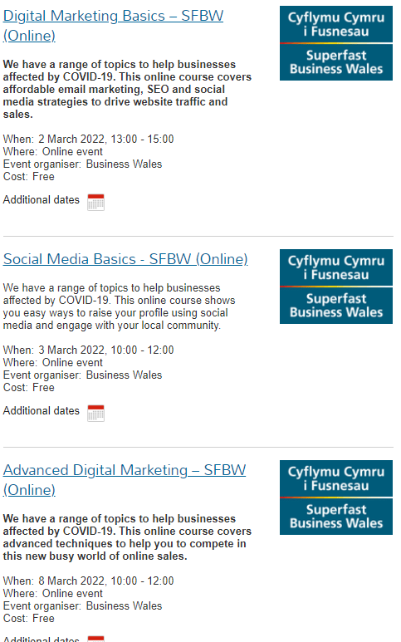
These are some of the networking events that the author has researched into and considered getting involved with. These events could help our business with both digital marketing and social media marketing which could be a big help in boosting sales annually. These events are all upcoming soon and are completely free to attend online.
Team-Working:
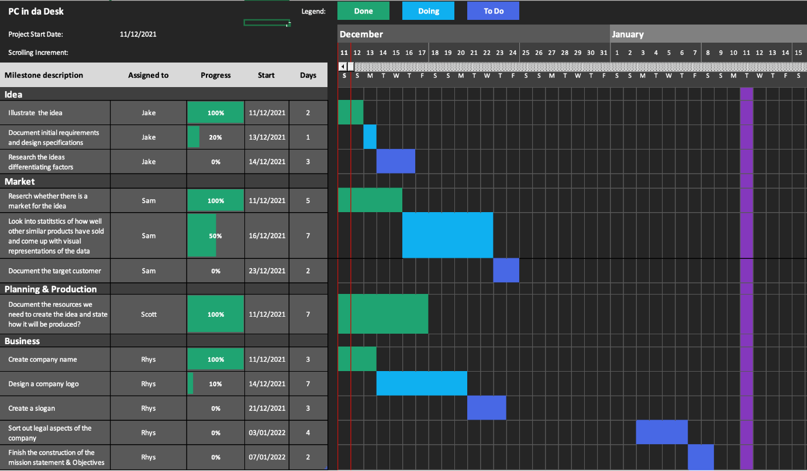
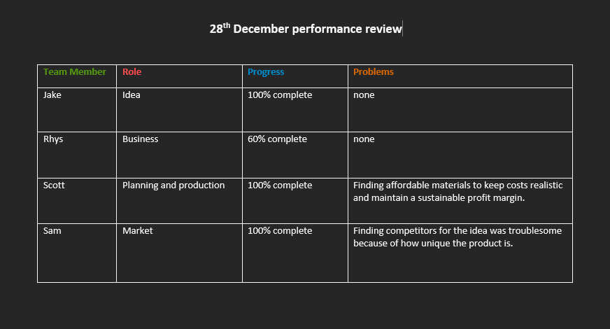
These are some teamworking charts that have been created for our project, as you can see we have set goals for each other and have regular progress reviews to ensure that we are all capable and on track to completing our goals. We also have group meetings from time to time where we give each other feedback and all discuss our business and goals and where we want to be by what date.

