Trees and Carbon Sequestration of Jersey Park, Briton Ferry, Neath Port Talbot

Introduction
Ecosystem services are both the indirect and direct benefits that humans obtain from natural environments, contributing to wellbeing, quality of life and environmental stability Walter et al (2005). These services are commonly categorised into provisioning, regulating, supporting and cultural services (IPCC, 2007). In recent decades, increasing attention has been given to regulating ecosystem services, particularly carbon capture and storage, due to accelerating climate change driven by rising atmospheric greenhouse gas concentrations (Epple C, 2013)
Trees play a critical role in the global carbon cycle by removing carbon dioxide (CO₂) from the atmosphere through photosynthesis and storing it as biomass in trunks, branches, leaves and roots (Nowak et al 2013). Urban and peri-urban woodlands, although smaller in scale than commercial forests, can make significant collective contributions to carbon sequestration while simultaneously providing additional ecosystem services such as air quality regulation, biodiversity support and recreational opportunities (Bolund and Hunhammar, 1999).
The aim of this study is to estimate the amount of carbon sequestered by a stand of trees within Jersey Park, Briton Ferry, Neath Port Talbot. Jersey Park is a publicly accessible green space within a semi urban setting, making it a suitable site for field-based ecological assessment. By estimating tree density, identifying species and measuring tree circumference, this study seeks to quantify the carbon storage of the site and assess its wider ecosystem service value. The findings will be used to evaluate the importance of the site and to suggest potential future management strategies that could enhance biodiversity and ecosystem services.
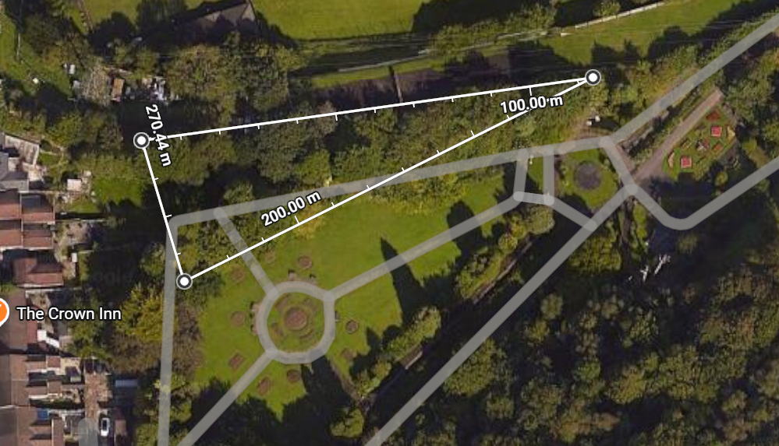
Figure 1 - Aerial view of Jersey Park

Methodology

Study Site
Jersey Park is located in Briton Ferry, Neath Port Talbot, South Wales. The park consists of a local amenity grassland, footpaths and areas of tree cover, with generally flat terrain and unrestricted public access. The presence of mature and partially mature trees within a defined stand made the site suitable for plotless sampling techniques while maintaining a low level of risk during fieldwork.

Tree Density Estimation
Tree density was estimated using a plotless sampling method. Specifically, the Nearest Individual method was selected due to its simplicity and suitability for small woodland stands and urban park environments. At each sampling point, the distance to the single nearest tree was measured. The mean distance between sampling points and nearest trees was then used to estimate tree density per hectare, following Field Studies Council guidance (Field Studies Council, n.d.a).
The Nearest Individual method was chosen because it is much more time efficient, easy to apply in the field and appropriate where tree stands are relatively small or irregularly distributed, such as those found within public parks. Compared to quadrant based approaches, the Nearest Individual method reduces field complexity while still providing a robust estimate of tree density.

Tree Measurements and Species Identification
For each tree recorded, the following data were collected:
- Tree species
- Circumference at breast height, measured at 1.3 m above ground level using a measuring tape
Circumference measurements were later converted to diameter at breast height , which is required for biomass and carbon calculations (Tree Doctors (2025). Species identification was undertaken using the tree id application provided by lecturer Elanor Alun and based on leaf shape, bark characteristics and overall form.

Carbon Storage Calculation
Carbon storage was estimated using the Natural Resources Wales (NRW) Tree Carbon Storage Calculator methodology (Natural Resources Wales, n.d.). Diameter at breast height values were used to estimate above ground biomass, assumed to represent dry weight. Carbon content was then calculated as 50% of dry biomass, as per the guidance from IPCC Good Practice Guidance for Land Use, Land-Use Change and Forestry (IPCC, n.d.).

Limitations and Assumptions
Several assumptions were necessary in this study, including uniform tree distribution and the applicability of generic biomass equations to all individuals. Below ground biomass was not directly measured and was estimated indirectly through standard ratios, which may introduce uncertainty into the final carbon estimates.

Results

Tree Density
The tree density was estimated using the Nearest Individual method, whereby the distance from each sampling point to the nearest tree was measured. The mean nearest individual distance was then used to estimate tree density per hectare, following Field Studies Council guidance. This method is appropriate for small woodland stands and irregular tree distributions commonly found in public parks (Field Studies Council, n.d.b)..
Tree density was estimated using the Nearest Individual method. The mean nearest individual distance was calculated from the measured distances (converted from cm to m) and used to estimate tree density:
Mean nearest individual distance = 3.49 m
Density = 1 ÷ (2 × 3.49)² ~ 0.0205 trees m⁻² = 205 trees ha⁻¹
This value was converted to trees per hectare by multiplying by 10,000, giving an estimated tree density of approximately 205 trees ha⁻¹

Table 1 - Nearest Individual distance measurements and mean distance
Tree Species | Nearest Individual Distance (cm) | Mean Distance (m)
Silver birch (Betula pendula) | 803 | 8.03
Silver birch (Betula pendula) | 577 | 5.77
Wellingtonia (Sequoiadendron giganteum) | 116 | 1.16
Wellingtonia (Sequoiadendron giganteum) | 127 | 1.27
Wellingtonia (Sequoiadendron giganteum) | 151 | 1.51
Wellingtonia (Sequoiadendron giganteum) | 212 | 2.12
Wellingtonia (Sequoiadendron giganteum) | 124 | 1.24
Sycamore (Acer pseudoplatanus) | 489 | 4.89
Sycamore (Acer pseudoplatanus) | 538cm | 5.38

Tree Characteristics
Tree species composition and circumference measurements are summarised in Table 2. Diameter at breast height was calculated using the formula: DBH = CBH ÷ π
Table 2 - Tree species, circumference and DBH values
Tree Species | Circumference at breast height (CBH) | Diameter at Breast Height (DBH)
Silver birch (Betula pendula) | 25cm | 7.96cm
Silver birch (Betula pendula) | 29cm | 9.23cm
Wellingtonia (Sequoiadendron giganteum) | 260cm | 82.20cm
Wellingtonia (Sequoiadendron giganteum) | 252cm | 80.20cm
Wellingtonia (Sequoiadendron giganteum) | 254cm | 80.84cm
Wellingtonia (Sequoiadendron giganteum) | 230cm | 73.20
Wellingtonia (Sequoiadendron giganteum) | 246cm | 78.34cm
Sycamore (Acer pseudoplatanus) | 102cm | 32.48cm
Sycamore (Acer pseudoplatanus) | 132cm | 42.02cm

Carbon Storage Estimates
Mean carbon storage values have been calculated to provide an indication of average sequestration per tree.
Table 3 - Estimated biomass and carbon storage per tree
Tree Species | Diameter at Breast height (cm) | Estimated above ground biomass (kg) | Estimated carbon storage (kg C)
Silver birch (Betula pendula) | 7.96cm | 8.94 | 4.47
Silver birch (Betula pendula) | 9.23cm | 12.94 | 6.47
Wellingtonia (Sequoiadendron giganteum) | 82.20cm | 6238.44 | 3119.22
Wellingtonia (Sequoiadendron giganteum) | 80.20cm | 5760.18 | 2880.09
Wellingtonia (Sequoiadendron giganteum) | 80.84 | 5875.78 | 2937.89
Wellingtonia (Sequoiadendron giganteum) | 73.20 | 4584.35 | 2292.17
Wellingtonia (Sequoiadendron giganteum) | 78.34 | 5431.99 | 2715.99
Sycamore (Acer pseudoplatanus) | 32.48cm | 300.61 | 150.31
Sycamore (Acer pseudoplatanus) | 42.02 | 572.28 | 286.14

Table 4 - Mean DBH and mean carbon storage by species
Tree Species | Number of Trees | Mean DBH (cm) | Mean Carbon Storage (kg C)
Silver birch (Betula pendula) | 2 | 8.60 | 5.47
Wellingtonia (Sequoiadendron giganteum) | 5 | 79.08 | 2789.07
Sycamore (Acer pseudoplatanus) | 2 | 37.25 | 218.22

Table 5 - Carbon storage by species group
Species Group | Number of Trees | Mean DBH (cm) | Mean carbon storage (kg C per tree) | Total carbon storage (kg C)
Broadleaf | 4 | 22.92 | 111.85 | 447.39
Conifer | 5 | 79.08 | 2798.07 | 13945.37

Figure 2 - Mean Carbon Storage per Tree by Species

Figure 3 - Total carbon storage by tree species

Interpretation
The carbon storage results indicate that Wellingtonia trees dominate the site’s carbon sequestration due to their large size and high biomass, accounting for the majority of total carbon stored at Jersey Park. In contrast, broadleaf species such as silver birch and sycamore contribute relatively little to total carbon storage, despite being present in similar numbers. This highlights the significant role that mature conifers play in urban and semi urban carbon sequestration.
These findings have implications for ecosystem services and park management. Carbon sequestration is a key regulating service, helping to mitigate climate change by removing CO₂ from the atmosphere. Maintaining and enhancing stands of large, fast-growing conifers could maximise this service. However, broadleaf species provide other important ecosystem services, including supporting biodiversity by offering habitat and food resources for birds, invertebrates, and pollinators, as well as cultural services like aesthetics and recreation.

Conclusion
This study aimed to measure the carbon sequestration capacity of a stand of trees within Jersey Park, Briton Ferry, and to assess its wider ecosystem service value. Using plotless sampling methods and standard carbon calculation approaches provides a practical and appropriate means of estimating carbon storage in an urban park setting.
Although the carbon storage of a single site may appear small in comparison to large forested areas, urban and semi urban green spaces such as Jersey Park make important collective contributions to climate regulation while delivering significant benefits for biodiversity and human wellbeing. With informed management and future enhancement, the site has the potential to further increase its ecological and social value.
Future management could focus on increasing species diversity by combining coniferous and native broadleaf species, enhancing resilience to pests and diseases while maintaining carbon storage potential. Deadwood retention and allowing natural regeneration in certain areas could further support biodiversity. Additionally, smaller scale planting of native broadleaf trees could improve the cultural and supporting ecosystem services without reducing overall carbon storage.
While the Nearest Individual method provides a practical and rapid estimate of tree density and carbon storage, it has limitations including assumptions about tree distribution. For more precise estimates, especially for large or irregular trees like Wellingtonia, Terrestrial Laser Scanning could provide detailed three dimensional volume measurements, although this requires specialised equipment and expertise. Despite these limitations, the study demonstrates that urban park woodlands like Jersey Park make meaningful contributions to carbon sequestration and provide multiple ecosystem services that benefit both the environment and human wellbeing.

References
Bolund, P. and Hunhammar, S. (1999) ‘Ecosystem services in urban areas’, Ecological Economics, Available at: PII: S0921-8009(99)00013-0
Epple C (2013) “Managing ecosystems for multiple environmental services and biodiversity in the context of climate change,” UNFCCC [Preprint]. Available at: https://unfccc.int/sites/default/files/epple_securing_multiple_ecosystem_services.pdf.
Field studies council (no date a) Method of carbon cycle. Available at: https://www.field-studies-council.org/resources/16-18-geography/water-and-carbon/carbon-cycle/method/.
Field studies council (no date b) Method of carbon cycle. Available at: https://www.field-studies-council.org/resources/16-18-geography/water-and-carbon/carbon-cycle/method/.
IPCC (no date) Annex A. Available at: https://www.ipcc-nggip.iges.or.jp/public/gpglulucf/gpglulucf_files/Glossary_Acronyms_BasicInfo/Glossary.pdf.
IPCC (2007) IPCC Fourth Assessment Report: Climate Change 2007. Available at: https://archive.ipcc.ch/publications_and_data/ar4/wg2/en/ch4s4-1-1.html?
Natural Resources Wales (n.d.) Tree carbon storage calculator worksheet. Available at: eng-worksheet-carbon-storage-calculator.pdf
Nowak, D.J. et al. (2013) “Carbon storage and sequestration by trees in urban and community areas of the United States,” Environmental Pollution, 178, pp. 229–236. Available at: https://doi.org/10.1016/J.ENVPOL.2013.03.019. .
Tree Doctors (2025) Tree Diameter (DBH) Calculator for Arborists. Available at: https://treedoctors.ca/tree-diameter-calculator-for-arborists.
Walter et al (2005) Ecosystems AND HUMAN WELL-BEING. Available at: file:///C:/Users/bc977521/Downloads/Ecosystem_and_human_well_being_synthesis.pdf.

