Calculating a Townsend Score Using Infuse Data

Census 2011 Variables used:

Overcrowding:
"F2159 ","All households"
"(F2158 + F2164)","Households with an occupancy rating of -1 or less*"
(Hint choose Bedrooms, occupancy rating [E][W])

Unemployed:
"F256","People aged 16-74: Economically active: Employees Part-time*"
"F260","People aged 16-74: Economically active: Employees Full-time*"
"(F557 + F556)","People aged 16-74: Economically active: Self - employed"
"F248","People aged 16-74: Economically active: Unemployed"
"F267 251","People aged 16-74: Economically active: Full-time student"
(Hint select by person Age/economically active)

Owner Occupancy:
"F2347","All households"
"F2351","Households:Owner occupied: Owns outright"
"F2353","Households:Owner occupied: Owns with a mortgage or loan"
(Hint select by household then tenure)

No Car:
"F989","All households"
"F991","Households (number of cars or vans): None"

Calculation:

Stage 1:

%Overcrowding =("(F2158 + F2163)","Households with an occupancy rating of -1 or less*"
/ F2159","All households")*100

% Unemployed =( “F248","People aged 16-74: Economically active: Unemployed"/ sum("F256","People aged 16-74: Economically active: Employees Part-time*","F260","People aged 16-74: Economically active: Employees Full-time*","(F557 + F559)","People aged 16-74: Economically active: Self - employed","F248","People aged 16-74: Economically active: Unemployed","F267","People aged 16-74: Economically active: Full-time student"))*100

%Not Owner Occ (non home owners) = 100 – (("F2351","Households:Owner occupied: Owns outright" +
"F2353","Households:Owner occupied: Owns with a mortgage or loan"/ F2347","All households")*100)

%NoCar = ("F991","Households (number of cars or vans): None"/"F989","All households")*100

Stage 2:
Var1 = Log(%overcrowding +1)
Var2 = Log(%unemployed +1)
Var3 = %not Owner Occupancy
Var4 = %NoCar

Stage 3:
Zscore1 = (Var1 – Mean(Var1))/S.D.(Var1)
Zscore2 = (Var2 – Mean(Var2))/S.D.(Var2)
Zscore3 = (Var3 – Mean(Var3))/S.D.(Var3)
Zscore4 = (Var4 – Mean(Var4))/S.D.(Var4)

Stage 4:
Sum(Zscore1 :Zscore4) = Townsend Index

New Methods to calculate the Townsend index of deprivation.

The UK data service has been updated and we now use INFUSE to access the 2011 census data. If you take time to explore the site you will notice that it is a work in progress but you do have access to lots of geo-referenced data.

To get access to the data we need to go to the Infuse website which is found in the aggregate data section of the UK data services.

At this point you need to choose Census Support you will then be prompted to login through the library and you Athens account in the usual way.

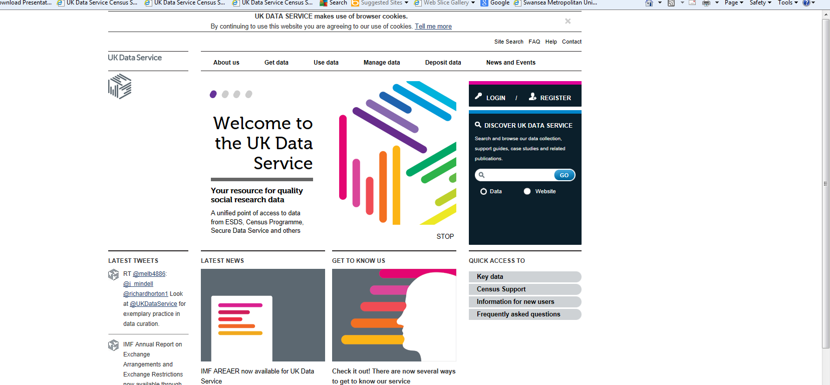

The Census Support window will then give you access to Aggregate data and Boundary (map) data. Look and the right hand side of the screen for the quick access tabs.

This is an example of a full set of statistics that will allow for the calculation of the Townsend index for Swansea, split into 780 wards.

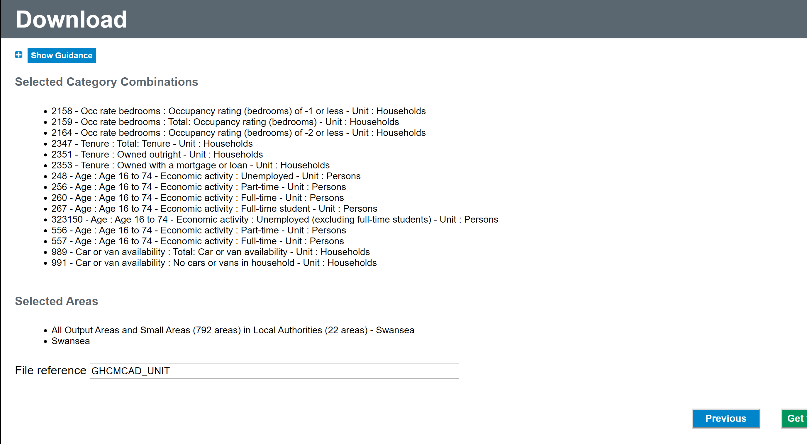

The data is downloaded in excel format and the geo-code or geo-label can be used to directly link the data to the map in MapInfo. Once you have geocoded the data across you can build thematic maps and look for data correlation between layers.

The pages will show 300+ topic combinations you have to select topics and information specific categories to filter down your selection. The page looks like this :-

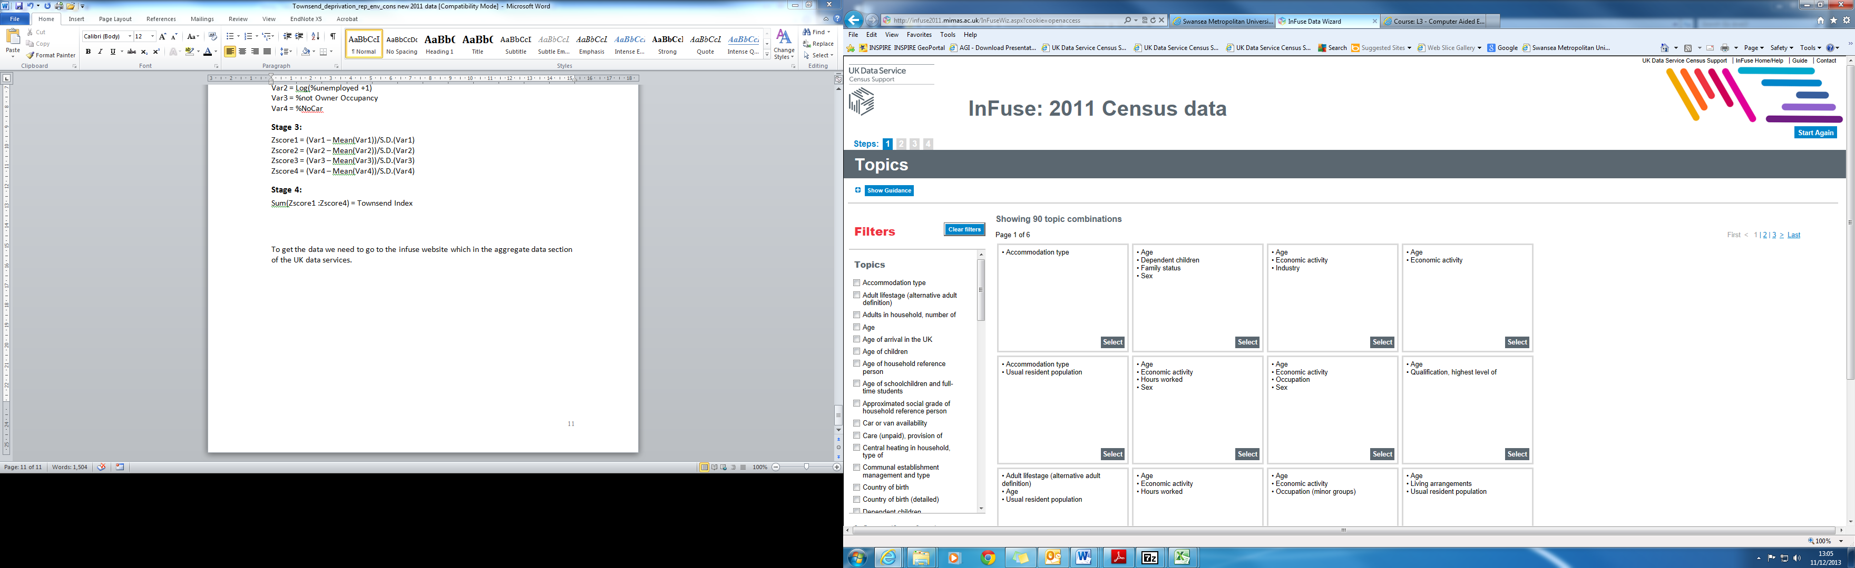

For example if we want to get the data for the Overcrowding rating we need to choose household and topics all and select the box stating Occupancy rating (rooms).

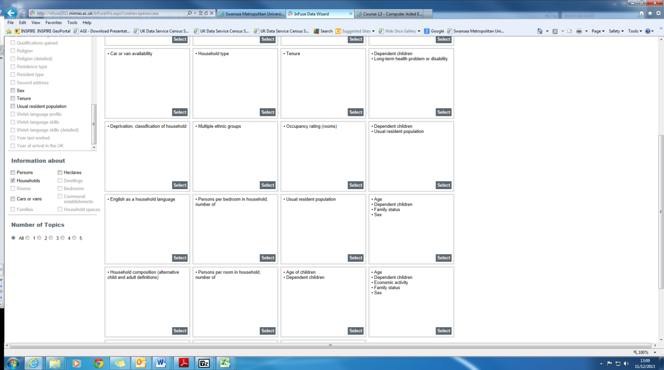

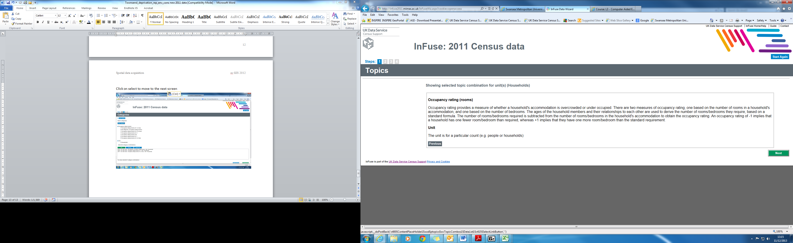
Click on select to move to the next screen

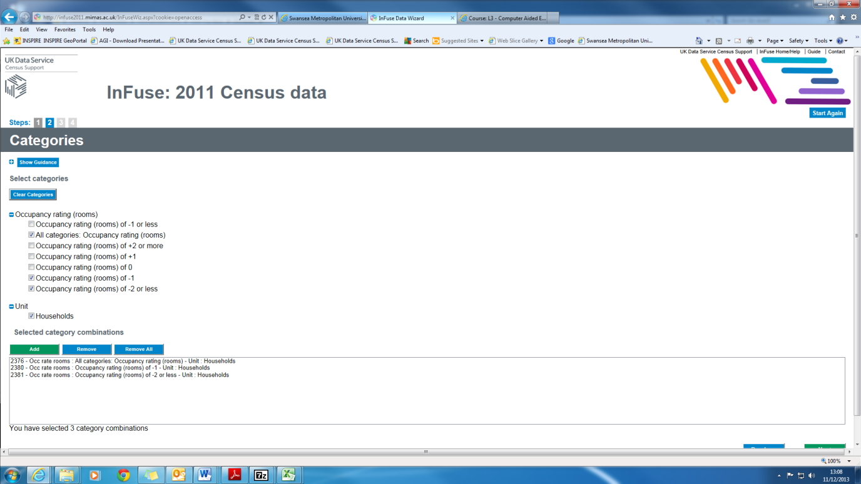

We continue to move back through the website and keep collecting our variable choices until we have built a complete picture of the data set that we require to calculate the townsend index of deprivation.

