Title Page
Module Name:
Graphics and Games Programming (ACCA6021)
Assignment Title:
3D OGL Games Programming
Student Name & Number:
Adam Williams (2008159)

Table of Contents
Contents
Title Page 1
Table of Contents 2
User Manual 3
Controls 3
Report 4
Including “OpenGL” Directories 4
Camera Position & Controls 4
Setting up Textures in the Array 6
Setting up the Cards 7
Drawing the Cards onto the Screen 8
Video Demonstration of Code 9
References 10
Appendix 11
Souce.cpp 11
Utils.h 25

User Manual

Controls
“W” – Camera up
“S” – Camera down
“A” – Tilt camera left
“D” – Tilt camera right

Report

Including “OpenGL” Directories
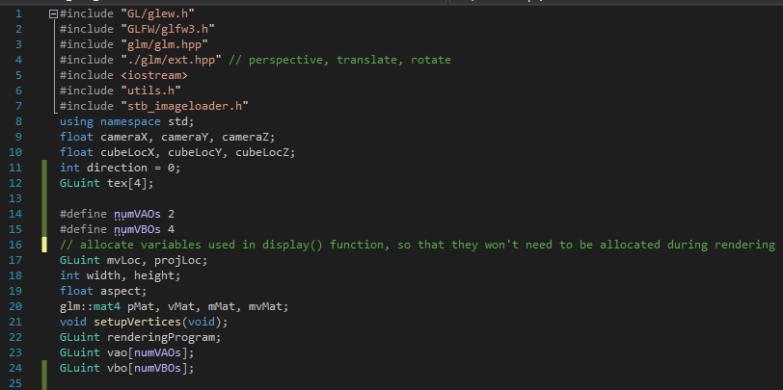Here I start off the code by making sure to include all the necessary “OpenGL” Directories I will be using through out the code. I also define variables related to the camera coordinates, and an texture array. I also define my VAOs, and VBOs.

Camera Position & Controls
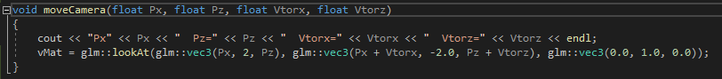This sets up the variables related to the camera controls such as px, and pz which are used for the camera position along the axis.
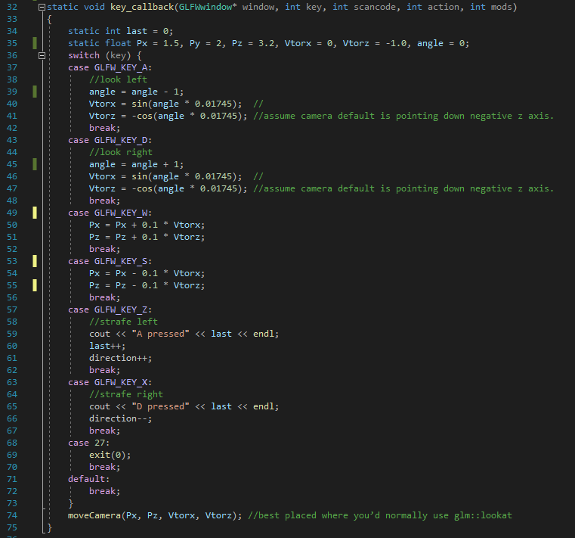This code updates the modifies and updates the camera position when one of the inputs is used. The static float at the top is the initial position of the camera. The first two “cases” are responsible for the camera angle rotation. When pressing “A” the camera rotates left, and when pressing “D” the camera rotates right. The third and forth case move the camera along the axis. When pressing “W” the camera moves forwards, when pressing “S” the camera moves backwards.

Setting up Textures in the Array
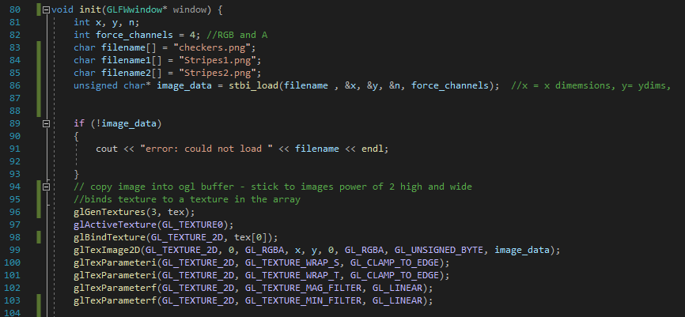This code here sets up the textures and defines the file names. The files used for the textures are then called upon and bound to a slot of the “tex” array so they can be called upon. This process is repeated 3 times for the 3 textures used.

Setting up the Cards
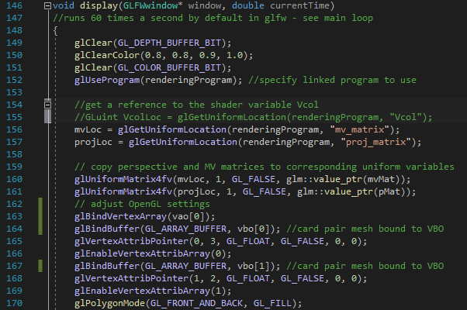Firstly, we setup the view matrix and the necessary render settings.
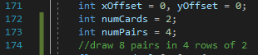
We then define the variables that are going to be used when setting up the cards. “xOffset” and “yOffset” are responsible for the position offset between all the cards giving space between them. It value will be changed later on. “numCards” is the variable responsible for how many cards will be in a pair, so it is set at 2. “numPairs” is the variable responsible for how many pairs will be rendered onto the screen.

Drawing the Cards onto the Screen
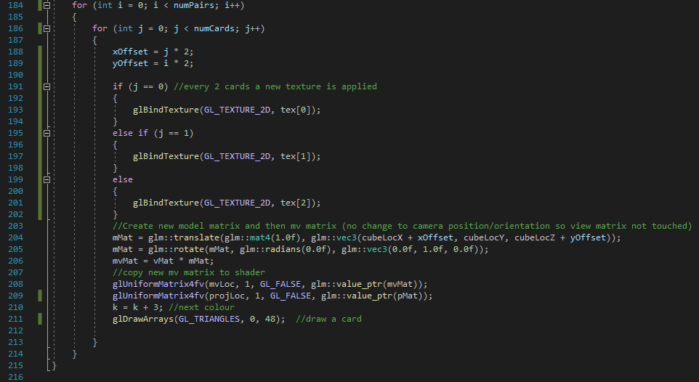This main loop is responsible for creating the correct number of cards, in the correct positions. Using the variables “numCards” and “numPairs” the loops will go around the correct number of times making 2 cards a pair for 4 pairs. This code also changes the texture used by changes the texture within the “tex” array being used each time variable “j” is increased.
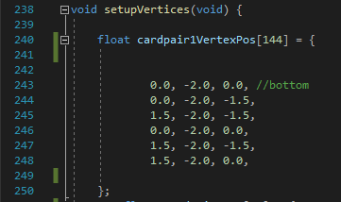
Here the coordinates for drawing the size of the card are defined here.  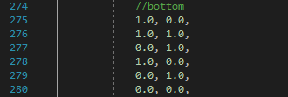
The coordinates for drawing the textures that go with the card is defined here.

Video Demonstration of Code
https://youtu.be/AktsT8_Z0r0

References
1.
OpenGL - The Industry's Foundation for High Performance Graphics. OpenGL - The Industry’s Foundation for High Performance Graphics [Internet]. The Khronos Group. 2011 [cited 2023 Jan 16]. Available from: https://www.khronos.org/opengl/
‌

Appendix

Souce.cpp
#include "GL/glew.h"
#include "GLFW/glfw3.h"
#include "glm/glm.hpp"
#include "./glm/ext.hpp" // perspective, translate, rotate
#include <iostream>
#include "utils.h"
#include "stb_imageloader.h"
using namespace std;
float cameraX, cameraY, cameraZ;
float cubeLocX, cubeLocY, cubeLocZ;
int direction = 0;
GLuint tex[4];

#define numVAOs 2
#define numVBOs 4
// allocate variables used in display() function, so that they won't need to be allocated during rendering
GLuint mvLoc, projLoc;
int width, height;
float aspect;
glm::mat4 pMat, vMat, mMat, mvMat;
void setupVertices(void);
GLuint renderingProgram;
GLuint vao[numVAOs];
GLuint vbo[numVBOs];

void moveCamera(float Px, float Pz, float Vtorx, float Vtorz)
{
cout << "Px" << Px << " Pz=" << Pz << " Vtorx=" << Vtorx << " Vtorz=" << Vtorz << endl;
vMat = glm::lookAt(glm::vec3(Px, 2, Pz), glm::vec3(Px + Vtorx, -2.0, Pz + Vtorz), glm::vec3(0.0, 1.0, 0.0));
}

static void key_callback(GLFWwindow* window, int key, int scancode, int action, int mods)
{
static int last = 0;
static float Px = 1.5, Py = 2, Pz = 3.2, Vtorx = 0, Vtorz = -1.0, angle = 0;
switch (key) {
case GLFW_KEY_A:
//look left
angle = angle - 1;
Vtorx = sin(angle * 0.01745); //
Vtorz = -cos(angle * 0.01745); //assume camera default is pointing down negative z axis.
break;
case GLFW_KEY_D:
//look right
angle = angle + 1;
Vtorx = sin(angle * 0.01745); //
Vtorz = -cos(angle * 0.01745); //assume camera default is pointing down negative z axis.
break;
case GLFW_KEY_W:
Px = Px + 0.1 * Vtorx;
Pz = Pz + 0.1 * Vtorz;
break;
case GLFW_KEY_S:
Px = Px - 0.1 * Vtorx;
Pz = Pz - 0.1 * Vtorz;
break;
case GLFW_KEY_Z:
//strafe left
cout << "A pressed" << last << endl;
last++;
direction++;
break;
case GLFW_KEY_X:
//strafe right
cout << "D pressed" << last << endl;
direction--;
break;
case 27:
exit(0);
break;
default:
break;
}
moveCamera(Px, Pz, Vtorx, Vtorz); //best placed where you’d normally use glm::lookat
}

void init(GLFWwindow* window) {
int x, y, n;
int force_channels = 4; //RGB and A
char filename[] = "checkers.png";
char filename1[] = "Stripes1.png";
char filename2[] = "Stripes2.png";
unsigned char* image_data = stbi_load(filename , &x, &y, &n, force_channels); //x = x dimemsions, y= ydims,

if (!image_data)
{
cout << "error: could not load " << filename << endl;

}
// copy image into ogl buffer - stick to images power of 2 high and wide
//binds texture to a texture in the array
glGenTextures(3, tex);
glActiveTexture(GL_TEXTURE0);
glBindTexture(GL_TEXTURE_2D, tex[0]);
glTexImage2D(GL_TEXTURE_2D, 0, GL_RGBA, x, y, 0, GL_RGBA, GL_UNSIGNED_BYTE, image_data);
glTexParameteri(GL_TEXTURE_2D, GL_TEXTURE_WRAP_S, GL_CLAMP_TO_EDGE);
glTexParameteri(GL_TEXTURE_2D, GL_TEXTURE_WRAP_T, GL_CLAMP_TO_EDGE);
glTexParameterf(GL_TEXTURE_2D, GL_TEXTURE_MAG_FILTER, GL_LINEAR);
glTexParameterf(GL_TEXTURE_2D, GL_TEXTURE_MIN_FILTER, GL_LINEAR);

image_data = stbi_load(filename1, &x, &y, &n, force_channels); //x = x dimemsions, y= ydims,
if (!image_data)
{
cout << "error: could not load " << filename1 << endl;

}
// copy image into ogl buffer - stick to images power of 2 high and wide
glBindTexture(GL_TEXTURE_2D, tex[1]);
glTexImage2D(GL_TEXTURE_2D, 0, GL_RGBA, x, y, 0, GL_RGBA, GL_UNSIGNED_BYTE, image_data);
glTexParameteri(GL_TEXTURE_2D, GL_TEXTURE_WRAP_S, GL_CLAMP_TO_EDGE);
glTexParameteri(GL_TEXTURE_2D, GL_TEXTURE_WRAP_T, GL_CLAMP_TO_EDGE);
glTexParameterf(GL_TEXTURE_2D, GL_TEXTURE_MAG_FILTER, GL_LINEAR);
glTexParameterf(GL_TEXTURE_2D, GL_TEXTURE_MIN_FILTER, GL_LINEAR);

image_data = stbi_load(filename2, &x, &y, &n, force_channels); //x = x dimemsions, y= ydims,
if (!image_data)
{
cout << "error: could not load " << filename2 << endl;

}
// copy image into ogl buffer - stick to images power of 2 high and wide
glBindTexture(GL_TEXTURE_2D, tex[2]);
glTexImage2D(GL_TEXTURE_2D, 0, GL_RGBA, x, y, 0, GL_RGBA, GL_UNSIGNED_BYTE, image_data);
glTexParameteri(GL_TEXTURE_2D, GL_TEXTURE_WRAP_S, GL_CLAMP_TO_EDGE);
glTexParameteri(GL_TEXTURE_2D, GL_TEXTURE_WRAP_T, GL_CLAMP_TO_EDGE);
glTexParameterf(GL_TEXTURE_2D, GL_TEXTURE_MAG_FILTER, GL_LINEAR);
glTexParameterf(GL_TEXTURE_2D, GL_TEXTURE_MIN_FILTER, GL_LINEAR);

renderingProgram = createShaderProgram(); //load, compile, create, attach and link shader programmes done here
cameraX = 0.0f; cameraY = 0.0f; cameraZ = 18.0f; //camera position
cubeLocX = 0.0f; cubeLocY = -2.0f; cubeLocZ = 0.0f; // shift cube down Y to reveal perspective
vMat = glm::lookAt(glm::vec3(cameraX, cameraY, cameraZ), glm::vec3(cubeLocX, cubeLocY, cubeLocZ), glm::vec3(0.0f, 1.01f, 0.0f));
// build perspective matrix
glfwGetFramebufferSize(window, &width, &height); //need these to fit clip space to window
aspect = (float)width / (float)height;
pMat = glm::perspective(1.0472f, aspect, 0.05f, 100.0f); // 1.0472 radians = 60 degrees
setupVertices(); //initial vertices x,y,z values
glEnable(GL_DEPTH_TEST);
}
void display(GLFWwindow* window, double currentTime)
//runs 60 times a second by default in glfw - see main loop
{
glClear(GL_DEPTH_BUFFER_BIT);
glClearColor(0.8, 0.8, 0.9, 1.0);
glClear(GL_COLOR_BUFFER_BIT);
glUseProgram(renderingProgram); //specify linked program to use

//get a reference to the shader variable Vcol
//GLuint VcolLoc = glGetUniformLocation(renderingProgram, "Vcol");
mvLoc = glGetUniformLocation(renderingProgram, "mv_matrix");
projLoc = glGetUniformLocation(renderingProgram, "proj_matrix");

// copy perspective and MV matrices to corresponding uniform variables
glUniformMatrix4fv(mvLoc, 1, GL_FALSE, glm::value_ptr(mvMat));
glUniformMatrix4fv(projLoc, 1, GL_FALSE, glm::value_ptr(pMat));
// adjust OpenGL settings
glBindVertexArray(vao[0]);
glBindBuffer(GL_ARRAY_BUFFER, vbo[0]); //card pair mesh bound to VBO
glVertexAttribPointer(0, 3, GL_FLOAT, GL_FALSE, 0, 0);
glEnableVertexAttribArray(0);
glBindBuffer(GL_ARRAY_BUFFER, vbo[1]); //card pair mesh bound to VBO
glVertexAttribPointer(1, 2, GL_FLOAT, GL_FALSE, 0, 0);
glEnableVertexAttribArray(1);
glPolygonMode(GL_FRONT_AND_BACK, GL_FILL);
int xOffset = 0, yOffset = 0;
int numCards = 2;
int numPairs = 4;
//draw 8 pairs in 4 rows of 2
float cardCols[18] = {
1.0,0.0,0.0,
1.0,1.0,0.0,
174.0 / 255.0,85.0 / 255.0,186.0 / 255.0,
0.0,1.0,0.0,
0.0,0.0,1.0,
233.0 / 255.0,66.0 / 255.0,17.0 / 255.0
};
int k = 0;
for (int i = 0; i < numPairs; i++)
{
for (int j = 0; j < numCards; j++)
{
xOffset = j * 2;
yOffset = i * 2;

if (j == 0) //every 2 cards a new texture is applied
{
glBindTexture(GL_TEXTURE_2D, tex[0]);
}
else if (j == 1)
{
glBindTexture(GL_TEXTURE_2D, tex[1]);
}
else
{
glBindTexture(GL_TEXTURE_2D, tex[2]);
}
//Create new model matrix and then mv matrix (no change to camera position/orientation so view matrix not touched)
mMat = glm::translate(glm::mat4(1.0f), glm::vec3(cubeLocX + xOffset, cubeLocY, cubeLocZ + yOffset));
mMat = glm::rotate(mMat, glm::radians(0.0f), glm::vec3(0.0f, 1.0f, 0.0f));
mvMat = vMat * mMat;
//copy new mv matrix to shader
glUniformMatrix4fv(mvLoc, 1, GL_FALSE, glm::value_ptr(mvMat));
glUniformMatrix4fv(projLoc, 1, GL_FALSE, glm::value_ptr(pMat));
k = k + 3; //next colour
glDrawArrays(GL_TRIANGLES, 0, 48); //draw a card

}
}
}

int main(void) {
if (!glfwInit()) { exit(EXIT_FAILURE); }
glfwWindowHint(GLFW_CONTEXT_VERSION_MAJOR, 4);
glfwWindowHint(GLFW_CONTEXT_VERSION_MINOR, 3);
GLFWwindow* window = glfwCreateWindow(600, 600, "glfw window", NULL, NULL);
glfwSetKeyCallback(window, key_callback);
glfwMakeContextCurrent(window);
if (glewInit() != GLEW_OK) { exit(EXIT_FAILURE); }
glfwSwapInterval(1);
init(window);
while (!glfwWindowShouldClose(window)) {
display(window, glfwGetTime());
glfwSwapBuffers(window);
glfwPollEvents();
}
glfwDestroyWindow(window);
glfwTerminate();
exit(EXIT_SUCCESS);
}

void setupVertices(void) {

float cardpair1VertexPos[144] = {

0.0, -2.0, 0.0, //bottom
0.0, -2.0, -1.5,
1.5, -2.0, -1.5,
0.0, -2.0, 0.0,
1.5, -2.0, -1.5,
1.5, -2.0, 0.0,

};
float cardpair1Tex[96] = {

//front
1.0, 0.0,
1.0, 1.0,
0.0, 1.0,
1.0, 0.0,
0.0, 1.0,
0.0, 0.0,
//right
1.0, 0.0,
1.0, 1.0,
0.0, 1.0,
1.0, 0.0,
0.0, 1.0,
0.0, 0.0,
//left
1.0, 0.0,
1.0, 1.0,
0.0, 1.0,
1.0, 0.0,
0.0, 1.0,
0.0, 0.0,
//bottom
1.0, 0.0,
1.0, 1.0,
0.0, 1.0,
1.0, 0.0,
0.0, 1.0,
0.0, 0.0,
//back
1.0, 0.0,
1.0, 1.0,
0.0, 1.0,
1.0, 0.0,
0.0, 1.0,
0.0, 0.0,
//front gable
0.0, 1.0,
0.0, 0.0,
1.0, 0.0,
//back gable
0.0, 1.0,
0.0, 0.0,
1.0, 0.0,
//left roof
1.0, 0.0,
1.0, 1.0,
0.0, 1.0,
1.0, 0.0,
0.0, 1.0,
0.0, 0.0,
//right roof
1.0, 0.0,
1.0, 1.0,
0.0, 1.0,
1.0, 0.0,
0.0, 1.0,
0.0, 0.0
};

float cardpair2VertexPos[144] = {

0.0, -2.0, 0.0, //bottom
0.0, -2.0, -1.0,
1.0, -2.0, -1.0,
0.0, -2.0, 0.0,
1.0, -2.0, -1.0,
1.0, -2.0, 0.0,

};
float cardpair2Colour[144] = {
//front
1.0, 1.0, 0.0,
1.0, 1.0, 0.0,
1.0, 1.0, 0.0,
1.0, 1.0, 0.0,
1.0, 1.0, 0.0,
1.0, 1.0, 0.0,
//right
1.0, 1.0, 0.0,
1.0, 1.0, 0.0,
1.0, 1.0, 0.0,
1.0, 1.0, 0.0,
1.0, 1.0, 0.0,
1.0, 1.0, 0.0,
//left
1.0, 1.0, 0.0,
1.0, 1.0, 0.0,
1.0, 1.0, 0.0,
1.0, 1.0, 0.0,
1.0, 1.0, 0.0,
1.0, 1.0, 0.0,
//bottom
1.0, 1.0, 0.0,
1.0, 1.0, 0.0,
1.0, 1.0, 0.0,
1.0, 1.0, 0.0,
1.0, 1.0, 0.0,
1.0, 1.0, 0.0,
//back
1.0, 1.0, 0.0,
1.0, 1.0, 0.0,
1.0, 1.0, 0.0,
1.0, 1.0, 0.0,
1.0, 1.0, 0.0,
1.0, 1.0, 0.0,
//front gable
1.0, 1.0, 0.0,
1.0, 1.0, 0.0,
1.0, 1.0, 0.0,
//back gable
1.0, 1.0, 0.0,
1.0, 1.0, 0.0,
1.0, 1.0, 0.0,
//left roof
1.0, 1.0, 0.0,
1.0, 1.0, 0.0,
1.0, 1.0, 0.0,
1.0, 1.0, 0.0,
1.0, 1.0, 0.0,
1.0, 1.0, 0.0,
//right roof
1.0, 1.0, 0.0,
1.0, 1.0, 0.0,
1.0, 1.0, 0.0,
1.0, 1.0, 0.0,
1.0, 1.0, 0.0,
1.0, 1.0, 0.0,
};
//initialse VAO and VBOs
glGenVertexArrays(numVAOs, vao); //we will use one VAO
glBindVertexArray(vao[0]);
glGenBuffers(numVBOs, vbo);//we have one VBO
glBindBuffer(GL_ARRAY_BUFFER, vbo[0]);//first VBO
glBufferData(GL_ARRAY_BUFFER, sizeof(cardpair1VertexPos), cardpair1VertexPos, GL_STATIC_DRAW);
glBindBuffer(GL_ARRAY_BUFFER, vbo[1]);//first VBO
glBufferData(GL_ARRAY_BUFFER, sizeof(cardpair1Tex), cardpair1Tex, GL_STATIC_DRAW);

glBindBuffer(GL_ARRAY_BUFFER, vbo[2]);//3nd VBO
glBufferData(GL_ARRAY_BUFFER, sizeof(cardpair2VertexPos), cardpair2VertexPos, GL_STATIC_DRAW);
glBindBuffer(GL_ARRAY_BUFFER, vbo[3]);//4th VBO
glBufferData(GL_ARRAY_BUFFER, sizeof(cardpair2Colour), cardpair2Colour, GL_STATIC_DRAW);

}

Utils.h
#pragma once
#include <string>
#include <iostream>
#include <fstream>
using namespace std;
string readShaderSource(const char* filePath);
GLuint createShaderProgram();

string readShaderSource(const char* filePath) {
string content;
ifstream fileStream(filePath, ios::in);
if (!fileStream.is_open()) {
cout << "file not found\n";
exit(1);
}
string line = "";
while (!fileStream.eof()) {
getline(fileStream, line);
content.append(line + "\n");
}
fileStream.close();
return content;
}

GLuint createShaderProgram() {

GLuint vShader = glCreateShader(GL_VERTEX_SHADER);
GLuint fShader = glCreateShader(GL_FRAGMENT_SHADER);
string vertShaderStr = readShaderSource("vertShader.glsl");
string fragShaderStr = readShaderSource("fragShader.glsl");
const char* vertShaderSrc = vertShaderStr.c_str();
const char* fragShaderSrc = fragShaderStr.c_str();
glShaderSource(vShader, 1, &vertShaderSrc, NULL);
glShaderSource(fShader, 1, &fragShaderSrc, NULL);

glCompileShader(vShader);
glCompileShader(fShader);
GLuint vfProgram = glCreateProgram();
glAttachShader(vfProgram, vShader);
glAttachShader(vfProgram, fShader);
glLinkProgram(vfProgram);
return vfProgram;
}

