Assignment title-
Utilising the Entrecomp Framework, critically evaluate your own creativity and enterprise skills and consider how you might be able to develop the creative and enterprising skills of primary learners through your own pedagogy.
Word Count- 5309

Contents page
Assignment response……………………………….. p.3
Reference list………………………………………...p.16
Appendix…………………………………………….p.23

Within this response, the Entrecomp framework will be utilised to reflect and evaluate my creativity and enterprise skills and suggest methods which will enable me to progress. Using knowledge of pedagogies and theory, I will consider ways to develop primary learners’ own creativity and enterprise skills.
Through history, creativity has been defined in many ways. The word creativity was often used in association with the arts (Robson, 2014, p.122). A creative person was skilled in music, dance, theatre or art itself. The I-paradigm (Glăveanu, 2012, p.26) saw a shift in this relationship and re-established how creativity was perceived. Guilford proposed the ordinary person could too be creative and it was a skill used in everyday life (Guilford, cited by, Glăveanu, 2012, p.26). Creativity is now deemed to be a ‘universal’ (Burns, Machadob and Cortea, 2015, p.181: Siraj-Blatchford, 2007, p.7) skill, that anyone can possess. Since this shift, creativity has had a very prominent role in modern society. There is a strong emphasis on creativity in education in the 21st century (Craft, 2009, p.5) and work forces are beginning to see the increasing need for creative and innovative people (Thorne, 2007, p.8).
Before being able to evaluate my own creativity, it is important that a definition is explored. Deciding on an exact, universally-accepted definition has proven difficult among educationalists and wider professionals (Desailly, 2012, p.2). Creativity is a multi-faceted concept (Treffinger et al., 2002, cited by Lucas, Claxton and Spencer, 2013, p.6) and therefore has no truly accepted definition (Prentice, 2000, cited by Robson, 2014, p.122). This ‘difficulty’ was noted by Piaget and Vygotsky, who both found creativity to be a vital enigma to solve yet struggled to comprehend it (Craft, Cremin and Burnard, 2008, p.xiii). Robinson defines creativity as the ‘imaginative processes with outcomes that are original and of value’ (2001, cited by Fisher, 2004, p.7). Whereas Bronson and Merryman state that it is the ‘production of something original and useful’ (Bronson and Merryman, 2010), a rather simplistic explanation in comparison to Education Scotland’s definition;
‘Creativity is a process which generates ideas that have value to the individual. It involves looking at familiar things with a fresh eye, examining problems with an open mind, making connections, learning from mistakes and using imagination to explore new possibilities’ (Education Scotland, 2013, p.3).
Arguably, this definition is the most relevant and detailed, therefore, will be the definition in mind throughout this discussion.
The QAA defines enterprise as ‘the generation and application of ideas, which are set within practical situations during a project or undertaking’ (QAA, 2018, p.7), whereas some regard it as a ‘series of personal skills and qualities’ (Rosa, 1992, cited by Breen, 2004, p.2). To be enterprising requires a person to be ‘intrigued by new concepts… creating new and innovative ways of developing existing ideas… being able to take calculated risks’ (Thorne, 2007, p.131). The interest in developing enterprise skills is growing since they are thought to be beneficial for personal development (Breen, 2004, p.32) and job prospects - it is thought that the demand for enterprise skills will rise by 70% in future jobs (Sander, 2017).
As the demand for aptitude in creativity and enterprise increases, it is important that all personnel within education can develop and nurture these skills. Research has shown that teachers’ creativity can have a direct influence on that of their pupils (Dău-Gaşpar, 2011), and so teachers with a poor grasp of the skill could be negatively impacting the creativity of pupils. Teaching creatively can often lead to teaching for creativity, which can result in pupils being more innovative as they model their teacher’s approach (Jeffrey and Craft, 2004, p.84).
It was highlighted that for teachers to be creative they must know themselves and their learners (Craft, 2000, p. 105). This is supported by Cremin who states ‘creative teachers are aware of themselves as creative beings’ (Cremin, 2015, p.43). It is suggested that teachers must be ‘nourished’ (Craft, 2000, p.105) to become creative, which requires focusing on personal development. This can prove difficult for some as research reveals that teachers spend little time focusing on themselves and their needs (Craft, 2000, p.105) and therefore, are unable to acknowledge their own abilities.
In keeping with this, to develop my creative ability and understanding of my skills I will use the Entrecomp Framework to evaluate my current level and identify ways in which I can progress.
The Entrepreneurship Competence Framework, also known as the Entrecomp, was written in 2016 by the Joint Research Centre for the European Commission (Bacigalupo et al, 2016, p.2). It was produced as a tool to guide and encourage entrepreneurial skills in all persons in Europe (Bacigalupo et al, 2016, p.2). It is comprised of three main areas; ‘Ideas and Opportunities’, ‘Resources’ and ‘Into Action’ - they each contain five competencies, which are made up of eight levels of proficiency.
The Entrecomp Framework aims to help produce lifelong learners who can adapt to the changing environment (Bacigalupo and O’Keeffe, 2018, p.10). As society advances at a rate higher than ever, the need for lifelong learners is vital (World Economic Forum, 2018, p.ix). It is necessary for workforces to ensure they are upskilling their employees to promote lifelong learners (World Economic Forum, 2018, p.v) that can face the challenges of an uncertain future. This highlights the usefulness of such a framework in modern society.
Regarding my own evaluation, there are some limitations to the framework. It is said that entrepreneurship requires enterprise skills, however enterprise is not confined to entrepreneurship (Breen, 2004, p.12). This is supported by QAA, who highlights that ‘entrepreneurship is defined as the application of enterprise skills’ (QAA, 2012, p.7). With this in mind, a note-worthy point is that using a framework designed to develop entrepreneurial skills may not allow for an in-depth assessment of enterprise, due to the fact that elements of enterprise exist outside of the framework. I believe this point is relevant for creativity as well.
Additionally, from a trainee teachers’ perspective, it is sometimes difficult to apply teaching scenarios to levels of the framework. This could be improved with the introduction of the EntreCompEdu Professional Skills Framework (EntreCompEdu, 2019) which is aimed at practitioners and directly related to entrepreneurial education.
Within the area ‘Ideas and Opportunities’ is the ‘Creativity’ competence. Each thread of Creativity will be used to evaluate my creative skills and note how to progress. I will use Practical Teaching Experience (PTE) in 2018 and 2019 to provide evidence of my current levels.
Be Curious and Open
Based on evidence from 2018 it is apparent that my current level is three. During PTE, I tried and tested many different innovative ‘hooks’ using skills I had previously learned and applied them to a classroom setting as a trainee teacher. A few of the innovative ideas are highlighted in my Summative Assessment written at the end of the placement (Appendix 1).
This highlights my willingness to take risks, unsure of how the class would respond to these ideas. It is stated that creative teachers are ‘comfortable with risk-taking in both their private and professional lives’ (Boden, 2001; Craft, 2001; Ofsted, 2003, cited by Cremin, 2015, p.38). Additionally, this is an attribute seen in enterprising individuals (Thorne, 2007, p.131). Risk-taking is known to be an element of effective teaching and enables student teachers to appropriately deal with the unforeseen (Desailly, 2012, p.3).
To progress onto Level 4, it states that I must be able to ‘actively search for new solutions that meet my needs’ (Bacigalupo, 2016, p.24). One method to do this, suggested by Leizrowice (2018), is the Creative Sandbox. This involves interdisciplinary thinking and the merging of different ideas. One creative sandbox method noted is undertaking multiple projects simultaneously (Leizrowice, 2018). It is often found that focusing on another project can help with solutions to the original problem. A more renowned approach is the Creative Problem Solving (CPS) model originally created by Osborn (1953 cited by Reynolds and Fletcher-Janzen, 2007, p.565). His approach to solution-finding involved both evaluation and adaptation of ideas. However, this model has since been adjusted and, some would say, improved, implying it was flawed (Yuan, date unknown, p.2). Despite this, the CPS model seems the most appropriate to help me achieve level 4.
Develop Ideas
Whilst on PTE, my mentor suggested I had my own behaviour strategy which I could implement to tackle the behavioural issues I had been having with the class. I identified several methods of solving the issue and decided the most appropriate to implement. This process of creating many ideas is known as ‘Fluency’, which is one of the four characteristics of Divergent Thinking - first introduced by Guilford (Guilford, 1967, cited by Almeida et al, 2008, p.54). The process of selecting a final idea is known as Convergent Thinking, and these are both important aspects of creative thinking (Craft, 2000, p.32). The week 2 end-of-week review and action plan, as well as my formative assessments, (Appendix 2) all show the process by which the behaviour strategy came about. This strategy was extremely successful, and I continued to use it the following year (Appendix 3). This shows ‘I can develop ideas that solve problems that are relevant to me and my surroundings’ which is Level 1.
To progress, I must satisfy the following: ‘Alone and as part of a team, I can develop ideas that create value for others’. This will involve creative collaboration with others, and it is thought that working as a team can encourage people to be more creative (Fisher, 2004, p.15). It provides a support network that can enhance our capabilities. Vygotsky’s theory of the Zone of Proximal Development highlights that an increase in development will take place when working collaboratively (Vygotsky, 1978, cited by Lin, 2015, p.12). However, collaborative learning can sometimes be at the expense of individualism (Hillmann, 2004). This can cause a decrease in intrinsic motivations and ability to be creative (Hillmann, 2004) and so it is important to find a balance between the needs of the creative individual and the collective needs of the group dynamic (Craft, 2009, p.10).
In order to reach this level, I will need to achieve a balance between the two. I will individually produce ideas using divergent thinking - I will then share these ideas in a group setting, where they can be built on and new ones can be shared.
Define problems
Currently, Level 2 best describes my skill set for this thread. It is apparent, from PTE ‘I can explore open-ended problems in many ways as to generate multiple solutions’ (Bacigalupo et al, 2016, p.24). During first-year PTE, my Assessment for Learning (AfL) strategies needed to be developed to ensure efficiency - this was noted in my formative assessment (Appendix 4). To ensure my approach to AfL was best suited to the class and their needs, I explored several different methods to find the most effective one (Appendix 5) thus producing multiple solutions. I was able to use the ‘Flexibility’ characteristic of Divergent Thinking to look at solutions from many different perspectives, giving me a holistic view of the problem.
To develop onto Level 3, I must ‘take part in group dynamics aimed at defining open-ended problems’ (Bacigalupo et al, 2016, p.24). To do this I must be willing to collaborate with others. It is suggested by Costa and Kallick that working interdependently is one aspect that will enable people to successfully approach problems (Costa and Kallick, 2008, p.36). Additionally, in Welsh education, collaboration across all areas of school life including teachers is encouraged (Welsh Government, 2015, p.5). However, until I become a Newly Qualified Teacher, it will be difficult to collaborate with others since my degree programme is predominantly composed of individual assignments.
Design Value
During my time in a large Year 1/2 classroom in 2019, I struggled with ensuring I was always aware of the location of each child. The large space, with many different areas meant that children were often out of sight. This was a problem that I felt needed resolving. Appendix 6 shows the Area Board I planned, designed and created to resolve this issue. This shows I can design and create valuable tools to help my needs which is a Level 5 skill - ‘I can create (alone or with others) products or services that solve my problems and my needs’ (Bacigalupo et al, 2016, p.24/25).
To progress I must be able to ‘develop and deliver value in stages, launching with core features of my (or my teams) idea and progressively adding more’ (Bacigalupo et al, 2016, p.24/25). Initially, I was confident in my idea; I made different versions and tested how durable it was at home. However, I omitted to think of the other people that would be using it and how the children would respond. The gradual introduction of the product with the children may have ensured its success. Additionally, being able to notice when a product needs adapting or developed would ensure a positive outcome. To do this I must be able to think flexibly, which is a Habit of Mind suggested by Costa and Kallick. It enables people to approach a situation holistically, thinking about all those involved and being able to overcome obstacles by perceive the bigger picture (Costa and Kallick, 2008, p.22).
Be innovative
Whilst on PTE the school celebrated World Toilet Day, a day dedicated to learning about sanitation and water supply around the world. I took this opportunity to educate children on the innovative designs of toilets internationally and how a small aspect of their day-to-day life has rid many countries of dangerous disease. This highlights my capabilities in communicating innovations and illustrates my acquirement of Level 2. My lesson plan (Appendix 7) illustrates how I communicated this to the children.
To progress to Level 3, I must be able to ‘tell the difference between types of innovations’ (Bacigalupo et al, 2016, p.24). To achieve this level, I must educate myself on the different types of innovation. Based on the theory The Learning Cone by Edgar Dale, one of the most effective ways to remember new information is through discussion. 70% of what we say is remembered according to this model (Dale, 1969, cited by Sivathanu, 2014). However, there are many misconceptions about his concept, some of which Dale highlights himself (Dale, 1969, p.128-134, cited by Kovalchick and Dawson, 2004, p.163). One misconception is the intended use of the Cone, as there was no clarification on whether it was a classification system or intended for lesson planning (Kovalchick and Dawson, 2004, p.163). From experience, I am aware that I benefit greatly from group discussion and therefore feel this will be an appropriate strategy to gain an understanding of the different types of innovations.
To further evaluate my creativity and enterprise skills, I used the competence ‘Motivation and Perseverance’. I made this decision in view of the notation that resilience is an attribute of an enterprising person (QAA, 2018, p.9) and persistence is a habit necessary for effective problem solving (Costa and Kallick, 2008, p.18). The thread ‘Be resilient’ will be used to assess my creativity and enterprise skills. During PTE I experienced many challenges with one 5-year-old pupil. His behaviour and negative attitude made teaching him difficult. I persevered with him with the help of my mentor, which produced some positive results however his behaviour remained an issue (Appendix 8). This demonstrates the skill required to reach level 5.
To reach level 6 I must develop strategies to overcome similar situations in the future as it is clear the approach I took, despite persevering, was not beneficial. Building Learning Power is an approach to education with the aim of producing better learners, prepared for lifelong learning. The approach proposed by Claxton, has 4R’s which underpin the method, one of which is resilience. Claxton suggests a model for perseverance and notes the implementation of it in a classroom would support pupils’ progression in becoming resilient (Claxton, 2002, p.23). Therefore, a slightly altered version may prove beneficial for an adult. However, I believe the best approach to achieve level 6 would be to implement the suggestions of Costa and Kallick. They describe a persistent person who can find strategies and overcome challenges, simply research, communicate, re-evaluate the situation and use prior knowledge (Costa and Kallick, 2008, p.178).
Using the Entrecomp Framework as a tool for self-evaluation has been both challenging and thought provoking. I have shown strengths in curiosity and designing value, but there are areas I must work to improve on. The strategies for progression I have discussed will ensure I can advance my creativity and enterprise skills for professional and personal benefits.
Creative and enterprising opportunities are important in childhood. Creativity can encourage children to have increased motivation and self-esteem (Fisher and Williams, 2004, p.1). High self-esteem is a necessary trait according to Maslow’s Hierarchy of Need. He proposes that ‘Esteem’ is a vital need of every child and will enable them to progress to ‘Self-actualisation’, which is deemed a ‘conception of creativity’ (Craft, 2000, p.54). Creative activities have also been known to induce ‘flow’ a theory proposed by Csikszentmihalyi (1992, cited by Fisher and Williams, 2004, p.11). When a person experiences ‘flow’ there is complete engagement in the experience (Shernoff and Csikszentmihalyi, 2009, p.131). This increases the chances of learning becoming consolidated and memorable.
Enabling children to develop enterprising skills will allow them to see the relevance in their learning and form connections (Young, 2014, p.15). It will encourage them to develop their ‘adaptability, perseverance, determination, creativeness and flexibility’ (Millard, Menzies and Baars, date unknown, p.10) as well as, developing attitudes in ‘self-reliance, open-mindedness and pragmatism’ (Millard, Menzies and Baars, date unknown, p.10). These skills and attitudes will help prepare children for the challenges in an uncertain future (Millard, Menzies and Baars, date unknown, p.16) and increase job opportunities as there is an increasing demand for children to have transferrable enterprise skills (Sander, 2017).
Despite the clear benefits to teaching and learning creativity and enterprise skills, it is thought that education supresses creativity (Robinson, 2009, p.16). Robinson reasons this is because children are being taught in an education system that was designed for the industrial economy as opposed to the 21st century (Robinson, 2009, p.16). This is supported by Sahlberg who adds that policy makers believe improvements in education can be achieved by focusing on information and competitiveness instead of creativity and innovation (Sahlberg, 2009, p.54). Data from a longitudinal study, conducted by Land in 1968 which measured levels of creativity in individuals, supports Robinson’s claim. He found that 98% of children at aged five could be defined as a ‘Creative Genius’ whereas only 12% were, at aged fifteen (George Land & Beth Jarman, 1992, cited by Vint, 2005, p.20). This research illustrates a vast decrease in creative children throughout their time in education.
Research conducted by Sommer and Sommer in respect of creativity and education show that individuals felt ‘the school system primarily encourages intellectual conformity’ (Sommer, 2014). This is supported by Robinson’s view that education systems are based on two models, one of which is The Intellectual Model (Robinson, 2001, p.23, cited by Sahlberg, 2009, p.54). This dismisses intelligence as anything other than academic skill, setting aside emotional knowledge, creative capability. However, this view can be criticised using Gardner’s Theory of Multiple Intelligence (1983, 1993a cited by Craft, 2000, p.10). He originally proposed seven intelligences that looked beyond academic ability and focused on individual strengths (Craft, 2000, p,10).
The Intellectual Model is visible in the content of the 2008 National Curriculum in Wales. The only subjects focused on creativity were Art and Design and Design Technology, in Key Stage 2 and 3 (NASUWT, 2017, p.32). In 2015, the need for emphasis on creativity skills in modern society was highlighted by The Arts Council of Wales action plan (Welsh Government, 2015, p.5). To achieve this, a Lead Creative Schools Scheme was set up to give creativity a prominent position in the curriculum and provide children with the necessary skills for a future in Wales (Welsh Government, 2015, p.8). The scheme has been used in conjunction with core subjects such as mathematics and shown to be extremely beneficial; developing curiosity, collaboration and imagination (Estyn, date unknown).
In the same year, the new curriculum for 2022 was released: Successful Futures, written by Professor Donaldson. Donaldson recognises the importance of creativity and enterprise in the 21st century and states that they ‘are central features of modern life that should be developed and extended throughout a school career’ (Donaldson, 2015, p.28). One of the four purposes of Successful Futures, which underpin all teaching and learning in Wales, is that all learners should be ‘enterprising, creative contributors’ (Donaldson, 2015, p.29).
With this in mind, it would be prudent to design a pedagogy that supports and enhances this new legislation.
One dimension of creativity is divergent thinking (Acar and Runco, 2012, p.115). Guilford, supports this, highlighting it is only an element of creativity, not to be mistaken as creativity (1967, cited by Baer, 2015, p.107). Divergent thinking and its connection with creativity was given considerable focus in the 1950’s when Guilford proposed the foundations for testing creativity which used divergent thinking (Baer, 2015, p.107). However, much research had already taken place regarding divergent thinking in the 19th century by psychologist, Binet (Baer, 2015, p.107) and it is not to be mistaken as Guilford’s concept, although his influence was ground-breaking in assessing creativity.
Divergent thinking can be defined as a ‘thought process used to generate original ideas by exploring diverse possible solutions, which is involved in many creative efforts’ (Kaufman, Plucker, & Baer, 2008; Runco & Acar, 2012 cited by Yuan, Lu and Hao, 2018, p.93). Guilford defined it as the ‘broad search for logical alternatives’ (Guilford, 1975, p.40, cited by Ivcevic and Nusbaum, 2017, p.343-365).
Guilford proposed four characteristics to divergent thinking: fluidity, flexibility, originality and elaboration (Guilford, 1967, cited by Almeida et al, 2008, p.54). Torrance (1969, 1974) used these characteristics within his own creativity test, Torrance Thinking Creative Test (cited by Almeida et al, 2008, p.54). Both tests developed by these psychologists have had an influential effect on creativity being assessed and measured.
It is clear that divergent thinking has many strong links to enterprise skills. The Entrecomp Framework, designed to develop entrepreneurship and enterprise skills, sees the discussion of producing multiple solutions and ideas as a competence within the framework (Bacigalupo et al, 2016, p.24). Thorne suggests for one to be enterprising they must possess the skill of ‘developing new ideas’ (Thorne, 2007, p.131) which is the process of divergent thinking. QAA states that enterprise is a combination of many skills including ‘idea generation’ (QAA, 2018, p.7).
My reasoning for choosing divergent thinking originated from Craft (2004). She states that ‘possibility thinking is the ‘engine’ of creativity’ (Craft, 2004, p.8) and that within divergent and convergent thinking is possibility thinking. This indicates, developing children’s divergent thinking will provide them with the skills to access their creative potential. However, despite Craft’s view, research has shown divergent thinking does not play a role in high levels of creative performance (Baer, 2016, p.110). Silvia suggested that divergent thinking is seen more frequently in ‘little-c creativity’ as opposed to ‘Big C-creativity’ (Silvia, 2008a, cited by Baer, 2016, p.110). Little-c creativity is referred to as ‘everyday creativity’ (Richards, 1990, cited by Kaufman and Beghetto, 2009, p.1) whereas Big-C creativity can be used to describe ‘creative greatness’ (Kaufman and Beghetto, 2009, p.1). Based on research, I believe everyday creativity merits encouragement. It is these small aspects of creativity that will help everyday people face challenges in their workplace and create new, innovative ideas.
Barnes notes that a curriculum that assists ‘children see different possibilities or make new connections in order to find answers to real questions is likely to promote creativity’ (Barnes, 2015, p.87). With this in mind, it is my belief that to develop the use of divergent thinking it would be beneficial to apply it to a real-life scenario.
To engage children in a real question or problem I feel it would be beneficial to utilise pupil voice when deciding the topic. When pupils feel listened to, they have increased self-esteem, motivation and achievement (Walker and Logan, 2008, p.2). Literature notes that using topics of interest to the children and allowing freedom of decision can strengthen creativity (Fedena, 2014; Hicks, 2015; Wilson, 2013 cited by Brockunier, 2016, p.5). Barnes formulated a list of real-life issues children are interested in, based on qualitative data from Year 6 children (Barnes, 2015, p.232). One issue is global warming, the real-life question in this scenario could be ‘How can we help reduce the effects of global warming?’. This question in particular would be aimed at upper Key Stage 2 however, could easily be adapted for all year groups.
A frequently used method to develop divergent thinking is brainstorming. Brainstorming was first proposed by Osborn as a method of producing many ideas to a creative problem or question. He suggested brainstorming should be completed in large groups with four rules: ‘focus on quantity, withhold criticism, welcome unusual ideas and combine and improve ideas’ (Osborn, 1942, cited by The Build Network, 2013). Many teachers still approach brainstorming in this way. Thorne advocates for this group work to solve creative problems stating it is the ‘simplest yet most effective technique’ (Thorne, 2007, p.55). However, it is often criticised and its ability to help groups produce creative ideas is questioned (Baer, 2016, p.110). Research has shown that brainstorming in groups can ‘hinder creativity’ (Baer, 2016, p.110) and if practitioners hope to develop creativity and originality then brainstorming will not work (Kaufman and Sternberg, 2010, p.416). A development of this method suggests the original brainstorming activity should be completed individually (Baer, 2016, p.110: Kaufman and Sternberg, 2010, p.416). Considering the aforementioned points, the approach I intend to implement regarding brainstorming to develop divergent thinking is as follows: brainstorming will be at first completed individually, for original thought to flourish. Then, I propose the class shares ideas, without judgement. Utilising these suggestions individually, children will generate more ideas. This is the ‘fluency’ aspect of divergent thinking. Finally, children will meet in groups of four to share ideas and expand on them; this is the ‘elaboration’ component.
‘Flexibility’ within divergent thinking involves viewing the problem from all perspectives (SparcIt, 2016). One way to teach this skill is to play ‘Devil’s advocate’ (Khatri and Dutta. 2018, p.1008). By doing this, children are challenged to create ideas/ solutions from perspectives they may not have thought of or even agree with. Another method used commonly in schools is the DeBono Thinking Hats. The six thinking hats, designed by Edward De Bono, is a tool for developing six different perspectives in any situation. One value of De Bono’s was to help focus attention (De Bono, 1985, p.14). This provides a methodical way of parallel thinking that allows children to think of all perspectives. Within the classroom, this can help develop children’s perspectives on global warming, which may help them generate new ideas. To implement in the class, I would adapt the use of ‘Thinking books’ (Fisher, 2004, p.164). Thinking books are a strategy used during registration for children to have individual, daily creative challenges. To make these challenges relevant to their learning every morning each child must develop their ideas/ perspectives based on their hat colour.
One method to improve divergent thinking is walking. Research has shown that walking can enhance original thoughts and ideas (Yanyun et al, 2017, p.2). This is supported by Oppezzo and Schwartz (2014) who found pupils had improved brainstorming skills when they were walking (cited by Orry, 2017). Additionally, walking outdoors can further enhance pupils’ skills (Orry, 2017). It is noted that the natural environment can increase creativity (Beames, Higgins and Nicol, 2012). In light of this, to further develop divergent thinking skills, I would utilise the outdoor environment halfway through a lesson to promote creative thought. This exercise should be completed in silence to further enhance original, individual ideas.
For these activities to be successful and for children to continue to develop their divergent thinking, I feel the environment created by teachers is a very important aspect. For children to be able to think divergently they must feel comfortable making mistakes (Khatri and Dutta, 2018, p.1009) and safe in the knowledge that none of the suggestions they produce will be deemed incorrect (Faculty Innovation Center, date unknown). This is an environment advocated by Carol Dweck, who developed The Growth Mindset (Brainwaves, 2017). This results in an environment where children can take risks. Risk-taking will enable divergent thinking skills to thrive (Khatri and Dutta, 2018, p.1009). This is supported by research suggesting a positive correlation between risk-taking and divergent thinking (Shen et al, 2017, p.3). However, a recent study contradicts this and found no correlation (Tyagi et al, 2017, p.5). Despite this, the ability to take risks clearly has an influence on divergent thinking and thus I feel it is an important ability to develop and nurture in the classroom environment. One method of doing this, proposed by Costa and Kallick, is the ‘thought-full environment’. This environment is ‘full of thought and… thoughtful’ (Costa and Kallick, 2008, p.99). They state it is the teacher’s role to create this environment. I propose this environment would best be implemented using positive language, attitudes and behaviour strategies. Children should always consistently be encouraged to think outside of the box and be praised for original thinking. The ethos inside the classroom should be one of mutual respect and positivity.
It is evident that creativity and enterprising skills are essential to succeed both educationally and in employment. With the advances in modern technology, the demand for both skills should increase. The inclusion of creativity and enterprise, as one of the four purposes in Successful Futures, should ensure the next generation will be suitably equipped with the necessary skills to meet these demands. Emphasis is placed on the abilities of teachers to produce creative and enterprising individuals. At this stage, it is important for practitioners to identify gaps in their abilities in order to be prepared to meet the expectations of the new curriculum. In light of this, in my position as a trainee teacher it is advantageous to identify my levels of proficiency using the Entrecomp Framework. Utilising the framework now will ensure I can act on the relevant areas in need of development to guarantee I am properly equipped to educate pupils. I am aware that there are elements within creativity and enterprise that may not be included in the framework and do seek to address all areas.
The use of divergent thinking as a way of developing creativity and enterprise skills is clearly valuable and relevant. Complex problem solving is the number one skill needed to thrive in 2020 according to World Economic Forum (Gray, 2016). Solving problems requires the ability to use divergent thinking. This illustrates the importance of acquiring and developing this skill in the 21st century. Baer notes the act of producing numerous ideas is not considered to be the creative element, but the ability to produce original ideas is (Baer, 2016, p.110). It can be deduced that as only aspects of divergent thinking involve creativity, it is questionable whether divergent thinking is the best skill to teach for the development of creativity and enterprise.
The most important element in developing divergent thinking is having a suitable environment in which children can freely express themselves without fear of ridicule. I feel this applies to all elements of creativity and enterprise because it facilitates the production of originality.
An education in creativity and enterprise has never been more relevant. Going forward, it is vital that teachers educate themselves in order to facilitate children’s learning. I think a key element to preparing children for the demands of their future careers will be promoting divergent thinking.

Reference List
Acar, A. and Runco, M.A. (2012) ‘Creative Abilities Divergent Thinking’, in Mumford, M. (ed.) Handbook of Organizational Creativity. London: Elsevier.
Almeida et al. (2008) ‘Torrance Test of Creative Thinking: The question of its construct validity’, Thinking Skills and Creativity, 3(1), pp.53- 58. https://doi.org/10.1016/j.tsc.2008.03.003
An, D., Song, Y. and Carr, M. (2016) ‘A comparison of to models of creativity: Divergent thinking and creative expert performance’, Personality and Individual Differences, 90(?), pp.78-84. https://doi.org/10.1016/j.paid.2015.10.040
Bacigalupo, M. and O’Keeffe, W. (2018) EntreComp into Action: get inspired, make it happen. Luxembourg: Publications Office of the European Union. DOI:10.2760/574864, JRC109128
Bacigalupo, M. et al. (2016) EntreComp: The Entrepreneurship Competence Framework. Luxembourg: Publication Office of the European Union. DOI:10.2791/593884
Baer, J. (2016) Domain Specificity of Creativity. London: Elsevier.
Barnes, J. (2015) Cross-curricular Learning 3-14. 3rd Ed. London: SAGE Publications Ltd.
Beames, S., Higgins, P. and Nicol, R. (2012) Learning Outside the Classroom-Theory and Guidelines for Practice. Oxon: Routledge.
Breen, J. P. (2004) ‘Enterprise, entrepreneurship and small business: where are the boundaries?’, International Journal of Entrepreneurship and Small Business, 1 (1/2), pp. 21-34. Available at: http://dx.doi.org/10.1504/IJESB.2004.005375 (Accessed: 23rd December 2019).
Brockunier, E.D. (2016) An Investigation of Creativity, Engagement, and Academic Success Using Student-Led Lesson Planning in One Third Grade Classroom. Undergraduate honours thesis. University of Arkansas.
Bronson, P. and Merryman, A. (2010) The Creativity Crisis. Available at: https://www.newsweek.com/creativity-crisis-74665 (Accessed: 21st December 2019).
Claxton, G (2002) Building Learning Power. Bristol: TLO Limited.
Costa, A. and Kallick, B. (2008) Learning and Leading with Habits of Mind 16 Essential Characteristics for Success. ASCD.
Craft, A. (2000) Creativity across the primary curriculum. Abingdon: Routledge.
Craft, A. (2009) ‘Changes in the landscape for creativity in education’, in Walker, A. (ed.) Creativity in Primary Education. Exeter: Learning Matters Ltd.
Craft,A., Cremin, T. and Burnard, P. (2008) Creative Learning 3-11 and how we document it. Stoke on Trent: Trentham Book.
Cremin, T. (2015) ‘Creative teachers and creative teaching’, In Wilson, A. (ed.) Achieving QTS Series: Creativity in primary education. London: SAGE Publications. DOI:10.4135/9781473909403.n4
Dău-Gaşpar, O. (2011) ‘The Teacher’s Creative Attitudes- An Influence Factor Of The Students’ Creative Attitudes’, International Conference The Future of Education. Florence, 16th- 17th June. Available at: https://pdfs.semanticscholar.org/3087/bf6bc4730a0cd304eadb92fc78ed9928856b.pdf (Accessed: 23rd December 2019).
De Bono, E. (1985) Six Thinking Hats. Barcelona: Granica Editions. Available at: http://index-of.co.uk/Social-Interactions/Six%20Thinking%20Hats%20-%20Edward%20de%20Bono.pdf (Accessed: 4th January 2020).
Desailly, J. (2012) Creativity in the Primary Classroom. London: SAGE Publications Ltd.
Donaldson, G. (2015) Successful Futures: Independent Review of Curriculum and Assessment Arrangements in Wales. Cardiff: Welsh Government.
Education Scotland (2013) Creativity Across Learning 3-18. Available at: http://www.educationscotland.gov.uk/ (Accessed: 21st December 2019).
EntreCompEdu (2019) ‘Professional Skills Framework’, EntreCompEdu [blog]. Available at: http://entrecompedu.eu/blog-content.php?id=281 (Accessed: 22nd January 2019).
Estyn (date unknown) Using the Lead Creative Schools Scheme to extend mathematical and creative skills. Available at: https://www.estyn.gov.wales/effective-practice/using-lead-creative-schools-scheme-extend-mathematical-and-creative-skills (Accessed: 5th January 2020).
Faculty Innovation Center (date unknown) How to Teach: Divergent Thinking? Available at:https://facultyinnovate.utexas.edu/sites/default/files/TeachingGuide_HowtoTeachDivergentThinking.pdf (Accessed: 6th January 2020).
Fisher, R. (2004) ‘Creativity across the curriculum’, in Fisher, A. and Williams, M. (ed.) Unlocking Creativity Teaching Across the Curriculum. Abingdon: Routledge.
Glăveanu, V.P. (2012) Creativity and Culture: Towards a Cultural Psychology of Creativity in Folk Art. Unpublished PhD thesis. Institute of Social Psychology of the London School of Economics. Available at: http://etheses.lse.ac.uk/415/1/Glaveanu_Creativity%20and%20culture.pdf (Accessed: 21st December 2019).
Gray, A. (2016) The 10 Skills you need to thrive in the Fourth Industrial Revolution. Available at: http://www.weforum.org/ (Accessed: 22nd January 2020).
Hillmann, P. (2004) Fostering Creativity, Individualism, and the Imaginative Spirit: Are Collaborative Thinking and Cooperative Learning Overemphasized in Education Today? Available at: https://eric.ed.gov/?id=ED490611 (Accessed: 3rd January 2020).
Ivcevic, Z. and Nusbaum, E.C. (2017) ‘From Having an Idea to Doing Something With it: Self-Regulation for Creativity’, in Karwowski, M. and Kaufman, J.C. (ed.) The Creative Self Effects of Beliefs, Self-Efficacy, Mindset and Identity. London: Elsevier.
Jeffrey, B. and Craft, A. (2004) ‘Teaching creatively and teaching for creativity: distinctions and relationships’, Educational Studies, 30(1), pp.77-87. DOI: 10.1080/0305569032000159750
Kaufman, J. C. and Sternberg, R.J. (2010) The Cambridge Handbook of Creativity. Cambridge: Cambridge University Press.
Kaufman, J.C. and Beghetto, R.A. (2009) ‘Beyond Big and Little: The Four C Model of Creativity’, Review of General Psychology, 13(1), pp.1-12. DOI: 10.1037/a0013688
Khatri, P. and Dutta, S. (2018) ‘Divergent Thinking- It’s Time to Change the Box!’, Research Review Journals, 3(10), pp.1004-1011. Available at: www.rrjournals.com (Accessed: 6th January 2020).
Kovalchick, A. and Dawson, K. (2004) Education and Technology: An Encyclopedia. Santa Barbara: ABC-CLIO, Inc.
Leizrowice, R. (2018) The Creative Sandbox Method: Finding Ideas Through Interdisciplinary Thinking. Available at: https://medium.com/swlh/the-creative-sandbox-method-finding-ideas-through-interdisciplinary-thinking-d89cdab3c3bf (Accessed: 2nd January 2020).
Lin, L. (2015) Investigating Chinese HE EFL Classrooms Using Collaborative Learning to Enhance Learning. New York: Springer.
Lucas, B., Claxton, G. and Spencer, E. (2013) ‘Progression in Student Creativity in School: First Steps Towards New Forms of Formative Assessment’, OECD Education Working Papers, 88(?), pp.1-45. Available at: http://www.oecd.org/edu/workingpapers (Accessed: 21st December 2019).
Millard, W., Menzies, L. and Baars, S. (date unknown) Enterprise Skills Teachability, Measurability, and Next Steps. Available at: https://uploads-ssl.webflow.com/5a86b2cd68b41700017162ca/5abd04cb79ff8ea7be2e5140_Enterprise%20Skills%20Teachability%2C%20Measurability%2C%20and%20Next%20Steps.pdf (Accessed: 4th January 2020).
NASUWT (2017) Creativity and the arts in the curriculum. Available at: http://www.nasuwt.org.uk/ (Accessed: 3rd January 2020).
Orry, J. (2017) Walking, thinking and creativity. Available at: https://www.dlgdigital.co.uk/news/walking-thinking-and-creativity (Accessed: 4th January 2020).
Reynolds, C.R. and Fletcher-Janzen, E. (2007) Encyclopedia of Special Education: A Reference for the Education of Children, Adolescents, and Adults with Disabilities and Other Exceptional Individuals, Volume 1. New Jersey: John Wiley & Sons.
Robinson, K. (2009) ‘Do schools really kill creativity?’, Education Today, 2(?), pp.16-17. Available at: http://www.educationtoday.com.au/_images/articles/pdf/article-pdf-0488.pdf (Accessed: 5th January 2020).
Robson, S. (2014) ‘The Analysing Children’s Creative Thinking framework: development of an observation-led approach to identifying and analysing young children’s creative thinking’, British Educational Research Journal. 40(1), pp.121-134. DOI: 10.1002/berj.3033
Sahlberg, P. (2009) ‘Creativity and innovation through lifelong learning’, Lifelong learning in Europe, 1(?), pp.53- 60. Available at: https://pasisahlberg.com/wp-content/uploads/2013/01/Creativity-and-innovation-in-LLL-2009.pdf (Accessed: 5th December 2020).
Sander, L. (2017) In the workplace of the future, these are the skills employers want. Available at: https://www.weforum.org/agenda/2017/03/in-the-workplace-of-the-future-these-are-the-skills-employers-want (Accessed: 23rd December 2019).
Shen et al. (2017) ‘Risk-Taking and Creativity: Convergent, but Not Divergent Thinking Is Better in Low-Risk Takers’, Creativity Research Journal, 30 (?) pp.1-28. DOI: 10.1080/10400419.2018.1446852.
Shernoff, D.J. and Csikszentmihalyi, M. (2009) ‘Flow in schools: Cultivating Engaged Learners and Optimal Learning Environments’, in Gilman, R., Huebner, E.S. and Furlong, M.J. (ed.) Handbook of Positive Psychology in Schools. Abingdon: Routledge.
Siraj-Blatchford, I. (2007) ‘Creativity, Communication and Collaboration: The Identification of Pedagogic Progression in Sustained Shared Thinking’, Asia-Pacific Journal of Research in Early Childhood Education. 1(2), pp.3-23.
Sivathanu, N. (2014) Adult Learning model. Available at: https://www.slideshare.net/SivathanuN/adult-learning-model-40911593 (Accessed: 4th January 2020).
Sommer, L. (2014) ‘The Right Hemisphere’, Classroom ThinkTank. Cannes Lions Festival, 15th June-21st June 2014. Available at: https://www.slideshare.net/leonardsommer3/classroomthinktankcanneslions2014 (Accessed: 5th January 2020).
SparcIt (2016) Divergent Thinking: How do your DT abilities affect your work? Available at: https://medium.com/sparcit-blog/divergent-thinking-how-do-your-dt-abilities-affect-your-work-a3a86ae82d1b (Accessed: 6th January 2020).
The Build Network (2013) The Real Don Draper Invented Brainstorming. But He Did It Wrong. Available at: https://www.inc.com/the-build-network/the-real-don-draper-invented-brainstorming-but-he-did-it-wrong.html (Accessed: 6th January 2020).
The Quality Assurance Agency for Higher Education (QAA) (2012) Enterprise and entrepreneurship education. Available at: http://www.qaa.ac.uk/ (Accessed: 22nd December 2019).
The Quality Assurance Agency for Higher Education (QAA) (2018) Enterprise and entrepreneurship education. Available at: http://www.qaa.ac.uk/ (Accessed: 22nd December 2019).
Thorne, K. (2007) Essential Creativity in the Classroom. Abingdon: Routledge.
Tyagi et al. (2017) ‘The Risky Side of Creativity: Domain Specific Risk Taking in Creative Individuals’, Frontiers in Psychology, 8(145), pp.1-9. https://doi.org/10.3389/fpsyg.2017.00145
Vint, L. (2005) ‘Fresh Thinking Drives Creativity and Innovation’, QUICK- Journal of the Queensland Society for Information Technology in Education, 94(?), pp.20-22. Available at: https://qsite.edu.au/publications/quick-magazine/ (Accessed: 6th January 2020).
Walker, L. and Logan, A. (2008) ‘Learner Engagement’ A review of learner voice initiatives across the UK’s education sectors. Available at: https://www.nfer.ac.uk/publications/futl80/futl80.pdf (Accessed: 6th January 2020).
Welsh Government (2015) Creative learning through the arts – an action plan for Wales. Cardiff: Arts Council of Wales.
Welsh Government (2015) Effective Collaboration. Available at: https://dera.ioe.ac.uk/24502/2/150922-info-booklet-en_Redacted.pdf (Accessed: 6^{h} January 2020).
World Economic Forum (2018) The Future of Jobs Report 2018. Available at: http://www.weforum.org/ (Accessed: 23rd December 2019).
Yanyun et al. (2017) ‘The Impact of Bodily States on Divergent Thinking: Evidence for a Control-Depletion Account’, Frontiers in Psychology, 8(?), pp.1-9. DOI=10.3389/fpsyg.2017.01546
Young, L. (2014) Enterprise For All The Relevance of Enterprise in Education. Available at:https://assets.publishing.service.gov.uk/government/uploads/system/uploads/attachment_data/file/338749/EnterpriseforAll-lowres-200614.pdf (Accessed: 4th January 2020).
Yuan, H., Lu, K. and Hao, N. (2018) ‘Interactive effort of motivational motor action and emotion on divergent thinking’, Personality and Individual Differences, 131 (?), pp.93-98. https://doi.org/10.1016/j.paid.2018.04.027
Yuan, X. (date unknown) The Using of Creative Problem-solving Tools on ‘Bad’ Business ideas: Edible Place. Available at: https://www.academia.edu/11264950/The_Using_of_Creative_Problem-solving_Tools_on_Bad_Business_ideas_Edible_Place (Accessed: 2nd January 2020).

Appendix
Appendix 1- End of Placement Summative Assessment (2018) written by the deputy head of Pembroke Dock CP School
Appendix 2- Series of evidence demonstrating the implementation of my behaviour strategy.
Appendix 3- Report 3- Mentor (2019)
Appendix 4- Formative Assessment Report written by Tom Cox (2018)
Appendix 5- Week 3 Action Plan demonstrating how I plan on developing many AfL strategies.
Appendix 6- Area board I designed and created independently to effectively manage the location of children.
Appendix 7- Lesson plan which shows I was able to educate learners on how some innovations have helped us and the planet.
Appendix 8- ARCs to show my perseverance with challenging behaviour.

Appendix 1- End of Placement Summative Assessment (2018) written by the deputy head of Pembroke Dock CP School
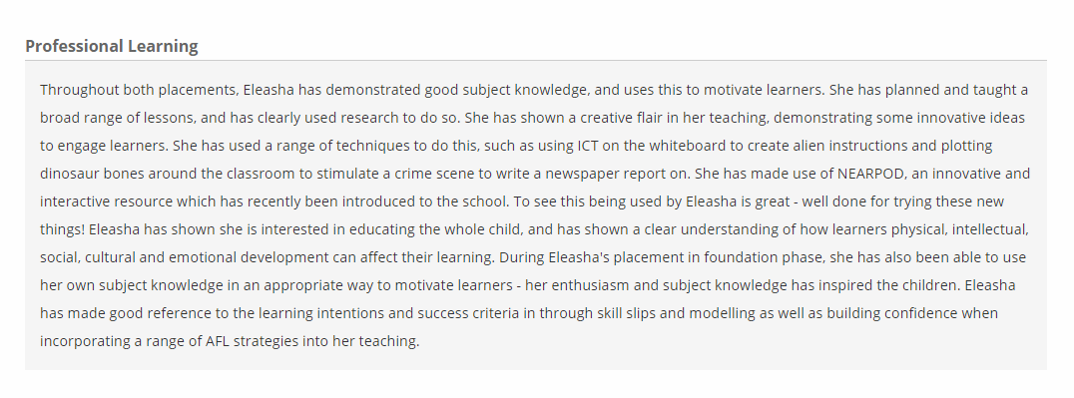
Accessed via https://swwcte.ac.uk/

Appendix 2- Series of evidence demonstrating the implementation of my behaviour strategy.
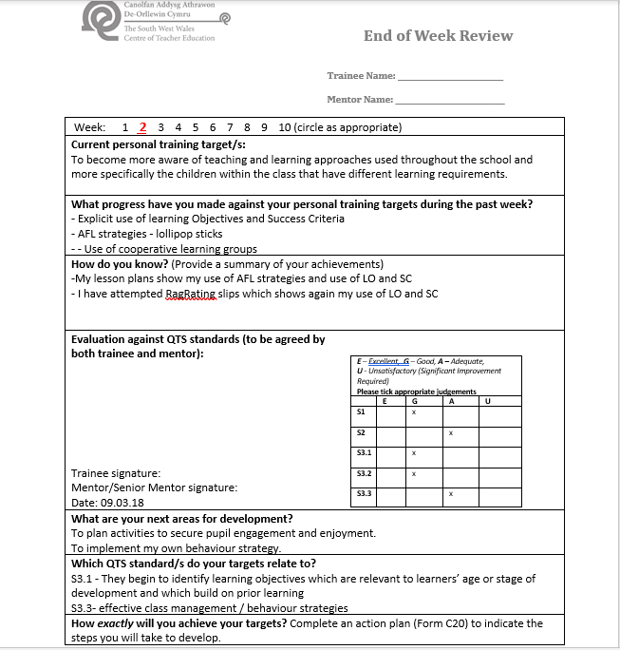
End of Week Review showing the agreed upon targets suggested by my mentor.

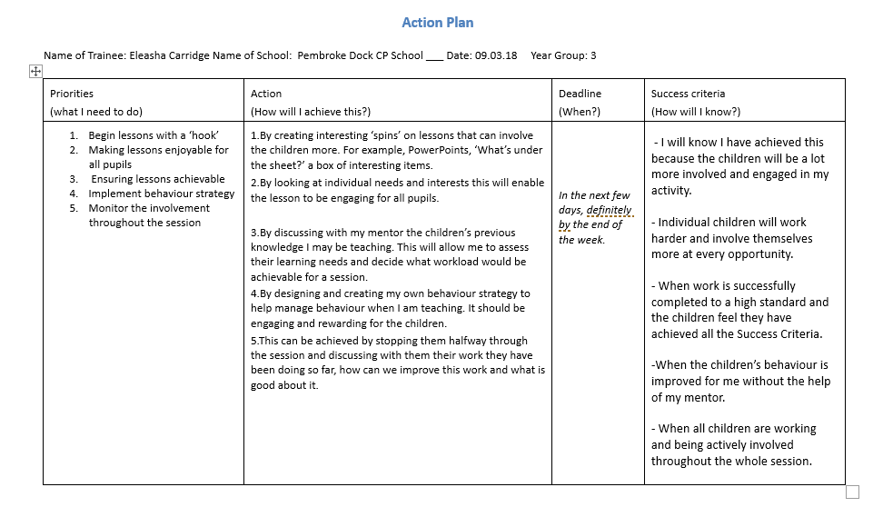
Action plan for Week 3 showing how I plan to achieve my target (number 4)

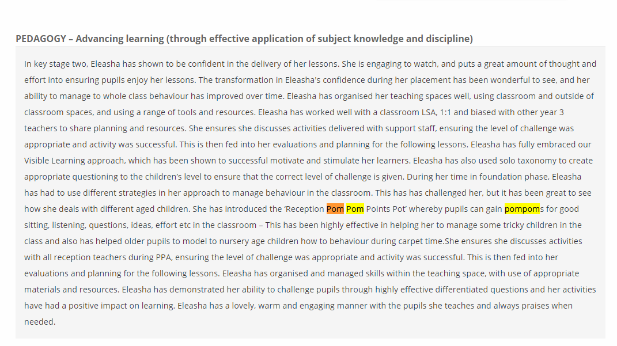
End of Placement Summative Assessment (2018) written by deputy headteacher- This comment is on the strategy’s successful implantation in Reception however it was originally implemented in Year 3.

Appendix 3- Report 3- Mentor (2019)
This illustrates the successful implementation of the behaviour strategy within another school.

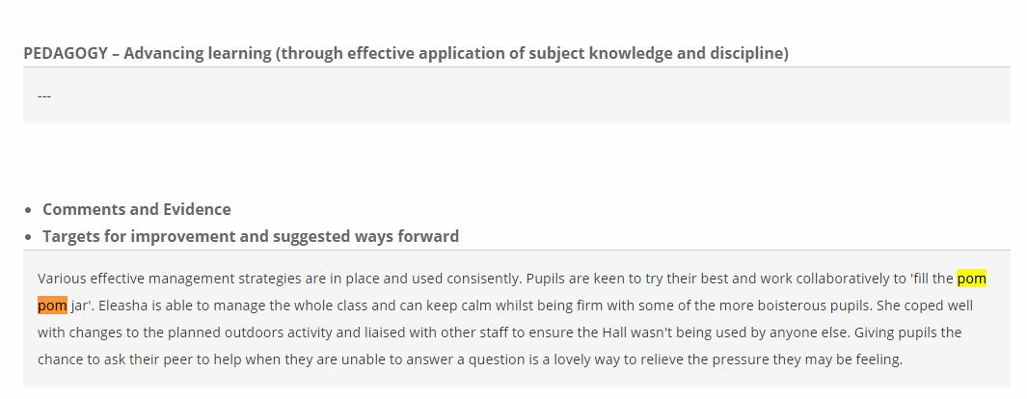
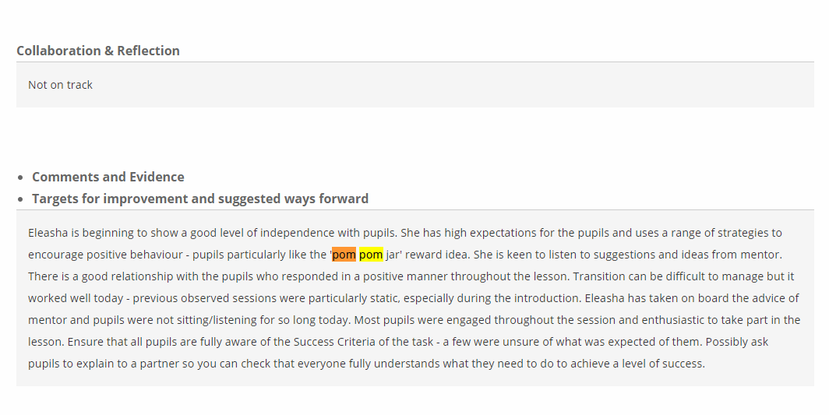
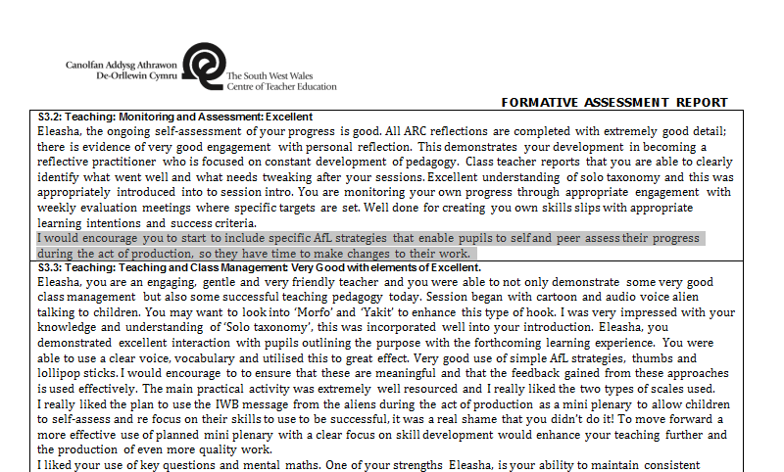
Appendix 4- Formative Assessment Report written by Tom Cox (2018)

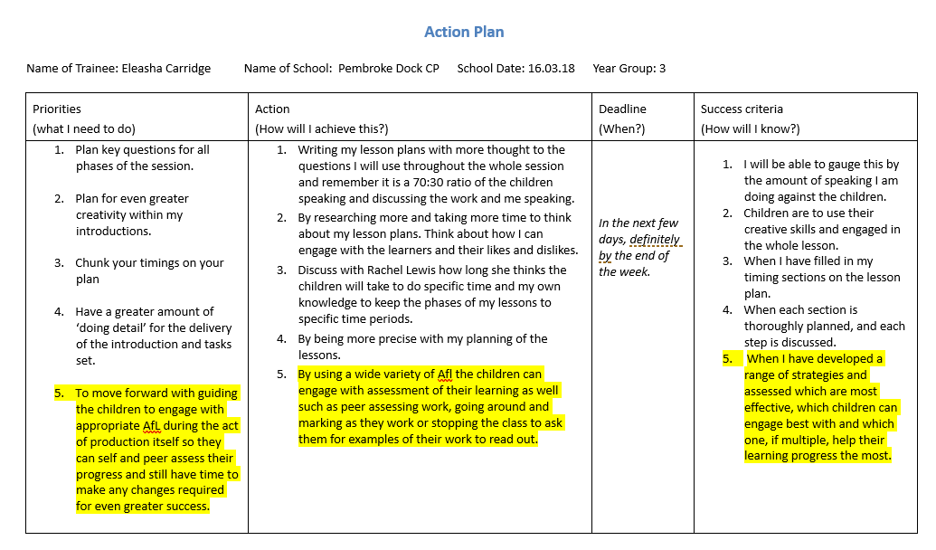
Appendix 5- Week 3 Action Plan demonstrating how I plan on developing many AfL strategies. Highlighted in yellow are the areas which apply

Appendix 6- Area board I designed and created independently to effectively manage the location of children.
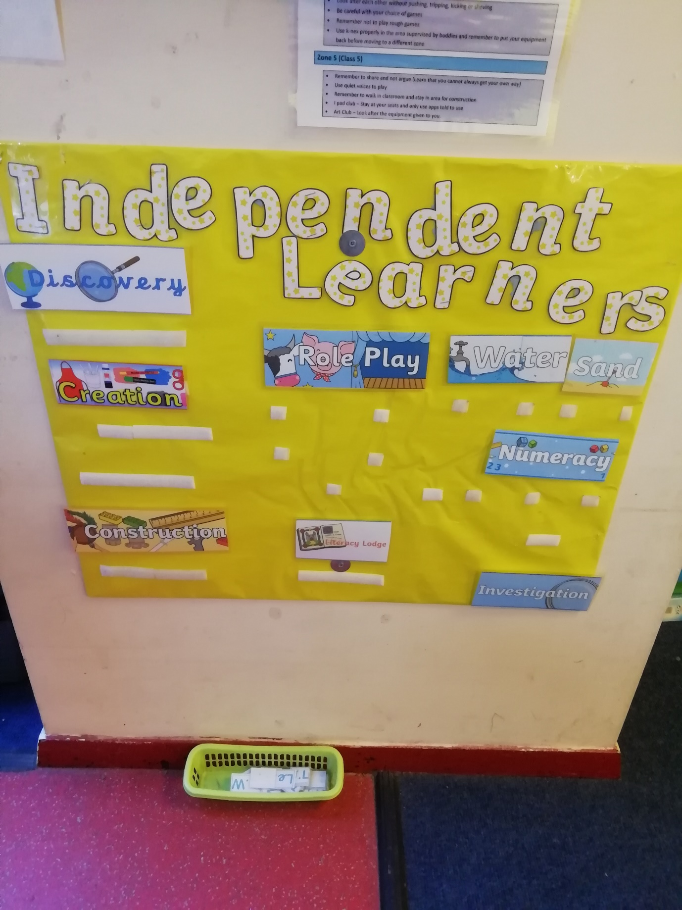
Appendix 7- Lesson plan which shows I was able to educate learners on how some innovations have helped us and the planet.
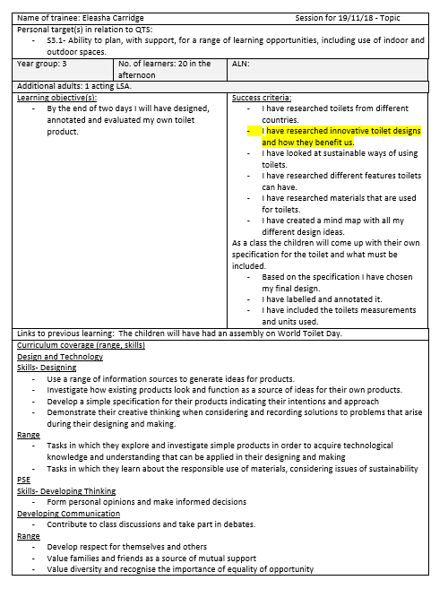
Highlighted in yellow are the areas which apply.
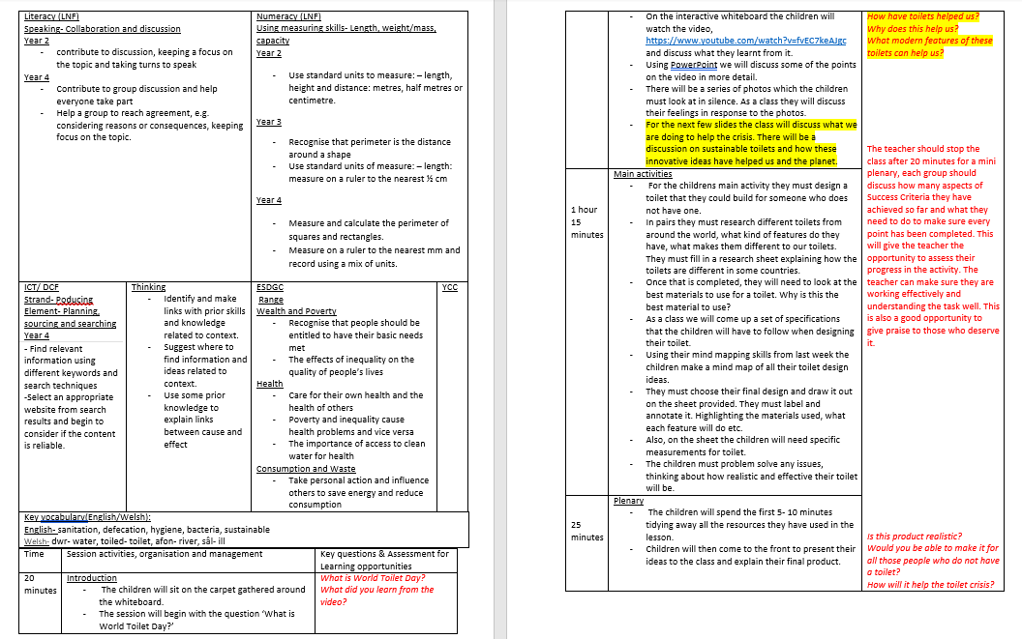
Appendix 8- ARCs to show my perseverance with challenging behaviour.
Highlighted in yellow are the areas which apply.



