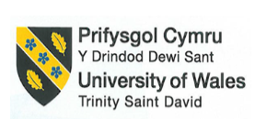

BMIH4005 Marketing Essentials
Name of the Student:
Student ID:
Name of the University:
Year:

Table of Contents
Component A: Marketing Plan 3
1. Introduction 3
2. Situation analysis: 5C’s 3
Company 3
Customers 5
Competitors 6
Collaborators 6
Climate: PESTLE 7
3. Objectives 9
4. Strategy 10
5. Tactics 10
6. Action: Gantt Chart 13
7. Control 14
8. Conclusion 14
References 15
Component B 17
Slide 1: Introduction 17
Slide 2: Situation Analysis 18
Slide 3: Objectives and Strategy 20
Slide 4: Tactics 21
Slide 5: Action and Control 22
Slide 6: Conclusion 23
Slide 7: References 24

Component A: Marketing Plan

1. Introduction
The primary purpose of this marketing plan is to evaluate how Hilton Hotels can engage the audiences and fulfil their business objectives. Hilton hotel needs to increase the number of hospitality technology and enhance its capabilities of Smart hotel rooms. This marketing plan will focus on the company's strategy to increase the number of customers for its smart hotel rooms along with integrating new technology in the rooms. The detailed marketing plan will be discussed in this study.

2. Situation analysis: 5C’s

Company
Strength  - Approximately £5.79 billion in revenue in 2022 (Hilton, 2023).  - A strong position in the U.S. with 5,666 hotels and 810,296 rooms (Hilton, 2023).  - It accounted for around 6,000 properties globally as of 2020 (Statista, 2021).  - The average daily rate was around £112.82 in 2021. | Weaknesses  - Poor reviews on social media platforms.  - The company lost almost £700,000 due to an incident of data breach incident in 2015.  - The hotel faced issues in managing a high number of employees as it had around 142,000 employments globally in 2021 (Statista, 2021).
Opportunities  - Product development would be a great opportunity for Hilton Hotel.  - Enhancing the number of Smart Hotels can help ensure the company's growth. | Threats  - Legal cases around Hilton negatively affect the brand’s reputation.  - The Russia-Ukraine conflict generates supply chain issues and Russia is one of the nations where Hilton have been operating for years.
Table 1: Analysis of SWOT
(Source: Author)
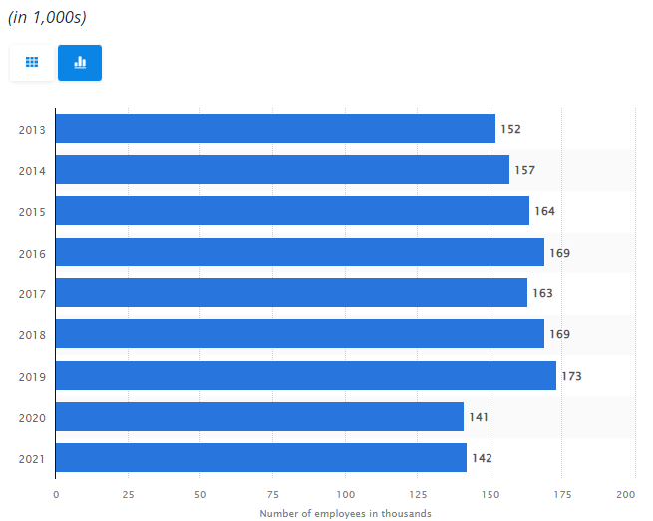
Figure 1: Number of Hilton global holding employees
(Source: Statista, 2021)

Customers
Bases of segmentation | Target customers of Asda
Geographic | Region: United Kingdom  Population Density: 281 per square kilometre
Demographic | Age: 16-45  Gender: Male and Female  Occupation: Businessman to serviceperson  Education: Higher studies  Social status: Upper and middle  Family size: Nuclear
Psychographic | Lifestyle: Active and digital lifestyle  Personality: Technophile
Behavioural | Occasions: Rare Personal Occasions  Benefits sought: Technology dependent  User status: Active and former  Attitude: Purchasing a holiday with the benefits of technology
Targeting
Hilton hotel will target demographic segmentation for the marketing of smart rooms.
Table 2: Market segmentation of Hilton Hotel’s smart rooms
(Source: Author)

Competitors
Among all the factors of Bowmans' strategy clock, Hilton Hotels can reduce its price for smart rooms to attract customers. Technology-integrated hotel rooms usually have high prices. Premier Inn also offers Smart rooms at a competitive price.

Collaborators
Hilton hotel can connect with Harrods UK which offers electric gadgets, smartphones, specialised vehicles and other accessories.

Climate: PESTLE
Dimensions | Descriptions | Impact
Political | - Resignation of prime minister and political uncertainties.  - Brexit incorporation increases taxation and tariff rate. | Moderate
Economic | - The CPIH in the UK increased by 8.8% as of 2023 (McAuley, 2023).  - The rate of inflation was 10.052% in February 2023 (McAuley, 2023).  - The GDP of the UK has fallen by 0.5% by the end of 2022 (McAuley, 2023). | High
Social | - Global supply chain issues decrease the rate of hotel booking in the UK.  - The purchasing behaviour of consumers shifts online. | High
Technology | - The integration of advanced technology in hotels.  - Machine learning and AI improve the marketing process. | High
Legal | - Health and Safety Act 19974 ensures workplace safety. | Moderate
Environmental | - Sustainability is a key trigger for the hotel industry. | Moderate
Table 3: Analysis of PESTLE
(Source: Author)

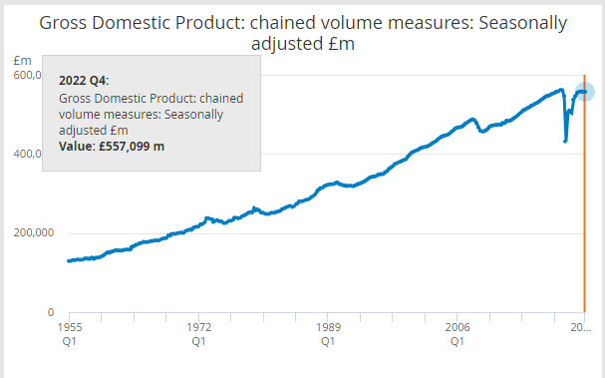
Figure 2: GDP of the UK
(Source: McAuley, 2023)

3. Objectives
Factors | Description
Specific | Hilton Hotel will increase its capacity of smart rooms and increase its customers in the UK.
Measurable | The company will offer almost 800 smart hotel rooms across the UK.
Achievable | The company can achieve its objectives with its 30.68% of net profit margin.
Relevant | The business objective of Hilton Hotel is to enhance the capacity of the hospitality industry by delivering expected experiences across the globe. Therefore, increasing the number of smart capacities is a step towards the long-term goal of the company.
Time-bound | The company will fulfil its objective within one year.
Table 4: Objectives
(Source: Author)

4. Strategy
Value propositions of the company: Hilton hotel is one of the largest hotel chains in the world and the brand accounted for more than 6,000 properties across the world in 2020. Hilton Hotel will provide smart rooms at the price of £205.58 to £78.56. On the other hand, Premier Inn, one of the major competitors, provides smart rooms at the price of £210.58 to £71.03. The inflation rate in the UK is increasing hence customers want reasonable prices for smart hotel rooms. Hilton hotel will design a moderate price range for the smart hotel room for UK consumers.
Connections of value propositions with customer segmentation: Hilton Hotel will be the provider of smart rooms and will target the age between 16 to 45 who prefer technology-integrated hotel rooms. The UK is now suffering from an unprecedented economic crisis. Therefore, the high price range will not be able to grab the attention of UK consumers. On the other hand, Hilton Hotels will offer luxurious services to UK consumers as the company will target the social status of the upper and middle classes.

5. Tactics
Factors | Descriptions
Product | Hilton hotel offers luxury hotels and resorts along with 7,165 properties across the world. It has a presence in 123 nations and territories along with 19 brands (Hilton, 2021). The company has a chain of hotels with luxury rooms, restaurants and bars. The smart hotels of the company have the facilities of wi-fi, self-controlling of Television, lighting and also temperature. These devices are equipped with high-technology sensors that are able to receive commands from guests through the Hilton Honors application. Hilton Honors have almost 128 million members as of 2022 (Hilton, 2021).
Price | Hilton Hotel will adopt competitive pricing policies for its luxurious services (Bowie et al., 2017). Hilton Hotel provides luxurious services for consumers across the globe in 123 countries. The company holds the upper upscale tier with an average price range for luxurious hotels is £75 in the UK. The price range is quite high as they provide high-quality amenities ‌(Corporate Finance Institute, 2020). The dedicated team of Hilton Hotel are responsible for providing extraordinary services to the customers.
Place | Hilton comprises 18 different brands across the world. Hilton Hotel and Resorts is one of them which has a presence in 123 nations across 6 continents. The company also has 216,379 rooms across the globe (Hilton, 2021). The company has more than 166 hotels in the UK under its 7 different brands. The brand will increase its smart rooms capacity and enhance its customer base in the UK. The company will also enhance its online customers (Jobber and Ellis- Chadwick, 2020).
Promotion | Hilton hotel will use both traditional and modern promotional approaches. Hilton Hotel will promote the brand name through a digital medium, general advertising on television, newspapers, sponsorship activity and others (Chaffey and Ellis- Chadwick, 2019). The company has around 361,000 followers on Instagram against 2061 posts (Instagram, 2020). The company will change its marketing tactics and place videos of a hotel stay in its TV advertisements. Hilton hotel will also showcase attractive offers through its website. The company will offer 17% discounts for the members of Hilton Honors.  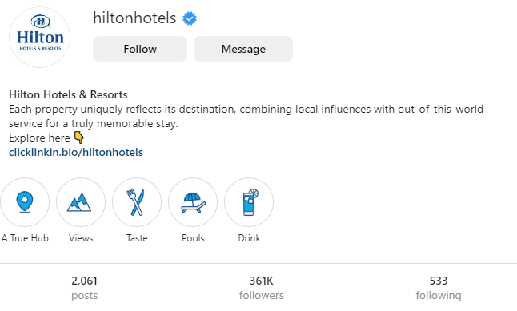Figure 3: Instagram followers of Hilton Hotel  ‌(Source: Instagram, 2020)
Table 5: Analysis of 4P’s of marketing
(Source: Author)

6. Action: Gantt Chart
Task | Metrics | Starts | End | November-January | February-April | May-July | August-October | November
Advertising
TV | How many views? | March | August
Radio | Promotional code | November | November
PPC | Click rate | November | November
Sales promotion
 | Contests | November | March
 | Discounts | November | November

7. Control
Hilton Hotel will measure its success by evaluating the increased number of customers. The customers will purchase more smart rooms. The company also increased its smart room capacity and wants to build almost 800 smart rooms in the UK. Hilton Hotel will evaluate its success through analysis of the customer's growth and their feedback towards the brand's service. (Ferrell, 2021) The UK hotel industry will reach almost £21 billion in the year 2023. The rate of growth revenue will be around 1.59%. Hilton Hotel wants to become the largest smart hotel provider in the UK and grab the large hotel market of the nation.

8. Conclusion
Hilton Hotel, one of the leading hotel brands, wants to increase its smart hotel consumers in the UK. Therefore, the company also needs to increase its smart hotel capacity which also will be increased within one year.

References
Bowie, D. Buttle, F. Brookes, M and Mariussen, A (2017), Hospitality Marketing. 3rd ed, Routledge, London
Chaffey, D and Ellis- Chadwick, F. (2019) Digital Marketing. 7th ed, Pearsons, London.
‌Corporate Finance Institute (2020). 5C Analysis. Available at: https://corporatefinanceinstitute.com/resources/management/5c-analysis-marketing/ [Accessed 3 Mar. 2023].
Ferrell, O.C., Hartline, M. and Hochstein, B.W., 2021. Marketing strategy. Cengage Learning.
Hilton, (2021). Hilton 2021 Annual Report. Available at: https://www.corporatereport.com/hilton/2021/ar/guest-experience/ [Accessed 3 March 2023]
Hilton, (2023). Hilton Brands. Available at: https://www.hilton.com/en/corporate/#:~:text=Hilton%20Honors,-Hilton%20Honors%20is&text=In%20fact%2C%20with%207%2C000%20properties,for%20every%20budget%20and%20occasion. [Accessed 3 Mar. 2023].
Instagram, (2020). Hilton Hotels & Resorts (@hiltonhotels) • Instagram photos and videos. Available at: https://www.instagram.com/hiltonhotels/?hl=en [Accessed 3 March 2023]
Jobber, D. and Ellis-Chadwick, F (2020), Principles and practice of marketing. 9th ed. London.
McAuley, N. (2023). Gross Domestic Product: chained volume measures: Seasonally adjusted £m. Available at: https://www.ons.gov.uk/economy/grossdomesticproductgdp/timeseries/abmi/pn2 [Accessed 3 March 2023]
Statista, (2021). Hilton Worldwide employee numbers 2021. Available at: https://www.statista.com/statistics/297758/number-of-hilton-worldwide-employees/ [Accessed 3 March 2023]

Component B
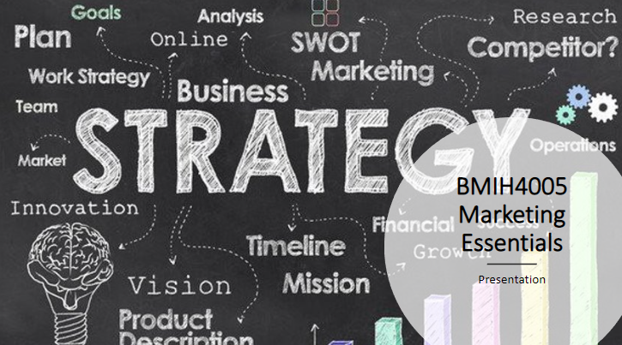

Slide 1: Introduction

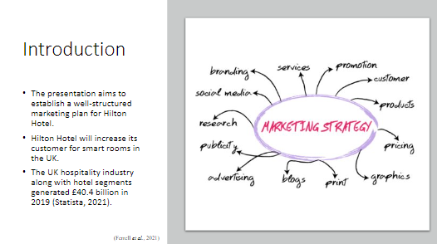
The presentation aims to establish a well-structured marketing plan for Hilton Hotel.
Hilton Hotel will increase its customer for smart rooms in the UK.
The UK hospitality industry along with hotel segments generated £40.4 billion in 2019 (Statista, 2021).
The UK hospitality industry is one of the leading industries in the world. Integration of technology in hotel rooms is the major trend in the hotel industry (Ferrell et al., 2021). Therefore, Hilton Hotel can ensure its business growth by improving its smart room’s customer segments. The organisation will increase its marketing for smart rooms in the UK.

Slide 2: Situation Analysis
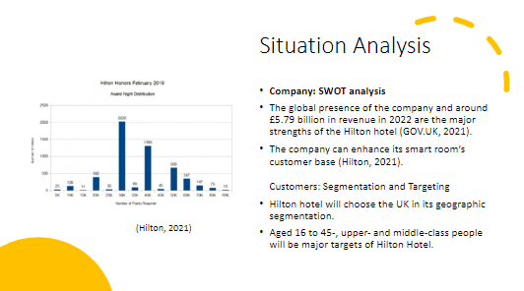
Company: SWOT analysis
The global presence of the company and around £5.79 billion in revenue in 2022 are the major strengths of the Hilton hotel ‌(GOV.UK, 2021).
The company can enhance its smart room’s customer base (Hilton, 2021).
Customers: Segmentation and Targeting
Hilton hotel will choose the UK in its geographic segmentation.
Aged 16 to 45-, upper- and middle-class people will be major targets of Hilton Hotel.
Hilton hotel would rectify its lost reputation by increasing its hotel capacity and developing its products. The high number of employees and managing their engagement are also major weaknesses of the Hilton Hotel. Therefore, the company will target demographic customer segmentation to develop the customer base of smart rooms in the UK. The data theft incident of the company has created legal issues that negatively impact the brand's reputation. On the other hand, the Russian market was one of the profitable areas for Hilton Hotels which has been affected by the conflicts between Russia and Ukraine.

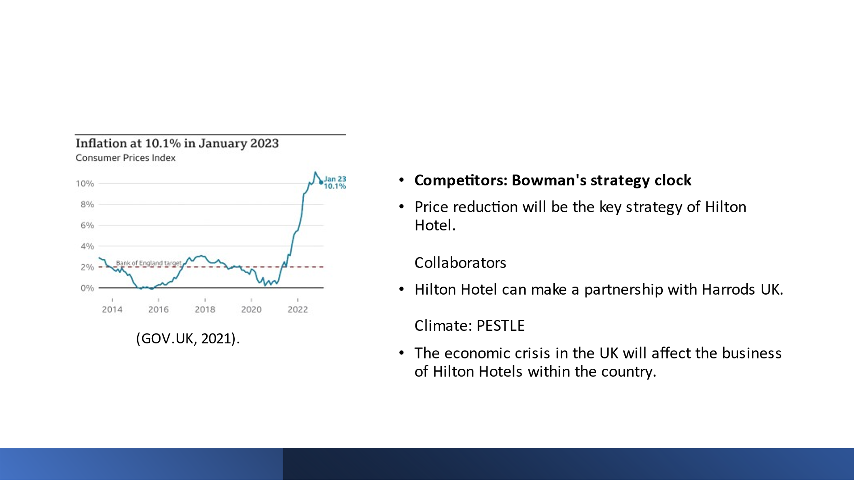
Competitors: Bowman's strategy clock
Price reduction will be the key strategy of Hilton Hotel.
Collaborators
Hilton Hotel can make a partnership with Harrods UK.
Climate: PESTLE
The economic crisis in the UK will affect the business of Hilton Hotels within the country.
Low price is the strategy that refers to becoming the lower-cost option for consumers in the marketplace. Harrods UK can develop smart-time tablets, smart mirrors and voice command capabilities gadgets for Hilton Hotel. The social factors and technological factors of PESTEL also provide a high impact on the company.

Slide 3: Objectives and Strategy
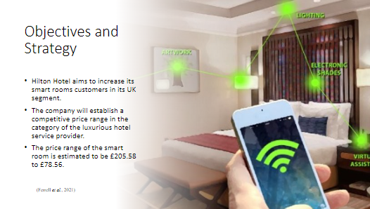
Hilton Hotel aims to increase its smart rooms customers in its UK segment.
The company will establish a competitive price range in the category of the luxurious hotel service provider.
The price range of the smart room is estimated to be £205.58 to £78.56.
A value proposition refers to the statements of the advantages that an organisation is offering to customers (Ferrell et al., 2021). Hilton Holiday will offer a luxurious smart room at a reasonable price for the guests.

Slide 4: Tactics
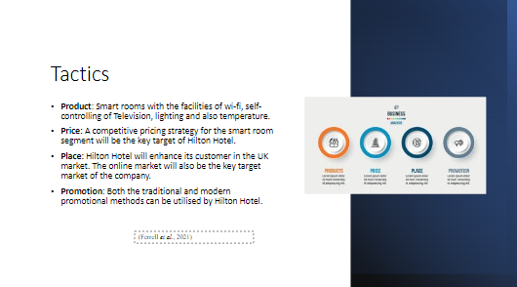
Product: Smart rooms with the facilities of wi-fi, self-controlling of Television, lighting and also temperature.
Price: A competitive pricing strategy for the smart room segment will be the key target of Hilton Hotel.
Place: Hilton Hotel will enhance its customer in the UK market. The online market will also be the key target market of the company.
Promotion: Both the traditional and modern promotional methods can be utilised by Hilton Hotel.
Hilton hotel has an extensive presence in 123 countries on six continents. The company has lost its reputation after the incident data breach in 2013. Additionally, the company received a mix of customer reviews on social media platforms. Therefore, Hilton Hotels wants to develop its business and increase the number of customers in the UK segments. Marketing tactics will play an important role in ensuring the growth of Hilton's business.

Slide 5: Action and Control
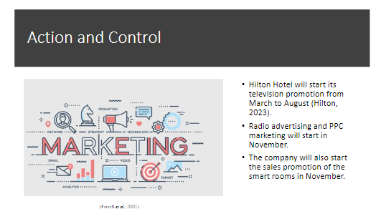
Hilton Hotel will start its television promotion from March to August.
Radio advertising and PPC marketing will start in November.
The company will also start the sales promotion of the smart rooms in November.
Hilton Hotel aims to fill the globe with the prosperity of hospitality and deliver extraordinary luxurious experiences to every guest. Hilton Hotel will evaluate the increased number of customers in the smart rooms segment and analyse its success by feedback analysis of the consumers.

Slide 6: Conclusion
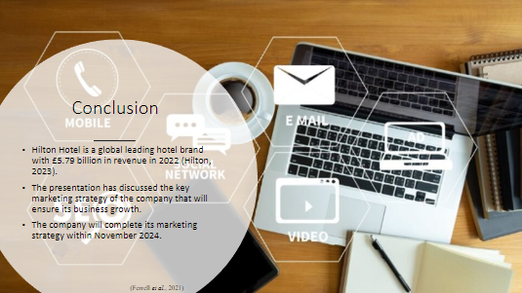
Hilton Hotel is a global leading hotel brand with £5.79 billion in revenue in 2022.
The presentation has discussed the key marketing strategy of the company that will ensure its business growth.
The company will complete its marketing strategy within November 2024.
Marketing strategy is responsible for setting out an organisation's business goals and identifying the target customers of the product or service. the marketing strategy also provides a chance to compare with the competitors and develop the business strategy.

Slide 7: References
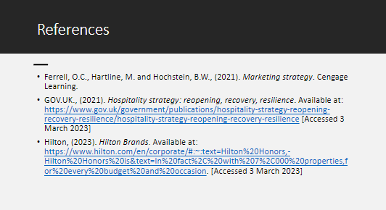
Ferrell, O.C., Hartline, M. and Hochstein, B.W., (2021). Marketing strategy. Cengage Learning.
GOV.UK., (2021). Hospitality strategy: reopening, recovery, resilience. Available at: https://www.gov.uk/government/publications/hospitality-strategy-reopening-recovery-resilience/hospitality-strategy-reopening-recovery-resilience [Accessed 3 March 2023]
Hilton, (2023). Hilton Brands. Available at: https://www.hilton.com/en/corporate/#:~:text=Hilton%20Honors,-Hilton%20Honors%20is&text=In%20fact%2C%20with%207%2C000%20properties,for%20every%20budget%20and%20occasion. [Accessed 3 March 2023]

