PROGRAMME: MSC PUBLIC HEALTH AND SOCIAL CARE IN PRACTICE
MODULE: SOCIAL EPIDEMIOLOGY AND PUBLIC HEALTH DEVELOPMENT
MODULE CODE: LCHS7000
LECURER: DR HAMDI HUSSAIN
ASSIGNMENT TITLE: COMPONENT 2 ANALYTICAL REPORT
STUDENT NAME: NAGINA BEGUM
STUDENT NUMBER: 2215742
Table of Contents
Task 1: Social epidemiological analysis 3
1. Introduction 3
2. Contextual background and underlying factors 3
3. National response to reduce gender health inequalities 5
4. Organisations supporting the target group 5
5. Conclusion 6
Task 2: Epidemiological Analysis 6
1. Introduction 7
2. Discussion 7
2.1 Public health measures available 7
2.2 Key determinants and risk factors 8
2.3. Populations Affected or At Risk 9
2.4. Public Health approaches and surveillance systems 9
2.5 Public health impact and consequences 10
2.6 Proposed health intervention programme 11
2.7 Strengths and weaknesses of epidemiological approach 12
Reference List 14

Task 1: Social epidemiological analysis
Title: Gender-Based Health Inequalities in the UK: Exploring Disease and Social Determinants

Introduction
Women are a vital part of any community; however, a great number of them must face the unequal differences in health. Such differences are what are known as health inequalities. As per the report of the WHO (2023), there is no even distribution of health care or health opportunities given to women and men. The low income, social pressure, gender bias, and violence often play against women. Poor mental health, reproductive health challenges, and cardiac disease are among the problems that they face. Several of them also find it difficult to access proper medical attention. Despite women having longer life expectancy, women experience a greater burden of disease over time, shaped not only by biological factors but also by social and cultural determinants. In this report, the most common health and social problems affecting women are explained, and the interventions that are being implemented to reduce them are outlined.

2. Contextual background and underlying factors
1. Mental health problems
Mental health abnormalities among women are higher than those in men. According to NHS statistics, women are nearly twice as affected by anxiety and depression. The demands of childcare, the running of the household, and work cause stress to many (Diez Roux, 2022). Others are faced with violence or relationship challenges that seriously impact their mental health. One out of every ten new mothers has postnatal depression. There is also increased pressure on women in terms of appearance and body image, which reduces their self-esteem. Most women do not seek assistance because of fear of judgment.
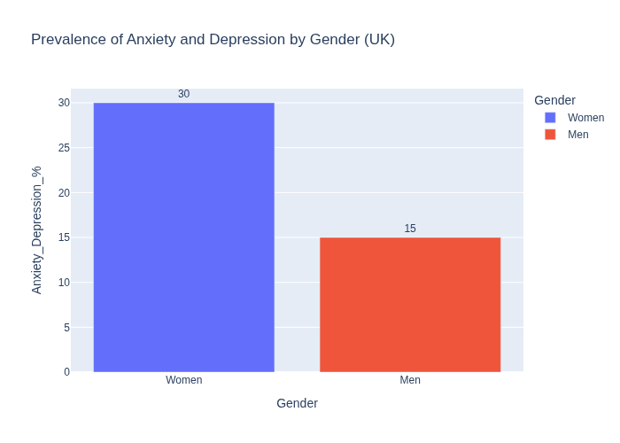
(NHS Mental Health Statistics,2024)

2. Reproductive and maternal health
Women are faced with multiple pregnancy and reproductive health-related issues. Others cannot get proper pre and postnatal care. It has been shown that women of black or Asian origin are 3 times prone to die during childbirth as compared to white women, which proves an unjust inequality in healthcare. Endometriosis, PCOS conditions are often underdiagnosed or misdiagnosed (WHO, 2025). Most healthcare professionals do not give serious consideration to the pain of women. Poor awareness and long waiting lines increase the plight of women.
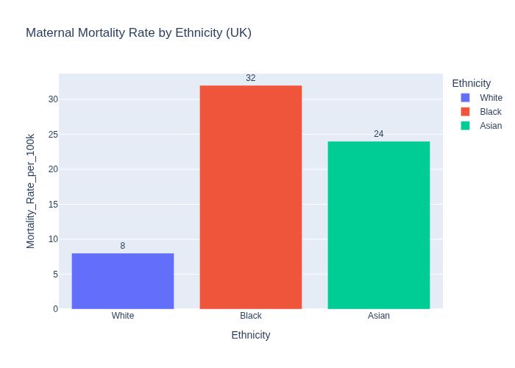
(MBRRACE-UK Report,2023)

3. Heart disease in women
Heart disease is responsible for one in four deaths among women in the United Kingdom, yet it is still often seen as a men’s problem. Women’s symptoms are different from men’s, they usually suffer chest pain, women might feel tired, short of breath, nauseous, or have pain in their back or jaw (Choi et al. 2023). These differences can make diagnosis slower. Risk factors include unhealthy diet, not exercising, high stress, and smoking. Many women, especially those with lower incomes, struggle to afford healthy food or gym memberships. To help, doctors should check more women for heart disease risk, and there should be more public campaigns about healthy living.
4. Poverty and low income
As opined by Taylor et al. (2022), women earn less as compared to men and this can lead to greater levels of stress and diminished ways of health. Most women make low income as compared to men, and this has negative consequences on their health. The average disparity between gender salaries is a 15% difference, in which women earn what men earn (Harries et al. 2021). The situation is even more challenging for single mothers who have to provide for their families single-handedly. Women do not have access to sufficient finances, which means they are not always able to afford healthy food, transportation to clinics, and even safe places to live. Stress about finances may become the cause of anxiety and other diseases. The government ought to offer more funding to the poor, expand the opportunities of low-income families, and encourage childcare to help. This would be beneficial to improve the mental and physical health of women.

5. Gender-based violence
Domestic violence against women is a serious problem that has implications for health and safety. According to Ons.gov.UK (2021), 25% women have experienced domestic abuse. Violence causes injuries, stress and depression, and persistent trauma. Most women hide their statuses because they are afraid of retaliation and a lack of support. The healthcare and the government should collaborate so can offer vital support to individuals. Physicians should be trained on identifying symptoms of abuse, and extra safe houses and hotlines are provided. Victimisation of youths can be avoided by educating them on respect and equality.
6. Access to healthcare
Most women have challenges in accessing the right medical care. Some people cannot visit the doctor because work or parenting responsibilities keep them busy. Others face discrimination or struggle with language barriers. The equality of care implies that black women are four times more likely to die in childbirth than white women (MBRRACE-UK, 2023). Some clinics are not culturally sensitive. They need to adapt to all cultures and make appointment systems more flexible.

3. National response to reduce gender health inequalities
The UK government has also taken several measures to make healthcare fairer for women. The Women's Health Strategy in England (2022) is aimed at enhancing how women are treated in the healthcare sector, especially regarding menopause, menstruation, fertility, and pregnancy (Gov.uk, 2022). The NHS Long-Term plan goals are decreasing maternal deaths, improving mental health support, and encouraging women to screen for cardiovascular diseases and cancer at the earliest stage. Every Mind Matters campaign help women understand mental health and where to find help. The other campaign is the Heart Health of Women campaign that informs women about the early signs of cardiovascular diseases.

4. Organisations supporting the target group
Many organisations in the UK aim the enhance the health of women. The Fawcett Society is one of those that presents gender equality advocacy and female rights (Fawcettsociety.org.uk, 2025). Before its campaigns gained momentum, the gender pay gap was 17.4% in 1997, and women’s health needs were often overlooked (Women’s Budget Group, 2020). Since then, the gap has narrowed to 14.3% by 2023, and female representation in Parliament has reached record levels (Office for National Statistics, 2023). Women's Health Concern is another major charity that provides reliable information on menopause, mental health, and sexual health. It also conducts sensitisation programs and advises women free of charge.

5. Conclusion
Women in the United Kingdom continue to experience significant health inequalities. They are at risk for mental health issues, reproductive and heart diseases, as well as social and economic challenges such as poverty and violence. These problems are caused by unfair social, economic, and cultural factors. Charities and national policies are offering support, but more action is needed. Healthcare providers should prioritise women's needs to ensure everyone can access care. This is not just about saving lives; it is also about fairness, respect, and dignity.

Task 2: Epidemiological Analysis in London

Introduction

Breast cancer is the uncontrolled growth of abnormal cells in breast tissue, forming a lump or tumour. If untreated, these cells can spread to other body parts. It is among the most common cancers affecting women, including those in London. Clinical signs include a lump or swelling in the breast, changes in breast shape or size, nipple discharge, skin dimpling, and localised pain. Socially and culturally, breast cancer affects families and communities in London, often causing fear, shame, and stigma. For many, discussing breast or reproductive health is private, which can delay seeking help. Treatment may involve surgery, prolonged therapy, distress, and financial strain. In 2022, 2.3 million women worldwide were diagnosed, with about 670,000 deaths (WHO, 2025). In London and the UK, about one in seven women will develop breast cancer in their lifetime, with thousands of new cases and deaths each year (Cancer Research UK, 2025; Breast Cancer UK, 2025). This study focuses on women in London.

2. Discussion

2.1 Public health measures available
The public health measures refer to the actions to prevent disease prevention to protect population health. In breast cancer, these interventions focus on prevention, protecting, and promoting the 3P of public health.
Prevention
Prevention is a term that can be used to refer to stopping disease before it starts. The public health education educates women on their healthy lifestyles, such as a healthy diet, physical exercise, non-use of tobacco, and limited use of alcohol (Stordal, 2023). Educational programs promote a regular practice of self-breast examination and screening to detect early breast cancer. The NHS Breast Screening Program is an invitation given to 50 to 71 years old to undergo a free mammogram on a tri-annual basis. Mortality is decreased through early detection.
Protection
Protection refers to exposure to the risk factors. Genetic testing is recommended by the NHS for women who possess a hereditary breast cancer history in their family or harbor BRCA1 or BRCA2 mutations (Pujol et al. 2021). Even though HPV immunisation only applies directly to cervical cancer, it still indirectly encourages awareness of women's cancers. Occupational health also prevents the exposure of harmful chemicals to the public environment.
Promotion
Initiatives like Be Clear on Cancer and the Pink Ribbon are ways of disseminating information in Health promotion. The campaigns allow an open dialogue, fight stigma, and fund research. Local groups receive community health workers who educate women about the need to join the screening programs.

2.2 Key determinants and risk factors
The risk of breast cancer in women has several determinants, which include biological, lifestyle, environmental, and social determinants.
Biological factors
Female sex hormones play a key role in health. High levels of both oestrogen and progesterone can increase risk, especially if menstruation starts early or menopause happens late. Not having children or having a first child after age 30 also raises risk, but less so.

Lifestyle factors
Strong risk factors are obesity, sedentary behaviour, alcohol consumption as well and smoking. Research has also been found to show that women who take more than one unit of alcohol per day are at a higher risk of breast cancer by 20% (Donat-Vargas et al. 2021). Obesity in postmenopausal women increases the risk due to the adipose tissue-derived oestrogen production.
Environmental and genetic factors
Breast cancer can develop when a young person is exposed to ionizing radiation or certain harmful chemicals at work. About 5% to 10% of all breast cancer cases are linked to inherited genes, such as BRCA1 and BRCA2.
Social factors
Some women may not be able to get screened or treated for breast cancer because they lack resources, belong to minority groups, or have limited literacy. Fear, stigma, and not having enough information can also delay seeking help.
These factors together cause differences in how often breast cancer occurs and how it affects women, depending on their background and lifestyle.
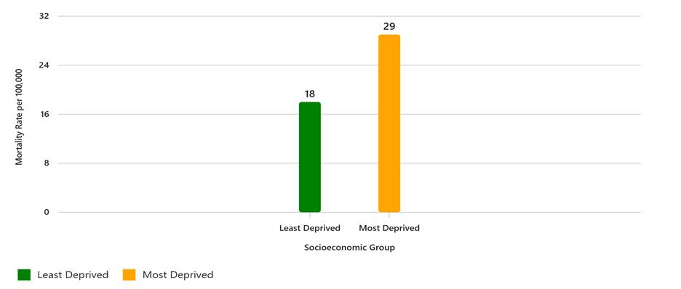
(CANCER RESEARCH UK, 2025)

2.3. Populations Affected or At Risk
Epidemiological studies show that breast cancer is most common in women over 50, with around 80% of UK cases occurring in this age group (Cancer Research UK, 2025). Younger women can also develop the disease, particularly those with a family history or harmful genetic mutations. Incidence rates are highest among White women, followed by Black and Asian women, although these groups are often diagnosed later. Women living in low socioeconomic area are less likely to participate in screening programs (Carcel et al., 2022). In terms of mortality, the UK records approximately 11,200 breast cancer deaths annually, with rates peaking in older age groups and being 12% higher in the most deprived areas (Cancer Research UK, 2025)

2.4. Public Health approaches and surveillance systems
In order to follow up on breast cancer, disease surveillance, which is a systematic means of following the new cases and outcomes in any given disease, is administered by the public health systems. Public Health England (PHE) in the United Kingdom is the chief surveillance agency, which currently functions as the UK Health Security Agency (UKHSA) (Hunter et al. 2022).
Types of surveillance
- Active Surveillance: Health officers gather data directly from hospitals, clinics, and labs.
- Passive Surveillance: Health practitioners report new cancer cases to national databases.
- Sentinel Surveillance: Selected hospitals monitor and report emerging trends (Mellor et al., 2024).
- Population-Based Registries: National systems like the UK’s NCRAS record all cancer incidences.
The UK Health Security Agency and NCRAS report 56,900 new breast cancer cases annually (over 150 per day), with 11,200 deaths per year (Cancer Research UK, 2025). Every 9 minutes, a woman is diagnosed with breast cancer in the UK, and annually, 11,500 women and 90 men die, equivalent to one death every 45 minutes (Breast Cancer Now, 2025). Globally, 2.3 million women were diagnosed with breast cancer in 2022, resulting in 670,000 deaths (WHO, 2025). If current trends continue, by 2050, global figures may reach 3.2 million new cases and 1.1 million deaths per year (IARC, 2025).
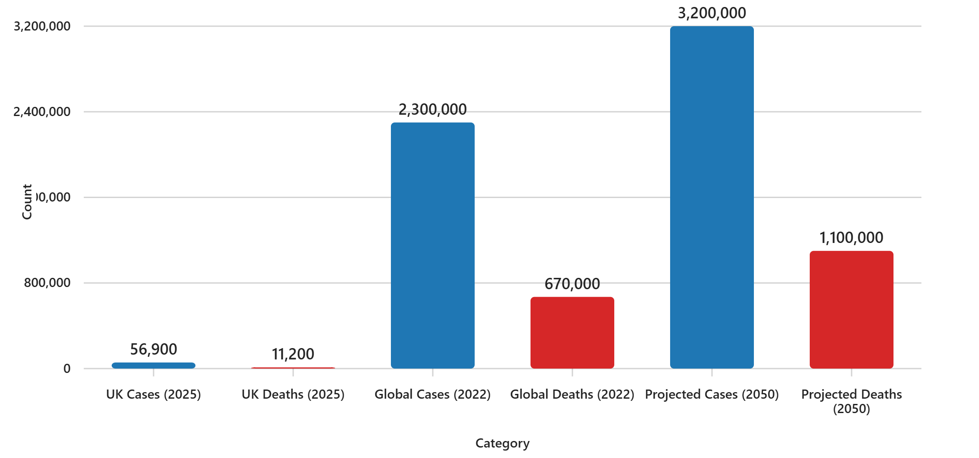
(Cancer Research UK, 2025)

2.5 Public health impact and consequences
Breast cancer poses serious short-term and long-term consequences on the health of women and the entire society.
Short‑term impacts:
Women can experience a lot of pain, fatigue, nausea, and emotional disturbance during treatment. Radiation therapy and chemotherapy have a possible effect of inducing loss of hair and weakening the immune system. Most women also feel nervous about their body image after a mastectomy (Moghnieh et al. 2025).
Long‑term impacts:
In case of early non-detection, breast cancer could spread to bone, liver, or lung tissue, thus minimizing the survival chances. Long-term consequences can be faced by the survivors, such as lymphedema, hormonal changes, and depression. The economic implication is significant; oncological treatment is not only very expensive but also time-consuming. There is a risk of women losing income because of extended treatment and family-related emotional and financial pressure.
As per the report of WHO (2023), the number of deaths caused by breast cancer in the world in a year is an average of 685,000 deaths; this places breast cancer as the largest cause of cancer deaths in women. The survival rates are on the rise in the United Kingdom due to the screening at an early stage, with an approximate survival rate of 76 of all women at least ten years after they are diagnosed with the disease.

2.6 Proposed health intervention programme
Name of the intervention: Women First: Early Detection and Support Programme.
Starting screening at 30 instead of 50 allows earlier detection of aggressive cancers in younger women, particularly those with genetic risks or family history. Reduces late-stage diagnoses, improves survival rates, and ensures equitable access to preventive care.

Main Actions | Description
Community Education | - Hold small workshops in local areas to teach women how to check their own breasts and understand the signs of changes.
Mobile Screening Units | - Use special vans with mammogram machines to visit deprived areas so women can get free breast checks (Kalyanpur et al. 2022).
Peer Support Groups | - Create small groups where women who have breast cancer or survived it can talk, share feelings, and support each other.
Cultural Awareness Campaigns | - Work with community and religious leaders to spread messages that breast cancer is not shameful and that every woman should get checked.
Evaluation of the Programme | Description
Process Evaluation | - Check how well the programme is done, for example, how many workshops happened and how many women got screened.
Impact Evaluation | - See short-term changes, for example, if more women now go for screening or know how to check their breasts.
Outcome Evaluation | - Watch for long-term results, like fewer women getting cancer at a late stage and more surviving for many years (Trivedi et al. 2022).
Economic Evaluation | - Compare the cost of the programme with the money spent on cancer treatment to see if it saves money in the long run.
Table 1: Proposed health intervention programme
(Source: Self-Created)

2.7 Strengths and weaknesses of epidemiological approach
Strengths: Epidemiological research provides empirical information on the disease patterns, etiological problems, and risk groups (Trivedi et al. 2022). They facilitate policymakers in developing effective prevention and screening programmes. Reliability is improved by the application of large volumes of data.
Weaknesses: However, some studies can disregard underreported cases or not consider women as a minority group. Low-income local regions entail inadequate data and cultural barriers that reduce the accuracy.
To sum up, breast cancer is still a serious public health issue in the UK and affects women from deprived backgrounds more than others. Preventing the disease, finding it early, and using targeted interventions are key to lowering both incidence and death rates. Ongoing monitoring, fair access to healthcare, and support that respects cultural differences can help reduce inequalities and lead to better outcomes for all women.

Reference List
Cancer Research UK (2025) Breast cancer statistics. Available at: https://www.cancerresearchuk.org/health-professional/cancer-statistics/statistics-by-cancer-type/breast-cancer (Accessed: 16 November 2025).

Choi, S., Ismail, A., Pappas-Gogos, G. and Boussios, S. (2023) ‘HPV and cervical cancer: a review of epidemiology and screening uptake in the UK’, Pathogens, 12(2), p.298. Available at: https://www.mdpi.com/2076-0817/12/2/298 (Accessed: 16 November 2025).

Diez Roux, A.V. (2022) ‘Social epidemiology: past, present, and future’, Annual Review of Public Health,43(1),pp.79–98.

England.nhs.uk (2024) News. Available at: https://www.england.nhs.uk/2024/05/record-numbers-of-women-accessing-perinatal-mental-health-support/?utm (Accessed: 01 November 2025).
Fawcett Society (2025) About us. Available at: https://www.fawcettsociety.org.uk/about (Accessed: 01 November 2025).

Gov.uk(2022)Ministerial foreword. Available at: https://www.gov.uk/government/publications/womens-health-strategy-for-england/womens-health-strategy-for-england (Accessed: 01 November 2025).

Harries, M., Macbeth, A.E., Holmes, S., Chiu, W.S., Gallardo, W.R., Nijher, M., de Lusignan, S., Tziotzios, C. and Messenger, A.G. (2022) ‘The epidemiology of alopecia areata: a population‐based cohort study in UK primary care’, British Journal of Dermatology, 186(2), pp.257–265. Available at: https://academic.oup.com/bjd/article-pdf/186/2/257/47149283/bjd0257.pdf

Maternal Mental Health Alliance (2022) 16,389 women were unable to access essential perinatal mental health care last year. Available at: https://maternalmentalhealthalliance.org/news/thousands-unable-access-essential-perinatal-mental-health-care/ (Accessed: 05 November 2025).

Mental Health Foundation (2023) Statistics: mental health in the UK. Available at: https://www.mentalhealth.org.uk/research-and-policy/statistics/mental-health-statistics-uk (Accessed: 05 November 2025).

Mental Health Foundation (2024) Anxiety: statistics. Available at: https://www.mentalhealth.org.uk/explore-mental-health/statistics/anxiety-statistics (Accessed: 05 November 2025).
Office for National Statistics (2021) Domestic abuse in England and Wales overview: November 2024. Available at: https://www.ons.gov.uk/peoplepopulationandcommunity/crimeandjustice/bulletins/domesticabuseinenglandandwalesoverview/november2024 (Accessed: 01 November 2025).

Office for National Statistics (2024) Domestic abuse victim characteristics, England and Wales: year ending March 2024. Available at: https://www.ons.gov.uk/peoplepopulationandcommunity/crimeandjustice/articles/domesticabusevictimcharacteristicsenglandandwales/latest?utm (Accessed: 05 November 2025).

Office for National Statistics (2023) Gender pay gap in the UK: 2023. Available at: https://www.ons.gov.uk/employmentandlabourmarket/peopleinwork/earningsandworkinghours/bulletins/genderpaygapintheuk/2023

Taylor, C.L., Ivcevic, Z., Moeller, J., Menges, J.I., Reiter-Palmon, R. and Brackett, M.A. (2022) ‘Gender and emotions at work: organizational rank has greater emotional benefits for men than women’, Sex Roles, 86(1), pp.127–142.

WHO (2025) Polycystic ovary syndrome. Available at: https://www.who.int/news-room/fact-sheets/detail/polycystic-ovary-syndrome (Accessed: 01 November 2025).

World Health Organization (2023) WHO report reveals gender inequalities at the root of global crisis in health and care work. Available at: https://www.who.int/news/item/13-03-2024-who-report-reveals-gender-inequalities-at-the-root-of-global-crisis-in-health-and-care-work (Accessed: 05 November 2025).

Women’s Budget Group (2020) The impact of austerity on women. Available at: https://www.wbg.org.uk/analysis/uk-policy-briefings/the-impact-of-austerity-on-women

Task 2

Breast Cancer Now (2025) Breast cancer in the UK 2025. Available at: https://breastcancernow.org/about-us/why-we-do-it/breast-cancer-facts-and-statistics/breast-cancer-in-the-uk-2025 (Accessed: 05 November 2025).

Breast Cancer UK (2025) Facts and figures. Available at: https://www.breastcanceruk.org.uk/about-breast-cancer/facts-figures-and-qas/facts-and-figures/ (Accessed: 05 November 2025).

Cancer Research UK (2025) Breast cancer statistics. Available at: https://www.cancerresearchuk.org/health-professional/cancer-statistics/statistics-by-cancer-type/breast-cancer (Accessed: 05 November 2025).

Cancer Research UK (2025) UK Breast Cancer Mortality by Deprivation Quintile. Available at: https://www.cancerresearchuk.org/health-professional/cancer-statistics/statistics-by-cancer-type/breast-cancer (Accessed: 05 November 2025).

Carcel, C., Haupt, S., Arnott, C., Yap, M.L., Henry, A., Hirst, J.E., Woodward, M. and Norton, R. (2024) ‘A life-course approach to tackling noncommunicable diseases in women’, Nature Medicine, 30(1), pp.51–60. Available at: https://www.nature.com/articles/s41591-023-02738-1 (Accessed: 16 November 2025).

Donat-Vargas, C., Guerrero-Zotano, Á., Casas, A., Baena-Cañada, J.M., Lope, V., Antolin, S., Garcia-Saénz, J.Á., Bermejo, B., Munoz, M., Ramos, M. and de Juan, A. (2021) ‘Trajectories of alcohol consumption during life and the risk of developing breast cancer’, British Journal of Cancer, 125(8), pp.1168–1176. Available at: https://www.nature.com/articles/s41416-021-01492-w.pdf (Accessed: 16 November 2025).

Hunter, D.J., Littlejohns, P. and Weale, A. (2022) ‘Reforming the public health system in England’, The Lancet Public Health, 7(9), pp.e797–e800. Available at: https://www.thelancet.com/pdfs/journals/lanpub/PIIS2468-2667(22)00199-2.pdf (Accessed: 16 November 2025).

Kalyanpur, A., Sudhindra, R.R. and Rao, P. (2022) ‘The role of mobile van mammography supported by teleradiology in the early diagnosis of breast cancer: an innovative approach to a growing public health problem’, International Journal of Health Technology and Innovation, 1(03), pp.2–8. Available at: https://www.ijht.org.in/index.php/ijhti/article/download/30/21

Lim, Y.X., Lim, Z.L., Ho, P.J. and Li, J. (2022) ‘Breast cancer in Asia: incidence, mortality, early detection, mammography programs, and risk-based screening initiatives’, Cancers, 14(17), p.4218. Available at: https://www.mdpi.com/2072-6694/14/17/4218

Mellor, J., Christie, R., Guilder, J., Paton, R.S., Elgohari, S., Watson, C., Deeny, S.R. and Ward, T. (2024) ‘A comparative study of influenza surveillance systems and administrative data in England during the 2022–2023 season’, PLOS Global Public Health, 4(9), p.e0003627. Available at: https://journals.plos.org/globalpublichealth/article/file?id=10.1371/journal.pgph.0003627&type=printable

Moghnieh, R., Bizri, N., Abdallah, D. and Sayegh, M.H. (2025) ‘Antimicrobial resistance surveillance and trends in armed conflict, fragile, and non-conflict countries of the Eastern Mediterranean Region’, Infectious Diseases of Poverty, 14(1), p.14. Available at: https://link.springer.com/content/pdf/10.1186/s40249-025-01287-8.pdf (Accessed: 16 November 2025).

Pujol, P., Barberis, M., Beer, P., Friedman, E., Piulats, J.M., Capoluongo, E.D., Foncillas, J.G., Ray-Coquard, I., Penault-Llorca, F., Foulkes, W.D. and Turnbull, C. (2021) ‘Clinical practice guidelines for BRCA1 and BRCA2 genetic testing’, European Journal of Cancer, 146, pp.30–47. Available at: https://www.ejcancer.com/article/S0959-8049(20)31448-9/

Stordal, B. (2023) ‘Breastfeeding reduces the risk of breast cancer: A call for action in high‐income countries with low rates of breastfeeding’, Cancer Medicine, 12(4), pp.4616–4625. Available at: https://onlinelibrary.wiley.com/doi/pdf/10.1002/cam4.5288

Trivedi, U., Omofoye, T.S., Marquez, C., Sullivan, C.R., Benson, D.M. and Whitman, G.J. (2022) ‘Mobile mammography services and underserved women’, Diagnostics, 12(4), p.902. Available at: https://www.mdpi.com/2075-4418/12/4/902

WHO (2023) WHO launches new roadmap on breast cancer. Available at: https://www.who.int/news/item/03-02-2023-who-launches-new-roadmap-on-breast-cancer (Accessed: 01 November 2025).

WHO (2025a) Breast cancer. Available at: https://www.who.int/news-room/fact-sheets/detail/breast-cancer (Accessed: 01 November 2025).

World Health Organization (2023) Global breast cancer initiative implementation framework: assessing, strengthening and scaling-up of services for the early detection and management of breast cancer. Available at: https://books.google.com/books?hl=en&lr=&id=P3yzEAAAQBAJ&oi=fnd&pg=PR6&dq=With+the+implementation+of+regular+breast+checks+among+women+since+the+age+of+forty+years,+the+rate+of+early+detection+and+high+survival+may+be+achieved+&ots=cfxLD9hV-J&sig=678d2joX4SvWGyfPT1_9r3lx2l8

