Table of Contents

Project Proposal Form 2

Project Report 7

Introduction 7
Literature Review 7

Methods 10

Findings 13

- Demographics and Performance Career 13
- CCM Voice Training Goals 16
- Vocal Health 18
- The CCM Learning Environment 20

- Voice Training Challenges 23

- PCGS In Their Own Words 24

Discussion 27

Conclusions and Recommendations 28

References 29

Appendix 1: Informed Consent Form and Questionnaire 33

Appendix 2: Ethics Form and Permissions Letter 40

Appendix 3: Interview Questions 55

Appendix 4: Inductive Analysis and Themed Excerpts 56
Project Proposal Form

- Project Title
Vocal training experiences and perceptions among adult Professional Contemporary Gig Singers (PCGS).

- The context
I am a private voice teacher of Contemporary Commercial Music (CCM) styles working in California, US. My background is unique as I have considerable education in functional voice pedagogy but am a predominantly self-taught performer. As I do not have a performance degree, I appreciate the value of non-institutional vocal learning.
While CCM voice training is increasingly available (Edwards et al., 2023), research into the experiences of Professional Contemporary Gig Singers (PCGS) is all but nonexistent, especially research about these singers’ relationships with voice training. In this study I will invite and explore performers’ own perspectives to bolster my skill set as a CCM singing teacher.

- The justification
The vast majority of professional singers in the US sing CCM (Wilson, 2021). By better understanding the perspectives of PCGS and the demands of the CCM marketplace, singing teachers may relate to gigging performers with more empathy and develop more effective training strategies for aspiring professionals (Wigginton, 2010).

CCM voice research is usually limited to Musical Theater singers, whose work environments and performance demands differ from those of PCGS (Morawska et al., 2022). Most CCM research focuses on testing and observing the tonal and physiological differences between CCM and Western Classical styles of singing, with few insider accounts of the needs and experiences of PCGS (Bartlett, 2014; Bartlett and Wilson, 2017).

This study will aggregate self-reported data from singers who are usually excluded from the literature, including performers who have learned and improved their singing technique through non-institutional means and singers who perform in multiple genres. Singers will be encouraged to relate their vocal performance and training experience, as well as their perceptions of the need for and availability of genre relevant voice training. Instead of asking researchers, teachers, and clinicians what CCM voice training should include, this project will offer an inside view of how PCGS work and learn, where they struggle, and what they need.
- The intended impact
Through my research I will continue to customize a rich and inclusive approach to teaching CCM that centers the needs of the individual and the demands of the marketplace (Chandler, 2014; Helding and Ragan, 2022; Benson, 2018).
Though the number of voice teachers familiar with CCM styles continues to increase (Rooney, 2016), CCM singers still struggle to find teachers with relevant experience (Bartlett and Naismith, 2020; LoVetri, 2008). This study may inspire future research about PCGS, toward the improvement of the quality, accessibility, and marketplace relevance of CCM vocal training in the broader community.

- The outlined intention
I will conduct this study as outlined on the Gantt chart below.
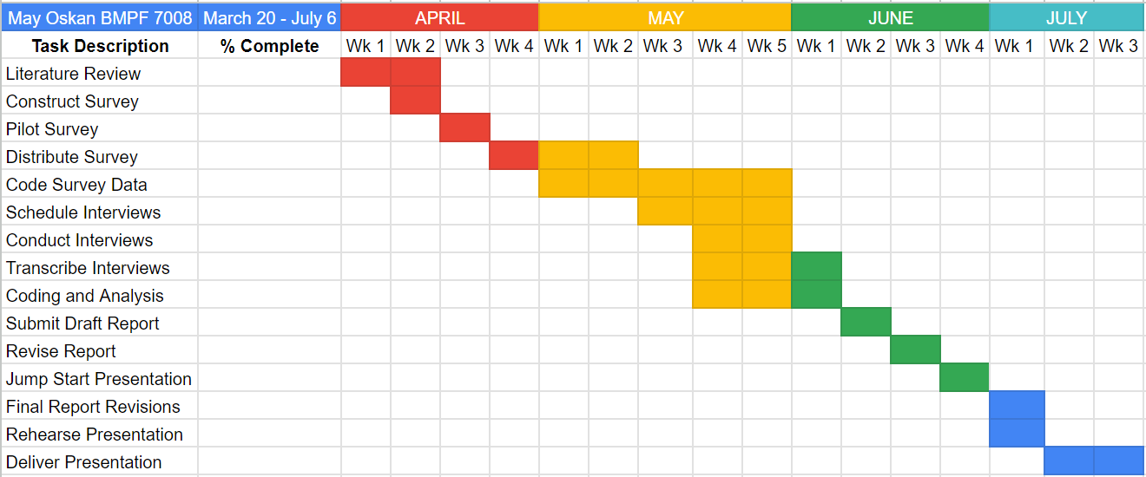
The literature review will focus on the goals and objectives of CCM voice training, as well as considering vocal health impacts and the current CCM educational landscape. By combining these topics I will synthesize a working model of the perceived needs of CCM singers and identify areas where voice education may fall short for PCGS.
I will distribute a self report survey questionnaire electronically to approximately 50 PCGS working in the United States. Questions will cover performance and voice training experience, vocal health challenges, and attitudes about vocal training. Participants will be identified via my extended personal network and social media. Survey respondents will remain anonymous unless they volunteer to participate in a follow up interview.

I will conduct follow up interviews with approximately ten percent of the questionnaire sample via online video meeting. The interviews will be semi-structured, with questions informed by survey results. My report and presentation will demonstrate a depth of understanding by incorporating various types of information (Robinson et al., 2011). Interview transcripts will be coded using thematic content analysis and excerpts will be categorized based on keywords and themes that emerge from the data.

- The ethics and insider research
In order to protect the immediate and long term interests of participants (Denscombe, 2003), I will adhere to the ethical application already approved by UWTSD.

As a practitioner researcher, I acknowledge the tension between these dual roles and their related expectations (Rowley, 2003). I will mitigate this concern by excluding current and past students from my participant population and by including performers I do not personally know. As I am also a PCGS, local participants may still be familiar with me and my work. I will minimize interference by allowing survey respondents to remain anonymous. In the interview process I will reduce bias by asking general questions and inviting participants to expand on whichever topics are most relevant to them. I will take care to respect cultural and educational differences (Mertens, 2012) when formulating my questions.
- Personal learning outcomes
  - Use my research experience and the collected data to identify future research topics and methodologies.
  - Enrich my CCM voice teaching practice with a broader understanding of working singers’ experiences.
  - Connect with other CCM voice teachers through sharing and discussing my findings.

References
Bartlett, I. (2014) ‘Reflections on Contemporary Commercial Singing: an Insider’s Perspective,’ Voice and Speech Review, 8(1), pp. 27-35.
Bartlett, I. and Naismith, M.L. (2020) ‘An Investigation of Contemporary Commercial Music (CCM) Voice Pedagogy: A Class of its Own?,’ Journal of Singing, 76(3), pp. 273-282.
Bartlett, I. and Wilson, P.H. (2017) ‘Working 9-5: Causal Relationships Between Singers’ “Day Jobs” and Their Performance Work, With Implications for Vocal Health,’ Journal of Voice, 31(2), pp. 243.e27-243.e34.
Benson, E. A. (2018) ‘Modern Voice Pedagogy: Functional Training for All Styles,’ American Music Teacher, 67(6), pp. 10–13.
Chandler, K. (2014) ‘Teaching Popular Music Styles’, in Harrison, S.D. and O’Bryan, J. (eds.) Teaching Singing in the 21st Century. Dordrecht, NL: Springer Science+Business Media.
Denscombe, M. (2003) The Good Research Guide for Small-Scale Social Research Projects. 2nd edn. Philadelphia: Open University Press.
Edwards, M., Zito-Edwards, J., and Meyer, D. (2023) ‘The Emerging Future of Collegiate Voice Instruction: Updated SWOT Analysis of Current Practice and Implications for the Next Generation,’ Journal of Singing, 79(3), pp. 331–338.
Helding, L. and Ragan, K. (2022) ‘Evidence-Based Voice Pedagogy (EBVP), Part 3: Student Goals and Perspectives,’ Journal of Singing, 78(5), pp. 635-640.
LoVetri, J. (2008) ‘Contemporary Commercial Music,’ Journal of Voice, 22(3), pp. 260-262.
Mertens, D.M. (2012) ‘Transformative Mixed Methods: Addressing Inequities,’ American Behavioral Scientist, 56(6), pp. 802-813.
Morawska, J., Niebudek-Bogusz, E., and Pietruszewska, W. (2022) ‘Considerations and Demands in the Voice Care of Contemporary Commercial Singers in Occupational Health and Safety Aspects,’ Medycyna Pracy, 73(1), pp. 33-41.
Robinson, A.L., Emden, C.G., Croft, T.D., Vosper, G.C., Elder, J.A., Stirling, C., and Vickers, J.C. (2011) ‘Mixed Methods Data Collection in Dementia Research: A “Progressive Engagement” Approach,’ Journal of Mixed Methods Research, 5(4), pp. 330-344.
Rooney, T. (2016) ‘The Understanding of Contemporary Vocal Pedagogy and the Teaching Methods of Internationally Acclaimed Vocal Coaches,’ International Journal of Learning, Teaching and Educational Research, 15(10), pp. 147-162.
Rowley, J. (2003) ‘Action Research: An Approach to Student Work Based Learning,’ Education and Training, 45(3), pp. 131-138.
Wigginton, J.R. (2010) ‘When “Proper” is Dead Wrong: How Traditional Methods Fail Aspiring Artists,’ Journal of Singing, 66(4), pp. 447-449.
Wilson, L.C. (2021) ‘Bel Canto to Punk and Back: Lessons for the Vocal Cross-Training Singer and Teacher,’ Voice and Speech Review, 15(3), pp. 330-341.
INTRODUCTION
As a voice teacher of popular music styles with training exclusively in voice science and functional pedagogy, I have a different background than many of my peers and colleagues in the voice training and research environment. The lack of literature pertaining to CCM voice and popular music gig singing in particular (Bartlett, 2014; Bartlett and Wilson, 2017) does not reflect my experience as a performer or teacher. As singers in popular styles must make do with the training resources available (cite), researchers in contemporary voice find meaning through the synthesis of different approaches (cite). Though bias against popular music styles is still a barrier (Meyer and Edwards, 2014), voice pedagogy literature is gradually shifting toward the inclusion of all genres (cite). I undertook this study, in part, as a small effort in that direction.

The term CCM, coined by Jeannie LoVetri as a way to stop defining “non-classical” vocal styles based on what they are not (cite), has become a somewhat limiting factor in popular music voice research due to its inclusion of musical theater. The workplace and technology demands, educational expectations, and vocal performance of musical theater singers is inherently different from PCGS (Morawska et al., 2022). The foundation of this study draws together research in CCM voice pedagogy, vocal health, voice physiology, and popular music education with the aim to advance the emerging discipline of popular music voice research.
The practical aim of this project is to identify areas for improvement in my teaching, as well as enhance my ability to mentor professional, semi-professional, and pre-professional PCGS working in various genres. Developing relevant pedagogy requires continuous adaptation to student needs and marketplace demands (Chandler, 2014; Helding and Ragan, 2022; Benson, 2018), and the results of this study will inspire my future research pursuits and learning goals. It is my hope that others may be similarly motivated to participate in discussions surrounding vocal training for popular music styles.

LITERATURE REVIEW
This literature review explores training goals for Contemporary Commercial Music (CCM) through existing research, including pedagogy topics and related vocal health studies. It considers the state of the current CCM learning environment and the absence of insider knowledge from the literature.

CCM Voice Training Goals
While the lifestyles of popular singers are well reported in the media, there is limited public understanding of their profiles as professional voice users (Morawska, 2022; Bartlett, 2014). Of the studies that include CCM singers, few are conducted by researchers experienced with CCM performance and even fewer consider the real world experiences of working singers (Bartlett, 2014). As such, there is no meaningful representation in the literature of how working singers engage with or perceive voice training.

As recently as the 2010s the focus of voice research shifted away from discussions of operatic performance and toward vocal function and the effects of voice training (Pestana et al., 2019). With the rise of technologies like electroglottography and magnetic resonance imaging (MRI), studies became more clinical (Pestana et al., 2019; Traser et al., 2016). While these methods advanced the study of voice physiology and led to a more objective, inclusive understanding of the singing voice (Edwards et. al., 2023), an awareness of vocal function is just one element in designing effective pedagogical approaches (Maxfield and Ragan, 2021).

Many studies explore the physiological and tonal distinctions between CCM and Western Classical singing styles (Rotsides et al., 2021), and it is widely accepted that the voice production and stylistic requirements of these genres differ greatly (Bartlett and Naismith, 2020). Efforts have been made to define the characteristics of CCM-specific vocal techniques like belting (Sundberg and Thalen, 2015) and twang (Titze, 2022; Sundberg and Thalen, 2010), and to categorize the various vocal timbres used in popular music (Heidemann, 2016). These papers rely on physiological and acoustic observations in an attempt to standardize the language of CCM singing pedagogy, which often approaches singing as a technical activity (Juntunen et al., 2023).

Laboratory-based studies on CCM voice use may overemphasize physical and tonal attributes and downplay the distinct historical, artistic, and vocational characteristics of CCM singing (Bartlett, 2014). Performance requirements such as spontaneous body movement (Turner and Kenny, 2011), as well as workplace demands and environmental concerns (Morawska, 2022) cannot be replicated in a laboratory environment.

Vocal Health
As a population with high vocal demands, singers of all styles are at increased risk for vocal pathologies (Rotsides et al., 2021). The strong glottal adduction and high subglottal pressure common to CCM singing technique are regarded as potentially harmful to the voice, but these assumptions are likely the result of aesthetic bias (Morawska, 2022). Some studies conclude that even extended techniques used in rock singing, such as growl and reinforced falsetto, do not necessarily contribute to vocal fold pathology if deployed correctly (Guzman et al., 2013; Morawska, 2022). A recent retrospective analysis did not find a significant link between singing style and the incidence of vocal pathology (Rotsides, 2021), though the participant population in this study was limited to singers who had sought treatment.

The impacts of singing behaviors on vocal health can be difficult to assess. The majority of studies to assess dysphonia among CCM singers use self-report surveys, which may not give an accurate clinical picture, as laryngeal pathology is sometimes observed in professional singers who identify as healthy (Sielska-Badurek et al., 2018). In addition, singers are likely to supplement their performance income with a vocally demanding day job such as teaching or hospitality (Bartlett and Wilson, 2017), which makes establishing causality difficult.

Self-report surveys may, however, illuminate some practical implications of CCM singing on vocal health. Unsurprisingly, singers with more knowledge of vocal health report fewer voice problems (Zuim et al., 2021; Ravall and Simberg, 2020). CCM singers tend to report a low awareness of vocal hygiene and may not seek clinical intervention for a voice complaint until it becomes severe (Morawska, 2022). Awareness of available voice care services and access to affordable medical care are significant determinants of whether a singer will seek treatment for a voice problem. In one study, nearly 37% of professional CCM singers surveyed cited insufficient health coverage as the primary barrier to seeking help (Gilman et al., 2009).

Given the lack of research that considers educational, vocational, and socioeconomic factors, I agree that at this point “clear evidence of (the) health of CCM singing production does not exist” (Sielska-Badurek et al., 2018: 670). Still, unsubstantiated assumptions about the nature of CCM singing persist in the educational landscape (Bartlett, 2014).

The CCM Learning Environment
In order to incorporate new knowledge and respond to shifts in the music marketplace, voice pedagogy must continue to adapt (Meyer and Edwards, 2014). While demand for “diverse and versatile training beyond the classical aesthetic” (Benson, 2018: 10) in collegiate settings is increasing, the rate of institutional change is slow. Accreditation standards and limited available credit hours (Edwards et al., 2023), as well as “a historical bias in favor of classical music” (Meyer and Edwards, 2014: 438) prevent colleges and conservatories from keeping up with marketplace demand.

In both institutional and private settings, the number of voice teachers with CCM training is increasing, but pedagogy for these styles is in its infancy and the “probability for uninformed or generic teaching is high” (Rooney, 2016: 149). Only two universities in the US offer masters degrees in CCM voice pedagogy (Meyer and Edwards, 2014), perpetuating the lack of robust, specific training for these styles (Sear, 2023).

As of 2013, singers of contemporary commercial music comprised 95.5% of the live performance marketplace in the United States, while 94% of classical singers were unemployed or underemployed (Wilson, 2021). Out of 371 universities with vocal performance programs, only twenty-eight currently offer degrees in CCM (Edwards et. al., 2023). The term CCM also encompasses musical theater singing, which has different stylistic, performance, and industry requirements than gig singing (Sear, 2023). These figures point to a disconnect between educational opportunities and the real world needs of working vocalists, due in part to the absence of these singers’ voices from research and academic decision making (Bartlett, 2014).

METHODS
When Australian voice pedagogue Irene Bartlett conducted a self-report survey of Professional Contemporary Gig Singers (PCGS) in 2014, she aimed to move beyond “the narrowness of research which tests and observes, but neglects to investigate the impact of singers’ own beliefs and practices” (Bartlett, 2014: 29). As I combed through voice pedagogy and music education literature Bartlett’s sentiment resonated, and I designed this project to collect the experiences of PCGS in their own words. By developing a deeper understanding of the performance lives, professional challenges, and voice training needs of these singers, I can better serve students already working in the popular music marketplace as well as those who aspire to do so.

I used an exploratory mixed methods design consisting of a literature review and two phases of data collection (Creswell, 2009), a thirty-five item questionnaire (included in Appendix 1, page **) and a series of seven follow up interviews. Mixed methods research has a broader potential to reach respondents “whose voices have been traditionally excluded” (Mertens, 2007: 214) from the literature, as is the case with PCGS. As I am most interested in the way participants understand their experience, however, my process relied more heavily on qualitative data (Denscombe, 2003). The guiding question was this: what experiences do PCGS have with vocal training, and how do these performers perceive the efficacy, accessibility, and style relevance of vocal training?

I began this study with anecdotal theories stemming from my experience as a CCM performer and voice teacher. The research question and methods I chose are products of my own worldview, as these “choices inevitably involve aspects of (my) personal history, social background, and cultural assumptions” (Morgan, 2007: 69). Knowing this, I wanted participant responses to shape my inquiry as much as possible, and to allow “theories (to) emerge from, rather than exist before, the data” (Cohen et al., 2007: 491). This approach falls within the realm of pragmatism, which focuses on the “consequences of research… rather than on the methods” (Kaushik and Walsh, 2019: 2).

Each topic section of the questionnaire included space for open answers, giving opportunities for reflection and self expression (Denscombe, 2003). I designed the follow up interview based on key trends I observed in the questionnaire responses. The goal of this iterative mixed methods framework was to not only confirm results through triangulating data sets, but to enrich my comprehension of these results (Robinson et al., 2011).

The questionnaire was built and distributed online using Google Forms and began with an information sheet and informed consent agreement (Bell and Waters, 2018). My current and past students were disqualified from participating. While practitioners can gain innovative new perspectives by researching their own work environments, assuming a researcher role within the context of my small private studio could upset the teacher-student dynamic or make it difficult to collect clear information (Breen, 2007). Instead of researching my own students, I intended to reach professional and semi-professional singers who do not have a detailed understanding of my work as a singing teacher. As the Covid-19 pandemic significantly impacted the amount of paid performance work available (Apruzzese et al., 2023; Denk et al., 2022), I also included gigging amateur vocalists.

Having performed in the same marketplace for over a decade, I drew a convenience sample of PCGS from my extended personal and professional network. Participant outreach consisted of email blasts to performance communities and social media posts using my band’s accounts. Convenience sampling is limited in terms of generalizability, and though generalization was not my aim, I modified my study design with that limitation in mind (Emerson, 2021). Specifically, I took care to recruit singers of varying ages, ethnicities, and backgrounds from multiple regions across the United States. I made sure to include transgender and nonbinary singers in my participant sample. I began by targeting vocalists I knew would be interested in sharing their experiences and asked them to forward the questionnaire to others, diversifying the study through snowball sampling (Denscombe, 2003).

While I intended to run the questionnaire for several weeks in order to collect twenty-five to fifty responses, I quickly received sixty-two responses and closed the questionnaire after ten days. I was motivated by this enthusiastic response, as it showed these singers’ interest in sharing their experiences and contributing to the research landscape.

The questionnaire uses a variety of question types to collect both easily analyzable data and more nuanced responses (Denscombe, 2003). The first section concerns demographics and performance history, including the vocal skills, techniques, and improvements each singer would like to acquire. The next section is about vocal training experience, including perceptions of accessibility, affordability, and relevance. The final questions concern vocal health and its perceived impact on performance.

For my second phase of data collection I used a semi-structured interview, giving participants guidance on what to talk about while allowing the flexibility to freely elaborate (Gill et al., 2008). Narrative is an increasingly popular way to interpret the actions and experiences of others (Merriam and Tisdell, 2016), and I aimed to derive rich narrative data from these conversations. Interview questions are included in Appendix 3, page **.

Sixty-one percent of questionnaire respondents expressed interest in a follow up interview. Given the constraints of this short project, I aimed to interview ten percent of total respondents, or six people. I limited the selection to professional and semi-professional vocalists who perform more than ten times per year, and confirmed seven interview appointments on a first-come basis. Interviews were conducted on Zoom for ease of accessibility and transcription. Transcripts were edited for clarity and identifying information was redacted.

Interview transcripts and open questionnaire responses were analyzed using the common method of thematic content analysis (Burnard et al., 2008), an inductive approach where theories and models are constructed through the analysis process (Constantinou et al., 2017). Open coding determined key themes, which were then narrowed into subject categories. Inductive analysis materials, including a thorough explanation of the coding process, are included in Appendix 4, page **. The result was an in depth immersion in the experiences and perceptions of the participants.

FINDINGS
Demographics and Performance Career
Sixty-two vocalists answered the questionnaire, including 38 women, 18 men, five nonbinary or gender expansive people, and one transgender woman. Most of the participants (60%) were based in the West Coast region of the US, due to my personal and professional connections here. About one fourth of participants were based in New England and the Mid-Atlantic regions, and the remaining 15% were spread throughout the South, Southwest, Midwest, and Rocky Mountains. 45% were between the ages of twenty-six and thirty-five, and 29% were between thirty-six and forty-five, also influenced by my own age (39) and the musicians I am most likely to know. Fifteen respondents were older than these ranges, and one was under twenty-five.

Distinction between professional, semi-professional, and gigging amateur status was based on whether vocal performance comprised a significant, supplemental, or occasional source of income, respectively. Professional and semi-professional vocalists were evenly represented, with 24 participants in each category. The remaining fourteen participants were gigging amateurs. Two semi-professionals remarked that health concerns, financial needs, and/or the Covid-19 pandemic had recently altered their performance status. It is reasonable to surmise that other singers had been similarly impacted (Apruzzese et al., 2023; Denk et al., 2022), and that some amateurs may have worked in semi-professional capacities as well.

73% of respondents began performing before the age of twenty-five, and 24% began between the ages of twenty-six and thirty-five. Two performers began later in life. 84% perform as a lead vocalist all or most of the time, and 10% sing lead and backup about half the time. 69% always or often play an instrument while performing vocals. 57% perform nationally outside of their home region, with 36% also performing outside of the US. The following charts give further context to the performance lives of these sixty-two vocalists.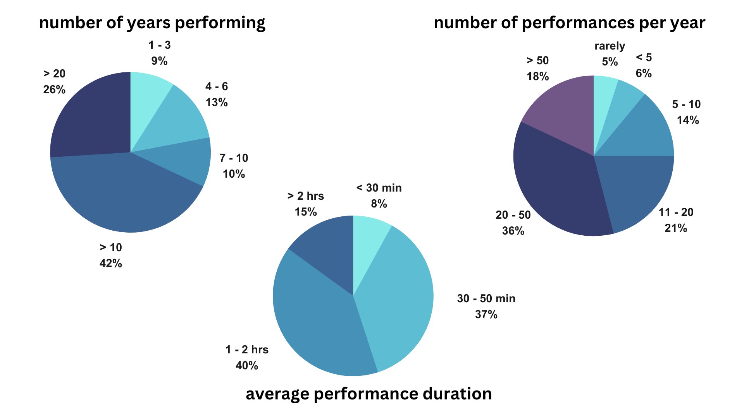If the intent of this study were to generalize, one could look at all of these charts together and assume that most PCGS sing twenty to fifty performances every year, each between thirty minutes and two hours in length, and enjoy decades-long careers. The aim of this study is not to generalize, though, especially given the small convenience sample (CITE).

Taking the interview data into account underscores that each performance career is distinct. One respondent remarked that they are currently in four bands, with duties ranging from cafe jazz gigs to pop background vocals to fronting a punk band where they utilize screaming techniques. Another shared that she sings a lot of “belting your face off musical theater”, and fills her schedule out with festival gigs singing original country music. Another had a professional jazz career while also working as a guest vocalist in Klezmer and Romanian bands. She now sings and produces children’s music.

Self accompanying on piano and/or guitar were commonplace for all seven interviewees, with one also performing regularly on trombone during her sets. This singer credits her formal brass training for her awareness of breath, and though she employs a variety of vocal textures in her jazz, pop, and swing-punk projects, she is an entirely self-taught vocalist. All but one interviewee mentioned touring, either in the US or abroad. One performs one hundred shows per year, between full band club gigs and solo sets. The impacts of touring are important to consider, as one hundred shows spread out over a year would only be two per week, but a tour often requires nightly performances for weeks at a time (cite). Gig singing can also involve specific technology requirements depending on venue, style, and artist preference (cite). 31% of survey participants wear earplugs during performances, and 19% use in-ear monitors. 19% use voice pedals or other live processing effects.

Participants performed in a mean average of six genres throughout their careers, ranging from hip hop to cabaret, country to metal. More than half had performed rock, pop, jazz, indie/alternative, folk/americana, or a combination of these, and around thirty percent are currently performing these same five genres. My positionality as a white musician who has also performed many of these genres influenced these results. (cite something about positionality). Among these varied experiences, a few strong themes emerged with regard to career needs, as outlined in the table below.

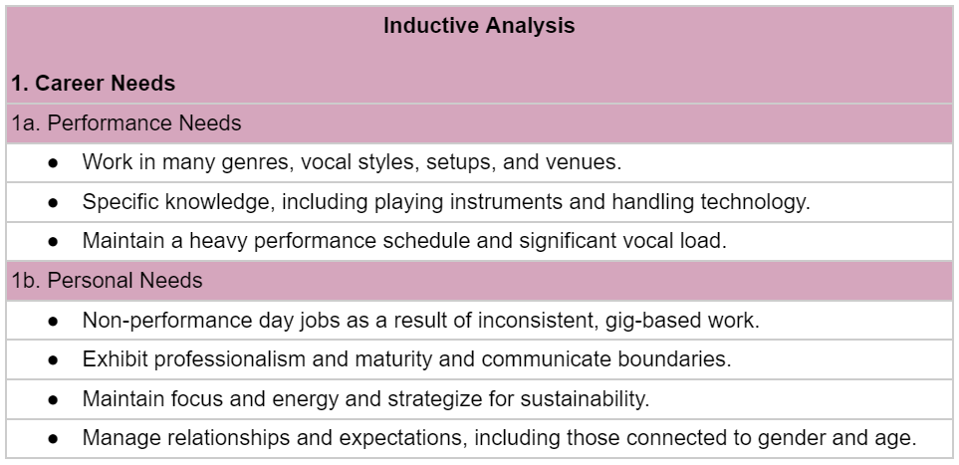
For the thirty-eight participants who are not full time professional vocalists, the need to seek and maintain other income sources impacts their performance availability, both financially and in terms of personal energy. As one remarked:

“It's really difficult to see a future with this career where I won't be needing to spend the majority of my time on something else to actually pay the bills. Which also just sounds exhausting.”

Another put it simply: “money is hard to come by!”. Several participants related the need to set realistic goals and self advocate in order to handle financial, creative, and interpersonal pressures. Three interviewees mentioned setting boundaries in terms of the performance work they take on, reflecting that saying “no” to projects has become both easier and more critical as they age. One reminisced about the intense performance schedules of their past, saying: “life in your twenties, man. I don't feel that way anymore”.

Gender related expectations also impact singers’ relationships with performance (cite?). Two nonbinary interviewees spoke of facing unique social pressures, one working to find a gender affirming vocal range, the other dealing with constant misgendering. Practical and technological issues can also arise. One questionnaire participant mentioned “there are specific monitoring accommodations I need and I am still actively figuring out as a female vocalist whose voice changed through male puberty”.

In an environment of changing career and personal demands, many participants related a need to strategize for sustainability. The unifying themes of resilience and adaptability carried over into discussions about voice training, as well.
CCM Voice Training Goals
When asked about their voice training needs and desires in two short answer questions, every participant said that they would like to improve something about their vocal performance. These responses are presented in the table below, including a tally of how many participants mentioned each topic.
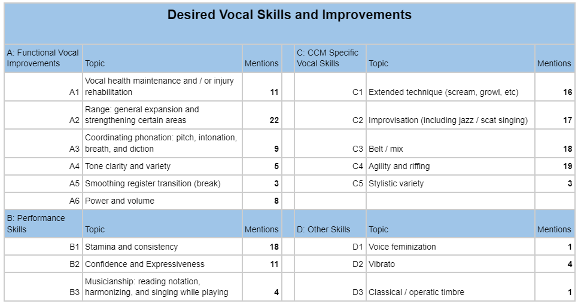

Many of these topics were echoed in interviews, especially musicianship, improvisation, and a variety of functional improvements. Overall, this table illustrates that many working vocalists seek training for highly specialized vocal skills, appropriate training for which may be difficult to access (cite). For instance, a musical theater teacher may be able to give excellent instruction in belting and agility, but may not teach extended techniques, improvisation, or the particular performance skills vital to sustainable gig singing. A teacher solely oriented in Western Classical styles may provide resources for functional vocal improvements, general performance skills, and developing vibrato, but the student would have to look elsewhere for the rest (cite).

Many interviewees mentioned seeking voice training for a short period, rather than on an ongoing basis, to acquire or refine specific skills. Several wanted to work on harmonizing, scat singing, and improvisation, developing the confidence to spontaneously co-create with others. Range had the most mentions in the open questions and was also a strong theme in interviews, with participants seeking more comfort, stability, and volume at lower and higher pitches. Technical proficiency and ease were often regarded as means to artistic ends (cite), as one respondent expressed wanting to “ultimately just feel more secure in all of that so I could enjoy the performance aspect of music more”.

Coaching and accountability surrounding practice was mentioned in several responses, including guidelines and regimens for warming up and healthy voice use. Stamina, consistency, and vocal health maintenance were top concerns, with one singer reflecting: “I don't think I'm doing damage. I don't think I'm doing badly. But I know that it could be better. Finding that balance is really the key”.

Vocal Health
Though it is not the primary topic of this study, vocal health factors impact both performance and voice training. The majority of surveyed singers experience at least one vocal health symptom during or after a performance, with over half reporting vocal fatigue. The next most common symptoms were limited range or control (27%), throat discomfort (24%) and hoarseness (23%). Only 32% reported none of the listed symptoms, and 45% reported that a vocal health concern has prevented them from performing. One respondent had a long history of vocal health issues resulting from a developmental difference in her jaw. She described an “unlivable situation” of recurring laryngitis that ended her full-time career as a jazz singer, and that continues to impede her confidence in vocal practice.

Some singers shared their experiences overcoming acute vocal injuries through voice therapy, vocal health education, and making technique adjustments. (Cite – those who have more education about vocal health are likely to experience fewer problems). Vocal health education is not universally available, however. Half of surveyed singers learned about vocal health from a private teacher. The other sources of this education, including clinicians, college courses, workshops, and knowledgeable peers, were about evenly represented. 24% of surveyed singers reported never learning about vocal health, but 39% described their understanding of vocal health as either fair or limited, indicating that some of these learning experiences were insufficient. The availability of accurate and relevant vocal health education was one of several barriers identified.
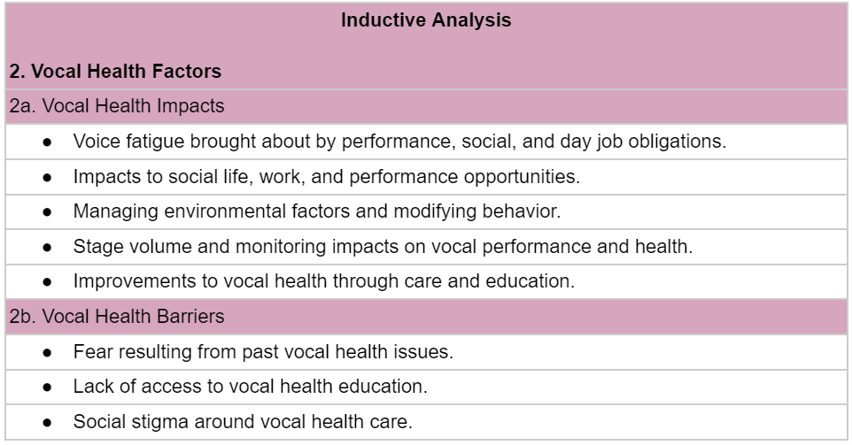
All seven interviewees also listed vocal fatigue as a top concern, with several mentioning the impact of non-performance voice demands, such as working a day job. (cite). Voice care considerations can impact the types of day jobs these singers take on, as well as their social engagement. One mentioned taking marketing and copywriting gigs in the past, saying “I really intentionally spent time not talking a lot”, but has let go of this strategy since becoming a full time voice professor. “I feel like I do nothing but talk all day long. I don't think I've ever talked so much in my life”, she reflected. This increased vocal load has led her to decline auditions, as well as limit her social interactions.

The characteristics of the gig environment also impact vocal health, including loud talking over ambient noise, lack of sleep, and irregular schedules (cite). Some performance cultures have specific challenges, as one interviewee described “the punk world where it's heavy drinking, bodily contact”. Another participant related the struggle of singing in European bars where patrons smoked cigarettes inside, while a third mentioned dusty conditions at days-long camping festivals. Vocal monitoring quality was frequently cited, with several singers expressing frustration with “horrible sound setups… where you can’t hear yourself”, and “using my body as an instrument” among amplified electric instruments. The connection between hearing well and singing healthfully (cite) was understood. The singer who performs one hundred shows per year reflected that “if you're trying to get over the band and you can't really hear what's going on, that's when it's easy to lose focus and do something careless or harmful”.

Asked what they are doing to maintain their vocal health, some responses reflected barriers to adequate education. Two singers shared that their vocal health knowledge has proven insufficient for their current vocal load. Proactively strategizing, or “rearranging my lifestyle around vocal care” was essential for some. Others didn’t have as clear a picture of what they could do differently, as one remarked with a laugh: “my brain is like, drink tea and wear scarves. I know that there's more tactical things than that. I don't really know where to find them”. Another said simply, “all I know, I know from Google”.

The CCM Learning Environment
Participants also gathered voice training from various places. Singers who did not identify as entirely self taught listed an average of three voice training sources. (cite – pop has long been taught as an oral tradition. history of pop exclusion from formal education). Still, group or private lesson experiences in college were second only to private instruction, indicating that some singers without university degrees in performance also benefited from college training.
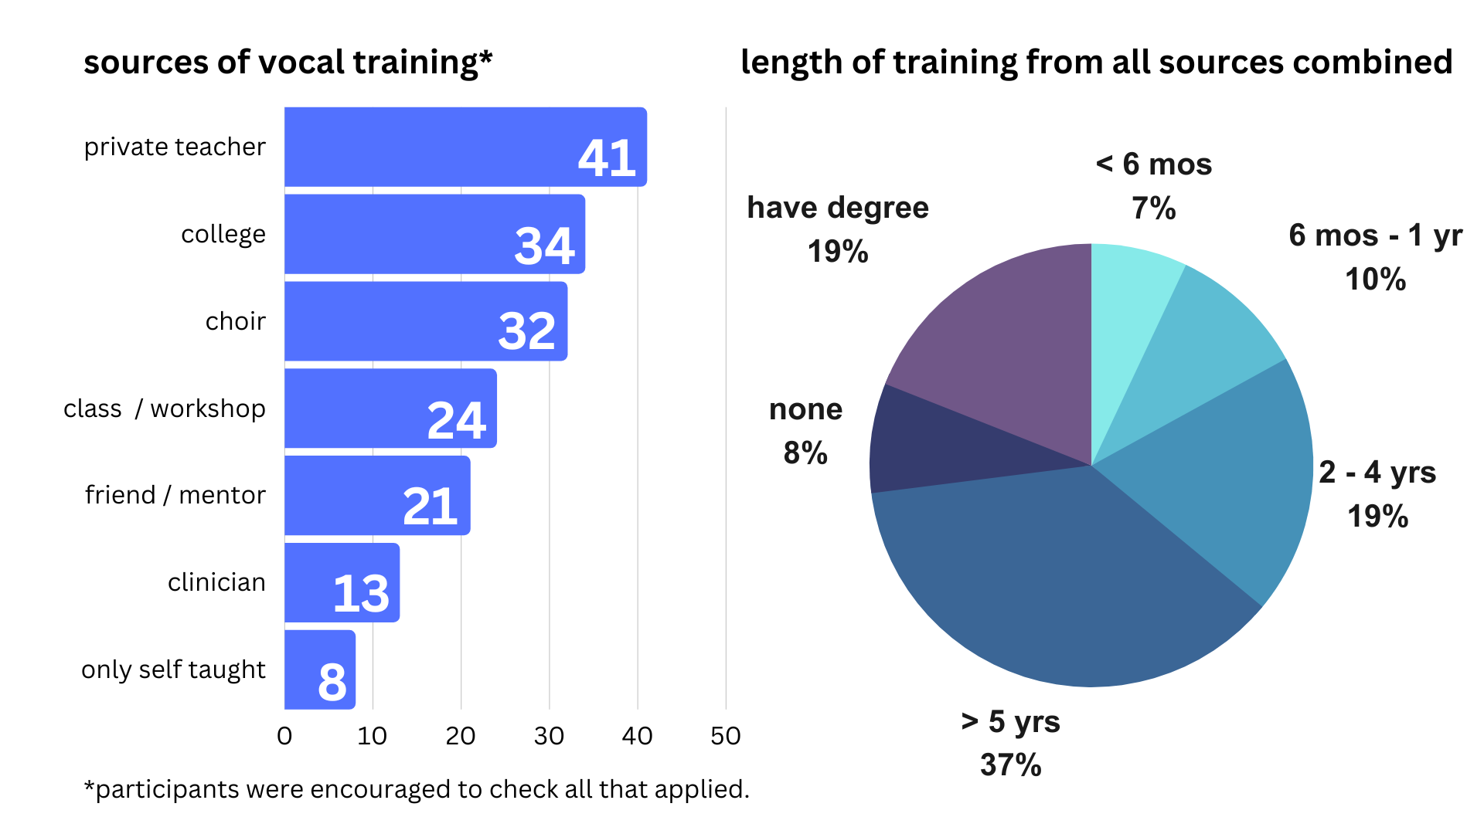
Internet resources were commonly used to replace or supplement formal training, with 69% of singers learning from YouTube, 46% taking an online course (such as those offered through Masterclass), and one third of participants building their skills via social media. Interviews underscored the importance of self directed learning, whether through buying voice textbooks and conducting independent research or by trial and error in practice. While some singers relied on emulation, experimentation, and peer feedback, two singers found success with systematic self teaching methods, using audio recordings as a feedback tool. One self taught singer described “practice… with a microphone helped me to discover parts of my range that I could only access very quietly, and then gradually became stronger and stronger”. For him, finding a sound that felt representative “was really frustrating until it wasn't anymore”.

Two interviewees emphasized a need to follow their curiosity to find useful methods and techniques, one saying “that's absolutely where it feels like the industry is right now, is curiosity led”. The other spoke of setting clear goals and taking the time to gradually understand their voice, and “being open to that being a much longer term process, like for the rest of your life, definitely helps”. Self advocacy and maturity were also themes for singers who were not self taught. All key themes appear in the table below.
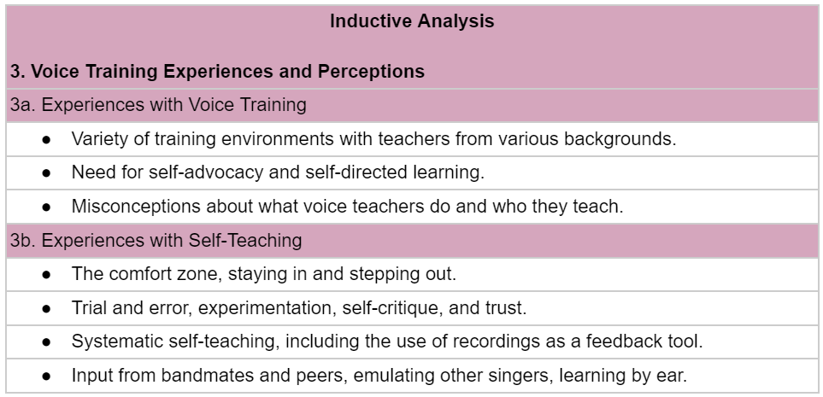
Several singers spoke of “bits and pieces from many sources and a lot of differing opinions”. The woman now working as a full time voice professor gave a detailed review of her formal education. She studied classical and musical theater in undergrad, then earned an MFA in theater performance while studying voice for the actor at a separate studio. She now studies functional voice through an independent workshop, and remarked that new training goals and perspectives were often in conflict with previous training.

Some participants came to voice training later in their careers. For two singers, this was partly due to misconceptions about what voice teachers do and who they work with. “I had the preconception before getting vocal lessons that it was bogus, that your voice is something you either had or didn't have”, one said, having come to voice training after being dissatisfied with her performances in a recording session. The other used to think that voice training was “for people that don't know how to sing”, and now “it's nice to change that perception in my head”. She also remarked that “talking with you is getting me inspired to really look into it more”.

To better understand how participants viewed voice training, both conceptually and in their experience, I asked nine questions using a five point Likert scale.
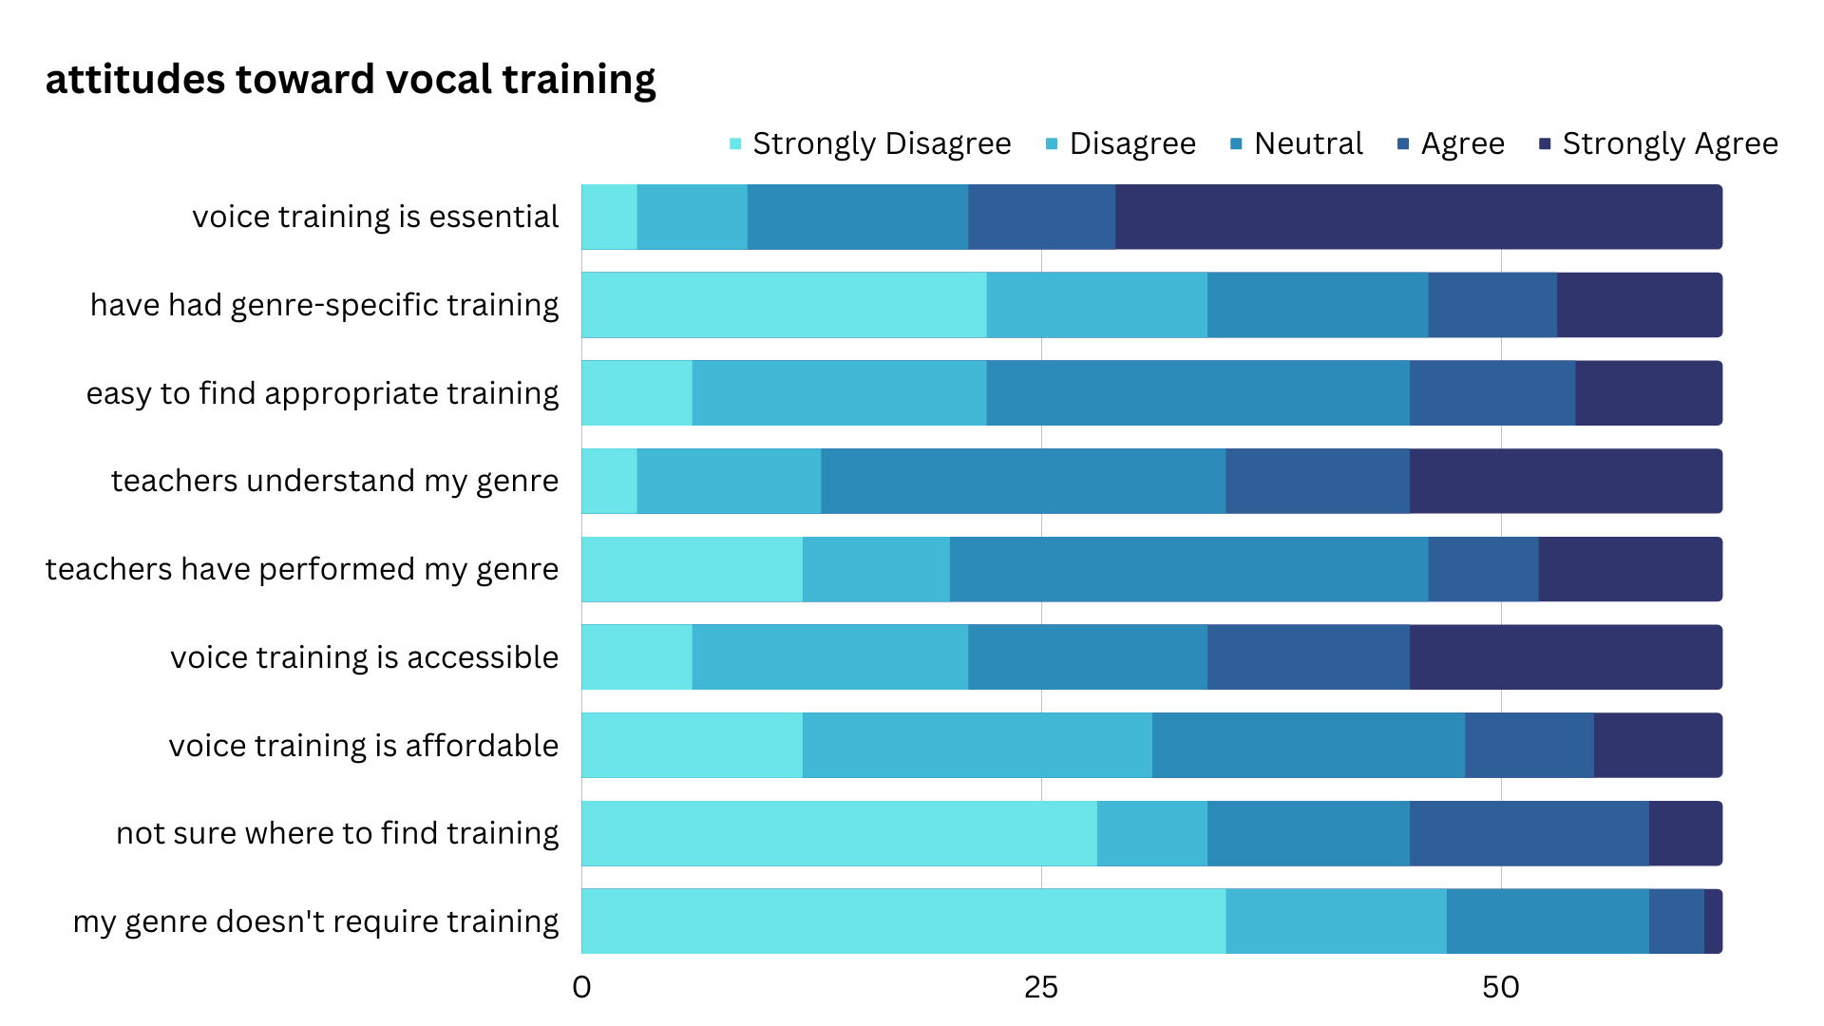
The majority of singers valued their voice training as essential to their current performance career, with an average rating of 4.4. Singers who had training for the style they currently sing were likely to place greater value on their training, and very few singers believe that their genre does not require training.

More than half of singers knew where to find voice training, but the ease of finding appropriate training drew a more neutral response. Singers expressed that teachers and mentors generally understood the genre they sang even if the teacher had never performed that genre, with both questions averaging a rating of 4.
Accessibility was also rated 4 on average, although the majority of singers responded neutrally or negatively on its affordability.

Voice Training Challenges
Though singers are likely to value the vocal training they receive regardless of genre, common frustrations emerged surrounding its accessibility and relevance.
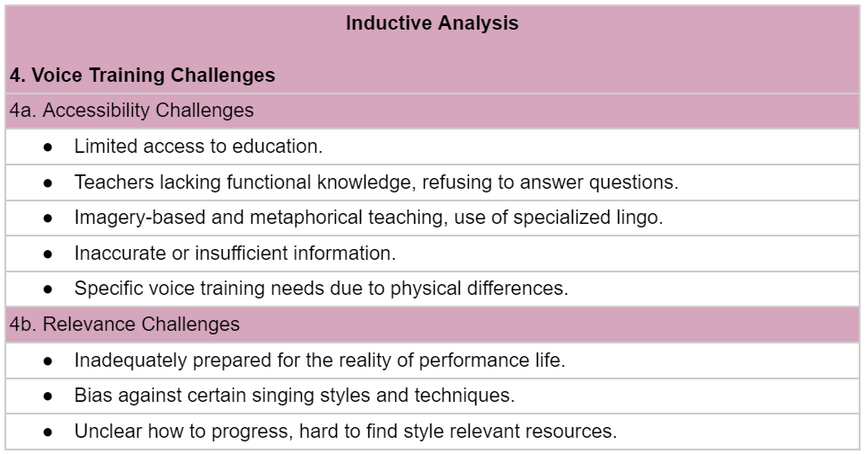
For some, voice training is simply not available where they live. For others, price is prohibitive. One woman spoke of making do with the gender affirming speech training she received as a way to work on her singing voice, and that “there’s not a clear path (affordable/accessible) for finding singing coaches for my specific voice needs”.

Many encountered a lack of understanding about their particular needs, as well as inflexible teaching styles. For the singer with a developmental difference in her jaw, opening tall vowels in her classical training was not an option. “Mostly the response was, well just try harder”, she said, even though that meant causing pain. The message to “just push through it” was echoed by other voice teachers throughout her training. Another classically trained singer spoke about the effects of misinformation. “It was terrifying that I was just going to up and lose my voice one day. It seemed inevitable, because I was working on musical theater, that eventually something bad will happen”. She felt that her progress was stunted by this apprehension.

Several singers expressed confusion about the use of imagery, metaphor, and specialized lingo. When it came to questions about vocal mechanics, one related that “I don't think any of my voice teachers were able to answer those questions. The answer I would get is you don't want to think about that. You can't feel those muscles, anyway, because they're so small.” Another singer, who was self taught until several years into her professional career, shared that “one of the coaches that I worked with would say things like now sing forward, sing backwards, and I didn't really have a concept of what those things meant. The feedback I would get is, you need to learn how to feel these things in your body. You know, just try. Like, figure it out”.

Others spoke of receiving excellent training that was difficult to apply across the spectrum of their singing styles. One singer who holds a university performance degree mentioned taking voice lessons for ten years before finding genre appropriate training for jazz and blues. Another felt that her years of technique “flew out the window” when she started singing pop and country music.

Popular music singers are likely to work in an array of styles and environments, and many feel that their formal education lacked marketplace relevance and inadequately prepared them for a portfolio career (cite). This is partly due to bias against certain styles of music (cite), a sentiment that also arose across these data.

In keeping with my own experiences as a gig singer, these participants seemed deeply curious about voice and proudly resilient. Still, finding the right resources for artistic growth isn’t easy. As one self taught vocalist put it, “there is a huge jump between where I think I am and where all these incredible vocalists are. There must be a middle because people get to the top. So where is the middle? It's just so strange to try to find the path.” In the final interview question, I asked these singers to create their own path.

PCGS In Their Own Words
When asked to design their ideal voice training situation, participants provided more than a wishlist of skills to acquire. The teaching approach and environment were just as important.
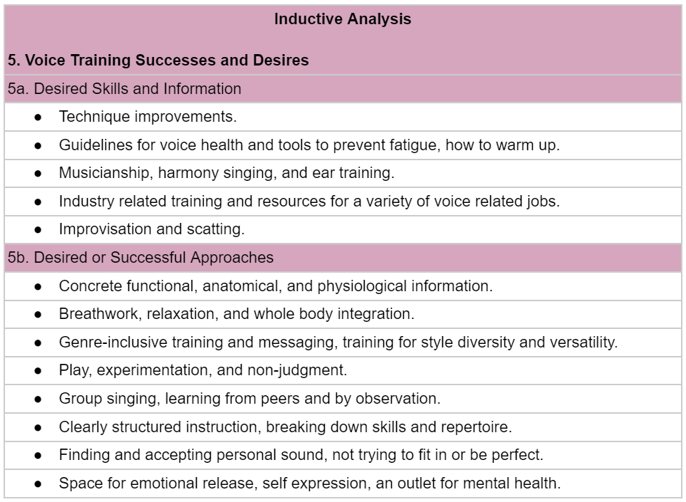
Along with the technique, musicianship, and skill based improvements already discussed, many singers seek guidance on vocal health and sustainability. Industry related resources for different kinds of vocal work were also mentioned, including instruction in session singing, voice acting, and voice teaching.

Versatility was a key theme, which can bolster employability in the music marketplace (cite). Rather than wanting to master a single genre, most respondents expressed wanting to “attack any style and have a pretty rigorous schedule. To have a huge rolodex of skills that I can pull out for any song or any request that pops up”. Others reflected stylistic diversity as a way to develop their personal style. As the punk, jazz, and pop singer put it, “I want to learn a little bit of everything so that I can feel in line with my voice and my throat and how things work. I think that it gives a certain confidence to be able to do so many different things with my voice”. Another mentioned using repertoire from different styles to develop technical skills, such as using “jazz pieces to work on my rhythm and delivery”, or classical pieces to discover new tone qualities. Two participants were inspired by experiences singing non-Western styles of music.
More than half of respondents stressed the importance of functional understanding, one reflecting that physiological knowledge “helped me really see from the inside out what's going on. It stopped being so magic”. By understanding the mechanics of her voice, she was able to “figure out how to continually improve”, and wished this approach had come earlier in her training.

Practical tools based on “concrete descriptions of what is happening with the muscles surrounding the larynx” was part of the picture. Every interviewee regarded whole body integration, whether through cardiovascular exercise, postural awareness, or stretching, as essential to building a productive relationship with their voice, with one noting “there is a direct correlation between how good I feel about my vocal performance and the overall health of my body”.
Specific modalities for breathwork, relaxation, and embodiment were mentioned, including tai chi, qigong, Alexander technique, and yoga. Three respondents also found straw phonation helpful for breathing, but seemed less aware of the functional benefits of semi occluded vocal tract exercises (SOVTEs) (cite).

Popular music styles value individuality rather than a single idealized pop sound (cite). Moving beyond perfectionism was important to respondents, rather than “inhibiting the specific characteristics of their voice” for the sake of singing “correctly”. The need for acceptance extended to musical styles and tastes, as well. The voice professor, who had more years of formal voice training than any other interview participant, imagines inclusive learning environments where “all music is important music, and it deserves to be performed, and there are different tools that can help us”.

Most singers mentioned the importance of experimentation and play for productivity and motivation. “For me that's where the magic has happened, being playful”, one singer related. Another underlined the importance of removing judgment. In order to make progress, “you can't be afraid to get a little weird”. Especially for singers wanting to learn harmony and improvisation, “a little bit of playful interaction with other musicians” was seen as most beneficial. One on one instruction was mentioned a few times, but six out of seven interviewees valued group instruction as part of their continuing voice education.

DISCUSSION
Through the limited scope of this small participant study, a separation between training needs for popular music and musical theater emerges. While belt and mix qualities are used in many popular music styles, the prevalence of belting in CCM training and research is likely due to the inclusion of musical theater under this umbrella term. Eighteen participants had an interest in improving their belt and mix skills, but about the same number of respondents were eager to learn improvisation, riffing, and extended vocal techniques such as distortion. These skills are generally not included in musical theater voice training. The emphasis on tone quality may itself be a remnant of classical voice training priorities, as the development of certain timbres is essential for acoustic forms of singing (cite). According to these 62 pop singers, stamina, range, and maintaining vocal health were more important.

Many singers present with vocal fatigue and other vocal health challenges. Given the frequency of long performances and with 68% of respondents having performed for over a decade, some canceled performances are to be expected. Still, vocal health is a concern, especially considering the environmental and behavioral factors involved in gig singing, and the low reported level of vocal health knowledge.

Participants reported diverse training and performance experiences. Though singers who received genre specific voice training are likely to value it more highly, the majority of singers rated their training as essential to how they currently perform. This is in direct opposition to the attitude that popular music singers will “reject” training that is not genre appropriate (cite). According to these participants, PCGS care deeply about their vocal development, have a strong sense of their needs, and are open minded about trying various approaches to the extent that these opportunities are available. A more relevant concern is affordability, as cost was a barrier for a majority of those surveyed.

Given the opportunity to imagine their ideal voice training situation, no one named a celebrity vocal coach or a prestigious music school. Instead, singers expressed a need for holistic training that respects all genres and all singers. Most singers placed high value on working as part of a group and creating an encouraging, collaborative environment together.

CONCLUSIONS AND RECOMMENDATIONS
As a student researcher undertaking my first participant study, I feel I overdesigned my data collection tools for the size of the project and may have worked from too broad a question. While this report offers a survey view of these singers’ experiences and perceptions, more specific future research with a more diverse sample population would be beneficial. Further research is also needed regarding the performance needs and experiences of transgender and nonbinary vocalists.

I was surprised at how many performers had studied voice in college, either in group classes or individually. Community college courses in vocal function and health would be an affordable option for working singers, and learning the fundamentals of voice production would benefit singers of all styles (cite from Benson). Following the upward trend in popular music representation in music departments across the United States (cite from Powell and Sear), many voice pedagogues are calling for changes and expansions in collegiate voice instruction. Bringing the firsthand wisdom of the popular music marketplace into institutional settings would result in more relevant training goals and teaching approaches.
Connecting with these singers inspired me to investigate new teaching approaches for my private studio, as well. Some of the desired skills, such as extended techniques and jazz improvisation, I perform but have little pedagogical framework for. I plan to design my upcoming independent studies in those two topics. The research process also underscored the importance of collaboration and open communication in creative and educational communities, practices I have continued to build in my performance and professional life.

REFERENCES

Apruzzese, J., Barretta, P.G., and Tompkins, T. (2023) ‘Impact and Hope for the Live Music Industry’, Ethnomusicology Review, 24, pp. 159-179.
Bartlett, I. (2014) ‘Reflections on Contemporary Commercial Singing: an Insider’s Perspective’, Voice and Speech Review, 8(1), pp. 27-35.
Bartlett, I. and Naismith, M.L. (2020) ‘An Investigation of Contemporary Commercial Music (CCM) Voice Pedagogy: A Class of its Own?’, Journal of Singing, 76(3), pp. 273-282.
Bartlett, I. and Wilson, P. H. (2017) ‘Working 9-5: Causal Relationships Between Singers’ “Day Jobs” and Their Performance Work, With Implications for Vocal Health’, Journal of Voice, 31(2), pp. 243.e27-243.e34.
Bell, J. and Waters, S. (2018) Doing Your Research Project: A Guide for First-time Researchers. 7th edn. New York: Open University Press.
Breen, L.J. (2007) ‘The Researcher ‘In the Middle’: Negotiating the Insider/Outsider Dichotomy’, The Australian Community Psychologist, 19(1), pp. 163-174.
Burnard, P., Gill, P., Stewart, K., Treasure, E., and Chadwick, B. (2008) ‘Analysing and Presenting Qualitative Data’, British Dental Journal, 204(8), pp. 429-432.
Cohen, l., Manion, L., and Morrison, K. (2007) Research Methods in Education. 6th edn. New York: Routledge.
Constantinou, C.S., Georgiou, M., and Perdikogianni, M. (2017) ‘A Comparative Method for Themes Saturation (CoMeTS) in Qualitative Interviews’, Qualitative Research, 17(5), pp. 571-588.

Creswell, J.W. (2009) ‘Editorial: Mapping the Field of Mixed Methods Research’, Journal of Mixed Methods Research, 3(2), pp. 95-108.

Denk, J., Burmester, A., Kandziora, M., and Clement, M. (2022) ‘The Impact of Covid-19 on Music Consumption and Music Spending’, PLoS ONE, 17(5), pp. 1-21.
Denscombe, M. (2003) The Good Research Guide for Small-Scale Social Research Projects. 2nd edn. Philadelphia: Open University Press.
Edwards, M., Zito-Edwards, J., and Meyer, D. (2023) ‘The Emerging Future of Collegiate Voice Instruction: Updated SWOT Analysis of Current Practice and Implications for the Next Generation’, Journal of Singing, 76(3), pp. 273-282.
Emerson, R.W. (2021) ‘Convenience Sampling Revisited: Embracing Its Limitations Through Thoughtful Study Design’, Journal of Visual Impairment & Blindness, 115(1), pp. 76-77.

Gill, P., Stewart, K., Treasure, E., and Chadwick, B. (2008) ‘Methods of Data Collection in Qualitative Research: Interviews and Focus Groups’, British Dental Journal, 204(6), pp. 291-295.
Gilman, M., Merati, A.L., Klein, A.M., Hapner, E.R., and Johns, M.M. (2009) ‘Performers’ Attitudes Toward Seeking Health Care for Voice Issues: Understanding the Barriers’, Journal of Voice, 23(2), pp. 225-228.
Guzman, M., Barros, M., Espinoza, F., Herrera, A., Parra, D., Munoz, D., and Lloyd, A. (2013) ‘Laryngoscopic, Acoustic, Perceptual, and Functional Assessment of Voice in Rock Singers’, Folia Phoniatrica et Logopaedica, 65, pp. 248-256.
Heidemann, K. (2016) ‘A System for Describing Vocal Timbre in Popular Song’, Music Theory Online, 22(1), pp. 1-13.
Juntunen, M., Arlin, E.P., and Liira, K. (2023) ‘Expression in Popular Music Singing as Embodied and Interpersonal’, Frontiers in Education, 8, pp. 1-10.
Kaushik, V. and Walsh, C.A. (2019) ‘Pragmatism as a Research Paradigm and Its Implications for Social Work Research’, Social Sciences, 8(255), pp. 1-17.
Maxfield, L. and Ragan, K. (2021) ‘Evidence-Based Voice Pedagogy (EBVP), Part 1: Voice Research Component’, Journal of Singing, 77(4), pp. 543-547.
Merriam, S.B. and Tisdell, E.J. (2016) Qualitative Research A Guide to Design and Implementation. 4th edn. San Francisco: Jossey-Bass.
Mertens, D.M. (2007) ‘Transformative Paradigm: Mixed Methods and Social Justice’, Journal of Mixed Methods Research, 1(3), pp. 212-225.
Morawska, J., Niebudek-Bogusz, E., and Pietruszewska, W. (2022) ‘Considerations and Demands in the Voice Care of Contemporary Commercial Singers in Occupational Health and Safety Aspects’, Medycyna Pracy, 73(1), pp. 33-41.
Morgan, D.L. (2007) ‘Paradigms Lost and Pragmatism Regained: Methodological Implications of Combining Qualitative and Quantitative Methods’, Journal of Mixed Methods Research, 1(1), pp. 48-76.
Meyer, D. and Edwards, M. (2014) ‘The Future of Collegiate Voice Pedagogy: SWOT Analysis of Current Practice and Implications for the Next Generation’, Journal of Singing, 70(4), pp. 437-444.
Pestana, P.M., Vaz-Freitas, S., and Manso, M.C. (2019) ‘Trends in Singing Voice Research: An Innovative Approach’, Journal of Voice, 33(3), pp. 263-268.
Ravall, S. and Simberg, S. (2020) ‘Voice Disorders and Voice Knowledge in Choir Singers’, Journal of Voice, 34(1), pp. 157.e1-157.e8.
Robinson, A.L., Emden, C.G., Croft, T.D., Vosper, G.C., Elder, J.A., Stirling, C., and Vickers, J.C. (2011) ‘Mixed Methods Data Collection in Dementia Research: A “Progressive Engagement” Approach’, Journal of Mixed Methods Research, 5(4), pp. 330-344.
Rooney, T. (2016) ‘The Understanding of Contemporary Vocal Pedagogy and the Teaching Methods of Internationally Acclaimed Vocal Coaches’, International Journal of Learning, Teaching and Educational Research, 15(10), pp. 147-162.
Rotsides, J., Chen, S., Winchester, A., Amin, M.R., and Johnson, A.M. (2021) ‘Laryngeal Pathologies Associated with the Genre of Singing and Professional Singing Status in a Treatment-Seeking Population’, The Laryngoscope, 131, pp. 2076-2080.
Sear, J. (2023) ‘Modern Vocal Pedagogy: Investigating a Potential Curricular Framework for Training Popular Music Singing Teachers’, Journal of Popular Music Education, online first, https://doi.org/10.1386/jpme_00105_1
Sielska-Badurek, E.M., Sobol, M., Olszowska, K., and Niemczyk, K. (2018) ‘Contemporary Commercial Music Singing Students – Voice Quality and Vocal Function at the Beginning of Singing Training’, Journal of Voice, 32(6), pp. 668-672.
Sundberg, J. and Thalen, M. (2010) ‘What is “Twang”?’, Journal of Voice, 24(6), pp. 654-660.
Sundberg, J. and Thalen, M. (2015) ‘Respiratory and Acoustical Differences Between Belt and Neutral Style of Singing’, Journal of Voice, 29(4), pp. 418-425.
Titze, I.R. (2022) ‘The Acoustic Characteristics of Vocal Twang’, Journal of Singing, 78(5), pp. 613-614.
Traser, L., Ozen, A.C., Burk, F., Burdumy, M., Bock, M., Richter, B., and Echternach, M. (2016) ‘Respiratory dynamics in phonation and breathing – a real-time MRI study’, Respiratory Physiology and Neurobiology, 236, pp. 69-77.
Turner, G. and Kenny, D.T. (2011) ‘Restraint of body movement potentially reduces peak SPL in western contemporary popular singing’, Musicae Scientiae, 16(3), pp. 357-371.
Wilson, L.C. (2021) ‘Bel Canto to Punk and Back: Lessons for the Vocal Cross-Training Singer and Teacher’, Voice and Speech Review, 15(3), pp. 330-341.
Zuim, A.F., Lloyd, A.T., Gerhard, J., Rosow, D. and Lundy, D. (2021) ‘Associations of Education and Training with Perceived Singing Voice Function Among Professional Singers’, Journal of Voice, 35(3), pp. 500.e17-500.e24.

APPENDIX 1: Informed Consent Form and Questionnaire

Vocal training experiences and
perceptions among adult Professional Contemporary Gig Singers (PCGS).
INFORMED CONSENT
You are invited to participate in a research study about the performance lives of gigging contemporary vocalists, and those performers’ experiences with formal and informal voice training. This survey is voluntary and there are no negative consequences for declining to complete it. Once you start the survey you can change your mind and stop at any time. To participate in this study you must be at least 18 years of age and perform primarily in the United States. This survey will take five to ten minutes to complete.
You do not need to be a full-time professional performer to participate. Semi-professional and gigging amateur singers are also invited to participate.
This questionnaire will ask questions about your experiences with vocal performance, training, and health. It includes questions about your educational and vocal health history. There is no compensation for participation. Though participating in this study may not benefit you directly, your response will help me learn about and communicate the diversity of working singers’ experiences, and may ultimately result in improved training for contemporary vocalists. At the end of the survey you will have the option to volunteer for a brief follow-up interview by providing your name and email address. If you do not wish to participate in an interview, your response will remain anonymous.
Confidentiality and Data Security
The principal researcher (May Oskan) is the only person who will have access to the data you provide. All data will be stored securely and will be deleted upon the completion of this project (July 6th, 2023). Your data won’t be used or shared for any future research studies. If your responses are shared in publications or presentations, results will be de-identified.
This study is being conducted by May Oskan, graduate student researcher in voice pedagogy at Voice Study Centre, University of Wales Trinity Saint David.
If you have questions about the research, complaints, or problems, please contact May Oskan at mvoskan@gmail.com
If you have questions about your rights as a research participant, complaints, or problems, please contact UWTSD Research Ethics Committee Representative Louise Emanuel at L.Emanuel@uwtsd.ac.uk

Please give your informed consent by answering the question below.
* Indicates required question

Do you wish to participate? *
Yes Skip to question 2 (Research Questionnaire)
No Skip to section 2 (Participation Declined)
Research Questionnaire
Section 1: Vocal Performance
- How old are you now? *
Under 25
26 - 35
36 - 45
46 - 55
Over 55

- What is your gender? *
Female
Male
Nonbinary / Gender Expansive
Would rather not say
Other:

- According to the definitions provided below, are you a professional, semi-professional, or gigging amateur vocalist? *
I am a professional vocalist: performing is a primary or significant source of income.
I am a semi-professional vocalist: performing is a supplemental source of income.
I am a gigging amateur vocalist: performing is an occasional source of income.

- At what age did you begin performing as a professional, semi-professional,
or gigging amateur vocalist? *
Under 25
26 - 35
36 - 45
46 - 55
Over 55

- For how many years have you performed as a professional,
semi-professional, or gigging amateur vocalist? *
Less than a year
1 - 3 years
4 - 6 years
7 - 10 years
More than 10 years
More than 20 years

- How many performances do you sing per year? *
I am primarily a recording artist and rarely perform live
Fewer than 5
5 - 10
11 - 20
Between 20 and 50
More than 50

- What is the average duration of your performances? *
Less than 30 minutes
30 minutes - 50 minutes
1 - 2 hours
More than 2 hours

- How much of the time do you perform as a lead or backup vocalist? *
I am always a lead vocalist
I mostly sing lead, and sometimes sing backup
I sing lead and backup about half of the time
I mostly sing backup, and sometimes sing lead
I am always a backup vocalist

- In performance, how often do you play an instrument while singing? *
Always
Often
Sometimes
Rarely
I play an instrument in performance, but not while singing
I never perform on an instrument

- In performance, do you use any of the following? (check all that apply): *
Earplugs
In-ear monitors
Vocal pedals or other electronic vocal processing effects
None of these

- What genres have you performed? (check all that apply): *
Pop
Rock
Hard Rock or Metal
Indie / Alternative
Rap / Hip Hop
Cabaret
Jazz
Folk / Americana
Gospel
Soul / Blues
Country
World Music
Electronic / Dance
Non-Classical Group Singing (i.e. Barbershop, A Capella)
Other (please specify)

- What genres do you currently perform most often? (check up to two): *
Pop
Rock
Hard Rock or Metal
Indie / Alternative
Rap / Hip Hop
Cabaret
Jazz
Folk / Americana
Gospel
Soul / Blues
Country
World Music
Electronic / Dance
Non-Classical Group Singing (i.e. Barbershop, A Capella)
Other (please specify)

- In what region of the United States are you based? *
West Coast (WA, OR, CA)
Southwest (NV, AZ, NM, TX)
Rocky Mountains (ID, MT, WY, UT, CO)
Great Plains (ND, SD, NE, KS, OK)
Midwest (MN, IA, MO, WI, IL, MI, IN, OH)
South (AR, LA, KY, TN, MS, AL, GA, FL, WV, VA, NC, SC)
Mid-Atlantic (NY, PA, NJ, DE, MD, D.C.)
New England (ME, VT, NH, MA, RI, CT)
Alaska
Hawaii
- What types of engagements have you performed? (check all that apply): *
Local: in my home city or town, or the immediate surrounding area.
Regional: in my home region (as designated above).
National: outside of my home region (as designated above).
International: in other countries.

- Is there anything you would like to improve about your vocal ability? (for example: expanded range, increased power or stamina, more expressiveness, etc.) *
- Are there specific vocal skills, techniques, or effects that you would like to learn? (for example: belting, riffing, screaming, improvisation, etc.) *
- Is there anything else you would like to share about your experiences with vocal performance?
Section 2: Vocal Training
- Have you received vocal training from any of the following sources, even for a short time? (check all that apply): *
College or university (group class or private lessons)
Class or workshop not affiliated with a college or university
Private voice teacher or vocal performance coach
Choir or ensemble director
Clinician or medical professional (speech-language pathologist, voice therapist, etc)
Knowledgeable friend, family member, mentor, or colleague
None, I am entirely self taught
- From all of the above sources combined, how long have you studied voice? *
Fewer than 6 months
6 months to 1 year
2 - 4 years
5 years or more
None - I am entirely self taught
I have a University degree in vocal performance

- Have you used any of the following resources to improve your vocal technique? (check all that apply):
Online course (MasterClass or similar)
YouTube
Social media (TikTok, Instagram, etc.)
Other (please describe)

Please rate the following statements on a scale from 1 to 5, with 1 representing “strongly disagree” and 5 representing “strongly agree”.

21. Voice training has been essential to the development of my current vocal technique. *

22. I have had specific voice training for the genre I currently sing. *

23. It is easy to find an appropriate voice class, voice teacher, or mentor to learn from. *
24. My voice teachers or mentors understand the genre of singing I perform.

25. My voice teachers or mentors have experience performing the genre of singing I perform.

26. Voice training is accessible for a vocalist like me. *

27. Voice training is affordable for a vocalist like me. *
28. I would like to improve my vocal technique, but I don’t know where to go. *
29. The genre or style of singing I perform does not require vocal training. *

30. Is there anything else you would like to share about your experiences with voice training?
Section 3: Vocal Health
- During or after a vocal performance, do you experience any of the following? (check all that apply): *
Vocal fatigue
Hoarseness
Limited vocal range or control
Throat discomfort, soreness, or pain
Loss of voice
None of these
Other (please describe)

- Has a vocal health concern ever prevented you from performing? *
Yes
No

- Have you received education about vocal health? *
Yes, as part of my vocal training in a college or university.
Yes, from a class or workshop not affiliated with a college or university.
Yes, from a private voice teacher or vocal performance coach.
Yes, from a clinician or medical professional (doctor, nurse, ENT, SLP, or laryngologist)
Yes, from a knowledgeable friend, mentor, or colleague.
No, I have never learned about vocal health.

- How would you describe your understanding of vocal health? *
Excellent
Good
Fair
Limited
- Is there anything else you would like to share about your experiences with vocal health?
- Would you like to participate in a brief followup interview? *
Yes
No
- If yes, please provide your name and email address below.

Thank you for taking the time to answer this questionnaire! Feel free to share the questionnaire link with other vocalists who might be interested in participating.

APPENDIX 2: Ethics Form and Permissions Letter
APPLICATION FOR ETHICAL APPROVAL

In order for research to result in benefit and minimise risk of harm, it must be conducted ethically. A researcher may not be covered by the University’s insurance if ethical approval has not been obtained prior to commencement.

The University follows the OECD Frascati manual definition of research activity: “creative work undertaken on a systematic basis in order to increase the stock of knowledge, including knowledge of man, culture and society, and the use of this stock of knowledge to devise new applications”. As such this covers activities undertaken by members of staff, postgraduate research students, and both taught postgraduate and undergraduate students working on dissertations/projects.

The individual undertaking the research activity is known as the “principal researcher”.

Ethical approval is not required for routine audits, performance reviews, quality assurance studies, testing within normal educational requirements, and literary or artistic criticism.

Please read the notes for guidance before completing ALL sections of the form.

This form must be completed and approved prior to undertaking any research activity. Please see Checklist for details of process for different categories of application.

Delete the Guidance Notes at the end of the form BEFORE submitting your application

SECTION A: About You (Principal Researcher)
1 | Full Name: |  | May Virginia Oskan
2 | Tick all boxes which apply: |  | Member of staff: | ☐ | Honorary research fellow: | ☐
3 | Undergraduate Student | ☐ | Taught Postgraduate Student | ☒ | Postgraduate Research Student | ☐

4 | Institute/Academic Discipline/Centre: | WAPPAR
5 | Campus: | Carmarthen
6 | E-mail address: | mvoskan@gmail.com
7 | Contact Telephone Number: | 1 (508) 360-5456
 | For students:
8 | Student Number: | 2129248
9 | Programme of Study: | MA in Professional Practice (Voice Pedagogy)
10 | Director of Studies/Supervisor: | Nick Samuel

SECTION B: Approval for Research Activity
1 | Has the research activity received approval in principle?  (please check the Guidance Notes as to the appropriate approval process for different levels of research by different categories of individual) |  | YES | ☒ | NO | ☐
 |  |  |  |  | Date
2 | If Yes, please indicate source of approval (and date where known): Approval in principle must be obtained from the relevant source prior to seeking ethical approval | Research Degrees Committee |  | ☐
3 |  | Institute Research Committee |  | ☐
4 |  | Other (write in)  WAPPAR Ethics Board Representative |  | ☒
SECTION C: Internal and External Ethical Guidance Materials
 | Please list the core ethical guidance documents that have been referred to during the completion of this form (including any discipline-specific codes of research ethics, and also any specific ethical guidance relating to the proposed methodology). Please tick to confirm that your research proposal adheres to these codes and guidelines.
1 | UWTSD Research Ethics & Integrity Code of Practice | ☒
2 | UWTSD Research Data Management Policy | ☒
3 | The California Consumer Privacy Act (CCPA) and the California Privacy Rights Act (CPRA) | ☒

SECTION D: External Collaborative Research Activity
1 | Does the research activity involve collaborators outside of the University? |  | YES | ☐ | NO | ☒
2 | If Yes, please provide the name of the external organisation and name and contact details for the main contact person and confirmation this person has consented to their personal data being shared.as part of this collaboration.
3 | Institution
4 | Contact person name
5 | Contact person e-mail address
6 | Has this individual consented to sharing their details on this form? |  | YES | ☐ | NO |  |  | ☐
7 | Are you in receipt of a KESS scholarship? |  | YES | ☐ | NO |  |  | ☐
8 | Is your research externally funded |  | YES | ☐ | NO |  |  | ☐
9 | Are you specifically employed to undertake this research in either a paid or voluntary capacity? | Voluntary | YES | ☐ | NO |  | ☐
10 |  | Employed | YES | ☐ | NO |  | ☐
11 | Is the research being undertaken within an existing UWTSD Athrofa Professional Learning Partnership (APLP) | If YES then the permission question below does not need to be answered. | YES | ☐ | NO |  |  | ☐
12 | Permission to undertake the research has been provided by the partner organisation | (If YES attach copy)  If NO the application cannot continue | YES | ☐ | NO |  |  | ☐

Where research activity is carried out in collaboration with an external organisation
13 | Does this organisation have its own ethics approval system? | YES | ☐ | NO | ☐
14 | If Yes, please attach a copy of any final approval (or interim approval) from the organisation

SECTION E: Details of Research Activity
1 | Indicative title: | Vocal training experiences and perceptions among adult professional and semi professional singers performing Contemporary Commercial Music styles.
2 | Proposed start date: | March 20, 2023 | Proposed end date: | July 6, 2023
3 | Introduction to the Research (maximum 300 words)  Ensure that you write for a Non-Specialist Audience when outlining your response to the three points below:  - Purpose of Research Activity  - Proposed Research Question  - Aims of Research Activity  - Objectives of Research Activity  Demonstrate, briefly, how Existing Research has informed the proposed activity and explain  - What the research activity will add to the body of knowledge  - How it addresses an area of importance.
4 | Purpose of Research Activity  The purpose of this project is to explore the vocal training experiences of Contemporary Commercial Music (CCM) singers from the performers’ own perspectives, as well as their perceptions of the need for and availability of genre relevant voice training. Research pertaining to singers of CCM styles is usually limited to Musical Theater singers or university students, whose work environments and performance demands differ from those of gigging CCM singers. I intend to consider the perspectives of performers from a variety of vocal training backgrounds, including self taught singers and singers who have training in genres they do not perform.
5 | Research Question  What experiences do singers of Contemporary Commercial Music have with vocal training? How do these performers perceive the efficacy, accessibility, and style relevance of vocal training?
6 | Aims of Research Activity  - To include gigging CCM singers in voice pedagogy literature.  - To inform and inspire future research about this population, toward the improvement of the quality, accessibility, and relevance of CCM vocal training.  - To start conversations about functional, genre inclusive voice training in CCM performance communities, as singers may not be aware that this kind of training is available.  - To increase my understanding of the needs of working CCM singers in various genres, and to identify opportunities for growth and improvement in my private teaching approach.  - To inform my future study in developing a genre inclusive functional voice curriculum.
7 | Objectives of Research Activity  - To consolidate existing literature on the priorities of CCM vocal training.  - To collect questionnaire responses from singers from a variety of performance and voice training backgrounds.  - To compare the priorities of CCM pedagogy to the priorities of performers currently working in the CCM performance marketplace.  - To explore the perceptions of gigging CCM singers with regards to vocal training relevance and accessibility.  - To invite further reflection through semi-structured interviews with performers.
8 | Proposed methods (maximum 600 words)  Provide a brief summary of all the methods that may be used in the research activity, making it clear what specific techniques may be used. If methods other than those listed in this section are deemed appropriate later, additional ethical approval for those methods will be needed.
9 | I am a performer and private voice teacher of CCM styles. As such, this research process has the potential to impact my teaching and performance practices, and my evolving practice may also influence how I relate to the study results. For this reason I am assuming a pragmatist perspective, which views the creation of knowledge as “an active process of inquiry that creates a continual back-and-forth movement between beliefs and actions” (Morgan, 2014: 1049). By using a grounded theory methodology my study will remain dynamic and reflexive, allowing additional points of focus and lines of inquiry to emerge from the results.  - Literature Review - Including existing literature about the performance, training, and vocal health experiences of CCM performers, CCM vocal training objectives, and related research reporting the various outcomes of vocal training in general.  - Questionnaire - All participants will be asked to provide numeric and ordinal data regarding their vocal training and performance experience. They may also provide narrative data explaining their experiences in more detail, including their reflections on the efficacy, relevance, and benefits of vocal training they have received. Participants who have received no formal vocal training will be welcome to share their thoughts on the accessibility, affordability, and relevance of vocal training.  - Semi-Structured Interview - A selected group of respondents who indicated a willingness to do so will participate in a followup interview. Participants will be welcome to provide additional narrative data about their experiences with and perceptions of vocal training.  - Reflective Journal - The primary researcher’s notes about the research process and responses will be included in the final report.  - Observation - I may observe performances or practice sessions, either in person or on video, to gain a greater understanding of participants’ experiences as working vocalists. These observations will potentially result in additional reflective journal entries or interviews.  Morgan, D.L. (2014) ‘Pragmatism as a Paradigm for Social Research,’ Qualitative Inquiry, 20(8), pp. 1045-1053.

10 | Location of research activity  Identify all locations where research activity will take place.
11 | Questionnaires will be distributed electronically to participants in the United States. Interviews and observations will take place in the United States.
12 | Research activity outside of the UK  If research activity will take place overseas, you are responsible for ensuring that local ethical considerations are complied with and that the relevant permissions are sought. Specify any local guidelines (e.g. from local professional associations/learned societies/universities) that exist and whether these involve any ethical stipulations beyond those usual in the UK (provide details of any licenses or permissions required). Also specify whether there are any specific ethical issues raised by the local context in which the research activity is taking place, for example, particular cultural and/or legal sensitivities or vulnerabilities of participants.
13 | As all of my research activity will take place within the United States, I will abide by the Federal Policy for the Protection of Human Subjects, as set forth by the United States Department of Health and Human Services. I will also abide by the codes of ethics of the two professional associations of which I am a member, the National Association of Teachers of Singing and the Pan American Vocology Association.

14 | Use of documentation not in the public domain: Are any documents NOT publicly available? | NO | ☒
14 |  | YES | ☐
15 | If Yes, please provide details here of how you will gain access to specific documentation that is not in the public domain and that this is in accordance with prevailing data protection law of the country in question and England and Wales.  N/A

SECTION F: Scope of Research Activity
1 | Will the research activity include: | YES | NO
2 | Use of a questionnaire or similar research instrument? | ☒ | ☐
3 | Use of interviews? | ☒ | ☐
4 | Use of diaries? | ☒ | ☐
5 | Participant observation with their knowledge? | ☒ | ☐
6 | Participant observation without their knowledge? | ☐ | ☒
7 | Use of video or audio recording? | ☒ | ☐
8 | Access to personal or confidential information without the participants’ specific consent? | ☐ | ☒
9 | Administration of any questions, test stimuli, presentation that may be experienced as physically, mentally or emotionally harmful / offensive? | ☐ | ☒
10 | Performance of any acts which may cause embarrassment or affect self-esteem? | ☐ | ☒
11 | Investigation of participants involved in illegal activities? | ☐ | ☒
12 | Use of procedures that involve deception? | ☐ | ☒
13 | Administration of any substance, agent or placebo? | ☐ | ☒
14 | Working with live vertebrate animals? | ☐ | ☒
15 | Other primary data collection methods, please explain in this box  For example, ‘focus groups’. Please indicate the type of data collection method(s) in this box and tick the accompanying box. | ☐ | ☒
16 | Details of any other primary data collection method: | ☐ | ☒
If NO to every question, then the research activity is (ethically) low risk and may be exempt from some of the following sections (please refer to Guidance Notes).

If YES to any question, then no research activity should be undertaken until full ethical approval has been obtained.

SECTION G: Intended Participants
1 | Who are the intended participants: | YES | NO
2 | Students or staff at the University? | ☐ | ☒
3 | Adults (over the age of 18 and competent to give consent)? | ☒ | ☐
4 | Vulnerable adults? | ☐ | ☒
5 | Children and Young People under the age of 18? (Consent from Parent, Carer or Guardian will be required) | ☐ | ☒
6 | Prisoners? | ☐ | ☒
7 | Young offenders? | ☐ | ☒
8 | Those who could be considered to have a particularly dependent relationship with the investigator or a gatekeeper? | ☐ | ☒
9 | People engaged in illegal activities? | ☐ | ☒
10 | Others (please identify specifically any group who may be unable to give consent) please indicate here and tick the appropriate box. | ☐ | ☒
11 | Other – please indicate here: | ☐ | ☒

12 | Participant numbers and source  Provide an estimate of the expected number of participants. How will you identify participants and how will they be recruited?
13 | How many participants are expected? | 25 - 50 questionnaire participants.  Approximately 5 interview participants.  1 - 5 observation participants, as opportunities arise.
14 | Who will the participants be? | Professional, semi professional, and gigging amateur vocal performers working in the Contemporary Commercial Music marketplace.
15 | How will you identify the participants? | I will distribute questionnaires electronically to performers in my extended network, including singers I know personally and singers with whom I am familiar through performances and social media.  I will also use snowball sampling, asking each respondent to pass the survey to at least two others. I will use the taxonomy developed by Meribeth Bunch and Janice Chapman to determine participant eligibility, according to performance style and type.  I will ask in the questionnaire whether respondents are willing to participate in a followup interview, and from those who are willing I will select a small group of interviewees with diverse vocal training and performance experiences.

16 | Information for participants: | YES | NO | N/A
17 | Will you describe the main research procedures to participants in advance, so that they are informed about what to expect? | ☒ | ☐ | ☐
18 | Will you tell participants that their participation is voluntary? | ☒ | ☐ | ☐
19 | Will you obtain written consent for participation? | ☒ | ☐ | ☐
20 | Will you explain to participants that refusal to participate in the research will not affect their treatment or education (if relevant)? | ☒ | ☐ | ☐
21 | If the research is observational, will you ask participants for their consent to being observed? | ☒ | ☐ | ☐
22 | Will you tell participants that they may withdraw from the research at any time and for any reason? | ☒ | ☐ | ☐
23 | With questionnaires, will you give participants the option of omitting questions they do not want to answer? | ☒ | ☐ | ☐
24 | Will you tell participants that their data will be treated with full confidentiality and that, if published, it will not be identifiable as theirs? | ☒ | ☐ | ☐
25 | Will you debrief participants at the end of their participation, in a way appropriate to the type of research undertaken? | ☒ | ☐ | ☐
26 | If NO to any of above questions, please give an explanation
27 | N/A

28 | Information for participants: | YES | NO | N/A
29 | Will participants be paid? | ☐ | ☒ | ☐
30 | Is specialist electrical or other equipment to be used with participants? | ☒ | ☐ | ☐
31 | Are there any financial or other interests to the investigator or University arising from this study? | ☐ | ☒ | ☐
32 | Will the research activity involve deliberately misleading participants in any way, or the partial or full concealment of the specific study aims? | ☐ | ☒ | ☐
33 | If YES to any question, please provide full details
34 | I will use voice recorders, cameras, and recordings of online video meeting sessions to conduct my interviews and observations. I will transcribe audio and video recordings to text as necessary in the process of building my report.

SECTION H: Anticipated Risks
1 | Outline any anticipated risks that may adversely affect any of the participants, the researchers and/or the University, and the steps that will be taken to address them.  If you have completed a full risk assessment (for example as required by a laboratory, or external research collaborator) you may append that to this form.
2 | Full risk assessment completed and appended? |  | Yes | ☐
2 |  |  | No | ☒
3 | Risks to participants  For example: emotional distress, financial disclosure, physical harm, transfer of personal data, sensitive organisational information
4 | Risk to Participant:  There is a risk of the disclosure of personal data, as interviews and performances will be recorded in audio and/or video formats. Transcriptions of these recordings will also be made.  There is a risk of personal discomfort at recalling previous experiences with vocal training. There is a risk of embarrassment or emotional distress as participants relate their history of access to vocal training, especially if they feel their access has been hindered for cultural, racial, financial, or other sensitive reasons. In addition, respondents who are familiar with me and my work may feel nervous participating in an interview, or feel pressure to answer questions in a certain way.  Because of the open ended question formats used, participants may accidentally divulge more personal information than they intended to share. | How will you mitigate the Risk to Participant:  Identifying participant information will be coded to protect confidentiality, and all data will be stored in password protected files. Data, including audio and video recordings, will be destroyed once the project is complete.  All questions will be optional, and a participant’s refusal to share potentially emotional information will not preclude their participation in the study. Respondents may share in as much or as little detail as they wish. If participants are more comfortable conducting the interview through a different medium, for example over the phone instead of via video call, I will accommodate reasonable requests for the purpose of prioritising their comfort.  Responses will remain anonymous unless the participant volunteers for a followup interview. In accordance with the DPA2018, CCPA and CPRA, respondents may request to have their responses deleted at any time before the study is complete.
5 | If research activity may include sensitive, embarrassing or upsetting topics (e.g. sexual activity, drug use) or issues likely to disclose information requiring further action (e.g. criminal activity), give details of the procedures to deal with these issues, including any support/advice (e.g. helpline numbers) to be offered to participants. Note that where applicable, consent procedures should make it clear that if something potentially or actually illegal is discovered in the course of a project, it may need to be disclosed to the proper authorities
 | N/A
6 | Risks to investigator  For example: personal safety, physical harm, emotional distress, risk of accusation of harm/impropriety, conflict of interest
 | Risk to Investigator:  There may be a risk of emotional distress as participants share their performance history and experiences with vocal training.  There is also a risk of conflict of interest and/or professional awkwardness, as some of the respondents will know me personally or know of me through professional circles, either as a CCM performer or as a voice teacher.  There is a risk of not getting enough participants to complete the questionnaire. | How will you mitigate the Risk to Investigator:  I acknowledge the risk of emotional discomfort, and will seek appropriate support as needed.  I will minimise this risk by using snowball sampling and reaching out to performers with whom I am not personally acquainted. I will also select interview participants with appropriate professional distance and the challenge of dual roles in mind.  I will minimise the time commitment required for participation by keeping the questionnaire succinct. If I don’t have enough questionnaire responses to draw meaningful conclusions, I will rely more heavily on interview material.
7 | University/institutional risks  For example: adverse publicity, financial loss, data protection
 | Risk to University:  The risk to the University is data protection. | How will you mitigate the Risk to University:  All data will be coded and stored under password protection to safeguard confidentiality. Data will be destroyed once the project is complete.

8 | Disclosure and Barring Service
9 | If the research activity involves children or vulnerable adults, a Disclosure and Barring Service (DBS) certificate must be obtained before any contact with such participants. | YES | NO | N/A
10 | Does your research require you to hold a current DBS Certificate? | ☐ | ☐ | ☒

SECTION I: Feedback, Consent and Confidentiality
1 | Feedback  What de-briefing and feedback will be provided to participants, how will this be done and when?
 | I will provide a project specific email address to participants at the end of the questionnaire so that they may contact me for further details or to discuss the results of the study. I will also offer participants a copy of the final report if they express an interest in reading it.
2 | Informed consent  Describe the arrangements to inform potential participants, before providing consent, of what is involved in participating. Describe the arrangements for participants to provide full consent before data collection begins. If gaining consent in this way is inappropriate, explain how consent will be obtained and recorded in accordance with prevailing data protection legislation.
 | Questionnaires will be distributed electronically, using either Survey Monkey or Google Forms. A full explanation of what will be involved in participating will appear on the first page, which will also act as a consent form. Participants will be informed that by clicking through to the questionnaire, they are providing consent.
3 | Confidentiality / Anonymity  Set out how anonymity of participants and confidentiality will be ensured in any outputs. If anonymity is not being offered, explain why this is the case.
 | Questionnaire responses will be anonymous. If the respondent indicates that they are interested in participating in a followup interview, there will be space to provide their name and email address for this purpose only. The names and email addresses of interview participants will be confidential, and any potentially identifying information provided in the interview process will be excluded from the final report. All records of participant information will be password protected while stored, and permanently deleted once the final report is complete. All participants will be made aware of these protocols, and of the steps I will take to protect their information.

SECTION J: Data Protection and Storage
In completing this section refer to the University’s Research Data Management Policy and the extensive resources on the University’s Research Data Management web pages (http://uwtsd.ac.uk/library/research-data-management/).
1 | Does the research activity involve personal data (as defined by the General Data Protection Regulation 2016 “GDPR” and the Data Protection Act 2018 “DPA”)? | YES | NO
 | “Personal data” means any information relating to an identified or identifiable natural person (‘data subject’). An identifiable natural person is one who can be identified, directly or indirectly, in particular by reference to an identifier such as a name, an identification number, location data, an online identifier or to one or more factors specific to the physical, physiological, genetic, mental, economic, cultural or social identity of that natural person. | ☒ | ☐
2 | If YES, provide a description of the data and explain why this data needs to be collected:
Audio and/or video recordings of interviews and performances.
Text transcriptions of audio and/or video recordings.
Names and email addresses of participants who elect to participate in a followup interview, as provided on the electronic questionnaire.

3 | Does it involve special category data (as defined by the GDPR)? | YES | NO
 | “Special category data” means sensitive personal data consisting of information as to the data subjects’ –  (a) racial or ethnic origin,  (b) political opinions,  (c ) religious beliefs or other beliefs of a similar nature,  (d) membership of a trade union (within the meaning of the Trade Union and Labour Relations (Consolidation) Act 1992),  (e) physical or mental health or condition,  (f) sexual life,  (g) genetics,  (h) biometric data (as used for ID purposes), | ☐ | ☒
4 | If YES, provide a description of the special category data and explain why this data needs to be collected:
 | N/A

5 | Will the research activity involve storing personal data and/or special category data on one of the following: | YES | NO
6 | Manual files (i.e. in paper form)? | ☐ | ☒
7 | University computers? | ☐ | ☒
8 | Private company computers? | ☐ | ☒
9 | Home or other personal computers? | ☒ | ☐
10 | Laptop computers/ CDs/ Portable disk-drives/ memory sticks? | ☒ | ☐
11 | “Cloud” storage or websites? | ☒ | ☐
12 | Other – specify: | ☐ | ☒
13 | For all stored data, explain the measures in place to ensure the security of the data collected, data confidentiality, including details of password protection, encryption, anonymisation and pseudonymisation:
 | All data will be kept in password protected cloud storage on Google Drive and will not be shared. Audio/visual data will be transcribed and will be shown to participants to check accuracy of reporting. Any USB sticks used to store or transfer data will be password protected. Participants who have elected to provide their name and email address for the purposes of a followup interview will be given a unique identifier to ensure confidentiality. The key matching identifiers to participant names and email addresses will be kept securely in a password protected folder on Google Drive.
14 | All Data Storage
15 | Will the research activity involve any of the following activities: | YES | NO
16 | Electronic transfer of data in any form? | ☒ | ☐
17 | Sharing of data with others at the University? | ☐ | ☒
18 | Sharing of data with other organisations? | ☐ | ☒
19 | Export of data outside the European Union or importing of data from outside the UK? | ☒ | ☐
20 | Use of personal addresses, postcodes, faxes, emails or telephone numbers? | ☒ | ☐
21 | Publication of data that might allow identification of individuals? | ☐ | ☒
22 | Use of data management system? | ☐ | ☒
23 | Data archiving? | ☐ | ☒
24 | If YES to any question, please provide full details, explaining how this will be conducted in accordance with the GDPR and DPA (and/or any international equivalent):
 | All data will be encrypted and kept in password protected cloud storage on Google Drive which will not be shared. Any USB sticks used to store or transfer data will be password protected. All data transfers will be encrypted and password protected. Participants who elect to provide their name and email address for the purposes of a followup interview will be given a unique identifier to ensure confidentiality. The key matching identifiers to participant names and email addresses will be kept securely in a password protected folder on Google Drive. The data will be stored until the completion of the project and then deleted. In accordance with the DPA2018, participants will have the right to ask to see what data is held relating to them, and this data will be deleted immediately if the participant requests this, in which case the data will not be used in the project. This protection also complies with the California Consumer Privacy Act (CCPA) and the California Privacy Rights Act (CPRA).
25 | List all who will have access to the data generated by the research activity:
 | The principal researcher, May Oskan, will have sole access to the research data.
26 | List who will have control of, and act as custodian(s) for, data generated by the research activity:
 | The principal researcher, May Oskan, will control and act as custodian for the research data.
27 | Give details of data storage arrangements, including security measures in place to protect the data, where data will be stored, how long for, and in what form. Will data be archived – if so how and if not why not.
 | All data will be encrypted and kept in password protected cloud storage on Google Drive which will not be shared. Any USB sticks used to store or transfer data will be password protected, and will be reformatted at the end of the project in order to destroy the data. The data will be stored until the completion of the project and then deleted.
28 | Please indicate if your data will be stored in the UWTSD Research Data Repository (see https://researchdata.uwtsd.ac.uk/ ). If so please explain. (Most relevant to academic staff)
 | My data will not be stored in the UWTSD Research Data Repository.
29 | Confirm that you have read the UWTSD guidance on data management (see https://www.uwtsd.ac.uk/library/research-data-management/) | YES | ☒
29 |  | NO | ☐
30 | Confirm that you are aware that you need to keep all data until after your research has completed or the end of your funding | YES | ☒
30 |  | NO | ☐

SECTION K: Declaration
31 | The information which I have provided is correct and complete to the best of my knowledge. I have attempted to identify any risks and issues related to the research activity and acknowledge my obligations and the rights of the participants.  In submitting this application I hereby confirm that I undertake to ensure that the above named research activity will meet the University’s Research Ethics and Integrity Code of Practice which is published on the website: https://www.uwtsd.ac.uk/research/research-ethics/
 | Signature of applicant: | May Virginia Oskan | Date:  February 05, 2023

For STUDENT Submissions:
32 | Director of Studies/Supervisor: |  | Date:
33 | Signature: |  | Date:

For STAFF Submissions:
34 | Academic Director/ Assistant Dean: |  | Date:
35 | Signature: |  | Date:

Checklist: Please complete the checklist below to ensure that you have completed the form according to the guidelines and attached any required documentation:
☒ | I have read the guidance notes supplied before completing the form.
☒ | I have completed ALL RELEVANT sections of the form in full.
☒ | I confirm that the research activity has received approval in principle
☐ | I have attached a copy of final/interim approval from external organisation (where appropriate)
☐ | I have attached a full risk assessment (and have NOT completed Section H of this form) (where appropriate) ONLY TICK IF YOU HAVE ATTACHED A FULL RISK ASSESSMENT
☒ | I understand that it is my responsibility to ensure that the above named research activity will meet the University’s Research Ethics and Integrity Code of Practice.
☒ | I understand that before commencing data collection all documents aimed at respondents (including information sheets, consent forms, questionnaires, interview schedules etc.) must be confirmed by the DoS/Supervisor, module tutor or Academic Director.
☒ | I have deleted the guidance notes before submitting the PG2 for consideration

RESEARCH STUDENTS AND STAFF ONLY
All communications relating to this application during its processing must be in writing and emailed to pgresearch@uwtsd.ac.uk , with the title ‘Ethical Approval’ followed by your name.
You will be informed of the outcome of your claim by email; therefore it is important that you check your University and personal email accounts regularly.
STUDENTS ON UNDERGRADUATE OR TAUGHT MASTERS PROGRAMMES should submit this form (and receive the outcome) via systems explained to you by the supervisor/module leader.

May Oskan Voice
21st February 2023

Dear UWTSD,

RE: Vocal training experiences and perceptions among adult professional and semi professional singers performing Contemporary Commercial Music styles.

I confirm that I approve of the research proposed regarding ‘voice training experiences and perceptions among CCM singers’ to be carried out by May Oskan of May Oskan Voice as a complement to their work with the company between March 2023 and July 2023.

Kind regards,

May Oskan

APPENDIX 3: Interview Questions
- Please briefly describe how you perform: style of music, with a band or solo, what kinds of engagements, about how many years you’ve been performing, etc.
- What are the greatest vocal challenges or limitations you have faced, or currently face? Was/is it clear how you might overcome these challenges?
- Think about all of the voice training you’ve received, from all sources. What was the most useful experience in your voice training? What was the most frustrating experience?
- What do you do to maintain your vocal health? Does this feel sufficient, or do you think you could improve upon your vocal health knowledge and/or practices?

- Let’s do a fun one. Imagine your ideal voice training situation. This could be with mentors, peers, friends, coaches real or imaginary, in a class, anything. What would it be like? What skills, techniques, and strategies would you learn? What would you achieve?

APPENDIX 4: Inductive Analysis and Themed Excerpts

Coding Process
Interview transcripts were downloaded from the Zoom platform and edited in Google Docs. Open coding was completed online using the comment function, and all initial codes were written on a separate document. Duplicates were removed and similar themes were grouped together, creating the framework below. Excerpts, including open questionnaire responses, were then categorized according to this framework, the results of which are included below.

1. Career Needs
1a. Performance Needs
Work in many genres, vocal styles, setups, and venues.
Specific knowledge, including playing instruments and handling technology.
Maintain a heavy performance schedule and significant vocal load.

1b. Personal Needs
Non-performance day jobs as a result of inconsistent, gig-based work.
Exhibit professionalism and maturity and communicate boundaries.
Maintain focus and energy and strategize for sustainability.
Manage relationships and expectations, including those connected to gender and age.

2. Vocal Health Factors
2a. Vocal Health Impacts
Voice fatigue brought about by performance, social, and day job obligations.
Impacts to social life, work, and performance opportunities.
Managing environmental factors and modifying behavior.
Stage volume and monitoring impacts on vocal performance and health.
Improvements to vocal health through care and education.

2b. Vocal Health Barriers
Fear resulting from past vocal health issues.
Lack of access to vocal health education.
Social stigma around vocal health care.

3. Voice Training Experiences and Perceptions
3a. Experiences with Voice Training
Variety of training environments with teachers from various backgrounds.
Need for self-advocacy and self-directed learning.
Misconceptions about what voice teachers do and who they teach.

3b. Experiences with Self-Teaching
The comfort zone, staying in and stepping out.
Trial and error, experimentation, self-critique, and trust.
Systematic self-teaching, including the use of recordings as a feedback tool.
Input from bandmates and peers, emulating other singers, learning by ear.

4. Voice Training Challenges
4a. Accessibility Challenges
Limited access to education.
Teachers lacking functional knowledge, refusing to answer questions.
Imagery-based and metaphorical teaching, use of specialized lingo.
Inaccurate or insufficient information.
Specific voice training needs due to physical differences.

4b. Relevance Challenges
Inadequately prepared for the reality of performance life.
Bias against certain singing styles and techniques.
Unclear how to progress, hard to find style relevant resources.

5. Voice Training Successes and Desires
5a. Desired Skills and Information
Technique improvements.
Guidelines for voice health and tools to prevent fatigue, how to warm up.
Musicianship, harmony singing, and ear training.
Industry related training and resources for a variety of voice related jobs.
Improvisation and scatting.

5b. Desired or Successful Approaches
Concrete functional, anatomical, and physiological information.
Breathwork, relaxation, and whole body integration.
Genre-inclusive training and messaging, training for style diversity and versatility.
Play, experimentation, and non-judgment.
Mapping sensation and imagination to physical reality.
Group singing, learning from peers and by observation.
Clearly structured instruction, breaking down skills and repertoire.
Finding and accepting personal sound, not trying to fit in or be perfect.
Space for emotional release, self expression, an outlet for mental health.

1: CAREER NEEDS
1a. Performance Needs

Work in many genres, vocal styles, setups, and venues.
I do a lot of contemporary “belting your face off” kind of musical theater. I perform as a solo performance artist with original works, in a more pop-country kind of crossover place. I sing as part of a duo. The tagline is like a little bit of pop, a little bit of country, and a whole lot of party. Oftentimes we're playing at larger venues, festivals, that kind of thing.

I’m mostly a recording vocalist. I produce children's music. I also produce my own music. I occasionally perform solo, mostly accompanying myself on guitar, sometimes piano. Sometimes I sing with an accompanist, or I'll perform as a duo. But at the height of my professional performance career I was leading a jazz band and also playing other instruments. I was performing as a featured vocalist in different types of folk bands, like a klezmer band, and a Romanian band, and things like that. No classical. Mostly jazz, folk songs, children's music, and original music.

Right now I'm in a show where I am performing as an actor, theater deviser and musician, and that's gonna go up in July, and that's a very unique experience. I also perform as a solo musician doing gigs.

I have performed in some folk groups, but predominantly I sing in an Indie pop band. I sang in a funk band for like five and a half years, and then I sang in a women's a cappella trio, kind of like a fusion group, for like a year. And then I started my own project where I was performing solo, and that morphed into my own band. I played at some festivals, normally in amplified settings. I've done some house concerts.

So I'm currently in four bands. One’s more like a hired singer kind of thing. Two bands that I front, one is very much straightforward punk, like political, goofy and hokey. I write some of the songs, and the singing style ranges from a lot of belting to a lot of rasp voice. For one of the other bands, it’s protest folk punk, almost like empowerment punk. And then the last one I sing back up, more like indie folk rock, so very simple harmonies. And then I am working on a solo album right now and in the process of just getting to trust myself as a solo artist and get out there more that way. And then our guitarist also wants to play more jazz, so we've been doing some busking here and there, and are looking for a stable gig at a cafe or a wine bar, or something like that. My solo stuff is more soft rock, singer songwriter.

Yeah, I've got a number of different projects. There's a band that I sing and play trombone in that is swing punk. Very lively, raucous dive bars and festivals are our main spots. Then there is one that is more for cocktail hours, and I sing and play trombone in there as well, a little bit of guitar. And weddings, gotten a couple of those. I do some background vocal work as well, in sort of a pop punk group. And I've got a solo thing that's very folky, but also jazzy.

What I'm working on right now is pretty straightforward, because all the material kind of fits within what I've been working on for the past 3 years. It all kind of fits in the same range.

Specific knowledge, including playing instruments and handling technology.
A lot of times either I have written and recorded the music and I sing with my own backing tracks, or I'm actively playing an instrument.

Prior to singing at restaurant gigs, I had no idea that I’d be purchasing, carrying and learning how to set up amplification equipment. Huge learning curve which, at the beginning, was stressful.

Maintain a heavy performance schedule and significant vocal load.
For a year or two we were averaging 2.5 shows a week. A lot of those were house band gigs, and so those would be four to five hour performances. We've played festival gigs where we've been a part of an installation at a four day festival, and I've had to play like seven times in a weekend, at three o'clock in the morning, and in camping environments. You have to be in the practice of doing that, you know. You don't just show up to a marathon without running all the time. So that was normal for me at that point in time. I was used to it.

Doing frequent long gigs is not very sustainable without rearranging my lifestyle around vocal care (including talking less in general, arguing less, gossiping less lol) and in particular it’s the antithesis of desk work which is hard if you have a full time job. I have to spend a lot of time undoing the muscle tightness from my day job if I want to be totally clear of muscle tension and have full lung capacity for gigging.

Singing in this punk band requires this particular kind of rasp voice, and there's a way to do it healthfully. I'm still in this process of really learning it, and getting it locked in. It definitely takes a lot of focus, lots of warming up in this particular style, and then making sure that the raspiness is coming from this area [gesturing at face] rather than down here [gesturing at throat]. The minute it starts to fall back is when I'm going to run into issues with having less control of my voice, or having it feel as though it's harder for me to send air through my throat without straining, and also to hit higher notes with clarity.

So I'm doing club dates with a band that's bass and drums and electric guitar. And I'm doing probably 50 of those per year right now on average. And then I'm also doing solo performances, it's just vocal and guitar. Probably another 50 of those per year.

1b. Personal Needs

Non-performance day jobs as a result of inconsistent, gig-based work.
It's hard to get paid well as a musician. It doesn't really feel like a plausible career for me, even though I'm in multiple projects that have shows. It's really difficult to see a future with this career where I won't be needing to spend the majority of my time on something else to actually pay the bills. Which also just sounds exhausting.

Exhibit professionalism and maturity and communicate boundaries.
If my “yesses” really count towards my goals and the things that I want as a professional, then the things that I’m saying no to, the opportunities those could have brought, are probably not in the main goal path.

I think about boundaries a lot. It's something that I've been working on for years, and it's hard to do with artistic things because it feels special, and they're rare compared to my regular work. I always want to prioritize them, and I always want to make space for them. But I think the older I get, the more I have to be like if I say yes to this project that is not giving me the support I need to do what they're asking me to do, I'm actually ruining other projects for myself.

Life in your twenties, man. I don't feel that way anymore.

Maintain focus and energy and strategize for sustainability.
Maintaining focus is really challenging, and it's been hard for me to find the balance of singing that [punk] style. And then also making sure I have enough energy so that I can sing the other things that I feel passionate about.

I put so much energy and presence into it that sometimes the next day I feel amazing. And then sometimes the next day I feel depleted, because I just put all of this out there and you're not getting back a livable, sustainable energy. I'm putting all of this energy into this thing, and I'm not getting back the financial means that can potentially help me deal with that need for relaxation the next day.

Manage relationships and expectations, including those connected to gender and age.
When I was starting to sing in performance, there was a lot of pressure for me, for myself and just culturally, to sing really high. Now, as somebody who identifies as gender nonconforming, I actually want to explore that more vocally. I have a lot of subconscious desires to sing high still, and to sing femininely, whatever that means.

In the culture as an appearing female singer, but really a non-binary singer, I mean it's one thing that most of the world doesn't recognize non-binary people period, or trans people in a way that’s respectful and meaningful. I've come to a place in my identity where I'm gonna let those things slide in the public eye, and if people ever ask me what I am, I'll tell them, and that's the way it'll be. And then it's kind of up to them to respect it, but I know me, and that's all I need in this life, and so that's another energetic human tax. Showing up as female I think that there's some micro aggressive discrimination amongst other musicians in bands, and then also solid, aggressive discrimination.

2: VOCAL HEALTH FACTORS
2a. Vocal Health Impacts

Voice fatigue brought about by performance, social, and day job obligations.
This is the first year that I've been a full professor, and I have noticed that in the past I would schedule my teaching jobs really intentionally. I felt like I had a lot of control over my schedule, so I could really optimize how much I was using my voice, when I was using it, what kinds of things I was working on. And then, as a professor, I feel like I do nothing but talk all day long. Oh, my goodness! I don't think I've ever talked so much in my life. I could definitely tell by the time November came around in the first semester how fatigued I was.

I was definitely overusing my voice. I was having the worst issues when I was getting recurring laryngitis, when I was teaching voice and performing and also working a day job where I had to talk a lot.

Maybe you work some kind of day job, and most day jobs require you to talk to communicate with coworkers. And then there's socializing on top of that, and that amount of using my voice is totally unsustainable.

I have noticed that I become more fatigued from long bouts of talking or expressive reading aloud, vs actually from singing. Also, teaching is very hard on my voice. I’m trying to figure out how to not strain my voice while working with large groups of children.

I’m having to learn much more about vocal health now since I just started doing 50+ gigs a year starting this year. Before that I maybe did 20 gigs a year and usually less than 2 hours at a time but I’m doing more restaurant and farmers market gigs that are 4-5 hours long. All the technique I learned before now were enough to get through 30m -1h of music or a bit more. But now I really have to be better with my body and more aware of minute details.

On the last tour, because the album that we're touring right now is a bit more demanding in terms of the singing style, for the first time at the very end of this tour I started to lose my voice a little bit. After 29 shows it started to go. Probably if I was gonna be doing that on a regular basis I would want to start doing warm ups just to see if that got me a little further down the road.

Impacts to social life, work, and performance opportunities.
Freelancers are like “yes, I gotta make all the money I can”, but also sometimes you're just taking a copywriting gig to make some money on the side, and you don't have to talk to anybody. I do a lot of marketing, and I didn't realize I really intentionally spend time not talking a lot.

I find myself being more introverted on breaks, weekends, those kinds of things. I'm finding myself doing that more and more, and that's so not usually who I am as a person. Just being flexible with that and noting, “okay, no, I'm not doing anything this weekend that requires me to use my voice”. That's just a choice I have to live with right now. That's probably the biggest shift, the hardest shift for me as an extrovert.

I'm really calculating where I'm taking jobs and what jobs they are. I made the decision to not submit for a few auditions this week, because I really don't think that it's going to be the best for my voice.

Managing environmental factors and modifying behavior.
Between doing all of the things for the festival that I needed to do, all of the travel, and zooming with my students, taking phone calls, still having my office hours available, it was really vocally taxing and exhausting, and I was sick two weeks later. I was on vocal rest, and just human body rest, for three days.

I think the biggest two things are trying to get regular exercise, always a struggle, and making sure to warm up. Just making sure to take that seriously.

Avoiding things that make it worse, obviously, like being dehydrated chronically. To make sure to stay hydrated, and avoid smoking, things like that.

The call times are kind of inconsiderate, and that time is important for vocal health, because I warm up during that time. I try not to drink or eat greasy foods. All of that gets harder when I'm at the venue.

I am not a diligent student of all the things that a vocalist should be doing. I do drink alcohol on occasion, and I do consume dairy, and I will even eat dairy before a show. I'll try to abstain from alcohol until after a performance. I have been trying to stay hydrated recently. Within the last two months I've removed caffeine from my day to day. I know that it's a desiccant and a stimulant, it can have different effects on the vocal cords. And I'll try to do some warm ups.

There was a point in time where I got sick, and we sang somewhere outside that had a lot of dust. I lost my voice for like a week and a half, and I tried to push through it.

I've learned to keep jugs of hot water on my person, and just drink lots of herbal tea, lemon juice. I'll make ginger, lemon, honey, whatever. That's been a big learning part of mine, is different supplements and things I can keep in my toolkit to keep myself hydrated and healthy.

Lack of sleep, hydration, allergies seem to be the biggest challenges in terms of vocal health.

I’m often vocally fatigued not by the actual singing but by the environment, like loud talking and shouting to people before gigs.

It's been a challenge to be in that environment of the punk world where it's heavy drinking, bodily contact.

I think there's always more that I could be doing. And I think there's also more that I could be not doing.

In Europe there were some bars where people smoked cigarettes inside. That's really gnarly to sing around. I just slept a lot, so I was able to avoid getting too terrible. My other lead singer did lose his voice halfway through our tour.

I really haven't had problems with losing my voice or having pain, or anything like that. It's just if I party too hard.

Lots of water, stay hydrated, and try to get enough sleep. Not too heavy meals. Not too much alcohol, things like that. I'll do maybe five minutes or less of yodeling. I like to yodel to warm up, and maybe a little bit of things I've picked up from other singers to get it going. But it hasn't really been something that I've made into a routine.

I think I function really well if I treat this similar to how athletes treat all of this, and I begin in the morning, and it carries me throughout the day.

Stage volume and monitoring impacts on vocal performance and health.
My constant struggle now is just one of using my body as an instrument in an environment in which everyone else around me is playing with amplified, electric instruments. So my biggest struggle is being able to hear myself well enough to be able to perform the way that I want to, and to basically learn the paradox of not pushing when I can't hear and compromise my tone. I'm researching in-ear monitors at the moment as a way to ameliorate that.

I have to be able to hear myself to feel comfortable. I have perfect pitch and tend to want to pay very close attention to that. I get very anxious when I can't verify for myself that I'm singing the way I want to.

There are specific monitoring accommodations I need and I am still actively figuring out as a female vocalist whose voice changed through male puberty.

Horrible sound set ups with no reverb and where you can’t hear yourself [impact vocal health].

The most difficult thing for me is learning how to maintain a smooth, even tone and intonation in amplified environments without being able to hear well.

Really important is, when possible, having decent sound systems. Playing with the band, if you can hear yourself well, it really reduces the risk of straining your voice. If you're trying to get over the band, and you can't really hear what's going on, that's always when it's easy to lose focus and do something careless or harmful.

Improvements to vocal health through care and education.
I've had several injuries, but have recovered each time without needing surgery, by tweaking my technique.

I had nodes, a hemorrhage and a polyp. I have NO issues singing for 3 years now BECAUSE I received Speech Therapy, Singing Therapy, and Physical Therapy and excellent vocal health education as a part of my rehab.

2b. Vocal Health Barriers

Fear resulting from past vocal health issues.
I still practice avoidance to a certain extent, because at the height of where I was performing the most I had such horrible symptoms. I was always getting recurring laryngitis. It was just an unlivable situation for me. I decided to step back because those symptoms were too much to deal with, so I've never been able to get back to that level of full time.

I had a node on my vocal cord in my early twenties which I believe I got from screaming too much, not from singing incorrectly and I feel like that has affected the volume of my voice ever since.

Lack of access to vocal health education.
I see these students are finding [vocal health information] where they can, and getting what they can.

All I know [about vocal health], I know from Google.

I have managed to steadily expand my range and power without harm to my voice over the past 3 years with a hodgepodge knowledge of vocal health. I would personally like more expert knowledge to draw from.

My brain is like, drink tea and wear scarves. But I know that there's more tactical things than that. But yeah, I don't really know exactly where to find them.

Social stigma around vocal health care.
Warming up is important, even though in a performance situation it can feel really silly to be the person wandering around backstage making silly noises and everything.

A lot of the instrumentalists kind of were mean and called [classical vocalists] babies, for taking care of their voice, and being so intense on how they cared for their voice. There would just be so many things that they would shy away from in order to take better vocal care, and that's the information that we got. It was like, be a weeny.

3: VOICE TRAINING EXPERIENCES AND PERCEPTIONS
3a. Experiences with Voice Training

Variety of training environments with teachers from various backgrounds.
In undergrad I was much more classically focused, classical and musical theater. Then I went to graduate school and got an MFA in theater performance. I was still studying voice, so that was like 7 years. While I was there I also attended training at Stella Adler [Studio of Acting, in New York], so I was studying voice for the actor and musical theater performance. After that, I did all of the online training with Jeannie [LoVetri]. I did all three levels for Somatic Voicework. I'm gonna be going back and redoing the levels again. I think next year I'll go back and continue working to do that.

In my classical voice training in college, the teacher was a performing mezzo soprano, or she had been. I wanted to learn classical voice. One teacher was a pop vocalist and another teacher was also an opera singer.

Bits and pieces [of voice training] from many sources and a lot of differing opinions!!!

Need for self-advocacy and self-directed learning.
It totally is that curiosity and want for something more. They just kind of have to happen upon it. I think that's absolutely where it feels like the industry is right now, is curiosity led.

I am still navigating and negotiating. I think being open to that being a much longer term process, like for the rest of your life, definitely helps.

I ended up doing my own research. I bought a textbook that was like the science of the singing voice, and learned about it myself.

Keep training, use it or lose it. At 60, I sing better now than I did in my 30s.

Misconceptions about what voice teachers do and who they teach.
I had the preconception before getting vocal lessons that it was like bogus, that your voice is something you either had or didn't have, and it was like a God-given talent versus a skill, like anything else that people work at.

I do think my perception of what vocal coaches do is off as well. I was always imagining vocal coaches being for people that don't know how to sing, rather than being for somebody that does sing, and wants to learn a different style or something along those lines. So it's nice to change that perception in my head. I feel like talking with you is getting me inspired to really look into it more.

3b. Experiences with Self-Teaching

The comfort zone, staying in and stepping out.
I did my Russian, I did my German, I did all of those things. Then, being challenged to do things from this century and the past century that are outside of my comfort zone. Like no one ever made me sing jazz, and that is a disappointment.

I have my comfort zone, and I feel very strong when I’m singing my songs or songs that I know well.

Trial and error, experimentation, self-critique, and trust.
When I was trying those different techniques that could be damaging, it worked out that it wasn't too bad. And then it was a lot of trial and error.

The things I've been working with have been range, and breath control and capacity, and volume. Those have been the three sort of focuses, and I've come a long way with each of those since I started performing. Since like, you know, 20 years ago or something.

You gotta really trust the people you're practicing with, because it can go so wrong.

Systematic self-teaching, including the use of recordings as a feedback tool.
I went to a studio to record an album with the band that I was working on. I noticed that in long sustained notes there was a lot of difficulty maintaining both tone and volume. In hearing playbacks oftentimes there's an idea of what you're trying to convey in your head, and then you're confronted with your technical ability, especially in a studio recording setting. That was probably like four years into playing with the band. At that point I sought vocal lessons. Before that I was entirely self-taught.

I started out with a pretty limited range. And then through practice, and especially with a microphone, helped me to discover parts of my range that I could only access very quietly, and then gradually became stronger and stronger. In the early days I found my voice very frustrating. To make it sound how I wanted it to, or just find a sound that felt and sounded good to me. And that was really frustrating until it wasn't anymore. After just working with it and recording and trying different things, and just finally finding what was natural.

Input from bandmates and peers, emulating other singers, learning by ear.
I like using a growl while I sing for the swing/punk stuff. I have learned a great deal from my bandmates encouraging me to try growling and giving me good references. They wanted me to sound more “Janis Joplin-y”, but not quite that far. They gave me a reference to Shannon Shaw, who is in Shannon and the Clams, and that was some good homework to try to emulate what she was doing with her voice. I do think some vocal training would have been a good idea.

I mostly do it by ear. It might be useful to look at it. Sometimes I'll dictate it onto a piano and then sing along with that. But it is mostly by ear.
4: VOICE TRAINING CHALLENGES
4a. Accessibility Challenges

Limited access to education.
One thing that I don't think people realize is that growing up in South Carolina I had almost no access to actual voice teachers. There was church music, and there was school choir, and that was it. So as far as any sort of information, if I go home and start talking about vocal health to anybody, it's like a foreign concept unless you're at a university. I think it's a huge, whole underserved population.

I've been studying the BA, BFA curriculum now for theater and musical theater, and I feel like it is so not standardized.

Teachers lacking functional knowledge, refusing to answer questions.
I would often ask detailed questions about the physical mechanics of what is happening with my muscles in my body when I'm singing, and I don't think any of my voice teachers were able to answer those questions directly, in the moment or afterwards, in an email or anything. Those questions would be brushed off a lot. Like what physically is happening to my muscles in my, around my larynx, to control these notes. And they would not be able to answer those questions. The answer I would get is “You don't want to think about that. You can't feel those muscles, anyway, because they're so small”. And I was thinking I can feel them, I can feel them when they hurt. I can feel them for sure.

There was still stuff in this middle range, where it would be more powerful if I had that mixing thing down, and it was just so frustrating to not be able to be there. The singing teachers I had weren't really giving me the tools that I needed to really understand it.

Imagery-based and metaphorical teaching, use of specialized lingo.
A lot of voice training is very, I don't know what the word is, like people use analogies a lot rather than specific, concrete language about what is really happening. I can be a very logical and concrete type thinker and sometimes that can be difficult for me.

One of the coaches that I worked with would say things like “now sing forward, sing backwards”, and I just didn't really have a conception of what those kinds of things meant. Like placement, I just couldn't really access. It was really hard for me to wrap my head around those concepts, much less figure out how to embody them. The feedback I would get is “you need to learn how to feel these things in your body”. You know, just try. Like, figure it out.

I really think that so much of singing is developing your imagination. There's a way of being able to envision your body from the inside out.

I was trying to engage in my breathing, and I was trying to do this, and I was trying to muscle my way through this thing and make myself understand it. And I was so aggravated, I was so frustrated. It really became a roadblock for me, thinking I'm just bad at voice.

Inaccurate or insufficient information.
It was terrifying that I was just going to up and lose my voice one day. I was practicing six to seven days a week like I was supposed to. It seemed inevitable, because I was working on musical theater, that eventually something bad will happen. I was doing Rodgers and Hammerstein. We were not going crazy yet. There was no need for that kind of fear. But there was a lot of fear and apprehension, and I don't think that I grew vocally from nineteen to twenty-one as much as I could have, because I was scared.

Because I didn't believe what people were saying about the kinds of music that I wanted to sing, I also didn't believe what they had to say about vocal health.

I've found that I max out what a specific teacher has to offer and move on to someone who has additional knowledge to offer for my continued education.

Specific voice training needs due to physical differences.
I think it's more common than people might realize, but I have an upper jaw undergrowth. So my upper jaw grew smaller than it was supposed to, and that created a lot of TMJ problems, tension in my neck and in my jaw, and that was largely ignored by vocal teachers. I would try to communicate to them that it was difficult for me to open my mouth really wide, and that I just had some physical limitations, and mostly the response was “well just try harder”. But that wasn't the answer for me, and that created a lot more straining. I think probably the better thing, what I wish I would have been met with, is maybe “well, let's figure out how we can try and ease some of that pain”. I don't know, anything but “just push through it” would have been better. That was classical voice, and I also ran into that pretty much anytime I took voice lessons.

I'm a good example of a person who tried to make a living as a vocalist. And you know people always respond negatively when I say, “and I failed”. They're like you didn't fail, it's okay. But I mean I kind of did, you know? And I think if I had had more support in terms of managing my vocal fatigue and understanding why I was in so much pain and how to [find] relief, that would be helpful.

4b. Relevance Challenges

Inadequately prepared for the reality of performance life.
I had some really good teachers, who had very much a mind on vocal safety, even as a young student. But I don't think that I was quite prepared for this amount of usage in all different ways.

By the time I started working on pop and country music, all of my technique flew out of the window because I had no idea what I was doing. I think bringing that in, and challenging students in different genres, would have been really helpful.

I took voice lessons for 10 years before coming across functional training that was genre appropriate.

Bias against certain singing styles and techniques.
In graduate school I had some really great vocal teachers who brought me into the world of contemporary musical theater in a safe way, because before it was still kind of that “no, no, no, thank you. We don't do that here” kind of feeling.

If I could go back in time perfectly, I would have Dr. Triniece Robinson at my undergrad telling me that there are no bad kinds of music to sing. Everyone in musical theater was like “You want to sing Taylor Swift? That's what you want to do? Why don't you do something real?” That kind of tired, tired attitude. I think starting at that place would have helped me value the good parts of the classical training I received, and see them as a tool that I put in my little shed. Not as the only tool.

It's so much easier for me to just listen and do something by ear, but actually seeing it on a page, and being able to produce that, it's very frustrating and it didn't feel super useful for the things that I wanted to do.

In school and choir and things like that the classical vocalists always had personal coaches and things along those lines. They were getting more information. But I was always in crusty, punky kinds of bands, and you don't go to anybody to learn those things. You just figure it out.

Unclear how to progress, hard to find style relevant resources.
Just having some sort of resource that points you to where you can learn different styles would be cool.

I've worked through different ideas and regimens on how I can work through my vibrato. But it's difficult. Some habits are just really difficult to unlearn, ultimately. And then there's the need to do these things on a very regular basis in order to incorporate them into your routine, and then master them. That's really hard. If I'm being honest, followthrough is a challenge.

I have done extensive training on my speaking voice (for gender affirming reasons), some skills of which have been transferable to my singing voice, but have not had any formal singing training. There’s not a clear path (affordable/accessible) for finding singing coaches for my specific voice needs.

There's no clear direction for contemporary singers to improve themselves. I would say, let's just either do it yourself, or flounder.

When I think of vocal training, I think of these master classes that Christina Aguilera has, and that creates a distancing thing for me because I know she's got a great voice, but that's not what I'm going for. There is a huge jump between where I think I am and where Ariana Grande and Beyonce and all these incredible vocalists are. Is there a middle? There must be a middle because people get to the top. So where is the middle? It's just so strange to try to find the path.

5: VOICE TRAINING SUCCESSES AND DESIRES
5a. Desired Skills and Information

Technique improvements.
I would love to improve the control I have, or my projection in my low register, or the quality of my vibrato, or my mix. There's all kinds of things, aspects of my voice that I'm constantly trying to work on.

The expressiveness that I could receive from my voice, that would be really cool. To be able to really get the power and the control that I want for my voice. I would love to have a more relaxed vibrato. To be able to feel comfortable with both the extremes of my range, both my low and my high, to feel really seated in that. And ultimately just feeling more secure in all of that so I could enjoy the performance aspect of music more. I'm thinking about my breath control often when I'm performing, which is something that I would love to just have on autopilot.

I always run into trouble if I'm not breathing enough.

I'm trying so hard to learn “Sunday Kind of Love”. I think I'm trying to do too much with some of the little vocal turns and things that Etta has in her recordings. But that's one of the skills I have been thinking about going to a vocal coach for, how much progress can be made in that area because it's sort of on hold right now.

Guidelines for voice health and tools to prevent fatigue, how to warm up.
I don't think I'm doing damage. I don't think I'm doing badly. But I know that it could be better. Finding that balance is really the key.

Receive information about how many hours in a day you should safely use your voice. Because, like I mentioned earlier, the reality for a lot of vocalists is that in order to make it as a career you have to teach and perform, and it's a lot of voice work. Some more information about how many hours I should be using my voice.

I don’t know if I need more information per se but I could use a coach to focus me on being committed to doing the things I know I should/could do (water, rest, stretches, nebulizer, warm up and cool down etc). I don’t do enough vocal warm ups so having a coach to force me to do it would be awesome. I’ve been hunting around for one.

Musicianship, harmony singing, and ear training.
Learning to harmonize would be cool, if that was a class. Not just reading music, because often you're not given a part. Learning how to write your own harmonies for a melody is important.

I think that having the theory down is helpful for harmonies.

I really want to learn how to sing harmony better, and I've had a little bit of a hard time figuring out how to find my way into that sensibility. It's starting to come just naturally. But I still struggle to find a good way to practice that.

Industry related training and resources for a variety of voice related jobs.
A lot of people are doing session work, or they're recording vocals on other people's stuff. People are doing other types of peripheral vocal work, too. Like voiceover, voice acting and things like that. So yeah, more industry, more of an idea of the variety that's out there, and how to find resources, even if they're not teaching these specific styles.

In a teaching situation, how can I teach voice without using my voice? How can I teach voice without demonstrating? Because it causes so much fatigue.

If [this study] is for trying to improve college programs and preparation for being a professional vocalist, just information about teaching voice. How to do it, how to put together lesson plans. And you're mostly going to be teaching kids. So you know, what is their vocal range? And can you sing in that range?

Improvisation and scatting.
Have access to a lot more scatting type stuff. That would be sweet. So then a solo can come up where we don't have another instrumentalist, and have total confidence in being able to do that.

I think the desire to be able to improvise is closely tied to having that confidence to be able to jump in on somebody else's song, or, you know, co-create in a moment. We're getting out of what I'm very practiced and confident in, and it requires a little bit more confidence and dexterity than I have right now.

5b. Desired or Successful Approaches

Concrete functional, anatomical, and physiological information.
The most useful experience, I think, was in level two of Somatic Voicework where we actually got to see what it's looking like inside during vocal production. Understanding what's happening on such a microscopic level has helped me really see from the inside out what's going on. It changed the way that I thought about it. It stopped being so magic. It took [away] some of the mystical “people are good singers or people aren't good singers”, and bridged to “this is just mechanics, and we figure out how to continually improve”. Having that earlier in the process would have demystified a lot of these things about vocal training, but specifically about vocal health.
I’d really focus on concrete descriptions of what is happening with the muscles surrounding the larynx. I want that.

How things feel and look inside your mouth when you're singing musical theater as opposed to opera as opposed to jazz. So more physical or physiological information to pair with the more imaginative stuff.
I remember my very first teacher made me go to an ENT to get pictures of my vocal cords, and it really helps to see what these things look like, so that you can use your imagination when you don't have a picture in front of you, or a video camera down your throat, so that you can get a better sense of how things work.

Breathwork, relaxation, and whole body integration.
I was able to overcome those challenges by resting the appropriate amount of time. I think the most important thing is just learning to relax while I sing.

Something that I learned in vocal training is this concept of relaxation in control, which in tai chi it's called song, or it might be qi gong. You have that kind of relaxed execution. We did a lot of relaxation exercises and face stretching, like face yoga, and worked on relaxed control of your face and that was really helpful.

She also emphasized the importance of cross-training cardio for vocal performance. There is a direct correlation for me between how good I feel about my vocal performance and the health of my body. Like the overall health. Not just here, you know [gesturing at throat]. So I really appreciated that from her.

We're learning how important the whole body is.

It would be really important to learn about breath in a more concrete way. Of course diaphragm is talked about a lot, but there are more muscles involved in breath. So learning about what's really happening in your body when you're breathing would be helpful. There are some really great exercises I learned from one of my teachers where you use a straw, and you have the back pressure to help train your voice, and I think that was one of the most helpful breathwork exercises that I learned.

The straw breathing thing is really useful for me. I think breathing is generally a little bit hard for me.

The biggest thing that I've learned is how to work with my body to get the different sounds that I want. Before studying voice I really had no conception of the way that different vowels affect your tone, or even the way that your posture might affect your breathing and your breath control, and how to direct your air.

I learned things like the Alexander technique, and where the support is coming from, and having me imagine tent poles in back of me, and imagine the back of my throat opening up, and not just thinking about all the sound in front of my face.

I have this straw contraption thing that I'm blowing into that I can put into resistance, and trying to get into more diaphragm breathing, and just keep up with my breathing techniques, so that I can be more and more in my body.

I started doing breathing exercises, a lot of which are rooted in yoga practices, that I find really help my singing. They help my breath control a lot. And my stamina on stage, so that I'm able to do longer performances with full vocal strength, and not start gasping for air.

My journey with singing, and my experience of becoming a confident singer, has really been about finding the resonance of my voice and of my body. Which didn't come from the classical training methods that I started out in through school.

I've tried a few different avenues of techniques. I've realized that, oddly, acting vocal stuff for me is the easiest way in. I'm somebody who really struggles a lot with letting go. I’m literally just trying to breathe and say what I mean.

Genre-inclusive training and messaging, training for style diversity and versatility.
Demystifying, being really honest, and having that kind of level platform of “all music is important music, and it deserves to be performed, and there are different tools that can help us” would be really key.

It'd be great if in college they had more options for what style of music you are learning and focusing on. That would be really cool. I know a lot of people that are performing their own music and children's music. Most of the people I know are singing in Indie bands and teaching kids. They're singing folk music, lots of different styles of music. Like I said I was in a klezmer band, so I was learning Yiddish music, and a Romanian band.

I definitely want to add stuff to my routine. I think adding semi-regular vocal lessons. Both in healthy technique, and then also in different style techniques.

What I really want to do is learn all different kinds of vocal techniques. I truly believe that learning a variety of information helps my brain to bring it all together, and integrate it into one solid thing, or my personal style. I want to learn a little bit of everything so that I can feel in line with my voice and my throat and how things work. I think that it gives a certain confidence to be able to do so many different things with my voice.

Like here's a barbershop thing that you can be involved in. And here's this pop punk thing. And here's this jazz thing. And here's this soul stuff, and to have maybe even a vocal coach for each thing. So that you can tap in and tap out of each type of style that you want to learn.

Being able to attack any style, and have a pretty rigorous schedule. To have a huge rolodex of skills that I can pull out for any song or any request that pops up.

What we've studied has been a variety of different styles of music, using styles of music to target specific technical abilities, like trying to sing an opera piece to work on that backwards tone, and your higher register, things of that nature. Or like jazz. I've sung some jazz pieces to work on my rhythm and delivery and intonation and dynamics.

I did this really cool voice training workshop that wasn't actually based on Western techniques. It was based more in Middle Eastern techniques.

Play, experimentation, and non-judgment.
I would encourage play, especially with warm-ups. Like it's good for this to be silly, and the more you take those warm-ups and play with them on your own, for me that's where the magic has happened, being playful with lip trills and things. And going wow, I’m just relaxed and playing around with this, and I just hit a note I had no idea I could ever hit, because I’m just playing.

A group obstacle course. Everybody's doing the same obstacle course alongside each other, in this very physically demanding space. But it's fun, and it's a game.

Working specifically to totally remove judgment because we're doing something entirely silly. You can't be afraid to get a little weird.

One on one could be good for some training things, too. But I think for this sort of stuff I want to learn, a little bit of a playful interaction with other musicians could be good.

Group singing, learning from peers and by observation.
There is something so magical about singing in a group of people where it makes that one sound. I really miss that so much, being one voice among a large group, but then achieving that kind of singular thing together.

One of the most fun things I've ever done as an aspiring vocalist was to sing with other voices. I learned so much about control and pitch and blending by just singing in an a cappella ensemble. I think that some kind of vocal instruction that is in an ensemble setting would be really cool to do. And to have it focus on ensemble vocals and/or games, and stuff like making up songs. That kind of stuff is really fun for me to think about. Receiving instruction in a group setting would be really cool.

Learning how to blend with other voices was huge, and also with certain pronunciations of a word, inflections like that have been hugely useful, and they always come back to me during recording processes. I'll share them with my bandmates that are doing background vocals, and it's just straight from my choir conductor.

I think it would be so great to have a personal coach, but to also have an environment where it's sort of like chamber a cappella groups are formed. Get one on one training, but also get the group experience. I am learning when I am with other people. I like the inflections they use, how they pronounce certain words, and their delivery. I like seeing how other people breathe, where they choose to take breaths within a phrase, that's pretty big to me. Body posture, too. I like seeing how people hold themselves, and what sort of stylistic things they do.

I remember, as a choir, just doing chord voicing exercises where we were kind of moving through chords where one section would move a note at a time. That just really helped open my mind to harmony and composition and a group working together in a big way.

I think it would be really cool to have like four singers that were kind of at the same level, and do almost like vocal games. Come up with, or maybe they're already out there, a combination of exercises and harmonies that could play with all different kinds of sounds, and interval training, and stuff like that.

Clearly structured instruction, breaking down skills and repertoire.
Like, “oh, you're struggling with that riff, let's move it up a half step. Let's move it up another half step. Let's do a series of warm ups that involve this riff, and then we'll work up from there”. The mental game of all of that, the physical game of it, just breaking things down into smaller pieces. I mean it's all been super helpful.

I really appreciate teachers who utilize imagination and are creative with that imagination, but are also structured with that imagination.

Finding and accepting personal sound, not trying to fit in or be perfect.
I think perfection, perfection and technique, and like trying to accept my voice has been hard, even though I really like it, which sounds confusing and contradictory. I kept on going to singing lessons and getting so upset, and my singing teacher doesn't deserve that. I needed to take a break from putting all that pressure on myself in that way. So it's also about not pushing myself to be the greatest singer of all time, at all times.

I feel like a lot of singers learn how to sing correctly, but they do so by sort of inhibiting their own specific characteristics of their voice in some cases. So I'm always interested in ways of helping people unleash whatever their particular vocal characteristics are. In my case I tried to change my natural voice to fit in with the choir, so to speak. But I found that I was a much better singer when I stopped trying to do that, and just embraced the sound I have. I think that process is probably different for everybody. But I think it's interesting to try and find ways to help people do that.

Vocal technique is all about the right teacher and there's truly no one size fits all for what students need to work on.

Space for emotional release, self expression, an outlet for mental health.
There's so many aspects that are challenging to me, and it's super emotional for me to work on my singing and to work on my technique.

The joy of the process was never about how beautiful I sounded. It was about like, this feels so good to articulate.

It's different from an instrument in some ways, because it’s within yourself. And so it is easy to get frustrated if you can't do something, because the feeling is that it's very much a personal problem. Versus an instrument, a physical instrument which can be more of a third party, easier to put down.

I’ve been singing forever, and there's more to having a voice than just the singing aspect of it. I think that there's something beautiful in being able to sing your own words and cast your own spells.

