Question 1
1a) i)
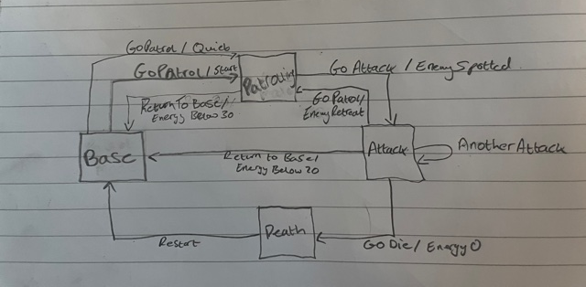

1a) ii)
If EnemySpotted {
Then Do (AttackEnemy
AnotherAttack ) }
Else If EnergyBelow20 {
Then Do (ReturnToBase
Quiet) }
Else If EnemyRetreat {
Then GoPatrol }
Else Energy0 {
Then GoDie }
End

1b)
Within finite state machines there are two types of methods used.
Mealy Machines, which outputs data both by its current states and outputs.
Moore Machines, which outputs data only by its current state.
The Mealy method often leads to a reduction of states due to it being able to output on its current states and outputs.

Question 3
3a)
Classification is the process of categorising a set of data in to classes and regression tries to predict an outcome given a set of variables.
Classification and regression are both types of supervised learning.
The difference between supervised and unsupervised learning is that supervised learning uses labelled vectors within its process.
3b)
h(x) = 0.418 + (0.163*0.6) =
0.5158
Residual Error = 0.5158 – 0.38 = 0.1358
3c)
Randomly generalate population of P
s(0) = {s(1,0),…s(P,0)}.
t=0
REPEAT
TotalFitness=0
FOR i = 1 TO P DO
Fitness (i,t) = v(s(i,t))
TotalFitness = TotalFitness + Fitness(i,t)
ENDFOR
FOR i=1 TO P DO
p(i,t) = Fitness(i,t)/TotalFitness
ENDFOR
t=t+1
UNTIL (t>predefined upper limit)
END
The aim of the fitness function is to select fittest of a population and modify and combine the chosen ones’ genotype to obtain a new genotype which is then given a place in the population at the expense of the most unfit.

3d)
Child 1 – 10101 0111110 101011
Child 2 – 01111 0101000 011110

Question 4
4a)
The purpose of the synaptic weights is to show the influence each node has on the output.
4b) i)
((0.4*0.9)+0.3) + ((-0.2*0.8)+0.3) + ((0.12*-0.12)+0.3) =
0.66 + 0.14 + 0.2856 =
1.0856
Φ (max(0,1.0856)) = 1.0856

4b) ii)
x = 1/(1+e^{-1.0856}) = 0.747
4c)
A dying ReLU is where the output remains 0 and occurs when the rate is too high or there is a negative bias. The solution to this is something called leaky ReLU. This is where you could substitute y = x when x<0.

