

Programme: BA (Hons) Leadership and Management Skills for the Workplace
BMSW6106 - Developing Emotional Intelligence Skills for the Workplace
Topic: Why building an emotionally intelligent workforce should be a business priority in this current volatile economic environment and how employers can train and develop their existing staff to make them emotionally intelligent workforce?
Assessment Task 1 –Individual Report
Name of the Student: Ionut Gradinaru

Executive Summary
Emotional intelligence and its benefits are significantly relevant in the post-pandemic market situation where employees need extensive workforce flexibility. The implication of the model is determinant of the improved employee performance, engagement, and turnover rate. The selected company in the report is Sainsbury’s for its criticality on employee satisfaction and turnover rate. The report has identified the most compatible emotional intelligence models that can be applied in Sainsbury’s for its performance development. The reasons and benefits of implementing these models have been provided. Moreover, the process and system implementations with the emotional intelligence model have also been provided along with corresponding recommendations in the report.

Table of Contents
Introduction 4
a) Sainsbury’s (Company background) 4
b) Briefly introduce the key EI model underpinning in the report 5
c) Application of EI models to Sainsbury’s with the importance of developing EI model in the workplace and the relationship between EI, business advantages, and effective management communication 7
d) Evaluating models of emotional intelligence by applying them in Sainsbury’s and explaining to which extent the models can meet the emotional intelligence development of the employees 11
e) Systems and process recommendations that influence better collaboration offering high EQ behaviours among existing staff in post-CoVID-19 situations 15
Conclusion 17
References 19
Appendix 1: Poster 22

Introduction
Emotional intelligence and its implication in the workplace have multiple benefits including the development of the working structure and engagement. The employment satisfaction and turnover rate can also benefit from the implication. The report will focus on the internal workforce arrangement of Sainsbury’s with the implementation of emotional intelligence models. The identification of the models and the benefits exerted by the models will be discussed. The report will also critically evaluate the application of the models in the company with profitable prospects. Moreover, the recommended system and process improvement including the emotional intelligence models, and frameworks will also be provided in the last section of the report.

a) Sainsbury’s (Company background)
Sainsbury’s is one of the most popular supermarket chains in the UK market with a £14.8 billion revenue and pre-tax profit of around £730 million. The company employs around 173,000 employees in its 1,400 stores and has a market share of around 15.3% in the UK market. The company has a high employee turnover rate of 14.4% according to its annual report in 2022. The customer satisfaction rating of the company is around 78% and the employee engagement rating of the company has been reported to be around 63% in 2022 ‌(MSQ Partners, 2020).
The emotional intelligence prospect is extensively higher for the mental health and well-being of the employees. The implementation of emotional intelligence is expected to increase working engagement by 20% in the company in one year. Understanding interpersonal and intrapersonal emotional intelligence has a prospect of increasing communication., and collaborativeness in a company ‌(MSQ Partners, 2020). Sainsbury’s is one of the major companies with a reduced turnover and recruitment prospects in the UK market. The EI initiatives are expected to create extensive value for its working in engagement.
According to a 2021 study of CIPD, for 21% of the organisations among 377 organisations in the study, EI provided a value of 12% higher customer satisfaction ‌(MSQ Partners, 2020). Therefore, EI or EQ implementation in the performance structure can improve employee engagement and behavioural outlook simultaneously. Moreover, EI implementation is also reported to increase around 5% of the employee performance rating.

b) Briefly introduce the key EI model underpinning in the report
The Mayer-Salovey-Caruso Emotional Intelligence Test (MSCEIT): MSCEIT was formed by the emerging scientific emotions understanding and their functions to assess emotional intelligence. It is an ability-oriented test designed to determine the four EI branches of Mayer and Salovey (Odukoya et al., 2020). Perceiving emotions, facilitating thought, managing emotions, and understanding emotions are the four branches of EI. Perceived emotion is the ability to perceive the emotions of others and develop bonds between individuals. It measures emotional intelligence through the ability of individuals to comprehend or perceive emotional information management. The MSCEIT test includes different creative tasks to determine the capacity of individuals to reason with emotional information by testing their ability (Odukoya et al., 2020). The performance-based approach maintains the appropriateness of the MSCEIT test for each real-life situation where individuals attempt to initiate a positive impression.
David McClelland’s Framework of Emotional Intelligence (EI): This framework demonstrates that emotional competencies are important to resolve emotional management issues in real-time contexts. According to Damayanti et al. (2023), it helps to discover the best set of competencies leading to the ultimate business success. According to this framework, the management of the organisations shapes the behaviour of individuals to fit their job roles to attain organisational success. Different combinations of competencies lead to the success of the company and the competency model algorithms are applied to work on the cluster level (Damayanti et al., 2023). The EI enables individuals to empathise with others and relieve stress to successfully manage conflict.
Richard Boyatzis’ Framework of Emotional Intelligence (EI): This framework focuses on various groupings of relationships existing between competencies in a system or organisational levels including complementary, compensatory, antagonistic, and alternate manifestations (Wamsler and Restoy, 2020). Competencies which have a complementary relationship enhance the effectiveness of individuals when used in conjunction with each other. It demonstrates one competency which does not interfere with the ability of others’ demonstration. This framework of EI expresses the relationship between conscientiousness and adaptability where an individual uses flexibility competency to overcome any complex situations. As mentioned by Wamsler and Restoy (2020), The demonstration of consistency and reliability interferes with the demonstration of adaptability. The effectiveness of an individual increases in different situations if they use both reliability and consistency.
Bar-on ’s model of emotional intelligence: This model assists individuals in managing their emotions and improving their ability to manage stress. Intrapersonal skills, adaptability skills, interpersonal skills, and stress management skills are the different dimensions of this model (Kanesan and Fauzan, 2019). This model develops the ability of individuals to respect the emotional status of others. Emotional self-awareness is the ability of individuals to recognise the feelings of individuals. Assertiveness develops the ability to express the beliefs, feelings, and thoughts of individuals to defend the rights of individuals. As described by Kanesan and Fauzan (2019), it develops the self-actualisation ability of individuals to realise their capacities. This model helps to understand social responsibility which is the ability to demonstrate the individuals as constructive members of each organisational group.
Daniel Goleman’s EI model: This model expresses that the learning capability is based on emotional intelligence (EI) resulting in the outstanding performance of the employees at their workplace (Ho et al., 2023). According to this model, the personal competencies focus on self-management and self-awareness whereas the social competencies concentrate on social awareness and relationship management. Self-awareness includes three sub-competencies such as emotional self-awareness, accurate self-assessment, and self-confidence. According to Ho et al. (2023), self-management helps to develop six sub-competencies such as adaptability, initiative, achievement drive, conscientiousness, trustworthiness, and emotional self-control. Social competencies include empathy, service orientation, and organisational awareness to develop team interaction. Relational management helps to develop communication skills, visionary leadership, conflict management, change catalysing, teamwork, and building bonds (Ho et al., 2023).

c) Application of EI models to Sainsbury’s with the importance of developing EI model in the workplace and the relationship between EI, business advantages, and effective management communication
Importance of developing EI in the workplace: Emotional Intelligence helps the leaders of Sainsbury’s to understand how emotions affect the work culture. EI implementation helps Sainsbury’s meet the requirements for a hybrid work culture to capture a higher degree of workplace engagement of the employees.
Understand the employee emotions: The EI model application helps Sainsbury’s to develop a strong tie among 1,89,000 employees operating in different territories (Sainsbury’s, 2023). The MSCEIT model application in Sainsbury’s helps the leaders to understand their ability to manage employees’ emotions to meet the organisational goals in the dynamic working environment. The leaders of Sainsbury’s use workforce management technology which helps the company to implement a web-based system producing optimised training schedules for all employees (Sainsbury’s, 2023). EI training helps the leaders of the company to model better behavioural aspects and work with the employees directly on applying their skills of employee emotion management.
Developing emotional competencies: Sainsbury’s applies David McClelland’s Framework of Emotional Intelligence (EI) to develop the emotional competencies of each employee to attain success. This is applied to provide a space for open reflection on the training agenda and communicate the seriousness of the training agenda to develop the emotional competencies of each employee (Kanesan and Fauzan, 2019). Sainsbury’s offers apprenticeships in different posts including data analytics, HR manager, business manager, technical trainer, risk manager, and customer-service developers.
Developing positive organisational outcomes: EI plays a significant role in succeeding as a leader and people get promoted for demonstrating their technical expertise. EI determines how well the leaders of Sainsbury’s manage the emotional excellence of the employees. The EI competency model is applied in Sainsbury’s to measure the success of the leaders to attain the organisational goals (Sainsbury’s, 2023). This model helps leaders and managers develop an authentic work culture by developing interpersonal and intrapersonal intelligence (Pîrvu, 2020). Daniel Goleman’s EI model is applied in Sainsbury’s to concentrate on the critical emotions of the employees and underlie the behavioural traits of the employees to predict their occupational performance (Sainsbury’s, 2023).
Relationship between EI, business advantages, and effective management communication: EI is capable of revealing how effective the organisational leaders are in dealing with various problems within the organisation. Danial Goleman stated that EI is the prerequisite factor for effective leadership revitalisation (Kanesan and Fauzan, 2019). Daniel Goleman’s EI model is used to understand the relationship between EI, effective management communication, and business advantages to develop the emotional excellence of the company. Sainsbury’s applied this model to improve self-awareness to have a deeper understanding of the emotions of individuals (Sainsbury’s, 2023). It helps to understand the logical relationships between the behaviour and actions of the employees of Sainsbury’s to attain business advantages. The organisational individuals of Sainsbury’s learn from their previous experiences and avoid making mistakes in future. The higher administration of Sainsbury’s conducts opens discussion sessions where each organisational individual shares their previous learning experiences and their usefulness in their regular corporate life (Sainsbury’s, 2023). Sainsbury’s managers have self-assessment quality which helps them to criticize and analyse the feedback from staff.
EI leaders have a higher degree of self-awareness about their behaviours and the way they influence their team members. It fosters more significant engagement of the team members and Sainsbury’s uses the organisational behaviour perspectives to manage the behaviour of each employee (Kanesan and Fauzan, 2019). The performance-based approach of the MSCEIT model helps Sainsbury’s to test the productivity levels of the leaders and their efficiency in managing each employee. Sainsbury’s benefits from an experienced HR team to underpin an in-depth employee insight enabling the leaders of the company to develop the business advantages. Richard Boyatzis’ Framework of Emotional Intelligence (EI) is applied by Sainsbury’s to recognise the emotions of the employees to make more rational business decisions. The leaders of Sainsbury’s use their ability to empathise with the emotions of the team members to take into account the employee’s perspectives to make more concise business decisions. This model is used in Sainsbury’s when the sales of the company are reduced by 10% and the employee turnover rate is increased to 5.6% in 2020-2022 (Sainsbury’s, 2023). The negative emotional status was developed among the employees of Sainsbury’s due to the COVID-19 pandemic. This model is used by the leaders of Sainsbury’s to increase the revenues of the company by £32.49 billion in 2023 which was increased by 7.44% from 2022 (Sainsbury’s, 2023).
Emotional intelligence (EI) in communication at the workplace assists the employees in building stronger connections by realising the emotions of others. EI enhances conflict resolution skills of the employees allowing the employees to resolve issues and preserving professional relationships (Wamsler and Restoy, 2020). The management of effective communication is developed in Sainsbury’s by developing the emotional intelligence of the employees. The people with higher EI lead more successful careers and develop better employee-manager relationships (Pîrvu, 2020). Bar-on ’s model of emotional intelligence is used to understand the importance of intrapersonal skills, adaptability skills, interpersonal skills, and stress management skills in developing an effective communication index (Wamsler and Restoy, 2020). The employee engagement survey and listening groups of Sainsbury’s are engaged to justify the EI status of the team members to develop effective communication (Sainsbury’s, 2023). The CEO of Sainsbury’s holds regular 1-hour question-answer sessions on the internal social media platforms of Sainsbury’s to understand the emotional status of each employee.

d) Evaluating models of emotional intelligence by applying them in Sainsbury’s and explaining to which extent the models can meet the emotional intelligence development of the employees
EI competencies model
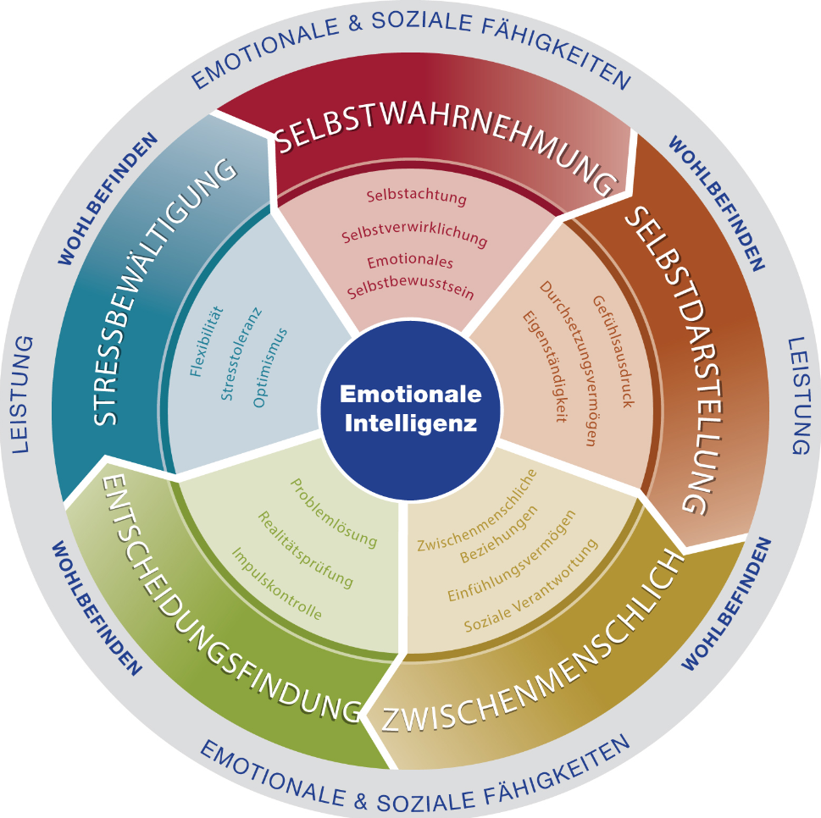
Figure 1: Emotional Intelligence Competencies model
(Source: ‌Verywell Mind, 2023)
Self-awareness: Self-awareness programs are extensively important for building emotional intelligence (Verywell Mind, 2023)‌. Understanding personal capabilities, strengths and weaknesses is extensively important for performance shaping in a workplace. Sainsbury’s has multiple working structures including sales, marketing, IT, supply, distribution and operations. According to Dacre Pool et al. (2019), the administrative and product selection roles are also equally important for the comprehension of sustainable commercial structure. Self-awareness can allow the employees to become self-sustaining to understand their capabilities. This can improve the working assigning structure and increase the performance as well ‌(MSQ Partners, 2020).
Self-regulation: Self-regulation is another spectrum of training for soft skills like communication, time management and so on. The stress management, conflict resolution and problem-solving aspects of each employee can provide extensive value to the formulation of a self-engaged workforce (EIA Group, 2022)‌. The HR division in the company is required to identify the time management expertise of individuals. This can provide extensive value to the corporate governance and policy compliance at Sainsbury’s.
Social awareness: Social awareness is another important spectrum that provides an extensive value to emotional intelligence. According to Prentice (2019), customer service and social impact identification are extensively important for the administrative division/. Moreover, it is also important for employees working in Sainsbury’s for the social outlook. It can not only increase the brand reputation but also its CSR status in the market. The modern market dynamics comprehension of product selection, and product availability are also dependent on social awareness. The employment plan is also required to be structured based on social awareness.
Relationship management: Relationship management refers to the interconnectivity of customers, suppliers and employees at Sainsbury’s. The company can build a better relationship spectrum by influencing social relationships and internal work relationships. This can increase the communication transparency and fluency for auditing interpretations as well.
McClelland’s framework of emotional intelligence
Need for achievement: Sainsbury can use the high-performance index and employee recognition model for motivational delivery for increased productivity. According to Prentice (2019), the company has a sales structure and culture focusing on incremental profitability and growth in the UK and global markets (Channell, 2021)‌. The emotional intelligence of detecting the motivational factors influencing the achievement need can cater for positive working engagement. According to Chang and Tsai (2022), the employees can build innovative strategic solutions to improve the performance model more accurately and proficiently. The performance indicator model is extensively useful for applying a framework like this. McClellan’s framework for emotional intelligence tends to develop emotional intelligence based on needs in the working structure. According to Dacre Pool et al. (2019), therefore, the need for achievement is also required to be associated with career growth opportunities.
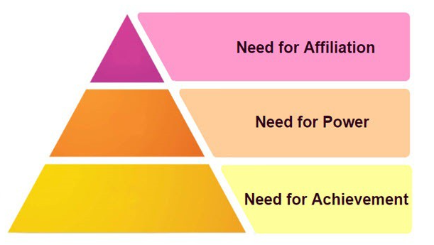
Figure 2: McClelland’s framework of emotional intelligence
(Source: Tziner et al., 2020)
Need for power: The power need refers to a direct relationship with career growth opportunities. Delegating the decision-making process to the employees increases their interest in new roles and responsibilities (Positive Psychology, 2023)‌. Anticipating increased responsibilities increases their capabilities of multitasking. Therefore, the perception of overall management and executive roles, and responsibilities increases as well. According to Wen et al. (2019), the need for authority also poses opportunities for career growth and the employees become more engaged with the profitability of the company. This can provide Sainsbury’s with a better-engaged structure.
Need for affiliation: According to Chang and Tsai (2022), interorganizational workforce association and collaboration are other factors that help to build emotional intelligence. The organisational structure focusing on the affiliation of two departments Marketing and IT can increase the data networking and accuracy of responsive marketing. The internal communication structure can also increase with the collaboration between the operation and the IT department. The navigation on inventory management, supply, production and IT department can also increase the operational performance index of Saindsbury’s extensively.
According to Chang and Tsai (2022), moreover, affiliation can also increase the communication between the work progress and networking between the synchronised functions of different operations. The roles and responsibilities of the employees can get opportunities for cross-functional management (Positive Psychology, 2023)‌. This can increase the internal communication resilience for working with a team or group simultaneously.
Bar-on’s model of emotional intelligence
Intrapersonal intelligence: Developing self-esteem, and self-actualisation regarding personal jobs, roles and responsibilities can be trained to the employees by Sainsbury’s. The company has a structured and organised working infrastructure that helps to detect the performance of the employees. Therefore, building intrapersonal intelligence can be achieved by helping employees detect the issue with personal skills and abilities (Connecting HR with Australia, 2023)‌. Self-esteem management and self-actualisation management are some of the major perspectives that can increase the self-motivated workforce. The realisation of personal position among the team and colleagues can allow employees to work on the improvement of sustainment. This can further increase their interest in the organising structure for working procedures.
Adaptability: Training on adaptability with new working frameworks or digital integration is the major profit of using Bar-on’s model in Sainsbury’s. The company has been reported to have invested more than £21 million in its digital integration of logistics and procurement auditing. The learning and training process has also been reported to cost around 17 % of the total training budget. Therefore, the adaptability to new digital integration for the communication in post-CoVID-19 model is extensive. Adaptability setup is extensively important for improving emotional intelligence strength. It can allow the HR department and employees to understand the issues other colleagues are going through to deal with the current situation.
Interpersonal intelligence: According to Tziner et al. (2020), moreover, interpersonal intelligence is another spectrum that is required to be covered by Sainsbury’s for an engaged and collaborative workforce. Most of its departments have multiple employees working in the same function for increased customer reflux in the post-pandemic situation. Therefore, the increased value of hygiene and personal issues are required to be realised by other colleagues. Working shifts and extra-horse situations can also benefit from the interpersonal intelligence development at Sainsbury’s.

e) Systems and process recommendations that influence better collaboration offering high EQ behaviours among existing staff in post-CoVID-19 situations
Recommendation 1 (Emotional Intelligence Champions program): Sainsbury’s can implement the Emotional Intelligence Champions program in the company for better emotional engagement of the employees with each other and themselves. The company can empower around 5% of the staff for the training and emotional intelligence development program who are interested and show performance for executive roles. Therefore, the other workforce might follow the same pattern being realised in the career growth opportunities. The mentoring capabilities and initiatives of the employees are required to be rewarded with recognition and incentives. The self-awareness, empathy and communication build-up is required to be encouraged by the managers in the company.
Building opportunities for team working on projects and constructively criticise the initiatives in team working can employ interpersonal emotional intelligence development. According to Guasp Coll et al. (2020), this strategy is evaluated with a 23% guaranteed increment in employee engagement due to a 2022 survey. Around £2 million budget is required for this program in the company which does not outbudget the initial training and resilience development program. The emotional intelligence champions program can, therefore, extensively improve the quality of the working structure in the company.
Recommendation 2 (Micro-recognition platform): Encouraging employees for high-EW behaviours is another way of encouraging self-awareness and social awareness in the workplace. Sainsbury’s can implement this program by detecting capabilities of coming up with new innovative ideas that can respond proactively to social demands. The inter-team communication initiatives are required to be encouraged so that employees can get a value orientation from that. This can help them get motivated to be engaged with the working objectives. The completion of each task disregarding the workforce postnatal can push the capability of the employees. It can increase their awareness of the working infrastructure development based on new strategic resolutions. This can further increase the formulation of strategic cohesion with a performance indication program.
The company can use this model to critically inspect the strengths, capabilities and weaknesses of the employees. The employees can become more and more resilient with the increased workforce for coping with shifts and extra hours of work if any colleague is on leave. According to Guasp Coll et al. (2020), this can potentially reduce employee retention and turnover by 15% according to a 2021 survey. Moreover, around £80,000 budget is required to implement this program in all branches of Sainsbury’s.
Recommendation 3 (Integrate emotional quotient into performance reviews): Sainsbury’s can integrate the EQ rating in the performance review. The existing performance review is based on objective completion and other tangible auditing. However, mentoring, helping and encouraging colleagues are not evaluated by the executive structure at Sainsbury’s. Implementing this program can allow employees to become more attentive to EQ proportionate and prospects. Anticipation of the working structure modification based on the needs of colleagues can increase with the implementation of this program.
The respect and open communication building can be influenced by the integration of this program as well. The program is expected to take around 1 year to create significant commercial growth for the company. According to Tziner et al. (2020), moreover, it can require around £40,000 budget to implement the existing KPI program of the company.

Conclusion
Emotional intelligence is one of the major courses of factors that increase employee engagement and satisfaction in a company. The 2020 global pandemic has created a significant disruption in the working structure of both the retail land service sector companies. Currently, employees are feeling extensively unsafe in the workplace. The structure, communication and accommodation criteria in the workplaces have changed entirely after the COVID-19 situation. Sainsbury’s is one of the major companies with critical retention and employee turnover rates.
The report has elaborated on the basic details and needs for the improvement of the EQ aspects in the company. The identification of emotional intelligence models has been provided. The reason for developing emotional intelligence with the use of the models has been elaborated in the report. Moreover, the critical evaluation of the models with specific factors in consideration has also been provided with corresponding recommendations.

References
Chang, Y.C. and Tsai, Y.T., (2022). The effect of university students’ emotional intelligence, learning motivation and self-efficacy on their academic achievement—Online English courses. Frontiers in Psychology, 13, p.818929.
Channell, M. (2021). Daniel Goleman’s Emotional Intelligence in Leadership: How To Improve Motivation In Your Team. Available at: https://www.tsw.co.uk/blog/leadership-and-management/daniel-goleman-emotional-intelligence/ [Accessed 12 December 2023]
Connecting HR with Australia, (2023). Having an emotionally intelligent workforce should be a priority post-COVID. Available at: https://www.insidehr.com.au/an-emotionally-intelligent-workforce/ [Accessed 12 December 2023]
Dacre Pool, L., Gurbutt, D. and Houston, K., (2019). Developing employable, emotionally intelligent, and resilient graduate citizens of the future. Employability via higher education: Sustainability as scholarship, pp.83-97.
Damayanti, S., Asbari, M., Setiawan, D. and Saputra, M.S., (2023). Emotional Intelligence: Mengapa EI Lebih Penting daripada IQ?. Literaksi: Jurnal Manajemen Pendidikan, 1(02), pp.279-285.
EIA Group, (2022). EmotionIntell - The Emotional Intelligence Model. Available at: https://www.eiagroup.com/white-paper/emotionintell-the-emotional-intelligence-model/ [Accessed 12 December 2023]
Guasp Coll, M., Navarro-Mateu, D., Giménez-Espert, M.D.C. and Prado-Gascó, V.J., (2020). Emotional intelligence, empathy, self-esteem, and life satisfaction in Spanish adolescents: regression vs. QCA models. Frontiers in psychology, 11, p.1629.
Ho, N.L.T., Guṇākaro, P.S. and Mahatthanadull, S., (2023). The Buddhist Emotional Intelligence Management: An Integration of Daniel Goleman’s Theory and Theravāda Perspective. Journal of International Buddhist Studies, 13(2), pp.01-23.
Kanesan, P. and Fauzan, N., (2019). MODELS OF EMOTIONAL INTELLIGENCE: A REVIEW. e-BANGI Journal, 16(7).
MSQ Partners, (2020). Aldi, Waitrose and Sainsbury’s Come Out on Top in MSQ’s High EQ Christmas Ad Research. Available at: https://www.lbbonline.com/news/aldi-waitrose-and-sainsburys-come-out-on-top-in-msqs-high-eq-christmas-ad-research [Accessed 12 December 2023]
Odukoya, A.J., Omonijo, D.O. and Olowookere, E.I., (2020). Review of studies on the psychometric properties of Mayer–Salovey–Caruso emotional intelligence test. Journal of Advanced Research in Dynamical and Control Systems, 12(7), pp.1961-1968.
Pîrvu, C., (2020). Emotional intelligence–A catalyst for sustainability in modern business. Theoretical and Empirical Researches in Urban Management, 15(4), pp.60-69.
Positive Psychology, (2023). The Theories of Emotional Intelligence Explained. Available at: https://positivepsychology.com/emotional-intelligence-theories/ [Accessed 12 December 2023]
Prentice, C., (2019). Managing service encounters with emotional intelligence. Journal of Retailing and Consumer Services, 51, pp.344-351.
Sainsbury’s, (2023). Values and Culture. Available at: https://sainsburys.jobs/working-for-us/values-culture/#:~:text=That's%20why%20listening%20and%20creating,our%20internal%20social%20media%20platform [Accessed 12 December 2023]
Sainsbury’s, (2023). About us- Sainsbury’s. Available at: https://www.about.sainsburys.co.uk/about-us [Accessed 12 December 2023]
Sainsbury’s, (2023). Annual Report and Financial Statements 2023. Available at: https://www.about.sainsburys.co.uk/~/media/Files/S/Sainsburys/documents/reports-and-presentations/2023/annual-report-2023/annual-report-and-financial-statements-2023.pdf [Accessed 12 December 2023]
Tziner, A., Fein, E.C., Kim, S.K., Vasiliu, C. and Shkoler, O., (2020). Combining associations between emotional intelligence, work motivation, and organizational justice with counterproductive work behavior: A profile analysis via multidimensional scaling (PAMS) approach. Frontiers in Psychology, 11, p.851.
Verywell Mind, (2023). How Emotionally Intelligent Are You? Available at: https://www.verywellmind.com/what-is-emotional-intelligence-2795423 [Accessed 12 December 2023]
Wamsler, C. and Restoy, F., (2020). Emotional Intelligence and the Sustainable Development Goals: Supporting peaceful, just, and inclusive societies. Peace, justice and strong institutions, pp.1-11.
Wen, J., Huang, S.S. and Hou, P., (2019). Emotional intelligence, emotional labor, perceived organizational support, and job satisfaction: A moderated mediation model. International Journal of Hospitality Management, 81, pp.120-130.

Appendix 1: Poster
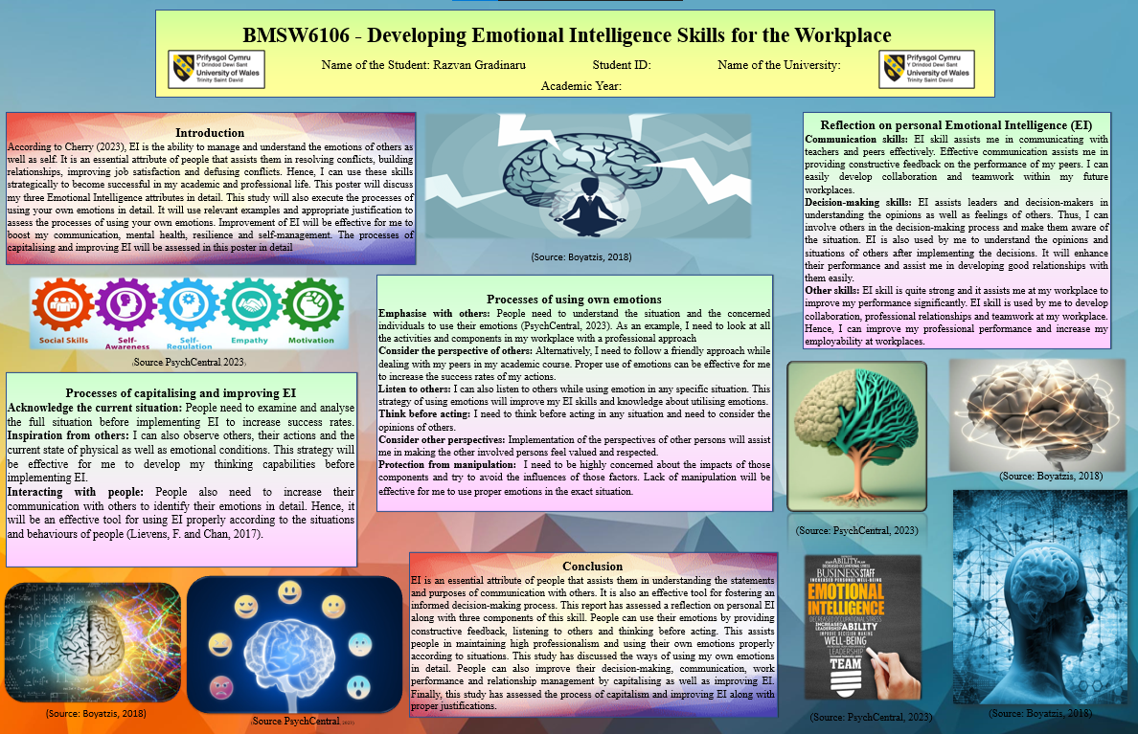
Figure 3: Screenshot of poster
(Source: Author)

