
Assessment 1 Entrepreneurship
Module code: LCBB5001 Lecturer: Nishi Ramsurrun

“Juicylicious”
(Individual Report)

Stefan Vasilev Zamfirov
University of Wales Trinity Saint David, London Campus,
BA Business and Management, London, United Kingdom
2024063@student.uwtsd.ac.uk

Contents
Introduction 3
Decision – Making Process 4
Market Segmentation 6
Range of Products 7
Product Life Cycle 9
Feasibility Analysis 12
Market Research 13
Action Plan 14
Conclusion 15
References 16

Introduction

Juicylicious is a new founded company, offering a wide variety of fresh juices and smoothies. The primary objective will be to give our clients access to an appetising, health-oriented, and nutritionally sound food product that is suitable for the way they now lead their lives. Our smoothie and fresh juice bars go above and beyond the expectations of our customers in comparison to the current offerings of smoothies and fresh juices that are available on the market. This is accomplished by providing a diverse selection of juices that are made with high-quality ingredients at prices that are more affordable than their competitors while still maintaining healthy profit margins.

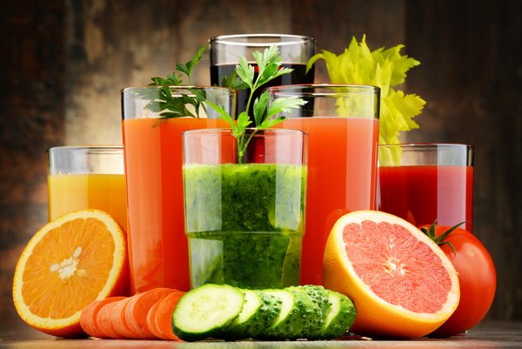
(Source: monticellllo – Fotolia)
(Accessed: 24.07.2022)

Decision – Making Process
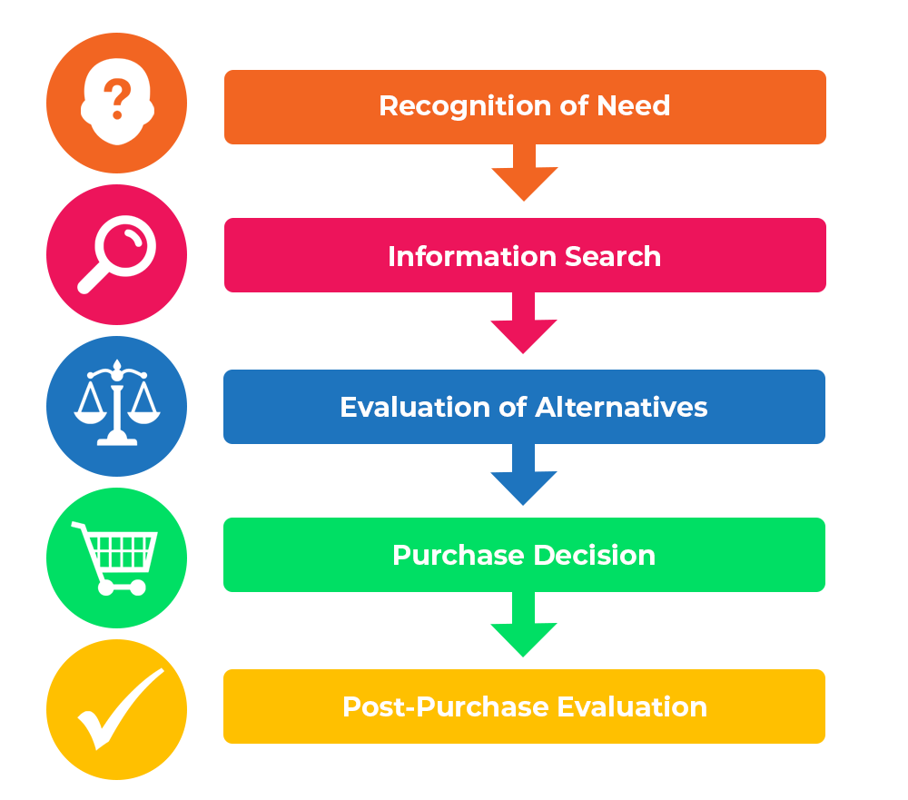
Figure 1
(Source: www.professionalacademy.com)
(Accessed: 24.07.2022)
In Figure 1 we explain the decision-making process of our customers in 5 easy steps:
- Recognition of need (I need a drink)
Identifying the customer's precise demands is the first step in the procedure. In order to feel “normal” again, the consumer has to address the sensation that something is missing.
In our case a customer starts to feel thirsty.
- Information search (What drinks are being offered)
In this stage the customers are subconsciously figuring out what drinks are being offered.
In our case the customers think about all drink that they could’ve think of.
- Evaluation of Alternatives (Which drink should I choose)
The consumer will start looking for the best offer once they have decided what would meet their wish or requirement. Price, quality, or other essential considerations may be the basis for this. Customers research products by reading several reviews and comparing pricing before selecting the one that best fits their needs.
In line with our example, the customer start questioning his decision.
- Purchase Decision (Buying the drink)
At this point, a customer has likely done one of three things: considered all the available information and reached a logical conclusion; made a choice based on emotional connections or experiences; or caved into marketing or advertising tactics. Most likely, a combination of all three of these has taken place.
The customers purchase our drink.
- Post - Purchase Evaluation (Was this the right drink for me)
The review phase is crucial for both the business and the client. Was the product true to what the marketing and advertising efforts claimed? Has the product met or surpassed your expectations?
The customer very much like our product that he has chosen – he would recommend them to a friend.

Market Segmentation

Targeted customers are all age groups and genders. We made four distinct market categories in this example of our market segmentation for fresh and smoothie drinks. Our example combines situational impacts with a segmentation technique focused on benefits. In this case, four market categories have been determined. They are as follows:
- Health Focus
- Really Thirsty
- Sporty
- On the Go
Health Focus: Consumers that place a high value on healthy eating and taking care of their bodies make up the target audience for items with a health-centric orientation.
Really Thirsty: “They would be attracted to packaging words such as “refreshing” and “hydrating”” (Generate Press, 2022)
Sporty: These customers are different from the "health focus" market segment example in that they do not always aim to eat or drink in a healthy manner. Instead, while engaging in demanding or endurance sports, people look for beverages that provide functional advantages.
On the Go: This market group would choose a more substantial beverage, like a milk-based beverage, a juice blend with greater consistency, or a bigger portion of a more conventional soft drink.

Range of Products

Our fresh juice and smoothie bar provides customers with the option to tailor any juice or smoothie to the customer's specific requirements, whether those requirements are related to their health and nutrition or simply to their taste. The fresh juices and smoothies are made with real fruit and are of a high quality.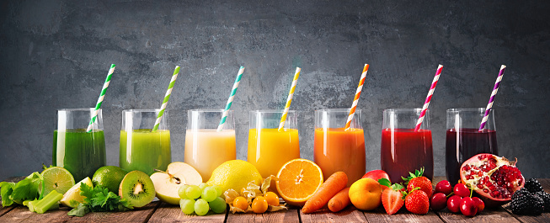
(Source: monticellllo – Fotolia)
(Accessed: 24.07.2022)

Fresh:
Fruits - Apple, Orange, Pear, Watermelon, Pineapple, Lemon, Grapefruit and Peaches.
Veggies – Carrot, Beetroot.
Smoothie: “Smoothies are thick, creamy beverages usually blended from puréed fruits, vegetables, juices, yogurt, nuts, seeds, and/or dairy or nondairy milk.” (Ansley Hill, 2020)
“The most basic smoothie starts with two essential ingredients — a base and a liquid. From there, you can combine ingredients to your liking.” (Ansley Hill, 2020)
Additional Products:
- Fruits: Berries, banana, apple, peach, mango, kiwi and pineapple.
- Vegetables: Kale, spinach, baby spinach, avocado, cucumber, beetroot, and carrots.
- Nuts and seeds: Almond butter, peanut butter and chia seed.
- Herbs and spices: Ginger, cinnamon, and cocoa powder.
- Liquid: water, fruit juice, vegetable juice, milk and nondairy milk.
- Sweeteners: maple syrup, raw sugar, honey and vanilla extract.
House specials:
Smoothie:
Fountain of youth: avocado, banana, kiwi, baby spinach, kale, almond milk.
Merry Berry : raspberries, strawberries, blueberries, banana, almond milk, maple syrup and ice.
“Mandarin Breakfast” (Bryan, 2021): Ground Flaxseed, yoghurt, mandarins, milk, banana, vanilla extract.

Product Life Cycle

Maturity-------------------------------------
Rejuvenating----------------------------------------------------------------------------
Growth---------------------------
Decline---------------------------------------------------------------

Although It is reasonable to assume that the great majority of recently introduced items have a life cycle and are expected to pass through the same four phases: Introduction, Growth, Maturity and Decline, there is a fifth stage called “Rejuvenation”. In order to increase our products life cycle, we going to implement these three strategies.
- Innovation and adding new “features”.
“Once a product reaches maturity and the market is saturated, it gradually starts to decline” (Ceuta Healthcare, 2021). Because of this, one approach to lengthen the life of a product is to always seek out ways to make it better, distinct, and even stand out from similar items that have already hit the market. Like adding baby suitable receipts to our smoothies.
- More and more advertisement.
No matter what stage our product is now at, an innovative and well-executed advertising campaign may do wonders to revive our product's image and boost sales. Our company is modern so we would like to focus more on internet advertisement by inviting influencers to try our products for free in exchange of a advert posts.

- Identifying new market
And last, finding new customers for our product is a fantastic approach to perhaps increase its lifespan. For example, expanding by introducing our product in several locations may be a wonderful strategy to increase sales and go through the stages of the cycle.
“Jerome McCarthy introduced the term "4 P's" many years ago to describe a brand's marketing mix. All marketing textbooks use this terminology to refer to product, price, place and promotion.” (TheProduct, 2022)
Price: Our products will be sold in 3 different sizes, 350ml cups, 500ml bottles and 1L bottles. With our competitive pricing let’s take for example apple fresh juice. Price for 350ml cup will be £2.00 for 500ml bottle £3.00 and for 1L £5.00. “A typical apple will provide around a third of a cup of juice. With a high-quality juicing equipment, you can get a quarter cup of juice from little apples and up to a half cup from large ones. You will need about 48 apples of average size to make one gallon of apple juice.” (Teague, 2020) One gallon is around 4.5L which is 12 cups, 9 500ml bottles or 4 1L and a half bottles. “Current price of apples is £7 for 50 apples” (Fruit + Veg, 2022), £0.15 per cup, £0.45 for 500ml bottle and £0.65 for 1L per bottle.
12 350ml cups | Cost: £8.80 Retail: £24
9 500ml bottles | Cost: £11.05 Retail: £27
4.5 1L bottles | Cost: £10.05 Retail: 23£

Place: “If you pick a location for your juice bar that doesn’t get adequate foot traffic, you won’t make as much money or retain customers.” (Loomis, 2020) At a major supermarket, there are two locations that, for various reasons, perform quite well: one is at the entrance, and the other is near the vegetable section. If our juice bar is located near the entrance — either in the direct line of sight of customers as they approach the building or close to the baggage claim — we are likely to draw customers as they go by.

Promotion: Every business must place a significant emphasis on its marketing efforts. However, when it comes to a juice bar, your ability to advertise your brand might be the determining factor between merely surviving in the sector and attaining outstanding levels of success. We are focusing on placing our company's emblem in a location that is both highly visible and conspicuous at the front of our business. According to the findings of many market research, this is often located close to the site of origin of the bulk of items. “One of the most efficient ways to get the word out about our smoothie shop is to hand out fliers to individuals in the community that contain all of the important information they need to know about our company.” (Burban Media, 2022)

Feasibility Analysis

SWOT Analysis
Strengths: Our goods will be priced reasonably in relation to the kinds of foods that we will be offering. Each day, the food items that are offered will have been freshly prepared by our highly qualified chefs because they will have been created on site. Smoothies, juices, and a variety of herbal teas will be included in our line of beverage goods. Keeping our expenses at a level that is manageable for most people gives everyone, regardless of their age or financial level, the chance to experience our product.
Weaknesses: There are already a lot of fast food restaurants that sell both food and beverages, in addition to coffee shops with drive-through windows that sell the same kinds of things.
Opportunities: Because we are focusing on mass marketing, there is less space for us to mess up. If our marketing plan is unsuccessful, we will not lose a significant amount of money and will still have many opportunities to recover it back.
Threats: The pricing of cold beverages may fluctuate depending on the weather during the winter. It's possible that we need to consider the other options. For instance, we may have some warm juice on the menu at some point.

Market Research

(2017 – 2022)Over the five years through 2021-22, industry revenue is estimated to contract at a compound annual rate of 1.6% to £74.5 million. (Ibisworld, 2022) The increase in people's awareness of the need of maintaining a healthy lifestyle has led to an increase in demand for products that are both healthy and convenient, which has contributed to the industry's robust performance during the two years through 2018-19. Because customers believe that fruit juices and smoothies are healthier than coffee and other soft drinks, many of them have switched from drinking those beverages on the move every day to drinking fruit juices and smoothies instead. However, items produced by the sector are coming under more scrutiny since some of them have a high sugar content. As a result, customers are wondering how nutritious the products genuinely are, which has a negative impact on sales. (2022 – 2027)It is anticipated that the industry will make a full recovery from the COVID-19 (coronavirus) pandemic during the course of the term, mostly due to an increased awareness of health concerns.

Action Plan

Development objectives | Priority | Activities to be taken | Control | Time bound
Preparing all the documents needed for incorporation of the company. | Very High | Consult with a professionalist | Review progress each 5 days | 1 months
Start the business | Very high | Open up | Myself | 1 month
Obtain capital | High | Raise from share holders/ Savings | Check bank account | 4 weeks
Setup resources | Moderate | Rent out the cart/shak. Buy the equipment. | Myself | 3 weeks
Conduct Promotional & Marketing Activities | Moderate | Print and give out fliers. | Myself | 3 weeks

Conclusion

A common motivation for those who risk everything to launch their own company is the desire to achieve financial security. Although it's true that getting your business off the ground might require grit and result in some lean days when you're getting started, the ultimate objective of being your own boss is to cultivate financial independence so that you don't have to rely on other people for support. There is no upper limit to how lucrative running your own business may be if you have the will and work ethic to get there. If you have the intention of being wealthy, there is no reason why you shouldn't be able to accomplish that objective. Many business owners have the opinion that once they have experienced the autonomy that comes with operating their own company and making all of the important decisions, they will never want to return to a job where someone else is in charge.

References
Ansley Hill, R. L. (2020, May 11). Are Smoothies Good for You? Retrieved from Healthline: https://www.healthline.com/nutrition/are-smoothies-good-for-you#basics
Bryan, L. (2021, April 7). Mandarin Breakfast Smoothie. Retrieved from Downshiftology: https://downshiftology.com/recipes/mandarin-breakfast-smoothie/
Burban Media. (2022). 24+ Actionable Smoothie Shop Marketing Ideas. Retrieved from Themktgboy: https://themktgboy.com/smoothie-shop-marketing/
Ceuta Healthcare. (2021, january 19). How to extend the product life cycle. Retrieved from Ceutahealthcare: https://www.ceutahealthcare.com/latest-news/how-to-extend-the-product-life-cycle
Fruit + Veg. (2022). Apples and Pears Wholesale. Retrieved from Fruitandveg: https://www.fruitandveg.co.uk/fresh-produce/fruit/apples-pears/
Generate Press. (2022, July 24). Market segmentation example for drinks. Retrieved from Segmentationstudyguide: https://www.segmentationstudyguide.com/understanding-market-segmentation/market-segmentation-examples/market-segmentation-example-drinks/
Ibisworld. (2022, February 24). Juice & Smoothie Bars in the UK. Retrieved from Ibisworld: https://www.ibisworld.com/united-kingdom/market-research-reports/juice-smoothie-bars-industry/
Loomis, N. (2020, March 24). Tips For Choosing The Right Juice Bar Location. Retrieved from Juicernet: https://juicernet.com/tips-for-choosing-the-right-juice-bar-location/#:~:text=Within%20a%20large%20supermarket%2C%20there,attract%20people%20as%20they%20pass.
Teague, N. (2020, September 8). How Much Juice Comes From An Apple? Retrieved from Tastylicious: https://tastylicious.com/how-much-juice-in-an-apple/
TheProduct. (2022). 3 P's. Retrieved from Marketing Problem Solving: http://www.theproduct.com/marketing/3P.htm#:~:text=This%2C%20then%2C%20is%20the%20%22,pricing%20strategy%20it%20should%20use.

