UNIVERSITY OF WALES TRINITY SAINT DAVID
UWTSD LONDON
MODULE TITLE: Employability and Career Development
MODULE CODE: LCLM4005
TASK 2: Portfolio of Written Task
STUDENT NAME: Iryna Maksymuk
STUDENT ID: 2516276
LECTURER: Vicky Giannaka
DATE OF SUBMISSION: 17th August 2026

TASK 1: Job Adverts and Identify Key Skills
In order to critically evaluate the contemporary graduate labour market within the UK retail and business sectors, two distinct job advertisements for marketing-related positions were selected and analysed. Vacancy 1 is a Marketing Assistant role at a boutique law firm in London, sourced via Tiger Recruitment (see Appendix A). This position operates strictly within the Business-to-Business (B2B) sector, focusing on corporate reputation management, drafting client pitch documents, conducting market research, and executing professional networking initiatives through LinkedIn. Conversely, Vacancy 2 is a Digital Marketing Executive position at Fortnum & Mason, based at their iconic Piccadilly flagship headquarters in London. Operating within the luxury Business-to-Consumer (B2C) and premium retail sector, this role shifts the operational focus toward high-end brand heritage, multi-channel digital marketing execution, and supporting the delivery of the firm’s complex consumer digital strategy.
Despite the structural contrast between corporate professional services (B2B) and luxury heritage retail (B2C), both advertisements share critical requirements in terms of transferable attributes. Both employers explicitly emphasize the necessity of excellent attention to detail, exceptional written communication, tight deadline adherence, and high digital literacy.
The most prominent common denominator across both roles is Digital Communication Literacy, which requires strict compliance with organizational deadlines (Armstrong and Taylor, 2020). In the contemporary business environment, digital literacy is a core employability capability necessary for strategic value creation. In the context of Vacancy 1 (the boutique law firm), I would apply this skill to manage and schedule specialised B2B content for the firm's LinkedIn page, design professional email newsletters, and monitor analytics to track prospective corporate clients. In Vacancy 2, within the Fortnum and Mason framework, this same literacy translates into supporting the senior digital marketing team, coordinating cross-functional campaigns, and interpreting consumer engagement data to drive brand profitability. Utilising digital communication channels effectively allows a marketing professional to minimize communication gaps, reach targeted audiences accurately, and ensure that all external materials align with the firm's specific brand identity and tone of voice.

TASK 2: Self-Assessment and Evidence of Readiness
SWOT Analysis
A structured SWOT analysis was conducted to critically evaluate my current academic and professional profile against the rigorous requirements of the premium graduate employment market (Cole,2019).
Strengths
Solid foundational understanding of B2B communication channels, professional networking, and digital branding developed during the CertHE program (Cottrell, 2021). Deep knowledge of corporate social responsibility (CSR) and sustainability frameworks, such as B Corp standards. High digital and tech literacy, including practical skills in structured data analysis and visual formatting via Canva, MS Excel, and PowerPoint. Fluency in English (B2) and native Ukrainian, providing strong cross-cultural communication capabilities. In addition, I have a very strong motivation to learn new things and quickly adapt to changes. I am always open to developing new practical skills and learning about the UK business environment. I enjoy working in a team, and my personal enthusiasm helps me stay focused and complete university tasks on time.
Weaknesses
Limited direct corporate work experience within the UK professional services or luxury retail sectors. Moderate anxiety regarding public speaking and delivering formal analytical presentations to senior corporate stakeholders. Lack of hands-on experience in independently managing corporate digital platforms and coordinating large-scale client networking events from scratch. Furthermore, presenting my ideas can be stressful because English is my second language. Sometimes I worry about making grammar mistakes or losing confidence when speaking to a large audience. Because of this language barrier, I need more time to prepare for formal presentations or group debates.
Opportunities
Active utilisation of UWTSD London career development workshops, presentation initiatives, and individual consultations with career advisors. Access to certified professional courses through university partnerships (such as LinkedIn Learning and HubSpot Academy). Monitoring how iconic heritage brands like Fortnum and Mason utilise digital channels for storytelling to gain industry insights.
Threats
High saturation and intense competition within the London graduate labour market. Rapidly evolving software requirements, AI tools, and algorithms across digital marketing platforms, demanding continuous technical adaptation
Evidence of Readiness
To validate my readiness for employment and personal advancement, clear evidence can be drawn from my active academic performance and independent practice during my first year of the CertHE Business Skills for the Workplace program at UWTSD London.
Firstly, my academic focus has been strictly dedicated to developing commercial awareness and professional writing standards. Through the Digital Skills and Business Communications modules, I explored the core principles of audience engagement and structured data analysis. This academic exercise has directly equipped me with the analytical mindset required to handle the responsibilities outlined in both advertisements, specifically in researching prospective clients and identifying new market opportunities based on data rather than assumptions (Dench, 2021).

Secondly, a significant artifact demonstrating my practical evaluation of employers and readiness for the industry is my previous Mock Interview Preparation Document (Assignment 1). In my professional Cover Letter drafted for Tiger Recruitment, I successfully connected university academic concepts with real-world corporate values. Specifically, during university seminars, I focused heavily on corporate responsibility and market positioning. My analysis of Tiger Recruitment's B Corp Certification—which marks an organization's commitment to improving social and environmental conditions worldwide—proves my ability to evaluate firms from a macro-environmental perspective. This directly aligns with the job requirement to assist with legal directory and award submissions, where corporate reputation and ethical standing are paramount.

Finally, I have independently developed my technical capabilities to meet strict industry standards. As a proactive learner, I have mastered the use of digital tools like Canva to design professional visual materials, which directly mirrors my ability to prepare pitch documents or support digital content creation. Furthermore, my readiness in terms of collaboration, time management, and professional communication is supported by formal and informal feedback from module tutors and peers during my studies from September 2025 to the present.

Working on collaborative group challenges allowed me to demonstrate strong organizational skills, active listening, and strict deadline adherence, proving my capability to successfully draft and coordinate office newsletters and internal communications in a professional workplace environment.

TASK 3: Set Employment Goals and Personal Development Plan (PDP)
Career Goals
Based on the gaps identified in my SWOT analysis, my short-term employment goal is to overcome presentation anxiety and significantly enhance my public speaking and pitching capabilities within the next six months. My long-term career aspiration is to secure a permanent, full-time role as a Digital Marketing Specialist within a premium or luxury brand in London within two years of completing my higher education. These goals are essential to bridge the gap between academic theory and practical corporate execution.

Personal Development Plan (PDP)

Action Steps | Timelines | Resources Needed | Success Criteria
1.Enhance Public Speaking: Register for and complete university-led workshops on effective business presentations and active pitching. | October — December  (2025) | UWTSD London career support services and peer review sessions. | Delivery of a confident module presentation with minimal anxiety and clear articulation.
2.Professional Certification:  Complete specialized courses in Premium Brand Management and advanced MS Excel analytics via LinkedIn Learning. | January — March  (2026) | University library electronic databases and online platforms. | Attaining official industry certifications to add to my professional portfolio.
3. Practical Digital Campaign Management: Volunteer to support student-led networking initiatives or create a mock digital campaign layout for a premium brand. | April — June  (2026) | Collaboration with the UWTSD student union, analytical tools, and module leaders. | Successful execution of a digital media or networking project, measured by positive mentor feedback.

References
Armstrong, M. and Taylor, S., 2020. Armstrong's Handbook of Human Resource Management Practice.15th ed. London: Kogan Page.
Cottrell, S., 2021. Skills for Success: Personal Development and Employability. 4th ed. London: Red Globe Press.
Cole, G.A., 2019. Management Theory and Practice. 8th ed. London: Cengage Learning.
Dench, S., 2021. Employability Skills and Career Planning. 2nd ed. Oxford: Oxford University Press.
Job adverts
Fortnum & Mason, 2026. Digital Marketing Executive Vacancy Framework. [online] Available at: <https://uk.linkedin.com> [Accessed 9 August 2026].
Tiger Recruitment, 2026. Marketing Assistant - Legal Sector (Ref: AD180023). [online] Available at: <https://reed.co.uk> [Accessed 20 July 2026].

APPENDICES
Appendix A: Job Advertisement for Tiger Recruitment (Marketing Assistant)
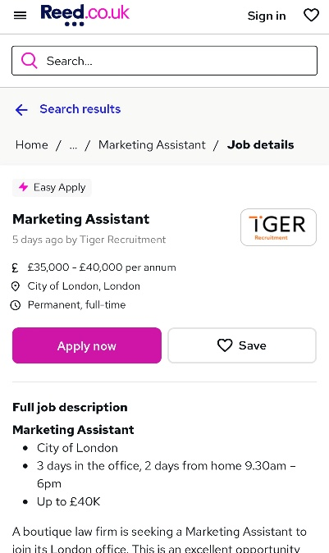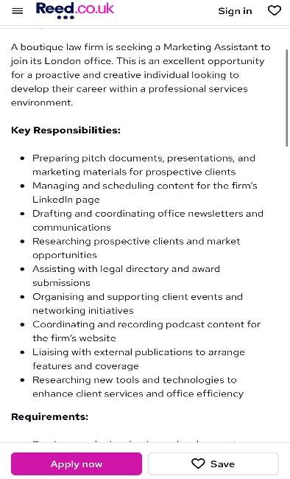

Appendix B: Job Advertisement for Fortnum & Mason (Digital Marketing Executive)


