

Programme: Master of Business Administration
Module: Marketing Management
Module code: LCMB7024
Title: Assessment component 1: Individual report
Lecturer’s Name: Haoran Liu
Student Name: Meetkumar Patel
Student ID: 2536671
Work Count: 2675
Term 1

Table of Contents
Task 1: Marketing Environment Analysis – BHP’s Transition Towards Lower-Carbon Products 3
1.1 Natural Environment 4
1.2 Political Environment 8
Task 2: Strategic Growth and Competitive Positioning – BHP's Transition to a Lower-Carbon Business Model 12
2.1 Recommendation of a strategic growth approach for BHP using Ansoff Matrix 12
2.2 Achieving Competitive Advantage 15
Task 3: Critical Reflection on AI Usage 18
3.1 Tool Disclosure 18
3.2 Critical Evaluation of AI Output 18
3.3 Contribution Analysis 18
3.4 Ethical & Professional Reflection 19
References 20

Task 1: Marketing Environment Analysis – BHP’s Transition Towards Lower-Carbon Products
There is an increasing pressure on the global metals and mining industry to minimise emission of greenhouse gas and also focusing on meeting the increasing demand for minerals which are important for low carbon transition (Enemuo and Ogunmodimu, 2025). It is reported by International Energy Agency that there is an increasing demand for essential minerals like copper, iron ore, and nickel due to the expansion of renewable energy technologies (IEA, 2024). BHP is one of the largest mining companies in the world, based in Australia. The following figure shows that company is focusing on achieving net zero operational greenhouse gas emission by 2050 (BHP, 2026).
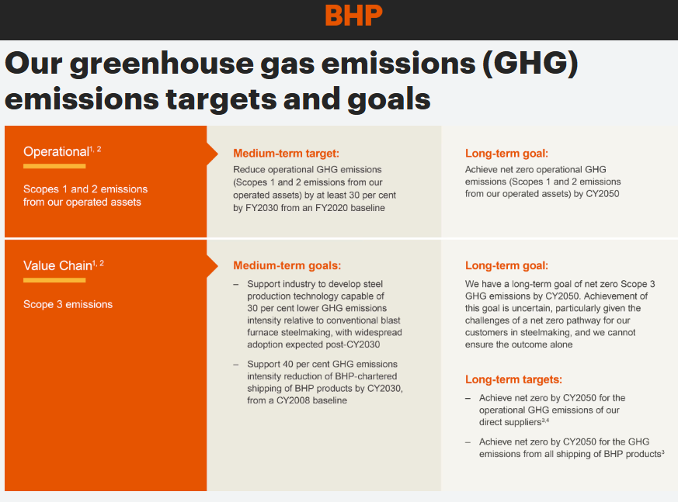
Figure 1: Emission targets of BHP
(Source: BHP, 2026)
It is investing substantially in low carbon products as well as sustainable mining practices. However, it is important for the company to focus on external marketing environment to ensure the success of this transition. The two major pestle factors there are influencing transition of BHP are the natural environment and the political environment.

1.1 Natural Environment
Kotler et al. (2024) states that analysing the marketing environment helps companies identify opportunities and threats that can affect strategies in the long run. The most important external environmental factor for BHP that is affecting it strategy is natural environment. This factor is the primary external factors for the company because its operations directly depend on natural sources and also contribute to degradation of environment significantly. Mining operations contribute to global emissions significantly with Tomaňová (2026) highlights that the mining sector is directly contributing almost 11% in global greenhouse gas emissions.
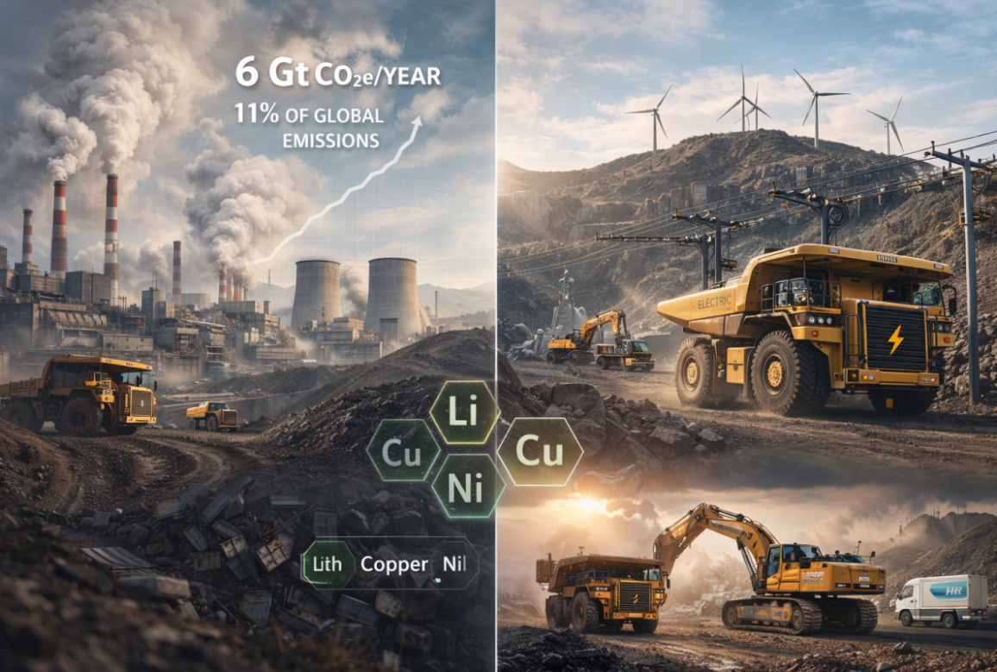
Figure 2: GHG emission by Mining and Metal Sector
(Source: Tomaňová, 2026)
To mitigate the increasing issues, several environmental initiatives have been implemented by BHP. It is committed to minimise its operational emissions live like scope 1 and scope 2 approximately 30% by 2030 which is compared with 2020 levels (BHP, 2026). The company also aims to the chief net zero operational emission by 2050. The annual report of the company highlighted that they will make efforts in CY2027 to stabilize value chain operations and maintain sustainable raw coal inventory levels (BHP, 2025). The company also focusing on enhancing climate related technologies, electrification of mining equipment, low carbon steel making research, and climate related technologies.
The following figure 3 highlights clean energy market is expanding rapidly with 20.9% CAGR from 2026 to 2030 (The Business Research Company, 2026) and it required several minerals.
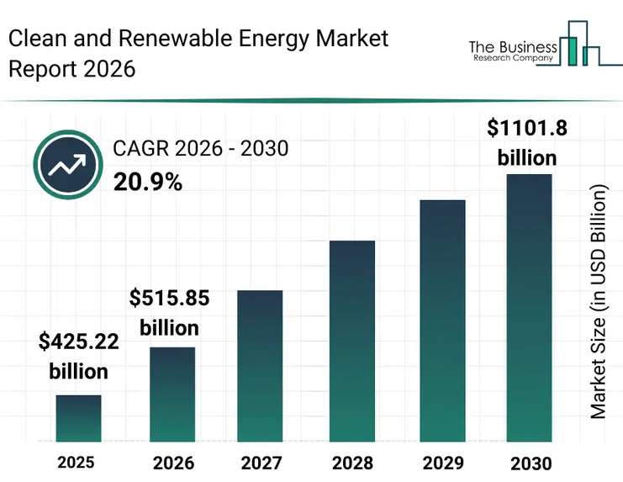
Figure 3: Clean energy market
(Source: The Business Research Company, 2026)
Therefore, a major opportunity has created for the company as well as the sector as this transition is increasing the demand for minerals. Electric vehicles, electricity greets, batteries, and renewable energy infrastructure needs copper, nickel, and potash. According to the following figure 4, the demand for copper is set to increase by almost 50% by 2040 to reach 42 million metric tons (Yergin et al., 2026).
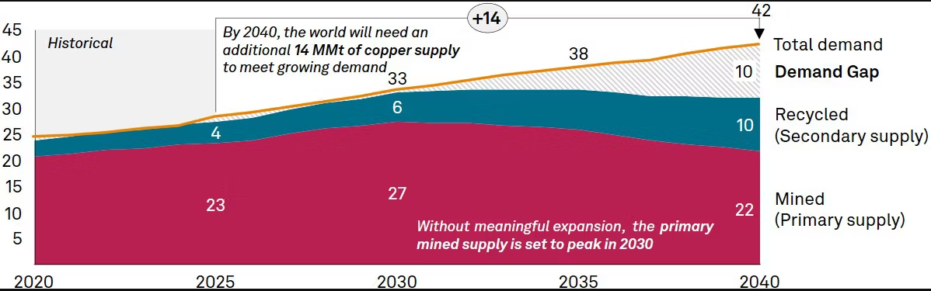
Figure 4: Global copper market
(Source: Yergin et al., 2026)
The following graph number 5 depicts that demand for nickel is also estimated to increase due to the increasing demand for cleaner energy (IEA, 2024).

Figure 5: Increasing demand of nickel for cleaner energy
(Source: Self developed)
As one of the largest producers of copper and nickel in the world, BHP has several market opportunities due to the increasing environmental concern and more focus on sustainability.
The company is also making collaborations with several steel manufacturers in order to ensure reduced emission in the steel production system. As steel manufacturing companies cause almost 7 to 9% of global carbon dioxide emission, it is important for them to make lower carbon iron ore products.
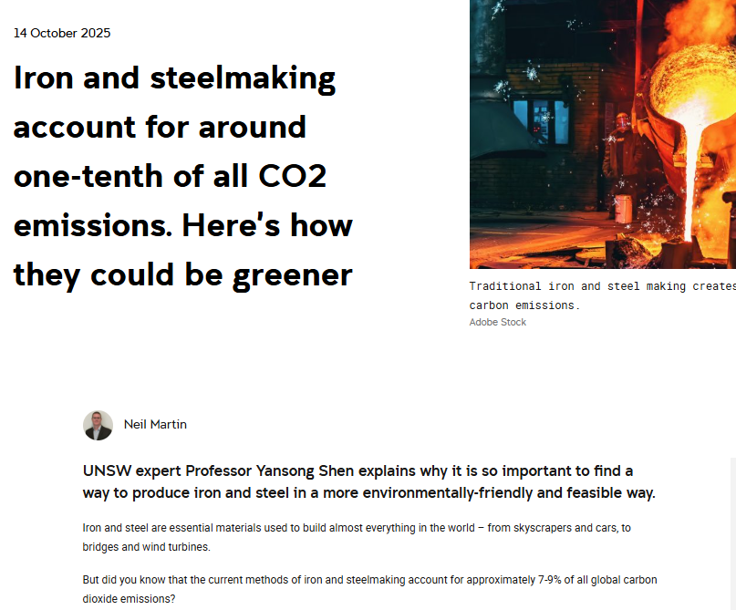
Figure 6: CO₂ emission by iron and steel making companies
(Source: Martin, 2025)
The above report confirms that iron and steel making is responsible for one tenth of the carbon emission.
These are also becoming popular among industrial customers who are focusing on minimising their carbon footprints.
However, there are several challenges the natural environment is posing to BHP. The challenges include cyclones, hit waves, floods, and droughts. These extreme weather events are disrupting mining operations increasingly. For instance, following report of figure 7 confirms that weather disruptions in Australia had significantly affected shares of mineral sources (Jino, 2026).
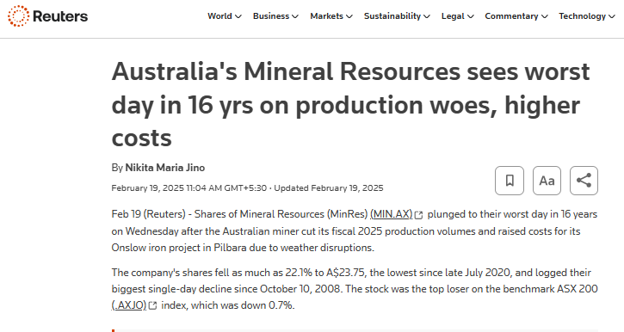
Figure 7: Impact of weather disruptions on mineral sources in Australia
(Source: Jino, 2026)
Stakeholders like environmental organisations, investors, local communities, and governments are demanding reduction in ecological damage and restoration of mining sites after extraction from the mining companies. If any company fails to implement these stakeholder expectations, then this can harm its brand image and effect investor confidence. 63% of mining & metals investors are avoiding investing in mining companies that fail to meet their decarbonisation targets (Taylor and Nana, 2022). Therefore, environmental sustainability is important for BHP to position itself as a responsible corporation among the environmentally conscious customers.

1.2 Political Environment
Another important factor for transition of BHP towards lower carbon products is political factor. The political environment has been selected because government climate policies, carbon reduction legislation, and critical mineral strategies directly determine approvals of mining, investment incentives, and market demand for low-carbon minerals. Although technological and socio-cultural factors also impact the transition of BHP, but political regulation creates the strongest external pressure. It influences requirements of operational compliance and future market opportunities.
The governments are introducing strict environmental regulations and setting carbon reduction targets and offering incentives that can affect mining companies directly. BHP has its operations in countries like Australia, the US, Canada, and Chile (BHP, 2026), which is confirmed by figure 8.

Figure 8: Locations of BHP
(Source: BHP, 2026)
Governments from these countries have strengthened environmental policies by implementing strict environmental standards and carbon reduction commitments. As shown in figure 9, Australia has a national target to minimise greenhouse gas emission by 43% by 2030 compare 2005 level (Gulliver, 2023).
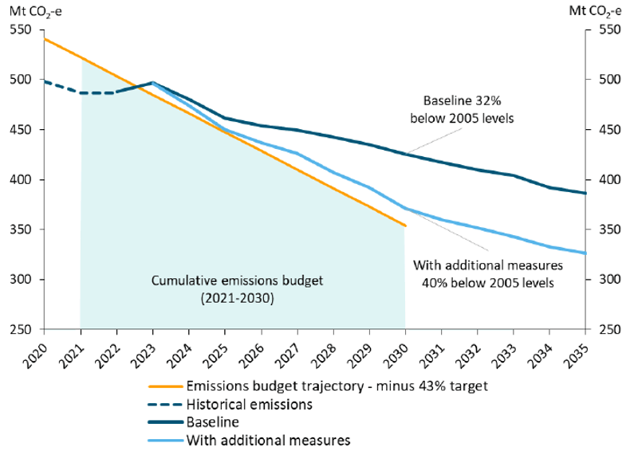
Figure 9: Emission goal of Australia
(Source: Gulliver, 2023)
This is pressuring business is to enhance their energy efficiency as well as implement several advanced cleaner technologies. In the same manner, the government of Chile has also implemented several climate policies for renewable energy (Climateactiontracker, 2025) which are directly impacting operations of mining companies.
BHP can have both opportunities and challenges due to government regulations. The company needs to focus on investing substantially in cleaner technologies to ensure compliance with governmental regulations in order capitalise the opportunities. For example, in North America, Europe, and Asia the governments are investing heavily develop clean energy infrastructure and enhance electric vehicle production, offering opportunities for the company. Moreover policy is like Inflation Reduction Act in the United States (Internal Revenue Service, 2026) as well as the Critical Raw Materials Act in European Union (European Commission, 2026) is also motivating investors to invest in responsibly sourced materials. Therefore, there is an increasing demand for copper and nickel products of BHP.
Political stability is also important for the company because it can impact long term investment decisions of the investors (Nguyen et al., 2025). With the stable government the investment risks can be reduced and expansion into low carbon production technologies can be encouraged. In summary, BHP should strengthen its relationships with regulators, governments, and other industry organisations to work collaboratively and ensure implementation of sustainable mining practices.

Task 2: Strategic Growth and Competitive Positioning – BHP's Transition to a Lower-Carbon Business Model

2.1 Recommendation of a strategic growth approach for BHP using Ansoff Matrix
BHP should adopt growth strategy considering the external factors which support business expansion and sustainability. The Ansoff matrix is a strategic framework which identifies four growth options namely market penetration, market development, product development, and diversification (The Strategy Institute, 2024).
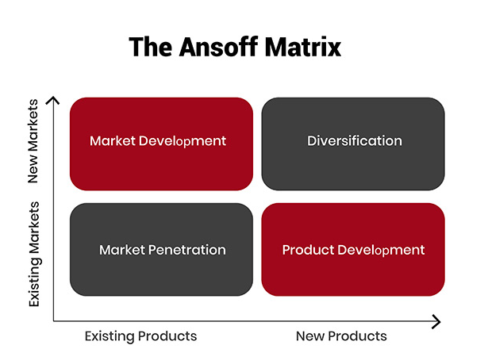
Figure 10: Ansoff Matrix
(Source: The Strategy Institute, 2024)
Product development is the accurate strategy for BHP to focus on introducing new and improved products into existing markets. Environmental analysis shows that strict government regulations for climate change and rising global demands need sustainable minerals to reshape mining industry. BHP can develop low-carbon iron ore, sustainably sourced copper and nickel, and innovative mining solutions. It enables BHP to meet increasing demand for environmentally responsible products to enhance competitive advantage and support long-term transition to low-carbon business model.
Product Development Strategy
BHP poses strong relationship with steel manufacturers, renewable energy companies, and industrial customers globally. Hence, Product Development strategy among the four strategic growth options of Ansoff Matrix (The Strategy Institute, 2024) is the most appropriate. Product development strategy helps BHP to respond directly to increased customer demand for environment-friendly products using low-emission raw materials. It can meet shifting global expectations maintaining existing customer base. The strategy involves introduction of new or improved products in existing market like producing low-carbon iron ore, sustainably sourced copper and nickel, and minerals extracted using renewable energy with advanced mining technologies.
Expanding Lower-Carbon Products:
The global steel production accounts 7-9% CO₂ emissions prioritising de-carbonisation for manufacturers (Dubec et al., 2026). BHP can expand its portfolio of low-carbon products as growth opportunity as steel producers are seeking mining companies to supply high-quality iron ore for low emissions. BHP has heavily invested in research with Asian Steel producers for low-emission steel production technologies, renewable electricity, and electrification of mining equipment. BHP is committed for climate innovation and de-carbonisation initiatives (BHP, 2026).
BHP can strengthen its market position by increasing investment in commercially available low-carbon products supporting environment. BHP can capture rapidly growing Copper and Nickel market demand with certified low-carbon mineral products as these are essential for electric vehicles, battery storage systems, wind turbines, and electric transmission networks. For example, figure 11 highlights that EVs use almost three times much copper than petrol-based cars.
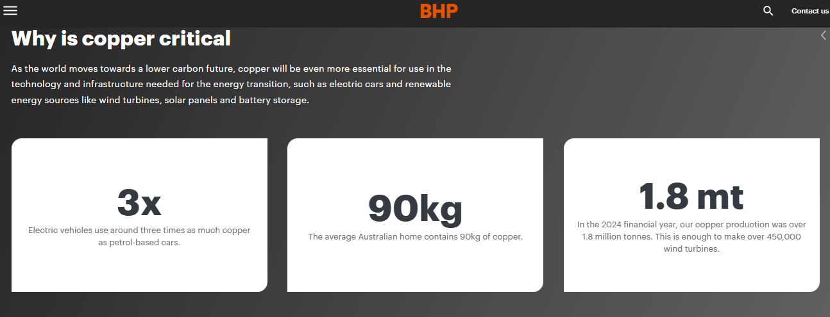
Figure 11: Importance of Copper
(Source: BHP, 2026)
During then, Market value of key energy transition minerals will increase due to current demand for global net-Zero targets. These is represented by figure 12.
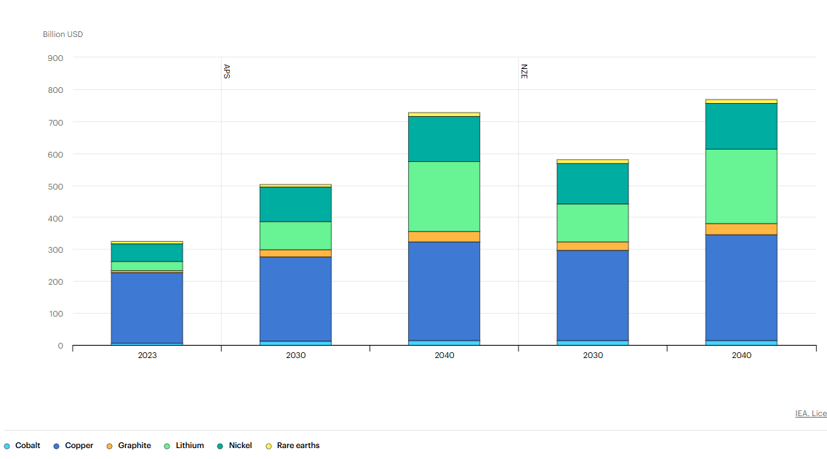
Figure 12: Market value of important energy transition minerals
(Source: IEA, 2024)
Investing in Green Innovation:
BHP should invest heavily in advanced technologies like electrical heavy trucks, renewable energy-powered mining operations, AI-ML for energy efficiency, and carbon capture technologies. Operational efficiency can be improved through digital technologies by optimising energy consumption, reducing waste generation, and improve resource recovery. Innovation is Key to achieve competitive advantage for reducing operational emissions and low-production costs for long-term (Ma, 2024). Automation and predictive maintenance can lower equipment downtime, reducing fuel consumption, and operational expenses. The World Economic Forum reports that circular economy practise can heavily reduce emissions improving long-term resource security (World Economic Forum, 2025). BHP can invest in circular economy to improve mineral recycling and resource recovery.
Implementation Challenges
Product development strategy offers various opportunities to the company but while ensuring successful implementation of this strategy the company may face various challenges. It is required substantial capital investment to develop low carbon technologies (Lai et al., 2024). Additionally, long research and development process as well as collaboration with technology providers, industrial customers, and governments are also required. Another issue is related to operational transformation because it involves changing of traditional diesel-powered mining equipment along with extended training to employees regarding new technologies and enhancing renewable electricity infrastructure. Therefore, the upfront cost is huge, increasing operational costs prior to the benefits are achieved. In addition to this, the company may face challenges in managing transitions towards sustainable production as the commodity prices are fluctuating remarkably. Hence, it is important for BHP to manage investments with expectations of shareholders efficiently to ensure enhanced financial performance.

2.2 Achieving Competitive Advantage
Kotler et al. (2024) explain to develop successful strategies and action plan companies need to gather information about the environment, the competition, and the market segments. According to the environment analysis of BHP it can be said that, with the help of product development strategy the company can achieve sustainable competitive advantage because it can help the company to achieve differentiation. It may be beneficial for the company that instead of competing on price primarily, it will compete by offering several sustainable products (Luo et al., 2024) which will have lower life cycle emissions.
According to Porter's Generic Strategies (Islami et al., 2020), BHP should implement differentiation strategy instead of cost leadership or focus. The company can differentiate itself by supplying responsibly sourced, low-carbon minerals, investing in green innovation, and building a strong ESG reputation. This strategy will help the company to create superior value for industrial customers who increasingly prioritise sustainability over price alone.
Industrial customers are now focusing on suppliers ESG criteria along with other factors like quality and cost. Suppliers of mining products need to have strong sustainability credential in order attract companies which produce renewable energy infrastructure, green steel, and electric vehicles. Hence, it is crucial for BHP to invest substantially in lower carbon products and also maintain strong relationships with their business partners.
The product development strategy also offers opportunities for premium pricing to the company. As illustrated in figure 13, the environmentally conscious customers are now willing to pay higher prices to ensure ethical sourcing (Novotny, 2025).
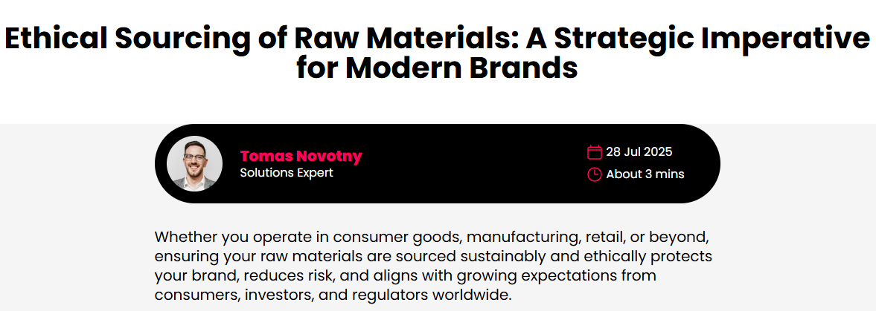
Figure 13: Importance of ethical sourcing
(Source: Novotny, 2025)
These investments can help the customers to ensure their ESG commitments and regulatory compliance. Consequently, with this strategy direct price competition can be reduced and customer loyalty can be enhanced.
In addition to this, the company can further improve its environmental performance to enhance its corporate reputation among stakeholders like investors, governments, and local communities. According to the report in figure 14, across the world the sustainable investment funds are expanding rapidly and the ESG focused asset has exceeded $30 trillion (Bloomberg, 2024).
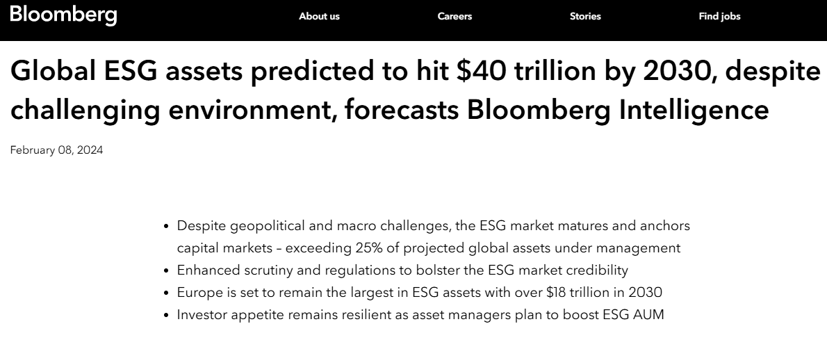
Figure 14: Global ESG assets
(Source: Bloomberg, 2024)
Therefore, by ensuring a strong sustainability profile, BHP can ensure its access to investment capital as well as it can also minimise reputational risks.

Task 3: Critical Reflection on AI Usage
In this section, we present a responsible and ethical approach towards utilization of Artificial Intelligence (AI) in development of marketing landscape and strategic growth analysis for BHP’s journey towards a low carbon model of operation. AI can help to generate the significant data from market operation that could help leaders for taking informed decision.

3.1 Tool Disclosure
Generative AI applications were mainly used as tools in the first stages of development of this report. The purpose of the applications was to assist with generating the main ideas, overcoming writers’ block and producing a simple framework for the implementation of such models like Ansoff Matrix. The application of AI at the final stages was aimed at proofreading the text to enhance its grammar and ensure the academic style. Along with the grammar correction AI can help in sentence constructions and meaning full sentence which would help form a meaningful writing.

3.2 Critical Evaluation of AI Output
Generative AI models regularly get "hallucinations." That means it may convey fabricated information or obsolete facts in a confident manner. From that AI text student can differentiate the false and authentic information on given context. For instance, all the AI-generated recommendations on the BPH’s sustainability timelines were verified with the official reports of the company regarding its goal of achieving net-zero operational emissions by 2050. Furthermore, all market figures, such as those concerning the clean energy market having the compound annual growth rate (CAGR) of 20.9%, were sourced and integrated manually to avoid logical inconsistencies in justifying the strategy.

3.3 Contribution Analysis
The divide between organisations with AI and original thought processes was unmistakable. The main concept of the paper, in this case that the most effective way for BHP to introduce low carbon iron ore and sustainably sourced copper to the market is to do so, was completely developed by human hands. The authors were called upon to think outside the box when developing interesting competitive advantages for BHP from the range of international political texts, including the US Inflation Reduction Act.

3.4 Ethical & Professional Reflection
There are ethical implications to consider when using AI to analyse marketing. AI tools can help support algorithmic bias or be the subjects of “greenwashing” if environmental statements are made that are difficult to verify. Marketed escrow is regulated by a professional code of ethics that requires analysis of accuracy, credibility and honesty. This report is intended to be used as a supporting tool to assist the manager's judgement. Transparency about AI is essential for academic integrity, and the proposed strategy takes into account credible data through fact-checking.

References
BHP (2025a). Annual Report. [online] BHP. Available at: https://www.bhp.com/ar2025.
BHP (2025b). Copper Critical | BHP. [online] Bhp.com. Available at: https://www.bhp.com/about/coppercritical.
BHP (2026a). Climate change. [online] Bhp.com. Available at: https://www.bhp.com/sustainability/climate-change.
BHP (2026b). Global locations. [online] Bhp.com. Available at: https://www.bhp.com/what-we-do/global-locations.
Bloomberg (2024). Global ESG assets predicted to hit $40 trillion by 2030, despite challenging environment, forecasts Bloomberg Intelligence | Press | Bloomberg LP. Bloomberg L.P. [online] 8 Feb. Available at: https://www.bloomberg.com/company/press/global-esg-assets-predicted-to-hit-40-trillion-by-2030-despite-challenging-environment-forecasts-bloomberg-intelligence/.
Climateactiontracker (2025). Policies & action. [online] Climateactiontracker.org. Available at: https://climateactiontracker.org/countries/chile/policies-action/.
Dubec, D., Šolc, M., Kovalčíková, K., Furman, J. and Marzena, K.-C. (2026). Industrial CO2 emissions, climate change, and human health: Decarbonization pathways in Iron and steel production. Green health, 2(2), p.16. doi:10.3390/greenhealth2020016.
Enemuo, M. and Ogunmodimu, O. (2025). Transitioning the mining sector: A review of renewable energy integration and carbon footprint reduction strategies. Applied Energy, [online] 384, p.125484. doi:10.1016/j.apenergy.2025.125484.
European Commission (2026). Critical Raw Materials Act. [online] European Commission. Available at: https://single-market-economy.ec.europa.eu/sectors/raw-materials/areas-specific-interest/critical-raw-materials/critical-raw-materials-act_en.
Gulliver, R. (2023). Australia has a revised target of reducing emissions by only 43% below 2005 levels by 2030, but even this goal may not be reached. [online] Climate Scorecard. Available at: https://www.climatescorecard.org/2023/06/australia-has-a-revised-target-of-reducing-emissions-by-only-43-below-2005-levels-by-2030-but-even-this-goal-may-not-be-reached/.
IEA (2024). Outlook for key minerals – Global Critical Minerals Outlook 2024 – Analysis. [online] IEA. Available at: https://www.iea.org/reports/global-critical-minerals-outlook-2024/outlook-for-key-minerals.
Internal Revenue Service (2026). Inflation Reduction Act of 2022 | Internal Revenue Service. [online] Www.irs.gov. Available at: https://www.irs.gov/inflation-reduction-act-of-2022.
Islami, X., Mustafa, N. and Latkovikj, M.T. (2020). Linking porter’s generic strategies to firm performance. Future business journal, [online] 6(1), pp.1–15. doi:10.1186/s43093-020-0009-1
Jino, N.M. (2025). Australia’s Mineral Resources sees worst day in 16 yrs on production woes, higher costs. Reuters. [online] 19 Feb. Available at: https://www.reuters.com/markets/commodities/australias-mineral-resources-sees-worst-day-16-yrs-production-woes-higher-costs-2025-02-19/.
Kotler, P., Armstrong, G., Harris, L.C. and He, H. (2024) Principles of marketing. 19th edn. Harlow: Pearson.
Lai, Z., Lou, G., Chung, S.-H., Fan, T., Ma, H. and Yu, M. (2024). The bright side of low-carbon technology sharing in a capital-constrained supply chain. Transportation Research Part E: Logistics and Transportation Review, [online] 193, p.103827. doi:10.1016/j.tre.2024.103827.
Luo, S., Sun, Z. and Zhang, X. (2024). Does green marketing improve corporate performance? International Review of Economics & Finance, [online] 97, p.103762. doi:10.1016/j.iref.2024.103762.
Ma, J. (2024). Carbon emissions and low-carbon innovation in firms. PLoS ONE, 19(10), pp.e0312759-e0312759. doi:10.1371/journal.pone.0312759.
Martin, N. (2025). Iron and steelmaking account for around one-tenth of all CO2 emissions. Here’s how they could be greener. [online] UNSW Sites. Available at: https://www.unsw.edu.au/newsroom/news/2025/10/Green-iron-steel-reduce-CO2-emissions.
Nguyen, M.H., Huong, T. and Nguyen, T.D. (2025). Corporate Investment and Political Stability: Role of an Enormous Anti-Corruption Campaign, Ownership Structure, and Financial Constraints in An Emerging Economy. SAGE Open, 15(2). doi:10.1177/21582440251340546.
Novotny, T. (2025). Ethical Sourcing of Raw Materials: A Strategic Imperative for Modern Brands | Sedex. [online] Sedex. Available at: https://www.sedex.com/blog/due-diligence-ethical-raw-material-sourcing/.
Taylor, A. and Nana, P. (2022). How mining & metals companies can make ESG work in a downturn | White & Case LLP. [online] Www.whitecase.com. Available at: https://www.whitecase.com/insight-our-thinking/mining-metals-2022-how-mining-metals-companies-make-ESG-work-downturn.
The Business Research Company (2026). Clean and Renewable Energy Market Report 2026. [online] The Business Research Company. Available at: https://www.thebusinessresearchcompany.com/report/clean-and-renewable-energy-global-market-report.
The Strategy Institute (2024). The Ansoff Matrix: A Powerful Tool for Business Strategy and Growth. [online] The Strategy Institute. Available at: https://www.thestrategyinstitute.org/insights/the-ansoff-matrix-a-powerful-tool-for-business-strategy-and-growth.
Tomaňová, P. (2026). Mining and Metals industry drives 11 percent of global emissions. [online] Lectura.press. Available at: https://lectura.press/en/article/mining-and-metals-industry-drives-11-percent-of-global-emissions/68647.
World Economic Forum (2025). Circular Transformation of Industries: Unlocking Economic Value. [online] World Economic Forum. Available at: https://reports.weforum.org/docs/WEF_Circular_Transformation_of_Industries_2025.pdf.
Yergin, D., Pascual, C., Kramarz, E., Noue, A. De La, Acosta, M., Bender, G., Bonakdarpour, M., Bailey, T. and Rajan, K. (2026). Copper in the Age of AI | S&P Global. [online] S&P Global. Available at: https://www.spglobal.com/en/research-insights/special-reports/copper-in-the-age-of-ai.

