University of Wales, Trinity Saint David

Governance, Legislation and Ethics Work-Based Project (ACCA5016)
Anton Hall 1809131

Contents
Report for Head of Information Governance 1
Introduction 1
1. Summary of Data Protection principles 1
2. Summary of Organisational policy 2
3. Actions to prevent further data breach 3
4. Evaluation of Actions 3
Report for Executive Board 4
Introduction 4
5. Risk Exposures 4
6. ICO Evaluation 4
7. Potential Occupational health report leak 5
Discussion Note for Governance Committee Meeting 5
Consideration of approaches to prevent data breaches 5
Conclusion 6
References 7
Appendix 1 1

Report for Head of Information Governance

Introduction
It has become evident that a manager in an operational department has accidently emailed the names and addresses of members of their staff to a member of the public. This incident has been passed on to the manager responsible for Information Governance in the organisation for further investigation. It is apparent that the operational manager had downloaded the list from an operational system to undertake the task more efficiently and has mistakenly attached the incorrect document when attempting to send a leaflet stored on his desktop out to a member of the public. This is a breach of the Data Protection legislation and upon further investigation it is established that scanned copies of staff sick notes and occupational health reports have also accumulated on the managers desktop. The purpose of this report is to inform the Head of Information Governance of the breach that has occurred and will address the following points:
- Summary of the Data Protection principles that may have been breached
- Summary of the Organisation’s policy
- Actions to be taken in line with the Organisation’s policy to further prevent such breaches
- Evaluation of actions required to be taken regarding those whose information was leaked

Summary of Data Protection principles
Through the occurrence of this data breach, many Data Protection principles would have been breached, all of which will be addressed in this section of the report. The Data Protection Act 2018 controls how personal data is used by organisations and has six key principles which must always be adhered to.
“Any person responsible for personal data must ensure that information is: (1) used fairly, lawfully and transparently; (2) used for specified, explicit purposes; (3) used in a way that is adequate, relevant and limited to only what is necessary; (4) accurate and, where necessary, kept up to date; (5) kept for no longer than is necessary; (6) handled in a way that ensures appropriate security, including protection against unlawful or unauthorised processing, access, loss, destruction or damage.” [1]
As the manager in the operational department has unwittingly sent out personal information of their staff members to a member of the public, the organisation have breached the first key principle as employees would not want their personal information shared and this would be considered unfair and unlawful. The Data protection principles state that the information held for individuals should be used for a specified purpose and should be relevant. The sharing of their information to an external source would again be a violation of this principle as there would be no known purpose for sharing this information and it would not be in any way relevant to the recipient. Arguably the most damaging principle which would have been breached by this information leak, is the issue surrounding security and the requirement to protect against unlawful and unauthorised processing of data. The manager of the operational team has shared employees’ personal details without their consent and has not managed their data with appropriate security as set out in the Data Protection Act. The incident has essentially shared extremely personal data of its staff members with a member of the public and has breached many of the key Data Protection principles which is a very serious concern.

Summary of Organisational policy
In relation to the breach, the organisational policy would need to be reviewed and elements of it put into practice where appropriate and necessary, dependant on the severity of the data leak. Any such incident should be reported as soon as possible to the organisations privacy officer to allow it to be dealt with effectively and efficiently, whilst also complying with company policy. There is a Privacy Policy in place which demonstrates that the organisation is:
“committed to the protection of the personal information of both its employees and clients.” [2]
Given the nature of the data breach which has occurred, the policy would have been somewhat voided hence the need to follow a procedure to report it to the Head of Information Governance within the organisation. The policy that outlines the procedure that should be followed is the Personal Data Breach Plan and Policy. In regard to the steps required to be followed to adhere to the organisation’s policy, the first action which should be taken is to identify the breach that has occurred. The breach should then be highlighted to the relevant responsible officer, in this case, the Head of Information Governance. This is done by completing a data breach report form and emailing the completed form to both the privacy officer and IT security. Each breach should and will be reviewed on a case by case basis to determine what action should follow. At this point the Privacy officer will:
“ The Privacy Officer will acknowledge receipt of the data breach report form (if the person making the report has given their name) and take appropriate steps to deal with the report in collaboration with the data breach team.” [3]

In this particular circumstance, the member of public who has been sent the identifiable information of the employees’ should be contacted to explain the situation and it should be requested that they immediately disregard the data they have received and destroy the email from their devices. An attempt should also be made by the operational manager to recall the email where possible. In respect of the Privacy Policy which states that it will ‘inform employees of why and how we collect, use and disclose their personal information and obtain their consent where required’, the next step of the procedure should involve informing all affected staff members whose information has been leaked. It should be made clear to those concerned that all efforts have been made by the operational manager to recall the email and also that the member of public in receipt of the information has been requested to destroy it. The Privacy Notice states that the organisation have
“put in place appropriate security measures to prevent personal information from being accidentally lost, used or accessed in an unauthorised way, altered or disclosed.” [1]
This declaration applies to all existing employees, therefore it is highly likely that those employees whose data has been leaked will feel disgruntled and let down by the mistake that has happened. Following an assessment of the data breach and the reasons as to why it occurred, a security audit should take place to ensure that the data has not been leaked to any further sources. The Operational manager should be provided with further training to ensure they understand the seriousness of the breach and that it does not happen again in the future. It is also an option to further protect the data being held of employees, which could be done with password protection or further encryption. Please see appendix 1 for a detailed flow chart of actions that should take place in the event of a data breach.

Actions to prevent further data breach
There are many steps which can and should be taken to prevent further data breaches occurring within the organisation which include the following:
- The Organisational manager should be reminded of the Data Protection Act and the seriousness of a data breach
- Further training sessions should be provided and resources readily available to all staff
- Additional security measures put in place to protect data – password protected documents, encryption of documents etc
- Only a small number of relevant staff should have access to employee’s personal data
- Regular risk assessments should take place to evaluate current processes in regards to data
- Evaluate employee accounts regularly to ensure that any ex-employees have no access to personal data
- consider whether it is necessary to carry out any further privacy risk assessment

Evaluation of Actions
This section of the report will evaluate the actions that are required to be taken in respect of those whose information has been leaked. The first action that should be taken is to identify the data subjects who have been directly affected by the data breach and the content of information contained. Following this, the organisation should report the breach to the Information Commissioner’s Office (ICO) within 72 hours of being made aware of the data leak. The ICO states that:
“When a personal data breach has occurred, you need to establish the likelihood and severity of the resulting risk to people’s rights and freedoms.” [4]
- and given that employees’ names and personal addresses have been leaked, it is difficult to contest that this is not a reportable offence. Once it has been established who has been affected by the breach, it is imperative that these individuals are contacted and informed of what information has been compromised. The output of this contact can be made via letter or email, but should be done in written format to ensure that there is an audit trail of the subjects being informed. Given the nature of the identifiable information that has been leaked, it is considered to be a serious breach which could find the employees safety compromised in some way. In the written communication to the subjects, it should be explained that corrective actions have been put in place to retract the information from the member of public, in the form of attempting to recall the initial email and requesting that they destroy that which has been sent to them. In addition to this, it is important that a sincere apology is given to the employees’ whose information has been leaked and reassurances given that steps will be put in place to prevent this happening again in the future. The Data Protection Officer dealing with the breach should ensure that they update the data breach log which will ensure that there is a full audit trail of any instances which occur and any follow up actions can be reported. Please see appendix 1 for a detailed flow chart of actions that should take place in the event of a data breach.

Report for Executive Board

Introduction
This section of the report will evaluate the risk exposures associated with the data breach and the information that has been leaked. It will also be reviewed as to whether the ICO should be informed of the breach and reasons for this. The report will determine whether conflicting advice would be given if the content of information leaked was of a different category.

Risk Exposures
In relation to the data breach that has occurred, there are many risks associated to both the organisation and the data subjects whose information has been compromised. Given that this breach has leaked full names and addresses of staff members to a member of the public, this immediately poses a potential risk to the individuals safety. This information is highly confidential and in line with one of the key principles of GDPR, should be:
“processed in a manner that ensures appropriate security of the personal data, including protection against unauthorised or unlawful processing and against accidental loss.” [5]
As well as this, there is a risk that the employees could become the subject of identity fraud given the content of data that has been compromised. In addition to the effect on the employees who data has been leaked, there are also significant risks for the organisation. Both employees and customers trust the organisation to store their data safely and are of the understanding that it will only be used for its intended purposes, therefore if a data breach occurs, they are likely to trust the organisation much less with their information. An organisation works hard to build and maintain their reputation and the damage a data breach can do can be extremely detrimental. To support this,
“A 2019 Verizon study suggests that data security and privacy are essential to maintain customers. 69% of survey respondents would avoid a company that had suffered a data breach.” [6]
Following a data breach, the organisation is required to complete a full and in-depth investigation to understand how the breach happened and any contributing factors which can be improved upon to further prevent such issues reoccurring. This investigation will be timely to the company who will need to dedicate time and resources to both resolve the current issue and future proof the existing processes. In addition to this, a record needs to be kept of every data breach which occurs for audit purposes; therefore this will also add to the resources needed to be available.

ICO Evaluation
Following a data breach, it should be immediately determined as to whether the Information Commissioners Office (ICO) needs to be informed of the information leak. The ICO’s website states that:
“You must report a notifiable breach to the ICO without undue delay, but not later than 72 hours after becoming aware of it. If you take longer than this, you must give reasons for the delay.” [4]
In terms of the data breach which has occurred within the organisation whereby the full names and addresses have been leaked to a member of the public, it is determined that this would warrant the ICO being informed due to the nature of the information that has been compromised. GDPR explains that:
“A personal data breach may, if not addressed in an appropriate and timely manner, result in physical, material or non-material damage to natural persons such as loss of control over their personal data or limitation of their rights, discrimination, identity theft or fraud, financial loss, unauthorised reversal of pseudonymisation, damage to reputation, loss of confidentiality of personal data protected by professional secrecy or any other significant economic or social disadvantage to the natural person concerned.” [7]
It is therefore imperative that the data breach is reported to the ICO as soon as possible, so that they are informed of potential risks associated and impact that it may have on those affected. The ICO also advise that it should be considered whether users (employees in this instance), need to be informed of the breach. As highly personal information has been leaked, it has been established that the employees affected will be notified at the earliest possible opportunity.

Potential Occupational health report leak
If the Operational Manager had accidentally sent an Occupational Health report or sick note of an employee to a member of the public, it would again be a very serious data breach that would require an investigation and reporting to the ICO. The advice would therefore not differ greatly to that which has been discussed in question 5, however the risks associated are arguably more serious. In this scenario, there would be many risk exposures to both the individual and the organisation. Due to the sensitivity and confidentiality of the information contained within both a sick note and an Occupational Health report, it should be the case that only a very small number of employees within an organisation have access to it. In addition to this, it is questionable as to why the Operational manager has access to such confidential information which would usually be managed and accessed securely by the HR department. In terms of the advice provided in question 5, a key difference to this scenario is that there would be more embarrassment for both the organisation and the subject of the data leak. The employee whose highly personal medical information has been leaked will inevitably feel that they had been let down by the organisation and will feel a sense of humiliation. The organisation however will also have similar feelings towards the situation given that the data should be held much more securely with limited access to it. Following the leak of such sensitive information, an audit would likely need to take place within the organisation to establish why and how the information came to be in the possession of the Operational manager. It would also be the case that a review of existing practices should take place to implement guidelines for prevention of similar occurrences in the future.

Discussion Note for Governance Committee Meeting

Consideration of approaches to prevent data breaches
As referred to throughout this report, there are many considerations which can be made to existing protocols in an attempt to minimise the risk of such data breaches reoccurring in the future.
- Provide staff with training and courses on Data Protection and GDPR Principles
- Review existing organisational security policies – passwords/encryption etc.
- Organisation wide communication to remind staff of general Data Protection to adhere to
- Audit of employees who have access to confidential and sensitive information – ensure their access is still relevant and of a sufficient level
- Regular risk assessments to be carried out to evaluate existing processes and ensure they are kept up to date with guidelines

Conclusion
To summarise, this report has been prepared for the Head of Information Governance in order to inform them of the Data Protection principles that have been breached due to this information leak. The report also includes a list of actions which should be taken in line with the organization’s policy in order to prevent further breaches of a similar kind. The report also addresses how best to inform and deal with those subjects who have been affected by the data leak. In addition to this, a report has been produced for the Organisation’s Executive Board to discuss the risks associated with this data breach, as well as an evaluation of whether the ICO should be informed, which it was decided that they should. The report touches upon whether the risks identified with the information leak of content such as names and addresses would differ if it were more personal data such as sickness reports. To conclude, a discussion note for a Governance Committee meeting has been included which provides a brief note of considerations to approach in order to minimize the risk of further data breaches within the organization.

References
[1] “Data protection - GOV.UK.” [Online]. Available: https://www.gov.uk/data-protection. [Accessed: 09-Sep-2020].
[2] “Stantec UK Candidate Privacy Notice,” May 2020.
[3] “Stantec Personal Data Breach Plan and Policy.” .
[4] “Personal data breaches,” 2020. [Online]. Available: https://ico.org.uk/for-organisations/guide-to-data-protection/guide-to-the-general-data-protection-regulation-gdpr/personal-data-breaches/. [Accessed: 09-Sep-2020].
[5] “Personal data breaches | ICO.” [Online]. Available: https://ico.org.uk/for-organisations/guide-to-data-protection/guide-to-the-general-data-protection-regulation-gdpr/personal-data-breaches/. [Accessed: 09-Sep-2020].
[6] “How the Consequences of a Data Breach Threaten Small Businesses - Insights | Worldpay from FIS,” 10-Jul-2019. [Online]. Available: https://www.fisglobal.com/en/insights/merchant-solutions-worldpay/article/how-the-consequences-of-a-data-breach-threaten-small-businesses. [Accessed: 09-Sep-2020].
[7] N. Vollmer, “Recital 85 EU General Data Protection Regulation (EU-GDPR),” May 2020.

Appendix 1
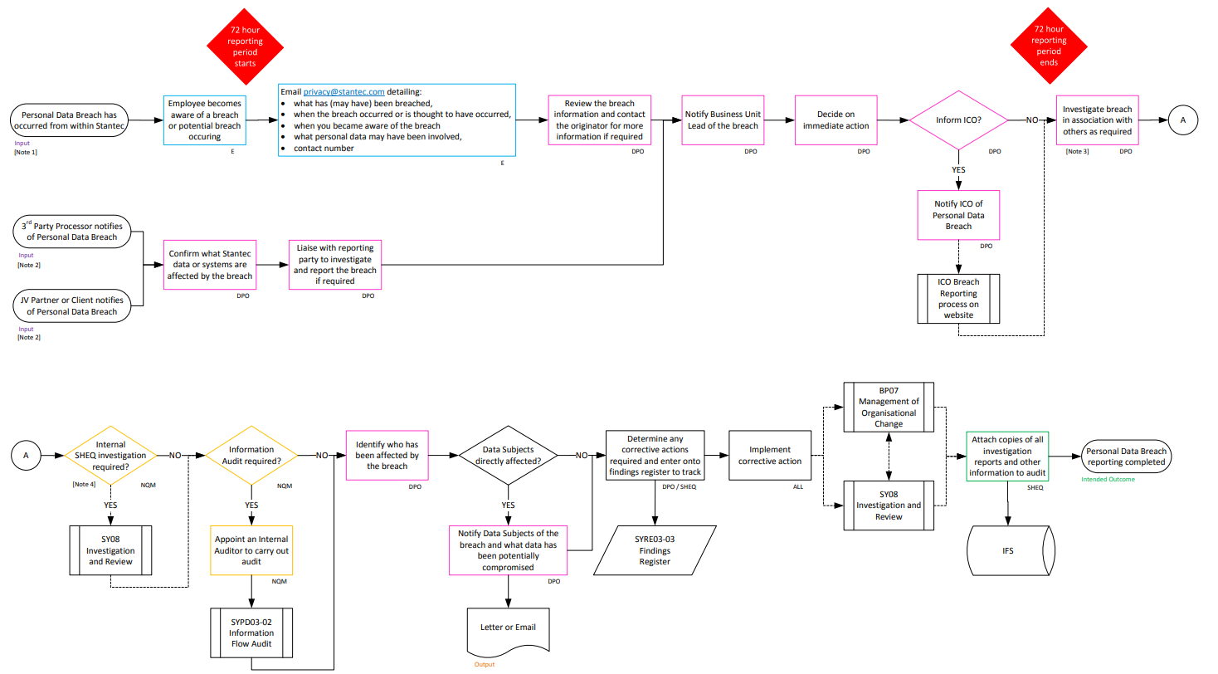
Figure 1 Stantec Data Breach Reporting

