Joel Codd 2117927

Mechanical Engineering and Energy & Environmental Engineering
Control & Automation

Summary
This paper explores the integration of Instrumentation, Control, and Automation (ICA) in wastewater treatment plants, which plays a vital role in enhancing the efficiency, safety, and environmental compliance of wastewater treatment processes. The adoption of ICA technologies has significantly transformed the operations of wastewater treatment facilities, reducing manual intervention and improving process control.
ICA in wastewater treatment is look at, highlighting the progression from manual systems to semi-automated processes in the mid-20th century, and further advancements to fully automated, AI-driven facilities in the 21st century. The key components of ICA, including sensors, process controllers, and actuators, are discussed in detail. Sensors, such as flow, pH, dissolved oxygen, and turbidity sensors, continuously monitor essential process variables to ensure efficient treatment. Process controllers, such as Programmable Logic Controllers (PLCs) and Supervisory Control and Data Acquisition (SCADA) systems, enable real-time process adjustments. Actuators, such as valves, pumps, and aerators, are responsible for executing the control actions.
In the pursuit of autonomous operation, modern wastewater treatment facilities are increasingly relying on advanced technologies such as Artificial Intelligence (AI), the Internet of Things (IoT), and Digital Twins. These technologies facilitate predictive maintenance, operational optimization, and real-time process monitoring, enabling facilities to function with minimal human intervention.
The paper also covers the regulatory frameworks and standards that wastewater treatment plants must adhere to, such as those established by the Environmental Protection Agency (EPA), the World Health Organization (WHO), and various national and international standards. Compliance with these regulations is facilitated through automated monitoring systems that ensure continuous adherence to environmental and safety standards.
Finally, recent technological innovations are discussed, including the application of smart actuators, AI-driven analytics, and digital twin simulations, all contributing to the growing trend of fully automated and efficient wastewater treatment plants. The combination of these advanced technologies promises to improve operational efficiency, reduce costs, and further enhance environmental sustainability in wastewater treatment.
Contents
Summary 1
Table of Figures 3
Acronyms 4
Introduction 5
History of ICA in Wastewater Treatment 6
Key Components of ICA in Wastewater Treatment 7
1. Sensors 7
2. Process Controllers 8
3. Actuators 9
Supervisory Control and Automation 11
Regulatory Standards and Compliance 13
Advancing Technology 13
Conclusion 15
Bibliography 16

Table of Figures
Figure 1 - Flow Sensor 7
Figure 2 - PLC controller (PLC Control , 2020) 9
Figure 3 - Waste Water Valves 10
Figure 4 - Submersible Waste Water Pump 10
Figure 5 - Mixer Installed at Waster Water plant 11
Figure 6 - SCADA System Example 12
Figure 7 - Membrane Bioreactor 14

Acronyms
- ICA: Instrumentation, Control, and Automation
- SCADA: Supervisory Control and Data Acquisition
- PLC: Programmable Logic Controller
- DCS: Distributed Control System
- AI: Artificial Intelligence
- IoT: Internet of Things
- HMI: Human-Machine Interface
- BOD: Biochemical Oxygen Demand
- TSS: Total Suspended Solids
- DO: Dissolved Oxygen
- EPA: Environmental Protection Agency
- NPDES: National Pollutant Discharge Elimination System
- ISO: International Organization for Standardization
- OSHA: Occupational Safety and Health Administration
- WHO: World Health Organization
- MBR: Membrane Bioreactor
- RO: Reverse Osmosis
- ML: Machine Learning
- BOD: Biochemical Oxygen Demand

Introduction
Wastewater treatment is a crucial process for maintaining public health and environmental quality by treating sewage and industrial effluent. Over the years, the sector has seen significant improvements with the introduction of Instrumentation, Control, and Automation (ICA) systems, which allow for more efficient, cost-effective, and environmentally responsible operations. The changes in ICA technologies ensure that wastewater treatment plants can function with minimal human intervention while maintaining high levels of performance, safety, and regulatory compliance. This paper explores the role of ICA in wastewater treatment, detailing its historical adoption, core components (such as sensors, controllers, and actuators), supervisory control systems, and relevant regulatory frameworks. It will also highlight some of the latest advancements in technology within this sector.

History of ICA in Wastewater Treatment
The integration of ICA in wastewater treatment has evolved through several technological phases. Early systems in the mid-20th century relied heavily on manual controls and mechanical systems. Operators would monitor various process parameters like water flow and chemical dosing, adjusting based on visual indicators or periodic checks. This system was labour-intensive and prone to human error, limiting efficiency and consistency in treatment (Metcalf & Eddy, 1979).
In the 1960s and 1970s, the introduction of pneumatic and electrical control systems paved the way for semi-automated operations. The introduction of Programmable Logic Controllers (PLCs) in the late 1970s marked the beginning of digital control systems in wastewater plants. These controllers provided improved reliability, flexibility, and accuracy in controlling mechanical processes such as pumps, valves, and aerators (Perry & Green, 1984).
By the late 1980s, the industry saw the introduction of Distributed Control Systems (DCS), which allowed for more integrated and sophisticated control over the entire treatment process. These systems could collect data from various sensors placed throughout the plant, enabling real-time process monitoring and control, which further enhanced efficiency and minimised human intervention (Distributed Control Systems in Wastewater Treatment, 1988).
In the 2000s and beyond, the convergence of digital technologies with the rise of the Internet of Things (IoT) and Artificial Intelligence (AI) enabled even more advanced control and automation capabilities. Wastewater treatment plants today can often operate autonomously, with AI-driven systems that predict maintenance needs, adjust processes based on sensor data, and detect anomalies before they lead to system failures (Boulos, Ibbotson, & Zhang, 2018).

Key Components of ICA in Wastewater Treatment

1. Sensors
Sensors are the backbone of any ICA system, continuously providing data on key process variables. These include parameters such as flow rate, pressure, pH levels, dissolved oxygen, turbidity, and chemical composition of the wastewater.
Some common types of sensors include:
- Flow Sensors: These sensors measure the volume of water entering and exiting the treatment facility. Flow measurement is essential for controlling the distribution of water through the various treatment stages.
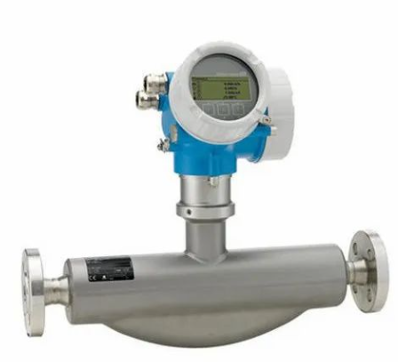
Figure 1 - Flow Sensor
- pH Sensors: pH sensors help monitor the acidity or alkalinity of the wastewater. These sensors are particularly useful for controlling the neutralisation process, especially in industries where acidic or basic waste is generated (Metcalf & Eddy, 1979).
- Dissolved Oxygen Sensors: These sensors measure the level of oxygen dissolved in the water, which is vital for the biological treatment stages where microorganisms break down organic matter.
- Turbidity Sensors: These are used to detect the presence of suspended solids in wastewater. High turbidity may indicate that the treatment process is ineffective or incomplete.
- Nitrate and Ammonia Sensors: These sensors are critical for removing nutrients such as nitrogen compounds that can contribute to eutrophication in receiving water bodies.
- Chemical Sensors: These sensors are used to monitor the concentration of specific pollutants, ensuring that harmful substances are adequately removed during the treatment process.

With advancements in sensor technology, many wastewater treatment facilities now use self-cleaning and self-calibrating sensors. These sensors are easier to maintain and more reliable, reducing the need for regular manual calibration and maintenance (Rieger, Thomann, Gujer, & Siegrist, 2010).

2. Process Controllers
Process controllers are responsible for interpreting the data from sensors and making decisions to optimise the treatment process. They receive input from the sensors and issue commands to actuators that adjust various operational parameters.
- Programmable Logic Controllers (PLCs): PLCs are rugged devices that automate simple control tasks such as switching pumps on and off. They are widely used in wastewater treatment because of their reliability and ability to handle harsh environments.
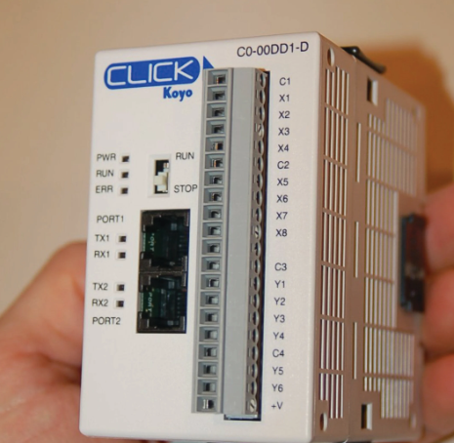

Figure 2 - PLC controller (PLC Control , 2020)
- Supervisory Control and Data Acquisition (SCADA) Systems: SCADA systems provide a centralised interface where operators can monitor plant performance, access real-time data, and adjust remotely. These systems also allow for alarm management, where operators are notified of potential issues or failures
- Advanced Process Control (APC): APC systems use sophisticated algorithms to optimise complex processes. AI and machine learning can be used to predict demand, look at trends, and adjust treatment processes to get the best possible results.
- Human-Machine Interfaces (HMIs): HMIs provide operators with a user-friendly interface to visualise real-time data and interact with the control system. These systems allow for easy adjustments and enable operators to quickly identify any anomalies in the process.
The combination of cloud computing and AI-driven analytics has revolutionised modern process controllers. These systems can now predict when maintenance is needed and identify potential system failures before they occur, reducing downtime and improving plant reliability (Tortajada, Joshi, & Biswas, 2012).

3. Actuators
Actuators are devices that execute the commands issued by the process controllers. These devices directly impact the physical processes of the treatment plant.
- Valves: Valves regulate the flow of water and chemicals throughout the system. They are used to control the volume of water entering and exiting each treatment stage. Several kinds of valves are used, gate, butterfly, pneumatic.
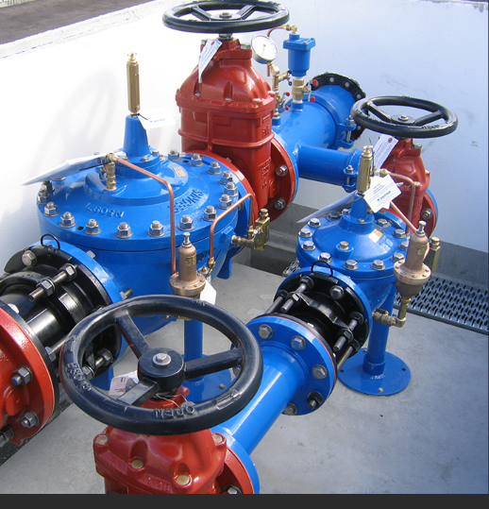
Figure 3 - Waste Water Valves
- Pumps: Pumps are essential for transporting wastewater through the various stages of treatment, including the aeration tank, clarifiers, and chemical dosing units.
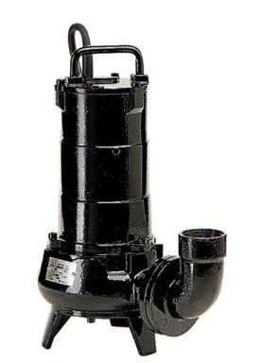
Figure 4 - Submersible Waste Water Pump
- Aerators: Aerators supply oxygen to the biological treatment stages, allowing microorganisms to break down organic matter. These are particularly important in the activated sludge process, where oxygen is crucial for the survival of aerobic bacteria.
- Mixers: Mixers ensure that chemicals are evenly distributed throughout the wastewater, especially in the coagulation and flocculation stages.
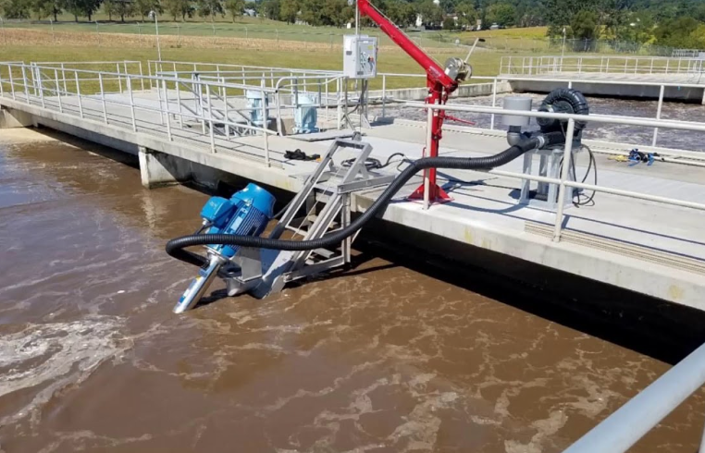
Figure 5 - Mixer Installed at Waster Water plant
As actuators become smarter, they now have the ability to communicate with process controllers in real-time, allowing for quicker responses and improved efficiency (Wang & Zhang, 2021).

Supervisory Control and Automation
The ultimate goal of ICA in wastewater treatment is to create systems that operate with minimal human intervention. This is achieved through the integration of various technologies that allow plants to function autonomously.
- SCADA Systems: SCADA systems are integral to monitoring and controlling plant processes. These systems allow operators to visualise real-time data, adjust settings remotely, and manage alarms that are triggered when something goes wrong.
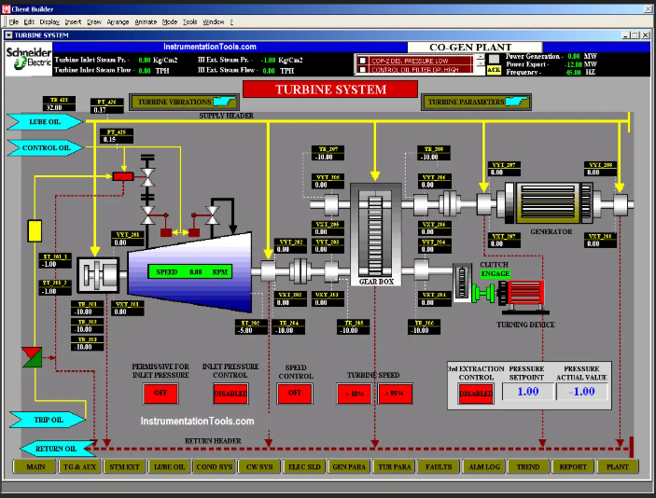
Figure 6 - SCADA System Example
- IoT Integration: The Internet of Things connects sensors, devices, and machines, allowing them to communicate over networks. This networked approach enables more efficient maintenance and monitoring. For example, sensors may alert technicians to failing equipment before it causes an issue, improving plant uptime.
- AI and Machine Learning: AI and machine learning are being used to improve process efficiency, optimise energy use, and detect anomalies. Predictive analytics allows for proactive decision-making, where the system anticipates issues and corrects them before they affect operations (NACWA, 2023).
- Digital Twins: A digital twin is a virtual model of a wastewater treatment plant. It allows operators to simulate different scenarios, test new processes, and optimise plant performance before making changes in the real world (Tortajada, Joshi, & Biswas, 2012).

Regulatory Standards and Compliance
Wastewater treatment facilities are guided by strict regulatory standards to ensure they operate safely and meet environmental protection requirements. These regulations are designed to protect public health, prevent pollution, and maintain water quality.
- EPA Guidelines: In the United States, the Environmental Protection Agency (EPA) sets guidelines for wastewater discharge, ensuring that treated water meets quality standards before being released into the environment.
- ISO 14001: ISO 14001 provides a framework for environmental management; which wastewater treatment plants can use to ensure they operate in an environmentally sustainable manner. (14001, 2015)
- NPDES: The National Pollutant Discharge Elimination System (NPDES) regulates the discharge of wastewater into US water bodies, ensuring that wastewater treatment plants do not harm aquatic ecosystems.
- European Water Framework Directive: In Europe, this directive aims to protect water resources by requiring member states to achieve and maintain good water quality across all bodies of water.
- WHO Guidelines: The World Health Organization provides global guidelines for wastewater treatment and reuse, particularly in developing countries where water scarcity is a concern (WHO, 2017)

Advancing Technology
Over the past decade, the wastewater treatment industry has witnessed the adoption of several cutting-edge technologies aimed at improving process automation and sustainability (WHO, 2017).
- Membrane Bioreactors (MBR): MBR technology combines biological treatment with membrane filtration, allowing for higher-quality effluent and more compact treatment systems. MBR systems are increasingly used in areas where space is limited or where high-quality effluent is required.
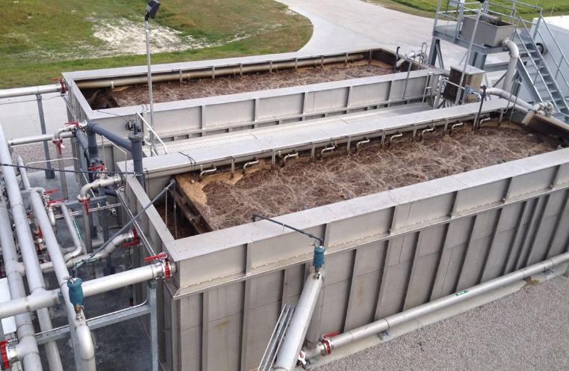
Figure 7 - Membrane Bioreactor
- Advanced Filtration Techniques: New filtration technologies, such as reverse osmosis and ultrafiltration, are being used to treat wastewater to a level where it can be reused in industrial applications, reducing water consumption (AWWA, 2022).
- Energy Recovery: Wastewater treatment plants are also adopting energy recovery systems that generate electricity from biogas produced during the treatment process. These systems make plants more energy-efficient and sustainable.

Conclusion
The adoption of ICA in wastewater treatment has transformed the industry, making plants more efficient, reliable, and capable of operating autonomously. The integration of sensors, controllers, and actuators, along with advanced systems like SCADA, IoT, AI, and digital twins, has enabled significant improvements in process control and monitoring. As the sector continues to embrace new technologies and comply with stringent regulatory standards, wastewater treatment plants will increasingly operate as highly automated, sustainable, and energy-efficient systems. The future of wastewater treatment lies in the continued advancement of ICA systems, with innovations that not only improve operational performance but also contribute to global efforts in protecting water resources and public health.

Bibliography
AWWA. (2022). American Water Works Association. Consulté le March 25, 2025, sur Smart Water Systems: Future Trends in Water Treatment: www.awwa.org/technology
Boulos, M. N., Ibbotson, R., & Zhang, Y. (2018). Smart Water Systems: The Internet of Things (IoT) and Artificial Intelligence (AI) in Water and Wastewater Treatment. Environmental Science & Technology, 1717-1725.
Distributed Control Systems in Wastewater Treatment. (1988). Water Environment Federation, 57-68.
Metcalf, L., & Eddy, H. (1979). Wastewater Engineering: Treatment, Disposal, Reuse. 3rd edn. New York: McGraw-Hill.
NACWA. (2023). National Association of Clean Water Agencies. Consulté le March 25, 2025, sur AI and Automation in Wastewater Treatment: www.nacwa.org/technology
Perry, R. H., & Green, D. W. (1984). Perry's Chemical Engineers' Handbook. 6th edn. New York: McGraw-Hill.
PLC Control . (2020). Examples of PLC Systems. Consulté le March 30, 2025, sur Control.com: https://control.com/textbook/programmable-logic-controllers/plc-examples/
Rieger, L., Thomann, M., Gujer, W., & Siegrist, H. (2010). Quantifying the effects of control strategies and measurement errors on wastewater treatment plant performance. Water Research, 831-844.
Tortajada, C., Joshi, Y. K., & Biswas, A. K. (2012). The Singapore Water Story. London: Routledge.
Wang, Y., & Zhang, J. (2021). Smart actuators for wastewater treatment. Environmental Science & Technology, 4776 4792.
WHO. (2017). Guidelines for the Safe Use of Wastewater, Excreta and Greywater. Geneva: World Health Organization. WHO.

