Appendix

Contents of appendix | Page number
1 – Blank observation schedule | 2
1a – Completed observation schedule | 3
2 – Blank questionnaire for the teacher | 4
2a – Teacher responses for questionnaire | 6
3- Blank pupil questionnaire | 8
3a – Pupil questionnaire responses | 10
4 – Interview questions | 14
4a – interview responses | 15
5 – Ethics form | 21
6 – Blank photography consent form | 35

Appendix 1 – Blank observation schedule

Observation Schedule for peer-assessment

Pupil name | On task? (Leuven scale 1-5 | Giving relevant feedback? | Is success criteria used? | Are they using feedback from their peer to improve their work? | Additional comments
Pupil A
Pupil B
Pupil C
Pupil D
Pupil E
Pupil F

Appendix 1a
Completed observation schedule
Observation Schedule for peer-assessment

Pupil name | On task? (Leuven scale 1-5 | Giving relevant feedback? | Is success criteria used? | Are they using feedback from their peer to improve their work? | Additional comments
Pupil A | 4 | Yes | Yes | Yes – asking a lot of questions about feedback received | N/A
Pupil B | 5 | Yes | Sometimes | No | N/A
Pupil C | 3 | Unsure due to location in classroom. Sample size too large could not see pupil | Unsure due to location in classroom. Sample size too large could not see pupil | Unsure due to location in classroom. Sample size too large could not see pupil | N/A
Pupil D | 4 | Yes | Yes | No | N/A
Pupil E | 2 | No | No | No | LA pupil sat next to another LA pupil.
Pupil F | 3 | No | Yes | No | Not very confident, sat with HA pupils and did not ask questions when received feedback

Appendix 2
Blank questionnaire for the class teacher

Appendix 2a
Teacher questionnaire responses

Appendix 3
Blank questionnaire for the pupils

Appendix 3a
Completed questionnaire by pupils

Appendix 4
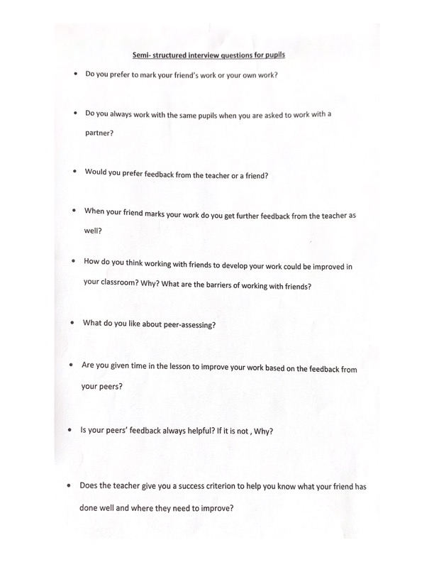
Interview questions

Appendix 4a
Pupil interview responses
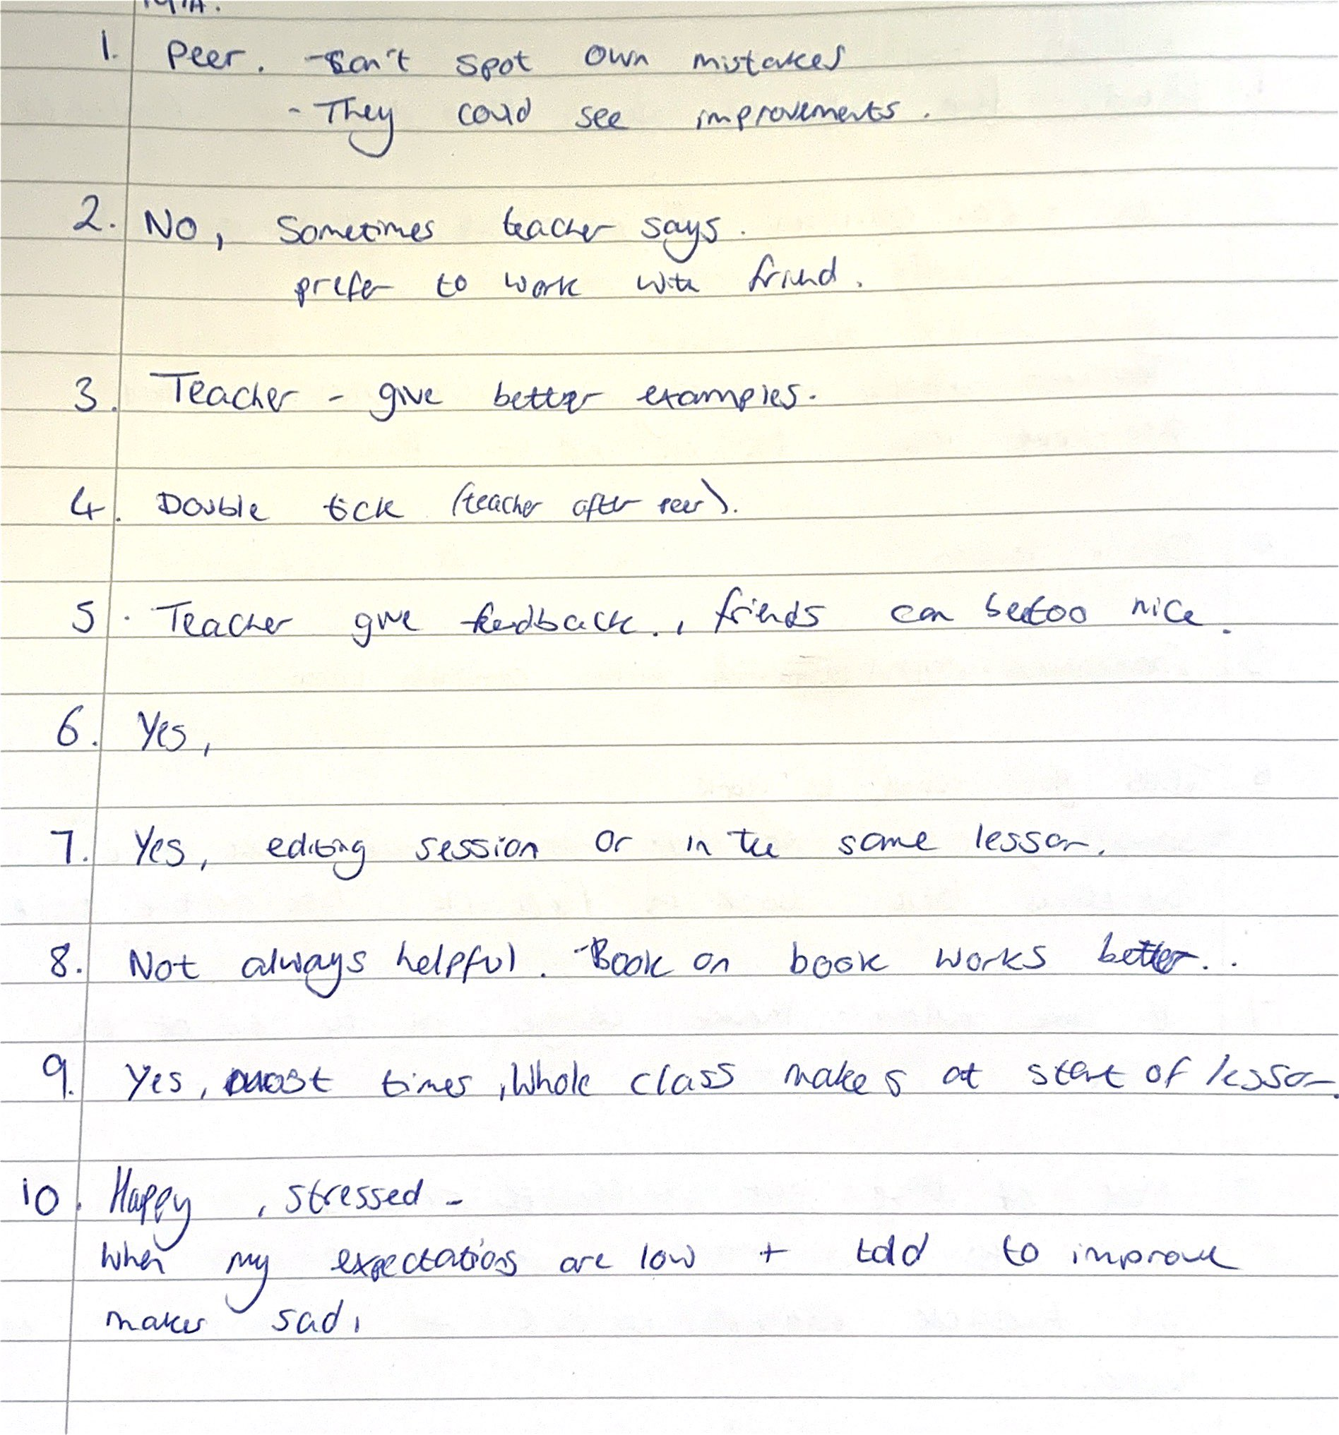
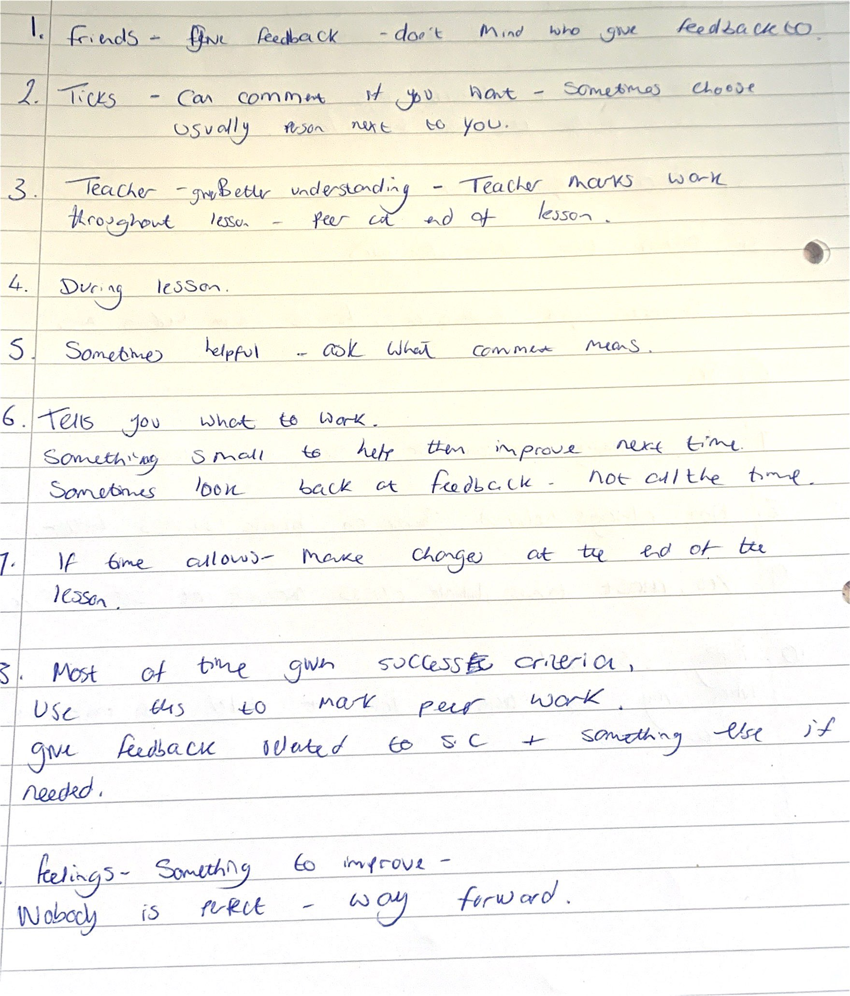
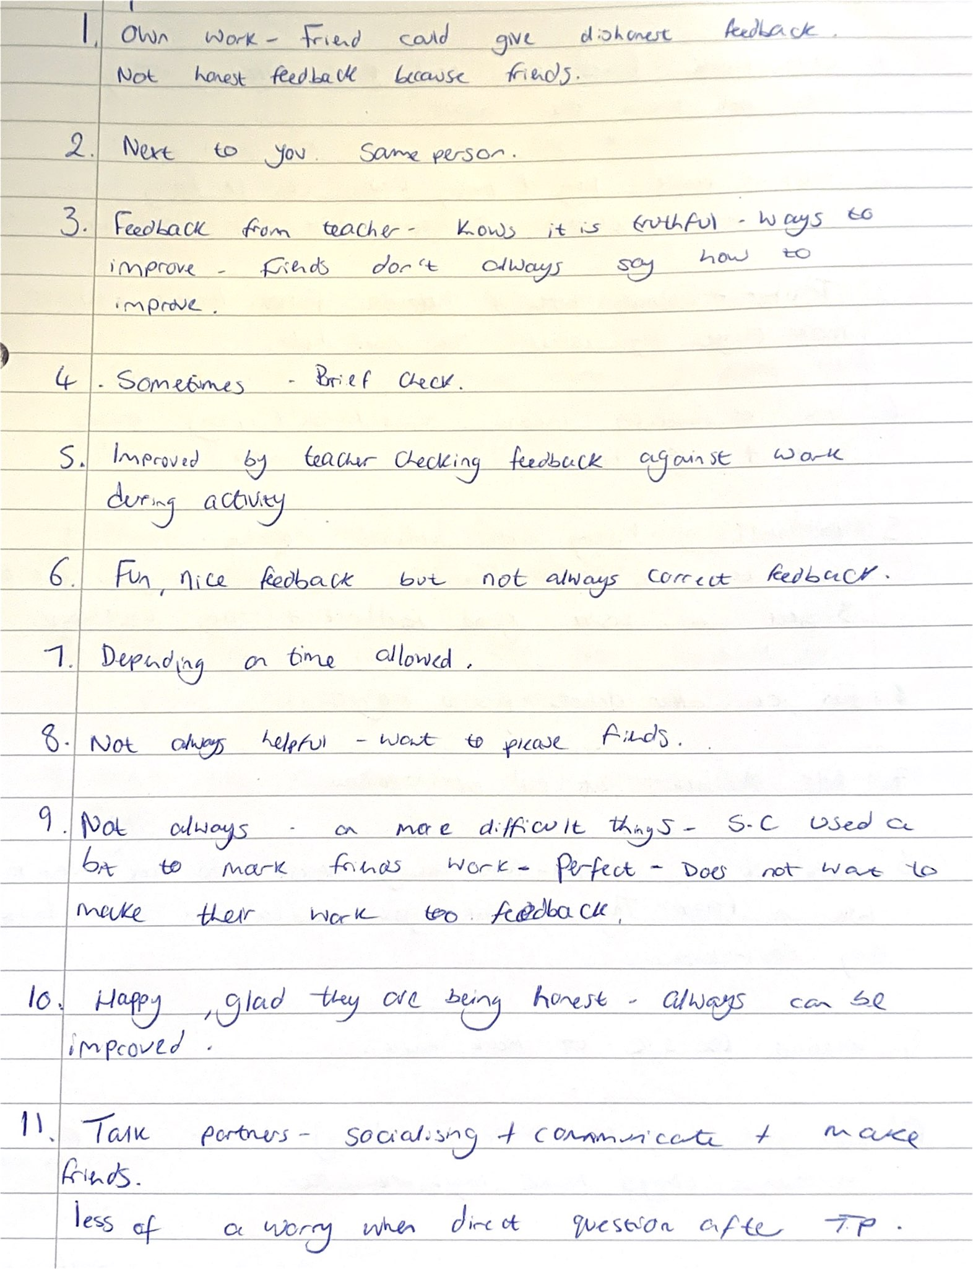
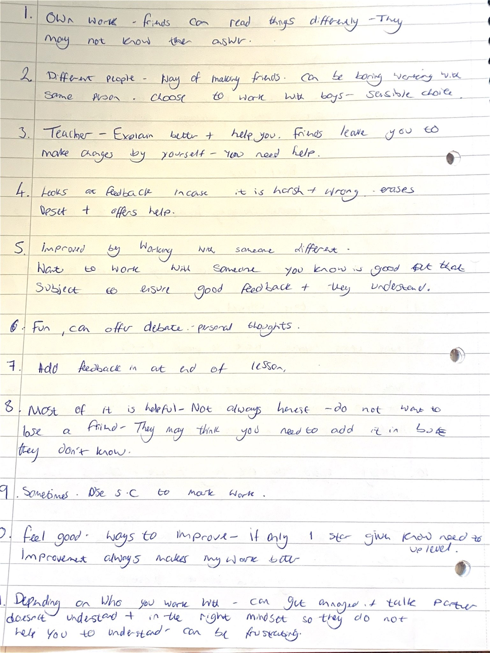
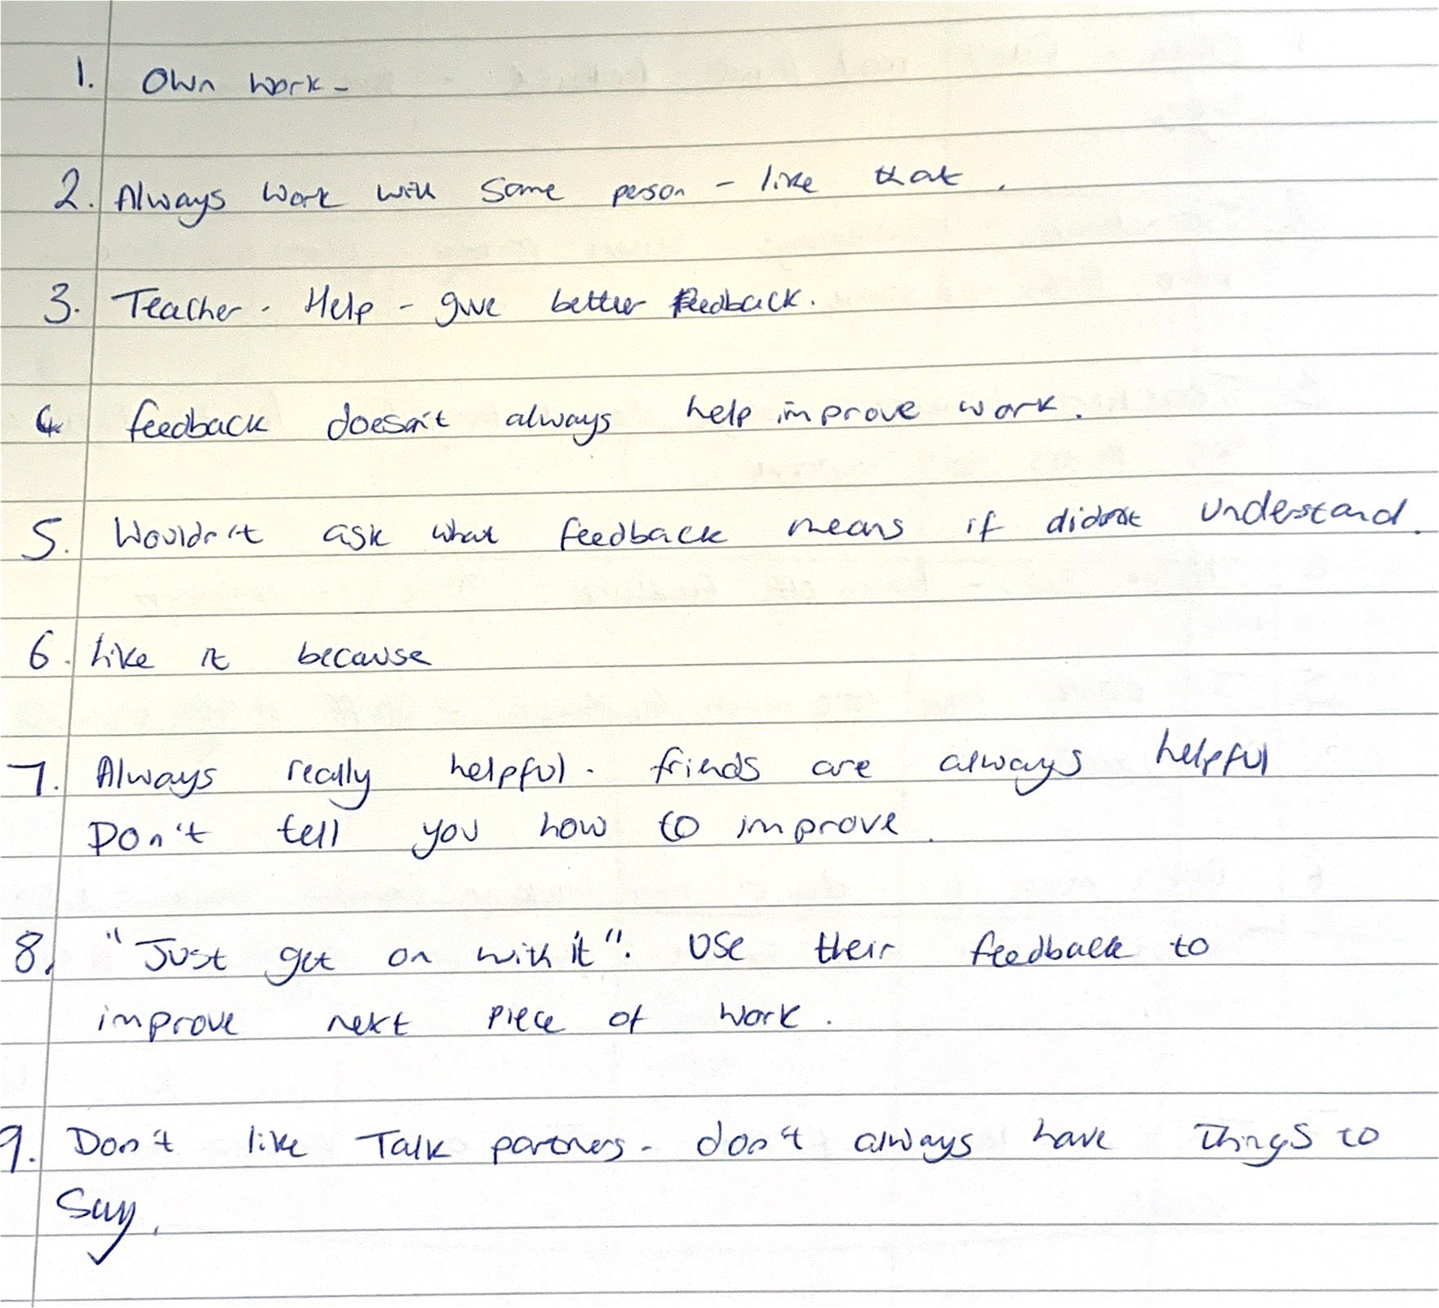
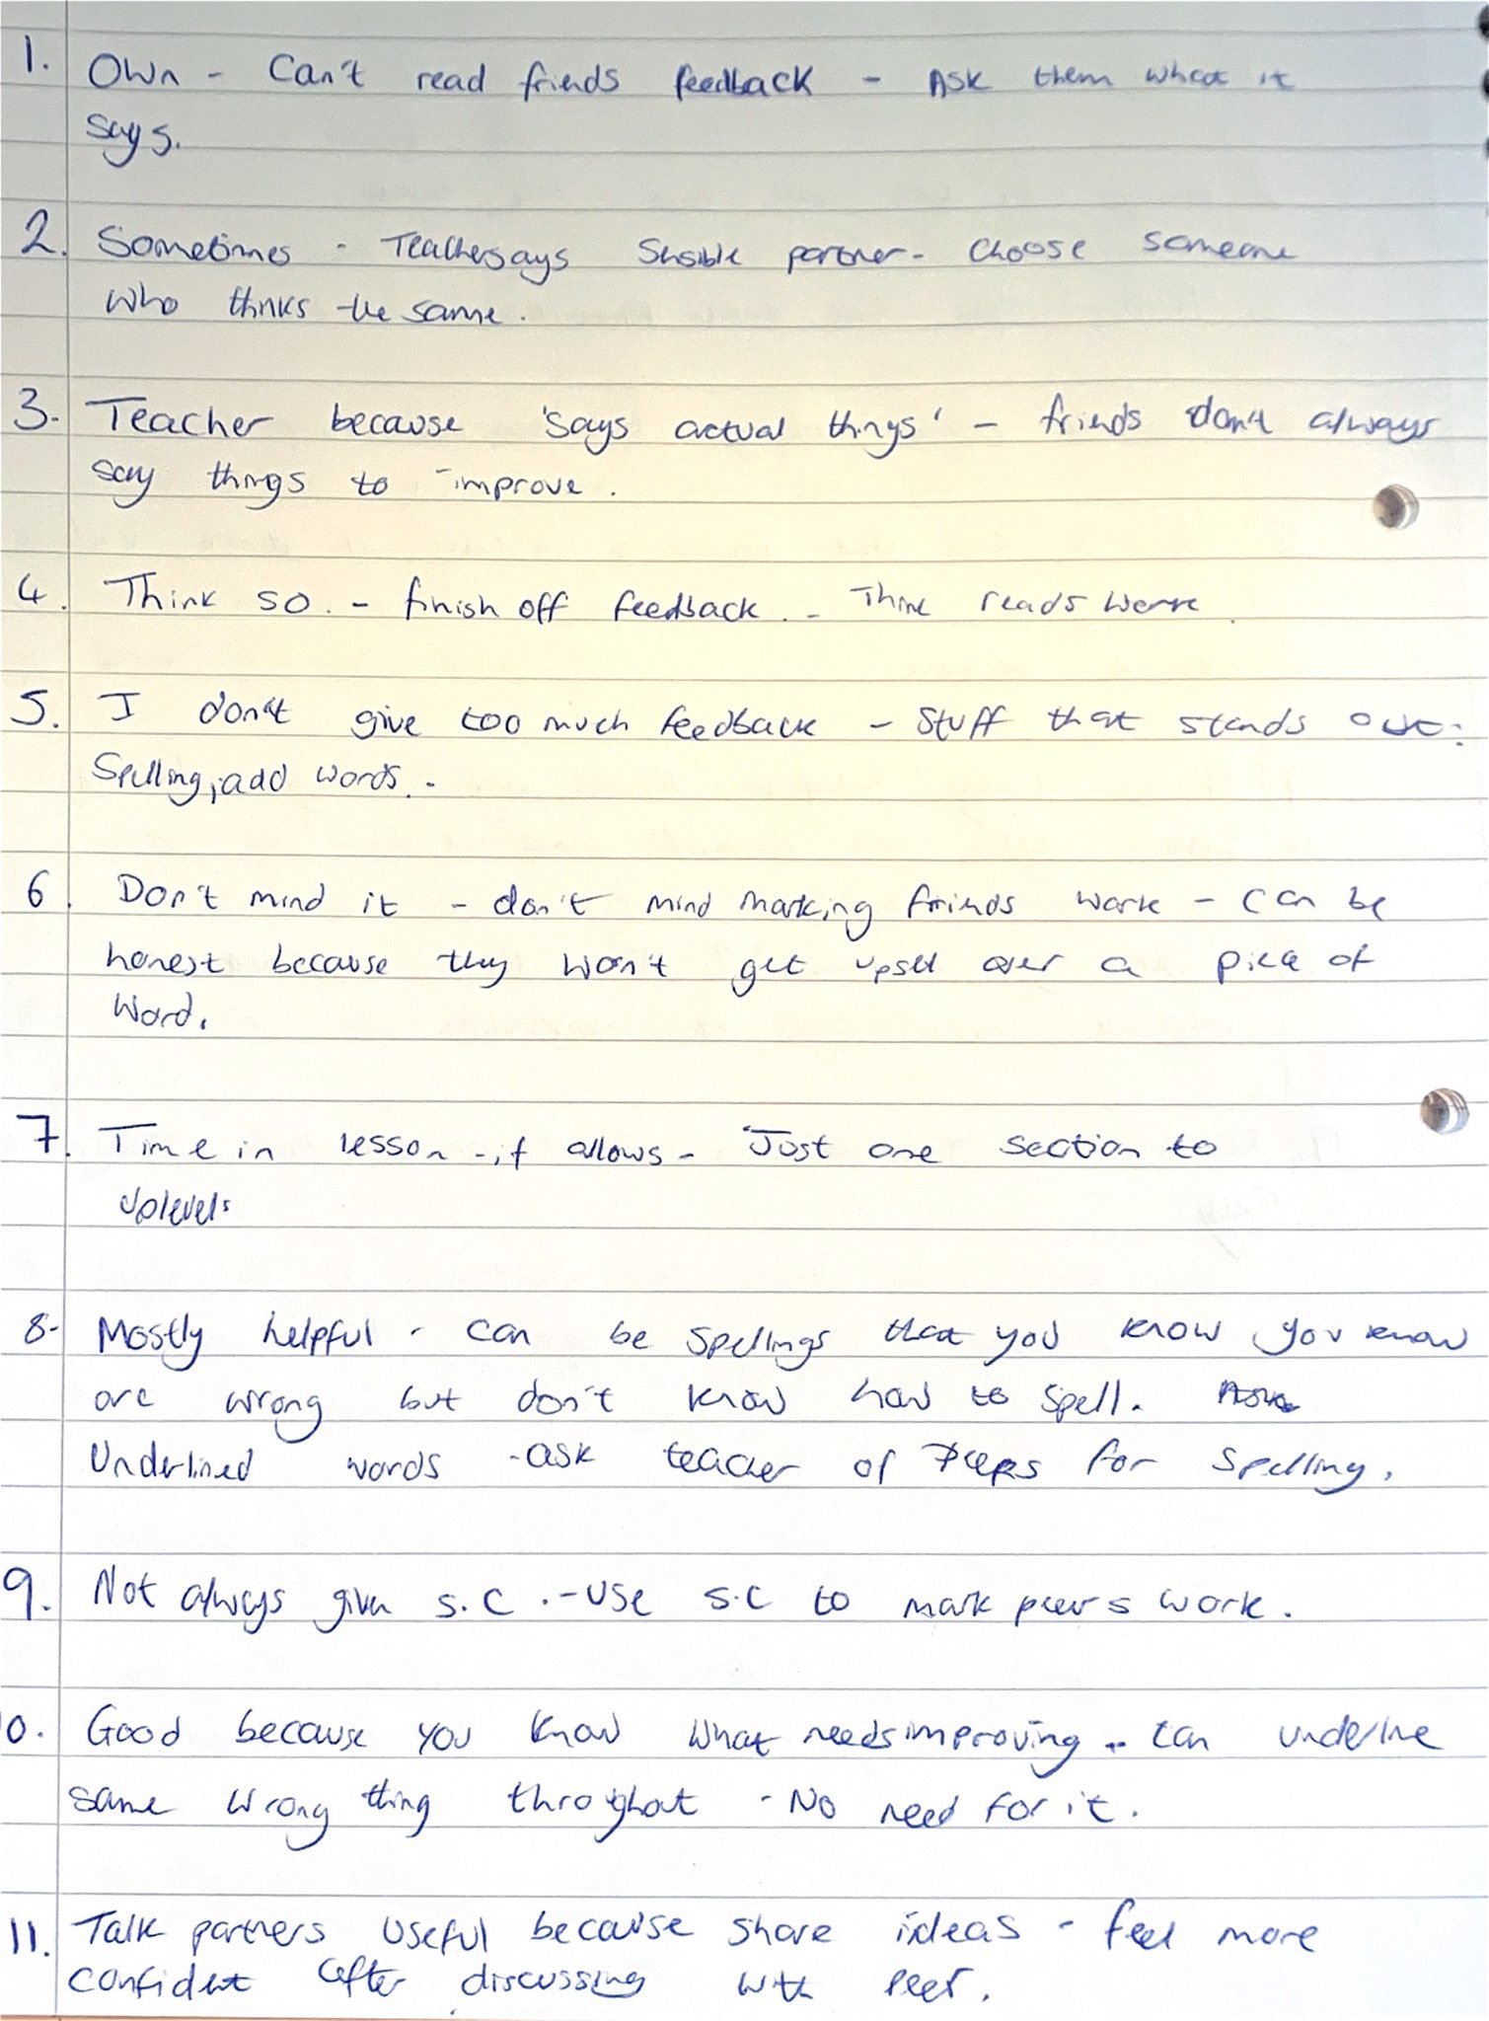

Appendix 5
Ethics form

APPLICATION FOR ETHICAL APPROVAL

In order for research to result in benefit and minimise risk of harm, it must be conducted ethically. A researcher may not be covered by the University’s insurance if ethical approval has not been obtained prior to commencement.

The University follows the OECD Frascati manual definition of research activity: “creative work undertaken on a systematic basis in order to increase the stock of knowledge, including knowledge of man, culture and society, and the use of this stock of knowledge to devise new applications”. As such this covers activities undertaken by members of staff, postgraduate research students, and both taught postgraduate and undergraduate students working on dissertations/projects.

The individual undertaking the research activity is known as the “principal researcher”.

Ethical approval is not required for routine audits, performance reviews, quality assurance studies, testing within normal educational requirements, and literary or artistic criticism.

Please read the notes for guidance before completing ALL sections of the form.

This form must be completed and approved prior to undertaking any research activity. Please see Checklist for details of process for different categories of application.

Delete the Guidance Notes at the end of the form BEFORE submitting your application

SECTION A: About You (Principal Researcher)
Full Name: |  | Alice Mary Tudor
Tick all boxes which app | ly: | Member of staff: | ☐ | Honorary research fellow: | ☐
Undergraduate Student | ☒ | Taught Postgraduate Student | ☐ | Postgraduate  Research Student | ☐

Faculty/School/Centre: | Initial Teacher Education, Yr Athrofa
Campus: | Carmarthen
E-mail address: | 1801577@student.uwtsd.ac.uk
Contact Telephone Number: | You may include your mobile number here
For students:
Student Number: | 1801577
Programme of Study: | BA Primary Education with QTS
Director of Studies/Supervisor: | Dr. Sioned V. Hughes

SECTION B: Approval for Research Activity
Has the research activity received approval in principle? (please check the Guidance Notes as to the appropriate approval process for different levels of research by different categories of individual) |  | YES | ☒ | NO | ☐
 |  |  |  | Date
If Yes, please indicate source of approval (and date where known): Approval in principle must be obtained from the relevant source prior to seeking ethical approval | Research Degrees Committee |  | ☐
 | Faculty Research Committee |  | ☐
 | Other (write in) ECAD5010  Module Lead |  | ☒ | 27.02.20

SECTION C: Internal and External Ethical Guidance Materials
Please list the core ethical guidance documents that have been referred to during the completion of this form (including any discipline-specific codes of research ethics, and also any specific ethical guidance relating to the proposed methodology). Please tick to confirm that your research proposal adheres to these codes and guidelines.
UWTSD Research Ethics & Integrity Code of Practice | ☐
UWTSD Research Data Management Policy | ☐
BEAR. Ethical guidelines for educational research: Fourth edition (2018) | ☐
 | ☐

SECTION D: External Collaborative Research Activity
Does the research activity involve collaborators outside of the University? |  | YES | ☐ | NO | ☒
If Yes, please provide the name of the external organisation and name and contact details for the main contact person and confirmation this person has consented to their personal data being shared.as part of this collaboration.
Institution
Contact person name
Contact person e-mail address

Has this individual consented to sharing their details on this form? |  | YES | ☐ | NO |  | ☐
Are you in receipt of a KESS scholarship? |  | YES | ☐ | NO |  | ☐
Is your research externally funded |  | YES | ☐ | NO |  | ☐
Are you specifically employed to undertake this research in either a paid or voluntary capacity? | Voluntary | YES | ☐ | NO |  | ☐
 | Employed | YES | ☐ | NO |  | ☐
Is the research being undertaken within an existing UWTSD Athrofa Professional Learning Partnership  (APLP) | If YES then the permission question below does not need to be answered. | YES | ☒ | NO |  | ☐
Permission to undertake the research has been provided by the partner organisation | (If YES attach copy) If NO the application cannot continue | YES | ☐ | NO |  | ☐

Where research activity is carried out in collaboration with an external organisation
Does this organisation have its own ethics approval system? | YES | ☐ | NO | ☒
If Yes, please attach a copy of any final approval (or interim approval) from the organisation

SECTION E: Details of Research Activity
Indicative title: | Pupils engagement with peer-assessment
Proposed start date: | 02.03.20 | Proposed end date: | 01.04.20
Introduction to the Research (maximum 300 words)
Ensure that you write for a Non-Specialist Audience when outlining your response to the three points below:
- Purpose of Research Activity
- Proposed Research Question
- Aims of Research Activity
- Objectives of Research Activity
Demonstrate, briefly, how Existing Research has informed the proposed activity and explain
- What the research activity will add to the body of knowledge
- How it addresses an area of importance.
Purpose of Research Activity

- To explore how a teacher in a Year 5/6 class uses peer-assessment strategies in their lessons to improve pupil’s knowledge and understanding

- To research into pupils’ engagement with peer-assessment and if the feedback is relevant and used to improve their work

- To trial three research tools: Observation, interviews and questionnaires. This will develop my awareness of the effectiveness of different research tools.

(this box should expand as you type)
Research Question

Pupils engagement with peer-assessment

(this box should expand as you type)
Aims of Research Activity
I will be looking further at AfL in general and the teachers use of different AfL strategies. My main focus will be on peer-assessment
- To explore how the member of staff includes peer-assessment strategies in their lessons
- To explore how pupils, engage with peer-assessment and if they use the feedback from their peers to improve their work
- To critically evaluate the different research tools linking this to literature and findings
- To develop my own knowledge and understanding of AfL as a whole and peer-assessment in more detail to improve professional practice
- To explore learners’ views of peer-assessment
(this box should expand as you type)
Objectives of Research Activity

- To explore the use of peer-assessment techniques and approached used by the lass teacher in a Year 5/6 class to develop pupils’ learning using a questionnaire and observations
- To interview pupils in Year 5/6 of mixed abilities and genders to gather their opinions on the use of peer-assessment
- To observe pupil’s engagement with peer-assessment in a Year 5/6 class
- To critically reflect on the process of using the three chosen research tools to collect and analyse data
- To find out the peer-assessment technique that pupils enjoy engaging with the most and find the most beneficial to engage with and use to improve their work

(this box should expand as you type)
Proposed methods (maximum 600 words)
Provide a brief summary of all the methods that may be used in the research activity, making it clear what specific techniques may be used. If methods other than those listed in this section are deemed appropriate later, additional ethical approval for those methods will be needed.
Interviews – I will interview six Year 5/6: a boy and a girl from each of the three ability groups within the class. The interview will be a semi-structured interview and I will start the interview with a relaxing question for the pupils to answer so that they feel more comfortable in answering the questions. I will build on the answers that I have received to gather a range of answers and feedback from pupils. All of the interviews with the pupils will take place in an informal setting, which will take place between myself and the interviewee so that pupils results are not being affected by other pupils. I will make it clear to all of the pupils engaging in the interviews that they are not forced into participating in the interview and they can withdraw at any time. The group of six learners will be asked if they wish to be involved in the interview and their response will be taken into consideration. I will ask pupils for their assent using ‘smiley face emoji cards’ to show that they are happy to continue. I will check on the children’s feelings and emotions throughout the interview to ensure that they are comfortable in the process and happy to continue. When I am making notes regarding the interview answers I will not refer to pupils with their names, I will use pupil A, B,C etc , to ensure confidentiality and their data cannot be linked to the individual.

Questionnaire - I have created a questionnaire for the teacher and the pupils to take part in. Every pupil in the class will be asked if they want to participate in the questionnaire and I will make it aware to all of the pupils that they have the right to withdraw at any time, I will ask pupils I they want to participate by using ‘smiley face emoji cards’ to show if they want to participate , as this is a whole class activity I will ensure that pupils are confident in being honest by asking them to put their heads on the table and raising the card , this will ensure that no other pupils are able to see other pupils responses. For the questionnaires I will use a range of open and closed questions, this will give me a range of data that I will be able to analyse and allow participates to respond to the questions in detail.

Observations – I will observe the Year 5/6 teachers use of peer-assessment techniques and how they ensure that pupils are progressing and developing their understanding through the use of peer-assessment. I will also be observing the pupil’s engagement with peer-assessment, I have decided to observe the same 6 pupils that I will be interviewing, this will give me pupils to focus on and I will be able to monitor their progress throughout the activities.
(this box should expand as you type)

Location of research activity
Identify all locations where research activity will take place.
The research activity will take place in a large Primary School in South Wales. There are 589 pupils in the school. I have chosen to perform my research on the Year 5/6 class that I worked with during PTE2, there are 24 pupils in the class made up of twelve Year 6 pupils and twelve Year 5 pupils.

(this box should expand as you type)
Research activity outside of the UK
If research activity will take place overseas, you are responsible for ensuring that local ethical considerations are complied with and that the relevant permissions are sought. Specify any local guidelines (e.g. from local professional associations/learned societies/universities) that exist and whether these involve any ethical stipulations beyond those usual in the UK (provide details of any licenses or permissions required). Also specify whether there are any specific ethical issues raised by the local context in which the research activity is taking place, for example, particular cultural and/or legal sensitivities or vulnerabilities of participants.
N/A

(this box should expand as you type)
Use of documentation not in the public domain: Are any documents NOT publicly available? | NO | ☒
 | YES | ☐
If Yes, please provide details here of how you will gain access to specific documentation that is not in the public domain and that this is in accordance with prevailing data protection law of the country in question and England and Wales.

(this box should expand as you type)

SECTION F: Scope of Research Activity
Will the research activity include: | YES | NO
Use of a questionnaire or similar research instrument? | ☒ | ☐
Use of interviews? | ☒ | ☐
Use of diaries? | ☐ | ☒
Participant observation with their knowledge? | ☒ | ☐
Participant observation without their knowledge? | ☐ | ☒
Use of video or audio recording? | ☐ | ☒
Access to personal or confidential information without the participants’ specific consent? | ☐ | ☒
Administration of any questions, test stimuli, presentation that may be experienced as physically, mentally or emotionally harmful / offensive? | ☐ | ☒
Performance of any acts which may cause embarrassment or affect self-esteem? | ☐ | ☒
Investigation of participants involved in illegal activities? | ☐ | ☒
Use of procedures that involve deception? | ☐ | ☒
Administration of any substance, agent or placebo? | ☐ | ☒
Working with live vertebrate animals? | ☐ | ☒
Other primary data collection methods, please explain in this box  For example, ‘focus groups’. Please indicate the type of data collection method(s) in this box and tick the accompany box. | ☐ | ☒
Details of any other primary data collection method:  (this box should expand as you type) | ☐ | ☒
If NO to every question, then the research activity is (ethically) low
risk and may be exempt from some of the following sections (please refer to Guidance Notes).

If YES to any question, then no research activity should be undertaken until full ethical approval has been obtained.

SECTION G: Intended Participants
Who are the intended participants: | YES | NO
Students or staff at the University? | ☐ | ☐
Adults (over the age of 18 and competent to give consent)? | ☒ | ☐
Vulnerable adults? | ☐ | ☐
Children and Young People under the age of 8? (Consent from Parent, Carer or Guardian will be required) | ☒ | ☐
Prisoners? | ☐ | ☐
Young offenders? | ☐ | ☐
Those who could be considered to have a particularly dependent relationship with the investigator or a gatekeeper? | ☐ | ☐
People engaged in illegal activities? | ☐ | ☐
Others (please identify specifically any group who may be unable to give consent) please indicate here and tick the appropriate box. | ☐ | ☐
Other – please indicate here:  (this box should expand as you type) | ☐ | ☐

Participant numbers and source
How will you identify participants and how will they be recruited?
How many participants are expected? | There will be 25 participants who will be taking part in the research  (this box should expand as you type)
Who will the participants be? | The participants will be 1 teacher and 24 pupils (mixed ability Year 5/6 class)  (this box should expand as you type)
How will you identify the participants? | I will be choosing 2 pupils from each ability group in the class, I will decide these pupils prior to the research day. I know the pupil’s ability as I have worked with these pupils previously during PTE2 in this school.  (this box should expand as you type)

Information for participants: | YES | NO | N/A
Will you describe the main research procedures to participants in advance, so that they are informed about what to expect? | ☒ | ☐ | ☐
Will you tell participants that their participation is voluntary? | ☒ | ☐ | ☐
Will you obtain written consent for participation? | ☐ | ☐ | ☒
Will you explain to participants that refusal to participate in the research will not affect their treatment or education (if relevant)? | ☒ | ☐ | ☐
If the research is observational, will you ask participants for their consent to being observed? | ☒ | ☐ | ☐
Will you tell participants that they may withdraw from the research at any time and for any reason? | ☒ | ☐ | ☐
With questionnaires, will you give participants the option of omitting questions they do not want to answer? | ☒ | ☐ | ☐
Will you tell participants that their data will be treated with full confidentiality and that, if published, it will not be identifiable as theirs? | ☒ | ☐ | ☐
Will you debrief participants at the end of their participation, in a way appropriate to the type of research undertaken? | ☐ | ☐ | ☒
If NO to any of above questions, please give an explanation
(this box should expand as you type)

Information for participants: | YES | NO | N/A
Will participants be paid? | ☐ | ☒ | ☐
Is specialist electrical or other equipment to be used with participants? | ☐ | ☒ | ☐
Are there any financial or other interests to the investigator or University arising from this study? | ☐ | ☒ | ☐
Will the research activity involve deliberately misleading participants in any way, or the partial or full concealment of the specific study aims? | ☐ | ☒ | ☐
If YES to any question, please provide full details
(this box should expand as you type)

SECTION H: Anticipated Risks
Outline any anticipated risks that may adversely affect any of the participants, the researchers and/or the University, and the steps that will be taken to address them.

If you have completed a full risk assessment (for example as required by a laboratory, or external research collaborator) you may append that to this form.
Full risk assessment completed and appended? |  | Yes | ☐
 |  | No | ☒
Risks to participants
For example: emotional distress, financial disclosure, physical harm, transfer of personal data, sensitive organisational information
Risk to Participant:  Pupils may feel under pressure to give the correct answer to the questions because they know that I am performing a research activity.  Pupils and the school may fear that their data may not be kept private | How will you mitigate the Risk to Participant  Pupils will be told that there is no consequence for anything they say, I will make this aware to all pupils who are participating in my research study. I will make it clear that I want open and honest answers and that I will not question them on any of the answers that they give that may not be correct. I will make it clear that the answers they give will affect their education in no way and there will be no repercussions for their actions and answers in regard to the research.  I will reduce the risk of pupils information being accessed by others by ensuring that throughout my research study I refer to the school as ‘school x’, I will
(this box should expand as you type) | also anonymise all pupils information by referring to pupils as pupil A,B, C etc. This ensure that the data provided cannot be linked to a pupil.  (this box should expand as you type)
If research activity may include sensitive, embarrassing or upsetting topics (e.g. sexual activity, drug use) or issues likely to disclose information requiring further action (e.g. criminal activity), give details of the procedures to deal with these issues, including any support/advice (e.g. helpline numbers) to be offered to participants. Note that where applicable, consent procedures should make it clear that if something potentially or actually illegal is discovered in the course of a project, it may need to be disclosed to the proper authorities
N/A
(this box should expand as you type)
Risks to investigator
For example: personal safety, physical harm, emotional distress, risk of accusation of harm/impropriety, conflict of interest
Risk to Investigator:  Allegations from pupils in the classroom while completing the research.  (this box should expand as you type) | How will you mitigate the Risk to Investigator:  I will be undertaking the observations and the questionnaires in the classroom where the class teacher will be present. I will perform the interviews with the pupils in the school corridor, this will be a safe place and members of staff are constantly passing by. The class teacher will also know that I am outside in the corridor, I have decided to keep the door open to the classroom so that the class teacher will be made aware of anything that is not taking place which is not professional.  (this box should expand as you type)
University/institutional risks
For example: adverse publicity, financial loss, data protection
Risk to University:  There is a risk that I could not behave in a way that could impact the relationship between school and university.  (this box should expand as you type) | How will you mitigate the Risk to University:  I will behave in a professional manner, at all times. I\ am confident that I will be able to do this as my ability to do this was complimented throughout my time on PTE2.  (this box should expand as you type)

Disclosure and Barring Service
If the research activity involves children or vulnerable adults, a Disclosure and Barring Service (DBS) certificate must be obtained before any contact with such participants. | YES | NO | N/A
Does your research require you to hold a current DBS Certificate? | ☒ | ☐ | ☐

SECTION I: Feedback, Consent and Confidentiality
Feedback
What de-briefing and feedback will be provided to participants, how will this be done and when?
N/A

(this box should expand as you type)
Informed consent
Describe the arrangements to inform potential participants, before providing consent, of what is involved in participating. Describe the arrangements for participants to provide full consent before data collection begins. If gaining consent in this way is inappropriate, explain how consent will be obtained and recorded in accordance with prevailing data protection legislation.
I will converse with my class teacher and senior mentor and inform them of the research I will be undertaking, providing reason and rationale behind the research. I will verbally ask pupils in Year 5/6 class if they wish to participate, I will also use ‘smiley face emojis’ for pupils to give consent. If the pupils show a green smiley face then I will be aware that the participant is happy to take part in the research study, I will continue to monitor the pupil’s feelings and emotions throughout the activities. If pupils show me the red angry face emoji then I will know that they are not happy to participate in the study, I will then ask them to wait till the questionnaire is finished. I will ask for assent from the pupils using emojis, this will be an individual exercise so that the children are encouraged to respond honestly with their interest and well-being in mind. Children will also be informed they can approach me at any time to ask questions and discuss their contribution to the project.
(this box should expand as you type)
Confidentiality / Anonymity
Set out how anonymity of participants and confidentiality will be ensured in any outputs. If anonymity is not being offered, explain why this is the case.
I will anonymise the school so that any data cannot be traced to the pupils in the school.
Throughout my research project I will not include pupils names, I will refer to them as pupil A,B,C etc., this will ensure that their data cannot be linked to individuals. If the teacher or the parents, ask for data from the research that I have completed then I will explain that all information is confidential, and I am unable to share this data with them.

(this box should expand as you type)

SECTION J: Data Protection and Storage
In completing this section refer to the University’s Research Data Management Policy and the extensive resources on the University’s Research Data Management web pages
(http://uwtsd.ac.uk/library/research-data-management/).
Does the research activity involve personal data (as defined by the General Data Protection Regulation 2016 “GDPR” and the Data Protection Act 2018 “DPA”)? | YES | NO
“Personal data” means any information relating to an identified or identifiable natural person (‘data subject’). An identifiable natural person is one who can be identified, directly or indirectly, in particular by reference to an identifier such as a name, an identification number, location data, an online identifier or to one or more factors specific to the physical, physiological, genetic, mental, economic, cultural or social identity of that natural person. | ☐ | ☐
If YES, provide a description of the data and explain why this data needs to be collected:
(this box should expand as you type)
Does it involve special category data (as defined by the GDPR)? | YES | NO
“Special category data” means sensitive personal data consisting of information as to the data subjects’ – (a) racial or ethnic origin,  (b) political opinions,  (c ) religious beliefs or other beliefs of a similar nature,  (d) membership of a trade union (within the meaning of the Trade Union and Labour Relations (Consolidation) Act 1992), | ☐ | ☐

- physical or mental health or condition,
- sexual life,
- genetics,
- biometric data (as used for ID purposes),
If YES, provide a description of the special category data and explain why this data needs to be collected:
(this box should expand as you type)
Will the research activity involve storing personal data and/or special category data on one of the following: | YES | NO
Manual files (i.e. in paper form)? | ☐ | ☐
University computers? | ☐ | ☐
Private company computers? | ☐ | ☐
Home or other personal computers? | ☐ | ☐
Laptop computers/ CDs/ Portable disk-drives/ memory sticks? | ☐ | ☐
“Cloud” storage or websites? | ☐ | ☐
Other – specify: | ☐ | ☐
For all stored data, explain the measures in place to ensure the security of the data collected, data confidentiality, including details of password protection, encryption, anonymisation and pseudonymisation:
(this box should expand as you type)
All Data Storage
Will the research activity involve any of the following activities: | YES | NO
Electronic transfer of data in any form? | ☐ | ☐
Sharing of data with others at the University? | ☐ | ☐
Sharing of data with other organisations? | ☐ | ☐
Export of data outside the European Union or importing of data from outside the UK? | ☐ | ☐
Use of personal addresses, postcodes, faxes, emails or telephone numbers? | ☐ | ☐
Publication of data that might allow identification of individuals? | ☐ | ☐
Use of data management system? | ☐ | ☐
Data archiving? | ☐ | ☐
If YES to any question, please provide full details, explaining how this will be conducted in accordance with the GDPR and DPA (and/or any international equivalent):
(this box should expand as you type)
List all who will have access to the data generated by the research activity:
(this box should expand as you type)
List who will have control of, and act as custodian(s) for, data generated by the research activity:
(this box should expand as you type)
Give details of data storage arrangements, including security measures in place to protect the data, where data will be stored, how long for, and in what form. Will data be archived – if so how and if not why not.
(this box should expand as you type)
Please indicate if your data will be stored in the UWTSD Research Data Repository (see https://researchdata.uwtsd.ac.uk/ ). If so please explain. (Most relevant to academic staff)
(this box should expand as you type)
Confirm that you have read the UWTSD guidance on data management (see https://www.uwtsd.ac.uk/library/research-data-management/) | YES | ☐
 | NO | ☐
Confirm that you are aware that you need to keep all data until after your research has completed or the end of your funding | YES | ☐
 | NO | ☐

☒ | have read the guidance notes supplied before completing the form.

SECTION K: Declaration
The information which I have provided is correct and complete to the best of my knowledge. I have attempted to identify any risks and issues related to the research activity and acknowledge my obligations and the rights of the participants.

In submitting this application I hereby confirm that I undertake to ensure that the above named
research activity will meet the University’s Research Ethics and Integrity Code of Practice
Signature of applicant: | A.M.Tudor | Date:  27.02.20

For STUDENT Submissions:
Director of  Studies/Supervisor: | Dr. Sioned V. Hughes | Date:  27.02.20
Signature: | S.V.Hughes | Date:  27.02.20
For STAFF Submissions:
Head of School/Assistant Dean: |  | Date:
Signature: |  | Date:

Checklist: Please complete the checklist below to ensure that you have completed the form according to the guidelines and attached any required documentation:
☒ | I have completed ALL RELEVANT sections of the form in full.
☒ | I confirm that the research activity has received approval in principle
☐ | I have attached a copy of final/interim approval from external organisation (where appropriate)
☐ | I have attached a full risk assessment (and have NOT completed Section H of this form)  (where appropriate) ONLY TICK IF YOU HAVE ATTACHED A FULL RISK ASSESSMENT
☒ | I understand that it is my responsibility to ensure that the above named research activity will meet the University’s Research Ethics and Integrity Code of Practice.
☒ | I understand that before commencing data collection all documents aimed at respondents (including information sheets, consent forms, questionnaires, interview schedules etc.) must be confirmed by the DoS/Supervisor, module tutor or Head of School.
☒ | I have deleted the guidance notes before submitting the PG2 for consideration

Appendix 6
Blank photography consent form




ECAD5010 Consent Form

Student teachers must gain the following written consent of the head teacher before trialling their research tools.

To be completed by the school:

I agree to ____________________________________ as a representative of Yr Athrofa to:

-Take photographs (Tick accordingly)

-Interview

-Take video

-Observe

-Quote school policy documents

-Questionnaires

Name of Head teacher ________________________ Signed _____________________

Name of school _______________________________

To be completed by the student teacher:

If I am granted such permission, I agree to abide by the ethics embodied within the EWC Code of Conduct and BERA Ethical Guidelines (2018) and will not distribute any such material to audiences beyond the University authorities without their permission.

Name of student teacher: Signed:

Student teacher UWTSD e-mail address:

Programme (e.g. BA Ed/PGCE Primary):

Date:

