Qualification: CIPD Diploma in Applied Human Resources

Module Name: 5ADCM- Contributing to Coaching and Mentoring in the Organisation

Word Count: 3297

Student Name: Catherine Evans
Student Number: 1919841
CIPD Membership Number: 49835269

By signing below, I confirm that the work/evidence presented is my own, unaided work. I understand the regulations pertaining to candidate malpractice and the action that may be taken as a result.

Signed: C. A. Evans
Date: 23 June 2021

CONTENTS PAGE
Evidence Matrix | 3-5
LO1 Be able to assess the impact of coaching and mentoring activity within an organisation and make recommendations for further development | 6-8
LO1 Bibliography | 9
LO1 Evidence | 10-17
LO2 Be able to support the implementation of coaching and/or mentoring programmes within an organisation | 18-21
LO2 Bibliography | 22
L02 Evidence | 23-32

Figures
Figure 1 Benefits of Coaching and Mentoring 18

Candidate name: Catherine Ann Evans |  |  |  |  | CIPD Membership/registration No.: 49835269
Qualification title: CIPD Diploma in Applied Human Resources |  |  |  |  | Unique Learner No. (ULN): 1919841
Unit code | Unit title |  | Assessment criteria no. | Evidence description | Evidence reference number |  | Assessor  initials | I/V initials if sampled
5ADCM | Contributing to Coaching and Mentoring in the Workplace |  | 1.1 | Outlook appointment with L&D to discuss current coaching and mentoring process | EV.1
5ADCM | Contributing to Coaching and Mentoring in the Workplace |  | 1.1 | Screenshot of Coaching and Mentoring intranet site | EV.2
5ADCM | Contributing to Coaching and Mentoring in the Workplace |  | 1.1 | Screenshot of coaches and profiles | EV.3
5ADCM | Contributing to Coaching and Mentoring in the Workplace |  | 1.1 & 1.2 | Coaching Contract | EV.4
5ADCM | Contributing to Coaching and Mentoring in the Workplace |  | 1.1 & 1.2 | Coaching checklist | EV.5
5ADCM | Contributing to Coaching and Mentoring in the Workplace |  | 1.1 & 1.2 | Coaching activity sheet | EV.6
5ADCM | Contributing to Coaching and Mentoring in the Workplace |  | 1.1 & 1.2 | Record of coaching activity hours sheet | EV.7
5ADCM | Contributing to Coaching and Mentoring in the Workplace |  | 1.3 | Screenshot College of Policing mentoring site | EV.8
5ADCM | Contributing to Coaching and Mentoring in the Workplace |  | 1.3 | Screenshot College of Policing reverse mentoring | EV.9
5ADCM | Contributing to Coaching and Mentoring in the Workplace |  | 1.3 | BetterUp mobile coaching app | EV.10
5ADCM | Contributing to Coaching and Mentoring in the Workplace |  | 1.4 | Meeting with L&D lead to discuss recommendations | EV.11
5ADCM | Contributing to Coaching and Mentoring in the Workplace |  | 1.4 | Notes from meeting with L&D | EV.12
5ADCM | Contributing to Coaching and Mentoring in the Workplace |  | 1.4 | Coaching feedback forms | EV.13
5ADCM | Contributing to Coaching and Mentoring in the Workplace |  | 1.4 | Transformational leadership certificate | EV.14
5ADCM | Contributing to Coaching and Mentoring in the Workplace |  | 2.1 | Walk and Talk Poster | EV.15
5ADCM | Contributing to Coaching and Mentoring in the Workplace |  | 2.2 | Examples of coaching policies | EV.16
5ADCM | Contributing to Coaching and Mentoring in the Workplace |  | 2.2 | Coaching and mentoring survey | EV.17
5ADCM | Contributing to Coaching and Mentoring in the Workplace |  | 2.2 | Pre-coaching questionnaire | EV.18
5ADCM | Contributing to Coaching and Mentoring in the Workplace |  | 2.3 | An email requesting attendance to observe coaching session | EV.19
5ADCM | Contributing to Coaching and Mentoring in the Workplace |  | 2.3 | Email to Senior Manager to recommend coaching | EV.20
5ADCM | Contributing to Coaching and Mentoring in the Workplace |  | 2.3 | Example of coaching template | EV.21
5ADCM | Contributing to Coaching and Mentoring in the Workplace |  | 2.3 | Guidance document on empathetic listening | EV.22
5ADCM | Contributing to Coaching and Mentoring in the Workplace |  | 2.3 | OSCAR Coaching sheet | EV.23
5ADCM | Contributing to Coaching and Mentoring in the Workplace |  | 2.3 | Email from Line Manager after coaching sessions | EV.24
5ADCM | Contributing to Coaching and Mentoring in the Workplace |  | 2.3 | 360 Feedback forms | EV.25
5ADCM | Contributing to Coaching and Mentoring in the Workplace |  | 2.3 | Screenshot of probation form | EV.26
5ADCM | Contributing to Coaching and Mentoring in the Workplace |  | 2.3 | Screenshot of reflective journal | EV.27
5ADCM | Contributing to Coaching and Mentoring in the Workplace |  | 2.4 | Intranet banner | EV.28
5ADCM | Contributing to Coaching and Mentoring in the Workplace |  | 2.4 | Email offering assistance | EV.29
5ADCM | Contributing to Coaching and Mentoring in the Workplace |  | 2.4 & 2.5 | Email to request dates of the workshop | EV.30
5ADCM | Contributing to Coaching and Mentoring in the Workplace |  | 2.4 & 2.5 | Screenshot of workshop | EV. 31
Candidate declaration:
- I confirm that the work/evidence presented for assessment is my own unaided work.
- I have read the assessment regulations and understand that if I am found to have ‘copied’ from published work without acknowledgement, or from other candidate’s work, this may be regarded as plagiarism which is an offence against the assessment regulations and leads to failure in the relevant unit and formal disciplinary action.
- I agree to this work being subjected to scrutiny by textual analysis software if required.
- I understand that my work may be used for future academic/quality assurance purposes in accordance with the provisions of the Data Protection Act 1998.
- I understand that the work/evidence submitted for assessment may not be returned to me and that I have retained a copy for my records.
- I understand that until such time as the assessment grade has been ratified through internal and external quality assurance processes it is not final.
Signature: |  | C. A. Evans |  |  |  | Date: | 23 June 2021

1.

A strong coaching culture within organisations can increase revenue growth and engagement as recording in a study by the International Coach Federation. (ATD, 2018)
It is however important that all employees at every level of the organisation are aware of the coaching and mentoring provision within their workplace.

One of the Chief Officer priorities is that all Line Managers undertake a Transformational Leadership course which introduces coaching and mentoring within our organisation. To further my knowledge, I arranged a meeting with the L&D lead on coaching and mentoring in our organisation. (EV.1)

With over 50 coaches and 7 executive coaches, we have an extensive facility that is widely utilised both internally and externally. All coaches undertake a two-day internal training course, and all hold Level 5 ILM. We currently have 7 executive coaches who hold Level 7 ILM qualifications.

Using our Coaching and Mentoring intranet page (EV.2) employees can request information on the available coaches and select their preferred coach/mentor by reading the profiles provided. (EV.3) This process is relatively new as previously employees would be allocated a coach by the L&D department. Feedback from this process was reviewed and changes made, as some employees did not feel comfortable with the assigned coach, and would therefore withdraw from the coaching agreement.

A coaching contract (EV.4) is then completed and agreed upon by both the coach and the coachee. The coach is provided with a coaching checklist (EV.5) and a coaching activity sheet (EV.6) The coach completes a ‘record of coaching hours form’ which allows the L&D department to establish costs. (EV.7). Coaching feedback forms have recently been introduced which will allow us to evaluate the effectiveness of our coaching and mentoring provision in the future.

Together with our formal coaching and mentoring, our organisation typically applies to coach in our one-to-one meetings and appraisals. (CIPD, 2020). Colleague mentoring also takes place and I am currently mentoring a new employee. Our formal and informal coaching blend and introduce employees to the coaching methods as a support mechanism.

Coaching styles can include ‘push’ which is fast and led by the coach or ‘pull’ which is slower and mainly includes listening and responding to the coachee. The ‘pull’ approach is the style that is encouraged within our organisation, which has been shown to increase creativity and commitment from employees. (HBR, 2016). The organisation has an appreciation of the work/life balance of its employees and Managers have 1:1 monthly meetings with their staff where any welfare issues are discussed to prevent any undue stress on the workforce.

Within Dyfed Powys we use the following coaching types:
Performance coaching – this is mainly used to bring about continuous improvement
Peer Coaching – used by coaches to discuss any issues and success stories as a dimension of staff development. (Joyce & Showers, 1980)
Face to face mentoring – a more experienced colleague sharing knowledge with a new colleague – I have personally mentored many colleagues face-to-face, but due to the pandemic I have been mentoring my colleague online for the last six months. This has worked relatively well but we are looking forward to returning to face-to-face once the restrictions are lifted. Even though it seemed difficult at first we have adapted our methods and my colleague has continued to develop through these difficult times.
Day-to-day coaching – I coach various colleagues informally during our daily conversations. As a Line Manager using the OSCAR model I ensure that I listen to any issues they may be having ie. time management, workload, stressful situations either at home or work. I always ensure I listen to them, ask questions and feedback to assist them and build up relationships.
Supervisory coaching – coaches attend coaching sessions to feedback to the coaches on their techniques, with the coachee’s permission.
Team coaching – Officers and Staff use team coaching widely within the organisation to help each other – this is used to help Officers help each other after difficult situations.

People development is one of the Chief Constables priorities and by introducing a coaching culture we are continuously improving our workforce. Individuals are coached and mentored to assist them with promotion processes to become great leaders, teams use coaching to develop and support each other which helps us to reach our organisational objectives. Our 2021 PDR process was completed on time by over 68% of the workforce – one-to-one meetings are recorded and can be used to support the promotion processes. (Deloitte,2021) tells us that workforce behaviour needs to be aligned to the organisational objectives and the pandemic has brought about changes from the traditional leadership methods of setting direction and ensuring compliance to coaching, teams and mentoring. This has been noticeable in Dyfed Powys Police with well-being now a priority.

As a hierarchical police force, we are guided by the College of Policing for the majority of our processes and procedures. The College drive coaching and mentoring within forces but I have identified that the majority of their guidance is for the Senior Leaders, including Superintendents and Chief Constables. (EV.8). They offer guidance on reverse mentoring but no guidance for staff in general, again providing opportunities for the hierarchy (EV.9). As a force, we are proactive in developing our coaching and mentoring provision for staff at all levels of the organisation and not just the leaders.

Due to the pandemic agile working has become commonplace in most organisations, and we have been home working for over 16 months. Technology has become more important than ever, and our coaching systems have become more automated, with coaching sessions taking place over skype. This has allowed our coaching sessions to continue and employees feel supported.

Coaching through mobile technology is available and this is something that organisations could introduce which would appeal to the younger working generation. An example of this is ‘BetterUp’ (EV.10) where coaches engage through an automated platform that gives measurable results, personalised coach matching, 360 feedback and Manager dashboards. 97% of their customers in 2020 were highly satisfied and the process adds value by providing staff instant access. The organisation doubled its value in 2020 and is now worth $1.73 billion which shows that technology such as this may be the future of coaching in large organisations. (BetterUp, 2021)

Well-being is paramount in Dyfed Powys Police with mental health being a high factor of concern due to the nature of the police officer role. By supporting staff with coaching we have created a more compassionate working culture. Our coaches are trained to ensure that models followed can be changed to suit the employee’s circumstance – an employee suffering from depression or anxiety may not be able to answer positive questions, and to re-engage them with a sense of purpose the coach’s task is ‘to light a candle in the darkness’ as written by Hetty Enzig (Illuminate, 2019)

After reviewing the coaching and mentoring provision within our organisation I identified that the organisation is already providing an excellent service but arranged a meeting with the L&D lead on coaching and mentoring. (EV.11) We discussed my recommendations and my involvement in future processes, which were met with enthusiasm. (EV.12)

I have reviewed our coaching and mentoring intranet site, which is very informative - I would however recommend that we need to ensure that employees of all levels are aware of the facility and know where to locate information about the process. We have agreed that this is an area that I can assist with.

Coaching feedback forms have been recently developed and these are completed quarterly. (EV.13) As this is a new process we do not currently have any feedback but over the next 6 months, we will be able to evaluate the effectiveness of our coaching and mentoring provision. Return on investment is another area that is not currently being measured. Along with the staff feedback, evaluation of costs including delivery and retention will be measured over the next twelve months. Within Dyfed Powys, we have a coaching and mentoring section that is included as an integral part of our L&D budget.

As the only force with a Leadership and Wellbeing strategy called Calon and with one of the strands already looking at further developing the coaching culture, I feel that coaching and mentoring are already embedded into our organisation, motivating our employees to continue even if they face any difficulties along the way (Clutterbuck, Megginson & Bajer,2016). Embedding this culture in the organisation and ensuring that it is highlighted in official documentation will ensure that stakeholders are aware of the value added by the provision. It will also allow external stakeholders to ‘know that we have got that coaching mindset’. (Anderson, Rayner & Schyns, 2009) and allow us to attract valuable applicants.

Different ways of delivering coaching is another recommendation that could be implemented and the Coaching lead was very interested in developing this further, this is an area that I will look to investigate. Peer coaching sessions are already in place but I would recommend that this is encouraged to allow sharing of knowledge and to ensure that the coaches are communicating efficiently. Sessions, where external coaches are invited to share experiences, would be beneficial in developing our existing coaches.

Another recommendation would be to arrange coaching and mentoring engagement sessions with our Call Handler department as they work in a highly stressful area. We could encourage training for coaches from this area as there are no participants as either coaches or coachees. I recommend that we develop a survey to assess attitudes to coaching and then implement the neuroscientific techniques as described by (Landsberg, 2015) which would allow us to assess attitudes and introduce a coaching culture to this area.

Lazlo Bock believes that corporate training is a waste of organisation budget and that the workforce should be empowered to teach each other and share knowledge. Google carried out surveys to establish key behaviours of Line Managers that they wanted which included being a good coach, not micro-managing and communication and if these behaviours are present Bock says ‘it’s become harder to be a bad manager’. All of our Line Managers undertake a Transformational Leadership Course which ensures that the key behaviours are present. (EV.14)

Our Chief Officers are extremely supportive of staff development and retention to improve the workforce capability. Our retention rate is extremely high and it is hard to prove if coaching and mentoring have a bearing on this due to the type of organisation. Our leavers are generally retirees as the police force is generally a career for life. However, (Taylor, 2014) suggests that turnover is reduced by Managers that demonstrate their values through their actions and words, and by organisations having a caring and supportive culture which we certainly have.

LO1. Bibliography

Anderson, V, Rayner, C & Schyns, B 2009, Coaching at the sharp end: the role of line managers in coaching at work. CIPD Publications, London.

BetterUp (2021) BetterUp raises $125 million. Available at:
https://www.betterup.com/en-us/about-us/news-and-press/betterup-raises-125-million-series-d-achieves-173-billion-valuation-and-expands-coaching-platform-with-betterup-care - accessed 23 June 2021

CIPD (2020). Coaching and Mentoring | Factsheets. Available at: https://www.cipd.co.uk/knowledge/fundamentals/people/development/coaching-mentoring-factsheet#gref - accessed: 10 May 2021

Clutterbuck, D. Megginson, D. and Bajer, A. (2016) ‘Building and Sustaining a Coaching Culture’, CIPD London.

Deloitte Insights (2021) The Social Enterprise in a world disrupted. Available at:https://moodle.uwtsd.ac.uk/pluginfile.php/334896/mod_resource/content/2/di_human-capital-trends.pdf - accessed 14 May 2021

Havard Business Review (2016) How your leadership has to change as your startup scales. Available at: https://hbr.org/2016/05/how-your-leadership-has-to-change-as-your-startup-scales?registration=success – accessed 23 June 2021
Joyce, B., and B. Showers. (1980). "Improving Inservice Training: The Messages of Research." Educational Leadership
Landsberg, Max, “Mastering Coaching”, (Profile Books, 2015)

Bock, L. (2015) Work Rules!. [S.I.]: Grand Central Publishing.

Stevenson, V (2019). Evolution of Coaching – Six Trends. Available at:
https://www.illuminate.co.com/index.php/2019/08/21/the-evolution-of-coaching-six-trends/ - accessed 15 May 2021
Taylor, S. (2014). Resourcing and Talent Management. (6th edition). London: Chartered Institute of Personnel and Development/Kogan Page.

Robinson, S. (2018) The Case for a Coaching Culture, Main. Available at: https://www.td.org/magazines/td-magazine/the-case-for-a-coaching-culture - accessed: 13 June 2021

Ward, N. and Stevenson, V. (2017) The Future of Coaching: Six Trends | Education Connected, Education Connected. Available at: https://educationconnected.co.uk/general-news/the-future-of-coaching-six-trends/ - accessed: 13 June 2021

LO1. Evidence

EV.1

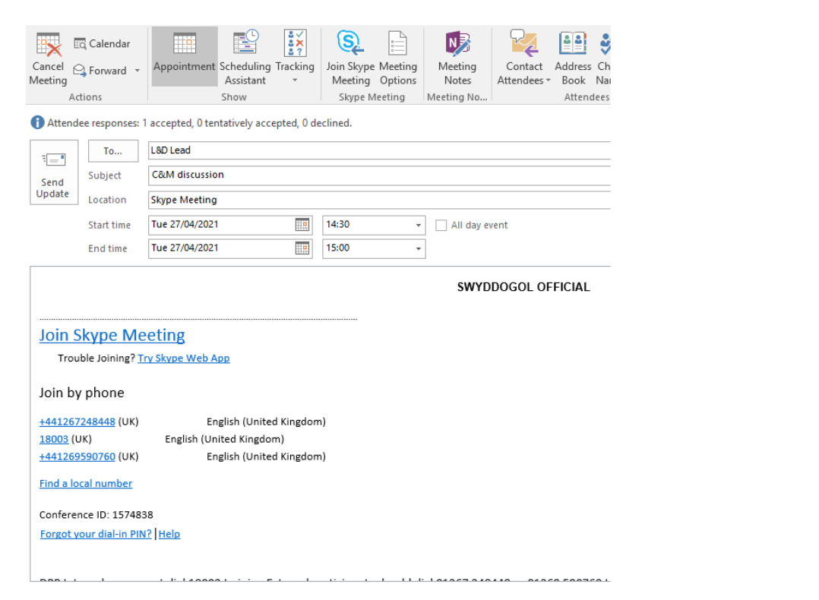

EV.2

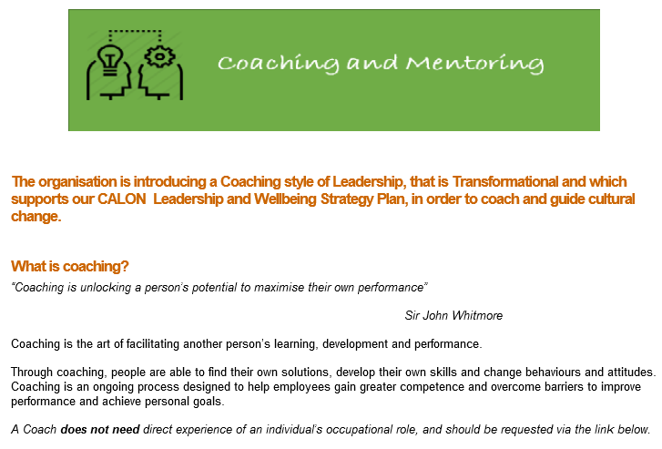
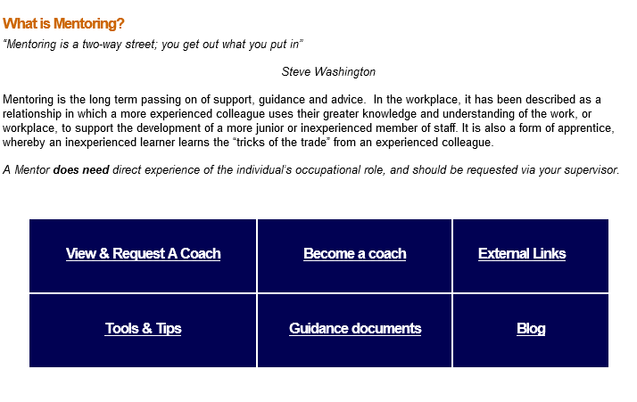
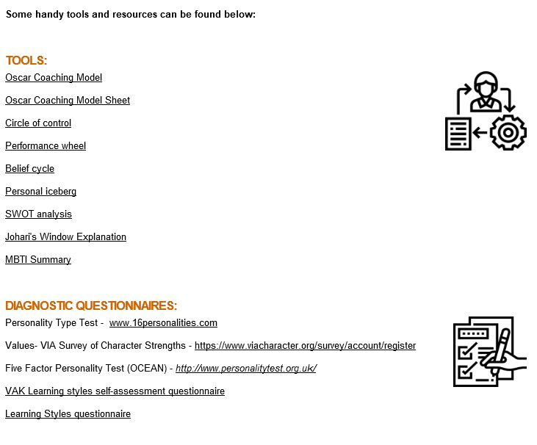

EV.3

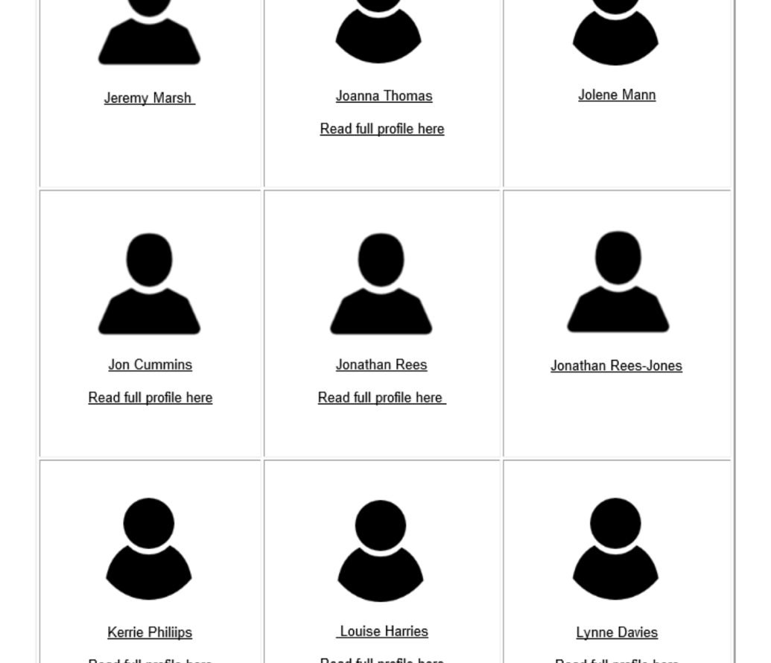

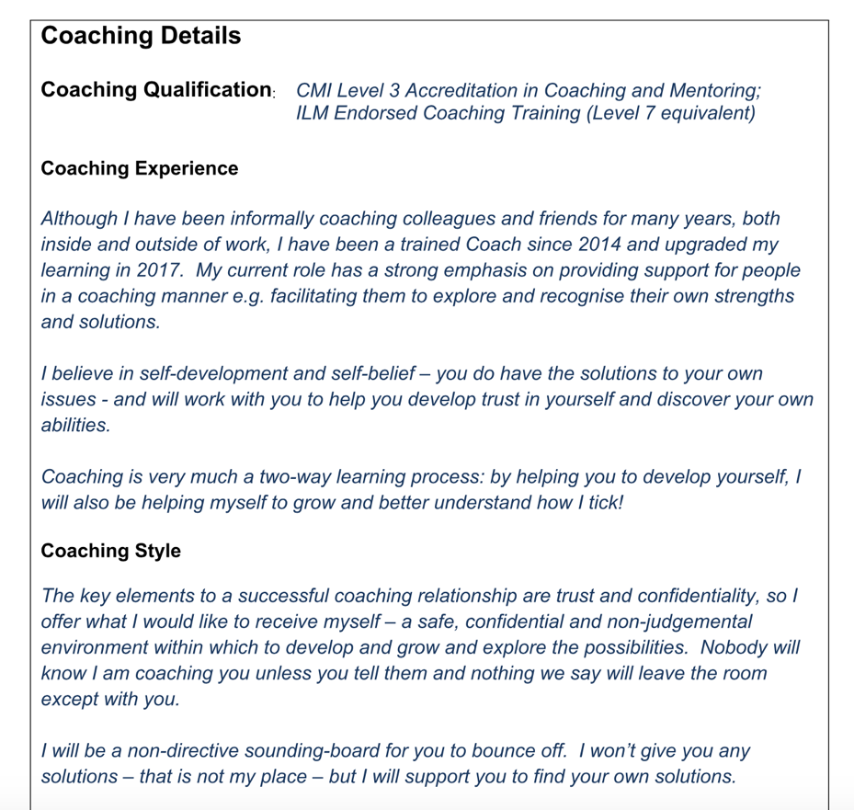

EV.4
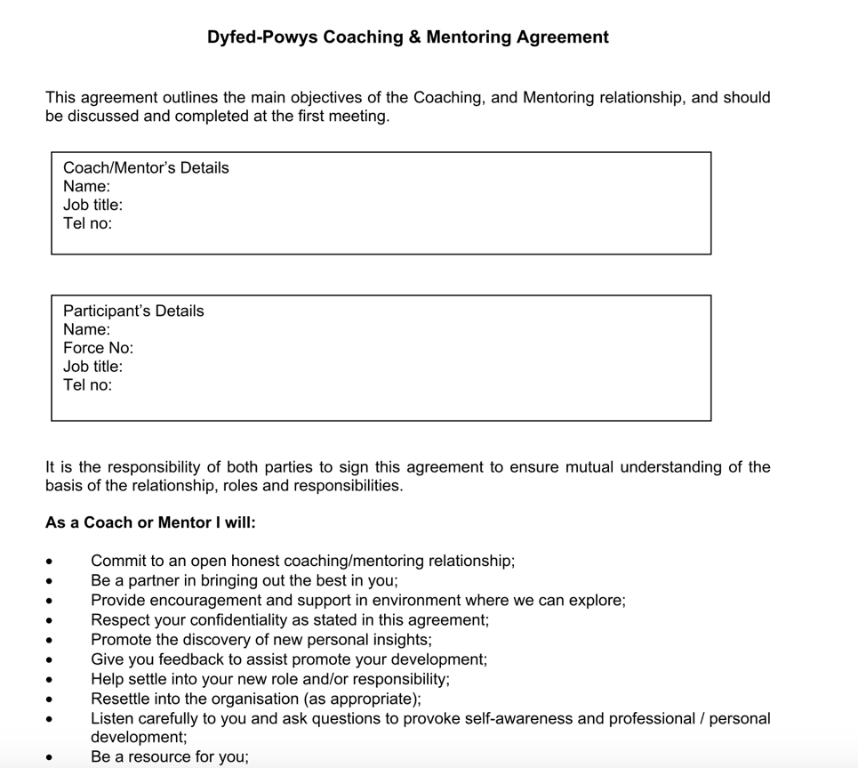

EV.5
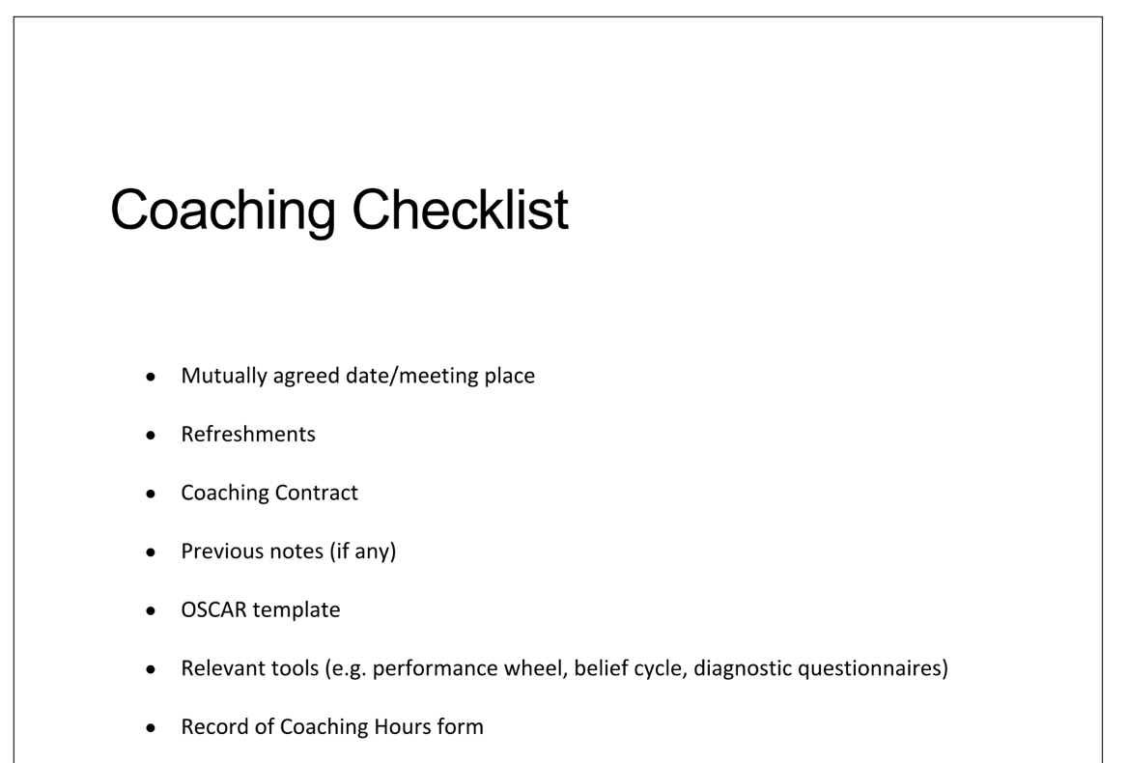

EV.6

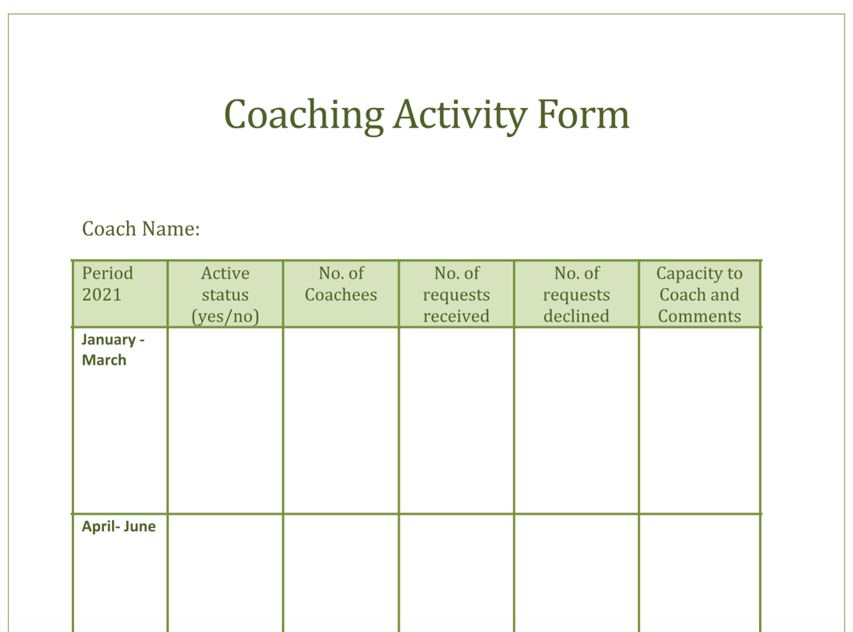

EV.7

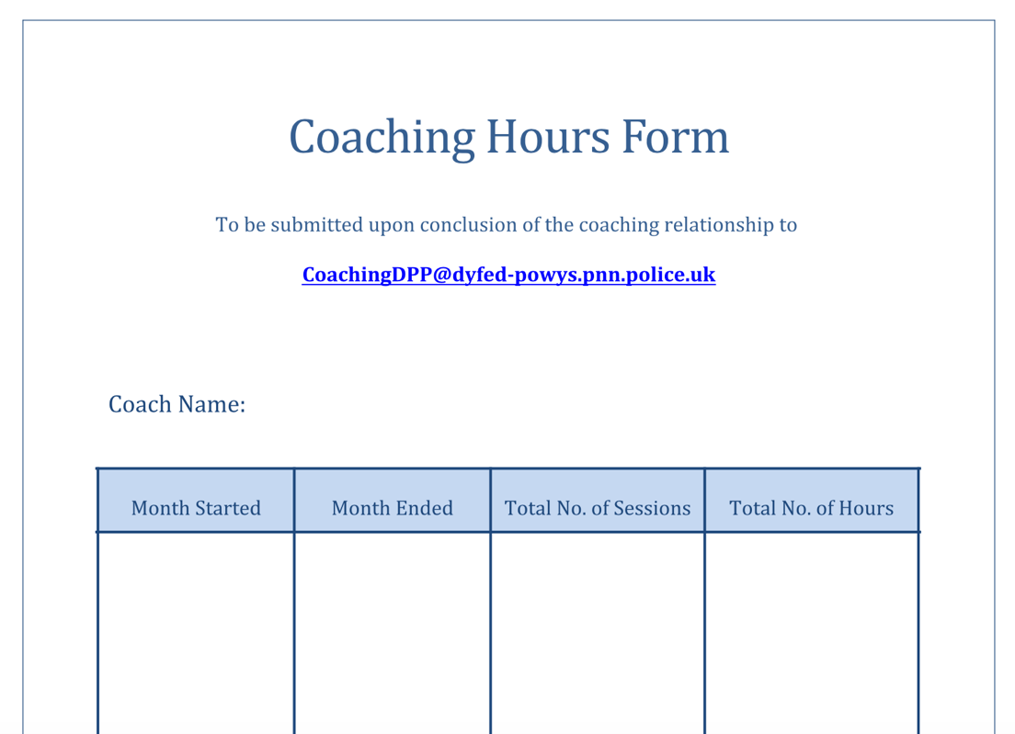

EV.8

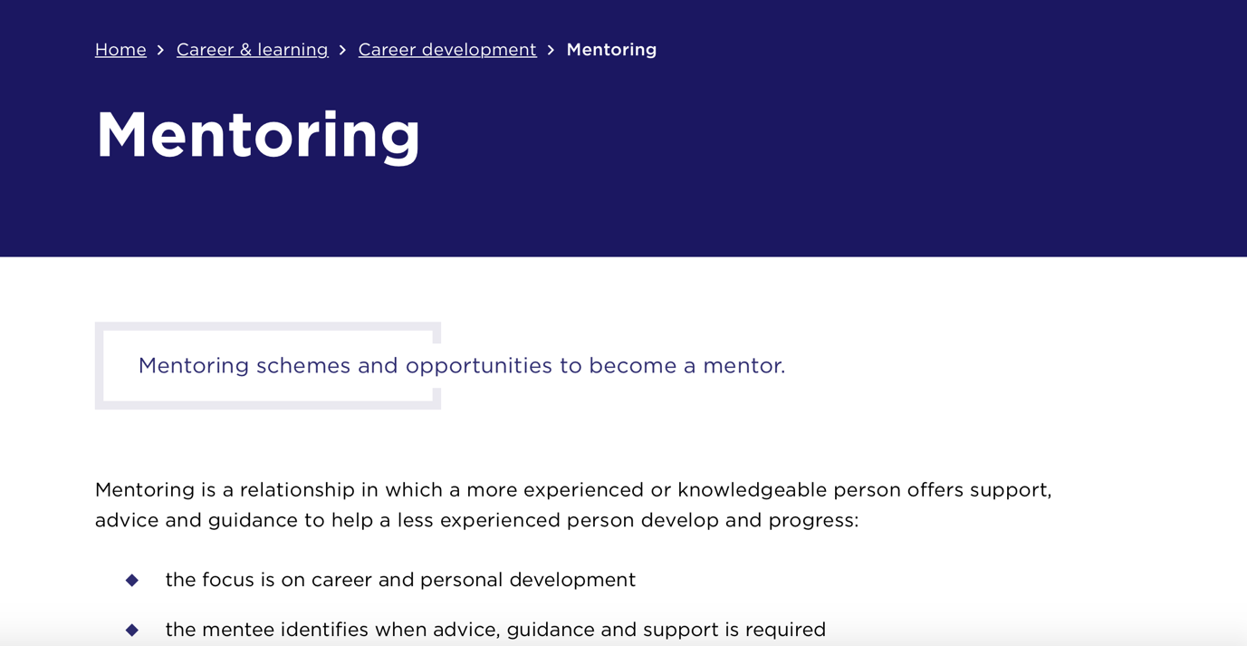

EV.9

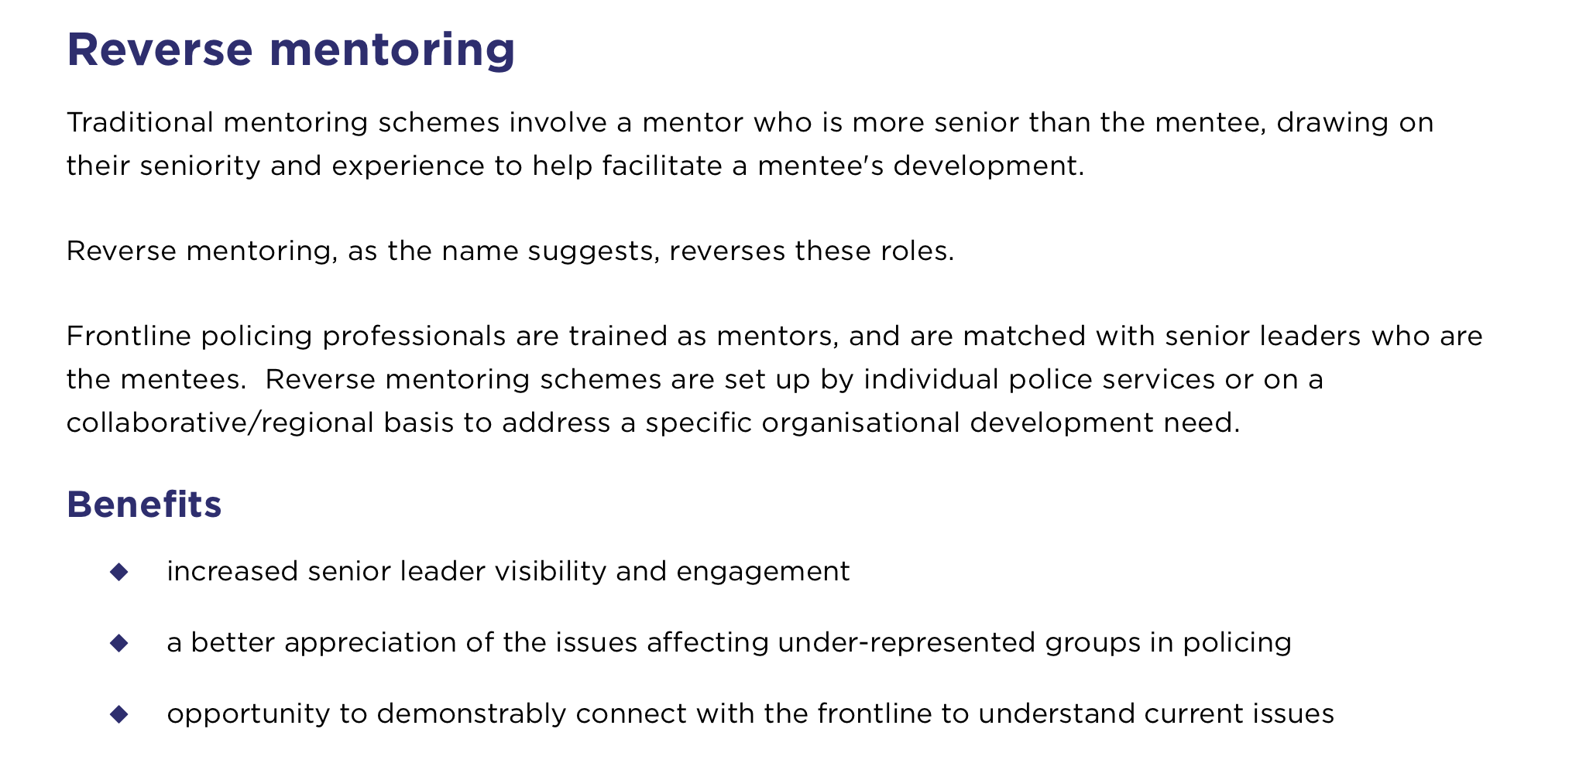

EV.10

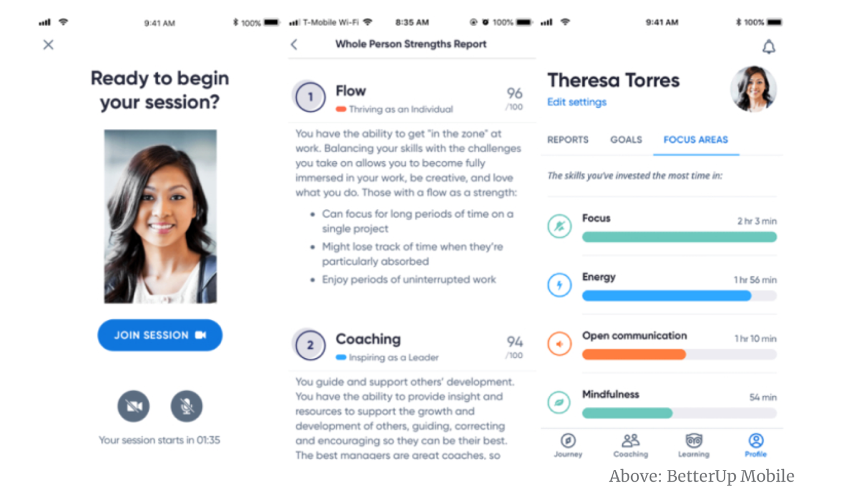

EV.11

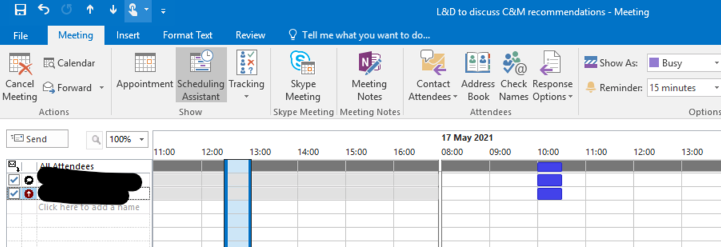

EV.12

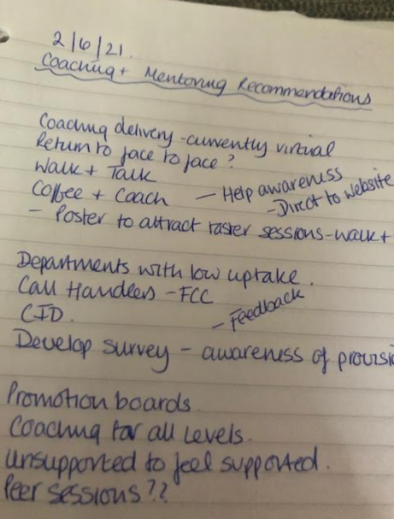
EV.13

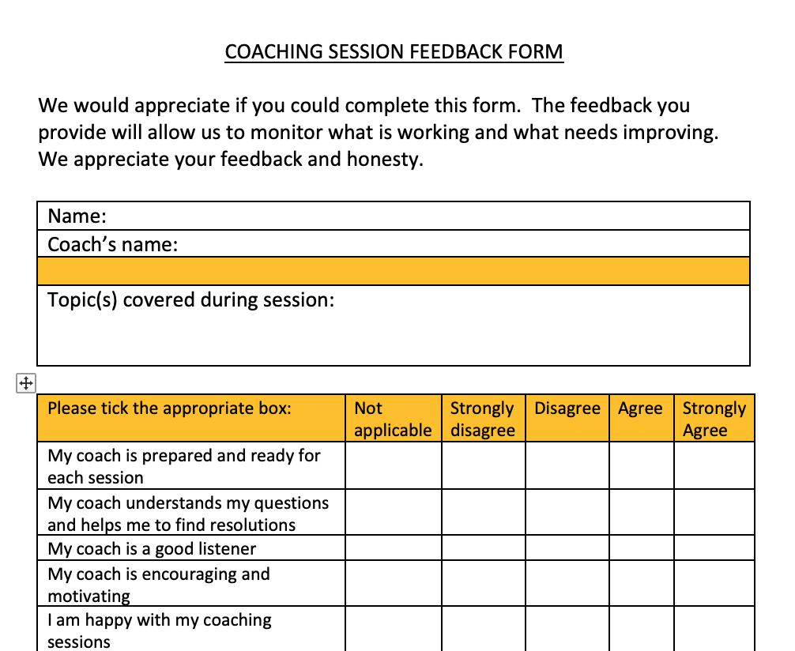

EV.14
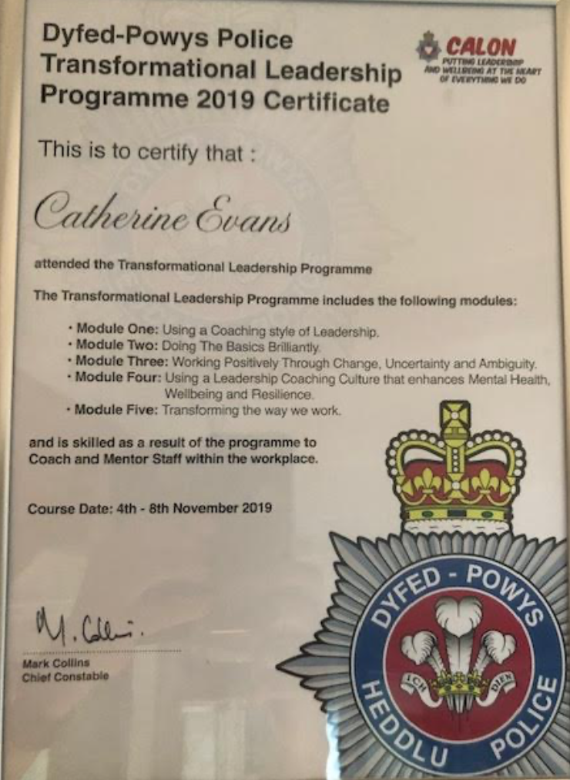

2.

Coaching and mentoring adds value to organisations, benefitting individuals and teams with L&D departments designing and managing the process. (CIPD, 2020).

Figure 1 shows some of the benefits of coaching and mentoring within organisations.
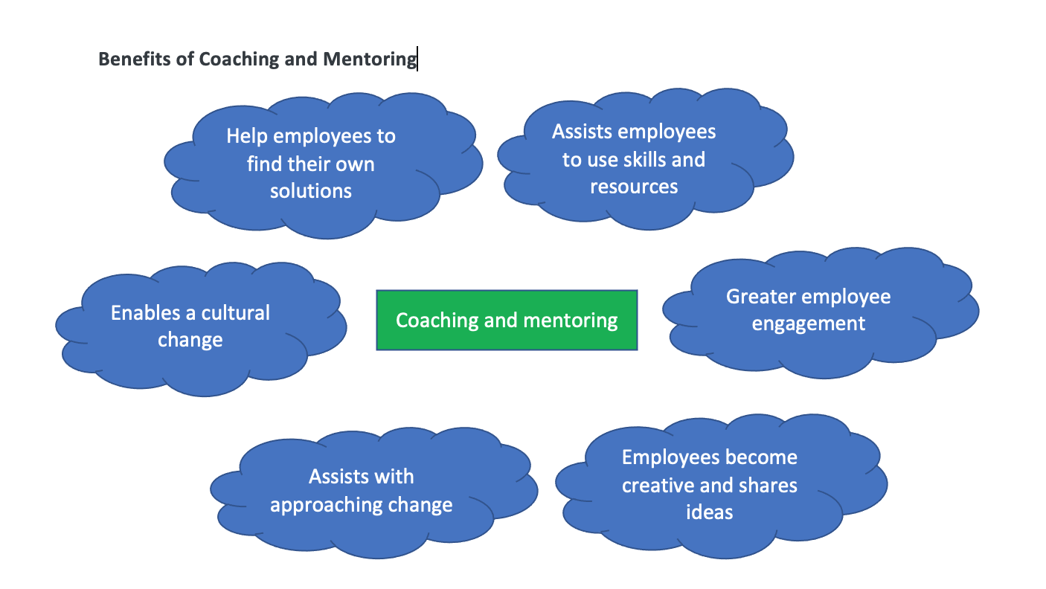
Figure 1. Benefits of Coaching and Mentoring (CIPD, 2020), (BrightHR, nd) (Accipio, nd)

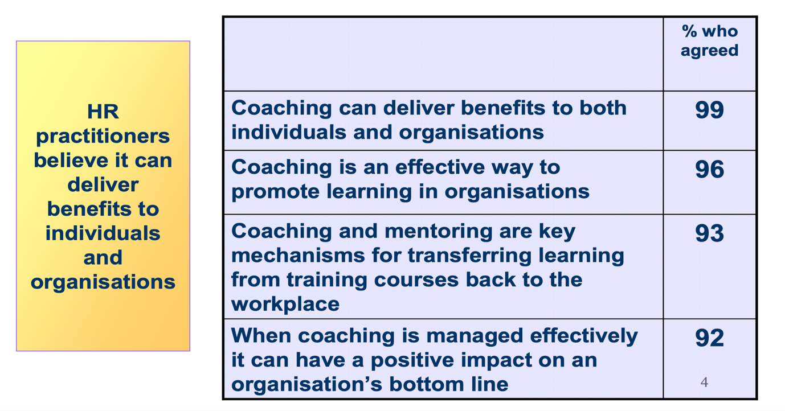
CIPD research L&D Annual Survey
There are however potential barriers to coaching. Time is one of the biggest barriers to implement successful coaching practice within organisations (Sutherland, 2005) and many sessions are abandoned when more urgent demands arise. Within Dyfed Powys, time is afforded for coaching sessions.
Cost is the other main barrier, but coaching should be seen as a major investment in the organisation, and the costs need to be explained and justified for the benefits to be identified. Alignment to the organisational objectives will show the value that coaching can bring. Return on investment is an area that our L&D department is currently starting to identify. This will hopefully increase over the next six months which will encourage expansion of coaching practices as research carried out by the Internal Coaching Federation showed that 86% of organisations benefitted from a return on investment from coaching with up to seven times the initial investment. (Price Waterhouse Cooper Survey, 2011)
Continuous development of our coaching practices is essential. ‘Walk and talk’ coaching is an area that could be developed as this has been proven to be successful and improve employee wellbeing, which is becoming increasingly important in our organisation during the pandemic. I discussed my ideas with the coaching lead and developed a poster that can be used ‘post pandemic’ when staff start to return to the workplace. (EV.15)
Dyfed Powys Police does not have a current coaching policy. I have collated some examples of coaching policies, to assist the lead in developing our policy and will offer assistance and advice when the policy is being developed. (EV.16) Whilst studying the policies I identified that many organisations match coaches and coachees. We encourage our coachees to select their coach from the list provided and feedback has proved that this is the preferred process.
I have developed a survey that will be distributed to the departments that we have identified have a low uptake on the coaching provision – this will hopefully increase their knowledge of the provision and also increase participation. (EV.17)
I have also developed a Pre-Coaching questionnaire to be distributed to the coachees before their initial session. This will assist the L&D department in evaluating the coaching sessions. (EV.18)
In a survey carried out by NHS Leadership Centre (Woolnough et al 2004) – 41% of coachees were promoted, compared to 15% of the non-coached group. We have recently introduced group coaching sessions for our promotion board processes and I am scheduled to attend the next session in late July. (EV.19). I have also recommended that promotion board applicants that are unsuccessful in the process, could be offered individual coaching to assist them in improving their applications and understanding what is required to allow them to progress. By offering this service I believe the applicants will feel increasingly supported by the organisation, rather than being demoralised by rejection. (EV.20)
Guidance documents for differing coaching scenarios could be provided to the coaches to assist them after the coachee has completed their pre-coaching questionnaire. I have developed an example document that could be used. (EV.21). These templates could be developed by the coaches during one of their training sessions, drawing on their past experiences of coaching which would ultimately assist any new coaches.
Empathetic coaches that are non-judgemental are more likely to facilitate agreement on goals and tasks (Asay et al 2001) and I have developed guidance on empathetic listening skills that could be added to the coach/mentor packs provided before the coaching sessions. (EV.22)
Coaching culture can be defined as ‘fostering, rewarding and expecting managers to be effective coaches and mentors’ (Lindbom, 2007, p. 101) or being embedded in the way that people at all levels work together. (Clutterbuck and Megginson, 2005a, p. 19) defines a coaching culture as “a culture where people coach each other all the time as a natural part of meetings, reviews and one to one discussions of all kinds” and this is how we define coaching at Dyfed Powys Police. Coaching takes part daily during our one-to-one meetings and team meetings.
As a Line Manager, I coach my staff daily using the OSCAR coaching model as a guide. I have also coached a staff member from another department using this model. (EV.23) I received confirmation from their Line Manager that the staff member had increased confidence after the coaching sessions and performance had improved. (EV.24)
I have also received coaching, and my coach has recently suggested asking my staff to complete a 360 feedback questionnaire to identify my leadership style and impact which will be sent out over the next few weeks. (EV.25) 360 feedback research has shown that feedback from colleagues positively motivates employee behaviour. (Edwards & Ewen, 1996).
All new staff are on a probationary period for the first six months and continuous evaluation takes place over this period which is analysed prior to the staff member clearing their probation period. Extensions to probation can be added if the need is identified and coaching or mentoring can be provided. (EV.26)
Another area that would be useful to introduce to our evaluation process would be Kirkpatrick’s 4 levels of evaluation. This model was first published in 1959 and covers the following:
Reaction – what they thought about the session – how much engagement and enthusiasm – use feedback forms
Learning – increased knowledge – increased confidence and motivation – informal assessment before and after
Behaviour – improvement of behaviour and capability – how well the training is applied – observations and interviews
Results – effect on business – a good return on investment – performance data

Although this model can be effective it is time-consuming, and Bersin (2006) observes that practitioners would struggle to apply the model fully due to a lack of guidance on measuring levels.

As part of our annual PDR process, we write monthly reflective journals. (EV.27) These are essential to our CPD and I encourage my team to use the Gibbs reflective cycle which was developed in 1988, using the following stages:
Description – what happened? What did you do? What did others do?
Feelings – How did you feel? Were there any difficulties?
Evaluation – What was good/bad?
Analysis – Why did you choose this example?
Conclusions – What have you learnt?
Action – What would you do differently next time?

Without reflection experience could be forgotten or learning potential lost (Gibbs, 1988) and using this model helps us to identify our strengths, areas for development and actions to take to improve our skills. As a Line Manager, I actively encourage two-way feedback, praising my staff on the performance areas that they are excelling in and discussing areas they could improve. I also ask them to feedback on my performance and explain to them what my goals are for our team.

As our mentoring processes have a long timescale there is a need for underpinning to ensure that relationships are flourishing or if not, to allow new relationships to be arranged.
I would like to look at ways that our coaching and mentoring provision could be adapted to allow coaches and coachees to keep an online log of their activity and a progress tracker, and this is an area that our IT department may be able to assist with to ensure transparency and accessibility. This would also allow our Chief Officers to assess the effectiveness of our programmes which will hopefully prove that coaching and mentoring is a valuable investment for the organisation.

Whilst collating information for this assignment I have become actively involved with the L&D department coaching lead, and I am looking forward to expanding my knowledge and undertaking my Level 5 ILM qualification. The next ILM course is scheduled for July next year and I have expressed an interest in observing the refresher course later this year. I also recommended adding an intranet banner to establish if any staff or officers would be interested in undertaking the training as we have over 1000 employees so there is a need for more trained coaches, to meet demand. (EV.28)

I have also offered my assistance to analyse the coaching feedback forms as they are returned over the next quarter. (EV.29). This will help us to identify if any of our existing coaches need refresher training and will allow us to build training programmes for our potential new coaches from the feedback data.

I have also emailed the College of Policing to establish if there are any upcoming coaching skills workshops that our current coaches could attend to refresh and improve their existing skills. (EV.30). The last workshop was for coaching under-represented groups and this was before the pandemic and we are hoping that they will be re-established soon. (EV.31)

I am impressed by the coaching and mentoring provision within Dyfed Powys Police and the Lead is enthusiastic about the provision continuing to improve through the pandemic and beyond. With the above recommendations in place, I believe we will have increased uptake of the provision. I have reflected on my leadership skills and realise that although I am not subconsciously coaching my staff, it occurs daily naturally by supporting them through regular meetings.

LO2. Bibliography

Accipio (nd) Value Benefits and Cost of coaching and mentoring. Available at: https://www.accipio.com/eleadership/mod/wiki/view.php?id=1793 – accessed 23 June 2021
Asay, T. P., and Lambert, M. J. (2001) ‘Therapist relational variables’. In D. Cain and J. Seeman (Eds.), Humanistic psychotherapies: Handbook of research and practice (pp 531-558), Washington, DC: American Psychological Association
Bersin J., (2006) High-Impact Learning Measurement: Best Practices, Models, and Business-Driven Solutions for the Measurement and Evaluation of Corporate Training. [Online] Available from http://www.bersin.com - accessed 20 June 2021

BrightHR (nd) What are the benefits of coaching and mentoring in the workplace. Available at: https://www.brighthr.com/articles/training/coaching-mentoring/benefits-of-coaching-and-mentoring-in-the-workplace/ - accessed 23 June 2021

CIPD (2020) Coaching and Mentoring | Factsheets. Available at: https://www.cipd.co.uk/knowledge/fundamentals/people/development/coaching-mentoring-factsheet#6991 -accessed: 17 June 2021

CIPD (2008) Learning and Development Annual Survey Report. Available at:: http:www.cipd.co.uk/surveys – accessed 23 June 2021
Edwards, Mark R. and Ewen, Ann J. 360-Degree Feedback: The Powerful New Model forEmployeeAssessmentandPerformanceAppraisal.AmericanManagement Association: New York, NY, 1996.
Jarvis, J. (nd) Danamayer.com. Available at: https://www.danamayer.com/wp-content/uploads/2020/01/Does-Coaching-Really-Work.pdf - accessed: 13 June 2021
Sutherland, V.J. (2005). Nurse leadership development: Innovations in mentoring and coaching – the way forward. London: NHS Leadership Centre.
Watson, A. (2019) Step Outside: Walking and Talking Coaching - International Coaching Federation, International Coaching Federation. Available at: https://coachingfederation.org/blog/walking-and-talking-coaching - accessed: 14 June 2021

Whittington, S. (2017) Six reasons why all leaders should coach, Steve Whittington. Available at: https://www.stevewhittington.com/2017/01/six-reasons-why-all-leaders-should-coach/ - accessed: 17 June 2021

LO2. EVIDENCE
EV.15
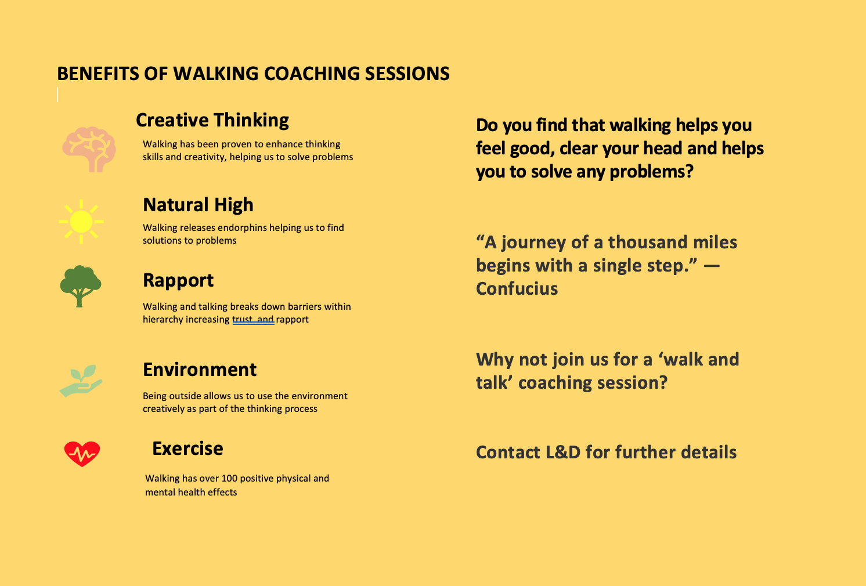

EV.16
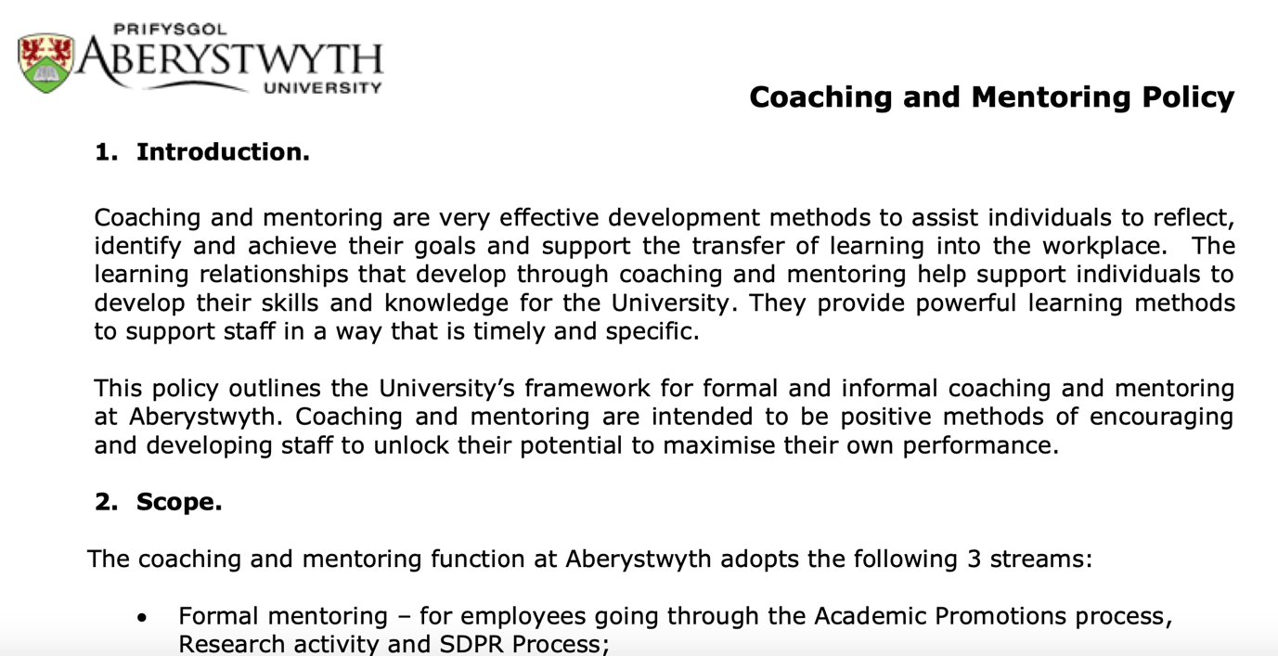

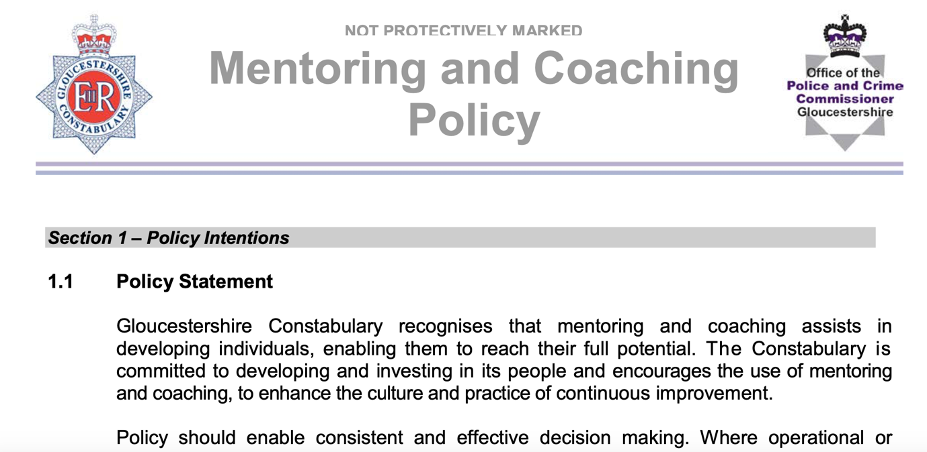
EV.17
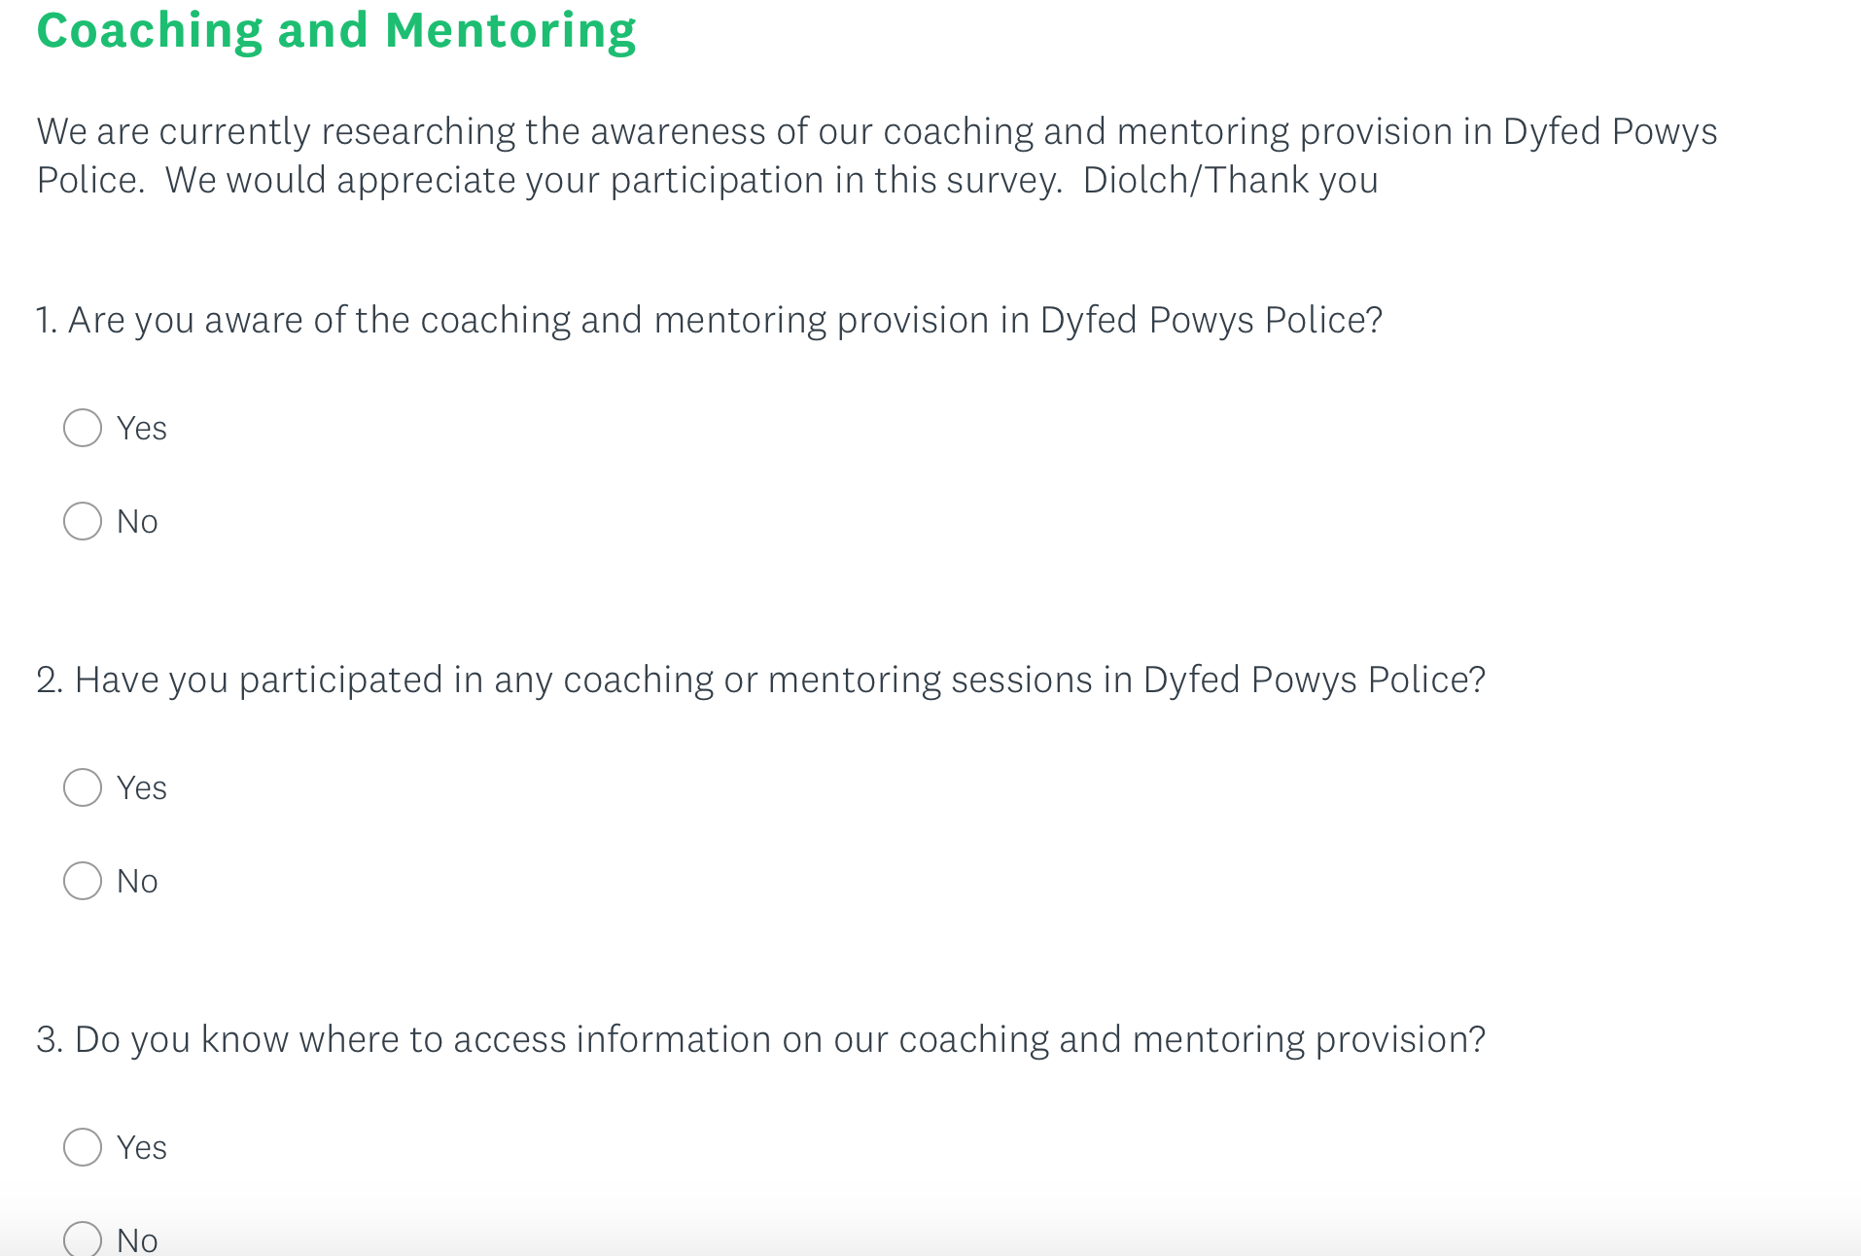

EV.18
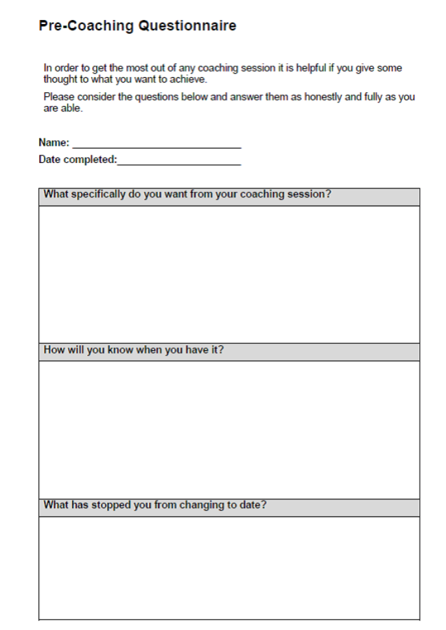
EV.19
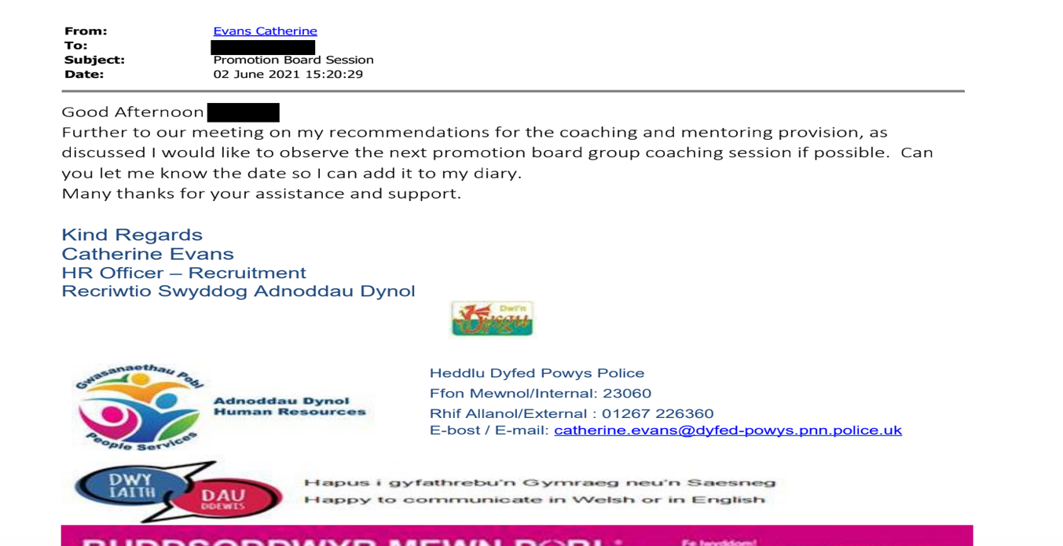
EV.20
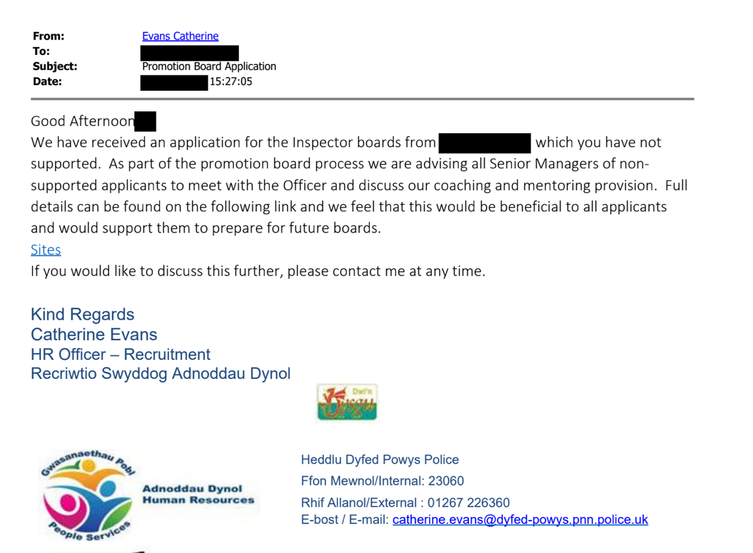
EV.21
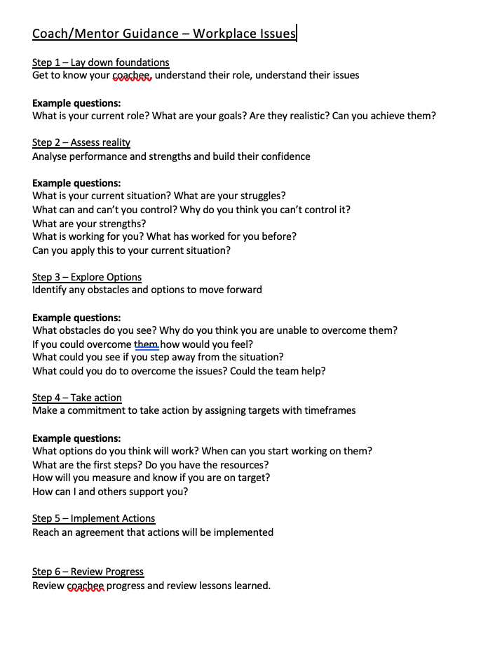
EV.22
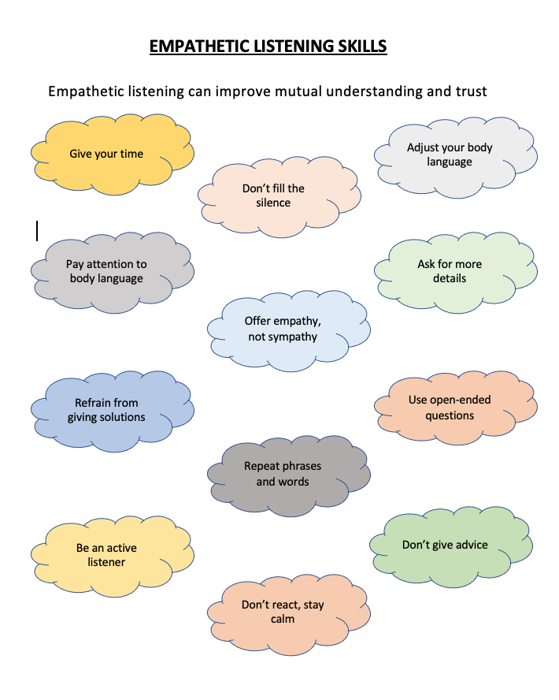
EV.23 – OSCAR COACHING SHEETS

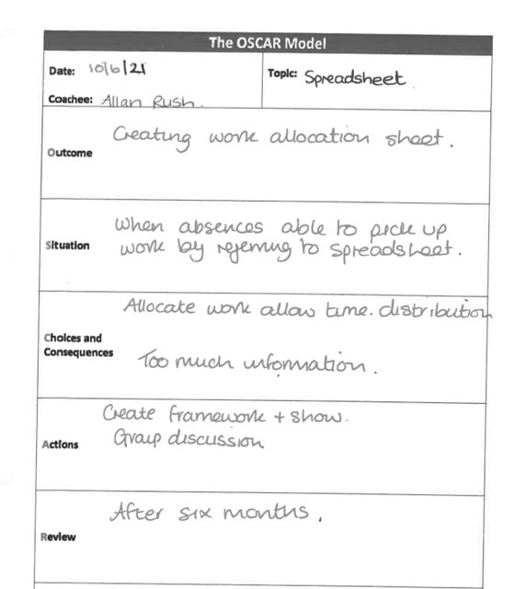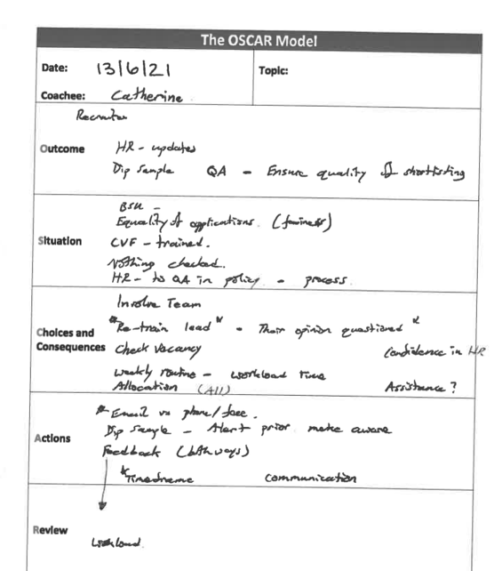
EV.24
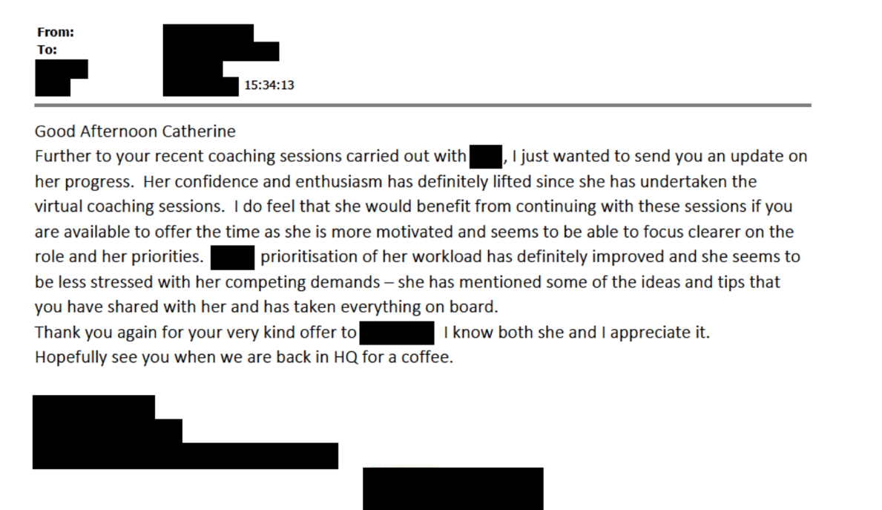
EV.25

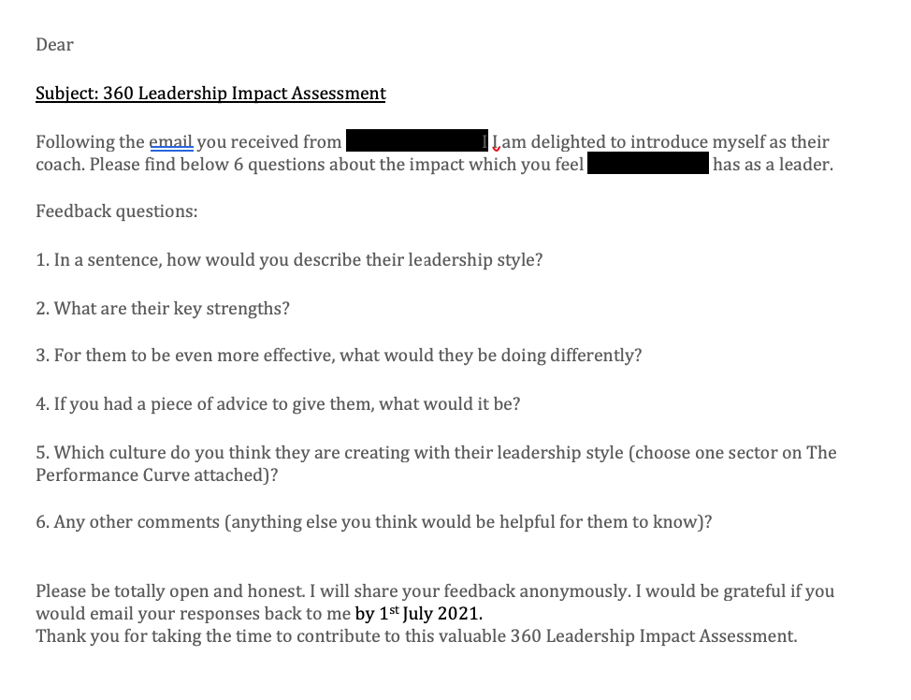
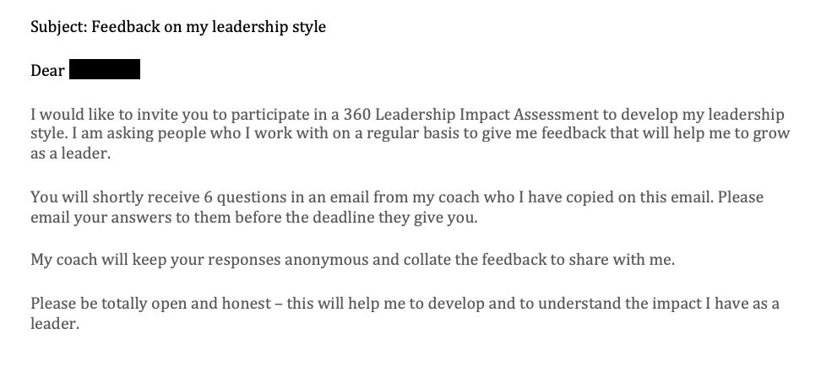

EV.26
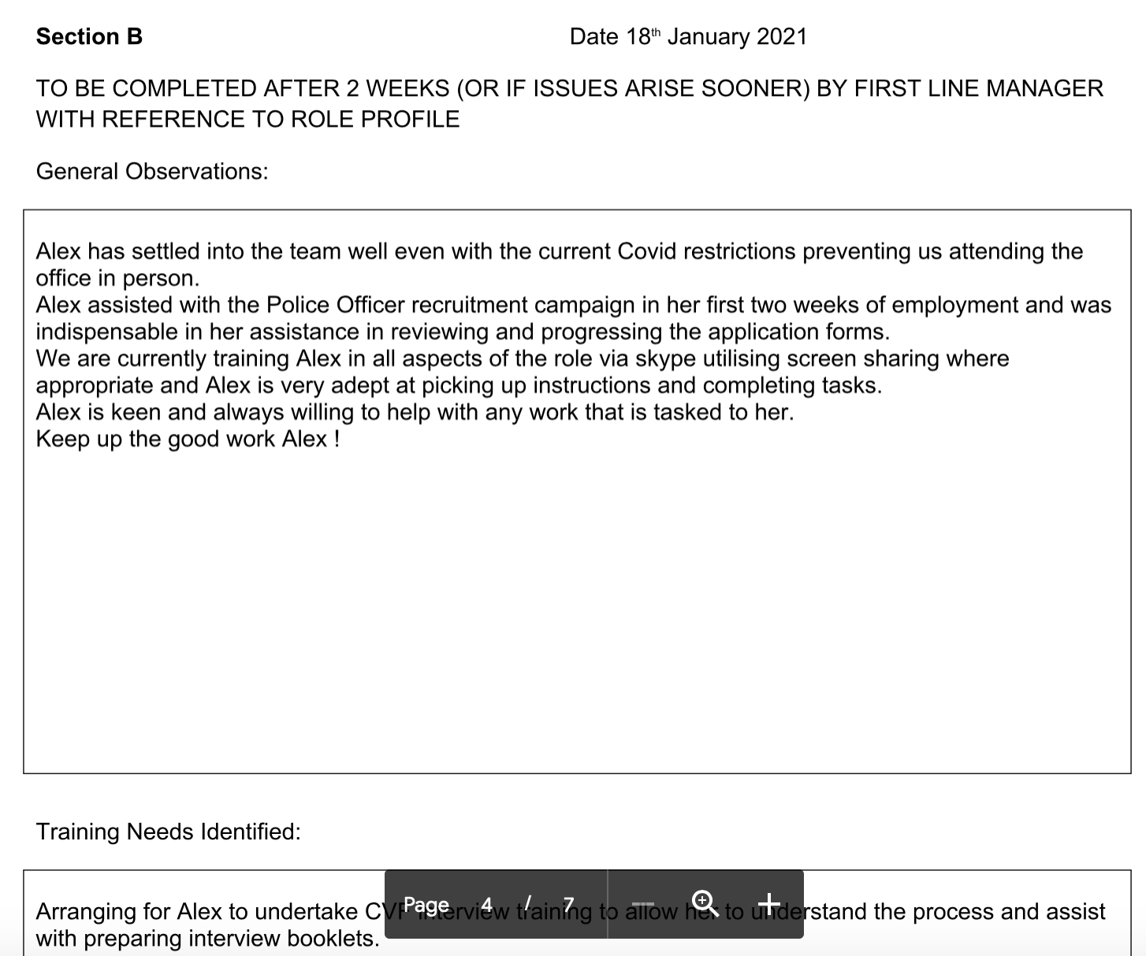

EV.27

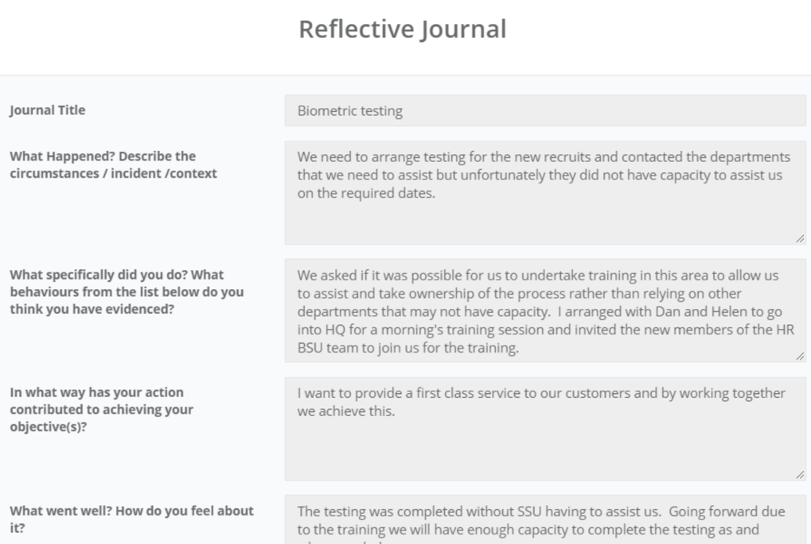

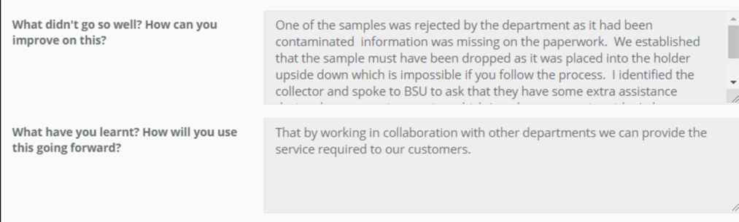

EV.28
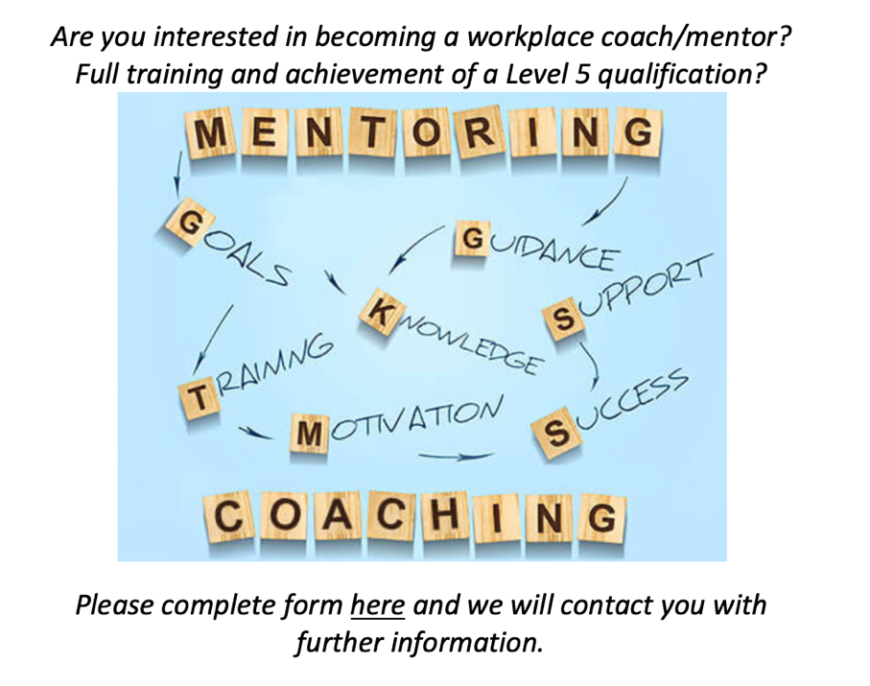

EV.29
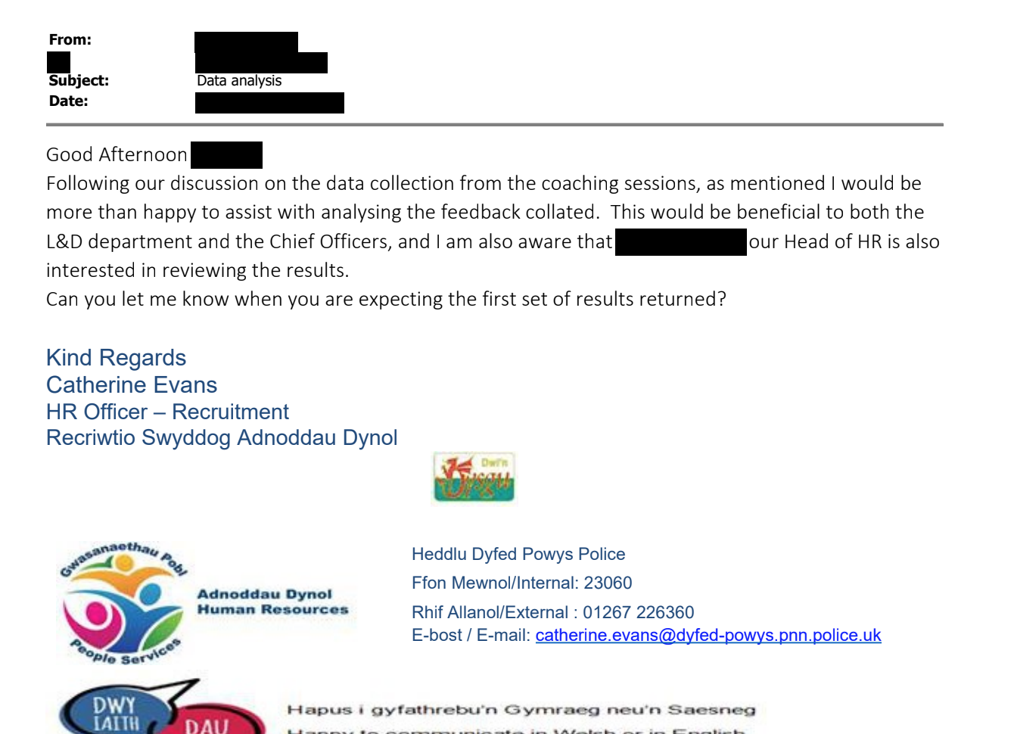

EV.30

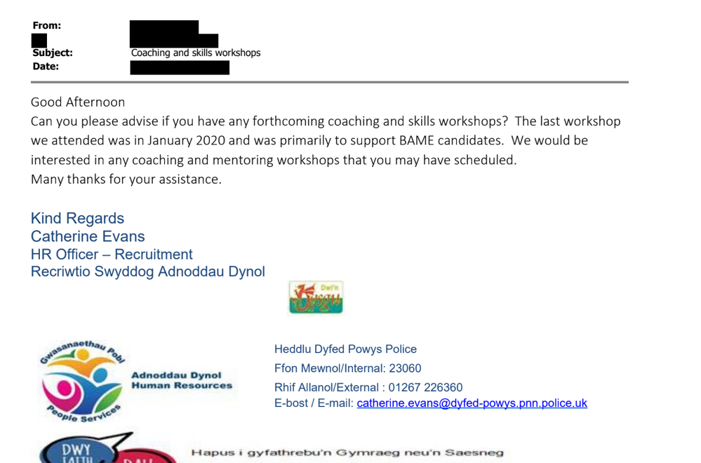

EV.31


