Project Planning For Construction
(ACBA5001)

Assignment Two – Quality Management

By Ellis Jones
(1708692)

Table of Contents

Management Procedure 1

Quality Management Procedure 4

Conclusion 8

Appendices 9

Bibliography 12

Management Procedure

In order to successfully deliver a large construction project such as student accommodation, the Site Manager will require frequent communication with a vast number of parties. Those that they will likely require the most liaising with are the Project Team (which is typically made up of the Client, the Design Consultants and their colleagues who are also representing the Main Contractor) and also the various sub-contractors and suppliers that make up the supply chain. A typical example showing the relationships between all parties within the traditional procurement approach is displayed in Appendix 1A.

“The Project Team is made up of people from many different firms. Their contributions vary and a lot of information has to pass among them. This requires a well organised network of communication using the latest technology”

Those that they will likely have the earliest involvement with are typically the design team. A design team often consists of multiple specialists such as architects, structural engineers, civil engineers, mechanical & electrical engineers, landscape architects and more. The extent of how much interaction is had between the site manager and the design team often depends on the type of procurement variant. Within the traditional procurement approach, the client would appoint the design team to develop the design to a relatively advanced stage (typically RIBA Stage 4) so that the main contractor can price and tender for the works. This differs to a design & build contract where the main contractor would have more involvement with the design process, carrying more responsibility and risk. Within the traditional procurement method, the consultants are directly contracted to the client and so the client takes the design risk.

“In simple terms, this (the traditional procurement method) is probably the most straightforward format in that that the customer employs the designers, they design the project, a contractor prices the design and once appointed, then goes on to build it” (Eynon, 2014)

The client will issue the main contractor with all design information which they have developed with the design team This is typically drawings, specifications, a model if the project is BIM compatible and any other design information required.

It is also essential that they provide drawing registers with revisions and dates to ensure that the Contractor is working to the correct drawings.

Despite a traditional procurement method not requiring any involvement in the design development for the main contractor, it is likely the site manager will still need to maintain lines of communication with the design team however this must be via the client. This communication is often carried out in the forms of RFI’s – Requests for Information, where a contractor will formally request information from the client. An example of a situation where a RFI may be issued could be due to design complications arising during the build. These complications may consist of issues such as unforeseen “made up” ground leading to a required change in the foundation design from the structural engineer or a clash on site with mechanical and electrical components leading to a change in design from the M&E engineer. Changes to design in a traditional procurement format will result in the Client issuing a Contractor with a PMI or AI, with the contractor then issuing these revised drawings to their relevant sub-contractors, ensuring that they note the design changes.

Across the duration of a project, there are often a large number of contractors appointed on a sub-contract basis. As shown in Appendix 1A, these contractors are individual firms who are then contracted under the main-contractor to carry out and complete specific elements of work.

The site manager must manage each of these sub-contract packages to ensure they are delivering their work packages to a high level of quality and in line with the agreed programme.

“The Site Manager ensures that all work carried out conforms to specified standards and design criteria. They are charged with enforcing the quality assurance system throughout the project, with due regard to the performance of sub-contractors, ensuring conformity to specified standards by all subcontractors and suppliers”
(Griffith, A, Stephenson, P, Watson, P, (2014)

Communication is often established between the site manager and sub-contractors through documentation such as formal instructions via emails, daily briefings and weekly sub-contract meetings. These meetings often feature an agenda, minutes and an action list. Ideally, sub-contractors will have their own manager or foreman who is in charge of their respective tradesmen, providing the site manager with a focal point for communication, rather than having to deal with a large number of trades directly.

Quality checklists should be in place to ensure sub-contractors are completing their work to an acceptable standard. For example, a brickwork quality checklist containing information such as the drawings and the section of the specification to reference, the mortar class, the finish, the pointing and the gauge bond. The checklist should also contain questions such as “is access adequate/safe?”, “are bricks/blocks undamaged?”, “is the setting out adequate and understood?”. It is often the case that a contractor will include text within the checklist stating that if any sub-standard workmanship, material or performance is identified during the quality check then a non-conformance report will be issued to the sub-contractor.

It is also essential that the sub-contractor is delivering their work in line with the project specification which is often produced by the architect. The specification will outlay the products they should be installing and how it should be installed. An example of this would be the type of plasterboard required in order to achieve the correct fire compartmentation – something which Is extremely important in buildings such as student accommodation. By producing quality inspection checklists that capture these specification requirements, the site manager can ensure the sub-contractors are carrying out their work correctly, compliantly and to a high standard of quality.

It is also the duty of the site manager to manage and monitor the quality of materials coming to site. The site manager should ask the sub-contractor to provide material certificates to show they are complying with the specification. An example of this could be concrete tickets showing that the correct grade of concrete has been used and that the concrete complies with British Standards or delivery notes for windows confirming that they meet the specified U-Values. The site manager should also receive concrete cube test results from the sub-contractor to ensure the concrete is of the correct compressive strength. Other items that sub-contractors should be providing to the site manager include product data sheets, warranties (if applicable) and also proof of competency of site personnel.

It is often the case that the client will allocate a clerk of works to the project. The clerk of works inspects works on site, ensuring they are being carried out to an acceptable standard and to what they perceive to be an acceptable level of quality. It is essential that the site manager maintains a good relationship with the clerk of works as a good working relationship between both parties is likely to lead to better quality in the build.

Quality Management Procedure

As quality is subjective to the individual, it is important that company-wide integrated management systems are adopted to ensure all individuals within the company are contributing to what the company perceives to be a high quality standard.

“Total quality management consists of organization-wide efforts and integrated systems of principles, methods, and best practices to install and make a permanent climate in which an organization continuously improves its ability to deliver high-quality products and services to customers”

https://www.google.co.uk/books/edition/Total_Quality_Management/PlIkDAAAQBAJ?hl=en&gbpv=1&dq=define+quality+management&printsec=frontcover

A company’s quality management system is made up of a number of different policies, processes and procedures.

Document control ensures that all information, specification, forms, drawings etc are current and that employees are working to the correct documents. Processes in place for document control include cloud systems with folders set up in a uniformed manner across all projects and drawing registers showing what revisions of drawings were received and when.

Training ensures that employees have the correct skill sets to carry out their work to the required level. An example of this would be SMSTS training for site managers, ensuring they are competent in their role and that they are well informed of the responsibilities of a Site Manager.

Quality checklists and hold points ensure works are completed to an acceptable standard before the next phase of works begin.

Non-conformances ensure that corrective action is taking place when sub-standard works have been carried out.

Internal audits are carried out to ensure the company is compliant with ISO requirements ahead of the official external audit. Individual sites are audited to check they are compliant with health and safety, environmentally compliant (site waste management plan, waste transfer notes etc) and compliant with the company’s quality management system (correct paperwork in place, quality procedures are being followed etc

“The essence of a quality management system is that quality is managed in ways which are clearly identified, well documented and efficiently planned, implemented and controlled so introducing quality management involves setting up procedures and providing documentary evidence that quality targets are being achieved”

(Fryer, B, 2004)

The quality and quantity of documents that are generated for a quality management system vary from company to company. Hold points enable a company to check the works of

The process map shown in Appendix 1b is an example of what a company may have as their processes and how they are linked with each other. The core processes are representative of the day to day operations of the company, from tender stage through to handover. The support processes are what help the core process run smoothly (e.g I.T support and equipment maintenance) and help the company improve (internal audits and training).

Quality is something which is desirable across many industries with many companies seeking certification and accreditation to prove that they can deliver their goods/services to a high standard. Whilst it is desirable however, it is also subjective as different people have different conceptions of whether or not something is of high quality.

Clients will expect the contractor to deliver a project on time to the agreed programme whilst maintaining high quality. Contractors will want to deliver the highest quality build possible as this will lead to a better reputation, better client feedback and increases the possibility of winning work in the future.

The International Organization for Standardization (ISO) defines quality as “the totality of characteristics of an entity that bears on its ability to satisfy stated or implied need”. A way in which companies can acquire the sought-after certifications previously mentioned is through implementing standards developed by the ISO. These standards are recognised internationally and ensure “consistency and transparency, as well as a transfer of best practices across the globe.” (Zhao, Castka, & Searcy, 2020).

One of the ISO’s most recognised standards is ISO 9001. Operating ISO 9001 enables a company to “enhance customer satisfaction through the use of quality management instruments that include methods for planning and improvements of processes and ensuring conformity to customer and applicable statutory and regulatory requirements.” (Abuhav, 2017). By implementing ISO 9001, organisations are demonstrating to their customers that the goods or services provided will be consistently to a certain standard. This would in turn increase customer confidence, customer retention, and therefore the reputation of the organisation.

Within ISO 9001, there are eight basic management requirements and five basic assurance requirements. (Hoyle, 2017). The five assurance requirements focus on:
- The organisation displaying commitment to attaining quality,
- Ensuring that effective policies are in place to inspire staff into reaching the customer’s needs and expectations,
- The organisation’s objectives being measurable and attainable whilst linking to the needs and expectations of customers,
- The organisation guaranteeing efficient processes in which to meet their objectives, and
- Proof that objectives are being met, and that the objectives remain equal or above that of the needs and expectations of customers.
(Hoyle, 2017)

Thorpe and Sumner state that “quality assurance is a structured approach to business management and control, which enhances the ability to consistently provide products and services to specification, programme and cost”. (Thorpe and Sumner, 2017).

The quality assurance process must have defined plans to be carried out efficiently and effectively. The plans involved will vary between industries, and plans may also change within a company if the company evolves. One recommended method of implementing, maintaining, and improving an ISO 9001-compliant quality management system is plan, do, check, act (PDCA). (Watkins, 2017),

Plan: Firstly, any goals must be identified – what are we trying to achieve? To ensure that these goals are being achieved, objectives must be set. As ISO 9001 states, the objectives should be measurable and attainable.

Do: Tests are designed and carried out to verify that the objectives are being met.

Check: The outcomes of the tests are reviewed to determine any variances (objectives not being achieved).

Act: If objectives are not being met, problems will need to be identified and corrected before tests are carried out again.

The cycle of PDCA will continue until objectives, and therefore the standards required, have been met. All outcomes of tests, problems, and corrections are documented and can be referred to and utilised in training exercises in future projects. The documentation of each step of the quality assurance process can help to pinpoint any potential lack of training in individuals or teams. It can also be used to assist managers when monitoring or reviewing individual/team performances.

A standard for a site manager may be the completion of quality checklists. A test that could be carried out here would be a random check-in on these quality checklists to ensure the site manager is completing them daily, as expected. If the checklists are not being completed as expected, and therefore the standard required not being achieved, the problem would need identifying and correcting – this may be in the form of a senior member of staff addressing the identified problem with the individual (the site manager). Once the problem has been corrected, another test can be performed until the standard required is achieved. If the site manager continues to fall short of achieving the standard, this might indicate a lack of training. If the site manager does continue to compile these quality checklists, it is highly likely to reduce the amount of defects/legacy issues on the project. An example of this could be a quality checklist to ensure a damp proof membrane has been lapped and installed as per the manufacturers recommendation, therefore mitigating the risk of water ingress in the future.

The purpose of a PDCA cycle is to “maintain continuous improvement”. (Abuhav, 2017). Throughout this process of continuous improvement, quality will be monitored and required standards will be maintained, both resulting in improved quality standards.

Conclusion

Appendices

Appendix 1A – Arrangement of Project Personnel

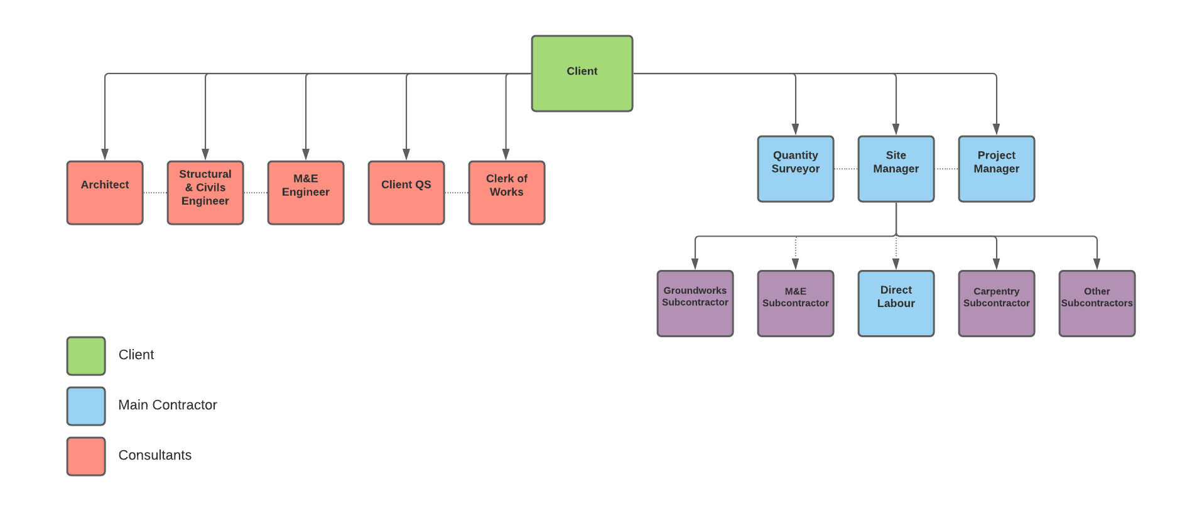

Appendix 1B – Process Map

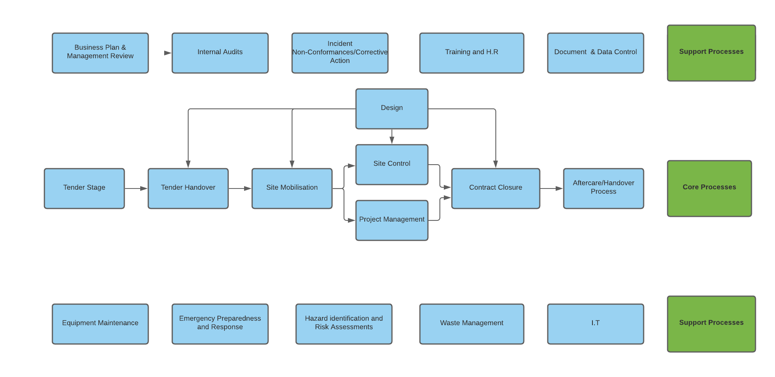

Appendix 1C – After Sales Procedure

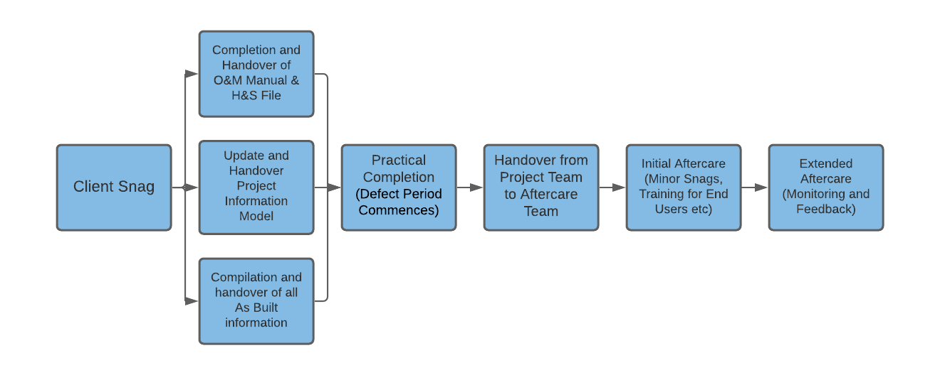

Bibliography

- Abuhav, I (2017). ISO 9001:2015 A Complete Guide to Quality Management Systems. Florida: Taylor & Francis. 1.

- (CIOB, The Design Managers Handbook, Eynon, 2014)

- Fryer, B, Ellis, R, Egbu, C, Gorse, C, (2004). The Practice of Construction Management: People and Business Performance. London: John Wiley & Sons. ...
- Griffith, A, Stephenson, P, Watson, P, (2014). Management Systems for Construction. New York: Routledge. 88.
- Hoyle, D (2017). ISO 9000 Quality Systems Handbook – updated for the ISO 9001:2015 Standard: Increasing the Quality of an Organization’s Outputs. United Kingdom: Taylor & Francis. p60.

- Thorpe, B, Sumner, P (2017). Quality Assurance in Construction. .: Taylor & Francis. 8.
- Watkins, S. (2017). ISO 9001:2015: A Pocket Guide. United Kingdom: IT Governance Ltd.
- Zhao, X, Castka, P, Searcy, C (2020). ISO Standards: A Platform for Achieving Sustainable Development Goal 2. Christchurch. 2.

