Programme: Master of Business Administration
Module : Human Capital Management component 1
Module Code: LCMB7023
Student Name: JAYBHAI RAJENDRABHAI JOSHI
ID: 2604116
Date of Submission: 15th October 2026

Table of Contents
Introduction 3
Task A: Designing Innovative Working Practices 4
1.1 Critical Evaluation of Traditional Work Design and Contemporary Innovative Working Practices 4
1.2 Recommended Innovative Working Practices for NHSX 8
Task B: Breeding an Environment Where Talent May Grow 12
2.1 Designing a strategic talent ecosystem to enhance the potential of human capital 12
2.2 Proposed talent growth strategy for NHSX 14
2.3 Implementation, Measurement, and Risks 17
Task C: Reflective report 20
Description 20
Feelings 20
Evaluation 20
Analysis 21
Conclusion 21
Action plan 21
Conclusion 22
Reference list 23

Introduction
Organisational competitiveness is influenced by integral innovative working practices and talent development strategies that shape the changing business environment. NexSpace Health Systems (NHSX) is facing challenges due to traditional hierarchies, limited employee autonomy, fragmented hybrid collaboration, and weak career pathways that limit innovation along with new knowledge sharing and talent retention.

Task A: Designing Innovative Working Practices

1.1 Critical Evaluation of Traditional Work Design and Contemporary Innovative Working Practices
Traditional work design shows an integrated hierarchy system with specialisation, control and formal authority unlike content prairie approaches that emphasis on agility, participation, flexibility and employee-technology integration. NHSX faces challenges of hierarchy approach while limited accountability in healthcare technology environments reduce talent management.
Approach | Key principle | Potential contribution to NHSX | Critical concern | NHSX implication
Traditional hierarchy | Formal control with centralised authority | Consistent governance with accountability | Complex and time-taking decision-making with restricted experimentation | Keeping strategic control with decentralise operational decisions
HPWS | Opportunistic control to foster ability, and motivation | Developing workforce capability and performance | Increased work pressure with performance intensity | Performance alignment with development and wellbeing
HIWS | Empowerment with participation, information and acknowledgement | Increased ownership with utilisation of employee expertise | Decisional standards with trust mediation | Employee empowerment defined accountability
Agile working | Working repetition, experimentation and constructive feedback | Responsiveness with improved innovation | Ambiguous work practices with uncontrolled autonomy | Objective and governance clarity in agile teams
Hybrid/flexible working | Flexible working practices | Improved employee experience and autonomy | Restricted collaboration and knowledge sharing | Structural flexibility
Sociotechnical systems | Alignment of technology, work, human, and structure | Integrated technological capabilities with human participation | Redesigning systemic processes | Delivering \overarching design details
Table 1: Comparative evaluation of work-design approaches
(Source: Influenced by Xu et al., 2023; Kakakhel and Khalil, 2022; Nguyen et al., 2024; Mancl and Fraser, 2022)
The comparison showed that replacement of hierarchy at NHSX with complete autonomy can result in structural collapse. Retaining hierarchical structure with clinical accountability, regulatory compliance, and risk management can help foster experimentation as suited for AI-enabled healthcare. In Employer Skills Survey 2024, it is found that 6% of employers suggest HPWS to promote performance infrastructure based on motivation, development, and contribution opportunities, where 63% provided training and 54% conducted training-needs assessments (Scottish Government, 2025). On the other hand, HIWS integrates sharing of information, voice, and distributed decision-making to strengthen employee participative infrastructure.
Agile working practices at NHSX can support rapid response to changing AI and digital-health requirements as depicted in Table 1. Hierarchical delays can be reduced with short developmental cycles, experimentation, and continuous feedback, while accountability is essential to mitigate issues of fragmented priorities with unclear ownership (Tettey et al., 2025). Likewise, a hybrid working system with deliberate collaboration provides employee empowerment.
Geographically dispersed workforce of NHSX must work to ensure collaboration and support asynchronous knowledge sharing for purposeful in-person interaction. The ACAS model of disciplinary procedure following the Tuckman’s team development strategies can establish the professional standard with flexible arrangements supported by fair, transparent and consistent processes (Aggrawal et al., 2024; Bansal and Bose, 2026).
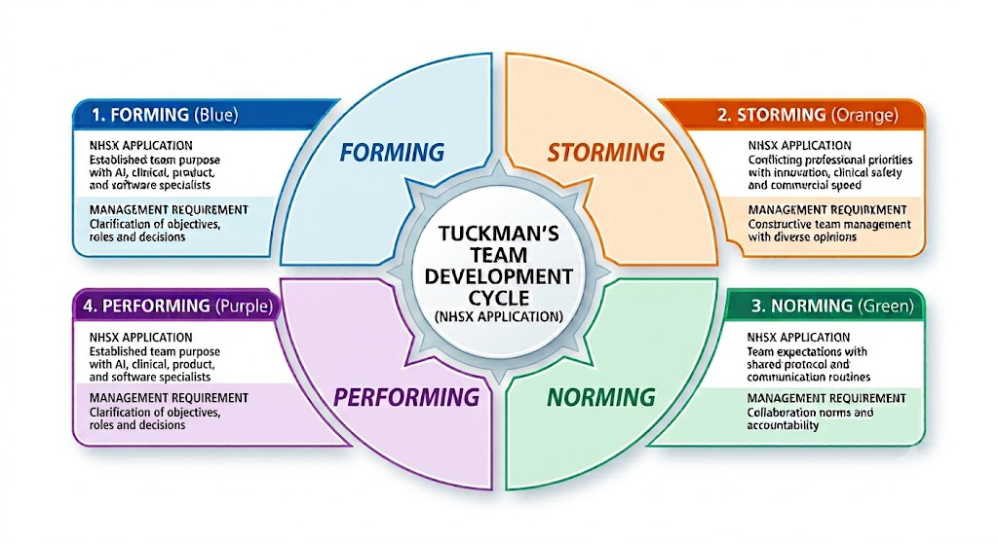
Figure 1: Application of Tuckman’s team development framework to NHSX
(Source: Influenced by Zirar et al., 2025)
After developing a strong team, the innovative work culture can be supported with the implementation of efficient translation strategies regarding innovative work design following the PERFORM model. Organisational performance and employee-benefit initiatives can be achieved here.

PERFORM dimension | Application to NHSX
Purpose | Objective transparency for patient-focused and innovation-oriented goals with alignment of cross-functional teams
Empowerment | Employee participation in appropriate operational decisions
Relationships | Strengthened collaboration of UK–India–UAE
Flexibility | Combine Agile and structured hybrid working
Optimisation | Experimentation for continual improvement of workflows
Recognition | Acknowledgement for innovation, knowledge sharing and contribution
Morale | Employee wellbeing preservation alongside performance expectations
Table 2: Performance management through PERFORM model
(Source: Self-developed)
Additionally, Sociotechnical Systems theory provides the oversight to NHSX’s challenges to balance human, technology, and structural components. A digital approach to collaboration and support decision-making while empowering employees can reduce fragmentation issues.
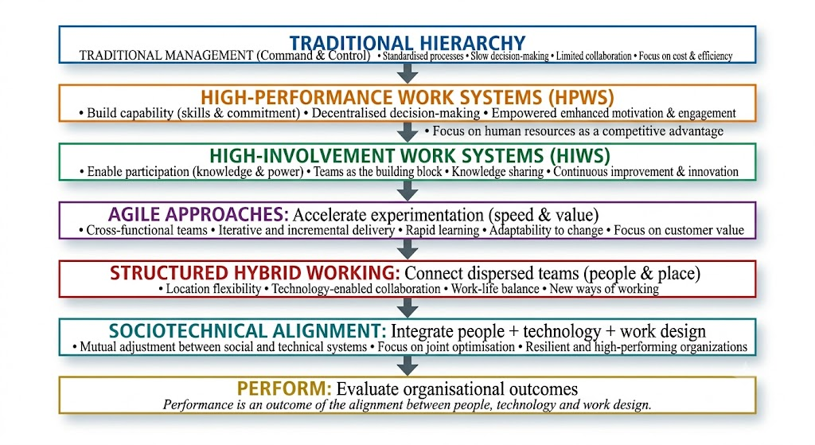
Figure 2: Integrated transition model of NHSX
(Source: Self-developed)
The resulting model is perceived to improve innovation with control while delivering accountability for autonomy and fair flexibility to support working transformation.

1.2 Recommended Innovative Working Practices for NHSX
The implementation of Connected–Empowered–Agile–Digital (CEAD) architecture to redesign work focusing on collaboration, autonomy and experimentation with onward-edge integration can facilitate overcoming challenges successfully.
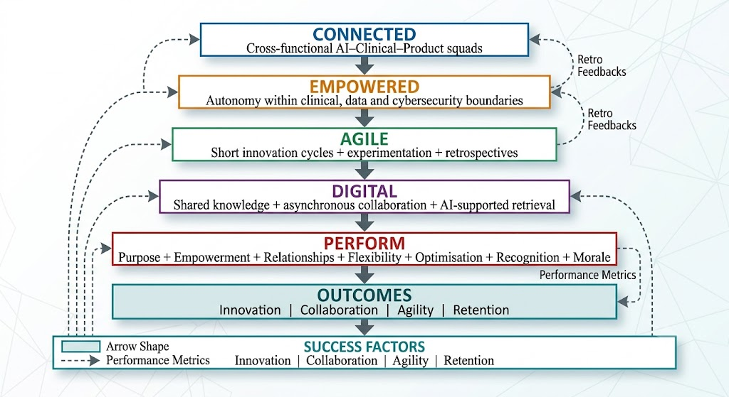
Figure 3: Proposed CEAD architecture
(Source: Self-developed)
ACAS model integrated horizontally into operationalisation of this model that highlights safeguarding governance with transparency and consistency into employment practices addressing flexible working and employee relations. Additionally, AI–Clinical–Product squad intervention can reduce the issues of functional data flow disruption and weak international knowledge sharing (Timilsina et al., 2023). The proposed intervention is planned to combine AI with clinical data and software-product systems to obtain defined outcomes of cybersecurity and UX expertise.
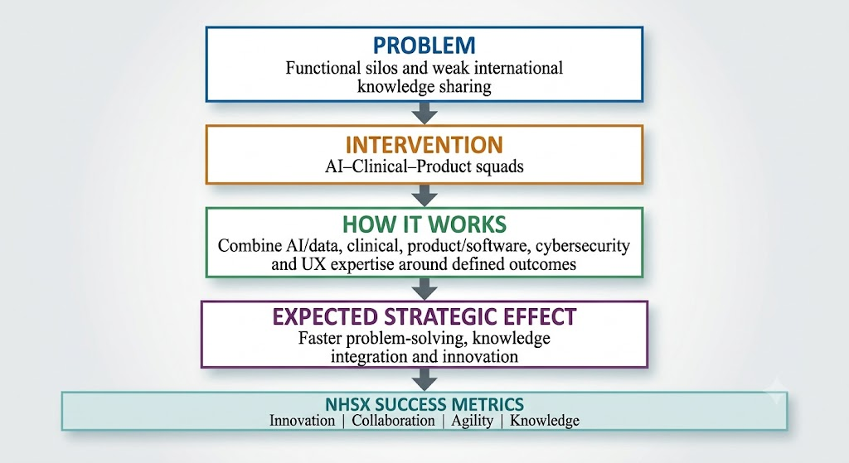
Figure 4: AI–Clinical–Product squad proposal
(Source: Self-developed)
Replacing the sequential departmental hand-offs with multidisciplinary squads supported with HIWS and HPWS can enable employee participation and contribution to improve performance based on innovative capabilities (Díaz-Leyva and Cascón-Pereira, 2026). However, functional diversity has the risk of professional conflict. Implementation of Tuckman's team-development logic and PERFORM's emphasis can support constructive conflict resolution with establishment of shared goals.
Dimension | NHSX practice
Where | Role-appropriate flexibility
When | Core collaboration for UK–India–UAE
Together | Complex collaboration with planned anchor system
Asynchronous | Decision logs and documented project updates
Fairness | Transparent criteria with consistent access
Table 3: Hybrid contract system
(Source: Influenced by Mayer et al., 2022)
Considering flexibility, unrestricted remote work will increase work complexities and increase collaboration problems. Hence, a structured model supported by Sociotechnical Systems Theory, as depicted in the figure above, can link the social and technological dimensions with employee perseverance, while HIWS can support employee participation in the designed effective working arrangements.
Element | NHSX intervention | Strategic contribution
Empowered | Autonomy for the workforce with set boundaries for clinical practices and data security | Rapid decision-making with accountability
Agile | Sprint lead to prototype and clinical feedback with retrospective | Spontaneous experimentation and adaptation
Digital | Shared workspace fostering AI retrieval and decision logs | Knowledge dissemination
PERFORM | Facilitates purpose, empowerment, flexibility, relationships, optimisation, recognition and morale | Performance evaluation with engagement and retention
Table 4: CEAD implementation and NHSX intervention
(Source: Influenced by Kanellopoulou et al., 2025)
The CEAD implementation flows from empowerment to agile, digital and PERFORM to develop innovative, collaborative and agile work environments leading to retention. Nonetheless, clear ownership and capability planning are essential here.

Task B: Breeding an Environment Where Talent May Grow

2.1 Designing a strategic talent ecosystem to enhance the potential of human capital
The construction of a strategic talent ecosystem is depicted below, where 600 employees of NHSX can continuously develop and perform at their highest potential.
Continuous capability development and learning
Creating a talent management ecosystem combining Senge’s Learning Organisation and Dweck’s Growth Mindset creates a blueprint for accelerating innovativeness for NHSX.
- Systems thinking and addressing employee wellbeing
Combining systems thinking with growth mindset philosophy will allow NHSX to equally prioritise high efficiency and employee wellbeing by integrating systematic KPIs to track project execution pace and employee burnout simultaneously (Bagherian et al. 2023).
- Personal mastery and growth mindset for retention
Discarding linear career progression paths, employees at NHSX will be given opportunities to execute daily tasks with evolving AI tools and digital technologies. Creating customised career progression opportunities helps high-performing employees to overcome deeply held assumptions about perceived career advancement limitations and increase employee retention (Havens, 2025).
- Team learning and cross-border collaboration
To address weak knowledge sharing, NHSX may develop cross-border high-potential groups where international team members collaboratively solve digital health platform problems. Developing collective intelligence capacities sparks creativity and cross-functional collaboration (Khalifa and Anwar, 2024).
- Mental models
NHSX must reduce internal organisational pressure by decoupling performance evaluation metrics from innovative capabilities, launching an isolated AI sandbox for employees to experiment with creative clinical decision-making tools, and encouraging them to learn from setbacks.
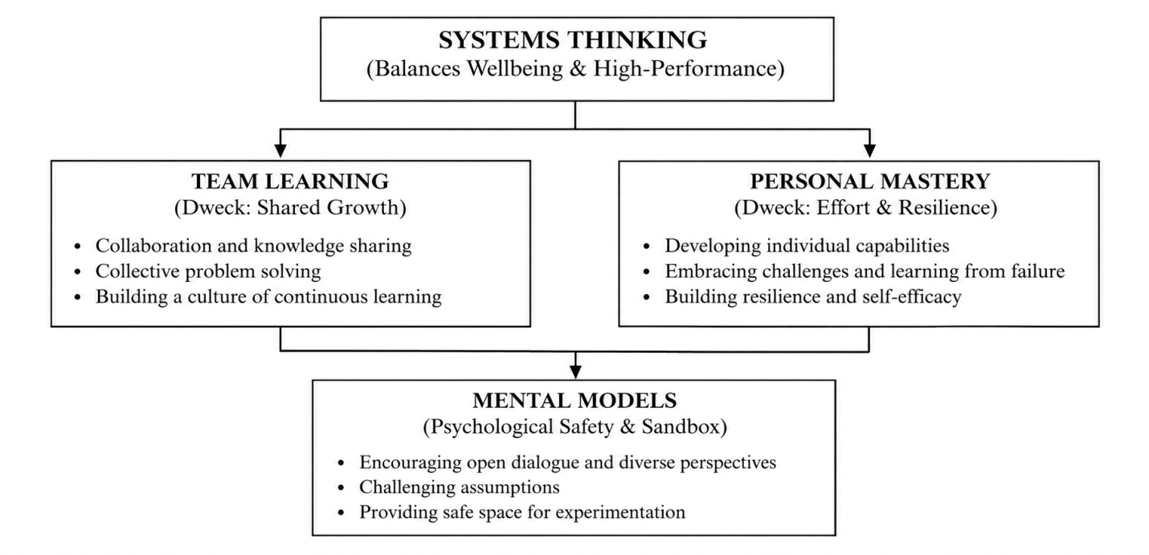
Figure 5: Integrating learning organisation and growth mindset to enhance talent ecosystem
(Source: Self-developed)
Combining Psychological Safety (Edmondson) with Talent Management Frameworks
Embedding psychological safety into talent management cycles can be an effective strategic direction for talent management at NHSX. Talent management teams at NHSX should develop agile cross-border interdisciplinary teams with decentralised decision-making authority, which will facilitate willingness to take risks and engage in creative experimentation, hence fostering talent deployment through safe autonomy (Chinyuku and Qutieshat, 2025). To encourage talent development, organisational culture should be modified by normalising mistakes and treating them as a source of learning data.

Blending Job Crafting Theory (SDT) with Self-Determination Theory to Employee Experience (EX)
SDT and job crafting foster employee wellbeing and high-performing capability by modernising employee experience.
Self-determination theory core aspects | Job drafting elements | Enabling Employee experience
Autonomy-control over decision-making | Task crafting-ability to alter scope, form, and number of daily activities | Employees are allowed autonomy to decide how and when they develop AI architecture within given project deliverables
Competence- intrinsic motivation to gain new skills | Cognitive crafting- unlocking underlying value and purpose of one’s job | Gaining autonomy to allocate 10% of work hours dedicated to self-directed learning, upskilling, and gaining access to experience with AI-enabled clinical platform solutions
Relatedness- intrinsic motivation to take part in team collaboration | Relational crafting- modifying the frequency and nature of workplace interaction | Eradicating the need for hierarchical approval to collaborate with cross-functional team members
Table 5: Creating a strategic ecosystem for enhanced EX combining SDT and Job crafting theory
(Source: Adapted from Olafsen et al. 2025; Hrnjić et al. 2024)

2.2 Proposed talent growth strategy for NHSX
NHSX can implement the following human capital management strategy to address the identified challenges.
Strategic pillars | Addressing problems | Proposed intervention | Expected outcomes
Pillar 1: Continuous learning with renewed focus on accelerating AI capability | Inadequate learning opportunities and slowed AI innovation | Launching an AI capability program integrating personalised development plans, AI digital skill pathways, and embedding scope for micro-learning | AI capability development must be integrated into organisational activities
Pillar 2: Taking accountability for psychological safety to foster innovation | Lack of creativity and stunted experimentation | Creating online creative brainstorming sessions within cross-functional teams, launching 360⁰ feedback, mandating post-project reflective sessions directed at learning from failure | Engaging in proactive experimentation with innovative AI-enabled digital tools
Pillar 3: Job crafting autonomy and employee experience enhancement | Hierarchical work practices and struggles to uphold employee wellbeing | Allowing flexibility to shape task design, freedom to participate in cross-border projects, autonomy to modify task execution plans, and decentralised decision-making ability | Enhancing employee autonomy and increased accountability
Pillar 4: Strategic talent management with clear career advancement pathways | Low retention rate | Proactive succession planning, linking transparent career pathways, promoting cross-departmental promotions | Increasing retention rate for high-performing employees by creating credible career progression opportunities
Pillar 5: Employee wellbeing and establishing sustainable performance metrics | Balancing employee wellbeing and performance expectations | Establishing quarterly review sessions to evaluate employee output against sustainable performance metrics, integrating KPIs to assess burnout, transparent feedback mechanisms, revising work hours to create work-life balance, making psychological safety a priority | Reducing job-related stress, fostering innovation, and creativity
Table 6: Proposed strategic interventions for human capital management
(Source: Adapted from Liu et al. 2023; Afnek and Khadem, 2026)

2.3 Implementation, Measurement, and Risks
Strategic growth pillars | Implementation plan | Identified risks | Measuring effectiveness with KPIs
Pillar 1 | Deploying a cloud-based learning and development platform integrating micro-learning modules | Employees may prioritise routine tasks over AI upskilling sessions | - AI training adoption Rate  - Micro-learning completion velocity
Pillar 2 | Mandating blameless post-project reviews and arranging structured cross-border innovative problem-solving sessions | Instead of expressing honest opinions, employees may stick to safe and routine reflective sessions | - Psychological safety index  - 360⁰ feedback participation rate
Pillar 3 | Integrating job crafting templates, launching decentralised portals to let employees apply for cross-border vacancies | Extreme task customisation may disorient the original strategic goal | - Job crafting utilisation rate  - Cross-border project participation rate
Pillar 4 | Creating an internal career mobility framework accessible to each staff member and conducting half-annual succession planning reviews | Lack of career advancement opportunities for employees in UAE and India compared to the UK | - High-performer retention rate  - Succession-planning effectiveness index
Pillar 5 | Redesigning performance metrics balancing technical outputs against sustainable wellbeing metrics, such as staff burnout | Employees may feel pressurised to report false wellbeing scores | - Dual-axis balanced performance score  - Employee burnout index
Table 7: Comprehensive diagnosis of the strategic talent development ecosystem for NHSX
(Source: Adapted from Jiang et al. 2026; Junça Silva et al. 2026)
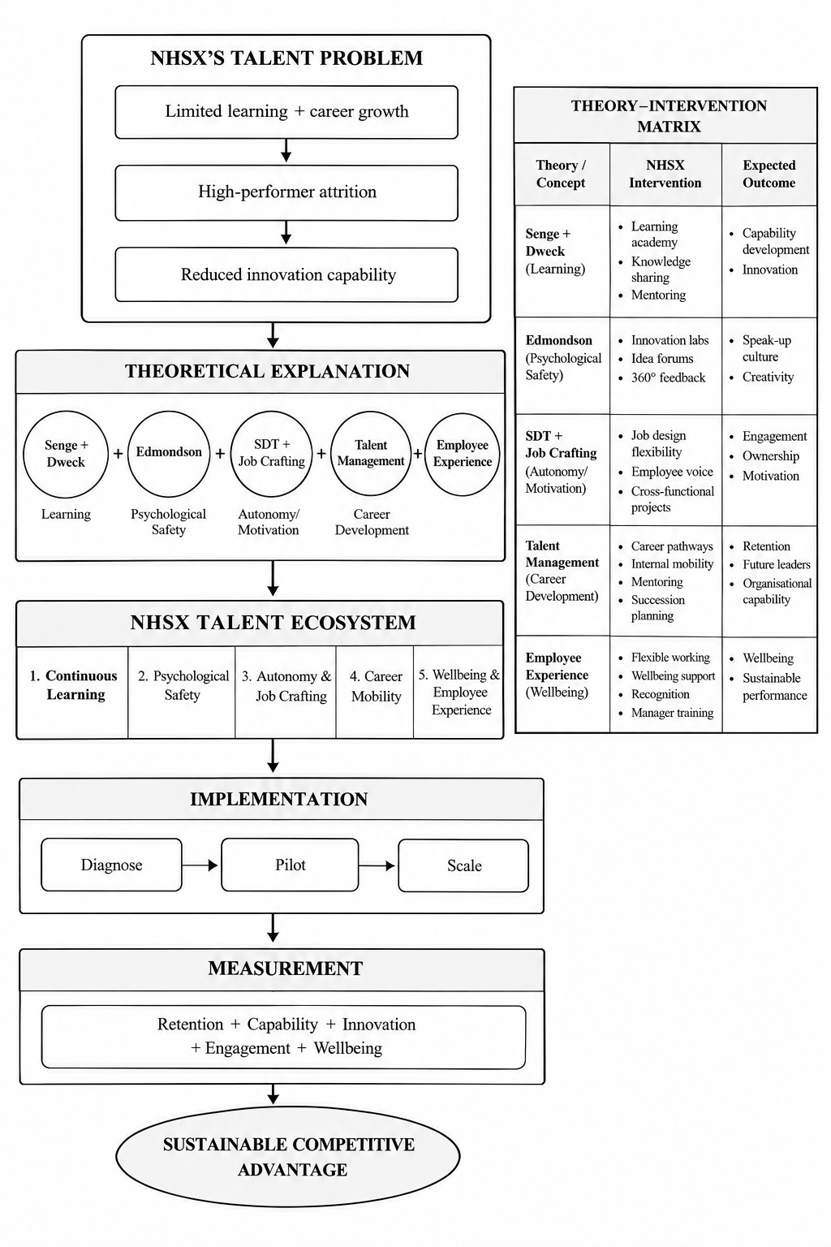
Figure 6: Comprehensive talent management strategy
(Source: Self-developed)

Task C: Reflective report

Description
Analysing business issues at NHSX shows that AI can act as a strategic mediator to support managers in maintaining employee wellbeing while balancing it with innovation and organisational performance (AI as Strategic Tool). While examining the role of AI in developing informed managerial decisions, it is found that employee experience related pattern identification and highlighting required intervention is used for automated insights along with human interpretations (Reflective analysis). Following the findings, I consider that human judgement alongside technological evidence is essential for organisational growth and innovation integration.

Feelings
Initially, I was cautious and optimistic to apply AI for data analysis and understand its influence to strengthen evidence-based HR decisions while retaining managerial responsibilities. The application of AI has shaped my understanding of integrating innovation while maintaining employee wellbeing and concerns for team collaboration. The experience involved employee performance understanding,team collaboration pattern detection and recommending career development options supported by AI. Following these experiences have shaped my confidence in implementing AI for its analytical value. However, I was concerned about the overreliance on automated decisions and outputs to maintain ethical judgement and empathy, where human oversight is critical (Reflective analysis).

Evaluation
AI implementation has highlighted value integration through rapid and spontaneous insights based on evidence across the managerial operations and responsiveness (Reflective analysis). However, the effectiveness of AI integration is limited in terms of data quality, ethical concerns and contextual interpretations that involve employee information (Aldoseri et al., 2023). Following the analysis, I have recognised AI as a supportive tool to support managerial processes to ensure efficiency in the process without replacing managerial judgement to influence wellbeing, development and employee trust (AI as strategic tool).

Analysis
I used AI to identify employee attrition patterns in the UK, India, and UAE, and the AI successfully identified the pattern, but could not exhibit contextual empathy. Although
AI definitely helped me to identify the time period when the high-performing employees were resigning, but it recommended that increasing technical outputs could bridge the productivity gap. If one follows its instructions blindly, it could exacerbate employee burnout, creating additional anxiety for them. Secondly, I searched for hyper-personalised AI digital skill pathways and micro-learning modules, but I noticed that it jammed learning materials that should take weeks to internalise into a few hours of learning sessions. In this case, I noticed AI recommendations cannot be blindly followed, human oversight is needed. Thirdly, I employed AI to conduct sentiment analysis on the anonymous 360⁰ feedback platforms to assess the degree of stress and anxiety among employees. Although it connected feedback metrics with real-life scenarios, it failed to consider cross-cultural sentiment differences in different regions (Reflective analysis).

Conclusion
As I applied AI in various instances in this assignment, I noticed that AI is greatly competent at identifying algorithmic patterns and symptoms much quicker and with high efficiency than human intelligence, but it lacks human empathy and fails to comprehend cultural differences (AI as a strategic tool).

Action plan
I intend to gain more knowledge about safely using AI, complying with data privacy regulations, using it as a decision-support tool, and cautiously applying its suggestions by cross-checking the merits of the suggestions. I want to enhance my cross-cultural competence to increase my employability scope in multinational teams (Personalised Action Plan).

Conclusion
As per the above discussion it can be surmised that NHSX is currently experiences a stagnant phase with declining knowledge sharing, innovation, and creativity as their talent management strategy is limited to recruitment and performance evaluation based on performance outputs. The proposed talent development ecosystem is designed to address the identified problems.

Reference list
Afnek, R. and Khadem, A., (2026). Crafting Your Employability: How Job Crafting Relates to Sustainable Employability Under the Self-Determination Theory and Role Theory. Sustainability, 18(2), p.979. https://doi.org/10.3390/su18020979
Aggrawal, S., Bosman, L. and Magana, A.J., (2024, June). Exploring teamwork experiences in collaborative undergraduate research (REU) programs through Tuckman's group development theory. In 2024 ASEE Annual Conference & Exposition.
Aldoseri, A., Al-Khalifa, K.N. and Hamouda, A.M., (2023). Re-thinking data strategy and integration for artificial intelligence: concepts, opportunities, and challenges. Applied Sciences, 13(12), p.7082.
Bagherian, A., Gershon, M. and Swarnakar, V., (2023). Identification of learning organisation key elements leading to successful implementation of Six Sigma: an empirical study. International Journal of Productivity and Quality Management, 38(3), pp.361-387.
Bansal, D. and Bose, S.K., (2026). Governing the digital age: Ethical principles, transparency, accountability, and human oversight in information technology law toward a sustainable regulatory framework. International Journal of Business and Management (IJBM), 5(1), pp.282-297.
Chinyuku, C. and Qutieshat, A., (2025). The role of psychological safety in strategy implementation: A brief literature review. International Journal of Applied Research in Business and Management, 6(1). https://doi.org/10.51137/wrp.ijarbm.2025.ccti.45721
Díaz-Leyva, C. and Cascón-Pereira, R., (2026). Beyond formal managerial hierarchy: Reimagining HRM in self-managing organisations. Human Resource Management Review, 36(4), p.101166.
Havens, S., (2025). An Integrated Framework Combining Kotter, Albrecht, and Senge for Sustainable Organizational Transformation. https://papers.ssrn.com/sol3/Delivery.cfm?abstractid=5216097
Hrnjić, A., Ivaniš, M. and Sutović, L., (2024). The impact of learning organization principles in enhancing organizational performance and quality. Economic Review: Journal of Economics and Business, 22(2), pp.15-42.
Jiang, H., Zhang, Y. and Yan, S., (2026). Employee–AI Collaboration and Career Sustainability: The Role of Job Crafting and AI Job Role Clarity. Behavioral Sciences, 16(8), p.1451. https://doi.org/10.3390/bs16081451
Junça Silva, A., Pombo, R. and Rueff Lopes, R., (2026). Hybrid work as a self-determining context: examining the psychological mechanisms behind job satisfaction. The Learning Organization, 33(7), pp.39-57. http://dx.doi.org/10.1108/TLO-01-2025-0021
Kakakhel, F.J. and Khalil, S.H., (2022). Deciphering the black box of HPWS–innovation link: Modeling the mediatory role of internal social capital. International Journal of Innovation Studies, 6(2), pp.78-91.
Kanellopoulou, D., Giannakopoulos, G. and Karkaletsis, V., (2025). Accelerating AI-powered digital innovation through “APSS'': A novel methodology for sustainable business AI transformation. Journal of Open Innovation: Technology, Market, and Complexity, 11(1), p.100495.
Khalifa, M. and Anwar, S., (2024). Applications of Organisational Learning in the Healthcare Sector. International Journal of Strategy and Organisational Learning, 1(1). https://www.doi.org/10.56830/IJSOL062024
Liu, G., Peng, H. and Wen, H., (2023). How self-leadership promotes job crafting: Based on the perspective of self-determination theory. Frontiers in Psychology, 14, p.1079196. https://doi.org/10.3389/fpsyg.2023.1079196
Mancl, D. and Fraser, S.D., (2022, June). The future of work: Agile in a hybrid world. In International conference on agile software development (pp. 63-70). Cham: Springer Nature Switzerland.
Mayer, K.J., Xing, Z. and Mondal, P., (2022). Contracting for innovation: Designing contracts that account for exchange hazards and the need for innovation. Strategic Management Journal, 43(11), pp.2253-2278.
Nguyen, M., Pontes, N., Malik, A., Gupta, J. and Gugnani, R., (2024). Impact of high involvement work systems in shaping power, knowledge sharing, rewards and knowledge perception of employees. Journal of Knowledge Management, 28(6), pp.1771-1792.
Olafsen, A.H., Marescaux, B.P. and Kujanpää, M., (2025). Crafting for autonomy, competence, and relatedness: A self‐determination theory model of need crafting at work. Applied Psychology, 74(1), p.e12570. https://doi.org/10.1111/apps.12570
Scottish Government (2025). Employer Skills Survey 2024 – Scotland. [Online]. Available at: https://www.gov.scot/publications/employer-skills-survey-2024-scotland/pages/high-performance-working-hpw-practices/ [Accessed on: 30/09/2026]
Tettey, D.J., Sunday, O.E., Azumah, N.C., Nwosu, N.C.P., Oluwatobi, B.T. and Chrisben, D., (2025. Agile hybrid methodologies for complex project execution: Balancing flexibility, control, and stakeholder value maximization. International Journal of Research Publication and Reviews, 6(3), pp.6190-6204.
Timilsina, M., Alsamhi, S., Haque, R., Judge, C. and Curry, E., (2023, December). Knowledge graphs, clinical trials, dataspace, and AI: Uniting for progressive healthcare innovation. In 2023 ieee international conference on big data (bigdata) (pp. 4997-5006). IEEE.
Xu, X., Lin, C. and Duan, L., (2023). Does hierarchical ranking matter to corporate innovation efficiency? An empirical study based on a corporate culture of seniority. Chinese management studies, 17(3), pp.594-619.
Zirar, A., Muhammad, N., Upadhyay, A., Kumar, A. and Garza-Reyes, J.A., (2025). Exploring lean team development from the Tuckman’s model perspective. Production Planning & Control, 36(4), pp.442-463.

