Appendix A

Observation Schedule
Based on ‘The Leuven Scale for Involvement’ and adjusted to include how different extremities of behaviour could affect the learning of other children in the class:
Level | Behaviour Rating | Actions
1 | Extremely Low | Low level behaviour that a child displays meaning they are not on task which does not affect any of the other children around them e.g. doodling
2 | Low | Behaviour incident between a small group of pupils distracting each other and not being on task but not affecting the other children around them e.g. talking and messing around
3 | Moderate | Behaviour incident involving an individual or small group that is affecting the other children around them resulting in them becoming frustrated and agitated e.g. talking and messing around
4 | High | Verbal altercation between a child/children and a member of staff or child/children and peers. Whole class affected and no longer involved in lesson. Teaching may also have to be halted while incident is being dealt with e.g. talking back
5 | Extremely High | Physical outburst towards peers or staff and the removal of a child/children from the class resulting in the children being significantly affected to the point where it is difficult to get them back on task

Child | Time | Behaviour Level | Description of Behaviour | Actions taken by teacher | Child’s Response
Child A
Child B
Child C
Appendix B

Interview Questions
- What did you learn in the lesson?
- What happens if someone misbehaves in this school?
- If people misbehave in class, why might they do that?
- Situation (1 each): If you did this (give example) how do you think the teacher should respond? (Options to involve methods of negative discipline and positive discipline)
- Thinking back to (an incident from the observed lesson) how do you think the teacher responded?
- Do you think this was the right way for the teacher to respond? Why?

(If there is no significant behavioural event during the lesson observation, low level disruption – which is likely to occur in some form will be used as the incident for question 5).

Situations for question 4:
- Shouting out, disrupting the lesson and talking over the teacher
- Doing harm to someone else in the class
- Name calling in class
- Not completing the work and doing something else instead
- Walking around the class and not working

Appendix C

Reflection Pro-Forma

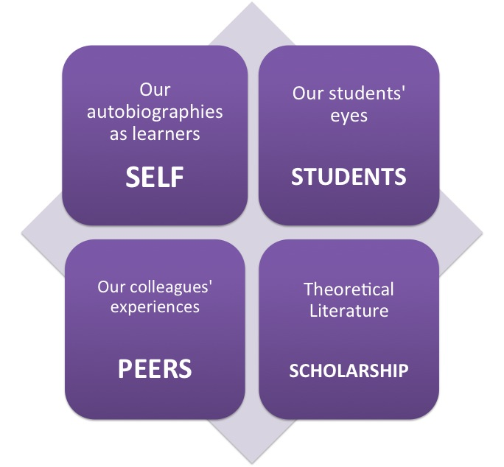
Brookfield’s Four Lenses

Gibbs’ Reflective Cycle

Appendix D
Consent Letter

Dear Parent/Guardian,
Your child’s school is a partner with Yr Athrofa at University of Wales Trinity Saint David in Carmarthen and Swansea. This school offers placements to students who are learning to be teachers.
The student-teacher in your child’s class has been given the task of planning, teaching and evaluating one lesson so that he/she can develop specific strategies to improve their own teaching. As part of this, student-teachers will be observing the children’s responses and asking some pupils their views on parts of the lesson. This is designed to inform students’ own practice and support children’s learning.
Any information collected would remain confidential, and both the school and the children would remain anonymous in work produced. The work undertaken would be in line with the University’s ethical guidelines. If, at any time, your child does not want to share ideas, they would not be required to do so.
If you are happy for your child to contribute to the project, please complete the parental consent form below and return directly to the school as soon as possible. If you are interested in the outcome of this project or if you have any questions, please contact the University Partnership Office - partnership@uwtsd.ac.uk.
Yours faithfully,
Catherine Morgan
Module lead – The Enquiring Teacher

As Parent/Guardian of……………………………………………………………………. (pupil name), I do / do not give
consent (please delete) for my child to take part in this project.
Signed……………………………………………………………………………. (Parent/Guardian).
Date………………………………………………………

Appendix E
Information Sheet
As part of Miss Williams’ training to become a teacher, I must carry out a project at school which I would like all your help with. My project will involve another student teacher – Miss Matthews coming into our classroom and watching a lesson take place. Miss Matthews will be observing how you respond to what I say or do if there is misbehaviour within the class during the lesson and making some notes. These notes will not include any of your names and only myself and Miss Matthews will ever see these notes.
After the lesson, I will be asking a few of you some questions with Miss Matthews about the lesson that has just taken place and how you think bad behaviour should be dealt with in school. This conversation will be audio recorded onto a mobile phone and will only be listened back to by myself and Miss Matthews.
The information that we collect from the lesson and the questioning will be used to write our project at university. Our lecturer who marks the project will read it to see what happened during this lesson but none of your names will be mentioned in our project so they will not know who you are. Once we have finished writing up our work, the notes that Miss Matthews made in class will be thrown away and the audio recording of the questioning will be deleted.
You do have to be in the lesson as you would any other lesson at school, but you have the choice as to whether you want to be written about in my project. You will not be in any trouble if you do not want to be a part of it. If you say yes now but change your mind later that is fine. We have received a consent form from your parent or guardian to say that they are happy for you to take part in this project, but it is still your choice – you can say no.
If you have any questions at all then feel free to ask me.
I understand what I am taking part in and I am happy to be part of Miss Williams’ research project.
Name:
Signature:
Date:

