Developing Innovation and Creativity for Business Advantage
A Critical Review of Change within Marks and Spencer

Samad Uddin (1710009)

Executive Summary
The research evaluates innovation and creativity and how it brings value to an organisation. Killay Spice have been around for over 10 years and is the only Indian restaurant in the locality. However, to grow and develop innovation is really important not only for the business itself but to be competitive within the industry.
The report analysed the theories and various models to measure innovation and creativity this has been applied to the chosen innovation for Killay Spice. To keep up with this modern time and to implement technology in the business Waitlist management application is an essential. It provides an advantage to both the guests and the business making sure everyone is prepared for the unknown. Waitlist applications encourage consumers to check-in electronically via the restaurant website to display an estimate of their waiting time. This minimises the waiting within the restaurant during peak times.
SWOT has been conducted to find out the area which requires change and what opportunities it would bring if done so. 4P’s, Innovation Matrix, Process Model, Open and Closed Model all help calculate the benefits and basically following a process to reach to success. The force field model has also been applied to calculate the forces for and against the innovation. This gives a succinct summary of all the relevant reasons that favour and hinder the idea, and all the information collected about a potential result summarised in a single chart.
Lastly it has been concluded that innovation and creativity does provide a business advantage and, in this case, will help the business be more productive in their approach to keep everything under control and provide the guests with the ultimate experience. However, risks and barriers should also be taken into account when it come to storing guest details or in terms of third party being able to access this data.
To ensure success in the future regular feedbacks should be taken from guests and staff to help identify any gaps or loops missing.

Contents
1.0 Introduction 1
2.0 Main Findings 2
2.1 SWOT 2
2.2 Innovation Matrix 3
2.3 Models of innovation 4
2.3.1 Open and Closed Innovation 4
2.3.2 The Innovation Process 4
2.4 Assessment of the Effectiveness 8
2.4.1 Barriers and Risk 8
3.0 – Conclusion 9
4.0 – Recommendations 9
Appendices 10
References 14

1.0 Introduction

This report would examine the importance of innovation and whether the competitive benefit of the organisation can be generated by capitalising on innovation opportunities. The organisation which will be discussed is Killay Spice Indian Restaurant.
Killay Spice is a traditional, fine Indian restaurant located in the heart of Killay. The aim of the business is to create a special and authentic experience within a comfortable environment in a lively, lavish restaurant. Killay Spice offers guests new insight into Indian culture, cuisine and hospitality catering for all types of celebrations. (Killay Spice , 2020).
Innovation is a successful, new offering, such as a product, service, method or interaction of an effective market concept that is viewed as unique and embraced by consumers. However, for innovation to be successful it requires good governance and leadership at all levels of the organisation. (Greenwald, 2014).
Creativity is the desire to overcome traditional patterns of thinking or behaving and to create new, innovative concepts, strategies or objects. (Sefton-Green, et al, 2011).
Creativity is all about discovering the mind's ability to generate new concepts. Whereas Innovation is really about making changes within pretty consistent systems. According to Varbanova creativity and innovation are interrelated. She states that creativity is a concept linked to something internal and intangible that is more complicated to measure, whereas innovation is external as it is about concepts which have been evaluated and shown to work in the actual world. This has also been proven from the statement of Theodore an American professor who stated that “Creativity is thinking up new things, Innovation is doing new things.” (Varbanova, 2017. P-64).

2.0 Main Findings

2.1 SWOT

The SWOT analysis is used to evaluate all four aspects used in the development of innovative ideas and techniques in an organisation. Such four criteria evaluate all internal and external influences relevant to a specific venture, product or policy. (Elmansy, 2015). It is used to determine the current state of the company before any future plans are determined. (MindTools ContentTeam, 2020).
It is a successful method to collect and coordinate knowledge from various market fields in a consistent and systematic way and a strong starting point for a broader strategic approach. However, there are some detriments of using SWOT such as obtaining data required is extremely costly and time-consuming. Key aspects are overlooked if important data is absent or a range of sources are not included. It needs to be revised regularly by businesses in order to benefit from it.
Within the identified organisation being able to identify the relevant factors of product performance under the SWOT framework enabled the management to recognise positive and negative points and therefore helped to identify the best option to transform a particular concept into a new innovation. (Appendix:1).
There is a lot of competition within the industry and being able to stay competitive in the market and meet the needs of customers innovative technology are required to enhance customer satisfaction, enhance the process and minimise costs.
After evaluating the SWOT analysis, the following innovations have been identified:
1. Cloud-based interface that serves as an operating network for the employees.
2. Customer-facing touchscreen devices which will enable guests to navigate through the menu, submit orders directly to the kitchen and pay in full.
3. Waitlist control applications which lets the restaurant inform diners once the tables are prepared on their mobile apps.
4. Interactive tables that integrate tablet functionality directly into the table design itself.
(Smart Sense, 2018).

2.2 Innovation Matrix

The Innovation Matrix is a framework that integrates the various elements of innovation. Davila, et al highlights that the Innovation Matrix underlines the point that not all inventions are generated on an equal basis. (Davila, et al. 2012). (Appendix:2).
As per the matrix three types of innovation exist:
Radical - It is a lot more of a complex approach which includes a process that is challenging, and risky. This is best defined as the ‘Blue Ocean Strategy’ – which is where business growth and profitability remain untapped, no rivalry and companies are seeking for innovative prospects. Establishing a new market, moving away from others. (Kim & Mauborgne, 2015).
Semi radical - This involves changes in either technology or the business model of an organisation.
Incremental - This is a common strategy across several successful businesses, which rely on the development of innovative goods/services. This strategy is practical as it eliminates the chance which radical innovation will generally entail. (Christiansen, 2014).
With the use of the innovation matrix and from the innovation ideas listed above, the one that is suitable to initiate is the waitlist management application. Guests can book themselves online and will be added to the waitlist. The app will then inform guests when their table is ready which means guests can attend at their own convenience.
This type of innovation falls within the category of incremental innovation. The business is already established and there are no significant improvements required although small changes are required within the business to ensure that they are competitive and are in line with the current trends. It will not hinder against the current methods however will improve the services and address the expectations of guests.

2.3 Models of innovation

2.3.1 Open and Closed Innovation

Open innovation strives to encourage the continuous stream of internal knowledge within companies and also to benefit from innovative external developments. It implies that businesses will and can incorporate both external innovations and internal pathways to step ahead with their innovation cycle.
Closed innovation is when businesses actively prevent themselves from disclosing any data. An organisation which likes to hold its research activities closed and has only established its initiatives under well specified limits.
Open and closed innovations are essentially distinct from the manner wherein innovation is created. Closed innovation firms work in a self-contained, creative framework while open innovation firms’ source external expertise for their strategies towards innovation management. These days, the debate on innovation is undoubtedly a critical component of a dynamic strategy, because it allows companies to obtain and retain competitive advantages. (Appendix:3).
Chesbrough first identified the idea of open innovation as the use of purposive inflows and outflows of knowledge to promote internal innovation process and widen the opportunities for external usage of innovation. (Chesbrough, 2006). However, Trott and Hartmann, have argued when Chesbrough presented the topic of open innovation, that Chesbrough "produced a false dichotomy by claiming that open innovation will be the only option to a closed innovation model." They have even gone on to say that it is “Old wine in new bottles” (Stijn Kelchtermans, 2013), (Chesbrough, et al. 2012).

2.3.2 The Innovation Process

Tidd and Bessant indicate that the aim of the process model is to have a full overview of the process and also to ensure that the organisation is capable of delivering the project by taking the correct approach whenever things go wrong. The innovation process can be seen as a journey from searching for opportunities, selecting the idea, implementation and capturing it. (Tidd & Bessant, 2013). (Appendix:4).
According to Jeschke et.al the key point of critique for process-models is that innovation-processes are not static and stages are not compulsively sequential, but instead recursive and disruptive. (Jeschke, et al, 2016).

Tidd states that although models are important to simplify things it also influences decisions and behaviours however there are some limitations:
- Too much emphasis is placed on the original idea and less on the process
- The quality of the idea is paramount
- It is very unclear about what success means either, technical, commercial or growth
- The sources of innovation are many and are many at different points
- There are loops
- It differentiates the context from the process
(Tidd, 2014).
Developing innovations in the context of new goods/services is amongst the most challenging management tasks. For this reason, the concept of innovation needs specialised process models and techniques capable of meeting expectations.
4P’s of Innovation
Tidd and Beasant developed the 4P’s of innovation which was first published in 2005. This is a tool often used to define innovation. In order to succeed, all organisations must remain innovative. Product, Process, Position and Paradigm are the four key aspects if innovation but organisations that gain long-term strategic advantages should remain innovative within those areas.
Product - Reflects any changes in the products and services offered by the company.
Process - This applies to improvements in the way goods are made and distributed.
Position - Change throughout the setting of the introduction of the products / services
Paradigm - Transformation in the actual psychological designs that define what the company does.
The model can be used to determine the innovation projects of the organisation as well as providing guidance. 4p's may be used to analyse maps with various companies operating in the same industry and using the tool as a means of determining where there might be fairly unexplored area that would offer substantial incentives for innovation. (Tidd & Bessant, 2013). (Appendix:5).
As time evolves and external factors change organisations have to adapt and respond and then incorporate other elements into the business mix to attract customers and make sure the products and services are meeting their needs which in turn is beneficial to the organisation as well as the customers.

Application of the Models
4P’s - Innovation brings value to business growth in multiple ways as it directs businesses to success. Analysing the innovative opportunities using the model, Killay Spice must modify their presence to the emerging innovations, with the purpose of delivering outstanding service. From the ideas identified in 2.1 the Waitlist application has been identified as the product/service innovation.
Product – Currently customers are having to come in and wait in the compact waiting area. Due to longer waiting time during busier days customers get frustrated and leave not knowing how long it will take. However, implementing the waitlist application will make the lengthy delays move faster. Guests can come in just before their time. The CRM centre can recognise loyal customers and provide additional rewards. It can also help to prioritise certain guests and filter according to their needs. Getting the Waitlist system in place will offer an incremental innovation which will seek to render existing products/services far more beneficial while focusing on minimising costs and the enhancement of functionality or efficiency.
Open & Closed - Closely examining open & closed innovation cycle, the idea arose by exploring the concepts and information available from external sources. It has really helped new approaches to surface that would help to address many issues and concerns which are currently taking place. To establish the waitlist application an open innovative approach has been taken. This has been achieved by researching the current market and the trends and by accepting them. Open innovation has been applied by accepting the free flow of internal knowledge from other organisations and developing these ideas through innovative external technologies. Whereas adopting a closed approach there are limitations such as spending more on research and development where success is not guaranteed. The ideas are kept closed within certain limits. However, adopting an open approach will help to take knowledge from others and learn from their experiences while exploring. (Herzog, 2011).

Innovation Process – This model is a good way of applying the process to innovation. This is an inherent way of embedding good practices. The innovation process acknowledged here within Killay Spice is future orientated as it’s a current trend, fitting with the demands of customers and integrating the innovation to be successful in the current modern market.
Search - As highlighted in 2.1 the SWOT analysis has evaluated the weakness of the business and where innovation is important. Highlighted below are some of the benefits of encouraging innovation:
- Adopting emerging technologies
- Embracing changes as adaptability is necessary for innovation to thrive
- Searching for different perspectives
- Keeping up with competitors by adopting the latest trends

Select – Waitlist app has been selected due to not being able to meet the demands of customers during busier times. The restaurant is the only Indian cuisine in that locality due to which there is an increase demand and waiting times. The waiting area is very compact with no use of technology within the business. Therefore, initiating the Waitlist application will help minimise the risks of not being able to cater to their needs.
Implement – Advertisement is important this can be done through text or by email highlighting the benefits of using the app as well as advertising special menu items rotating with the season. If using the waitlist app keeping them informed of their position in the queue. Another way in keeping guests engaged using the app is to create a lounge space this can also be used as another form of advertisement where key dishes and events are highlighted.
Capture – There are many benefits of implementing the Waitlist application:
- It gives an accurate estimation of wait time
- Improved guest experience
- Modernised and innovative thinking
- Benefit the business as staff are more organised, prepared and know what to expect during peak times.

2.4 Assessment of the Effectiveness

The Force Field Study was developed by Kurt Lewin in 1940. It is often used in the business sector to create and express go / no-go decisions. The theory behind Force Field is that circumstances are balanced by a tension of factors that influence improvement and those that resist change. In order for change to take effect, the driving powers should be increased and the resisting powers lowered. The framework is valuable for making choices based on evaluating factors for and against change, as well as for outlining the purpose behind this choice. (MindTools Content Team, 2019). (Appendix:6).
Criticisms of force field research typically reflects on the allocation of scores to both the driving or restraining forces. Many researchers say that the method is used in restricted contexts and that circumstances beyond such environments might be less relevant to Lewin's theory. (Connelly, 2017).
One of the advantages is that it offers a concise overview of all the different factors endorsing and opposing a given proposal, with all the evidence gathered on a possible outcome compiled into a single diagram.
One of the disadvantages is it needs the complete cooperation of those involved to include the correct data needed for a successful result. This may be a drawback because complete involvement is not feasible, leading to a study which may not include a clear representation of the powers. (Brent, 2018).

2.4.1 Barriers and Risk

The framework above has helped to conduct a force field analysis on the chosen innovation for Killay Spice. However, there are some risks involved on implementing the application:
- If the system crashes or remains unresponsive it will be a challenge to manage guests during peak times.
- The use of new technologies and partnership may not provide security of breaching customers privacy and access to sensitive information.
- Such external companies can often exchange or store confidential data with many others unfamiliar to the business, providing additional gaps and access points for cyber threats, therefore requiring increased diligence to secure important consumer data.
(Deloitte Advisory, 2016).

3.0 – Conclusion

After analysing several different models, it has been established that the implementation of technologies can help to foster creative innovations. Adjusting operating strategies will help to improve the customers experience, boost revenue and profits, and enhance operational performance.
From the findings it has been evaluated that the implementation of the Waitlist application will help the business to more aware of the customers and run the business more efficiently. Not only its benefit guests it also benefits the business by adapting to the needs of the guests, increased engagement and overall a better way to advertise special offers to entice customers. This will in turn generate higher revenues and make the business more sustainable.

4.0 – Recommendations
To implement the highlighted changes to the business, strategies need to be incorporated to make sure everything runs effectively. The measures required to do this are:
- A clear customer focused vision which can be communicated throughout the business. Business values should be embedded into the culture and these will act as guiding principles.
- Recognising target market and segmenting them accordingly to better understand and recognise their needs.
- Emotionally engage customers as attached customers are more likely to recommend the products and services.
- Using technology to get real time customer feedback
- Utilisation of a quality framework
- Taking continuous employee feedback for any gaps or improvements required
- Measuring the results achieved from the innovation

Appendices

Strength  - Excellent location away from the bustling city centre a local community and village set high above sea level.  - Good reputation amongst local communities.  - The only Indian restaurant located in Killay  - Clear principles and ethical mission statement  - Experienced team professional and skilled. | Weakness  - As the only Indian restaurant in the locality it is very busy  - Longer waiting times and no entertainment to keep them occupied.  - Small compact waiting area not much room during busier times as well as if seated no forms of entertainment especially for larger families  - Very traditional so there is no use of technology  - During peak times it’s difficult for staff to provide exceptional service or get orders right  - No exposure or advertisement
Opportunities  - Potential for growth by incorporating technology or apps such as entertainment through tablets, integrated tablets onto the table for children to keep them occupied  - Emerging needs of customers to follow the modern trends  - Investing in the development of a mobile app, wait list app, loyalty schemes and incentives which can increase sales.  - Invest more on free advertisement using social platforms and mobile app.  - Cloud based POS system for busier times which will enhance speed and accuracy. | Threats  - Economic decline  - Cost involved in incorporating technology to keep up with the modern trend  - Competition from others who are already established and are making full use of technology  - Technology requires constant internet connection  - No human interaction if everything is done through technology
Appendix 1- SWOT Analysis

Appendix 2 – Innovation Matrix
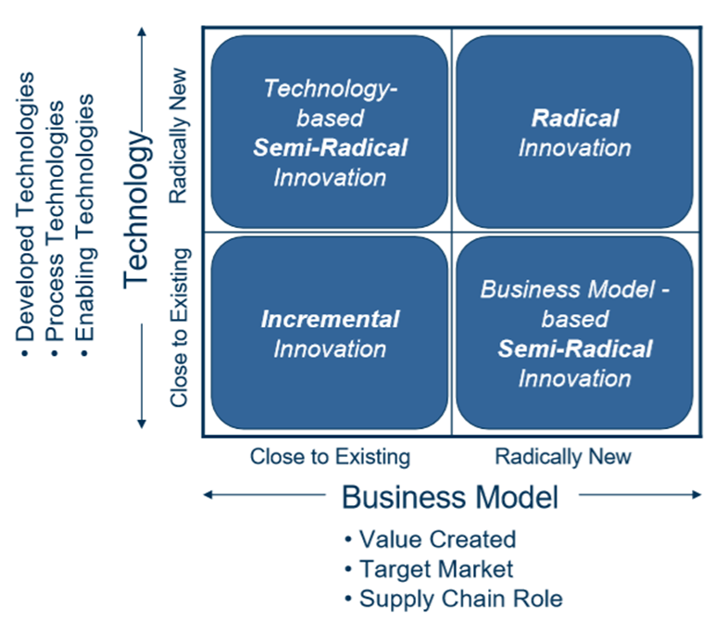

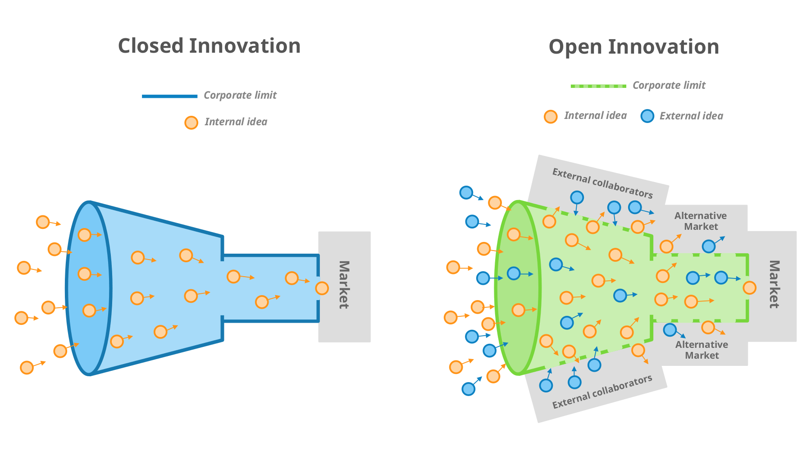
Appendix 3 – Open and Closed Innovation

Appendix 4 – Innovation Process Model
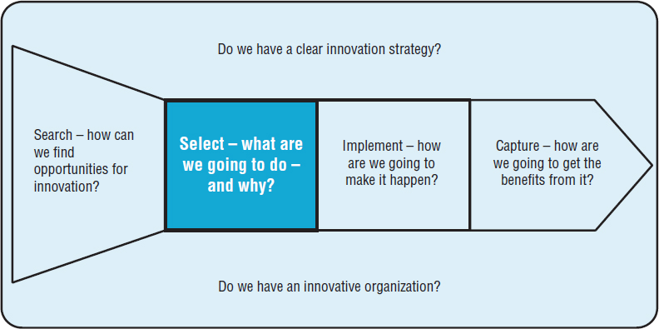

Appendix 5 – 4P’s to Innovation
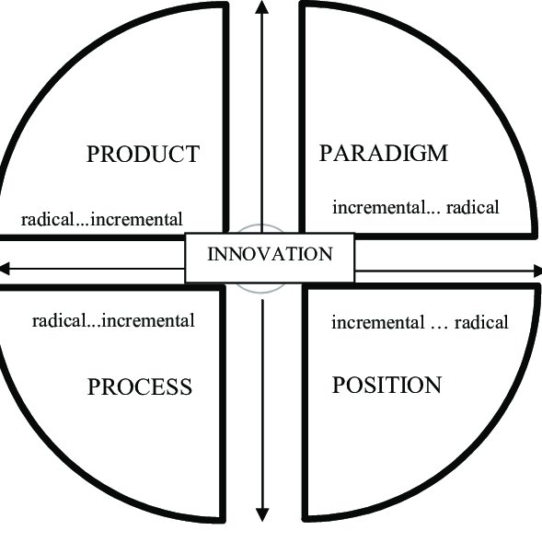

Appendix 6 – Force Field Analysis
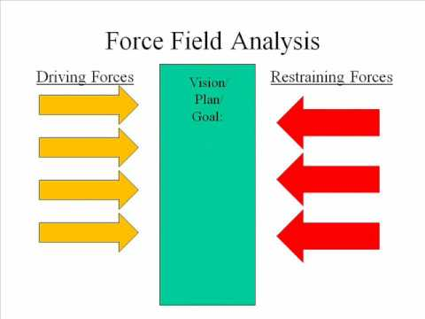

References
Brent, M. (2018). Advantages & Disadvantages of the Force Field Analysis. [Online]
Available at: https://careertrend.com/info-8613855-advantages-disadvantages-force-field-analysis.html
[Accessed 05 07 2020].
Chesbrough, H. W. (2006). Open Innovation: The New Imperative for Creating and Profiting from Technology. Boston: Harvard Business Review Press.
Chesbrough, H.J., Vanhaverbeke, W., West, J. (2012). New Frontiers in Open Innovation. Oxford: Oxford University Press.
Christiansen, B. (2014). Transcultural Marketing for Incremental and Radical Innovation. USA: IGI Global .
Connelly, M. (2017). Force Field Analysis - Kurt Lewin. [Online]
Available at: https://www.change-management-coach.com/force-field-analysis.html
[Accessed 05 07 2020].
Davila, T., Epstein, M., Shelton, R. (2012). Making Innovation Work: How to Manage It, Measure It, and Profit from It. Kindle: Pearson FT Press.
Deloitte Advisor, (2016). How restaurants can better manage, London: Deloitte Development LLC.
Elmansy, R. (2015). SWOT Analysis: Exploring Innovation and Creativity within Organizations. [Online]
Available at: https://www.designorate.com/swot-analysis-innovation-creativity/
[Accessed 02 07 2020].
Greenwald, M. (2014). What Exactly Is Innovation?. [Online]
Available at: https://www.forbes.com/sites/michellegreenwald/2014/03/12/what-exactly-is-innovation/
[Accessed 01 07 2020].
Herzog, P. (2011). Open and Closed Innovation: Different Cultures for Different Strategies. 2nd ed. Germany: Gabler Verlag.
Jeschke, S., Isenhardt, I., Hees, F., Henning, K. (2016). Automation, Communication and Cybernetics in Science and Engineering 2015/2016. Switzerland: Springer International Publishing.
Kelchtermans, S., Beule, F.D. (2013). Proceedings for the 8th Europen Conference on Innovation and Entrepreneurship. Reading: ACPI LTD .
Killay Spice, (2020). Killay Spice - About Us. [Online]
Available at: https://killayspice.com/
[Accessed 02 07 2020].
Kim, W.C., Maughborne, R. (2015). Blue Ocean Strategy, Expanded Edition: How to Create Uncontested Market Space and Make the Competition Irrelevant. Boston : Harvard Business Review Press.
MindTools Content Team, (2019). Force Field Analysis. [Online]
Available at: https://www.mindtools.com/pages/article/newTED_06.htm
[Accessed 05 07 2020].
MindTools Content Team, (2020). SWOT Analysis - How to Develop a Strategy For Success. [Online]
Available at: https://www.mindtools.com/pages/article/newTMC_05.htm
[Accessed 02 07 2020].
Sefton-Green, J., Thomson, P., Jones, K., Bresler, L. (2011). The Routledge International Handbook of Creative Learning. London: Routledge Taylor and Francis Group .
Smart Sense, (2018). The Top 11 Restaurant Innovations. [Online]
Available at: https://blog.smartsense.co/the-top-11-restaurant-innovations
[Accessed 02 07 2020].
Tidd, J. (2014). Youtube - Developing an Innovation Process. [Online]
Available at: https://www.youtube.com/watch?v=l9sNGnxMEXE
[Accessed 03 07 2020].
Tidd, J. Bessant, J. (2013). Innovation Strategy. USA: Wiley Publications.
Tidd, J. Bessant, J. (2013). Managing Innovation: Integrating Technological, Market and Organizational Change. 5th ed. Kindle: Wiley Publications.
Varbanova, L. (2017). International Entrepreneurship in Arts. London: Routledge Taylor and Francis Group.

