Name: Mabel Osemwonyemwen Idukpaye
Student No.: 1805997
Module Title: UEC
Module Code: (BMSW5103)
Lecturer Name: Dr Kenny Tang

1st TERM

TASK
Choose any specific case study (either your current employers or if not currently working, any organisation of your choice, for example an organisation that you have previously worked for) and:
- Critically analyse the factors that influence your organisation’s ability to maximise customer value
- Identify the systems that supports your organisations quality processes and provide a critical understanding of the extent to which you think those systems are effective in meeting customer requirements.

Table of Contents

Introduction
Chapter 1 Dimensions of customers value
Chapter 2 Service Quality SERVQUAL
Conclusion
References

INTRODUCTION

The aim of this report is to explain the features that develop Morrison super Market’s skill to optimise their customer’s assess and in addition to know the system that supports their grade of operations.
The report aim to make known the service quality dimensions, which could be made used of to estimate customer contentment, and determine the consequence of dimensions of service quality (empathy, tangibility assurance, reliability and responsiveness) on customer customer’s satisfaction in Morrison.
Morrison was founded in the year 1899 by Willaim Morrison. W Morrisons began the company with eggs and butter sales in Rawson market,Bradfort, united Kingdom, functioning under the name of William Morrison Ltd. Ken Morrison took over the organisation in 1952, at the age of twenty one . In 1958, Morrisons began a little store in the centre of the city. The company has 475 shops across the United Kingdom. It’s sales were majorly on grocery and food. They source and process a massive range of food items in their producing items, which made them better advantaged over the standard and source . Morrisons have a lot of staff making food in store compare to other big supermarkets.
The company has over 132,000 staff. It provides competition in prices and hundreds of special offer each.
Every organization’s goal is always to create a customer value in the mind of its customers. Customers are interested in more than just the physical product they are buying but pays more attention to the service level, company return policies, financial arrangements, warranties and quarantines: which makes up the total product.
Morrisons has become larger and stronger, striving to be becoming more known and approachable to customers. Growth is a rapid, worthwhile and sustainable, sustain on a strong cash flow and balance sheet basis.

SERVQUAL is a multi-dimensional project, structured to enhance and develop consumer wants and perceptions of a service among the five ... The diagnostic value of the project is anchored on the model of quality service which forms the SERVQUAL.

CHAPTER 1
DIMENSIONS OF CUSTOMER’S VALUE
Customer value is a strong instrument in attracting and keeping customers and has become one of the most viable features in other succeed in an organisation. Even though the importance of customer value is extensively known, it is relatively segmented making it not to have a clear definition of the concept. Prior studies on the profit impact of market strategies contend that value is ascertained by product quality, price and customer expectations. According to Simchi-Levi 2008, customer value is an important factor in determining the type of supply chain required to serve the customers and the type of services for retaining them. Customer value is a source for competitive advantage. Quality management have become popular and organisation have learned to enhance the quality of products and the organisation internal operations processes which brought about significant performance improvements. Products quality may not bring a clear source of competitive advantage. According to Slywotzky 1996, to create and deliver superior customer value to high value customer will increase the value of an organisation. Customer value is on the view on the organisation’s customers, considering what they want and believe they get from what they are buying.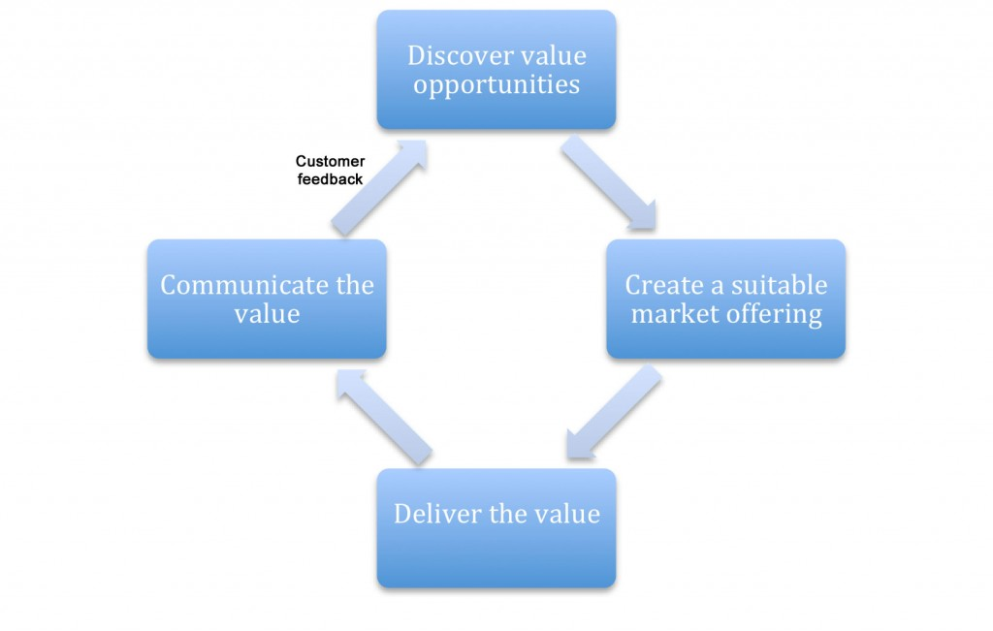

The 5 Dimension of Customer Value
- CONFORMANCE TO REQUIREMENTS
- PRODUCT SELECTION
- PRICE AND BRAND
- VALUE-ADDED SERVICES
- RELATIONSHIPS AND EXPERIENCES

1. CONFORMANCE TO REQUIREMENTS.
is Morrison conforming to customer requirement? Are there customer asking for products quality, or low price?, do they care about pollution?
Morrisons Supermarket has been able to conform to its customer’s requirements by providing and adhering to customer’s responses. Over the years Morrisons have improved on customer value as a result of conforming to reqirements. They are becoming more known and viable to many individual by constructing a wider and big company. Their customers have always asked for quality products. Through this dimension of customer value, they care about quality products, air pollution and moderation in product pricing.
Extract from Wm Morrison supermarkets PLC Annual Report and Financial Statement 2018/19 annual shows there has been tremendous improvement on customers experience. This improvement assist customer watnt scored increase by 8% pts in 2018/19. Also they’ve been able to get response from customers on the enhancements friendliness of colleaques , store cleanliness and queue times. One of the most significant reason customers shop at Morrisons is the value for money. Morrison pursue to decrease their prices through ‘’ price crunch’’ and a captivating promotional programme. In 2019, they launched an initiative to decrease prices and benchmarked quality on customers’ preference. They have made improvements on their band which support customer with healthier eating and dietary requirement.
Morrisons are so much concerned tackling climate change. They have been able to do this by reducing its impact and creating efficiencies. Morrison is working with the carbon trust to make it happen. They have set a determined science bases carbon reduction target to lower direct emissions by 33% by 2025 and 53% by 2030 against a 2017 baseline.
Morrisons is doing great in the retail industry as a result of them listening hard and responding to changing demands of its customers.
Listening to their customers and answering promptly is the heart of its business. They always acknowledge customer’s persistently producing needs and expected value in order to grow and compete. In 2018, almost a quarter of a million of Morrisons shoppers gave feedback as to their in store shopping experiences while one and a half million customers got in touch with them through its customer service contact team. These interconnections give a rich and valuable source of data. Furthermore, their staff spends time in store interacting with customers, understanding their perceptions on the shopping experience and learning how they can improve.
The outcome of all this listening , Morrisons acknowledge that great value for money, good quality and a fast and calm shopping tour is significant to customers. The IGD reports that 85% of shoppers are striving to enhance their diet in some way, acquiring a variety of method to attain this. Listening to customers helped Morrisons to understand this trends and how they can serve customers needs better. Customers always value the expertise of their food maker on market streets and they continuing to train their staff. Customer are happy and tell Morrisons how important ‘local’ is to them. Expecially diary and meat and its local continue to grow. Morrisons target is to become truly integrated locally providing many locally produced drinks and food to many stores and also being important and integrated to the communities they serve. Value for money is one of the significant reasons customers choose grocery retailer. Morrisons always reduce prices through ;Prince Crunch’

2. PRODUCT SELECTION (what sort of product they sell. Are they grocery product)
Product selection is a decision process in which the design team chooses one or few product theory for additional development. Product selection is very important for a retailing shop such as Morrison. No one can give customer s everything at once, but the obtainable product selection should give enough alternative. If for instance a customer looking for trouser in red cannot find one, there should be alternative to choose from a different colour let say yellow.
A retailer could expand the number of buying customers by changing and enhancing the product selection. Selection rectifications aid the customer in getting the products they were looking for or an adequately similar one that please their needs, say Harvard Business review, it is therefore wise to examine the buyer’s critical decisive factors while in the shop – product price, size, brand, color, taste etc. it would also be advisable to think about the alternatives the customers could select from if they fail get the perfect product.
Morrisons are British born and bred, value-led grocer. They have grown from a market stall to the UK’s fourth largest supermarket group. They are food makers and shop keepers which makes them different from their competitors.(wm Morrison supermarkets plc Corporate Responsibility Report 2018/19)
Morrisons retails groceries through a string of supermarket and an online home delivery service in England. The organization offers mainly food and groceries, great of which it origin and processes through wholly own manufacturing facilities. This gives them close control over source and quality as do the number of trained and committed professionals in the store who prepare food for customers. Morrison’s have more skilled staff preparing food in store than any other retailer.
Morrisons have series of new products range patterned to provide a larger range of products to larger range of customers. These comprise best premium range, concentrated on wealthy shoppers , the Nutmeg clothing range to rival Sainsbury’s TU and Tesco’s F&F brands, a newly online flower offer flowerworld.co.uk which sells fresh bouquets with free delivery, also a new ‘food to order’ service which permits customers to order party food to be picked up in store.
The introduction of new products reveal how Morrison’s is expending their request, appending to an already large scale portfolio of product and services as well as a pharmacy , dry cleaning , café and petrol stations.
One thing Morrisons have got right with their locations is the density of competitors
 | Lidl | Morrisons | Sainsbury’s

3. PRICE AND BRAND [lovemoney.com] 28/4/20
According to inewa.co.uk in a price comparison in 2018, the consumer group found out that Morrisons was the cheapest supermarket followed by Asda and Sainsbury’s while Waitrose is the most expensive.
Morrisons
Comparison of 12 staple shopping items from 3 shops
Products | Lidl | Morrisons | Sainsbury’s
Fusilli pasta 500g | 0.78 | 1 | 1.05
Bran Flakes 500g | 0.55 | 1.11 | 0.65
Tinned plum tomatoes | 0.28 | 0.35 | 0.35
Tinned tuna x 4 | 2.49 | 3 | 4
Organic semi-skimmed milk 4 pints | 1.49 | 1.8 | 1.8
Organic free-range eggs mixed weight x 6 | 1.25 | 1.25 | 2.25
Unsweetened soya UHT milk | 0.59 | 0.60 | 0.85
Multiseed loaf | 1.29 | 0.75 | 0.95
Tinned cat food x 6 | 2.29 | 2.57 | 2.5
Non-bio washing powder 20 to 25 washes | 1.99 | 3.2 | 2.5
Chipolata sausages x 12 | 1.89 | 2 | 1.5
Apples x 6 | 0.62 | 1.25 | 0.8
TOTAL | £15.51 | £18.87 | £19.20
Sourced from: www.lovemoney.com -28/4/20

From the table above, Lidl is consistently cheaper across most of the items, followed by Morrison’s and then Sainsbury. Sainsbury is the most expensive.
supermarkets | Lidl | Morrison’s | Sainsbury’s
Position | 1st | 2nd | 3rd

4. VALUE-ADDED SERVICES [about, do they have any other kind of services eg online service, delivery]
Value-Added services are non services or features attributes that are far off the standard voice calls, this term is so popular in the telecommunication industry, however it can be used nearly any service industry in reference to services that are utilized at no or at a little cost to advance the main business. Core services are mostly basic services, support services, and complementary services.
This is a unique feature to Morrisons amongst its competitors, and the in-store experiences add to its appeal
Morrisons operates other kind of services such as online services, delivery services.
Morrisons operates a delivery services. This delivery services are for in store purchases and online purchases. However, Morrisons operates online services such as purchases and delivery. Customers are able to purchase goods and service through their online services. Products purchased online are either delivered to customer’s residence known as home delivery or collected through click and collect. The click and collect are delivered to store for the customers to pick items up. The click and collect are usually free. Morrisons offer a free delivery when customers spend a minimum of £40. The minimum spend excludes delivery charge and carrier bag charges. On like Sainsbury’s delivery pattern. Sainsbury’s free delivery is on purchases over £100 after 2pm from Monday to Thursday. Sainsbury’s delivery charges between £1 and £6 when a customer spends between £40 and more. Purchases under £40 are charged £6.95. Nonetheless Sainsbury’s does the free click and collect. Morrisons also operates ‘My more card’. My more card are given to Morrisons existing cardholders and gives customers five Morrisons more points per £1 spent in store. When customers earns 5,000 points they get £5 voucher which is branded Morrisons Fiver .the more card is used in store and online,

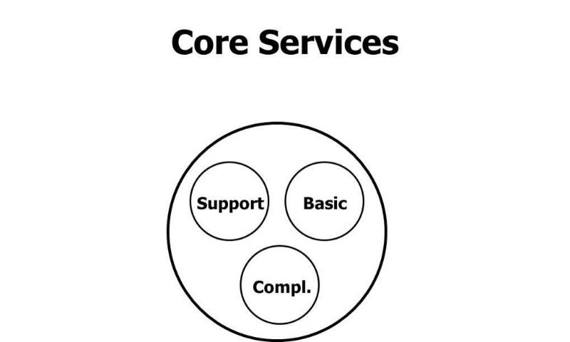
Sourced from 18/05/20

CHARACTERISTICS OF VALUE ADDED SERVICE
- They are not basic services.
- They are not solely used for expansion purpose.
- They are add-on to the fundamental services
- They add value to cores service
- They could motivate enlarged demand for standard services
- Occasionally, they stand alone operationally
- They stand alone in terms of their profitability
Value added service enable organization to establish customer’s loyalty. Customers are enticed to an organization that gives more value added services. These services also make customers very joyous. And customers are more likely to carry on with the services of the organization that makes them happy

- RELATIONSHIPS AND EXPERIENCES {what of sort of relationship do they with their customers}
Morrisons
Morrisons have a cordial relationship with their esteemed customers. They have been able to be different from other large supermarkets in the UK such as Sainsbury’s, Asda , Tesco, and Waitrose. Morrison used a simple strategy, which is a develop customer service. To demonstrate the high quality service, Morrisons have well trained staff who work in the fresh food units , such as pie shop, meat counter, oven fresh and fish bar. For customers to have nice experiences shopping with Morrisons, they have invested in new IT facilities to continue improvement. Their old computing systems have been replaced including check out monitors. This has made customer spend less time at till , the new computing system works efficiently, time saving, and and easy to use for colleagues . morrisons have been able to have a good relationship with customers by using the ‘Morrisons HOT Services’ .HOT stands for ‘Hello, Offer, Thank you’. All staff engage in this services at every stores. The aim of this HOT is to improve closer relationship between staffs and customers, to attain high level of customer service in communication. Staffs chat with customers to aid them feels that they are very important to the organization. It motivates staff to take part with customer by rendering great service, compete with other major supermarkets pull a lead. With the new multi-channel CRM, enables the organization to strengthen stronger customer relationship by greater understanding and satisfying the customer preferences, tastes and shopping habit of their customers. In turns, it will aid Morrisons to choose customers with more important and individual offer, advance new product ranges and carry out more marketing programmes .

SUMMARY TABLE
 | Lidl | Morrisons | Sainsbury’s
Conformance to requirements
Product Selection
Price and Brand | 1st | 2nd | 3rd
Relationship & Experience

To be more competitive
To serve customer better
Find local solution
Develop popular and useful services
To simplify and speed up the organization
To make core supermarket strong again

CHAPTER TWO
SERVICE QUALITY SERVQUAL
Quality of service can be explained as a in-depth customer appraisal of a specific service and the level to which it reach their assumptions and gives satisfaction.
Organisations modify, advance and produce essential strategies to ascertain the distinct variables determining service quality, in other to enlarge the number of their customers depending on the competitive market place by assessing customer satisfaction with regard to the different aspects that determine service quality.
Organisation have realised that service quality brings about sustainable and competitive advantage. Service quality and customer satisfaction are analytical outcome/result element/part for organisations are thinking about growth development, and competition in the market. Service quality has been defined by different researchers; they affirm that it includes conforming to requirements.
The SERVQUAL model is mostly employ multi-faceted research tool for customer satisfaction and comprises of these dimensions: empathy, tangibility assurance, reliability and responsiveness. Customer satisfaction always has a correlation with service quality.
Dimension of Service Quality
This report examine five dimensions of service quality Empathy, Tangibility, Assurance, Reliability, and Responsiveness) that have an effect on customer satisfaction, in order to recognise each factor’s potential effect on Morrison. These dimensions comprises of five dimensions of the SERVQUAL model.
- Empathy
- Tangibility
- Assurance
- Reliability
- Responsiveness

EMPATHY
Customers are required to perceive that they are made priority giving services; Empathy connotes caring, giving individual attention and giving services to customers. The core of empathy is bringing the feeling of the customer is special and unique. According to Parasuraman et al states that quantitative studies that have specified service quality model dimensions have used access, security and credibility to scale empathy.
Morrison is for all customers to have an outstanding experience when the store. To achieve this, it pursues to give service above and beyond customer’s expectation. Nonetheless, the predicted issue appears. All employees is commanded to follow the HEART model of taking care of and handling issues. Firstly, an employee must ‘listen and hear what a customer has to say’ then, must empathise with them and then Apologise for the circumstances. Finally, they must acknowledge to the customer’s need by taking action and follow up.
However, empathy is hard to infuse in employees. Morrison tries to employ for this features and train substantially increase on it. Employees are trained to always see things from customers’ point of view. Every day in store, employees are often asked same or similar questions by customers. Whilst it would be wearied of hearing same question all the time, staff are reminded that, to the customer, it is the first time the question is being asked. Furthermore, employees are also trained on how to give alternatives. When an answer to a customer’s question is no, the staff will always give one or more alternatives and ask the customer if any of these will be suitable.

TANGIBILITY
Parasuraman et al. recognise Tangible as physical facility (personnel, communications materials and equipment) it is the physical image of the service that customers will use to evaluate service quality. Tangible are correlated with the physical facilities, machines, and tools utilise to provide the service, as well as rendition of the services, such as cards (debit and credit), statement, speed and efficiency of business. Many benefits are added in tangibles such as external appearance, opening hours, and speed and efficiency of the business. Parasuraman et al affirmed that tangibles have the same significance as empathy. The authors contended that it is sensible to examine adding opening hours of operations under empathy dimension. Sharmin et al. regard tangible as a definite element showing regularities revealing regularities across cultures.

ASSURANCE
Assurance has been defined as employees’ courtesy and knowledge, and their dimension to transfer confidence and trust to customer. The belief of researchers on the classifying of assurance among service quality dimensions is differed. Assurance is classified as the first according to Gronroos, while the Parasuraman ranked it in fourth position. Assurance means keeping customer’s enlightened in their native language and attending to them, irrespective of their educational level, age and nationality. Parasuraman affirm that assurance stipulates the attitudes of the employees and their behaviour, and the staff’s potential to give cordial, courteous, and confidential and competence services.

RELIABILITY
Every new Morrison’s staff, before meeting any customer attends a training an orientation session. The start training also gives the fixture for the most significant service quality topic to discuss; customer satisfaction. Which include proper way of greeting customer, neatly dressed, and how to answer question rightly. Staffs are trained not to guess when they don’t know the answer to a question. Incorrect information irritates customers. When a staff is unable to answer to a customer rightly, another staff who can is contacted immediately.
Parasuraman et al. found that reliability means organisation carry out a service rightly the first time. Furthermore, it reveals that organisations aspire to accomplish vows give attention to the solutions. Reliability has been ranked as the first dimension of the SERVQUAL service quality model. According to Lam, reliability is ranked as the first in the dimensions of the service quality model.

RESPONSIVENESS
Parasuraman et al. highlighted that the responsiveness of willing staffs includes telling customers precisely when things will be done, offering them absolute attention, promoting services and acknowledging in line with their requests. Responsiveness was categorised as the 3rd dimension in SERVQUAL 1994. It is readiness to assist customers and give fast services. This dimension highlights thoughtfulness and quickness in trading with customer’s seek, questions , problems, and complaints. Responsiveness is transmitted to customers by duration of time they have to hold on for assistance, answers to questions or observant to issues. Also responsiveness expresses the desire of flexibility and ability to patronise the service to the customer needs.
IN STORE SUPERMARKETING RANKINGS
Three major big super markets have been rated in an in store ratings. Customers have rated their shopping experiences with them for a period of 6 months on features including store appearance, staff availability, and quality of both fresh and own label products and value for money.
Below is table showing how supermarkets compare in store customers.
BEST AND WORST IN STORE SUPERMARKETS 2018
supermarkets | Store appearance | Staff availability | Quality of own label products | Quality of fresh products | Value for money
Morrisons | **** | *** | **** | **** | ***
Lidl | *** | ** | **** | **** | *****
Sainsbury’s | **** | **** | **** | **** | ***
Sourced from: https://www.which.co.uk 19/05/20

Summary Table 1
Dimensions | Lidl | Morrisons | Sainsbury’s
Empathy | 4/5 | 4/5 | 4/5
Reliability | 5/5 | 3/5 | 3/5
Assurance | 4/5 | 4/5 | 4/5
Responsiveness | 2/5 | 3/5 | 4/5
Tangibility | 3/5 | 4/5 | 4/5

From the table above it can be seen that:
Empathy Lidl, Morrisons and Sainsbury’s have the same rating: 4/5
Reliability, Lidl is rated 5/5, while Morrisons and sainsbury’s are 3/5,
Assurance Lidl and Morrisons, and Sainsbury’s are 4/5
Responsiveness Lidl is 2/5, Morrisons 3/5 and Sainsbury 4/5
Tangibility Lidl 3/5, Morrisons and Sainsbury’s are 4/5
TOTAL SUMMARY TABLE
DIMENSIONS | POSITIONS
Lidl 18/25 | 2nd
Morrisons 18/25 | 2nd
Sainsbury’s 19/25 | 1st

Totally every component together and putting on rank, Sainsubry’s is 1st position while Morrisons and Lidl are 2nd position.
From the summary table above it could be seen Lidl is the best supermarket for value for money with a five star rating but worst on availability of staff in store with a two star rating.
For availability of staff in store, Sainsbury’s is the best with a four star rating followed by Morrisons with a three star rating.

CONCLUSION
From the research results, it could be deduced that consumer psychology and service
quality have a productive impact on customer value. By paying attention to the best service
component, it will make consumers feel enjoyable so as to create high customer
value. While customer value has a positive and important effect on loyalty. The higher the
Customer value, the more positive customer loyalty would be to the products manufactured by the organisation. Therefore if the price is high but the interest acquired by the customer is not many, it will have an effect on the loyalty given by the customer
Morrisons has excellent customer service. They maintain a good relationship with their customers not only in store but through their various crusades such as Lets Grow for schools, their farming programme and their support of various charities. It has a unique and focussed strategy to retain customers through sourcing the best products at affordable prices. Morrisons is predominantly a U.K supermarket and has not branched out on a global scale. This gives it the position to focus on local consumer needs which could facilitate customer acquisition. Morrisons traditional store layout and care for quality is surely attracting customers but its lack of online store is a hindering factor to growth.

REFERENCES
(Online) Available From: https://www.ukessays.com ( Accessed 01/04/20)
(Online) Available From: https://www.lovemoney.com (Accessed 28/4/20)
(Online) Available From: https://www.localdatacompany.com (Accessed 28/04/20)
(Online) Available From:https://www.thesun.co.uk (Accessed 05/05/20)
(Online) Available From: https://erply.com/uk ( Accessed 15/05/20)
(Online) Available From: https://www.which.co.uk (Accessed 19/05/20)

