Name | Student Number | Date | Lecturer’s Name | Your score
Emma Kavanagh | 2434603 | 25/06/2025 | Ellie Ristic | To be filled by the marker  ___/40
You will have 75 minutes to complete this assessment. It is divided into three sections: note-taking, paraphrasing and writing a paragraph.
---------------------------------------------------------------------------------------------------------------------
1. Take diagrammatic notes from the passage below using the space provided:

It's difficult to know whether undergraduate study is right for you until you've experienced it first-hand. Many first-year students have second thoughts on their decision to go to university for a number of reasons. For example, you may have changed your mind about the career you'd like to pursue, and the course you're enrolled on is no longer suitable. Another common reason is that you're struggling to cope with the workload or aren't being challenged enough on the course; perhaps you don't respond well to the teaching and assessment methods or it's simply not what you expected. Thirdly, it might well be that the university you have chosen is too big or too small; you've stayed close to home and would like to move away or you moved further away and are feeling homesick. There might also be financial reasons. Maybe you cannot afford the tuition or accommodation fees, living costs are out of your budget or you're not comfortable with the idea of accumulating and dealing with student debt. Finally, let us not underestimate personal circumstances. You may have a disability or health issues that make university life difficult to cope with, you have a delicate family situation or you're finding it challenging to balance your studies with other commitments.
Adapted from: https://www.prospects.ac.uk/applying-for-university/changing-or-leaving-your-course

Space for your notes (max 12 marks):
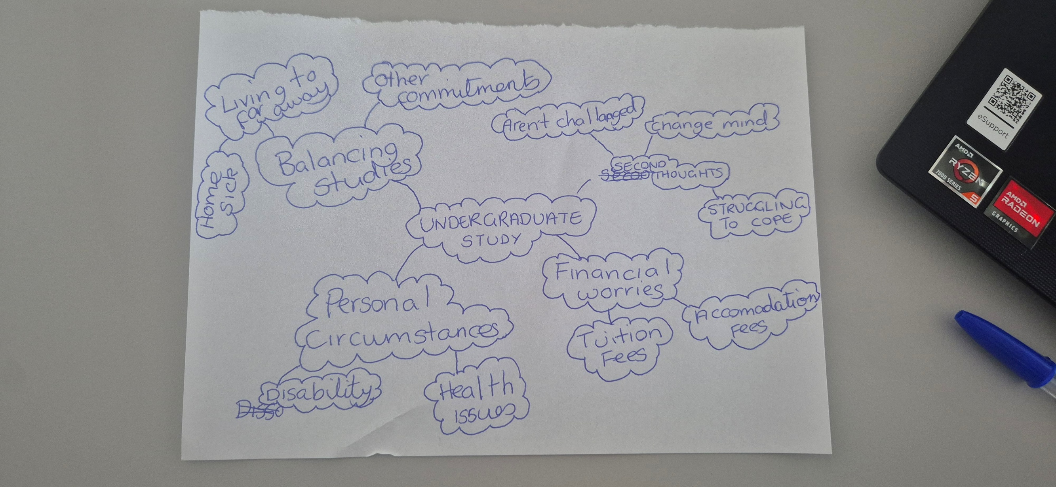

2. Paraphrase the following sentences (max 3 marks for each, max 12 marks in total):

- It's difficult to know whether university study is right for you until you've experienced it first-hand.
____________________________________________________________________________________________It can be complex to be sure that university study is the correct choice for you until you have experienced it first-hand._______________________________________________________________________________________________________________________________________________________________________________________________________________________________________________________

b) Developing good study habits is essential for academic success. ____________________________________________________________________________________________iIt is vital to have a heightened sense of study skills to have academic success.____________________________________________________________________________________________________________________________________________________________________________________________________________________________________________________________________________________

c) When you feel overwhelmed with your studies, consider adopting strategies to manage stress more effectively.
____________________________________________________________________________________________________When you feel engulfed with your your studies contemplate new procedures that will aid with controlling your stress more successfully. ____________________________________________________________________________________________________________________________________________________________________________________________________________________________________________________________________________

d) Consistent reading practice can improve your writing skills.

____________Routine reading patterns can enhance your writing skills._____________________________________________________________________________________________________________________________________________________________________________________________________________________________________________________________________________________________________________________________________________________________________________

3. Write a well-structured paragraph (8 sentences) on the following topic:

The challenges of studying at a UK university.

Your paragraph must be written in full sentences (no bullet points) and in an academic style.

(max 16 marks in total)
It is challenging to be sure that university studies are fitting for you until you have experienced it firsthand. A lot of first-year students reconsider their decision to study for numerous reasons, including rethinking the course they have enrolled in. Another usual explanation is that they are overwhelmed by the amount of coursework. In certain circumstances, the teaching approach may not be working for them, and they are not responding to it to the best of their ability. Perhaps the course is merely not what you had anticipated. It may be that you have relocated and feel isolated because you are away from a support circle. Another reason why a student would be doubting starting university is because of financial difficulties; the burden of the increasing student debt, tuition fees, and accommodation fees may override the desire to study. Ultimately, we shouldn’t de-emphasize private matters such as health conditions or disabilities that make life burdensome to manage; studying is incompatible for some people.

