

An essay to explore with the use of the DMAIC process whether the physical training programme for RLC soldiers during phase 2 training and in unit, is adequate preparation for MATT2 assessments.

Kristian Kormi

Logistic Officers’ Contracts Course
Contents Page

Title Page 1

Contents 2

Introduction 3

Define Stage 5

Measure Stage 8

Analyse Stage 10

Improve Stage 12

Conclusion 14

References 15
Introduction

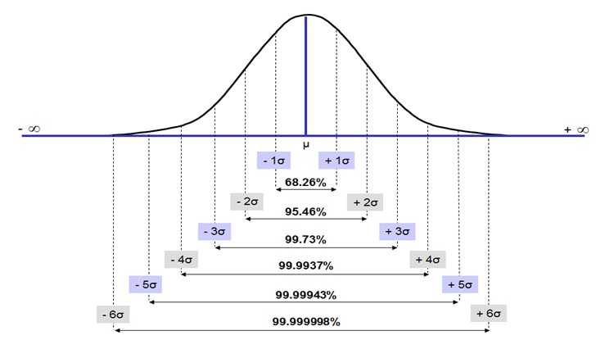
The Six Sigma measurement tool was first introduced in 1986 by engineer Bill Smith, while he was employed at Motorola. This tool is used to help measure key business processes with the aim to improve production or services to achieve a reliability of over 99.99% or 3.4 defects per one million defect opportunities (Alaya & Quatrebarbes, 2015). The tool’s aim is to reduce variability in every aspect of a business with the primary intent of meeting customer expectations. However, although the ultimate goal of six-sigma is to achieve a reliability of over 99.99%, in practice the tool is used to record data and make continuous improvements towards the sixth sigma value. Therefore, by using the Six Sigma Measurement Tool and evaluating business processes, businesses can strive for a more cost-effective business model.
Figure 1
Figure 1. Probability distribution graph detailing how as each sigma value increases variation decreases to over 99.99% (Sixsigma Institute, 2019). Therefore, a higher sigma value leads to less variation, meaning less defects during production or a service.

With less defects comes many advantages to the customer and business, for example higher customer satisfaction, improved yield and higher shareholder value for the business. Therefore, many businesses have adopted the six-sigma approach as a way of business management. One of the most widely used six-sigma tools is the DMAIC process. The DMAIC tool is used to characterise a process through the Define, Measure and Analyse stages and them optimise using the Improvement and Control stages (Tang, 2006). Thus, by using these 5 stages, the DMAIC process is an ideal tool to assess the effectiveness of current management methods and produce an efficient, reliable and cheaper management process for organisations.

Fitness is an important part of any job within the British Army. Physical standards underpin the ethos of the force and play a vital role in ensuring service personnel are ready to deploy and react in uncertain times. These standards are set in policy and delivered in accordance with Military Annual Training Test 2 (MATT 2.) The standards are outlined and clear to follow in JSP 898 (Ministry Of Defense, 2014).

However, rising concerns are being publicised by the media as to the health and fitness of service personnel. In 2014 a study concluded that “according to BMI, 56.7% of the study [Army] population were overweight and of those individuals 12% were obese” (Sanderson, et al., 2014, p. 193). This was reinforced in 2018, by a freedom of information request that revealed that “nearly 18,000 members of the British armed forces are clinically obese; more than 30,000 troops are considered overweight; and there were 8,662 obese soldiers in the Army” (Morris, 2018). These statistics are worryingly high, outlining issues in the deployability of the force and framing a need for changes solve this concern.

Therefore, this essay will explore whether physical training programmes for Royal Logistic Corps (RLC) soldiers would benefit from a six-sigma approach, preparing the recruits’ physical fitness for their future units. Using the Define, Measure, Analyse and Improve stages from the DMAIC tool to break down and assess current methods of training, this essay will assess whether the issue of fitness can be addressed at the earliest stage of a soldier’s career.

Define Stage

Military physical fitness requirements vary from unit to unit and can be considered a subjective topic based on the commanders’ direction. However, the mandatory baseline fitness requirements for any commander are set out in JSP 898, Defence Direction and Guidance on Training, Education and Skills.

For RLC soldiers this consists of two assessments;

Biannual Physical Fitness Assessment (PFA) - 44 press ups (21 for females) in 2 minutes, 50 sit ups in 2 minutes and a 1.5 mile run in less than 10 minutes and 30 seconds (13 minutes for females).

Annual Fitness Test (AFT) - 8-mile loaded march, with 15kg in less than 2 hours. This assessment is led by a Physical Training Instructor (PTI) (Ministry Of Defense, 2014).

Using Alaya and Quatrebarbes’ (2015) Define method, we can characterise the different elements of the process to fit the six-sigma tool. Therefore, we define the organisation as the training teams and unit Physical Training Instructors (PTI), the product as a fit, MATT 2 compliant soldier and the customer as the unit requiring a ready, deployable soldier. Therefore, the organisation (training teams and unit PTIs) need to provide the training to meet customer demand.

Figure 2 below (page 6) shows a Process Map, outlining a soldier’s path from civilian to a trained soldier within a unit. Highlighted within the red box are the establishments in which a soldier must pass physical assessments. Starting at phase 1, a recruit is taught the basics of military skills and begins a physical training regime to prepare them for MATT 2. However, neither the PFA or AFT have to be passed at this stage for a recruit to graduate to phase 2. Once at a phase 2 training establishment, a recruit must be able to pass an AFT in order to complete training and post to a unit. Failing to do so, sees the recruit kept back for remedial training until they can pass. However, they are not required to pass the PFA during this training, and it isn’t until they are at their unit that they are required to do so. Furthermore, once employed within a unit, a soldier still has a 6-month grace period before a PFA pass is mandatory. Failure to pass either a PFA or AFT results in the individual being placed on remedial training and a series of escalating warning orders until they can either meet the criteria or are discharged from the army. Injury is also a cause for concern with injured soldiers requiring rehabilitation Physical Training (PT) taking them away from the mainstream programmes.
Post to unit

Initial fitness test prior to recruitment
Phase 1 training

Phase 2 training

AFT
Remedial training
PFA (every 6 months)
AFT (every 12 months)
Pass
Fail
Discharge from Army
Post to unit
Remedial training
Pass
Fail
Figure 2
Figure 2. Training pathway for a soldier’: red box highlights times when soldiers need to pass physical assessments

According to JSP 898 (2014, p. 56) five (PT) sessions per week must be undertaken whilst at phase 2 training. These are led by PTI’s and are planned and timetabled through the duration of the training programme to fit in with other training. These training sessions are broken down in 40 to 60 minute periods but can be timetabled as double periods to conduct an AFT or longer training periods.

However, once at the unit, these mandatory training sessions are reduced to 3 times per week and may be as simple as a personal fitness regime organised between PTIs and service personnel (SP), structured to ensure that the individual is able to demonstrate the minimum fitness level required to pass the relevant single Service fitness test or assessment.” (Ministry Of Defense, 2014, p. 56). However, different units and different commanders may choose to do more than what is mandated.

Importantly, defining the current process outlines how the system works but does not provide enough insight as to failings or potential areas for improvement. Therefore, it is important to also define what activities PT sessions consist of as well. PT is conducted in four varieties of activity, strength and conditioning, cardio, flexibility and mobility, and green PT (military activity). These four types of PT each have pros and cons. Indeed, too much of one type can lead to injury, For example too much cardio or green PT, whereas too much of flexibility and mobility or strength and conditioning can lead to a loss in fitness (Gettman & Pollock, 1981, p. 44). Therefore, it is important to strike a balance using a holistic approach towards fitness in order to prepare soldiers for the PFA and AFT which require a balance of cardiovascular fitness and strength (Figure 3).

Figure 3. Failure mode and effects analysis (FMEA) table This table shows the potential negative effects of each type of physical training, highlighting the current controls and recommended action to be taken.

Function description | Failure Mode | Effects | Current controls | Recommended action (Improve Stage)
Strength and conditioning training | Muscular-skeletal strains due to heavy lifting. | Injury occurring to joints or muscles, preventing individual from attending future sessions. | Lessons are conducted to teach individuals the right techniques of lifting weights. | Build up training to gradually get individuals to the required standard.
Cardio training | Over worked in sessions. | Exhaustion leading to individual not being able to participate in future sessions. | Steady state exercises, based off ability of the group. | Build up training to gradually get individuals to the required standard.
Flexibility and mobility training | Excess sessions. | Fitness lost due to lack of arduous physical training. | Limited sessions, conducted after arduous session. | Conduct outside of PT timings, so not to interfere with other forms of training.
Green PT | Arduous training, more risk of injury. | Injury occurring, rendering individual unable to attend PT sessions. | Closely monitored, more PTIs on each session. | General fitness needed for these sessions; other PT sessions need to prepare individuals.

Therefore, continuing with the DMAIC process, it is important to measure and analyse not only where there are personal fitness failings, but also what current programmes are in place and whether they are adequate. This will in turn highlight areas of failings or where efficiencies and changes can be made to improve the service provided for the customer. The aim of the process is to eliminate failures and improve efficiency, which translates to customer satisfaction. Therefore, greater quality of physical standards translates to a more satisfied, deployable unit.

Measure Stage

This stage will be broken down into two parts, firstly measuring the PT programmes during phase 2 training and secondly PT training once the soldier has reached their unit.

Phase 2 training for RLC recruits is conducted at three establishments. Worthy Down for chefs, Leconfield for drivers and Deepcut for every other trade. All three of these establishments, follow similar programmes with recruits undergoing five PT sessions per week.
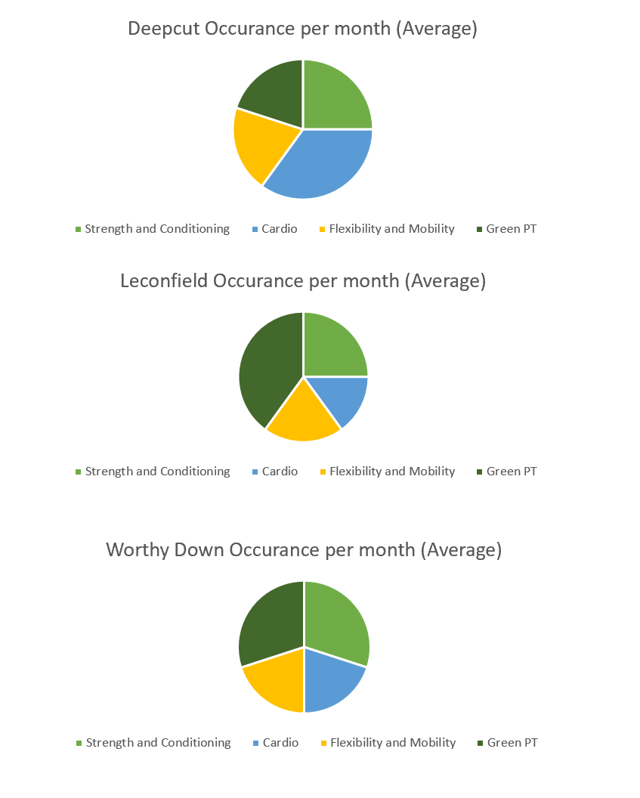
Figure 4

Figure 4 depicts 3 pie charts representing the breakdown of PT sessions in an average month. The first shows Deepcut, the second shows Leconfield and the third shows Worthy Down.
Figure 4 shows the breakdown of 20 PT sessions in an average month. It should be noted that there can be a slight variation to the programmes in summer and winter months dependant on weather. But as these graphs show all three establishments share a similar approach towards strength and conditioning, and flexibility and mobility sessions with around 1 session per week. The difference lies in cardio vs green PT. Whilst both activities can be considered cardio based activities, green PT is often a more arduous session lending itself better to AFT practice whereas cardio sessions are more directly aimed towards PFA. This is a source of variation which has potential impacts on customer satisfaction.

After phase 2 training, soldiers are then posted to a multitude of different regiments. The PT programme at most regiments is the same, with 2x40 minute sessions on Tuesday and Thursday, a sports afternoon on Wednesday and a1x80-120 minute session on Friday, usually green PT. At unit there is less scheduled PT than at phase 2 and an onus is put onto the individual to conduct there own training outside of work. This allows a great degree of variation.

Analyse Stage

During the analysis stage the findings from the measurement stage are critiqued in more detail in order to identify sources of variation. Variation is the cause of defects, both positive and negative therefore, it is important to analyse where there are differences in processes in order to provide a quality service.

Starting with phase 2 training, Figure 3 shows a difference between the three establishments and how PT sessions are timetabled. However, regardless of which PT sessions are run it is important to remember that every recruit passes an AFT in order the complete the course. This means that PT sessions must be adequate in the service they provide, preparing soldiers for the next unit. The variation occurs when it comes to PFA results though. Not all recruits leave phase 2 able to pass a PFA, which is highlighted by the units 6 month grace period for newly arriving soldiers. The discrepancies in timetable might therefore be a cause of defects which needs to be addressed in the search of six sigma accuracy.

At unit is where we find a more consistent PT timetable. Virtually every unit uses the same schedule but has the freedom of planning sessions in order to prepare soldiers for the MATT2 requirements. However, as at phase 2 this freedom causes variation. Using the “5 Why’s” approach we can narrow down to the root causes of each issue (Gangidi, 2019, p. 296).

Starting with PFA failures.
Why do soldiers fail a PFA? They lack the cardiovascular fitness to run the distance in the allocated time. Why do they lack the fitness? They do not train their cardiovascular fitness to the required standard (could be due to injury). Why do they not train cardiovascular fitness? There are not enough cardio training sessions per week. Why are there not enough sessions per week? Sessions consist of other activities other than cardio. Why do PT sessions conduct other activities? Sessions could be poorly planned or, other activities could be planned to combat other areas of fitness, such as preparation for AFT.

5 why’s method for AFT failures at a unit.
Why do soldiers fail an AFT? Soldiers have lost the conditioning and fitness required for the test (could be due to injury). Why are soldiers not conditioned? They have not trained or prepared for the more arduous event. Why have they not trained? Not enough strength and conditioning or green PT sessions have taken place. Why have these sessions not taken place? Sessions are focused around other types of fitness which soldiers are struggling with.

Therefore, the 5 why’s highlights the root cause of PT sessions not delivering the desired results required pass the PFA and/or AFT. This could be attributed to poor planning or sessions planned to mitigate against failures in another area. However, both cases show the importance of a balanced PT schedule. It should also be considered that injury plays a role in both areas. Injury can happen at any time and is impossible to mitigate against completely. However, under-training can be as detrimental as over-training when it comes to likelihood of injury (Gabbett, 2016) further illustrating the need for a balanced and well thought out training programme.
Improve Stage

Having characterised the causes leading to defects in the process, it is clear to see that variation is the issue. To aspire towards a six sigma 99.99% reliability rate in production (training fit, MATT 2 compliant soldiers), it is important to eliminate variation where possible. The army hopes to achieve this with a different take on physical fitness. Programme THOR (Training Human Optimisation for Readiness) aims to achieve this when the programme rolls out later in the year (2019) (Ministry of Defence, Army, 2018, p. 16). Figure 5 shows the physical traits that the programme hopes to achieve.

Figure 5

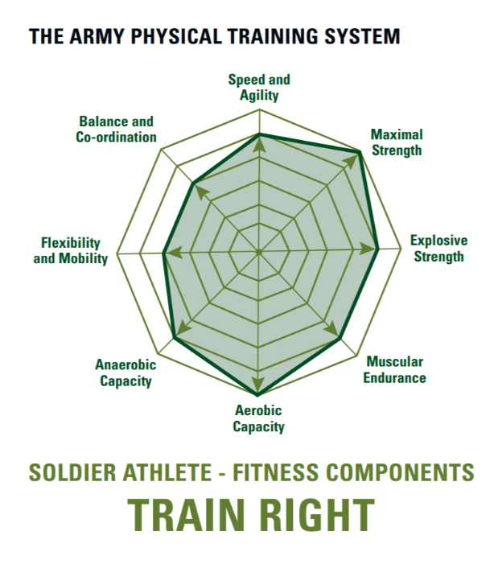

Figure 5. A visual representation of the fitness qualities Programme THOR aims to deliver soldiers. It covers a wide range of abilities and flattens out the strengths and weaknesses into a more rounded profile.

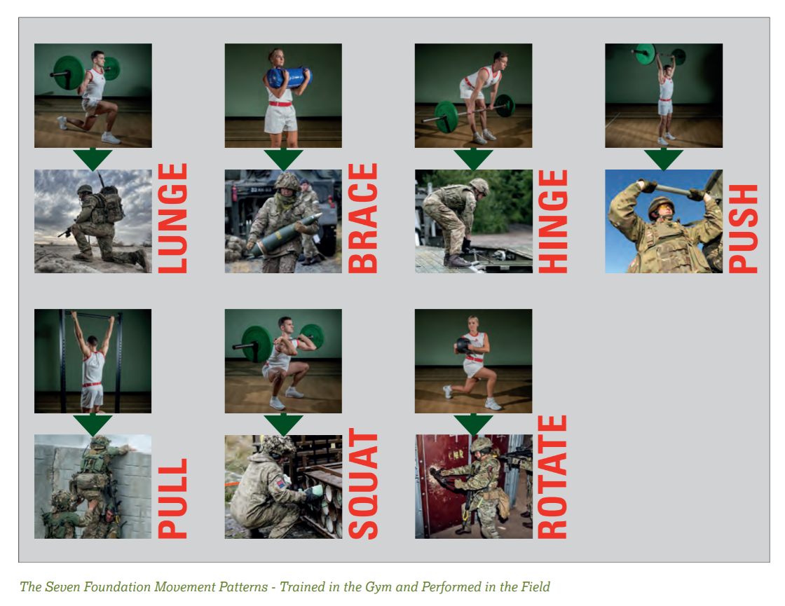
Figure 6

Figure 6 shows the 7 foundation movement patterns which Programme THOR focuses on. These 7 movements are responsible for being the main cause of muscular-skeletal injury (Ministry of Defence, Army, 2018).

Programme THOR will comprise of a wider range of exercises and activities relating to the ‘real world’, eliminating the issue with people having solely specific strengths and weaknesses. As a result, this should eliminate the variation within PT schedules in different training establishments and units. Furthermore, a prescribed training programme will bring continuity between training establishments and units, as well as have a steady approach fitness which will avoid injuries (See Figure 4 – FMEA for recommended action).

Conclusion

This essay has explored whether the physical training programme for RLC soldiers is adequate preparation for MATT2 assessments. Here, we have used the DMAIC model to characterise the process before making suggestions for improvement towards a sig sigma 99.99% reliability of production.

In the define stage, the current physical fitness programmes were outlined both at phase 2 training and in unit, which brought forward the areas which could then be measured to spot if variation is occurring. During the measure stage, variation was proved by comparing the different schedules within the training establishments as well as units. Analysing these findings showed how CTQ was not always being achieved. Indeed, soldiers were not necessarily being trained for both the PFA and AFT assessments equally at different establishments leading to a direct impact on customer satisfaction (where the customer is the unit requiring MATT 2 compliant, deployable soldiers). Finally, this presented ideas for optimisation in the improve stage. Programme THOR which is slowly being introduced to training establishments and the wider army units hopes to address these defects. It will introduce a structured rounded approach to physical fitness with the intention of building soldiers up to the standard. Furthermore, the training focuses on fundamental movements that will not only avoid injury but educate individuals to avoid injury at work. Programme THOR supports the findings found through the DMAIC characterisation phase and improves the sigma quality of the process by eliminating some of the variation that led to defects, unfit soldiers.

References
Alaya, A. B. & Quatrebarbes, A., 2015. The Six Sigma Method : Boost Quality and Consistency in Your Business. 50Minutes.com (Management & Marketing). [Online]
Available at: https://search-ebscohost-com.proxy.library.lincoln.ac.uk/login.aspx?direct=true&db=e020mww&AN=1096511&site=eds-live&scope=site
[Accessed 14 July 2019].
Gabbett, T. J., 2016. The training-injury prevention paradox: should athletes be training smarter and harder?. British Journal of Sports Medicine, 50(5), pp. 273-282.
Gangidi, P., 2019. A systematic approach to root cause analysis using 3 × 5 why’s technique. International Journal of Lean Six Sigma, 10(1), pp. 295-310.
Gettman, L. & Pollock, M., 1981. Circuit weight training: a critical review of its physiological benefits.. The Physician and Sportsmedicine, Volume 91, pp. 44-60.
Ministry of Defence, Army, 2018. Annual Health Report 2018, London: MoD.
Ministry Of Defense, 2014. JSP 898 Defence Direction and Guidance on Training. 1 ed. London: Ministry Of Defense.
Morris, J., 2018. Evening Standard. [Online]
Available at: https://www.standard.co.uk/news/uk/nearly-18000-members-of-british-armed-forces-are-obese-a3961466.html
[Accessed 14 July 2019].
Sanderson, P. W., Clemes, S. A. & Biddle, S. J. H., 2014. Prevalence and socio-demographic correlates of obesity in the British Army. Annals of Human Biology, 41(3), pp. 193-201.
Sixsigma Institute, 2019. Six Sigma DMAIC Process - Measure Phase - Measurement System. [Online]
Available at: https://www.sixsigma-institute.org/Six_Sigma_DMAIC_Process_Measure_Phase_Measurement_System.php
[Accessed 14 July 2019].
Tang, L. C., 2006. Six Sigma : Advanced Tools for Black Belts and Master Black Belts.. 1 ed. Chichester, England: Wiley.

