Personal Career Development

Natasha Brookes
1806574

Contents Page
Page 1 – Intro
Page 2 – Kolb
Page 3 – Employability Skills
Page 4 – Employability Skills
Page 5 – Understanding Procedures
Page 6 – Self Motivation
Page 7 – Learning Styles
Page 8 – Swot
Page 9 – SMART Objectives
Page 10 – SMART Objectives
Page 11 – Career Ambitions/Aspirations
Page 12 – Moving Forward…
Page 13 – Conclusion.
Page 14 - References

Introduction

In my portfolio I’m going to be looking at what my journey throughout my life, this report will cover me looking at my readiness for employment for the future. I will analyse what my strengths and weakness are and find different solutions that can give me more knowledge. I will come up with an action plan, this will reflect on some of the skills I have learned plus it will help me to see that what subjects what we have covered over this year. I am going use these key skills to produce a lifeline that will guide me to understanding where my life and future career may be headed.

This essay starts with me explaining where my career path is going and explain what challenges I have experienced since leaving school, I will be looking at the different experiences I’ve had and what I need to continue to learn in order to go futher in my Career Plan for the future is uncertain for me, but it is important to develop a career plan that will provide financial support and personal fulfilment over the course of my professional life. To make this transition from school to a professional career, I am going to plan a plan that will help me stay focused and motivated in meeting my goals and objectives.
At the end of my career, I want to be recognized as a positive team leader who can bring the best within myself and with others around me by studying at the University of Walsh this has prepared me for these objectives by implanting team work, passion for my career and love for diversity. I have realised that to achieve all my goals I have to study and work hard.

Kolb Experiment learning style Theory
Knowing a person's (and your own) learning style enables learning to be orientated according to the preferred method. That said, everyone responds to and needs the stimulus of all types of learning styles to one extent or another - it's a matter of using emphasis that fits best with the given situation and a person's learning style preferences.
David Kolb published his learning styles model in 1984 from which he developed his learning style inventory. Kolb's experiential learning theory works on two levels: a four-stage cycle of learning and four separate learning styles. Much of Kolb’s theory is concerned with the learner’s internal cognitive processes
This experimental Theory defines learning as the process whereby knowledge is created through transformation of experience the learning
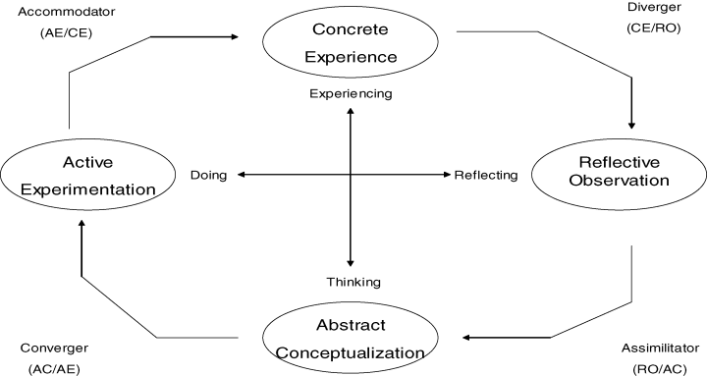

(Thomas F.Hawk, 2007)

My journey started for me since Leaving school on a great path to accomplish all that I desire by working hard, staying focused and taking the appropriate stages to get there. I have attened several different colleges such as Lewisham College, Croydon College and I have attended lots of different courses allocated all over London, some of the courses that I have completed over the years have been Travel and Tourism, Health and social Care, Electrical Installation, Heating and Ventilation, plus there are always different little local groups that I have attended over this period of time such has painting and decoration, Drama, English literature and language which was also a great help for my to build up my knowledge and have me prepared for the next stage of my jorney. Since leaving school as well as learning different subjects and various types of education skills, I have had lots of different jobs along the way, I have worked for several companies that has taught me lots of different way not only by working for organizations and large establishments, plus I have had a business of you own which I have ran single handedly, Studying at university has given me a wide knowledge of different skills. What I have learnt academically has given me the confedence to look into futher education plus I have been developing my interaction skills with my of fellow students whilst building my communication skills.
Employability Skills
Employability Skills can be defined as a set of skills that are neccesary to work effeciently in a company.
-Soft skills
-Work Readiness Skills
-Fundamental Skills
These types of skills while all crucial are not equal, both work readiness skills and soft skills would be nothing without the basic fundamentals
+Communication
In any and all environments of work, even for small businesses consisting of one person Communication becomes vital at at least one point, without effective or at least basic fundamental communication skills oppurtunities, networking, customers and supplies could be affected negatively.
+Time managmenent
Arguably the most important skill to posess, working in any timeframe effectively and efficiently is crucial to any business, with Supply and Demand being the main contributor to income and profit for ALL businesses being able to work well with time can be the difference in service that may push your business closer to its targets and goals
+Problem Solving
Being able to solve problems, obstacles and issues well will always prove to be an asset along with Decision Making (See Below). Being able to solve problems can save on costs and within companies and as an employee could be rewarding.
+Decision Making
Making Decisions well along with Time Management can especially when looking for work or running your own business be crucial to the future.
Making clever and well informed decisions can outset your business and you as a person moreso than competitors or other employees.
+Team Working
Previously I have hilghlighted the ability to communicate well in any situation, this is prevalent as being able to cooperate with a number of parties well can provide a plethora of results

Understanding Procedures and Policies
Being able to understand the basic rules and regulations set by any authority is crucial and important when it comes to working well in any business environment.
Specifically
In the workplace, health and safety regulations are paramount to the well-being of the employees and the employer. Many hazards are present in today's work environments, above all being able to work in a safe environment is key It's a job that is so important that there are occupational safety standards and regulations set by the Occupational Safety and Health Administration (OSHA).

OSHA ensures that all of their guidelines for health and safety are followed to a T if not then a plethora of fines can be set upon the businesses which don’t adhere to these rules.
In any business the most important thing is its employees, ensuring they are safe is paramount to basic human rights.

Health and safety procedures in the workplace reduce the employee illnesses and injuries greatly. These procedures can help you and your employees understand the potential hazards in your work environment.
(Weakley, 2016)

Self motivation
My career plan For the future is unsure, but it is essential to create a career plan that will provide economic assistance and private satisfaction throughout my career. In order to make this shift from college to a professional career, I will plan a plan that will assist me to remain focused and driven to achieve my goals. Self efficiency Effort regulations, Academic achievement. (Meera Komarraju, 2013) Since leaving school my self motivation has got better over time has I have different ways of doing thing how I study in class with others helps with buliding my teamwork this gives me the ability to do what needs to get done, Without any influence from other people or situations I have the capability with my own self motivation to finish my work for any dead lines I awlays find my strengh to get the task complete even if I find that im struggling and feel down heart at time but a will always finish what I started, other member who I work with they help keep up my motivation by them explaining to me what I need to know hoew to solve the problem that’s why teamworking I count very important to me regaurdless If I can cope with working on my own. When working alone and im having trouble here are some motivational process steps it is a process that needs cautious achievement approach. These measures can assist you achieve the required result: evaluate the person or group's preferences and personality characteristics to be motivated. It may not be the same what motivates a group of individuals as what motivates another group of individuals. Swot gives the motivational stratigies to reach my goal with performance expectations from the motivation object Or make it clear how the required result can be achieved by me.
Learning styles
There are 7 different learning styles they are known as
Visual, Aural, Verbal, Physical, Logical, Social, Solitary
These different styles have more influence then we realise. My preferred style helps me to learn more easily, I feel that that best way that I learn is by been visual, verbal and Aural.
Verbal: The temporal and frontal lobes, especially two specialized areas called Brocaï¿½s and Wernickeï¿½s areas (in the left hemisphere of these two lobes).
What I have observed that the best for me to learn is being verbal has I’m a very good communicator when speaking with others plus when I am doing any assignments verbal communication has to play a great part when achieving my goals or having to interact with others in a working enviroment.
Visual: The occipital lobes at the back of the brain manage the visual sense. Both the occipital and parietal lobes manage spatial orientation.
Visual learning helps my mind to take on task and complete them once I can see what I need to do, this form of learning helps me brain to process what I cant understand when things are being explain to me so this give me more confedience learning this way.
Logical: The parietal lobes, especially the left side, drive our logical thinking.
My logical way of learning has served me well in my past expeirience working for Bloomberg had helped me to improve through me working with differents systems over the years. Although I have some of all the 7 different skill avaible these 3 are my main strengths
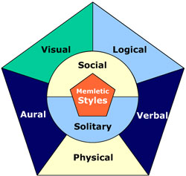 (Advanogy.com, 2019)

SWOT Analysis
My SWOT anaysis for my career development show all my strengths and weaknesses the internatal factors plus the opportunity to explore my extrenal factor has well with the SWOT diagram this will help show (Kumar, 2009)
My Strengths such as what do I do really well, what advantages do I have under my belt.
The Strengths I would list would be my extensive ability to communicate effectively with my team, quite efficient timekeeping and utilising of my assets and resources, being unafraid to ask for help whilst being independent enough to work well on my own.
My weaknesses do I feel I could have done better, where am I feeling vulnerable, for my opportunities.
Regarding my weaknesses I feel as if whilst my time keeping is efficient it could however improve.
MY opportunities do I realise what I have not addressed so far, is there any emerging trends on which I can capitalise
I understand that finishing university after studying business will greatly help my chances of finding a job whilch will not only help me hone my skills in the field but with the proper networking and branching out ( of which I believe is one of my strengths ) I could climb the corporate ladder of the company I work in quite effectively.
My threats will my weaknesses make me vulnerable, so I have any thing blocking my way to achieving my goals
The possible threats that could affect me range from a possible inability to finish my course, whilst I have put in a considerable amount of work I understand that things may arise which could affect my ability to progress further.

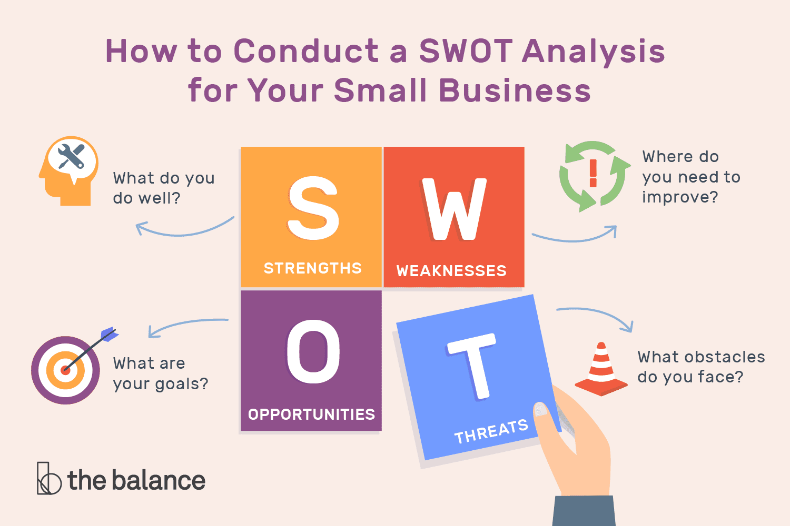 (Gregory, 2019)
SWOT is a technique that helps you analyse your strengths and weaknesses, and it helps you uncover your opportunities that you might otherwise not spot. When you look at yourself in the SWOT framework you are able to separate yourself from others and develop your talents and abilities. (Gregory, 2019)

Smart Objective
Goals are part of every aspect of business/life and provide a sense of direction, motivation, a clear focus, and clarify importance. By setting goals for yourself, you are providing yourself with a target to aim for. A SMART goal is used to help guide goal setting.
Review and understand the expectations of the world of employment
Looking for work can be challenging there is a lot of expections that we look for here is a list of some of them. The type of work that is being looked for, this will change once (Career key, n.d.)
Type of work
Security: Having a job that ensures the continuous employment of whoever is employed
Company: working for a company which is ethically correct in its methods of working
Advancement: being given the opportunity either from that job or from the credentials and skills gained from that job into a similar field of work
Co-workers: having colleagues of which are reliable and consistent in their ability to work well
Pay: being paid accordingly to the employees needs whilst adhering to the financial requirements of the business
Supervision: having a mentor or manager who can happily and reliably give help and advice needed per request whilst being unbiased and responsible
Hours: having enough hours to balance being productive and having a personal life away from work, this is key to employees having a positive mental attitude and thus being able to work well.
Benefits: reaping rewards whether from working hard or add on bonuses from working at a company (for instance the Free Gym Membership one would get from working at Virgin Atlantic)
Working Conditions: working in an environment which is safe, this is the most basic need of all as without this there could be Health and Safety Regulation concern.
These are the key elements for job expectation that are expected when faced with looking for a job these expectations are what I’m expecting from a company, so this is for me has an employee to have my own standards of satisfaction or if I’m dissatisfied and example of my expectation is a belief that I could get a promotion

Career ambitions

Studying Business skills in the work place has helped me to alter my direction. When I first arrived at university what my expectations where at the begging has change over time I started my career looking to be a travel agent but has time has gone on now that I have settled in to my studies, (M.A>C>T>Kuijpers,J>Scheerens, 2016) Im looking to stay at university but also seek employment. Working hard is the key to any success as well has looking for work and attending university I have found that increasing my professional knowledge and training has opened several different doors for me, Increase in my earnings shows that through education what I have been learning knowledge and gain confidence has given me the drive to venture out of my comfort zone and put my best foot forward really has worked for me on a whole. The fact that I have a need motivation has helped me increase in my communication with others and now this experience for this year is drawing near I can say with real pride that all the new experiences I have been having has helped me to advance my thought process to bigger hights, the thinks that would have been a stumbling block for me in the past has now subsided now I have new gateways opening up and on offer for me.
Aspirations
Im motivated and inspired to enhance my professional skills, With working full time at company shows that I have stability and predicatilty show that I looking sor a secure position not omnly to myself but it lets my mangers know, I have great expectations of what position im seeking for a future that has a lot of promising signs for myself, especially when I keep working in the field that I am at the moment and I really enjoy. (Barara White, 1995) I like to be my own person that strive on her own motivation, the most valuble thing is my freedom for my independence and last of all I believe in balance and my ability to work effectively.

Moving Forward
The introduction to a plan of what I hope to be my career, going ahead I beieve that managing over a team of fellow employees would be the next logical step, whilst for years I have been working well independently and in teams I believe that managing a team effectively in any business market or company will help not only improve my management, communication, timekeeping and decision making but fulfil my hopes to move up and be more successful in a business workplace.
According to Esteemed career blog WhenIWork the Skills required for Team management would be

1. Vision
Any good Manager and Leader will always have the best intentions for the Company at heart, this doesn’t only mean the Profits being raked in or the Goals to be set but the employees working there too, without a clear purpose and vision for the company moving forward these things can be lost, for example recently a Disneyland scandal has erupted wherein they were found to be overworking and underpaying staff, this in recent light of events has shown that whilst they had the companies profits in their sights their intentions regarding what is best for the employees working at every level were lost.
Not having a clear vision in mind when acting as an executive operating over your fellow colleagues can provide negative results all around the board, not paying attention to the careful balance of communication on all fronts can often ruin a business so when setting your eyes on any target in mind make sure your goals account for Everything.
A way to do this effectively is by looking at the operation of your business from all perspectives, from customer to shareholder seeing what you can do for the employees to the suppliers can help keep in check your vision and make targets more realistic
2. Communication

Regarding speaking effectively with your colleagues and employees, being able to communicate effectively carries many meanings, from being sincere without coming across as non-authoritative, or making it clear that the numbers matter most whilst seeming robotic the art of effectively communicating to fellow colleagues is incredibly difficult however there are many ways to (as previously mentioned) keep these factors in balance.

What’s key is making sure that the purpose of being in the workplace is to be productive.

3. Organization

Perhaps the most important factor in any business management, being organised demonstrates your ability to have all facts, resources and assets ready, often being preapared is the most proffesional thing to do in any stage of the employemtn timeline, from researching the business you hope to be joining in the interview stage to researching and looking into partners and rivals, a prepared and organised team leader is never unsettled by the changing of the workplace and as such can lead colleagues to success.
Conclusion.
In all I believe that the next greatest step for me is to join business management, my extensive time spent researching problem solving, decision making and communication to regulations, rules and vision, I believe that moving ahead as a manager will sharpen my business skills and help me improve personally to deal with situations along with being the next logical step on my career timeline.
Leading up to this point I believe my emploaybility skills, determination and resourcefulness have paved the way for me to lead other unto the same skills I have acquired.

Advanogy.com, 2019. overview of learning styles. [Online]
Available at: https://www.learning-styles-online.com/overview/
[Accessed 5 September 2019].
Barara White, 1995. The career development of successful women. Emerald insight, Issue 0964-9425.
Career key, n.d. [Online]
Available at: https://www.careerkey.org/choose-a-career/top-job-expectations.html#.XXEkMDZKiUk
[Accessed 5 september 2019].
Gregory, A., 2019. TheBalanceSMB. [Online]
Available at: https://www.thebalancesmb.com/swot-analysis-for-small-business-2951706
[Accessed 05 09 2019].
Halvorson, C., 2019. WhenIWork. [Online]
Available at: https://wheniwork.com/blog/management-skills/
[Accessed 05 September 2019].
Kumar, A., 2009. Personal, Academic and Career Development in Higher Education. 1st ed. londo: SOARing to Success.
M.A>C>T>Kuijpers,J>Scheerens, 2016. Career Competencies for the Modern Career. Journal of Career Development, Issue https://doi.org/10.1177%2F0894845305283006.
Meera Komarraju, D. N., 2013. Self-efficacy and academic achievement: Why do implicit beliefs, goals, and effort regulation matter?. learning and individual Differences, Volume 25, pp. 67-72.
Thomas F.Hawk, A. j., 2007. Decision Science Jornal of Innovative Education , 5(1).
Weakley, L., 2016. WorkplaceDiversity. [Online]
Available at: https://workplacediversity.com/news/The-Importance-of-Health-and-Safety-in-the-Workplace-
[Accessed 05 September 2019].

