

Global Business Environment

LCBB4005 Task 1 - Business Environment Analysis

Submission Date: 09/05/2023
Name of the Lecture: Dr. Mohammed Asim
Studen ID: 2235333
Student Name: Andzhelo Markov
Table of Contents
Introduction 3
A Brief Introduction To Poland 3
Application of theories of the business environment in Poland 4
PESTLE Analysis 4
Porter's Diamond 5
Value Network 6
Critical evaluation of opportunities and challenges that are present in Poland 7
Discuss and analyze the different barriers experienced by foreign businesses in Poland 9
Appropriate strategies and other relevant recommendations to enable Aston Martin to succeed in Poland. 11
Conclusion 12
Reference 13

Introduction
International trade refers to the buying and selling of products and services as well as the transfer of money between countries. Because of globalisation and technological development, international trade has taken on more significance. Overseas businesses encounter a variety of difficulties, including language barriers, unfamiliar regulations, and unstable governments.
Successful companies may have anticipated these difficulties by conducting in-depth analyses of the local business environment. The political and legal atmosphere, the economy, social and cultural standards, technology advances, and environmental considerations all need to be taken into account. An in-depth research of the environment, including the identification of possibilities and dangers, is essential for a company's success in a new market.
Establishing a solid organisational plan is essential when entering new markets. Consideration of the target country's culture, economics, and government might increase a company's chances of success in that market. The plan should also align with the larger objectives of the business.
Corporate governance is as important as business strategy when it comes to a company's worldwide success. Transparency, accountability, and legal compliance are all bolstered by well-established governance structures, which are thus essential for every business. The company's reputation, legal duties, and other issues might worsen without proper corporate governance practises.

A Brief Introduction To Poland
Poland is home to over 38 million people in central Europe. A varied economy is formed when long-standing industries like agriculture, manufacturing, and mining coexist alongside newer ones like IT, biotech, and renewable energy. With a GDP of over $614 billion in 2020, Poland ranked ninth in the EU and 23rd in the globe.
Poland's economy is open and trade barriers are minimal since the country is a member of the European Union and the World Trade Organisation (WTO). The Schengen Area, in which the country is included, allows free travel between European Union member states for both people and goods. This has made Poland a popular location for the establishment of branch offices of global firms (SP, 2023).
However, there are challenges to conducting business in Poland. Corruption is still an issue in a number of sectors, and the country's legal and regulatory structure may be complicated by bureaucracy and red tape. In addition, a shortage of competent employees has created a talent gap in a number of industries. Organisations with Polish operations should adjust their methods to fit the peculiarities of the Polish market (Kent et al., 2019).

Application of theories of the business environment in Poland
Many theories of the business environment can be applied to Poland to gain a deeper understanding of the factors that shape business in Poland. Here are a few illustrations:

PESTLE Analysis
Political: In Poland, the government is reliable and free. Membership in the European Union (EU) ensures open markets and safe investments. Policies and regulations put in place by governments have good intentions—they protect businesses—but they may be too bureaucratic and confusing at times (Mokhtar et al., 2022).
Economic: The Polish economy includes a mix of traditional and cutting-edge methods and industries. The country's economy has been growing steadily over the last several years, and it is now the ninth biggest in the European Union (Soares et al., 2023). However, there are challenges to overcome, such as an inadequate supply of skilled labour in certain industries and a lower GDP per capita than other EU countries.
Social: Poland has a large and growing population, and the country's urbanisation rate is significant. More people than ever before come from all walks of life to call this place home. Polish workers may feel the effects of an ageing population and a relatively young median age.
Technological: Poland's IT sector is booming, and the country is quickly becoming a hub for startup IT businesses. The government has also put money into ecologically safe and renewable energy sources (Soares et al., 2023). Digitalization and technology infrastructure, particularly in outlying places, have some ways to go before they're fully developed.
Legal: Foreign companies often struggle to make sense of Poland's complex legal structure. Corruption remains an issue in several sectors, which may have a chilling impact on investment and innovation.
Environmental: When it comes to environmental protection, Poland has gone a long way in recent years, particularly in terms of the quality of its air and water. Nonetheless, more work needs to be done to counter climate change, biodiversity loss, and wasteful resource use (Mokhtar et al., 2022).
Poland has a wealth of opportunities for businesses seeking to expand into Central Europe, despite challenges such as the complexity of its legal and regulatory system. As a result of familiarising themselves with the features identified by this PESTLE study, businesses will be better able to navigate the Polish business environment and take advantage of opportunities .
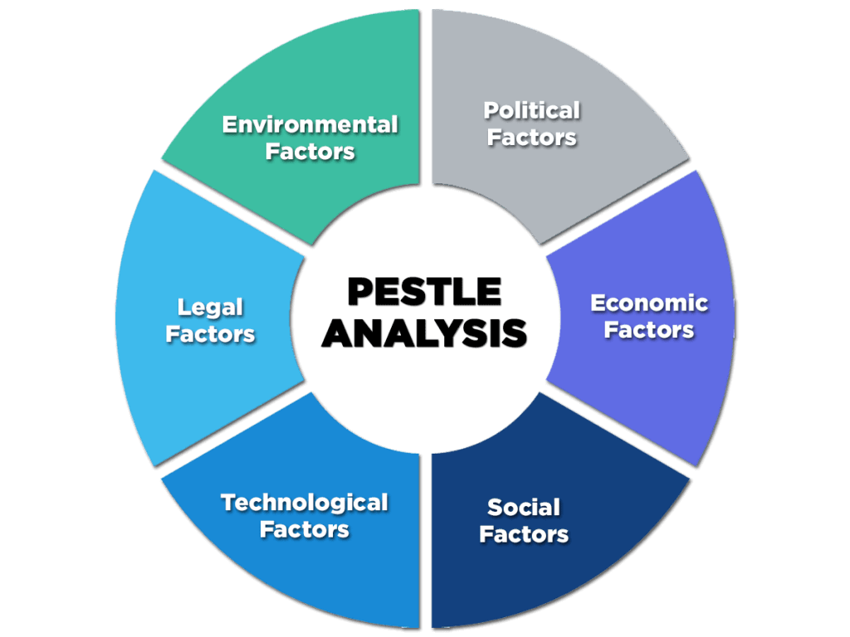
Figure: PESTLE Analysis
(Source: CIPD, 2023)

Porter's Diamond
Porter's Diamond model is a helpful tool for analysing a country's competitive advantages. Below, it will take a look at what makes Poland competitive from a business perspective, using the framework of Porter's Diamond:
Factor Conditions: In comparison to other EU countries, Poland's large and diverse labour pool comes with a low hourly wage (Naser, 2021). The country also has an abundance of natural resources, particularly in the agricultural and mining sectors. Poland has also invested in academic endeavours, notably in the areas of IT and biotech.
Related and Supporting Industries: Poland has a highly linked and mutually beneficial industrial sector. For instance, the automotive industry benefits from a solid supply network. Many new and established companies in the country specialise in software engineering, cyber security, and other tech subsectors, indicating the growth of the country's IT industry (KAPLAN, 2022).
Firm Strategy, Structure, and Rivalry: Competition is fierce for Polish businesses, particularly in the manufacturing and technological sectors. Numerous multinational corporations have established operations here, in addition to numerous large domestic ones. Government initiatives, such as research and development tax credits, have also been implemented (KAPLAN, 2022).
Demand Conditions: The Polish domestic market is substantial and growing, and the nation also has convenient access to the much larger European Union market. The nation's consumers are becoming more selective and demanding across the board, but notably in the food, fashion, and technology industries. Poland's thriving consumer market might be attributed in part to the country's young and well-educated populace (Naser, 2021).
Poland's competitive edge comes from the strength of its workforce, its natural resources, and its auxiliary sectors. By using these strengths and compensating for weaknesses like a dearth of skilled workers and a convoluted regulatory environment, businesses may develop strategies for success in the Polish market.
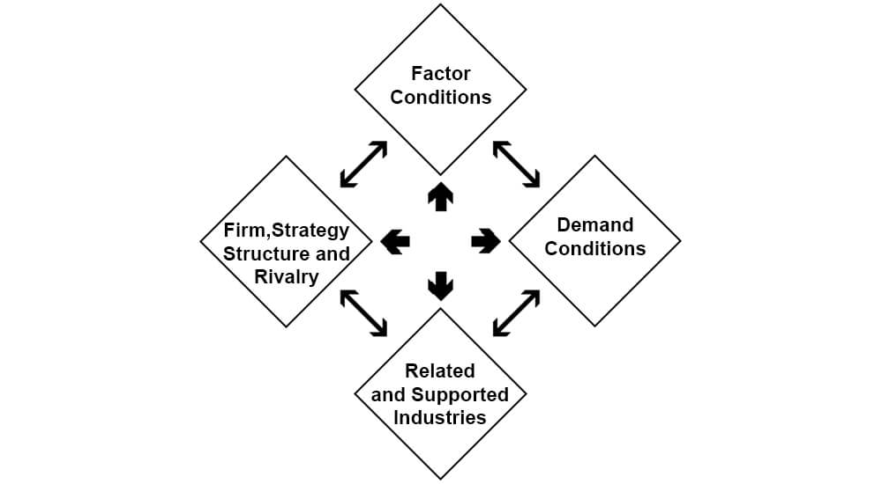
Figure: Porter's Diamond
(Source: HBR, 2020)

Value Network
Value networks are groups of companies that work together to better serve their customers. Below is a look at Poland's value network from the perspective of the country's business climate:
Suppliers: Poland is home to a plethora of providers that cater to a variety of markets, most notably manufacturing. The nation has a well-developed infrastructure to support the mining and agricultural sectors, as well as the car industry. Poland is also home to a growing number of technology companies, many of which specialise in software development and network defence.
Producers: As a result of their contributions to the Polish economy, many Polish businesses are classified as producers. Both the automobile and technology industries are thriving there. In addition to the energy and food industries, Poland also boasts a substantial and well-established business community in a variety of other areas (Krishen et al., 2019).
Distributors: In order to help bring products and services to customers, Poland has a number of distributors. There are a wide variety of both domestic and international labels available in the country's well-developed retail sector (Wolniak et al., 2020). Poland is home to a thriving e-commerce sector, spearheaded by industry titans such as Allegro and OLX.
Customers: Poland's large and growing middle class is a direct result of the country's young and well-educated population. The nation's consumers are becoming more selective and demanding across the board, but notably in the food, fashion, and technology industries. The Polish middle class is growing, which might lead to increased demand for certain products and services (Krishen et al., 2019).
Competitors: The manufacturing and the IT industries are very competitive in Poland. Numerous multinational corporations have established operations here, in addition to numerous large domestic ones. Additionally, Poland is home to a wide variety of innovative, internationally competitive businesses (Wolniak et al., 2020).
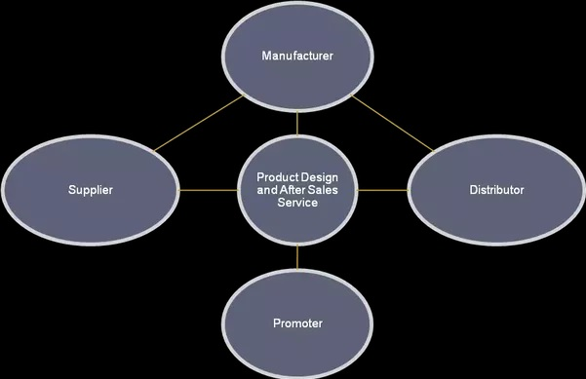
Figure: Value Network
(Source: IR, 2021)

Critical evaluation of opportunities and challenges that are present in Poland
Poland is a desirable location for enterprises because of its central location within the European Union, its big and growing consumer market, and its relatively low labour costs compared to other EU countries. Although Poland presents numerous opportunities, precautions must be taken to avoid potential pitfalls. In this article, I will discuss the pros and cons of doing business in Poland, as well as provide recommendations for enhancing corporate governance, business strategy, and awareness of cultural norms.
Opportunities:
Poland's huge and growing consumer base means the nation has promising market potential for products and services. With a population of close to 40 million, Poland is home to a growing middle class (IEA, 2022). Companies like Ikea, McDonald's, and Carrefour, to mention a few, have expanded rapidly in Poland as a result of the country's welcoming business environment. Poland has a large and well-educated labour population, which excels in IT, engineering, and the hard sciences. Poland's colleges produce a considerable number of new graduates each year, adding to the country's already sizable pool of educated employees.
The Polish government has initiated several programmes to encourage economic development and innovation, including policy incentives for R&D and startup finance.
Challenges:
Due to the country's bureaucracy and the many laws and red tape necessary to create a company in Poland, business formation may be difficult and time-consuming. Companies may have trouble getting started, which wastes resources. Polish culture and values are unique and may be at contrast with those of other countries. Because of this, there is a higher risk of making mistakes in business conversations and decisions (IEA, 2022). Even though corruption in Poland has decreased in recent years, business owners still worry about it. This might lead to unfair competition, lengthy delays, and increased pricing.
Recommendations:
Any company operating in Poland needs to have solid corporate governance in place, with clearly delineated lines of authority, established risk management processes, and clear compliance policies and procedures. This strategy may lessen the risks associated with bribery and rule-breaking (Sulich and Rutkowska, 2020).
In order to be successful in the long run, businesses operating in Poland need to tailor their strategies to the country's unique cultural norms, legal system, and market conditions. They may be more likely to succeed in the long run and adapt to changing market conditions if they do this.
Businesspeople in Poland might benefit from learning more about Polish culture, particularly as it relates to negotiations and business decisions. Doing so has the potential to deepen your relationships with local partners and customers and reduce the chance of communication breakdowns (Sulich and Rutkowska, 2020).
Examples:
In 2019, the Swedish furniture behemoth IKEA opened a store in the middle of Warsaw, Poland. After studying the market and cultural norms, the company adapted its product offering and store design to the area. As a result, the store has been successful, and Ikea's reputation in Poland has improved.
Carrefour, a French grocery giant, bought the Polish supermarket brand Biedronka in 2018. The acquisition was meant to help Carrefour strengthen its foothold in the Eastern European market. However, the company's efforts to merge the two operations were slowed by cultural differences and regulatory obstacles. Carrefour overcome these challenges by investing in employee training programmes and establishing tight working relationships with local authorities to ensure compliance with all requirements (IEA, 2022).
U.S.-based IT behemoth IBM said in 2017 that it will invest $200 million in its Polish business over the next five years. With this funding, IBM hoped to expand its operations across Central and Eastern Europe. To ensure the continued success of its business in Poland, IBM invested in training programmes to enhance the skills of its Polish workforce and placed a premium on fortifying its relationships with local partners and customers. To benefit from Poland's pro-business and pro-innovation policies, the company also worked closely with the Polish government.

Discuss and analyze the different barriers experienced by foreign businesses in Poland
Foreign companies in Poland may confront a number of challenges that hinder their capacity to function efficiently and compete in the local market. The purpose of this article is to explore and analyse some of the major challenges faced by foreign enterprises in Poland, using examples where possible to illustrate my points.
Bureaucracy and regulatory environment: One of the major obstacles for foreign enterprises in Poland is the nation's complicated regulatory framework, which may make it challenging to negotiate the process of establishing and running a company. For international companies, this might mean waiting around and extra expenses (Juszczyk et al., 2022). In 2018, the American electric vehicle manufacturer Tesla had trouble securing the required licences to construct a charging station in Poland. The corporation had to work with the government to have the project approved and finished (GOVUK, 2021).
Cultural barriers: It may be difficult for foreign enterprises to forge partnerships with Polish partners and clients due to the country's cultural disparities. In 2019, the German grocery retailer Lidl came under fire in Poland for an ad campaign that some Polish people found offensive. The business was forced to offer an apology and alter its advertising tactics in order to restore its standing in the nation.
Language challenges: For international companies doing business in Poland, language hurdles might be a problem. There are a lot of English speakers in Poland, however Polish is the country's official business language. In 2017, for instance, the American fast food brand KFC had difficulties in Poland owing to linguistic problems. To better serve its local clientele, the firm found it necessary to provide its personnel with language training (Juszczyk et al., 2022).
Competition from local companies: Given their established brands, strong customer bases, and market expertise, local companies operating in Poland may present a serious threat to foreign companies doing business there. As an example, Polish ride-hailing startup Bolt (previously Taxify) gave the American software firm Uber a run for its money in 2017. Since Bolt already had such a strong foothold in the Polish market, Uber had to make some changes to its pricing and advertising in order to compete.
Corruption: Corruption may be a problem for international companies doing business in Poland, leading to unethical behaviour and higher expenses. For instance, corruption in Poland's energy industry presented difficulties for the Norwegian energy firm Statkraft in 2018 (Juszczyk et al., 2022). In order to get the approvals it needed to begin operations in Poland, the corporation had to traverse a convoluted regulatory landscape and deal with unscrupulous authorities.
Foreign companies in Poland might take various measures to break through these restrictions. To succeed in the nation, businesses may teach their staff in the local language and culture, forge tight connections with local partners and consumers, and coordinate closely with government regulators. Foreign companies may overcome the challenges of entering the Polish market by studying the practices of successful competitors and adjusting their tactics to fit the country's culture and economy (GOVUK, 2021).

Appropriate strategies and other relevant recommendations to enable Aston Martin to succeed in Poland.
Aston Martin is known for producing high-end sports cars and luxurious grand tourers. Aston Martin will require well-considered strategies and recommendations to ensure its long-term success in Poland if it chooses to join that market.
Aston Martin should do extensive market research on the market climate, client preferences, and competitive landscape in Poland before opening a full-scale business there. The findings of this study will allow the firm to better plan for the future of the Polish market and satisfy the demands of its customers there. For instance, the business should consider the demand for high-end vehicles in Poland, the purchasing capacity of customers, and the strength of the competition (WUF, 2019).
It's possible that Aston Martin may tailor its products and marketing campaigns specifically for the Polish market. You may achieve this by advertising to Poles and offering vehicles that can handle the weather and roads of Poland (Agache et al., 2021). For example, the company may form partnerships with prominent Poles to promote its products in that nation.
The key to Aston Martin's success in Poland will be the company's ability to establish a customer-friendly distribution network. One strategy for entering a new market is to form partnerships with established businesses there. The company has to consider expanding into digital channels and e-commerce platforms to meet the needs of customers who want to make purchases in this manner.
Aston Martin has to prioritise the customer experience to stand out in Poland and grow its customer base. Design options, concierge help, and stellar support even after the sale are all instances of personalised services. The company may, for instance, staff a customer service helpline with native Polish speakers to handle queries from Polish-speaking customers.
In order to navigate Poland's convoluted legislative structure and cultural quirks, Aston Martin might consider teaming up with established Polish businesses and groups. To do this, it may be necessary to partner with local businesses in the manufacturing, retail, and industry sectors. The company must also maintain communication with Polish authorities to ensure it is operating lawfully in the country (WUF, 2019).
If Aston Martin wants to succeed in Poland, it has to do market research, develop a localization strategy, establish a solid distribution network, prioritise the customer experience, and consider partnering with relevant Polish firms and groups. Using these methods, Aston Martin can capitalise on the growing demand for luxury sports cars and grand tourers in Poland (Agache et al., 2021).

Conclusion
Poland's growing middle class, educated workforce, and business-friendly government make it a desirable location for international investment. However, bureaucracy, cultural differences, and corruption are all risks that must be mitigated. Businesses will do better in Poland if they modify their approach to fit the local market, cultural norms, and regulatory environment. In order to do this, a firm may need to alter its product offering, train its staff, collaborate with regional companies, and ensure good corporate governance. This will help businesses take advantage of opportunities in Poland while limiting risks. The key to success in the Polish market is a blend of strategic planning, analytical thinking, and cultural sensitivity.

Reference
Agache, I., Akdis, C.A., Akdis, M., Canonica, G.W., Casale, T., Chivato, T., Corren, J., Chu, D.K., Del Giacco, S., Eiwegger, T. and Flood, B., 2021. EAACI Biologicals Guidelines—Recommendations for severe asthma. Allergy, 76(1), pp.14-44.
CIPD, 2023, “PESTLE analysis”, Available at https://www.cipd.org/uk/knowledge/factsheets/pestle-analysis-factsheet/ [Accessed on 29th April 2023]
GOVUK, 2021, “Overseas business risk: Poland”, Available at https://www.gov.uk/government/publications/overseas-business-risk-poland/overseas-business-risk-poland [Accessed on 29th April 2023]
HBR, 2020, “The Competitive Advantage of Nations”, Available at https://hbr.org/1990/03/the-competitive-advantage-of-nations [Accessed on 29th April 2023]
IEA, 2022, “Poland needs a stronger push to reduce emissions and ensure secure energy supplies, new IEA policy review says”, Available at https://www.iea.org/news/poland-needs-a-stronger-push-to-reduce-emissions-and-ensure-secure-energy-supplies-new-iea-policy-review-says [Accessed on 29th April 2023]
IR, 2021, “Value Networks and Why They Matter”, Available at https://www.interaction-design.org/literature/article/value-networks-and-why-they-matter [Accessed on 29th April 2023]
Juszczyk, O., Juszczyk, J., Juszczyk, S. and Takala, J., 2022. Barriers for renewable energy technologies diffusion: Empirical Evidence from Finland and Poland. Energies, 15(2), p.527.
KAPLAN, T., 2022. THE IMPACT OF COVID-19 PANDEMIC IN THE PERSPECTIVE OF PORTER’S DIAMOND MODEL. International Research In Social, Human And Administrative Sciences V, p.43.
Kent, A.J., Davis, M. and Davies, J., 2019. The Soviet mapping of Poland–a brief overview. Miscellanea Geographica, 23(1), pp.5-15.
Krishen, A.S., Leenders, M.A., Muthaly, S., Ziółkowska, M. and LaTour, M.S., 2019. Social networking from a social capital perspective: a cross-cultural analysis. European Journal of Marketing, 53(6), pp.1234-1253.
Mokhtar, M.M., Zuri, W.W.M., Rasid, N.M., Asmadi, A.A. and Manaf, N.A., 2022, October. Decision Making on the Renewable Energy Penetration in Malaysia via SWOT-PESTLE Analysis: Hydrogen Fuel Cell and Solar Photovoltaic Thermal Technology. In IOP Conference Series: Materials Science and Engineering (Vol. 1257, No. 1, p. 012009). IOP Publishing.
Naser, N., 2021. Porter Diamond Model and Internationalization of Fintechs.
SP, 2023, “Why Poland”, Available at http://www.studyinpoland.pl/en/about-poland#:~:text=Poland%20is%20located%20in%20the,(around%202%20million%20inhabitants). [Accessed on 29th April 2023]
Soares, C.A., Shendrikova, D., Crevani, G., Silinto, B. and Colombo, E., 2023. Enabling factors for the development of mini-grid solutions in Mozambique: A PESTLE-based analysis. Energy Strategy Reviews, 45, p.101040.
Sulich, A. and Rutkowska, M., 2020. Green jobs, definitional issues, and the employment of young people: An analysis of three European Union countries. Journal of environmental management, 262, p.110314.
WUF, 2019, “The Eleventh Session of the World Urban Forum”, Available at https://wuf.unhabitat.org/sites/default/files/2022-06/files/WUF11_Programme.pdf [Accessed on 29th April 2023]
Wolniak, R., Saniuk, S., Grabowska, S. and Gajdzik, B., 2020. Identification of energy efficiency trends in the context of the development of industry 4.0 using the Polish steel sector as an example. Energies, 13(11), p.2867.

Appendix: Task 2


