Introducing The Modern Workplace
Anton Antonov (1908495)

TESCO

Introduction
Few companies are leading the retail market of the United Kingdom. Tesco is one of them. It has around 28% market share in the UK. In 1919, Tesco was established by Jack Cohen. Currently, the company is headed in Hertfordshire, England, United Kingdom. Tesco is a multinational company also. The company has almost 7000 stores and shops in seven different countries across Europe and Asia. Groceries and daily basis products are the main business of the company. But the company has a banking service also. Tesco provides wholesale and retail banking. The company has come a long way. Its structure and organisational performances are identical. The company has a great cultural history which is going to be discussed here. The company makes great leadership for their employees and the management system is very effective compared to other companies. These are all going to be discussed here briefly(Wood et al., 2016).

Structure of Tesco
The organization Tesco is considerably one of the versatile infrastructure running its business on the groceries merchandise and retails. The structure of the organization has been recognised as the hereditary structure which the organization Tesco carry. The hereditary structure is mainly a functional structure which shows their concern and focuses on the different sections of the organization(Sreenivasan et al., 2018).
Culture of Tesco
One of the fundamental factors which stabilized the organizational synchronization factor within and outside the process of the organization. The culture makes sure that employees, as well as the customers who constantly get into the organizational process, stay in intact behavioural instincts. In better words, it can be said the cultural factor makes a solid platform where every one of them such as the employees as well as the clients shares a mutual understanding and interact in a well-behaved manner. As the organization, Tesco is an employee-owned organization, therefore, the culture of team orientation fosters some of the factors such as the innovation, empowerment, personal growth and sincere growth in serving the client with qualified products and meaningful solutions(Awadari and Kanwal, 2019).
Peoples of Tesco
As in the previous section of the study the cultural factor has been briefly elaborated which makes sure that the employees and their employable interaction with the client. In this part, the peoples or the workers have been signified. Some too many people are from different cultures and beliefs. With the proper organizational culture who are being led by the management system of Tesco make all these people in a mutual platform where they are being introduced to each other so that a common communication can be built which will later out as a positive organizational performance within Tesco(Wrigley et al., 2019).
Organizational Performance of Tesco
The organizational performance of the organization Tesco makes sure that all of the factors such as the peoples, their cultures and the structure of the organization work smoothly. These following factors will make sure that the organization will run in its best manner hence improvement in fulfilling and meeting the goals and objectives of the organization Tesco.
Analysis of the Relationship
The analysis or the relationship of each of these factors can be evaluated by highlighting the organizational process of the organization Tesco. The company Tesco focuses mainly on the items which generally fulfil the needs of the consumers. Products such as groceries, daily products, household items and many more items are being sold in the organization Tesco. As it is a customer-oriented company so the employees and the management of the organization need to provide a strong basement where proper services can be provided to the consumers. To maintain this stabilizing factor the organization has taken different kinds of approaches and theories such as the democratic leadership within the organization so that peoples of different cultures can be brought down together and engage in the mutual communication within themself. Different types of management systems have been developed such as the Human resource management system which makes sure that the different kinds of people of various beliefs, cultures and religions can interact with others to engage in teamwork and make the organizational process run smoothly.
So these are some of the factors which coherently analyze the relationship between the organizational performance, peoples, culture and structure of the organization Tesco(Awadari and Kanwal, 2019).
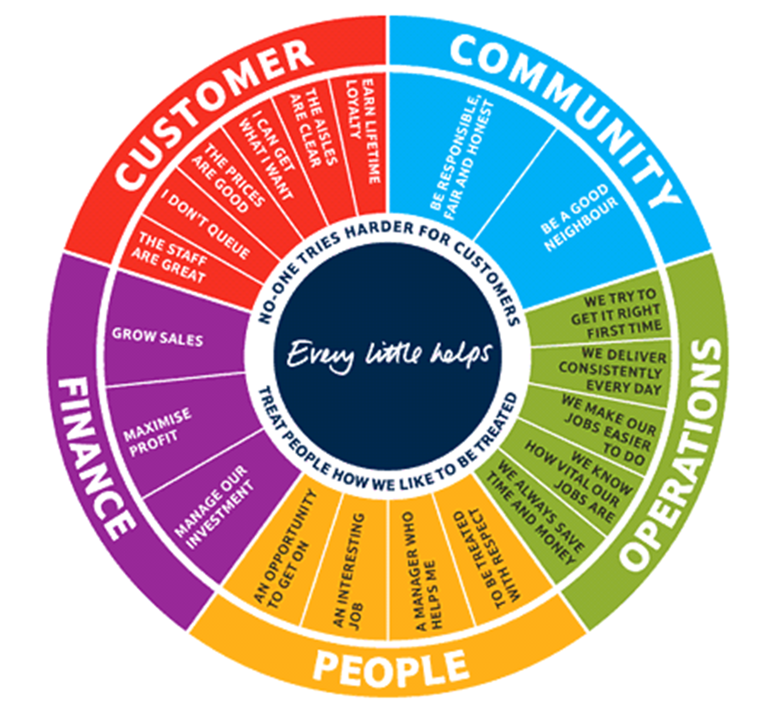
Figure1: Organization Analysis of Tesco.
Source: (Awadari and Kanwal, 2019)

Nature of managerial work within Tesco
- Customer satisfaction: Customers are the ultimate goal of Tesco products. All the business activities and hard labour were done by Tesco are to satisfy customers. So the management of Tesco is very much focused on their customers. Every week Tesco serves millions of consumers through offline and online facilities.
- Affordability: Tesco wishes to attract customers of all classes. As it is a retailer company so Tesco supplies mainly common products which are a daily basis. The price of the products is affordable so that anyone can buy it according to their needs. With this price, they maintain high quality also.
- Non-food products: As a retailer, Tesco has a large number of food products. But they have no food products also. It has a large volume of household products, common dry goods, tobacco products, toiletries, newspaper, wine, alcohol, magazines and many more.
- Profit-making: Tesco is neither a charitable business nor a not for profit organisation. It is a profit-making company like other companies do. So company management is working hard to generate more profit. In 2019, the company has made a revenue of around 64 billion GBP. In terms of gross revenue, it is the third-largest company in the world.
- Expansion: Expansion of business is another vital nature of Tesco management. In 1919, the company was established as a group of stalls markets. By 1939, the company opened almost 100 stores in the United Kingdom very rapidly. Since 1990, the company has expanded its business globally. Currently, the company has almost 7000 stores worldwide.
- Service business: Company management believes in providing services also. Tesco bank which provides wholesale and retail banking. Tesco mobile is another product of the company(Wood et al., 2017).
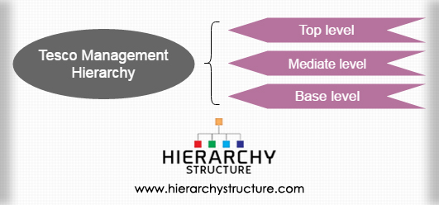
Figure 2: Tesco Managerial Process
Source : (Wood et al., 2017)
Role of leadership
- Motivation: Leaders play an important role in motivating followers towards the goal. If followers or employees are disturbed or demotivated in any way, leaders boost up their morale and motivate them to perform the job and finish it.
- Human resource development: Tesco is a large multinational company. The company employs almost 450000 employees from different races, beliefs and qualifications. So it needs to provide training most of the time. Leaders recommend the name for whom the training is needed.
- Social responsibilities: Leaders are responsible to commit social participation. For example, Tesco is committed to reducing its carbon emission by 2050 in a planned way and leaders elaborate the plan to their team on how to emit that carbon which is harmful to society.
- Proper utilization: During the period of unwanted lockdown, leaders know how to use properly the team to satisfy the job.
- Direction: A right direction is needed to perform the job appropriately. Leaders direct them to achieve their goal.
- Organise: To perform a job different machinery may be needed. Leaders organise all the machinery and experienced employees.
- Technical support: There may be any technical problem that arises to perform a job. In that case, leaders provide or arrange technical support and solve them.
Variables for effective management and leadership :
Variables for effective management are :
- Scope: Management should utilize the scope properly when it comes because those scopes may not be available at all the time.
- Time: Proper use of time is more important for effective management.
- People: Identification or selecting the right people is also important.
- Process: Management should know what is the best process to perform the job.
- Risk management: It is another important part of company management. So management should calculate the risk factors also.
Variables for effective leadership are :
- Characteristics of the leader: Leaders can lead the team.
- Characteristics of the follower: The followers or employers should follow the command of the leader. The command should be easily transferable between leader and follower.
- Characteristics of the circumstance: Leader should consider and calculate what the circumstantial demand is. Otherwise, it may be complicated (Alavi et al., 2018).
Evolution of the Behavioural Approach
The relationship factor is considered as one of the fundamental factors which the organization Tesco focuses briefly on. In better words, it can be said that as the organization is considerably big and versatile as well in terms of their operational process and the workers or employees. So it is a very basic need for the organization to develop and implement some of the approaches which will make sure that the organization runs smoothly. In regarding the following statement an evidential illustration can be provided in a manner that the smoothness of the process can only be achieved when there will be a mutual platform so that the employees could get connected internally. The behavioural approach makes sure that the interrelationship factor stays strong in between the employees. The management of the behavioural approach focuses on the relationship between human and the well being of the employees. rather than that it simply sets the task and demands it to be completed efficiently. Another fundamental factor is that the behavioural style of managers creates a condition which keeps the employees motivated and satisfied(Mattison et al., 2018).
With the help of the behavioural approach, the management can easily access and look on to the positive and negative factors of their peoples or the workers. This particular factor will again help in providing proper rectification to the employees and the workers by the management whenever required. The behavioural approach also consists of the environmental manipulation which is being done in such a way that the probability of the behaviour of the target gets adjusted according to the desire(Stamps, 2016).
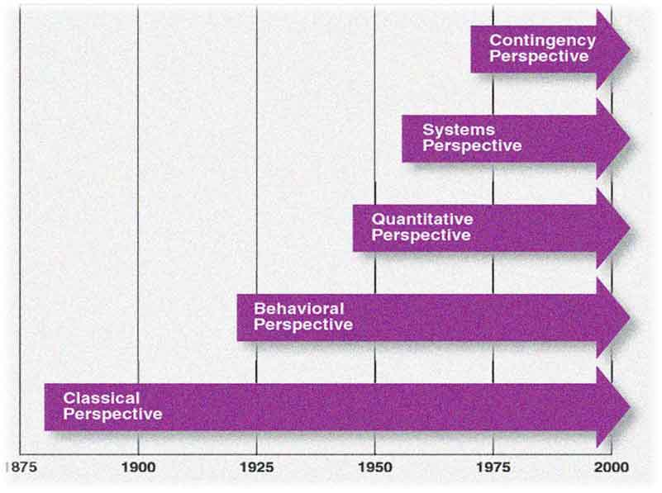
Figure 3: Behavioural Approach Evolution
Source: (Stamps, 2016)

Factors that affect the behaviour of different Individuals
About the following factor which has been described in the previous section of the study, there are also some of the factors present which affect individual behaviour. Some of the factors are a personal factor, environmental factor and the organizational factor.
- The personal factor gets divided into two categories the first is the biographical factor which states that every human has some certain characteristics which are inherited and generic and learned factor which state that with the environmental interaction a relative change in the behaviour comes permanently. In the behavioural factor some of the subparts are present such as the physical characteristics, showcases the height skin and many more. The factor of physical characteristics can be defined as slim and tall people expect to dress well and act sophistically whereas fat people are supposed to be jolly. The age factor determines the old element which is being judged in the corporate sector very often. The learning factor highlights the personality which gets the judgement by the psychological attire, the attitude determines judgement on the physical behaviour and perception which affects the thinking or virtual image of an individual.
- The environmental factor consists of the economical factor, as the behaviour of the individual gets changed due to the economical availability, level of employability, rate of wages, technological development and socio-cultural factors.
- Lastly, the organizational factor which affects the behaviour of the individual consists of elements such as the physical facilities or the arrangement of the peoples or employees. People often can react if there is an uncomfortable factor within the organization. Lastly, Leadership again acts as one of the severe factors, as individuals can oppose if they are facing any issue regarding the leadership(O’Leary et al., 2018).
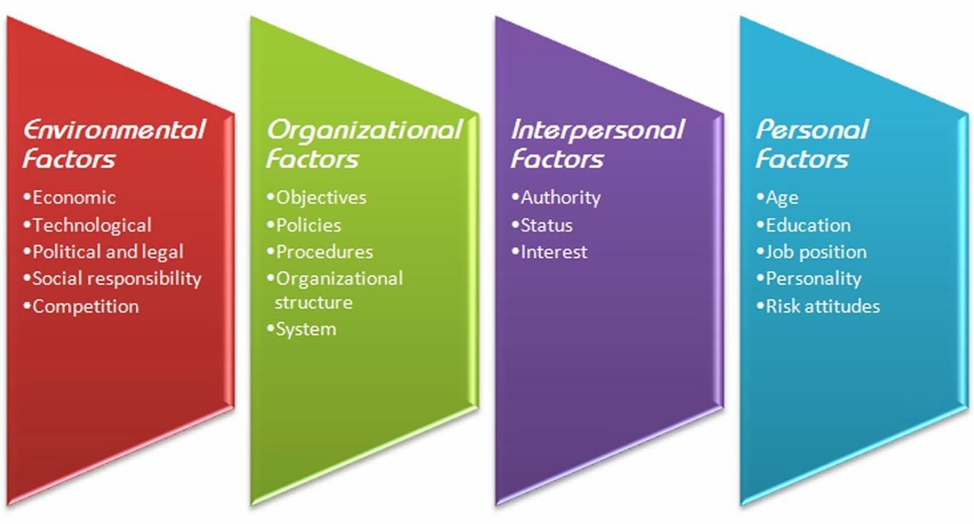
Figure 4: Factor Affecting Behaviour
Source: (O’Leary et al., 2018)
Conclusion
Tesco has a great contribution to reducing unemployment. Currently, the company employs around 500000 people overseas. The company is always working hard to satisfy the demand and supply chain. Not only that, currently the company is wishing to set up new stores for NHS staff and other temporary workers who are providing treatments to the patients of Covid-19 as BBC said. Finally, it can be said that the company has achieved a huge experience from the retail business field and taking part in the betterment of the society as well as the customers.

Reference list
Alavi, S., Habel, J., Guenzi, P. and Wieseke, J., 2018. The role of leadership in salespeople’s price negotiation behavior. Journal of the Academy of Marketing Science, 46(4), pp.703-724.
Awadari, A.C. and Kanwal, S., 2019. Employee participation in organizational change: A case of Tesco PLC. International Journal of Financial, Accounting, and Management, 1(2), pp.91-99.
Awadari, A.C. and Kanwal, S., 2019. Employee participation in organizational change: A case of Tesco PLC. International Journal of Financial, Accounting, and Management, 1(2), pp.91-99.
Mattison, S., Moya, C., Reynolds, A. and Towner, M.C., 2018. Evolutionary demography of age at last birth: integrating approaches from human behavioural ecology and cultural evolution. Philosophical Transactions of the Royal Society B: Biological Sciences, 373(1743), p.20170060.
O’Leary, D., Suri, G. and Gross, J.J., 2018. Reducing behavioural risk factors for cancer: An affect regulation perspective. Psychology & health, 33(1), pp.17-39.
Sreenivasan, R., Ludbrook, L., Fisher, B., Declosmenil, F., Knower, K.C., Croft, B., Bird, A.D., Ryan, J., Bashamboo, A., Sinclair, A.H. and Koopman, P., 2018. Mutant NR5A1/SF‐1 in patients with disorders of sex development shows defective activation of the SOX9 TESCO enhancer. Human mutation, 39(12), pp.1861-1874.
Stamps, J.A., 2016. Individual differences in behavioural plasticities. Biological Reviews, 91(2), pp.534-567.
Wood, S., Coe, N.M. and Wrigley, N., 2016. Multi-scalar localization and capability transference: exploring embeddedness in the Asian retail expansion of Tesco. Regional Studies, 50(3), pp.475-495.
Wood, S., Wrigley, N. and Coe, N.M., 2017. Capital discipline and financial market relations in retail globalization: insights from the case of Tesco plc. Journal of Economic Geography, 17(1), pp.31-57.
Wrigley, N., Wood, S., Lambiri, D. and Lowe, M., 2019. Corporate convenience store development effects in small towns: Convenience culture during economic and digital storms. Environment and Planning A: Economy and Space, 51(1), pp.112-132.

