chemistry (ome)
  - Hand grenade chemistry
Jenkins, Christopher
ACDA4011
December 10, 2020
Table of Contents
1. Abstract 2
2. Introduction 2
3. Method – Tools for selecting energetics 3
4. Method – The energetic train 4
5. Results 10
6. Discussion 10
7. Conclusion 11
8. References 12

Abstract
  - This report has been created to detail the top-level functioning of a military grade hand grenade and the considerations that have to be made in the selection of the energetic materials that make up the explosive train.
  - For each phase of the initiation train through to the main effect materials will be identified and have their mechanism of energy release described.
  - The completed article detailed in this report is not for manufacture and is only intended to demonstrate the theoretical knowledge gained during the duration of the chemistry module.

Introduction
  - Early hand grenades and Evolution to modern style Hand grenades have been used in warfare for centuries with some of earliest being recorded as being used as incendiary weapons during the Byzantine period (330 to 1453 CE). These weapons were relatively crude compared to modern grenades often made with a ceramic body filled with an exact composition that has remained undiscovered.
  - The designs were enhanced through the centuries which lead to multiple effects being identified and improved for greater results. There are multiple styles of grenade used in most modern military forces with fragmentation grenades, smoke grenades and incendiary grenades to name a few.
  - This report will focus on the explosive components used in a High Explosive (HE) grenade commonly manufactured to have a fragmenting effect to combat infantry and other lightly protected targets.
  - An example image of a time delay fragmentation grenade [1] can be seen in figure 1.
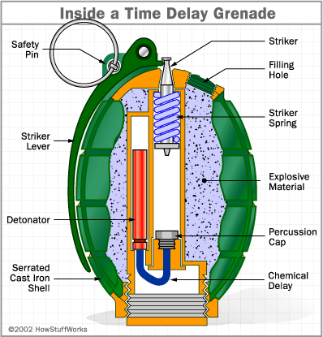
Figure 1.

Method – Tools for selecting energetics
  - For the example grenade in figure 1 the following explosive components need to identified, with each of their chemical make-ups assessed to ensure that the input received is sufficient to cause a reaction and that their output is also sufficient to cause an appropriate reaction in the next component to continue on the explosive chain.
  - There are a number of tools that should be used when assessing the suitability of an energetic material:
    - Oxygen Balance - This is the amount of oxygen present in an explosive compound expressed as a percentage of weight. This can be derived from the formulae $OB\%= -\frac{1600}{molecular weight}*\left(2C+\left(\frac{H}{2}\right)+M-O\right)$ , where C is number of carbon Atoms, H is the number of hydrogen atoms and O is the number of Oxygen atoms.
    - When the Oxygen balance has been calculated there are two sets of rules to be considered.
      - The first is the Kistiakowsky-Wilson Rules as seen in table 1.
Rule number | Conditions
1 | Carbon atoms are converted to carbon monoxide
2 | If any oxygen remains then hydrogen is then oxidized to water
3 | If any oxygen still remains then carbon monoxide is oxidized to carbon dioxide
4 | All the nitrogen is converted to nitrogen gas, N 2
Table 1 – K-W Rules.
      - If the oxygen balance is lower than -40% then the Modified Kistiakowsky-Wilson Rules [2] should be used, these are shown in table 2.
Rule number | Conditions
1 | Hydrogen atoms are converted to water
2 | If any oxygen remains then then carbon is converted to carbon monoxide
3 | If any oxygen still remains then carbon monoxide is oxidized to carbon dioxide
4 | All the nitrogen is converted to nitrogen gas, N₂
Table 2 – Modified K-W Rules.

    - The Heat of Formation also know as the standard enthalpy of formation is the amount of heat absorbed or evolved when one mole of a compound is formed from its constituent elements at a standard temperature and a pressure of 1 atmosphere [3].
      - Using the heat of formation equation will result in a value of energy being either negative value ∆H < 0 known as an exothermic reaction, or positive value ∆H > 0 known as an endothermic reaction.
    - Hess’s law is used to calculate the total change in enthalpy, it states that regardless of the multiple stages or steps of a reaction, the total enthalpy change for the reaction is the sum of all changes [4].
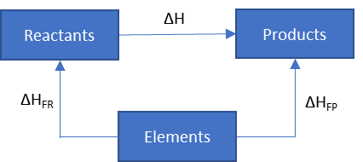
Figure 2 – Hess’s Law.

Method – The energetic train
  - For the grenade detailed in figure 1 there are four main stages of the energetic chain which take place after the removal of the safety pin and release of the striker lever.
  - Primary explosive.
    - The percussion cap containing the primary explosive/initiating compound. This component will start the initiation train and usually contains the most sensitive energetics found with in the grenade. Common energetic materials sensitive to stab impact used in military percussion detonators are Lead Azide and Silver Azide.
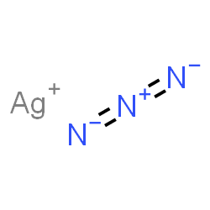
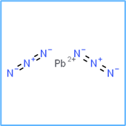
Lead azide [5]. N₆Pb Silver azide [6]. AgN₃
    - Modern primary explosive components have been designed to reduce the amount of highly sensitive material used and commonly employ multiple layers of energetic materials pressed to specific densities depending on the output required.
    - For the purpose of this report the percussion cap will be said to filled entirely with Lead azide. Formed from the reaction of Sodium azide and lead nitrate in an aqueous solution it has the properties detailed in table 3.
    - Lead azide used in UK service is manufactured by rapidly stirring a solution of sodium azide with a solution of lead aetate or lead nitrate [7].
Lead Azide Properties
Chemical formula | N₆Pb
Appearance | White powder
Melting point | 190°C
Ignition Temp | 350°C
Standard enthalpy | 462.3kJ/mol
Detonation velocity | 5180m/s
Table 3 – Lead Azide properties.
    - The output from the percussion cap takes over onto the chemical delay, this composition is implemented to provide a time delay between the initiation of the percussion cap and initiation of the detonator.
  - The chemical delay.
    - Black powder was first developed in China and used in warfare from 904AD, it is a chemical mixture of the oxidizer the mineral form of Potassium nitrate known as saltpeter (KNO₃₎ and the fuel which is a combination of powdered Charcoal (C) and Sulphur (S).
    - When the mixture is pressed into a tube or cord to an equal density throughout has historically been used to provide an equal steady burn. This burn is subsonic and is said to deflagrate rather than detonate.
    - For this grenade a black powder variant known as Gunpowder G20 is being used as it is already accepted for used in the UK munitions industry. Its ingredients listed by percentage weight are shown in table 4 taken from the Explosive Hazard Data Sheet (EHDS) [8].
Ingredient | Percentage of mixture
Potassium nitrate | 75.5
Charcoal | 14.5
Sulphur | 10
Table 4 – Gunpowder G20 ingredients.
    - The materials sensitiveness characteristics are also given in the EHDS and are listed in table 5 [8].
Test | Result
Figure of insensitiveness | 110
Figure of friction | >5.2
Temperature of ignition | >250°C
Ignition by flash | Explodes
Behavior on inflammation | Ignites and supports train throughout
Ignition by electric spark | No ignition at 4.5J
Table 5 – Material sensitiveness.
    - The addition of stabilizers will aide in the uniform pressing of the material and the burn rate could be tailored for its desired effect by adding in a plasticizer.
    - A commonly used simplified balanced equation is [9]:
10KNO₃ + 3S + 8C → 2K₂CO₃ + 3K₂SO₄ + 6CO₂ + 5 N₂
    - Taking the molecular masses of KNO₃ as 101g, Charcoal as 12g and Sulfur as 32g we can work out the products following combustion of the material by substituting them into the first half of the balanced equation
10 (101) + 3(32) + 8(12) which would give 1010g for KNO3, 96g for S and 96g for C. Giving a total of 1202g.
    - The Standard enthalpy of formation values [10] for the materials can now be plugged in
10 (-494.0) + 3(0) + 8(0) → 2(-1150.18) + 3(-1437.7) + 6(-393.5) + 5(0)
Products Reactants

    - The heat of formation can now be calculated by subtracting the reactants from the products.
4940.0 + 0 + 0 → -2300.36 + -4313.1 + -2361
4940.0 → -8974.46
Therefor: (-8974.46) – (-4940.0) = -4034.46 kJ/mol
    - If the delay composition used in the grenade were 15g in weight the output would be:
-4034.46 x 15/1202 = -50.35 kJ
  - The detonator.
    - There are various explosive materials that can be used in detonators and for many years Tetryl was the go-to choice in military munitions, however this material is no longer being used in new designs and is currently being replaced in in-service munitions.
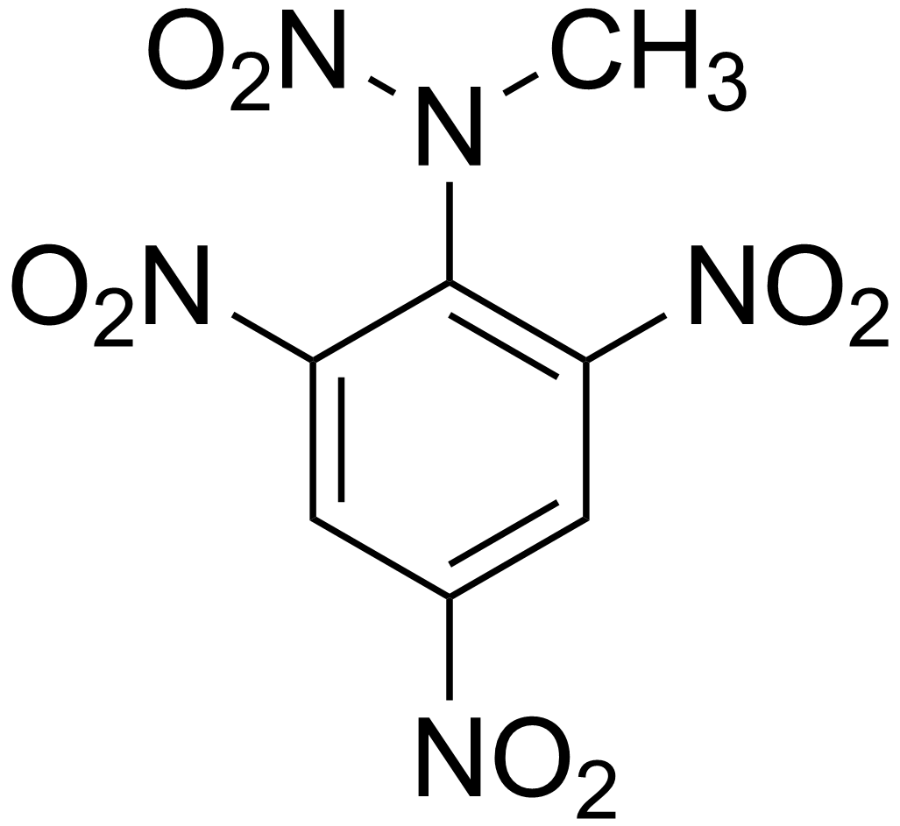
Figure 2 - Tetryl structure.
    - A suitable replacement explosive material used in the detonator can be plastic explosive which can be poured or molded to fit the detonator casement. In this study the explosive of choice is Pentaerythritol tetranitrate (PETN). That when combined with a plasticizer agent produces a plastic explosive.
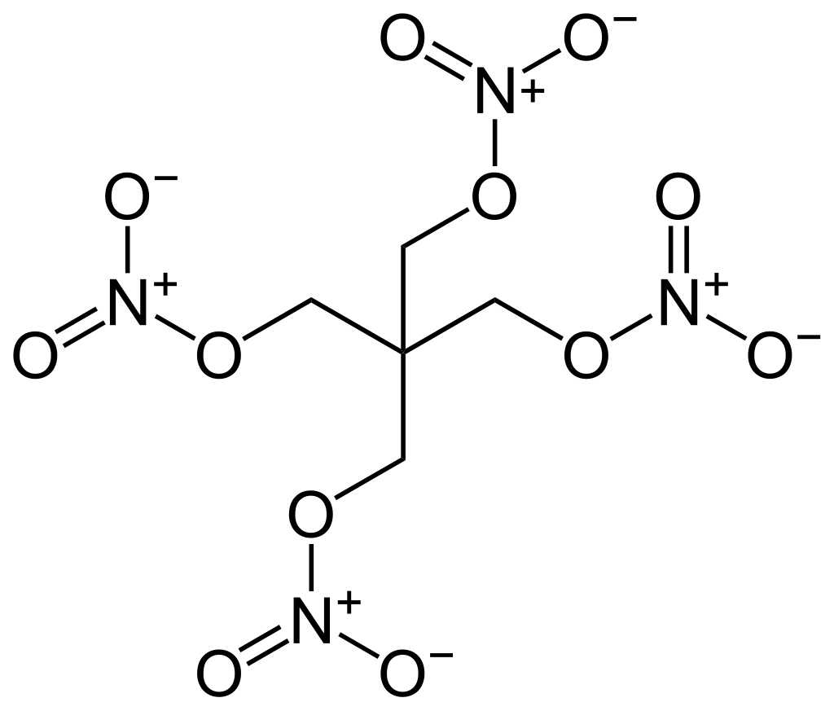
Figure 3 – PETN structure.
    - Its formulae is C₅H₈N₄O₁₂
    - Its properties are listed in table 6 [11].
PETN Properties
Chemical formula | C₅H₈N₄O₁₂
Appearance | White Crystalline
Melting point | 141.3°C
Ignition Temp | 190°C
Molar mass | 316.137g/mol
Detonation velocity | 8400m/s
Table 6 – PETN properties
    - The materials sensitiveness characteristics are also given in the EHDS and are listed in table 7 [11].
Test | Result
Impact sensitivity | 3J
Friction sensitivity | 60N
Deflagration point | 202°C
Ignition by flash | Fails to ignite
Behavior on inflammation | Ignites with difficulty fails to support train for more than one inch
Ignition by electric spark | Explodes at 0.45J  No ignition at 0.045J
Table 7 – PETN sensitivity
    - The oxygen Balance is derived from the formulae
$OB\%= -\frac{1600}{molecular weight}*\left(2C+\left(\frac{H}{2}\right)+M-O\right)$ , where C is number of carbon Atoms, H is the number of hydrogen atoms and O is the number of Oxygen atoms. Substituting the values listed in section 4.4.3
$$OB\%= -\frac{1600}{316.14}*\left(2(5)+\left(\frac{8}{2}\right)+0-12\right)$$
OB% = -10.122%
    - Implementing the standard K-W rule for the balanced formulae and Hess’s law [12].
C₅H₈N₄O₁₂ → 5CO₂ + 4H₂O + 2 N₂ -2O
5C + 4H₂ +2N₂ + 6O₂
    - Working out the molecular masses of the elements in the reactants and products the molecular mass of the materials can be worked out:
C₅H₈N₄O₁₂ has a molecular weight of 316.137g/mol
    - We can work out the products following combustion of the material by substituting them into the products half of the balanced equation
5(-393.5) + 4(-241.8) + 2(0) = -2934.7kJ/mol
    - And the reactants is given as -538.5kJ/mol [13].

    - The heat of formation can now be calculated by subtracting the reactants from the products.
∆H = ∆H_{FP -} ∆H_{FR}
= -2934.7 – (-538.5)
= -2396.2kJ/mol
  - Main explosive material.
    - There are many materials in use as main charges in military applications including HMX, Torpex, RDX and in earlier devices TNT and TATB.
    - For this application as a grenade main charge of Rowanex 1100 has been selected due to its vast use in in-service munitions and extensive testing.
    - Rowanex 1100 is a RDX mixture consisting of 88% RDX and 5% HTPB binder and 7% plasticizer [14].
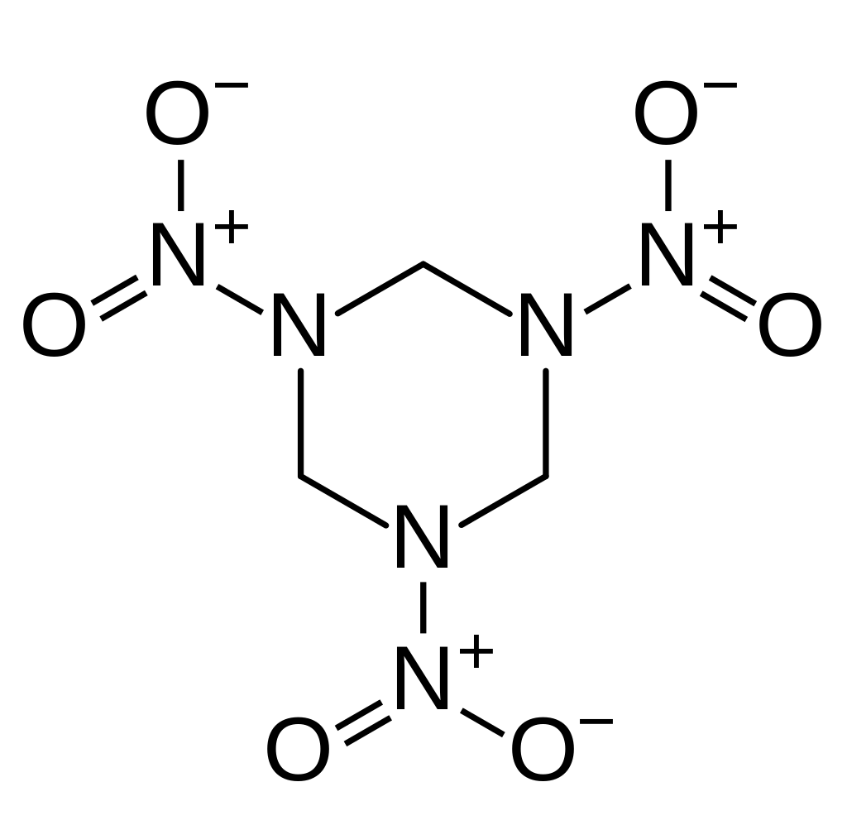
Figure 4- RDX Structure
    - RDX’s formulae is C₃H₆N₆O₆
    - The materials sensitiveness characteristics are also given in the PEHDS [15] and are listed in table 8.
Test | Result
Figure of insensitiveness | 110
Figure of friction | 3.8
Temperature of ignition | 215°C
Ignition by flash | Fails to ignite
Behavior on inflammation | Ignites and supports train throughout
Ignition by electric spark | Ignition at 0.45J but not at 0.045J
Table 8 Rowanex 1100 sensitivity

    - The oxygen Balance is derived from the formulae
$OB\%= -\frac{1600}{molecular weight}*\left(2C+\left(\frac{H}{2}\right)+M-O\right)$ , where C is number of carbon Atoms, H is the number of hydrogen atoms and O is the number of Oxygen atoms. Substituting the values listed in section 4.5.4.
$$OB\%= -\frac{1600}{222.12}*\left(2(3)+\left(\frac{6}{2}\right)+0-6\right)$$
OB% = -21.609%
    - Implementing the standard K-W rule for the balanced formulae and Hess’s law [12].
C₃H₆N₆O₆ → 3CO + 3H₂O + 3 N₂
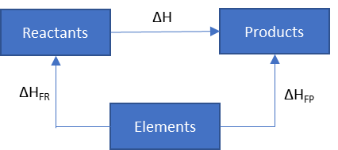
3C+3H₂+3N₂+3O₂
    - The heat of formation can now be calculated by subtracting the reactants from the products.
∆H = ∆H_{FP} - ∆H_{FR}
When ∆H_{FP} = (3x-110.5) + 3(-241.8) = -1056.9kJ/mol
When ∆H_{FR} = 209.165kJ/mol [16]
∆H = -1056.9 – 209.165 = -1266.065kJ/mol

Results
  - This relatively short report has only touched on the possible energetic materials that could be selected for the explosive train in a military hand grenade. Each of the stages of initiation have multiple solution options that would need to be assessed for their positive and negative reasons for being selected or not selected.
  - Each of the results calculated in 4.3.10, 4.4.11 and 4.5.8 show that the reactions are exothermic meaning that they are combustive reaction thus they are releasing heat.
  - Further trials and testing on the individual energetic materials would need conducted to ensure that the calculated and measured values are not vastly dissimilar.

Discussion
  - The selected materials of a Lead Azide as primary explosive gun powder G20 as the delay composition, PETN as the detonator material and Rowanex 1100 as the main charge.
  - While the available energy that has been calculated suggests that the munition would function as designed further research would need to be conducted to ensure the sufficient take over onto each step in the energetic train.
  - Additional work would also need to be conducted to ensure the that the striker profile and force provided by the spring is sufficient for the initiation of the percussion cap.
  - Further additional work would need to be conducted to ensure the delay provided by the delay composition is acceptable, it is likely that alterations to the mixture would need to be performed to confirm the correct delay and that the dimensions need for the composition do not exceed those afforded by the internal dimensions of the grenade.
  - Safety of each of the proposed solutions has also not been addressed in this report and further work would have to be conducted to ensure their suitability for service when manufactured into the grenade.

Conclusion
  - The primary reason behind the decision on selection for the individual explosive materials was that these materials are already qualified for use in munitions and thus the number of tests that would need to be conducted are less than if experimental materials were selected.
  - The final design needs to be safe for not only service use but also safe to manufacture, to confirm this multiple trials and tests would need to be performed prior to going into series manufacture.
  - The manufacturing process would need to be assessed to ensure that the consistency in the products manufacture could be maintained.
  - Other factors that would also have to be considered prior to going into series manufacture are:
    - Ability to mass manufactured at a reasonable cost
    - Availability of base materials
    - Time it takes to manufacture
    - Amount of additional trials and testing that need to be undertaken

References

[1] | T. Harris, "How Grenades Work," HowStuffWorks.com, 22 Jan 2002. [Online]. Available: https://science.howstuffworks.com/grenade.htm. [Accessed 17 Nov 2020].
[2] | J. Akhavan, "The Chemistry of Explosives," in The Chemistry of Explosives , Padstow, Cornwall, The Royal Society of Chemistry, 2004, pp. 78-79.
[3] | E. Gregersen, "Heat of Formation," Britanica, 20 Sep 2019. [Online]. Available: https://www.britannica.com/science/heat-of-formation/additional-info#history. [Accessed 23 Nov 2020].
[4] | S. Cohen, "Hess's Law," Chemistry Libretexts, 22 Aug 2020. [Online]. Available: https://chem.libretexts.org/Bookshelves/Physical_and_Theoretical_Chemistry_Textbook_Maps/Supplemental_Modules_(Physical_and_Theoretical_Chemistry)/Thermodynamics/Thermodynamic_Cycles/Hesss_Law#. [Accessed 23 Nov 2020].
[5] | Chemspider, "Lead Azide," chemspider, [Online]. Available: http://www.chemspider.com/Chemical-Structure.55508.html. [Accessed 24 Nov 2020].
[6] | Chemspider, "Silver Azide," Chemspider, [Online]. Available: http://www.chemspider.com/Chemical-Structure.55601.html . [Accessed 24 Nov 2020].
[7] | D. Holley, "OME Block 1 lesson 4 Primary explosives chemistry," UWTSD, 2020.
[8] | BAE Systems, Explosive Hazard Data Sheet number 1047, Chorley: BAE Syetms, 2000.
[9] | J. Calvert, "flash bang whiz," 21 Dec 2002. [Online]. Available: http://mysite.du.edu/~jcalvert/phys/bang.htm#Blac. [Accessed 27 Nov 2020].
[10] | E. Alan D, "Standard Enthalpies of Formation," 11 Jul 2016. [Online]. Available: http://chemistry.alanearhart.org/resources/Handouts/enthalpy-qr.pdf. [Accessed 27 Nov 2020].
[11] | Eurenco, "Pentrrite (PETN)," Eurenco, Paris.
[12] | A. J, "Table 5.1 Balanced reaction formulae," in Thechemistry of explosives, Cambridge, Cambridge RSC, 1998, p. 77.
[13] | J. F. L. S. E. S. Hussein Y. Afeefy, "Condensed phase thermochemistry data," nist.gov, [Online]. Available: https://webbook.nist.gov/cgi/cbook.cgi?ID=C78115&Mask=2#Thermo-Condensed. [Accessed 27 Nov 2020].
[14] | R. H. Philip Cheese, "Studies on the Effect of Ageing on a Studies on the Effect of Ageing on a," ndia.org, [Online]. Available: http://proceedings.ndia.org/5550/monday_briefings/cheese.pdf. [Accessed 01 Dec 2020].
[15] | BAE Systems, "Provisional Explosive Hazard Data Sheet number 430," BAE Systems, Radway Green, Cheshire, 2018.
[16] | G. W. X. G. J. Z. a. Y. A. W. Junqing Yang, "High-Energy Nitramine Explosives: A Design Strategy from Linear to Cyclic to Caged Molecules," American Chemical Society, vol. PMC6645143, 2018.

